Developing relations and workplace achievements
Romeo Makiadi
1906720
BMSW5102
Molly Jack
A1 Resit

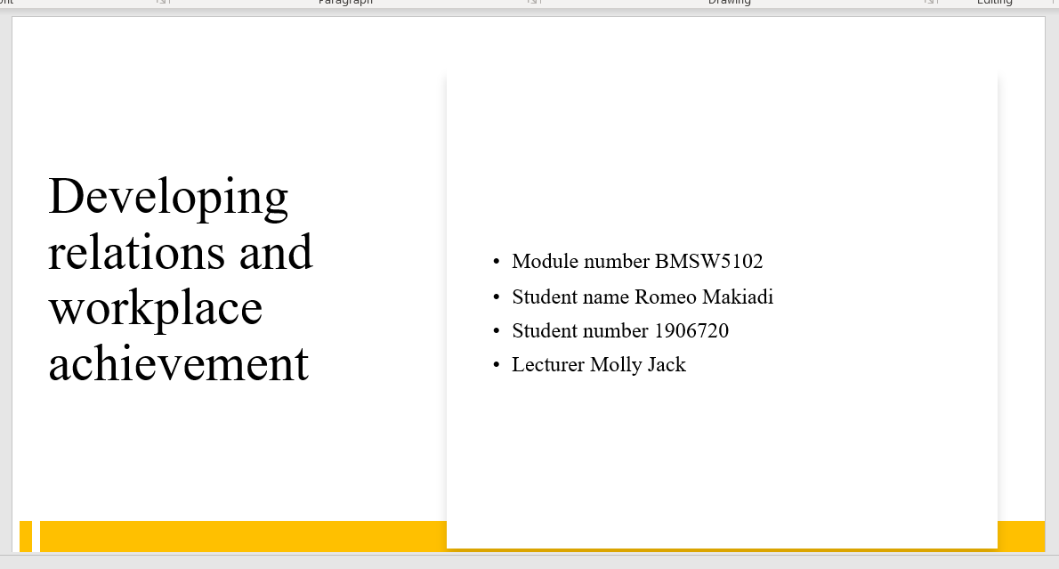
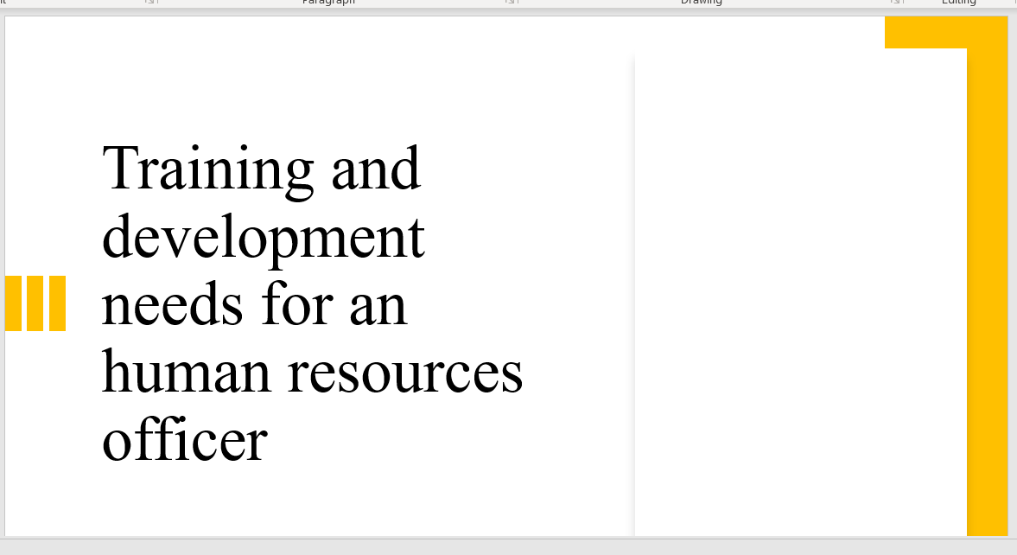
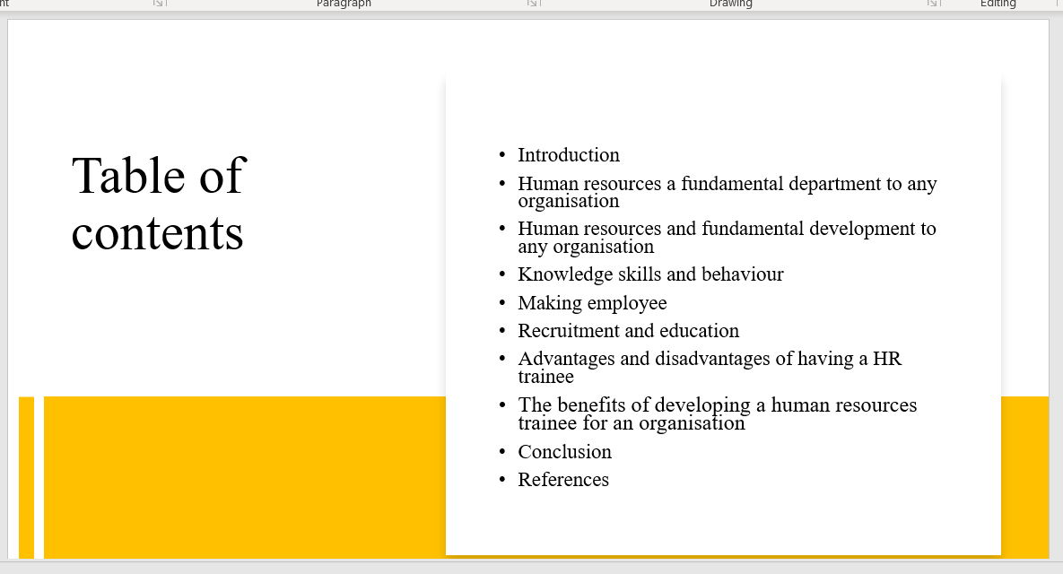
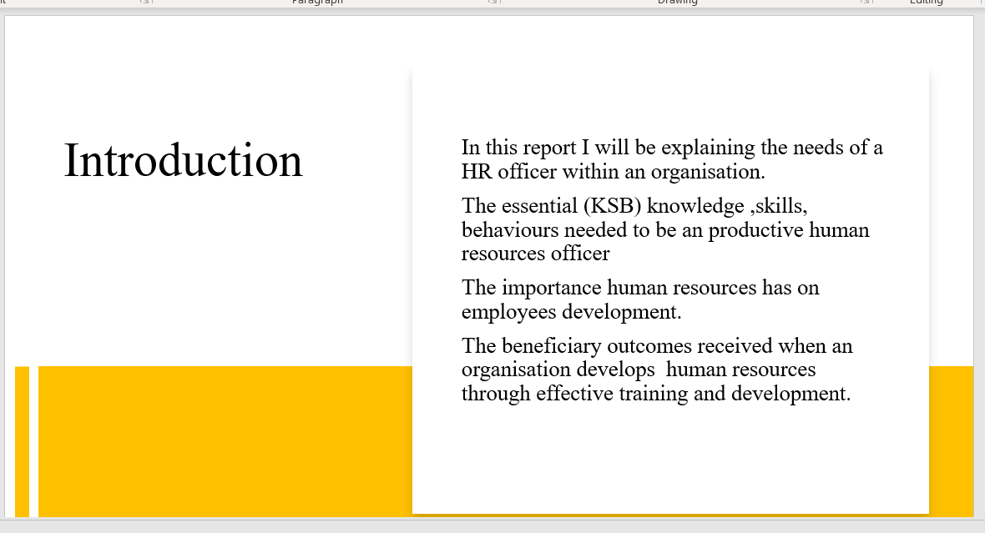
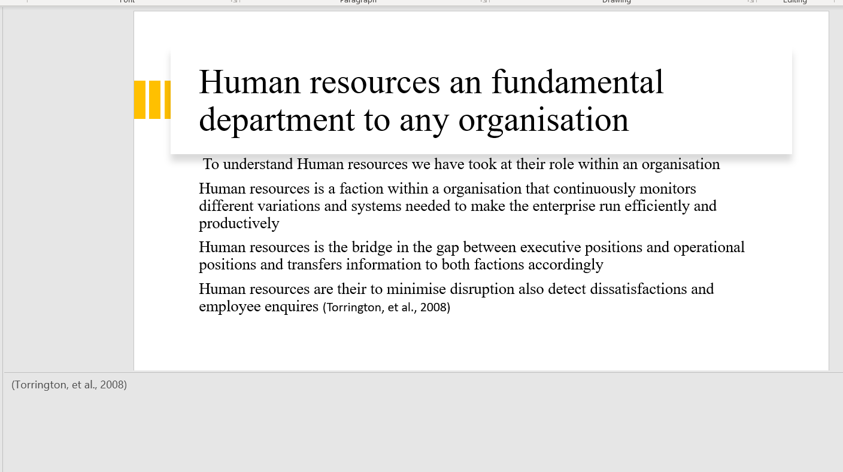
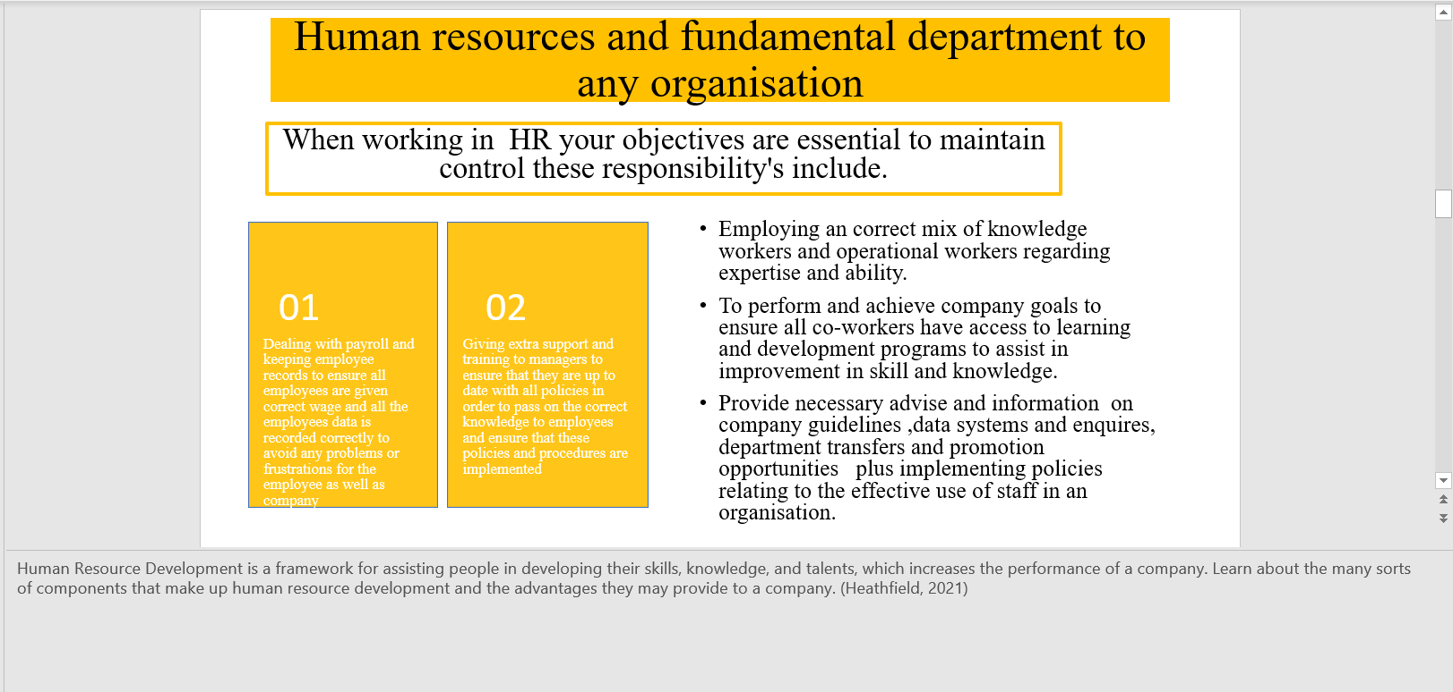
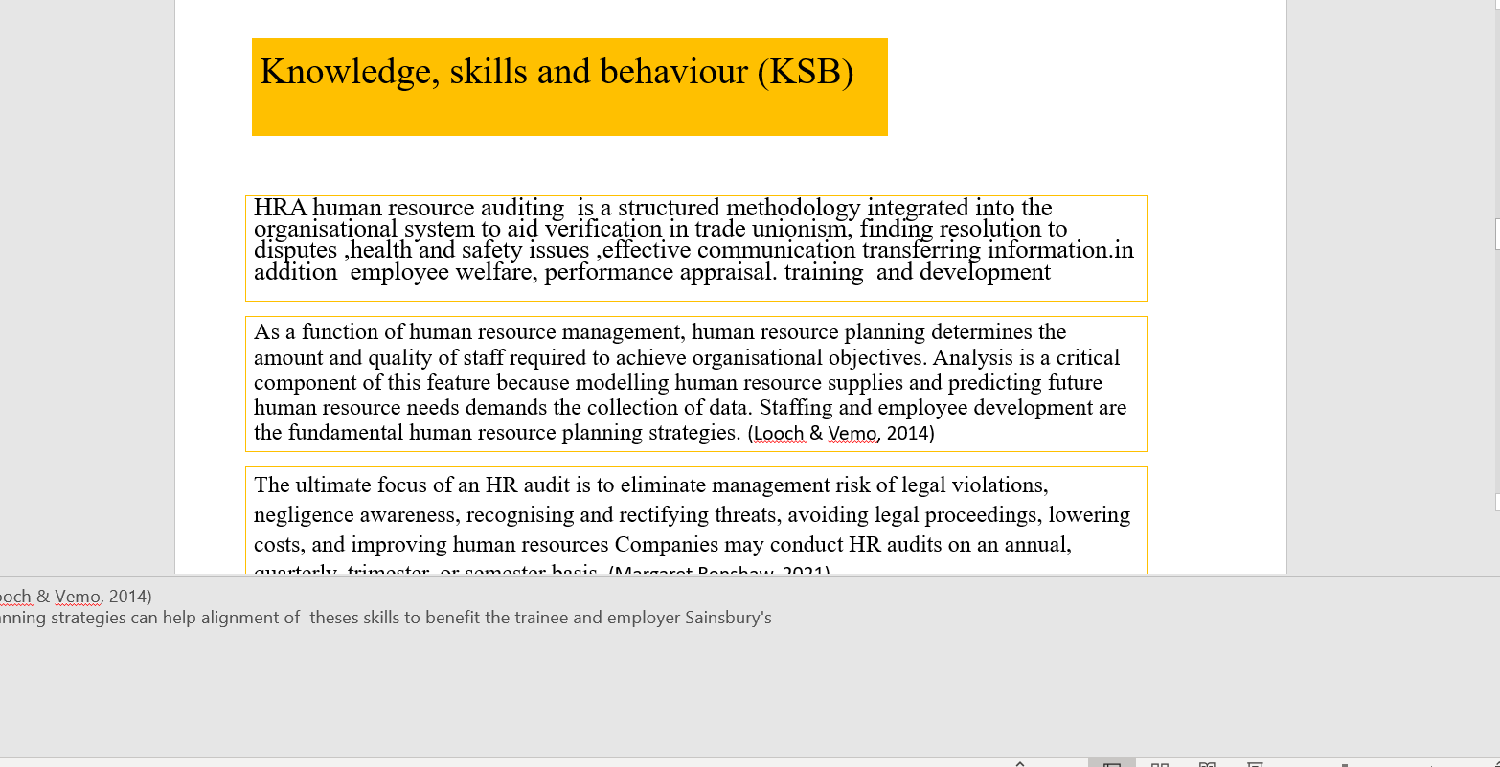
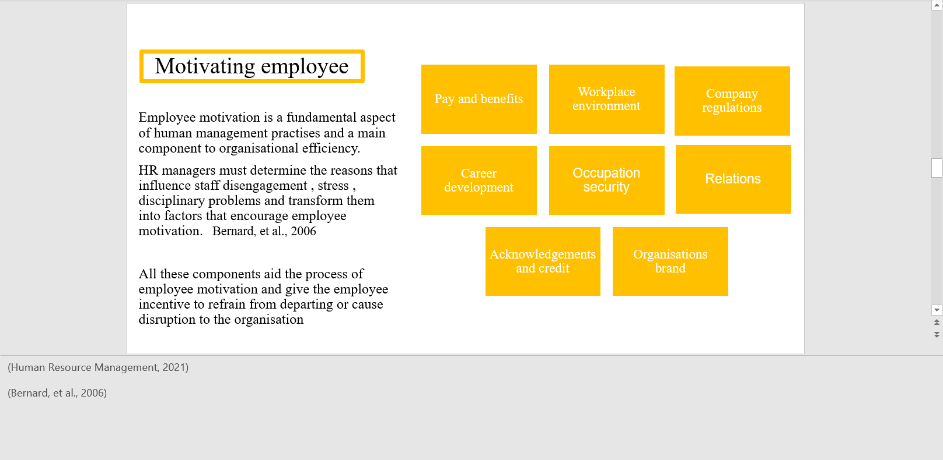
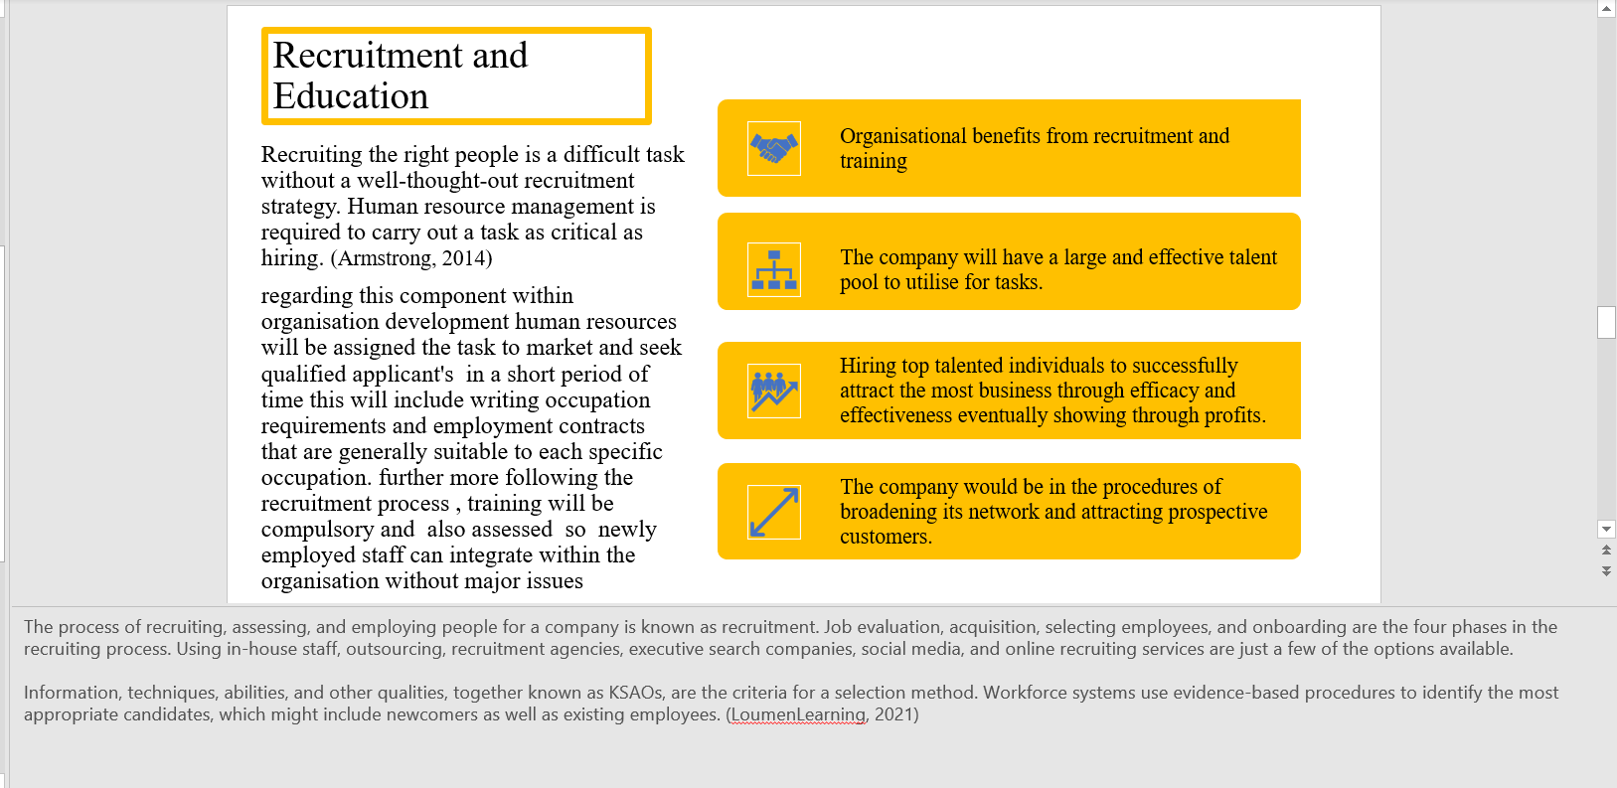
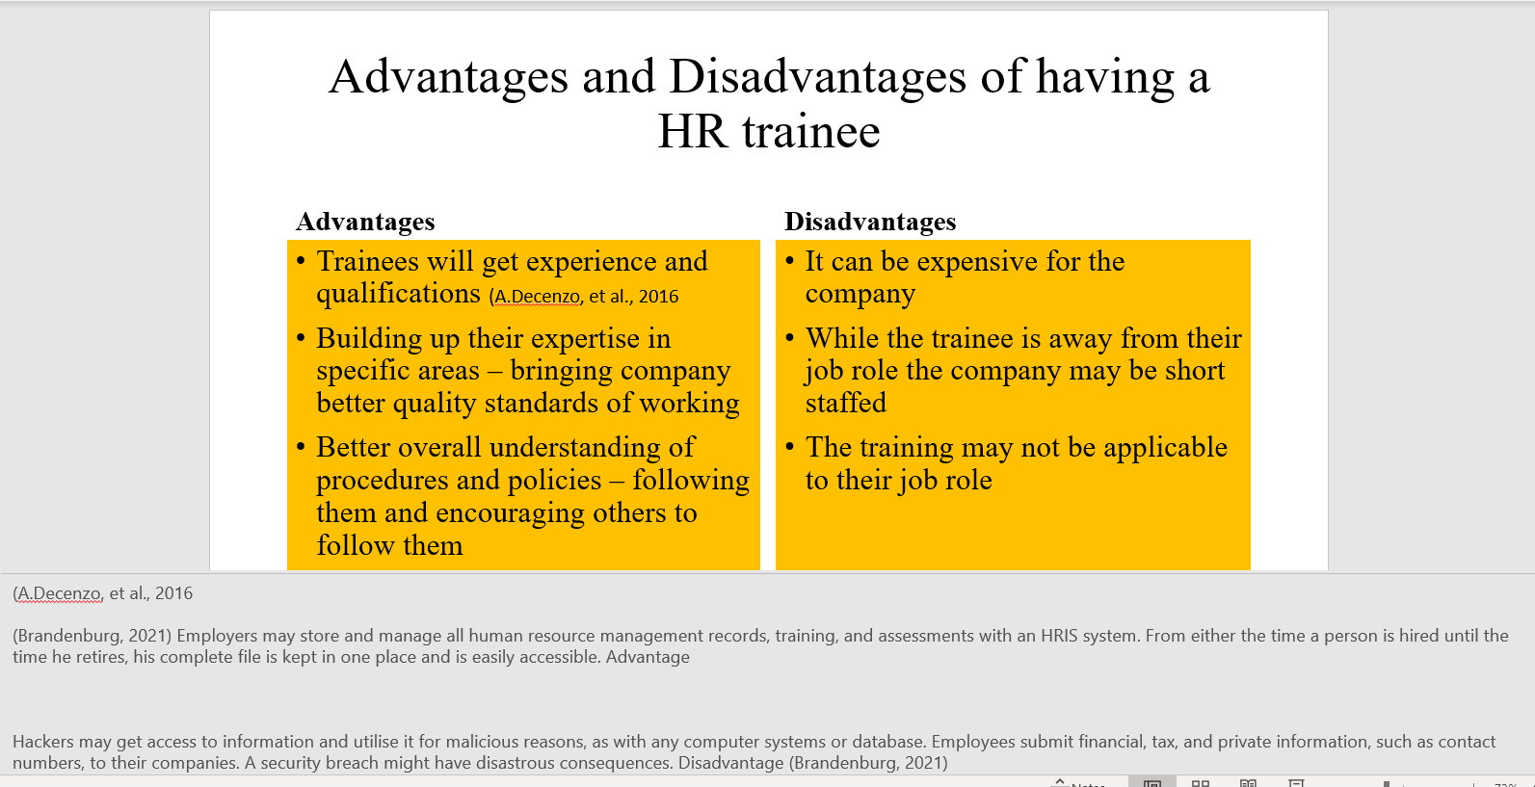
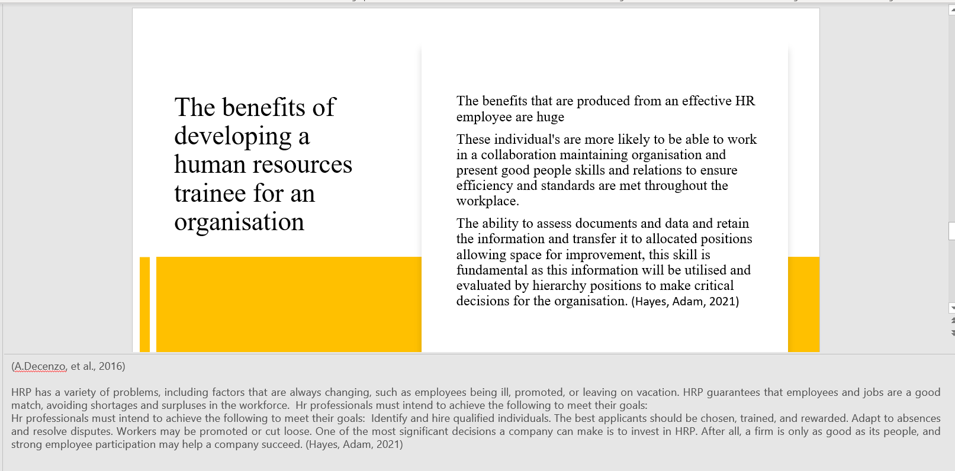
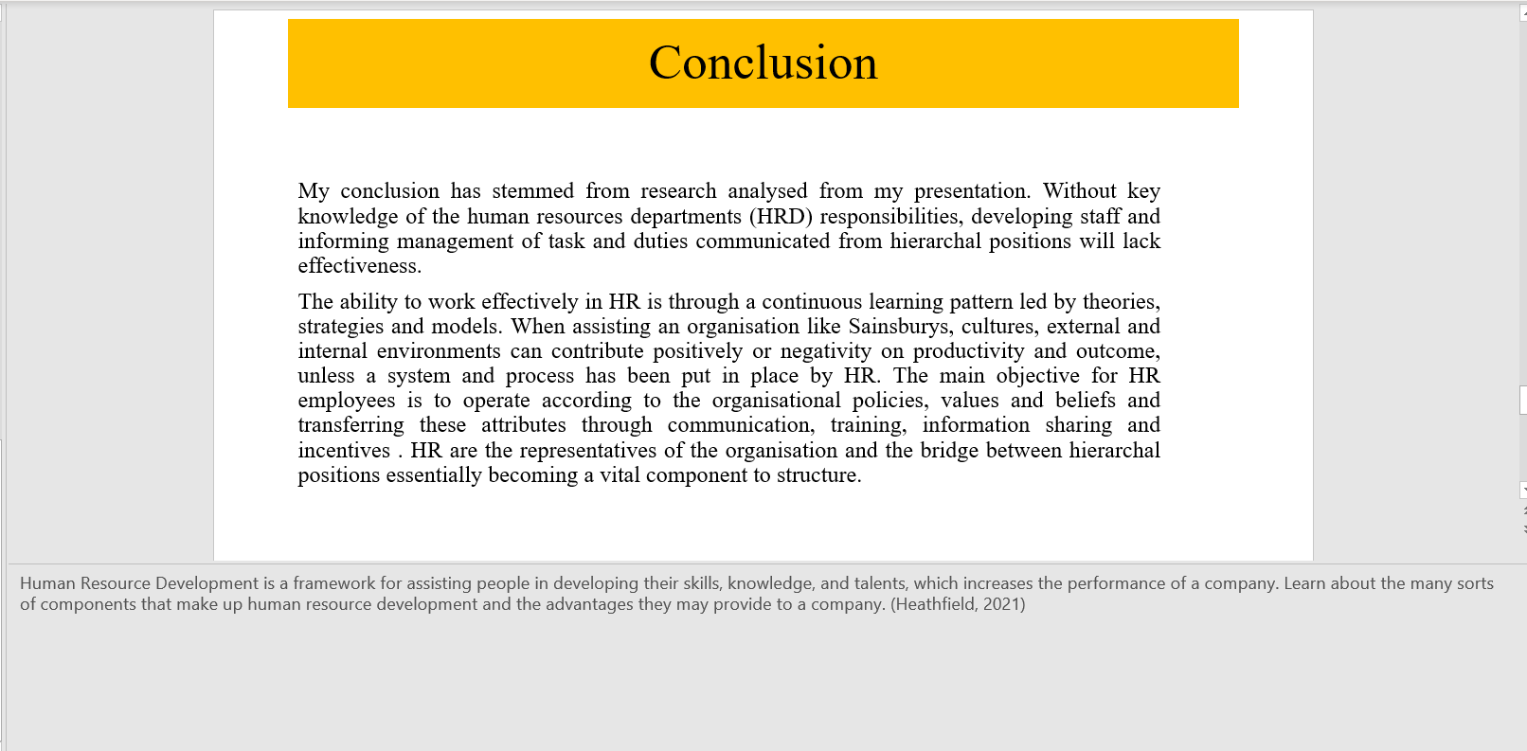
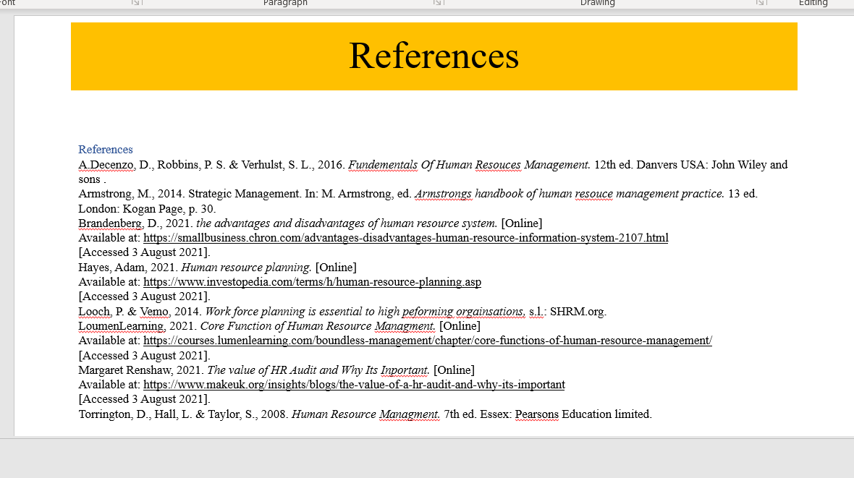

Supporting literature

Supporting my prestation is a further analysis of the requirements needed to be a human resource official. the organisation in question is Sainsburys warehouse the strategic methods put in place by HR development is crucial to the company’s productivity and academic methodologies, need to be evaluated and understood before application. In addition, an appendix audit Critically assessing the potential benefits to the organisation of developing myself as an HR officer through effective training and development

Strategic methods

HRM aim to meet company goals and necessitate skilled personnel, HR are tasked with supporting a wide range of company aims. Responsibilities of line managers are for implementing and enforcing a strategy that aligns with specific policies. However, line managers must first be involved in the formulation of HR strategy. Secondly, ensuring that the HR rules will be implemented and workable given the resources and environment make this available for them. Thirdly, giving managers the training and on the spot advice if that is necessary. (Armstrong, 2014)Understanding the values that come from the strategic methods and utilising the development vehicles provided by the company will boost confidence and
motivation to succeed and will encourage drive plus minimise uncertainty in tasks and procedures.

HR policies must be merged with strategy development and this should then be used to
strenthen or modify an improper organisation behaviour, internal or external and these new contributes will aid an employee with the functions of collaborating with a variety of stakeholders in policy areas such as employee effectiveness and health and safety. Sourcing personnel entails creating job descriptions and candidate profiles to benefit the company and gain advantage over competitors. Acknowledging HR as a strategic asset department will contribute to utilising HR more successfully by maintaining great policies that glorify dedication and, as a result, encourage a readiness in staff members to strive and aspire to aim higher to pursue the highest goals set. (Swanson & Torraco, 1995)

Organisation behaviour theory

This theory addresses how individuals act independently and in teams within the business as well as how community structure in terms of format procedures and attitudes. Training process has strong connection to behavioural theory from beliefs and values and culture differences After considering all the feedback, trainers should make changes to the programmes to preserve what works and enhance what doesn’t. Trainers should revisit many aspects of the training process and seek fresh techniques, even if the topic is the same for various learners. (Bunthoeun & Vice, 2019)
Training is important because it reduces teaching errors, provides chances for employees to develop and recommend improvements, enhances interactions and relationships, and encourages participation. (Bunthoeun & Vice, 2019)
Establishing and enforcing rules on topics like as work environment, performance evaluation, equal opportunity, disciplinary processes, and absences are processes that can cause a reaction, so reason and cause and a correspondence area must be applied to avoid further disruption understanding this as an HR trainee is essential. As a result, behavioural issues have an impact on human resources departments'

(HRM) methods to organisational development and production, as well as improving
organisational competence and capacity to accomplish stated goal and desired objectives. (Armstrong, 2014) according to (Thorndike ,1911) on behavioural approach, which shifted the direction of motivation from the internal to the external. Thorndike established that mammal behaviour is influenced by contextual factors rather than being solely determined by intuition. His "Law of Effect" stated that conduct that is followed by a pleasurable condition or incentive is more likely to occur, whereas behaviour that is followed by an unpleasant state or discipline is less likely to be repeated. As a result, the environment plays a major factor in motivation. (Bernard, et al., 2006). This information will aid continues learning as unforeseen factors can affect external features and transmit negatively to internal

Critical evaluation of SHRM (Strategic human resources management)

Strategic alliance, or strategic alignment of business and human resource objectives is ideal but difficult to execute. Without using critical models and theories to help assist Human resource responsibilities. Furthermore, there are various models that employees in HR should be familiar with to be able to problem solve different scenarios concerning working closely with various departments, increasingly in a consultancy role, assisting line managers to understand and implement policies and procedures. promoting equality and diversity as part of the culture of the organisation. The following are models used by human resources

Contingency theory
HRM methods are influenced by the environment and occurrences of the business. As Paauwe (2004:36) mentions, "the relationship between the relevant independent variables, such as human resources management policies and practises, and the dependent variable performance will vary depending on influences such as company size, age and technology, capital intensity, degree of unionisation, industry or sector ownership, and location." Contingency theory is linked to the concept of fit, or the requirement for alignment between a company's HR's strategic planning process and the variables within its surroundings externally and internally. (Armstrong, 2014)
The best practice models
This concept is founded on the idea that a set of widespread Human resource management methods that are the best in every scenario and that implementing them would result in improved operational efficiency. There have been several lists of "best practises," the most often cited of which being Pfeffer's (1998):
- Job security
- Careful recruiting
- Self-managed groups
- High performance incentive
- Training to ensure a qualified and motivated staff
- Decrease of status disparities
- Information sharing
This theory is more suited Sainsburys warehouse ideology and can be helpful with more research
Ethical Misconduct in HR Activities Examples
Misconduct in Different Forms Employee, supervisory, and managerial behaviour examples Providing false expenditure records, incorrect overtime classifications, misleading time and shifts worked, and biased opinion in performance reviews and pay increases are all examples of misconduct. This form of behaviour can be detrimental to staff. Understanding these misconduct activities are not acceptable at Sainsburys and it will contribute to a successful transition into an HR position. HRD, when executed properly, will help your business recruit, and retain top personnel. Furthermore, to avoid confusion When change is required, using a template to guide employees through the specifics may be the difference between a peaceful implementation and one that frustrates workforce. demonstrate your change control process, from request flows to monitoring and reporting outcomes, this document will be used analysis and for a visual depiction of the process, you may include this tool in your change management strategy. (Simon, 2021)
Benefits employees can contribute
(Heathfield, 2021) offering employees with the ability to continue to improve their talents, as well as incentive to do so, will assist to retain and motivate them. Employees are more likely to stay when they believe they have gotten adequate assistance and development. Productivity will rise and the company maintains assets, training resources, employee expenditure and value of money.

References
A.Decenzo, D., Robbins, P. S. & Verhulst, S. L., 2016. Fundementals Of Human Resouces Management. 12th ed. Danvers USA: John Wiley and sons .
Armstrong, M., 2014. Strategic Management. In: M. Armstrong, ed. Armstrongs handbook of human resouce management practice. 13 ed. London: Kogan Page, p. 30.
Bernard, L. C., Mills, M., Swenson, L. & Walsh, P. R., 2006. An Evoloutionary Theory of Human Motivation. Genetic, Social, and General Psychology Monographs, 13(2), pp. 131,132, 136.
Brandenberg, D., 2021. the advantages and disadvantages of human resource system. [Online]
Available at: https://smallbusiness.chron.com/advantages-disadvantages-human-resource-information-system-2107.html
[Accessed 3 August 2021].
Bunthoeun, D. S. & Vice, R., 2019. Training as a Management Skill Training and Developing Staff. Skill Upgrading for Trainers, 1(1), pp. 7,10, 11.
Hayes, Adam, 2021. Human resource planning. [Online]
Available at: https://www.investopedia.com/terms/h/human-resource-planning.asp
[Accessed 3 August 2021].
Heathfield, S. M., 2021. What is Human Resource Development. [Online]
Available at: https://www.thebalancecareers.com/what-is-human-resource-development-hrd-1918142
[Accessed 2 Auagust 2021].
Looch, P. & Vemo, 2014. Work force planning is essential to high peforming orgainsations, s.l.: SHRM.org.
LoumenLearning, 2021. Core Function of Human Resource Managment. [Online]
Available at: https://courses.lumenlearning.com/boundless-management/chapter/core-functions-of-human-resource-management/
[Accessed 3 August 2021].
Margaret Renshaw, 2021. The value of HR Audit and Why Its Inportant. [Online]
Available at: https://www.makeuk.org/insights/blogs/the-value-of-a-hr-audit-and-why-its-important
[Accessed 3 August 2021].
Simon, B., 2021. Human Resource Management 101: Functions, Policies & Procedures. [Online]
Available at: https://www.smartsheet.com/human-resource-management
[Accessed 2 August 2021].
Swanson, R. & Torraco, J. R., 1995. The Stragic Roles of Human Resources Development. Human Resouces Planning, 4(18), pp. 11,12.
Torrington, D., Hall, L. & Taylor, S., 2008. Human Resource Managment. 7th ed. Essex: Pearsons Education limited.

Appendix B
Personal Skills Audit
Name: Romeo Makiadi 1906720
Job role: Human Resources Officer

Please tick as appropriate to indicate how you would rate your skills in relation to following work/ functional areas
 | Very good | Good | Adequate | Little or no experience
Information Technology
Use Microsoft office word |  | 
Use Microsoft excel spreadsheet
Use a data base
Use specialist HR software
Use the internet
Use email
Use PowerPoint

 | Very good | Good | Adequate | Little or no experience
Communication skills
Drafting contracts of employment
Taking notes of disciplinary
Write reports
Produce material to support presentations
Delivering a training session
Resolving disputes/complaints
Interviewing
Advising on HR issues

 | Very good | Good | Adequate | Little or no experience
Problem solving skills
Make good use of verbal reasoning skills, able to handle complex data and make selective use of information
Explore more than one solution in to solve a problem
Consider the ideas of others to help solve problems

Supervisory management
How much experience have you had in your role | - month | 1-3 months | More than 3 months
How many people have you managed at any one time | None | 1-5 | Above 5

I declare that the information given in this form is true
Signed | Romeo Makiadi
Date | 2 august 2021

