Joao balde

Student id:1909676
Sylvia Hoffman
  - BMSW4001_LON

Intro
Hi my name Joao Balde, I am originally from Portugal but my parents are from Guinea-Bissau and Senegal. This assignment is a reflection on what I learned on academic and employability skills. I didn’t have any clue how this module going to be because this was my first experience studying abroad, so for me this was a new experience but I was sure that would be something that will improve my knowledge and prepare me better for the workplace. Everything was very straightforward in the first week of first term soon I realized the stance of this module is to give us some essential tools for the workplace. The lessons were very good and dynamic, it was pleasure to attend them, the lectures gave us a good support anytime we needed.
I have learned how to paraphrase, reflective writing referencing, summarising, writing a cover letter etc and I really improved on my cv writing, report writing and academic writing. I was familiar with summarising, however paraphrasing was something entirely new to me in academic writing. I learned how to make summaries of the text using the annotations. It was significantly simpler when I wrote it in my own words using the diagrammar notes. I was really pleased to learn how to use such a tool because I always had a issue with having some academic writing added. The observations gave me a good understanding of what I should be working on in my thesis.
I did not have any clue what a guide could be and under what conditions it would be used until I began the course. But, without examples, my lecturer clarified the surprising implications of having a 'zero' rating. have now studied the different referencing methods for newspapers, documents, web posts, newspapers and other outlets that are various.

Gibbs model
Gibbs reflective process allows you to reflect about the stages of an event or operation regularly and you can use every one of the captions to organise your reflection. The reflective process of Gibbs can also be helpful in helping you think through all the stages of an event or operation.

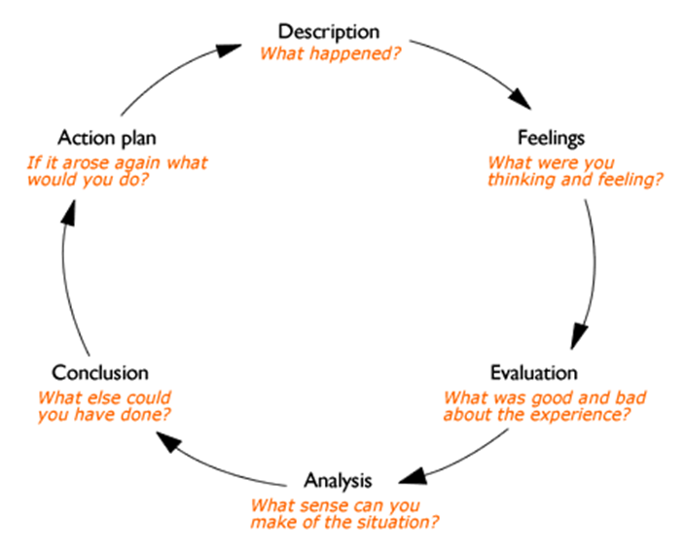
Description
What went wrong? Do not yet make assumptions, or seek to reach conclusions; just explain.

Feelings
What your emotions and actions were? Should not go on to examine these once again.
Evaluation
Where was good in the experience and what was awful? Make assumptions about interest.
Analysis
How can you make sense of what is happening? To support you, bring in suggestions from beyond the field.
What was happening, really? Were the perspectives of different individuals similar or varying in significant ways?
General conclusions
How can be derived from these observations and the analyses you conducted, in a common sense?
Specific conclusions
How do you conclude from your own particular, special, personal circumstance or way of doing things?
Personal action plans
How would you do differently next time in this sort of situation?
What steps would you take based on what you've learnt?

Kolb’s Experiential Learning Cycle
Kolb's experiential learning theory works on two levels:
four-stage learning process, and four different forms of learning.
A lot of Kolb's theory is all about learner's inner cognitive processes.
Kolb notes that research includes knowledge of abstract concepts that
can be applied flexibly in a variety of different situations.
New items in Kolb's theory include the basis for the development of new concepts.

Kolb "1974 sees learning as an interconnected process, for each stage supporting and feeding one another into the next. At any point it's possible to enter the loop and follow it along its rational chain. Efficient learning, but, just happens if a learner can perform the model through all four phases. Therefore, as a learning operation, no single phase of the process is efficient all by itself.

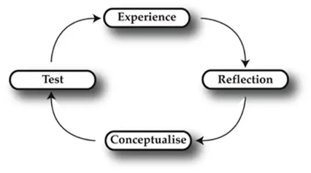

Learning styles and descriptions
Knowing the learning method of a individual (as well as your
own) helps learning to be organised according to the approach you like.
That being said, everybody reacts to and requires the stimulation of all forms of learning styles to some degree or the Other a matter of using focus that best suits the particular situation and also the learning style preferences of a individual.

Diverging
Such people will look at issues from various perspectives. They are pretty easy. Rather than watching, they tend to collect information, and then use creativity to resolve issues. They are best at looking at practical issues from many different perspectives.
Kolb named this style diverging as these persons do best in circumstances where, for instance, brainstorming involves thoughts-generation.
Individuals with a divergent style of learning have wide social preferences and like gathering knowledge. People are really interested in them, they tend to be creative
and expressive and they tend to be powerful in the arts. Those with the diverging style enjoy working in teams, listening freely and getting personal input.

Assimilating
A succinct, rational approach includes the assimilation of the learning preferences. Ideas or concepts are much more essential than individuals.
Instead of a realistic opportunity, these individuals need a proper explanation. They excelled in interpreting and organising broad-based knowledge in a simple, logical format. Those with an assimilated thinking style are less those-focused and more engaged in thoughts and abstract ideas. Individuals with this approach are drawn to logically sound ideas, rather than concrete value-based solutions. This style of learning is critical for knowledge and scientific career performance. Those with this approach enjoy readings, seminars, developing theoretical models and taking time to think things along in structured learning circumstances.
Converging
Individuals with a converging type of learning will fix issues and then use their learning to find realistic solutions.
We prefer technological activities, and are less worried with individuals and social factors.
Accommodating
The Accommodating style of learning is (hands-on), and
is based on experience instead of logic. Such individuals use research from many other individuals, and recommend a realistic, conceptual method. We are drawn to new opportunities and interactions, and preparations are being carried out.
They sometimes act on the impulse of 'right' instead of the rational study.
Those with an welcoming style of learning may rely solely
on others for knowledge rather than doing their own studies.
This form of learning is common within the general public.

Driscoll’s Model
Driscoll discovered the pattern. It is known as one of the easiest of all styles.
There are just issues that revolve around the whole model.
This was developed with the simple intention of reflecting one's own reflection.
Plus, during the early 1990s, it was built. It was influenced by a
1970 questioning of Terry Barton. There had been three important problems in that.
Model is very helpful when describing excellently-established reflective prose.
The explanation for this is that it allows the author structure his text in a more positive and succinct manner. There were only three basic questions that have to be answered.
Therefore you must have a clear example of the past in order
to set things right for the future and prevent some sort of mishappening.
Therefore, by analysing past errors one will learn
to cope better with similar circumstances than before.
How to reflect in driscoll’s model
There's no magic ingredient for learning how to start thinking writing.
It fits for every single person accordingly. Many people like to speak out loud about their experiences and some people want to keep it a bit quiet. The art of reflective writing may have many methods. Your aim will be to get more organised.
Paraphrasing
The document being paraphrased is usually explained or clarified by a paraphrase.
A paraphrase is usually implemented with verbum dicendi — an injunctive term to signify the paraphrase change .A paraphrase should not be followed by a similar quote.
Usually, the paraphrase helps to bring the argument of the source into perspective or to explain the context it appears within. Usually, paraphrases are more informative than summaries. At the end of the sentence, for example, one might add the origin.

Employability skills
Employability skills could be described as the skills that an
person needs to transfer to making them 'attractive to employers.'
Employers also outline a set of skills they expect from an employee, along with strong professional understanding and subject matter expertise.
Communication skills
May be the most essential of all life-skills is being able to communicate effectively.
This is what helps us to transfer on knowledge to others, and to consider what is being said to everyone.
A person with good communication skills has the capacity to determine the most suitable contact form and style in any particular situation. The capacity to determine the most suitable contact form and style in every particular situation, managing disputes and the ability to successfully interact in hard circumstances. Oral presentation the majority of job roles may require some aspect of presentation skills and talking to or as part of a group. Clear and well-structured written correspondence planning and delivery, including emails, letters, business reports, etc. Writing skills must involve good word processing skills.
Interpersonal skills
A social skill is any competency that promotes dialogue and contact with others
where social rules and relationships are formed, communicated, and altered verbally and nonverbally.
The learning process of those skills is called socialisation.
Interpersonal skills are important for socialisation to respond to each other.
Social skills are really the tools that allow people to connect, know, ask for support, meet those needs in the right way, get on well with everyone, make friends, build positive relationships, defend themselves and, ultimately, be able to engage harmoniously with community.
Build critical characteristics of character such as
credibility, respectfulness, accountability, honesty, compassion and citizenship.
Such characteristics help to develop an actual moral compass, enabling people
to make sound thought and behavioural decisions, engaging in social competence.
Personal skills specific competencies are linked to how you articulate yourself.
You can tell the level of personal abilities of an individual easily by
watching how they communicate in the workplace and in daily life with others.

General awareness
General knowledge is information which has been acquired over time across different media. It excludes advanced
learning which can only be gained by intensive training and information limited to a single medium.
General awareness is an important part of crystallised knowledge. It is closely correlated with the general intellect and open-mindedness.

Conclusion
The lesson plan was built in a way that showed me all I learned but in a significant new aspect. What I learned from Terms 1 or 2, from my
essays and paragraphs, has helped me to making my concerns clearer.
I've also learned to incorporate the skills I've gained in order to make
my writings more relevant so that I can achieve better marks than before.
My lecturer carried out rigorous practises and exercises to get us more used
to the academic writing method and it was a positive experience to myself
That experience would be helpful to me as a learner. To conclude, I now know how crucial this module was for me it gave me more tools for the workplace.

References
Borton, T. (1970) Reach, Touch and Teach. London: Hutchinson.
Jasper, M. (2013). Beginning Reflective Practice. Andover: Cengage Learning.
https://www.skillsyouneed.com/ips/communication-skills.html
https://www.allassignmenthelp.co.uk/blog/driscoll-model-of-reflection/

