Academic Skills Assignment 1 2017 – The Rising Star Theatre Company

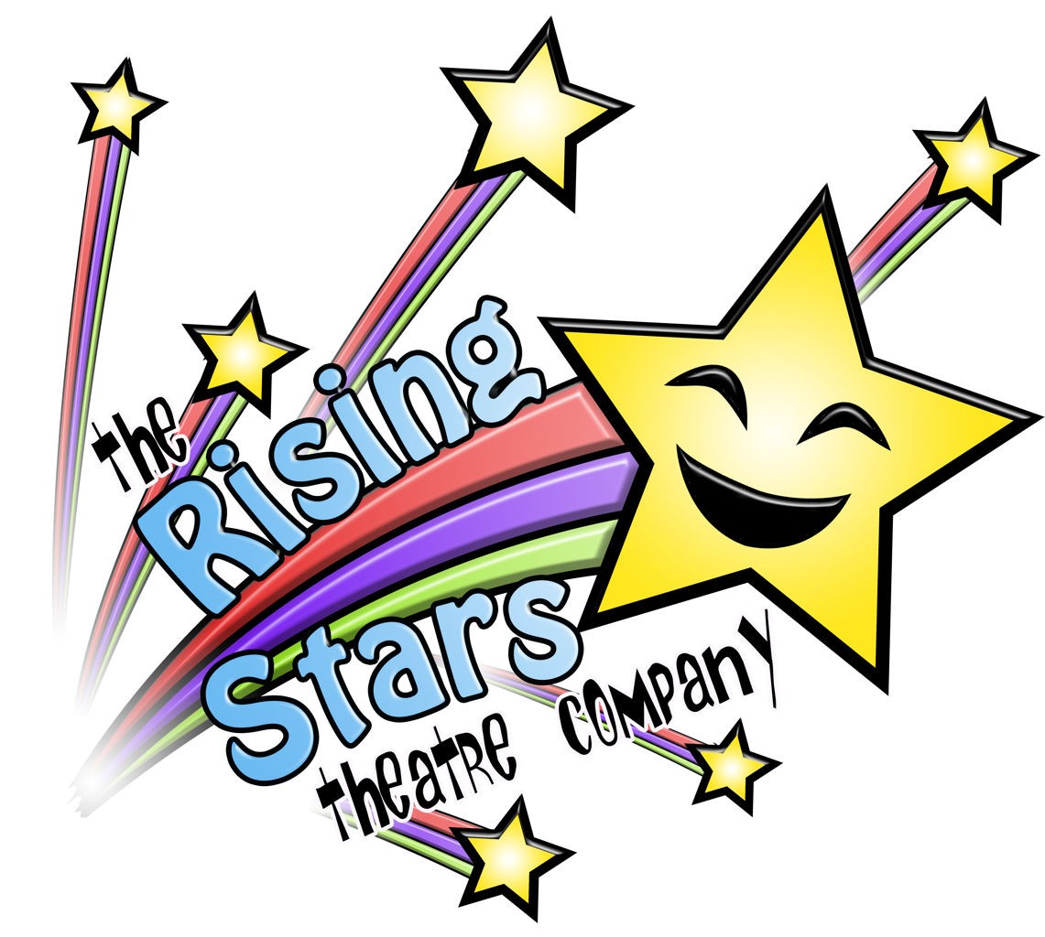

OCTOBER 2017

MODULE NAME: Academic Skills
Project Name: Rising Stars
Name: Kate Oliver, Amy Collins, Rhodri Shepherd, Jack Gilmore Jones & Cai Ellis
Student Number: 1702582, 1703573, 1702359, 1706465 & 1706655

Table of Contents

1. eXECUTIVE sUMMARY 1
2. Introduction 2
2.1 Report Remit 2
2.2 Background of the organisation 2
2.3 Aim and Objectives 2
2.4 Project Team 3
2.5 Project implementation 4
2.6 Conclusion 5
3. References 6

List of Figures
FIGURE 2-1 - PROJECT TEAM CHART 3
FIGURE 2-2 – PROJECT GANTT CHART 4

LIST OF TABLES
TABLE 1:
Table 1 illustrates the group’s meetings throughout the weeks
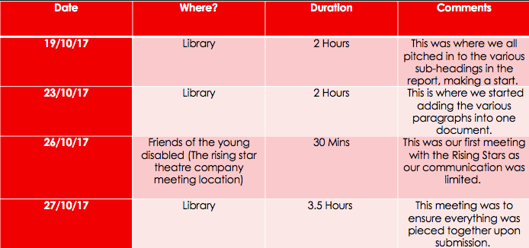

Table 2:
Table 2 illustrates the questions asked when the group met up with the rising star theatre company

Questions

What would you like from our group?

Would you like to expand?

would you be open to the idea of merging with other organisations with the same aims?

would you be interested in any marketing aid to help promote the organisation?

why do you have such a long waiting list?

what resources would you need to expand?

APPENDICIES
APPENDIX ONE: THIS ILLUSTRATES THE PRESENTATION GIVEN FROM THE RISING STARS THEATRE COMPANY

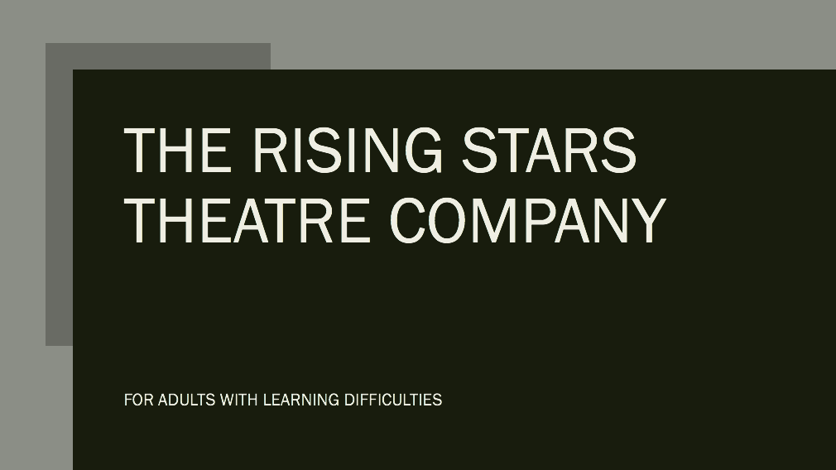

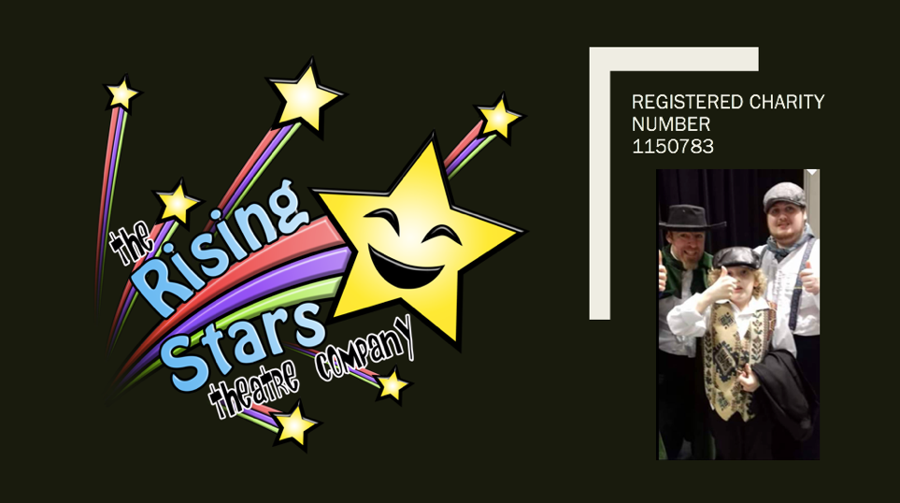

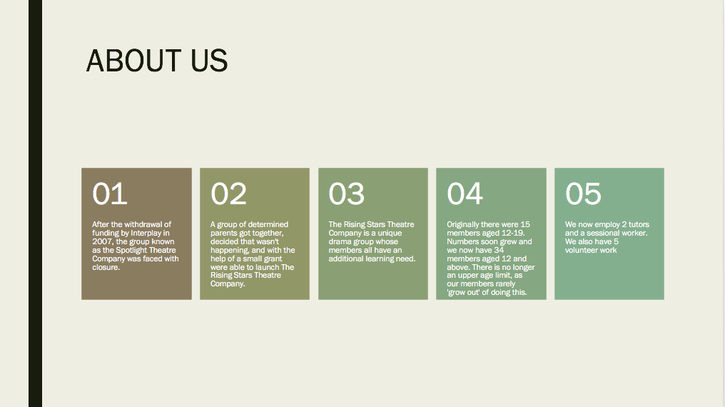

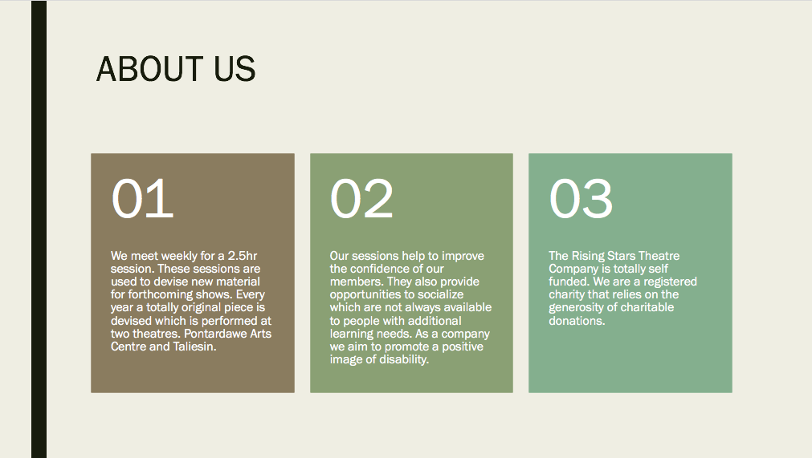



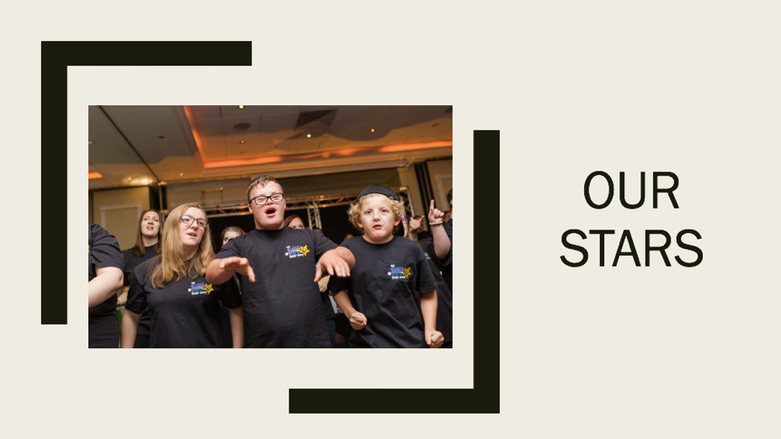

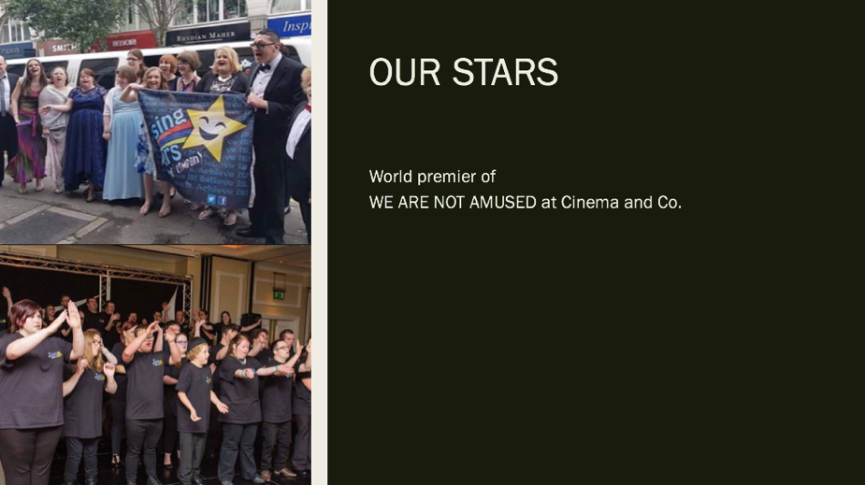

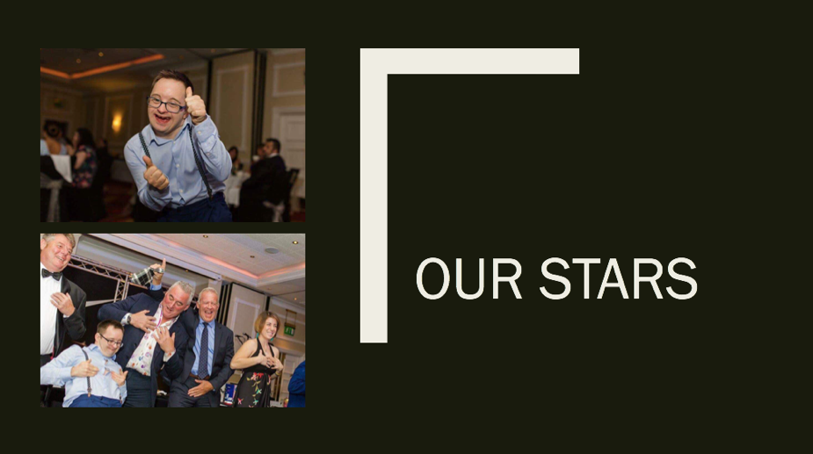

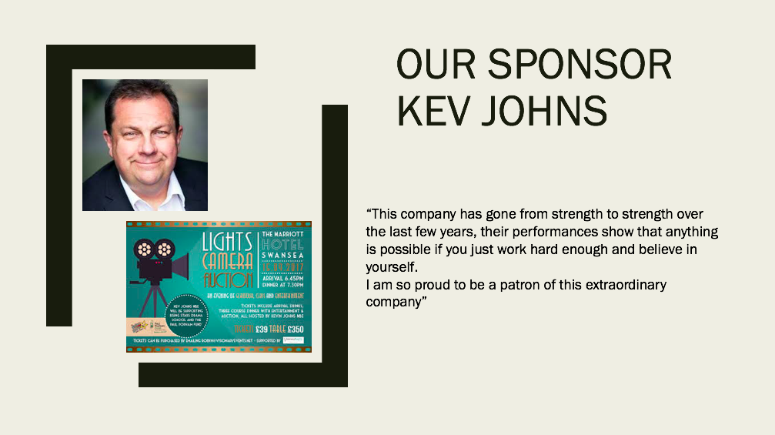

eXECUTIVE sUMMARY

The group has been partnered with The Rising Stars Theatre Company, the aim of the charity, that was founded in 2007, is to provide individuals with learning difficulties a place to perform within an inclusive drama group. Their goal is to increase the confidence of each individual member, by providing them with a safe environment to express themselves. On account of the learning difficulties making it difficult to do this (icommunicate Therapy, 2017). They strive to promote a positive image surrounding those with learning difficulties (The Rising Stars Theatre Company, 2017). As a charity, they rely on donations from the public and ticket sales from their show to fund the work they do, which is why they’ve asked the group for help promoting their upcoming show. Other objectives given by the charity included Recruit at least 5 committee members by January 2018, creating a newspaper advertisement to highlight their contribution to the community, and to arrange a collaboration with Ysgol Crug Glas to make a showcase production.

Introduction
This report details a project with the aim of raising awareness for the charity The Rising Stars Theatre Company. The charity aims to provide individuals with learning difficulties the opportunity to perform in a unique drama group. The report will inspect the charity’s aims and objectives, give a brief background of how and why the Rising Stars Theatre company was founded, as well as examining ways in which the group can help spread awareness. This stems from a meeting the group had with The Rising Stars Theatre Company on Thursday the 26th of October 2017.

Report Remit
This report details the group’s collaborative project with The Rising Stars Theatre Company, focusing on how the group can work with the charity to achieve their goals. After a meeting with the charity, they established that acquiring more support for administration duties was their primary objective.

Background of the organisation
The Rising Stars Theatre Company was founded in 2007 following the closure of the Spotlight Theatre Company. The charity’s predominant objective is to provide individuals with learning difficulties a place to perform within an inclusive drama group. The group was founded with only 15 members, but has since grown to host 34 members, aged 12 and over. The Rising Star Company is currently running with two tutors that work closely with each individual group member, as well as a sessional worker, and 5 volunteers. The group meets every Thursday night to practice (Gina,2017). Their mission statement is : "To promote, maintain, improve and advance the health , well-being, education and citizenship of young people and adults with disabilities, particularly those within the Neath Port Talbot , Swansea and the surrounding areas, as well as for public benefit by the promotion and advancement of the arts; in particular, but not exclusively the arts of drama, music and dance. Also to offer opportunities to perform in integrated stage performances." (Rising Stars Theatre Company, 2017)
Rising Star Theatre Company Presentation (2017)- SEE APPENDIX ONE

Aim and Objectives
Aim: To raise awareness for The Rising Stars Theatre Production Company
Objective 1: Recruit at least 5 committee members by January 2018.
Objective 2: Promote their upcoming show on the 4th of March.
Objective 3: Create a newspaper advertisement to highlight their contribution to the community.
Objective 4: Arrange a collaboration with Ysgol Crug Glas to make a showcase production.

While deciding on these objectives, the team assured that these targets were as SMART as possible. For targets to be SMART, they have to adhere to five specific requirements. Which are, “1) Specific – define exactly what is being pursued? 2) Measurable – is there a number to track completion? 3) Attainable - can the goal be achieved? 4) Realistic – doable from a business perspective, and 5) Timely – can it be completed in reasonable amount of time?” (Williams, 2012)

Project Team
Kate Oliver – Project Team Leader
Kate is the team leader in the group. Her role is to liaise with the charity and to ensure the charity are achieving the level of progress they desire. Kate also assigns tasks to the rest of the group to verify the work load is distributed evenly.

Amy Collins - Resource Investigator
Amy is the resource investigator of the group. Her responsibilities include gathering background information on the charity, also ensuring that all members of the group are aware of the charity’s values and objectives.

Rhodri Shepherd – Finance Coordinator
Rhodri is the Finance coordinator; his responsibilities include ensuring all of the aims and objectives are achievable with the finance the charity and group have available. Also, another responsibility is solving small problems that can potentially occur during the time the team are working with Rising Stars.

Jack Gilmore Jones – Team worker
Jack is a team worker; he communicates with each group member of the group to ensure that all the work is completed on time. His responsibilities also include reducing any friction that might arise between group members.

Cai Ellis – Quality Control
Cai is the quality control of the group, he ensures that all work is completed and then passed to him with enough time to add all the finishing touches to the report. With responsibilities such as correcting the language throughout, and verifying each individual reference is authentic and formatted accurately.
(Figure 2-1. Project team chart demonstrating each member of the group)

Project implementation
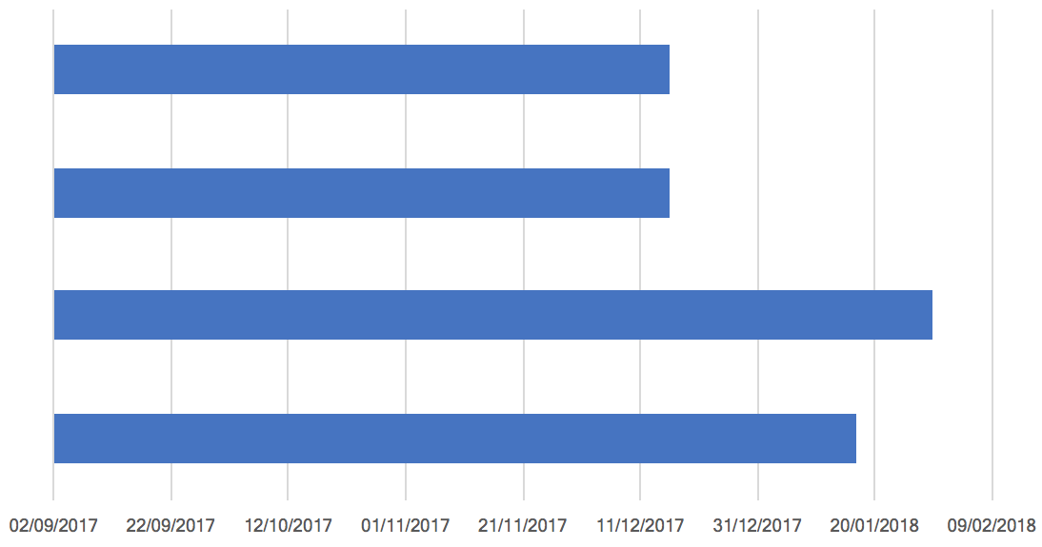
In order to recruit a wider range of members for the committee, the group have planned to approach pre-existing committee members and enquire as to why they decided to accept their role within the charity. The group also wish to find out how rewarding the role committee member is, in order to entice other volunteers. Additionally, the group will be collaborating with Ysgol Crug Glas. Fortunately, another group are collaborating with the school, which allows us consistent communication to both institutions. The charity would also like more exposure in the local community, which coincides with the groups final objective. The final objective will be contacting the local newspaper to see enquire whether it’s possible for an article to be written on the charity, in order to help raise awareness.
Arrange a collaboration with Ysgol Crug Glas
Create a newspaper advertisement

Advertise their next show
Recruit at least 5 committee members

FIGURE 2-2 – PROJECT GANTT CHART

During some of these objectives there are some key milestones, some of these include, having an interview with the Rising Stars, and the newspaper company in order to assure that the advertisement is ready for their upcoming show. Also, there are will be certain processes to undergo while recruiting 5 new committee members, such as key interviews, and discussions with the administration team.

Conclusion
To conclude, after a productive meeting with The Rising Stars Theatre Company, the group have now discovered how they can contribute effectively towards the specific goals held by the charity. The group can now proceed to work at the goals set, by undertaking the ideas set in place to accomplish these goals.

References

The Rising Stars Theatre Company, (2017). The Rising Stars Theatre Company, for adults with learning difficulties [PowerPoint presentation]

The Rising Stars Theatre Company. 2017. The Rising Stars. [ONLINE] Available at: https://www.facebook.com/groups/36562862521/

Williams, C. (2012). MGMT (5th ed.). USA: SouthWestern College Publishing.

Cameron, G. (2017). pom.small@gmail.com. [email].

icommunicate therapy. (2017). Adults with Special Needs and Learning Disabilities - icommunicate therapy. [online] Available at: https://www.icommunicatetherapy.com/adult-communication-difficulties-2/adult-learning-difficulties-intellectual-disability/ [Accessed 30 Oct. 2017].

