Module Title: Strategic Management

Nike

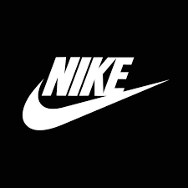

Student ID:2132211
Student Name: Noble Kuriakose Mathew

Executive Summary
This report reveals the Nike product marketing strategy. In comparison to earlier offerings, the evidence shows Nike's efforts to revive the sector. In this regard, Nike's current and future status is rated in the status or market, competition, and organisation sections of the comprehensive marketing plan supplement in this file. It also serves as an example of Nike's marketing and advertising campaigns for the 4ps and 7s models. His SWOT and PESTLE assessments have also been compared to internal and external forces. As a result, Nike may offer a variety of products that are tied to one another, proving its ability to do so.

Table of content

Introduction 5
Key strategic Issues of Nike 7
Porter 5 forces 7
PESTEL Analysis of Nike: Micro and Macro Environment 10
SWOT Analysis 13
Mendel's Stakeholder Analysis 17
Internal Analysis of Nike: McKinney's 7’s Models 18
1. Strategy 18
2. Structure 19
3. System 19
4. Shared Value 20
5. Skill 20
6. Style 20
7. Staff 21
Analysis of the Strategic Option of Nike for sustaining in the Market 21
Ansoff Matrix 22
Conclusion and Recommendation 23

Introduction
Nike is one of the world leading retailer company, is popular among the customer for offering the trendy and cost effective attire and footwears to the customers (Nike, 2022). Being the prominent retailer company, the Nike also faced the challenges in terms of the market their product and services. For this the strategies management must be deployed in the way that can effectively promote the services to the potential customer. Although, the lower pricing strategy of the company is one of the biggest strengths of the company. However, with the expansion, the Nike Company confronts several problems, including disruption in growth. The case study identified several challenges of Nike in the past including; the company suffered from labour legal difficulties in its sector of business due to its inadequate resources. The firm also suffered as a result of a lack of critical resources. The NIKE Company is diversifying its product portfolio, but the end outcome is confined to garnering considerable market share in gear and sports footwear categories. Furthermore, the NIKE Company is confronted with the obstacle of a lack of well-developed marketplaces as a result of difficulties such as product patent protection, counterfeiting, and price. Such difficulties impede the company's growth. For this, the report investigates external and internal environments on the company's business and marketing strategies. Also, the development and competitive tactics are examined. For this purpose, the internal and external analysis of the company is also conducted with the help of the SWOT analysis model. Plus, the company needed to deploy the PESTLE analysis model to determine the micro and macro factors of the company. Including political, economic, social, technological, environmental, and legal. Furthermore, in light of Mickenny 7s’s model, the operation of the internal factor of the company such as; strategy, skills, management style, staff, structure shared value, and system of the company, enabled the company to explore where the improvement was needed.

Business Model
A strategy is important because it informs financial backers of an organization's advantages and makes it easier for them to understand how the organization operates. An effective marketing plan generates revenue for Nike and supports future growth.

Nike's Customer Segmentation
Nike provides something for everyone who wants to buy sports clothing, shoes, and equipment. Nike is further divided into the major sections as follows;

Nike's Value Proposition
Individuals are roused to become competitors by Nike. Their brands' standing, quality, and inventiveness hugely affect the things they produce. While purchasing Nike, buyers look for this since it is the groundwork of the organization. We offer many sorts of workplaces. Selection of products for various sports and hobbies. What matters to regular people, however, is that they receive items that have been extensively researched and created using the greatest raw materials and procedures available. is the company's representative and is concerned about the company's brand reputation.

Nike's channel
Nike uses a variety of methods to market its products and services. Its primary channel of appropriation is physical stores, especially those bearing the Nike logo. The company has actual business offices all over the world and a sizable appropriation organization. Additionally, Nike has a global online marketplace accessible from over 45 countries. Additionally, Nike uses digital, print, television, print, and web-based entertainment to promote the event and has played and group sponsorships from a wide range of companies.

Nike Relationships with Customers
Self-service is effectively the extent of customer connections. Customers go to stores (both online and offline) to study, buy, and use items. There is interaction with the vendor if required. Furthermore, the site provides answers questions sessions. Additionally, customer support by contact number, email, or live chat is available. They can also use the "Nike ID" customizing software, which brings Nike products closer to your preferences.

Nike's revenue flow
The sale of things such as footwear, clothes, equipment, and accessories generate revenue for the firm. In 2019, his total revenues were $39.117 billion whereas, in 2020, the total revenue of Nike is $37.403B. This means the revenue of Nike declined to 4.38%.

Nike Resources
In terms of resources, the most important Nike resources are its real design, employees, and licensed innovation. Nike offers one deals location in California and five deals areas in Memphis. The Tea Sports Exploration Lab, where more than 40 scientists are working on advancement, is reviewed by Nike for people. Licensed invention - He also has the third-largest US portfolio of plant patents.

Key strategic Issues of Nike
This section elaborates on the model and techniques in order to overcome the obstacles faced by Nike. The use of porter's five forces analysis, SWOT analysis, PESTLE analysis, value chain analysis, and market stakeholder and the 7s' model can be effective ways to overcome and minimize the company's risk.

Porter 5 forces

Threats of the new entrance

New market entrants and the new company may alter the competitive landscape for Nike. The degree of the influence of new competitors on businesses in the gaming footwear, clothing, and equipment of the firm is distinguished by this section of the Five Powers study. The additional external elements increase Nike Inc.'s helpless new competitor danger.

- Trademark development comes at a high cost (weak power)
- Macro scale economies (weak power)
- Less cost of the economy (moderate power)

It is difficult for new competitors to successfully compete with huge giants like Nike and gain an advantage over new entrants in sports footwear, apparel, and equipment due to the high cost of marketing. New competitors' ability to alter the current landscape is further constrained by the low cost of doing so. The second-most important risk in this area of the five-force analysis is posed by Nike Inc.'s new participation.

Rivalry among the competitors

The sports footwear market share held by Nike Inc. depends on competition. This section of the Five Powers Examination explains the significance of competition for the economy and for how different organizations portray themselves. The supporting external elements offer Nike a crucial advantage.

- Market growth is slow (strength)
- Companies' aggressiveness is high (strong force)
- A moderate number of businesses (medium strength)

The lower market rate is due to the significant market penetration of companies and market saturation. This situation creates a lot of power as Nike and other competitors compete for a slowly developing market. Meanwhile, companies are in fierce competition to increase their market share. Also, very few companies have a significant impact on Nike. Once again, external forces contribute to a strong rivalry, Nike Inc. Gains a competitive edge and increases its share in the global sports footwear, apparel, and activewear industry.

Bargaining Power of Buyer

Customers of Nike directly affect how we perform. This part of the Five Forces model demonstrates how customers affect an organization's competitiveness and the environment of the industry. The following outside factors, according to Nike, support customers' merger bargaining power:

- Shifting costs to lower prices (strong power)
- Reserve accessibility is Moderate (Medium Power)
- Single buyers have small numbers (weak power)

Consumers are more likely to purchase non-Nike athletic shoes when switching costs are low. Customers may opt to buy other items rather than constantly buying from Nike because alternatives are reasonably available. can be shortened to Customers having minimal negotiating power which results in those external circumstances. This portion of the Five Forces survey shows that Nike's strategy for the athletic footwear, apparel, and equipment industry is heavily dependent on consumer power.

Purchasing power of the supplier
The business is influenced by the suppliers due to the current availability of basic materials. This component of the Five Forces Analysis sells with the impact of suppliers on the company and industry environment. Variables of the external that influence a supplier's bargaining power, according to Nike:

- A large overall supply (weak power)
- There are several vendors (weak power)
- An individual supplier with a medium size (medium strength)

The impact of individual supplier activities on Nike's company is mitigated by high supply. Similarly, having many suppliers lowers the influence of individual supplier needs on huge corporations like Nike Inc. Because of the medium volume of suppliers, supplier influence is medium. Nonetheless, this element of the Five Forces survey shows that Nike has weak leverage that reflects the bargaining power of its suppliers. As a result, the supplier is one of the key drivers of Nike's strategy in the athletic footwear, equipment, and apparel business environment.

Threats of Substitute
The strength of reserves in the business environment is recognized in this component of the Five Forces Analysis. The external factors listed below continue to provide a moderate alternative danger to Nike Inc.

- Substitutes are available in moderate quantities (moderate power)
- Per exchange price, modest performance (moderate power)
- Switching costs are lowest (strong power)

Consumers have significantly different solutions for Nike items; therefore the fair availability of substitute products puts Nike under mild pressure. Customers are relatively inclined to choose replacement items in this context because of their moderate performance when compared to Nike's athletic shoes, clothes, and equipment. This potential is further aided by low switching costs. Nonetheless, this element of the five-force analysis demonstrates that the alternative has very minor effects on Nike Inc.

PESTEL Analysis of Nike: Micro and Macro Environment
Every athlete in the world may find inspiration and innovation from Nike. One of the biggest manufacturers of athletic wear and accessories is Nike, but he needs to maintain a high level of security in a field that is quite cutthroat. This helped the company in analysis the micro and macro factor of the company including; political, economic, and social. Along with this, environmental, technological, and legal factors are also determined. This enabled the company to have insight into the macro as well as micro factors of Nike (Riwayadi, Deliabilda and Panahatan, 2021).

Political Analysis – Enterprise backends should pay special attention to political factors. This is the area that is generally hidden. For instance, the majority of current political changes only have an impact on the profits and methods of production of businesses. Although it may appear unimportant, an organization's viability is determined by political issues. Some of these are, for Nike

- The US government has created several growth-oriented projects. Nike's primary market is the United States, which accounts for 41% of all sales in 2019.
- 10% of Nike products are manufactured in China and are sold in the US market, industry experts claimed that the corporation was mainly untouched by the tariff increase (Hadju et al., 2022).
- However, Nike is constantly affected by changes in tax charges and manufacturing rules and regulations by the government
- Political instability makes operations more difficult or impedes the balance of payment.

Economical factors – As Nike is least vulnerable to economic concerns than other competitors and companies due to this it sells a mid-range good with a solid reputation, some economic elements are nevertheless noted below.

- A market slump might be terrible news for Nike and other established businesses. A consumer might decide to shift to less expensive, low-quality goods when this occurs or even when a reasonable degree of quality is simple to create.
- Nike's revenue largely depends on low labour costs in Asian countries. And if conditions improve in less economically advanced nations, Nike costs may increase globally (Deshmukh, 2021).
- Nike has the economic means to look for small new demands in the market where the firm sold out its goods.

Social factors – There has never been a time when public relations was more crucial. The modern company places a high value on social standing, hence the following things are that are important to note:

- More and more people are choosing healthier lifestyles as a result of the expanding global "health awareness." These people will undoubtedly purchase a tonne of athletic apparel and send Nike into a frenzy.
- Conversely, Nike has faced criticism for its dubious production methods. The Nike sweatshop scandal is such a serious matter that it merits its own Wikipedia entry.

Technological factors – Businesses have a wide range of opportunities to develop due to technology. Technology enhances the value of businesses like Nike by developing a design that would be liked by the customer. The technological aspects that affect this include the following:

- Things can explode and vanish more quickly than ever before because of social media. Nike excels at using social media to develop its brand, but misuse can have unintended consequences (Selitskaia, 2021).
- Nike Company is able to employ informative, informed metrics to optimize targeting, production, and revenue thanks to technological advancements.

Environmental factors – Environmental issues are taking on greater significance. Although not many things affect Nike in this way, it's nevertheless important to note.

- Environmental damage arises from Nike's factories that create goods in large quantities. Nike's manufacturing facilities sometimes even directly damage waterways and, like most factories, emit significant amounts of air pollution.
- Nike has significant promise for the environment, but it is also devoted to improving how things are done now.

Legal factors – Legal aspects are sometimes summed up with political aspects in "PEST" analysis, although they are separated in our PESTLE analysis. Legal factors affect the productivity and efficiency of any company, Nike also has to deal with different legal factors
- It is not surprising that Nike, like other large corporations, minimizes its tax obligations. As Nike manufactured products in house government should levy a minimum tax on them
- In addition, Nike can get into legal issues as a result of dubious marketing strategies, such as false discounts.
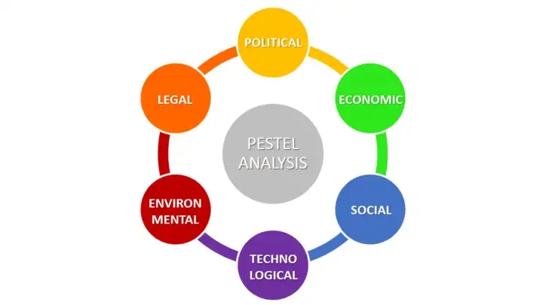
PESTEL Analysis of Nike, Source: (Brand Minds, 2021)

SWOT Analysis
This gave the company a viewpoint about what are the opportunities and the strength of the company. Along with, highlighting the factors of the threats and the weaknesses where the company needs improvement.

Nike Strengths – Nike had some strengths that identity by Nike to grow rapidly.
Nike has a large number of customers who are obsessed with Nike and follow every trend of Nike, these customers provide feedback, and their following trend habits make Nike a recognizable brand in the market. Because its high calibre, Nike's market share reached to $232b in January Year 2022. The CEO of Nike, Mark Parker says the company can still consider environmental issues in the community despite specializing in real estate. The CEO started working to evaluate the environmental problem. Nike builds an Iconic Relationship with Michael Jordan that proved as a successful relationship in terms of sales in the corporate sector. The Air Jordan One shoe is the outcome of their partnership. Additionally, Nike collaborated with a well-known jock to help style the Air Jordan One Shoe. Nike has been able to achieve decades of unheard-of success thanks to its ability to support and grow sub-brands like Converse and Harley. Low manufacturing costs – Nike's sneakers are primarily produced in foreign factories. Vietnam produced 51 pairs of Nike shoes in 2021, China produced pure gold, while the United States produced twenty. There are various operations in Brazil, India, Argentina, and Mexico. Nike employs expert staff who work in-house to design shoes and various sporting gear (Zhang, Zhang and Du, 2022). According to Nike, their company is succeeding because they give each product thorough research. Nike has clever marketing strategies and campaigns (NIKE, 2019). Demand generation financing is very important, as are advertising, promotions, endorsement agreements, media print, and accessories. Nike spent a total of Dollar 3.7 billion in 2019 and Dollar 3.6 billion in 2020 and dollar 3.1 billion in 2021, respectively. The entire is successfully reaching many clients through social media and marketing initiatives. Supporting the Black Community - The entire company runs a wonderful marketing campaign and just released a campaign to fight racism on behalf of the Black community. Nike is the industry leader in footwear holding the highest market share.

Nike’s Weaknesses – For the past twenty years, it has been a pattern of poor operating conditions to target foreign countries. These include child labour, forced labour, low pay, and hazardous working circumstances that are labelled "unsafe." strong distributor Greek deity's retail section undercuts Nike due to its rating sensitivity and influence. Oversubscription exists for 65 percent of Greek deity products sold to wholesalers or retailers. Greek deity has no issues with their rating system because shopkeepers are their main clients. Although Nike's earnings report has shown growth, a quick review of its past performance may reveal a different picture. Greek deity is still threatened financially. Nike owes $9.4 billion in debt as of age 21 relying on the American market Greek deity continues to be passionate about the U.S. market for sales and earnings even after securing its position abroad. Recently, it is reported that North America was considered to be the major source of income. As 49% of the sale was recorded from the USA while the remaining was from other countries. former employees claimed that Greek deities had treated them unfairly since they were citizens of European countries (Reuters, 2021). Complaints were filed by women that Nike has a harmful work environment for women. Greek gods committed as part of its Move to Zero effort to convert each asset of it to renewable energy of 100 percent and to achieve zero carbon emissions. Anyhow this approach is considered as it contradicts Nike's approach of emphasizing innovative ideas over the property. This gives the appearance the Greek deity can never be sincerely devoted to halting climate change and that its promises are merely marketing ploys. The female staff also mentioned and complain about the sexual misbehaviour and molestation that was faced by them and is widespread in the workplace. The New York Times spoke with fifty past and present Nike demigod employees about the workplace atmosphere. Reports elaborate that Nike features a hostile work environment that is riddled such as sexual misconduct.

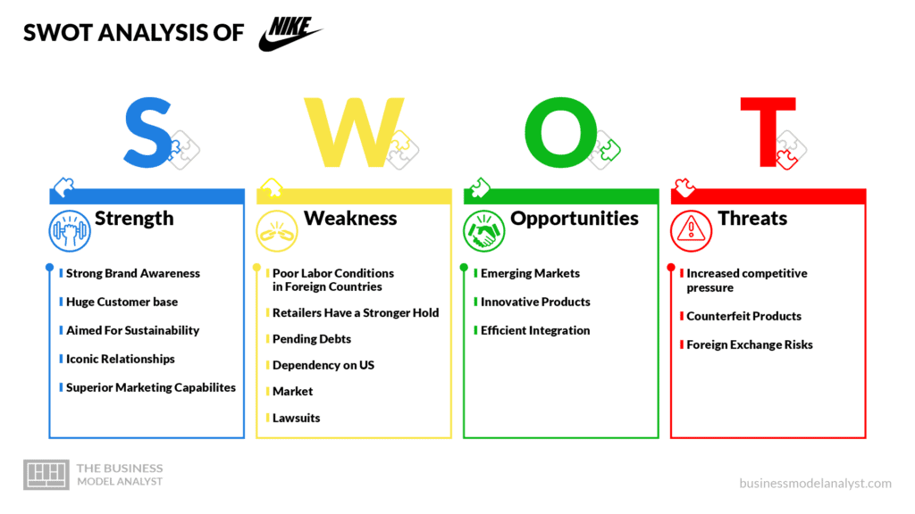SWOT analysis of Nike, Source: (business model analyst, 2022)

Nike’s Opportunities – Despite Nike's present popularity, the brand has a lot of potentials. That’s because of the continued success of establishing markets like Brazil and India and china. Nike invented a variety of cutting-edge goods, but there is still much room for development. A greater range of technology for health and fitness is now available from Nike. Items like wearable technology that tracks physical activity are among the first technologies that are created when building revolutionary technology products. Sportswear and technology can work well together because there is little research on this aspect of the fashion industry. Effective Integration Independent manufacturers develop and provide Nike products. Brands have the option of purchasing most of them or creating their own to create a supply chain that is more efficient and streamlined. Some of the largest brand stores and wholesale suppliers are among the significant merchants with which Nike has cut ties. Distributors like Bob's Store won't be getting any more business from us. The goal of the action is to improve the customer experience and increase product placement. Nike has access to a lot of funding and can purchase small businesses and start-ups in the artificial intelligence sector (Liu and Bi, 2022). The business recently acquired Select, a platform for predictive analytics, to expand its capability for online sales and estimate customer purchasing habits. Nike has acquired the virtual shoe start-up RTFKT in a merger with Metaverse. You're right when you remark that the company just makes shoes for the fictional upper atmosphere. RTFKT said, however, that in addition to the digital version, it had also worked with a young artist named FEWOCiOUS to offer the physical shoes. Nike plans to be able to sell virtual shoes in his Metaverse, where customers may use his Metamask wallet to purchase a variety of in-game treats. Nike recently announced that it would stop taking part in the wholesale market in the USA. The Nike solely aims to sell its products online, through Nike's applications, and in-store. Nike claims that by eliminating distributors, its profit margins will double. Nike also has the authority to determine prices and direct the shopping experience for customers. Nike increased the intensity of its Consumer Direct Strategy.

Nike’s Threats – The likelihood of product fraud is heightened because of the company's international commerce. Cheap Nike knockoffs can be purchased from wholesalers and retailers in large quantities. Despite using inferior materials, low-cost products nonetheless bear the Nike logo may be detrimental to the growing competitive pressure. Despite being the market leader in the sports industry, Nike nevertheless faces competition from competitors and emerging businesses. Due to the fierce competition, Nike must enhance its marketing and advertising budget. According to (Liu, 2022), Nike spent $3.5 billion in its fiscal year 2020, primarily on the growth and expansion of the company. Plus, the primary aim of Nike if to expand growth by focusing on the innovation of the products. budgetary restrictions in marketing, like Adidas and Under Armour's products made with athletes in mind. Businesses like Under Armour, Adidas, and Lululemon are boosting their expenditure, which puts further pressure on Nike's advertising and marketing costs. Brands are susceptible to fluctuating exchange rates as a result of their global activities. Nike releases their financial information in USD. Earnings are impacted by the US dollar's volatility relative to other financial currencies. Whether the corporation is patent litigation is controversial, contested in the media, and reveals some shady information about the people involved. Primeknit and Flyknit shoes are at the center of a heated patent dispute that is currently being heard in a German court. In 2022, Nike recorded a 38% decline in sales; if the recession deepens as predicted, sales may fall much worse (Nike, 2022). Nike is reliant on a variety of overseas markets. The most recent gain in share price, which was brought on by a surge in Chinese sales, serves as evidence of this. Since China and the United States are Nike's two main export markets, escalating trade tensions between the two superpowers would gravely jeopardize the company's financial health. Nike and Adidas are in a legal dispute over Adidas's Primeknit shoes.

Mendel's Stakeholder Analysis
Mendel's matrix is ​​very interesting and helps influence Nike stakeholder groups. There are two aspects to consider. The group's interest in the organization and its impact on the organization (Giunipero and Denslow, 2022). Permission definitions can be categorized in different ways, depending on the area of ​​expertise to which they fit well and the needs of an organization that requires a lot of access. The matrix can be used by Alibaba to identify threat areas and the stakeholders it supports. This tool helps you develop new strategies and modify existing strategies.

High Power and Low Interest: They must be pleased by Nike, a corporation. Organizations can move stakeholders into critical player categories by making them happy and satisfied. Consumers can be satisfied by high quality and the product should be made according to their requirements and need (Onyejekwe, Obi and Ismail, 2021).

High Power and High Interest: When there is high power and strong interest, important players are a part of this type of matrix. Nike has the ability and motive to successfully sway strategy. The decision to invest in these kinds of stakeholders and whether or not to educate them is up to the Nike company. Support from these stakeholder groups might be anticipated if they are informed and taken into account by the Board.

Low Power and Low Interest: If Nike stakeholder groups fall into this category, they often put up the least effort. Low power consumption and low-interest Low interest and very little influence are shown in the organization.

Low Power and High Interest: Change is not met with opposition and the Nike stakeholder group has little influence but lots of interest. In order to prevent Alibaba from cooperating with other forces, there should be enough information provided about this type of organization.

Internal Analysis of Nike: McKinney's 7’s Models
To analyse, the internal operation of the company, Mckinney's 7s model is used. This is to be an effective strategy for analysing the organizational alignment of the company. This helped the company insight into how different internal factors or the company’s structured themes and strategies. According to Alam, (2017), the following are the internal factors of the company description.

Strategy
Nike A's strategy also considers competitive forces and rival action. This strategy will ensure Nike Adapting to market shifts, changing consumer preferences, and making considerable efforts to outperform the competition are all ways that Company A can ensure its long-term existence. Ongoing analysis of shifting consumer preferences, market trends, and consumer behaviour is a vital component of Nike A's strategy. This is a compulsory component of Nike A's strategic direction since it allows the business to support competition, stay relevant to its audience, and spot demand gaps in the consumer market. Then, businesses proactively close these gaps through product and marketing solutions (Allaoui, Bourgault, & Pellerin, 2019). Let's say Nike uses both value-based and premium pricing techniques to market its goods. Valuable pricing uses customer perception to decide the highest product.

Structure
As stated by Arvand and Baroto, (2016), In terms of the structure of Nike, there is some division which is as follow;

Organizational structure – Nike A has a flatter organizational hierarchy that accelerated Nike A's decision-making process while increasing employee organizational commitment.

Internal department coordination – Nike A has a high degree of coordination across several divisions. Nike structured department segment vise that frequently establishes cross-functional teams and innovative techniques to perform the task.
Internal team dynamic – Nike supported the team-oriented synergy work to achieve the target goals and objectives.

Centralization & Decentralization – Nike A primarily supports decentralized decision-making. Nike A also centrally ensures that managers oversee and approve various initiatives.

Communication – The communication within Nike influences the overall company. There is a flow of defined and structured communication among all the members of the company.

System
As controls for measuring performance and target achievement, each system established and delimited in Nike A includes specially built instruments and techniques. The light of the duties and activities of each division, these checks and projections are specifically made for each division. Additionally, each office promotes its own controls that enable people to assess execution and the relationship between departmental responsibilities and jobs. (Baishya, 2015).

Shared Value
The traits of Nike come to mind as a commitment to quality and a focus on customer requirements. At Nike, we make an effort to understand our customers so that they are at the centre of all we do. Nike places a high priority on quality as well. The core values of Nike An are created and communicated in order to support creative and robust hierarchical designs that enable individuals to put on their best performance while fostering authoritative inspiration and devotion. Development, trustworthiness, receptivity, and obligation make up our core values.

Skill
People who work for Nike A are extraordinarily talented and skilled, and they deserve our respect. Each participant is chosen based on their skills and potential. To aid in their growth and advancement, Nike An significantly spends in hiring and training the best people. Nike A hires workers, assigns them tasks, and trains them to the necessary levels of proficiency (Jollyta et al., 2021). The company assures that the representative is a Nike A and that all requirements for the job are satisfied. The development of its employees' skills and capacities is extremely important to Nike A. To help Nike representatives grow their careers, we provide regular education classes and programs. Nike A focuses on unexpected private and professional developments.

Style
Nike A believes in revolutionary or participatory authority. Through a participatory initiative approach, Nike An allows employees to be involved with the dynamic cycle and functional decisions. This enables leaders to regularly consult with employees and other trailblazers to identify potential problems and receive feedback on crucial procedures and projects. Nike A can foster worker and other partner proprietorship, hierarchical commitment, and representative ownership through the participatory initiative.

Staff
The employees at Nike consist of both headquarters and contractor staff. Nike A employs a considerable number of people and has operations all over the world. Employees are recruited within and outside for various roles and positions based on the urgency and needed qualification level.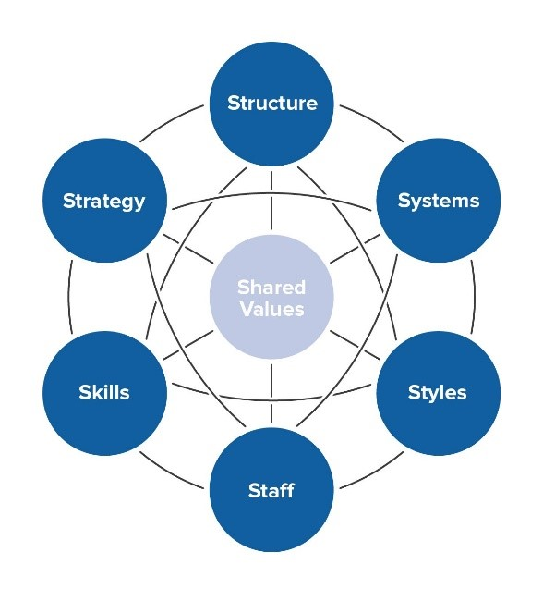, Mckinsey 7s Framework Of Nike A, Source: (Eassy48, 2022)

Analysis of the Strategic Option of Nike for sustaining in the Market
In order to uphold and maintain its position in the market, Nike also adopted the frame of the Ansoff matrix. This also enabled the company to conceptualize the risk associated with the different strategic plans and future goals.

Ansoff Matrix
There are four elements of the Ansoff matrix, that helped the company in anlysis of product development, market penetration, market development, and diversification

Product Development:
If a company chooses to provide a new product to a current client by altering the design, functionality, or features in order to keep the existing It indicates that we are implementing a robust expansion strategy. This is Nike's main expansion strategy. Product Development is included in this rigorous growth strategy and deals with the most recent product advancements to raise Nike’s profit margins. Instance, Nike's mission statement focuses that the incorporation of novel & cutting-edge goods elements, such as distinctive and alternative footwear innovative designs. Commodities are produced in greater quantities thanks to modern technology, which also shields them from market competition. Although consumer purchasing patterns change, new products' worth and allure never change. Therefore, Nike's approach to product creation promotes the widely used competitive tactic of difference. The Shoe Company wants to improve its demand share by using cutting-edge innovations in the construction and rate of its sports shoes.

Market penetration:
Market entrance happens when an organization takes on a serious extension technique to enter a market by delivering a similar item in the equivalent endlessly market section however at various price tags. It is essential for Nike's auxiliary development procedure, which it uses to break into the market. This strategy supports delivering critical deals profit. For example, Nike circulates an enormous number of athletic shoes to American buyers as a feature of its market entrance plan. Despite the fact that Nike's entrance system is seen as an optional objective given its predominant situation in the worldwide shoe business. The partnership is broadening its market infiltration through some extra techniques, for example, the expense initiative procedure of a firm, which has expanded because of fair efficiency. Acquiring a piece of the pie is this technique's primary objective. Clients are constantly attracted to Nike's low costs since it sells its shoes and packs at such low costs. In this methodology, an organization's piece of the pie develops as an ever-increasing number of clients purchase its item. Moreover, the organization's monetary goal is to expand its pay and income by making a major number of deals.

Market Development
This is the most profitable strategy for the firm since it helps to broaden the company's growth by focusing on different markets and market segments. Nike, for example, intends to build shoe stores throughout Africa and the Middle East in order to boost sales and earnings. Additionally, companies apply market development tactics by creating new and unique items tailored to the market to create new market segments such as B. Creating Products and Services for Bodybuilders https://www.mdpi.com/2071-1050/14/4/2418. However, the saturation of the global Nike store market could dictate the company's future growth. Additionally, the financial, demographic, and geographic aspects of the company's growth are all significantly influenced by a solid growth strategy. However, a broad competitive strategy for differentiation benefits the business.

Diversification
To cut losses and offset gains, address the introduction of new products and services in entirely new markets. Diversification is Nike's least important growth strategy. Nike had previously used this approach in the early stages of its business,, including developing garments and sporting goods in its product mix, the plan is centered on manufacturing new products in new markets to do business. Here I am. Sports shoes were the only product the company produced in the past (Anjum, Ming and Puig, 2022b). Diversification might help Nike's overall strategy for differentiating itself from the competition. This strategy's primary objective is to lower any potential financial risk associated with entering new markets.

Conclusion and Recommendation
Nike is the world's largest brand of clothing, footwear, and essentials. It successfully grasps the attention of the customers through the low-pricing strategy. Plus, in terms of potential customers, Nike maintains its position (Heri Erlangga, 2022). Also, regarding employees and the staff of the company, the supervisor of the company adopts the participatory leadership style in which all the employees have the right to be involved in the decision-making process. By all means, it is concluded that Nike world's largest brand also faced the difficulties of the economic crises, As a result, Nike should concentrate on a "key player group" to assist the business in making judgments. A benefit is that low-power, high-interest groups can be changed through investment. Anlysis the challenges of Nike, it is recommended that Nike Inc. must prioritize tactics to deal with competition, which is identified as the most potent force in this five-force study. Nonetheless, client bargaining power and the prospect of alternatives are crucial. Nike Inc. advises prioritizing product development efforts to ensure a competitive edge (Anjum, Ming and Puig, 2022). Nike Inc. is also advised, based on this five-force analysis, to create methods to attract and retain more consumers while minimizing the impact of alternatives in the sports footwear market environment.

Reference list

Alam, P. (2017). (PDF) Measuring Organizational Effectiveness through Performance Management System and Mckinsey’s 7 S Model. ResearchGate. [online] Available at: https://www.researchgate.net/profile/Parveen-Alam-2/publication/325529746_Measuring_Organizational_Effectiveness_through_Performance_Management_System_and_Mckinsey.

Allaoui, S., Bourgault, M. and Pellerin, R. (2019). Business transformation frameworks: Comparison and industrial adaptation. Journal of Enterprise Transformation, pp.1–28. doi:10.1080/19488289.2019.1571538.

Anjum, A., Ming, X. and Puig, L.C.M. (2022a). Analysis of Strategic Human Resource Management Practices in Small and Medium Enterprises of South Asia. [online] Research Anthology on Human Resource Practices for the Modern Workforce. Available at: https://www.igi-global.com/chapter/analysis-of-strategic-human-resource-management-practices-in-small-and-medium-enterprises-of-south-asia/295387.Anjum, A., Ming, X. and Puig, L.C.M. (2022b).

Analysis of Strategic Human Resource Management Practices in Small and Medium Enterprises of South Asia. [online] Research Anthology on Human Resource Practices for the Modern Workforce. Available at: https://www.igi-global.com/chapter/analysis-of-strategic-human-resource-management-practices-in-small-and-medium-enterprises-of-south-asia/295387 [Accessed 23 Dec. 2022].

Arvand, N. and Baroto, M.B. (2016). How to implement strategy more effectively. International Journal of Business Performance Management, 17(3), p.301. doi:10.1504/ijbpm.2016.077246.

Baishya, B. (2015). Mc Kinsey 7s Framework in Corporate Planning and Policy. International Journal of Interdisciplinary Research in Science Society and Culture(IJIRSSC), 1(1).Brand Minds (2021). Nike — a PESTEL analysis. [online] Medium. Available at: https://brand-minds.medium.com/nike-a-pestel-analysis-a213cbc18ad9.

businessmodelanalyst (2022). [online] Businessmodelanalyst.com. Available at: https://businessmodelanalyst.com/wp-content/uploads/2022/07/SWOT-nike-1024x576.webp.Deshmukh, C. (2021). [online] Ejsss.net.in. Available at: https://www.ejsss.net.in/print_article.php?did=9707.

Dyer, Jensen, R.J., Bryce, D.J., Godfrey, P.C. and Dyer, J.H. (2022). Strategic Management: Concepts and Cases. Google Books. John Wiley & Sons.Eassy48 (2022). [online] Essay48.com. Available at: https://www.essay48.com/assets/images/long-article/img9.jpg.

Giunipero, L.C. and Denslow, D.L. (2022). The evolution of supply chain literature: key theories, concepts and categorisations. www.elgaronline.com.

Edward Elgar Publishing.Hadju, Y., Salimi, Y.K., Bialangi, N. and Ischak, N.I. (2022). Analysis Of Protein And Bioactivity Of Nike Fish (Awaous melanocephalus) Extract As Antioxidant. Jambura Fish Processing Journal, 4(2), pp.103–112. doi:10.37905/jfpj.v4i2.15254.

Heri Erlangga (2022). Micro Financial Sharia Non-bank Strategic Analysis: a Study at BMT Beringharjo, Yogyakarta. Budapest International Research and Critics Institute-Journal (BIRCI-Journal), 4(2), pp.1677–1686.

Jollyta, D., Oktarina, D., Gusrianty, Astri, R., Kadim, L.A.N. and Dasriani, N.G.A. (2021). Cluster Analysis Based on McKinsey 7s Framework in Improving University Services. Journal of Artificial Intelligence and Engineering Applications (JAIEA), 1(1), pp.1–8. doi:10.53842/jaiea.v1i1.45.Liu, S. (2022). [online] Nike.com. Available at: https://about.nike.com/en/newsroom/reports/nike-inc-reports-fiscal-2020-fourth-quarter-and-full-year-results.

Liu, S. and Bi, C. (2022). Problems in Li Ning’s Strategy and Countermeasures. Technium Social Sciences Journal, 38, pp.279–290. doi:10.47577/tssj.v38i1.7812.

Meng, S., Wei, B., Xu, G. and Zhang, R. (2021). Analysis of Enterprise Operation Under the Impact of COVID-19 Epidemic: A Case Study of Nike Inc. [online] www.atlantis-press.com. doi:10.2991/aebmr.k.210917.024.

NIKE (2019). Nike Sale. Nike GB. [online] Nike.com. Available at: https://www.nike.com/w/sale-3yaep.Nike (2021). NIKE, Inc. Reports Fiscal 2021 Fourth Quarter and Full Year Results. [online] investors.nike.com. Available at: https://investors.nike.com/investors/news-events-and-reports/investor-news/investor-news-details/2021/NIKE-Inc.

-Reports-Fiscal-2021-Fourth-Quarter-and-Full-Year-Results/default.aspx.Nike (2022). Nike. Just Do It. [online] Nike.com. Available at: https://www.nike.com/.

Onyejekwe, S., Obi, J.C. and Ismail, E. (2021). Highway Development-Related Gully Erosion: The Case of the Okigwe-Isuikwuato Highway, Southeastern Nigeria. Lecture Notes in Civil Engineering, pp.467–482. doi:10.1007/978-981-16-5543-2_38.

Reuters (2021). NKE.N - Nike Inc | Stock Price & Latest News | Reuters. [online] www.reuters.com. Available at: https://www.reuters.com/markets/companies/NKE.N/.

Riwayadi, E., Deliabilda, S. and Panahatan, M. (2021). PESTLE ANALYSIS OF FINANCIAL TECHNOLOGY IN INDONESIA. [online] Available at: http://proceedings.conference.unpas.ac.id/index.php/icoissee/article/download/693/581.

Selitskaia, E. (2021). The B2B Marketing Plan for Punnu Games. [online] www.theseus.fi. Available at: https://www.theseus.fi/handle/10024/499463.

Zahedi, R., Zahedi, A. and Ahmadi, A. (2022). Strategic Study for Renewable Energy Policy, Optimizations and Sustainability in Iran. Sustainability, 14(4), p.2418. doi:10.3390/su14042418.

Zhang, L., Zhang, H. and Du, X. (2022). On Global Promotion Strategy of Chinese Table Tennis Events based on SWOT Analysis. Forest Chemicals Review, [online] pp.608–618. Available at: http://www.forestchemicalsreview.com/index.php/JFCR/article/view/581.

