Student Name:Valentin Victor ZLate

Student ID:2022008

Course Name:LCBB5001 Entrepreneurship
Lecturer: Vasilios Tavlaridis
Executive summary
Business plans are an essential document used for target audience as well as help to evaluate internal capacity of the company. For intense, a business plan used to analyze market penetration and segmentation that help to boost up market share of the company. The current business plan is focusing on Apple smartphones and analyzing its external and internal factors along with its human management practices to evaluate its financial resources for growing business.

Table of Contents
Introduction 3
Company background 3
Products description 4
SWOT analysis of apple 4
PESTLE analysis of Apple 6
Explain the target market strategies of the company adopted to reach their customers 8
Evaluate the human resource practices and management of Apple 9
Analysis of different financial resources of the company used to grow in the business 10
Conclusions 11
References 12

Introduction
A business plan is a document that helps to describe a company's core business values, market activity, product portfolio, future objectives, goals and business strategy to achieve the goal. A good business plan must include each factor that differs from a company's products, services, marketing, target positioning, segmentation, financial planning and budget implementation. The current report is a business plan description that includes SWOT analysis, PESTLE analysis, market segmentation, human resource management strategy of the chosen company Apple.

Company background
Apple Inc was first founded on 1st April 1976 by Steve Jobs and Steve Wozniak. The main vision of the founders was to bring something revolutionary to the newly made company and change the path of computers along with providing people with an innovative approach regarding their computers (Apple.com, 2022). Steve Jobs wanted to prepare a set of new computers that would be small, portable and user-friendly that could be used by people in homes or offices. Apple is denoted as the most innovative, technology-based and user-friendly computer brand that provides stylish, innovative designs to their computer, laptops, tablets and other accessories.
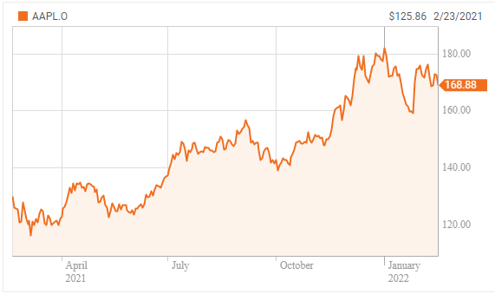
Figure 1: Gross trade of Apple in 2021
(Source: reuters.com, 2022)
Apple Inc. is a USA multinational technology corporation that is dedicated to the customers of electronics, software and other computer devices. Apple is denoted as the largest tech company according to its revenue of $365.8 billion in 2021, and in the January of 2021, it was denoted as the world's most valuable company. Except that Apple is the fourth largest personal computer manufacturer by individual sales globally and it is the second-largest and most adopted mobile phone manufacturer globally (Apple.com, 2022).

Products description
Apple Inc. is not only a manufacturer of mobile phones, laptops, computers, tablets and other computer-based devices but it is also known for its designs, features, innovation and technology usage in its devices. Apple is a big name in the Smartphone market, personal computer market, and tablets, wearable’s, mobile and computer accessories and sells a variety of electronic services through their online and offline stores. The company's innovative product portfolio includes iPhone, Mac book, iPod, home IoT devices, accessories and other devices. iPhone is the company's Smartphone brand or series based on innovative iOS systems and other tech-savvy features (Apple.com, 2022). Mac Book is the company's personal computer and laptop series that is based on macOS operating system and is denoted as the most valuable innovation in the computer segment. The present business plan is focusing on the iPhone's business strategy, market and target audience analysis through SWOT and Pestle evaluation.
Main body

SWOT analysis of apple
Strengths  - One of the key strengths of Apple is its highly innovative product and the company significantly improves their product portfolio in every launch.  - Apple is a renowned and high-value brand globally that holds a potential luxury customer market.  - Apple is the largest technology company globally and the second-largest smart phone manufacturer in the world.  - Apple's distribution channels are highly innovative and technology-based as the company has almost 470 stores in 16 countries along with online services. Not only through its website, but apple products also enlisted in leading marketplaces such as Amazon, Flip kart and others.  - The core strength of the company is its high margin which is majorly used for research and development projects to build strong branding.  - High brand valuation leads the company to high revenue earnings. | Weaknesses  - Maximum apple products are incompatible with various third party applications that are required for daily life. This issue is the focused weakness of Apple Inc.  - Being a technology leader brand the customer expectation is always high for innovative inventions, but in recent years the company focuses on their designs more than customer technology expectations.  - The company has some significant products which they improve or prelaunch every time. This product limitation leads to market disturbance and lack of invention.  - The main weakness of the brand is its high price which is not affordable for all working professionals. The limitation of the customer segment decreases its market expansion and brand development.  - The company is not dedicated to promotion and branding which lead to weakness in advertising and marketing.
Opportunities  - Despite having high pricing, Apple's market is still expanding and various customers are buying products as the brand has become a fashion and status statement for millennial.  - The production, operation and service management of Apple consists of highly trained and qualified employees that help to increase opportunities in the competitive market (forbes.com, 2022).  - The parental control system in the devices increases customer satisfaction and trust as the devices are hack proof.  - Apple is expanding its business through various other markets such as video streaming, music streaming, live content streaming, and game streaming which is increasing its potential. | Threats  - Apple is highly dependent on China and its production has been highly affected due to the Covid-19 attack. The china disruption led to future disturbance in the company's distribution and production network.  - Copied products with brand image have been developed globally that lead to misconception among the customer between real and fake brands.  - High level of competition in the smart phone and computer market by rivals such as Samsung, Google threatening Apple's business expansion.  - The USA government restricts imports from china that increase the high threat to Apple's production and manufacturing. In addition, China traffic disturbs its R&D project.

PESTLE analysis of Apple
Political | - Apple is the largest American technology multinational smart phone company that has assembled a large amount of revenue since its first product launch. This high amount of accumulation leads to higher corporate taxation in the USA where income inequality is the most disturbing political issue.  - China dependence on the brand for lowering manufacturing costs differs from the USA's political perspective. Social and political disturbance in China lead to disruption of manufacturing and increasing cost. In addition, America has been restricting China imports in the country to boost up internal manufacturing (Tien, 2019, p.2).  - Apple smartphone's main production chain is built in China which leads to business disturbance in the USA and Japan like countries where China product or China connection is highly restricted.
Economical | - Due to the pandemic outbreak, the labour cost increased in China because the cloud took away the cost advantage of Apple goods.  - Slowing down of middle-class incomes in developed countries such as the United States of America that could shrink the expanding potential market for luxury high-cost products marketed by the brand.  - The higher exchange rates of the US dollar made the apple product more expensive and disturbing business in China and Europe.
Social | - The biggest growth in the potential customer base of Apple will be distracted in coming years in some areas such as Africa, which is not at all familiar with Apple products due to its high level of poverty.  - The high cost of apple products increases racial discrimination in the market where poverty, income inequality and social status difference are the high rising issues in the contemporary market (Chen et al., 2021, p.3053).  - Apple's main target audience is the young generation of high economy countries such as America who are getting detached from the products that drive themselves in regional and global markets.  - Higher tension with China leads to business disruption in the USA and other Asia-Pacific countries for cultural and social distance.
Technological | - The Smartphone market is highly competitive and the nearest competitors of Apple such as Samsung, Google have a strong infrastructure to copy Apple's model's designs and technology easily. For intense, Google only took a year to develop a similar app called Google pay as like apple pay (pestleanlysis.com, 2022).  - The customer market of Apple is limited and new offerings such as the Apple TV market is very limited due to its high pricing and availability of other products at a cheap price.  - Growing market demand for smart phones and tablets reduces Apple's other personal computer ranges that leading to a compressed product portfolio of the company.
Legal | - Apple smartphone's entered a highly regulated financial sector through its Apple pay services. This activity can increase the level of regulation and government parental control on the company activity according to US customs and border protection (CBP) (usa.gov, 2022).  - As per company news, Apple is going to enter into another highly regulated sector which is automobile’s manufacturing which leads to high regulatory, litigation costs to Apple.  - Due to providing financial service, the company would face financial restrictions and ligation regulations.  - The company is highly dependent on some intellectual property law products such as music and software which can lead to privacy and litigation issues to the company in future business perspective (usa.gov, 2022).
Environmental | - The main environmental problem occurring for the company is the disposal of electronic devices which contain lithium batteries. Companies must assume the concerns regarding landfills with these unused non-working devices in the environment.  - The high increase level of population and environmental concerns in china lead to a decrease in Apple's products as well.  - China's initiative to cut down greenhouse gas generation and usage of non-renewable energy sources for production can lead to high-cost manufacturing expenses for Apple.  - Increased levels of climate change concern cut down the usage of energy and raw materials leading to regulations and initial expenses to the company.

Explain the target market strategies of the company adopted to reach their customers
Apple smart phone is a high-cost electronic manufacturer which has a luxury customer base that helps to maintain the brand image intact for decades. Apple's marketing strategy refers that the brand is minimalist yet expanding through highly innovative distribution channels. Apple's brand value proposition is entitled "Beautiful designs that work right out of the box", which indicate that the company is highly focused on its smartphone products, not on the packaging or look. Apple has become the world's largest innovative IT firm which develops various tech-based products that improve human's life. The company technically avoids the price wars in the competitive markets with the rivals emphasises its exclusive value proposition and marketing strategy.
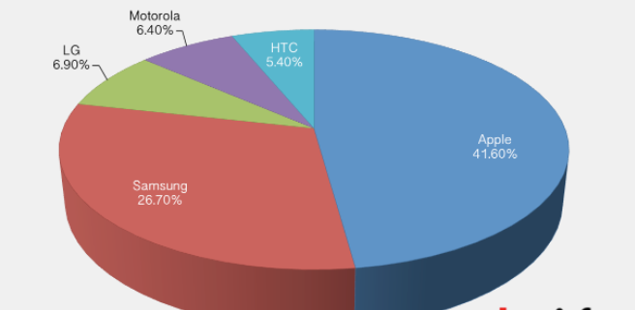
Figure 2: Apple's smart phone market comparing other brands
(Source: ft.com, 2022)
Despite high prices and other factors, maximum customers are repeaters and buy each product after launching (Terentii et al., 2018, p.122). This is the magic of the company's highly innovative marketing and business planning which make the brand user-friendly. The company focuses on its branding and business value more than its other factors as according to media and business analysts Apple does not sell products it sells brand prepositions that help to boost up its value as well.

Evaluate the human resource practices and management of Apple
Apple smart phones are denoted as the most innovative and largest tech-hub in the world where maximum people are working in the position of marketing and technical services. In addition, maximum work in this company is automated and controlled by AI devices (Trivedi, 2019, p.8). The principal objective of the company is to grab attention and retain its highly qualified employees. To achieve these objectives and future goals the company implemented various human resource practices to attract highly qualified and skilled professionals.
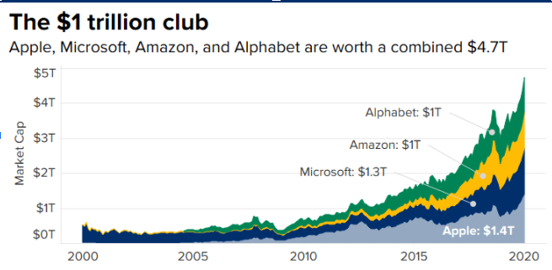
Figure 3: Apple's human resource practises
(Source: cnbc.com, 2022)
The company minimises the effort for selecting workforces by investing in their capabilities. Its highly structured human resource management is a crucial element of managing high competitiveness in the smart phone market. The company's innovative human resource practices are the key driving measures for changing brand valuation in the smart phone market segment quickly and easily (Redpath and Vogel, 2020, p.180). The company recruits high quality and competent employees to achieve a competitive edge in the smart phone market. Employees of Apple are also empowered to offer product discounts that help the company to understand customer demands and applicable discount strategies in smart phone segments (Malfona, 2018, p.53).

Analysis of different financial resources of the company used to grow in the business
The capital framework is a simple measure of how the equity and debt are utilised by the company to finance and operations costs. Apple smartphone's total stakeholder's market share is $96.5 billion in 2019. This amount involves $43.4 billion in the common stake per valuation and the rest in paid capital. And the rest 53.7 billion is in earnings from other comprehensive income of $639 million (Apple.com, 2022).
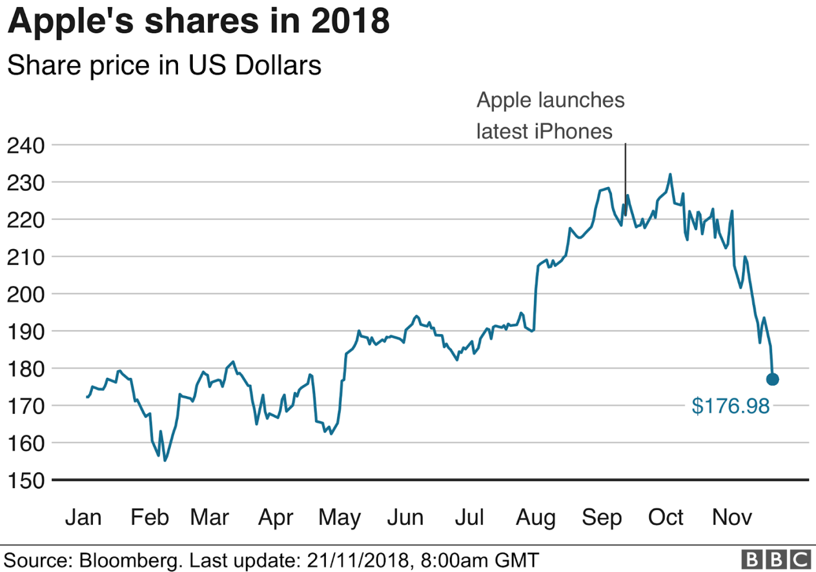
Figure 4: Apple's Market share 2018
(Source: Bbc.com, 2022)
The second finance source of the company is debt structure which refers to the amount the company owes from the creditors and is classified by periods. Apple smartphone's present liabilities were almost 489.7 billion which contain almost $29.7 billion in accounts (Li, 2021, p.71). In addition, the payable amount of 13.5 billion is in short-term notes and through bonds, along with long0term debt amount and other previous liabilities is $136 billion. Overall Apple smartphone's total liability is $225 billion which is almost a 3%hike from 2018 (Bbc.com, 2022).

Conclusions
According to the overall discussion, it can be concluded that the Apple smartphone's business plan is quite different from other nearest brands and it has been facing various internal and external issues as well. The market segmentation of the iPhone is highly volatile and high cost that disturbs its popularity in various countries and market segments.

References
Apple.com, 2022. Apple report. Available at:https://www.apple.com/in/newsroom/2021/10/apple-reports-fourth-quarter-results/ [Accessed on 28th January, 2022]
Chen, X., Liu, Y. and Gong, H., 2021, December. Apple Inc. Strategic Marketing Analysis and Evaluation. In 2021 3rd International Conference on Economic Management and Cultural Industry (ICEMCI 2021) (pp. 3053-3061). Atlantis Press. https://www.atlantis-press.com/article/125965812.pdf
cnbc.com, 2022. Why HR pros from Apple and Netflix say the C-suite needs to address #MeToo at work. Available at: https://www.cnbc.com/2018/05/11/hr-pros-from-apple-netflix-the-c-suite-needs-to-address-metoo.html [Accessed on 28th January, 2022]
forbes.com, 2022. Apple Becomes 1st Company Worth $3 Trillion—Greater Than The GDP Of The UK. Available at: forbes.com/sites/zacharysmith/2022/01/03/apple-becomes-1st-company-worth-3-trillion-greater-than-the-gdp-of-the-uk/?sh=6ab30e575603 [Accessed on 28th January, 2022]
ft.com, 2022. iPhone maker reaches new mark as US stocks kick off 2020 trading with record high. Available at: https://www.ft.com/content/9642f2e6-2da2-11ea-a126-99756bd8f45e [Accessed on 28th January, 2022]
Li, Y., 2021. Apple Inc. Analysis and Forecast Evaluation. Proceedings of Business and Economic Studies, 4(4), pp.71-78. http://ojs.bbwpublisher.com/index.php/PBES/article/view/2389
Malfona, L., 2018. The Apple Case. Ardeth# 03 (II-Fall 2018): MONEY. The Economies of Architecture, p.53. https://books.google.com/books?hl=en&lr=&id=j3yIDwAAQBAJ&oi=fnd&pg=PA53&dq=business+plan+of+apple+inc&ots=Uhg-pwVi9l&sig=Fbi6V-sts80iTorGth-DgkKU-hA
pestleanlysis.com, 2022. Apple Pestle. Available at: https://pestleanalysis.com/apple-pestle-analysis/ [Accessed on 28th January, 2022]
Redpath, I.J. and Vogel, T.J., 2020. ACCOUNTING STANDARDS FOR STOCKBASED COMPENSATION–A CASE STUDY OF APPLE, INC. Journal of Business and Accounting, 13(1), pp.176-189. http://asbbs.org/files/2020/JBA_Vol_13.1_Fall_2020.pdf#page=176
reuters.com, 2022. Apple’s profile. Available at: https://www.reuters.com/companies/AAPL.O [Accessed on 28th January, 2022]
Terentii, K.O., Volovyk, O.I. and Savchenko, L.V., W. EDWARDS DEMING’S POINT 13 IMPLEMENTATION. HR STRATEGY OF APPLE INC. ПРОБЛЕМИ ПІДГОТОВКИ ПРОФЕСІЙНИХ КАДРІВ З ЛОГІСТИКИ В УМОВАХ ГЛОБАЛЬНОГО КОНКУРЕНТНОГО СЕРЕДОВИЩА, p.122. https://www.researchgate.net/profile/Olena-Pokhylchenko/publication/348961926_Identifikacia_zmin_v_tradicijnij_logistici_pid_vplivom_cifrovih_tehnologij/links/601932af299bf1b33e408171/Identifikacia-zmin-v-tradicijnij-logistici-pid-vplivom-cifrovih-tehnologij.pdf#page=122
Tien, N.H., 2019. International distribution policy comparative analysis between samsung and apple. International journal of research in marketing management and sales, 2020(1), p.2. https://www.researchgate.net/profile/Nguyen-Tien-32/publication/338719419_International_distribution_policy_comparative_analysis_between_samsung_and_apple/links/613c55f401846e45ef3e4a14/International-distribution-policy-comparative-analysis-between-samsung-and-apple.pdf
Trivedi, S., 2019. A Study on Development of Personal and Management Skills in Apple Inc. International Journal of Human Resource Development and Management, 9(1), pp.1-9. http://mail.ripublication.com/ijhrdm19/ijhrdmv9n1_01.pdf
usa.gov, 2022. Import and export rules. Available at: https://www.usa.gov/import-export [Accessed on 28th January, 2022]

