
dEVELOPING RELATIONSHIPS AND WORKPLACE ACHIEVEMENT

14th APRIL
University of Wales Trinity Saint David

Executive Summary
The purpose of this report is to critically evaluate development vehicles available to an organisation appropriate to the development needs of the individual by comparing different models/theorists and distinguishing the similarities and differences between them. I will develop a plan to meet the identified development needs and expectations of an individual.

Table of Contents
Executive Summary 1
Introduction 3
Main Findings 4
Conclusion (average of 10% of word count) 9
Bibliography 10

Introduction

Building a positive relationship in the working environment can have an impact on job satisfaction. It consists of good communication so engaging with one another is easier and messages are delivered more clearly. Also, a healthy working environment encourages those to work harder and become motivated. The overall productivity of an organisation is said to be higher when developing vehicles are put in place. A development vehicle is something that is implemented to development ones needs and to allow them to grow. There are four main development vehicles: training, motivation, employee engagement and performance management.

Main Findings

In this essay we will explore three development vehicles used in the workplace and will describe the benefits of these using real case studies.

Development Vehicles

- Motivation

Employee motivation forms an essential part of an organisation, particularly in the area of management. It is often seen as the foundation of effective management and is integral to other development vehicles such as performance management, decision making and managerial ethics (Steers, Mowday and Shapiro, 2004). There are many theories for motivation in the workplace that have developed over the years. Motivation factors are related to a person’s job satisfaction and include advancement, the work itself, possibility of growth, responsibility, recognition and achievement (Herzberg, 1966). In 1954, psychologist Abraham Maslow first presented the idea of a hierarchy of needs when he published the book, Motivation and Personality. This began the theory that individuals are need to satisfy different personal needs until a level of satisfaction is reached, before moving onto the next level (Gawel, 1994). His theory is often demonstrated as a pyramid where the lowest levels consist of the most basic needs and the more complicated needs are at the top. His hierarchy can be categorised into the following: physiological needs, safety, love, esteem and self-actualisation (Fallatah and Syed, 2017).

Physiological needs consist of the basic necessities required for survival, such as oxygen, food, drink, shelter, warmth, and sleep. In terms of safety, individuals should feel secure and protected in their work environment, and away from any harm and danger. The third step in the hierarchy is the sense of belonging and feeling loved; the idea that a strong, intimate relationship with colleagues and peers motivates the behaviour of the individual. Esteem needs can be further categorised into two; i) self-esteem, including dignity, a sense of achievement and independence and (ii) the need for respect from others. Maslow indicated that the need for respect or reputation is most important for children and adolescents and precedes real self-esteem or dignity. The final stage, self-actualisation, means self-fulfilment and achieving personal goals (Mcleod, 2019). Maslow expresses this as ‘to become everything one is capable of becoming’ (Maslow, 1987, p. 64).

Maslow also claimed that:

The urge to write poetry, the desire to acquire an automobile, the interest in American history, the desire for a new pair of shoes is, in the extreme case, forgotten or become of secondary importance. For the man who is extremely and dangerously hungry, no other interests exist but food. He dreams food, he remembers food, and he thinks about food, he emotes only about food, he perceives only food and he wants only food. The more subtle determinants that ordinarily fuse with the physiological drives in organising even feeding, drinking or sexual behaviour, may now be so completely overwhelmed as to allow us to speak at this time (but only at this time) of pure hunger drive and behaviour, with the one unqualified aim of relief. (Maslow 1943, pp. 373–374).
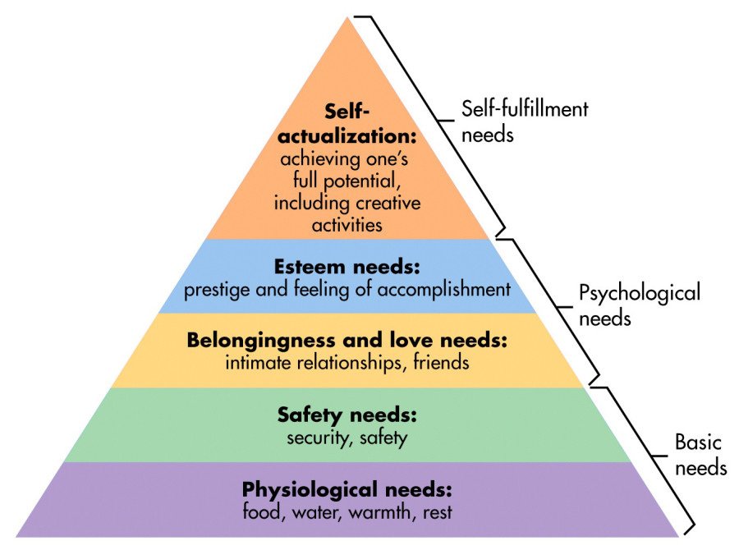
Image 1. Maslows Hierarchy of Needs (Mcleod, 2019).

Another interesting theory for motivation is the Two-Factor Theory, proposed by psychologist Frederick Herzberg in 1960. This theory denotes that individuals have two different types of needs and different components of the workplace (Alshmemri et al., 2017). The first category can is described as the hygiene factor; which comprises an individual's minimal survival needs (Lundberg et al., 2008). In the workplace these factors included company policies, interpersonal relationships, salary and working conditions (Alshmemri et al., 2017). The theory proposes that a lack of hygiene factors can lead to job dissatisfaction, but their presence doesn’t really create any satisfaction (Gawel, 1997). This differs to Maslow's hierarchy of needs as he believed those factors were milestones that needed to be satisfied in order to reach self-actualisation. The second category is known as the growth needs, which refers to factors intrinsic within the work itself, such as recognition of the completion of an activity, achievement and responsibility. According to Herberg these are the motivating factors, similarly to Maslow’s hierarchy of needs, it proposes that individuals try to reach their full potential and once it has been reach they then work as motivators for others (Lundberg et al., 2008).

2) Performance Management

Performance is believed to be about carrying out the work, and consequently the results of doing the work. (Otley, 1999). Performance at work is affected by a number of factors. They should be considered when managing, measuring, altering and rewarding performance. These include:
- Personal factors such as the individual's skill sets, commitment, and motivation.
- Leadership factors such as the quality of encouragement, guidance and support provided by the management team
- Team factors such the quality of support given by colleagues.
- System factors; the system of work and resources provided by the organisation.
- Situational factors; internal and external environmental changes (Isaac Mwita, 2000).

Performance management is a vital part of human resource management (HRM), where the outcome is to is improve and develop the performance of employees, thereby enhancing the overall performance of the organisation (Hartog et al., 2004). Currently there is no specific or unanimous model for performance management (Guest, 1997).

Christoph Mabey denoted that the presence of management training and development systems can potentially make a huge impact to an organization’s performance (Mabey and Gooderham, 2005);
Policy statement - a formal document outlining a management development policy. Although it is not actual practice itself, it a good ad-hoc way of describing good management and is considered an important strategy to an organisation.
Appraisals - where employees are given the opportunity to review their progress and discuss any development needs with their line manager. This can be particularly useful for individual growth and development, and therefore the company as a whole.
Career planning - When carried out effectively, career planning can help to fulfil organizational skill knowledge requirements and can also help with succession planning. In turn th individual will feel that personal and professional development career goals are being attended to (Mabey and Gooderham, 2005).

Edwin Locke proposed the Goal Setting Theory in 1968. This theory implies that setting personal goals is a huge factor in motivating an employee to achieve their full potential. The idea is that if the goals are not met, then the employee will continue to work harder to try to achieve that goal and therefore there will be an overall improvement in performance (Salaman et al, 2005).

3) Employee Engagement

Employee engagement is defined as “an individual employee’s cognitive, emotional, and behavioral state directed toward desired organizational outcomes” (Shuck, 2011).

Maceyand Scneider proposed the self-determination theory (SDT). His focus was predominantly on organisational effectiveness and task performance as a result of employee engagement. SDT research has shown that employees who are engage in their work also demonstrate better physical and mental well-being. The well-being of employees is essential in terms of workers’ rights and it also prevents absences and health insurance costs, in places that apply. SDT has been utilised in the workplace for more than thirty years. It is also used as a reference from training modules and development programmes in a variety of settings (Meyer and Gagnè, 2008).

In 1993 Willian Kahn, William Kahn researched workplace behaviour and identified three conditions that allow an employee to be their “full self” at work; I) does an employee believe that their work is meaningful? ii) Do they feel physically and mentally well enough to harness their full potential at this moment in time? And iii) do they feel safe and secure being their full selves in their work environment? Kahn also denoted that employee engagement can fluctuate based on external and internal factors and doesn’t always remain constant (Peakon, 2019).

Kahn’s ideologies are also very much in line with Maslows hierarchy of needs as well Herzbergs two factor theory.

Case Studies

Case 1

Employees that are motivated by their work are more likely to function better and make less mistakes or cause accidents. In contrast, unmotivated individuals can cause disruption in the workplace and can make the progression of an organisation stagnant (LLP, B, 2019).

Tesco enables motivation of employees by utilising Maslow and Herzbergs theories, including hygiene factors and satisfying factors. Employees at Tesco are motivated and empowered through the delegation of responsibility and good communication. They are also involved in decision making. Tesco also holds annual forums in which employees can contribute to wider issues and discuss salary increases. In this way, staff are being recognised and acknowledged for their work, and as result rewarded for it (LLP, B, 2019).

Tesco staff can even influence what food goes onto its restaurant menus. Employees thus become motivated to make choices that will increase their use of the restaurants (LLP, B, 2019).

Case 2

Harrods is an international retail brand, with a reputation for luxury products and prestigious values. Harrods values are: British; Luxury; Service; Innovation and Sensation (Engage for Success, 2019).

Harrods conducted their first survey to determine how employees felt about working at Harrods. It is an integral part of the Harrods HRM programme (Engage for Success, 2019). The results of the survey lead to Harrods to implement changes in the following four elements:

i) Organizational structure - the new structure is broader allowing employees to have more responsibility. This allows employees to explore other opportunities within the business, thereby increasing job satisfaction.
ii) Changing leadership - Creating an environment where employees are encouraged to act more independently by making their own decisions. Senior managers delegate to ground level employees to take on, more leadership duties, such as dealing with customers.
iii) Communication - Enhanced communications let all employees know about the company strategies, operational decisions and plans that will also affect their work personally. Staff are also encouraged to inform management of their own opinions of the decisions being made.
iv) Living the brand values. Making sure that everyone understands and believes the brand values and models (Engage for Success, 2019).

Conclusion

It is clear that development vehicles are necessary for improving work life of employees and the organisation. This is shown by the improvement of the organisations in the case studies. Development vehicles help the growth of a business, by encouraging employees to work harder and fulfil their job satisfaction, thus increasing productivity. Maslow’s theory of Hierarchy of needs is a significant model since employees should prioritise certain needs to motivate them and that some needs take precedence over others. As a result, prioritising necessary jobs is why it is important for employees to be motivated since the organisation will maximise productivity. Personal management helps employees to develop new skills and provides a continuous process of improving performance by setting goals both individually and as a team which are aligned to the strategic goals of the organisation, and developing the knowledge and capability of the workers. It is a crucial aspect of an organisation as it shows really where the organisation is gearing towards and what aims and objectives need to be overcome. Lastly, employee engagement is essential for the workplace because it is about being included fully as a member of the team, focusing on clear goals, being able to trust your team members and react accordingly to constructive feedback, supported in developing new skills, thanked and recognised for achievement. All types of development are seen as important and with a combination of all them, a firm can truly master the art of professionalism and harmonisation within the workplace.

Bibliography

Alshmemri, M., Shahwan-Akl, L. and Maude, P., 2017. Herzberg’s two-factor theory. Life Science Journal, 14(5), pp.12-16.
Den Hartog, D. N., Boselie, P., & Paauwe, J. (2004). Performance Management: A Model and Research Agenda. Applied Psychology, 53(4), 556–569. doi:10.1111/j.1464-0597.2004.00188.x
Engage for Success. (2019) Case Study: Increasing employee engagement through the HRM (Harrods) - Engage for Success. [online] Engage for Success. Available at: https://engageforsuccess.org/case-study-increasing-employee-engagement-through-the-hrm-harrods
Fallatah, R. H. M., & Syed, J. (2017). A Critical Review of Maslow’s Hierarchy of Needs. Employee Motivation in Saudi Arabia, 19–59. doi:10.1007/978-3-319-67741-5_2
Gawel, JosephE. (1997). Herzberg's theory of motivation and maslow's hierarchy of needs. Practical Assessment, Research & Evaluation, 5(11). Available online: http://PAREonline.net/getvn.asp?v=5&n=11
Guest, D. (1997). Human resource management and performance: a review and research agenda. The International Journal of Human Resource Management, 8(3), pp.263-276.
Herzberg, F., Mausner, B., Snyderman, B. and Herzberg, F. (1943). The motivation to work.

Inc. (2019) “21 Ways to Be a Better Leader” [online]
https://www.inc.com Accessed date 14th April 2019

Investopedia (2019) “Management by Objectives” [online]
https://www.investopedia.com Accessed date 14th April 2019

Isaac Mwita, J. (2000). Performance management model. International Journal of Public Sector Management, 13(1), pp.19-37.
LLP, B. (2019). Maslow and Herzberg - Motivational theory in practice at Tesco - Tesco | Tesco case studies, videos, social media and information | Business Case Studies. [online] Businesscasestudies.co.uk. Available at: http://businesscasestudies.co.uk/tesco/motivational-theory-in-practice-at-tesco/maslow-and-herzberg.html
Lundberg, C., Gudmundson, A., & Andersson, T. D. (2009). Herzberg’s Two-Factor Theory of work motivation tested empirically on seasonal workers in hospitality and tourism. Tourism Management, 30(6), 890–899. doi:10.1016/j.tourman.2008.12.003
Mabey, C. and Gooderham, P. (2005). The impact of management development on perceptions of organizational performance in European firms. European Management Review, 2(2), pp.131-142.
Maslow, A. (1943). A Theory of Human Motivation. Lanham: Dancing Unicorn Books.
Mcleod, S. (2019). Maslow's Hierarchy of Needs. [online] Simply Psychology. Available at: https://www.simplypsychology.org/maslow.html [Accessed 9 Apr. 2019].
Meyer, J. P., & Gagnè, M. (2008). Employee Engagement From a Self-Determination Theory Perspective. Industrial and Organizational Psychology, 1(01), 60–62.doi:10.1111/j.1754-9434.2007.00010.x
Otley, D. (1999). Performance management: a framework for management control systems research. Management Accounting Research, 10(4), 363–382.doi:10.1006/mare.1999.0115
Peakon. (2019). William Kahn: The Founding Father of Employee Engagement - Peakon. [online] Available at: https://peakon.com/blog/future-work/william-kahn-employee-engagement/ [Accessed 16 Apr. 2019].
Shuck, B. (2011). Integrative Literature Review: Four Emerging Perspectives of Employee Engagement: An Integrative Literature Review. Human Resource Development Review, 10(3), 304–328.doi:10.1177/1534484311410840 l
The Balance Careers. “Level 1 Management Skills” [online]
https://www.thebalancecareers.com Accessed date 14th April 2019

Zenefits (2019) “Top 10 Ways to Improve Employee Efficiency” “[online]
https://www.zenefits.com Accessed date 14th April 2019

Appendix

Personal Development Plan
Name: Mukta Uddin Date: 14th April 2019
Personal Development Planning (PDP) is a process by which an individual to reflect upon their own learning, performance or achievement by being speculative and create a plan for their personal, educational and career development or goals for their own personal development.
A PDP allows people to become more aware of their strengths and weaknesses and how to combat those weaknesses. It is an organised and clear way to display ones reflection on themselves which is essential for personal growth and career growth.
Objectives  What do I want to be able to do  or do better? | Success criteria  How will I recognise success?  How will I review and measure my improvement? | Actions  What methods will I use to achieve my learning objectives? | Implementation  How will I practise and apply what I learn?
Be able to obtain transferable skills in the work place | - Be able to carry out different roles in the workplace  - Be able to solve problems outside of own role  - Have strong communication skills  - Have good judgement and decision making  - I will measure my improvements monthly | - Take on different roles such  - Engage with employees to improve communication skills  - Use brain teasers and logic puzzles to improve problem solving  - Mind maps  - Be able to identify pros and cons to solutions then make clear judgement | Since I will have transferable skills, it should enable me to become a more all rounded employer. I can be assigned different tasks and show a different light on it, with different solutions. I can help in different departments when needed, allowing me to have a more dynamic work lifestyle.
Become more organised and work efficiently | - Have better time management  - Achieve more in less time  - Be productive  - Prioritise tasks  - Make fewer unimportant decisions  - Be able to delegate  - I will measure my improvements in organisation monthly | - 80/20 rule – split time evenly so you get more done in less time  - Set goals for each time interval  - Take breaks- allow yourself to digest the work  - Keep distraction list  - Communicate effectively | Becoming more organised will allow to become a more productive and efficient manager. I will be able to prioritise my workload effectively and get more work done in a given time. I will be able to meet deadlines and produce the best quality of my work, which would therefore enhance the overall organisations service.
Motivate employees | - Be a trustworthy employer  - Be transparent  - Acknowledge hard work  - I will measure this by checking in with employees monthly to see their progress | - Share positive feedback with employees  - Allow room for the employees to grow  - Recognise their hard work and regularly consult with them  - Offer flexible scheduling | If employees are motivated, this can lead to a better quality of service provided. Hard working skills can be implemented and as a result, the employee will feel satisfied with their job. This will then make me a more satisfied manager since the employees are improving their skills and maximising their full potential.
Be able to take control of team activities | - Exude natural leadership skills  - Be co-operative  - Become a strong communicator  - Be part of the team  - Be honest  - Have strong decision making capabilities  - Show commitment and passion  - I will measure this yearly when I take on leadership roles | - Take ownership and responsibility for actions  - Designate specific roles in team that outline different strengths  - Give credit when its due  - Give freedom and be flexible  - Create strong bond with team | My leadership skills will improve, where I can comfortably take on responsibilities of high importance that can in return, lead to my management satisfaction. I can then pass on these vital leadership skills to others in the workplace to improve the overall efficiency and productivity or the organisation.

