AC1.1 Understand the purpose and value of the people profession.
Q: With reference to the CIPD Profession Map, appraise what it means to be a people professional
The primary goal of the people profession is championing better work and working lives. (CIPD, 2024)
According to Armstrong, (2020) this involves shaping roles, creating opportunities, and building organisations and environments that empower individuals to perform at their best, drive exceptional organisational outcomes, support economic growth, and establish fair, inclusive, and meaningful work as a societal standard.
According to CIPD, (2023) the people profession enhances value by empowering individuals, driving organisational achievements, and advancing societal progress. It enables employees to realise their potential, aligns HR strategies with business goals, and promotes fairness, inclusion, and well-being.
By cultivating supportive and inclusive work environments, it increases productivity, innovation, and employee satisfaction, contributing to sustainable economic growth. Ultimately, the profession advocates for ethical practices and quality work, fostering a healthier, more equitable, and prosperous society.
An HR or people professional is responsible for leading and supporting an organisation's workforce. (CIPD, 2017)
Taylor and Woodhams, (2022) states that a “professional is a member of a profession” and argue you are recognised as a professional when you join a professional organisation, such as the CIPD. This membership demonstrates your dedication to the standards, ethics, and ongoing development required in your field.
With reference to the core behaviours and core knowledge of the CIPD Profession Map HR professionals responsibilities involve recruiting and inducting new staff, assessing the need for training and providing development programs, employee relations management, labour law compliance, performance management, payroll and benefits administration, writing HR policies, workforce planning, and promoting equality and diversity. (CIPD, 2024)
Their role is important in building a positive working environment, boosting employee satisfaction, and helping the overall success of the organisation. (CIPD, 2023)
The CIPD Profession Map illustrates that HR is more than just a collection of separate tasks; it is deeply connected to broader professional competencies, ethical principles, and leadership behaviours that shape the HR field. It offers a framework for HR professionals to enhance their skills and align with the values and goals of the organisation. (An, 2021)
Adhering to the code of conduct within a profession is important and determines whether people professionals can help each other to maintain trust and credibility. It ensures that they act consistently and ethically to create a positive culture in the workplace. (The HR Dept, 2023)

AC1.2. Know own personal and ethical values and apply these consistently in their (people practice) work.
Q: Discuss your personal and ethical values (one of each), with examples of how these are evident in your work. (If you have yet to work in people practice, explore how you believe your values would inform your work.)
There are many personal values in people practice a HR professional can relate to. These include integrity, fairness, respect and empathy.
Fairness means that there is an equal approach to all. For example, an HR professional can demonstrate it by ensuring that promotion and payment for performance, or recognition for anything for that matter, are merit-based without personal biases or popular group feeling. (CIPD, 2024)
Fairness in HR practices is manifested in actions such as ensuring that recruitment is not biased, company policies are applied consistently, and there is equal pay for equal work. It involves impartial performance appraisals, clear opportunities for career development, and flexibility in work arrangements to accommodate employees with personal problems. (Armstrong and Taylor, 2014)
Fairness also entails the amicable resolution of conflicts, making decisions openly, and giving all employees equal opportunities regarding resources and development. Moreover, the HR department facilitates an enabling environment for people with disabilities and ensures that all employees are treated with respect, equity, and justice. (CIPD, 2021)
Fairness in human resources is important to me, as it builds trust, increases morale, maintains legal standards, promotes diversity, and contributes to organisational success. For me, it creates an environment where employees feel valued and motivated, which benefits both the individuals and the organisation as a whole. Prioritising fairness as an Assistant HR Business Partner in my opinion, helps create a respectful and motivated workplace.
To conclude personal values help create a sense of purpose and direction, both personally and professionally. They ensure that our actions are consistent with who we are and what we believe in, leading to a more authentic and fulfilling life.
Ethics play a vital role in shaping the behaviour and decision-making processes of people professionals. Ethical values in human resources are the guiding principles that will help HR professionals in interactions, policies, and decision-making processes to ensure fairness, integrity, and respect are upheld within the workplace. (CIPD, 2023)
For example, Integrity is crucial for HR professionals as it forms the basis for trust, guides ethical decision-making, and fosters a positive organisational culture.
Folkman, (2020) argues integrity helps in building trust between HR and employees. Honesty, transparency, and fairness on the part of HR help employees feel secure and supported. This trust is essential for effective communication and boosting employee engagement.
Furthermore, Integrity builds trust between HR and employees. When HR shows honesty, transparency, and fairness, it helps employees feel secure and supported. This is a very important constituent of effective communication and helps in improving employee engagement. (CIPD, 2022)
This is evident during the recruitment process by fostering integrity it means being transparent with the recruitment process. In short, it includes spelling out requirements for a particular post a person has applied for, candidate feedback regarding their application, and informing them of their fate according to merit and without undue influence or partiality. In this way, the trust is gained and upheld through them. (Sayed, 2022)
AC1.3 Know the importance of people professionals contributing to discussions in an informed, clear and confident way to influence others.
Q: Discuss reasons why this is important and the consequences of people practitioners not being willing or able to influence others.
Informed, clear, and confident communication is a core enabler for people professionals to influence decisions, engender trust, solve problems, and promote open debate. (CIPD, 2023)
The importance of informed communication in HR is supported by numerous studies and HR principles. Good decisions can only be made through effective communication with the right data to back them up; this ensures that policies and actions are based on fact and reflect the needs of the organisation. (Armstrong, 2020)
People professionals present ideas persuasively to implement positive change and ensure that their views are heard. This will build credibility, promote inclusive debate, and result in innovative solutions with evidence-based accuracy. For example, HR professionals must effectively convey job responsibilities, performance expectations, and company policies to ensure employees have a clear understanding of what is required of them. This promotes alignment and minimises the risk of misunderstandings. (Harper, 2023)
Regular contribution to discussions also enhances the ability to communicate, driving personal growth and professional development. Mastering these competencies helps people professionals make a difference and attain results in their organisations.
With reference to the CIPD professional map, courage and influence are essential qualities that enhance communication within human resources. This means confidently challenging decisions, persuading stakeholders, building relationships, and learning from mistakes to enhance decision-making. (CIPD, 2024).
The lack of ability to influence others, especially in a professional setting, can lead to various adverse effects for both individuals and organisations where good practice is not followed. For example, Plouffe, (2012) argues that effective leadership is deeply rooted in the capacity to influence teams, foster engagement, and inspire action. Without this influence, leaders may find it challenging to motivate their teams, leading to low morale, disengagement, and lack of performance.
Without the courage to challenge wrongdoing, unethical practices can continue, eroding trust and integrity. A lack of influence can undermine HR's credibility, causing employees and leaders to lose confidence. Ineffective persuasion can lead to poor decisions, making it hard to implement fair and ethical policies. (People Management, 2021)
Institute of Directors, (2024) demonstrates an example of organisations behaving unethically. Between 1999 and 2015, the Post Office's defective Horizon IT system led to the unjust prosecution of over 700 sub-postmasters on charges of theft and false accounting. This case has been described as "the largest miscarriage of justice ever seen in the UK."
According to the BBC there were many implications following this scandal such as financial cost to taxpayers. The UK government has earmarked hundreds of millions of pounds for compensating those wrongfully convicted, which will impact the Uk taxpayers. (Seddon, 2024)

AC 1.4 Know when and how to raise matters that might be unethical or illegal.
Q: Discuss, with examples, when and how you would react to both unethical and illegal matters (one of each).
According to Forbes Business Development Council addressing unethical matters at work is crucial for maintaining integrity and trust. (Expert Panel, 2025)
For example, If I was to observe unethical behaviour in the workplace such as, a colleague manipulating financial records I would gather and document the evidence, keep detailed records of the unethical behaviour, including dates, times, locations, and any witnesses then report the incident to my manager or the compliance department.
I would ensure to adhere to the company's whistleblowing policy, and code of conduct to safeguard myself as whistleblowing involves exposing unethical, illegal, or harmful actions taking place within an organisation. (CIPD, 2024)
Deontological ethics would stress my obligation to report this behaviour, as it is fundamentally wrong to let dishonesty go unaddressed. (Young,2023)
A high-profile case demonstrating unethical behaviour is the Volkswagen emissions scandal, widely known as "Diesel gate,". This was exposed after the U.S. Environmental Protection Agency (EPA) revealed that the company had used software to manipulate emissions tests in its diesel cars. Approximately 11 million vehicles around the world were impacted, resulting in substantial financial penalties, numerous legal proceedings, and severe damage to VW's reputation. Customers who purchased VW vehicles with the expectation of owning environmentally friendly, compliant cars were misled, resulting in a loss of consumer trust. (Leggett, 2018)
Dealing with illegal issues in HR necessitates thorough documentation and strict compliance with company policies and legal obligations. It is crucial to respond swiftly and responsibly to resolve these matters. (CIPD, 2019)
For example, if I was to witness illegal matters in the workplace such as property theft, I would initially collect evidence of the theft, such as surveillance footage and witness statements, and understand what was stolen and when.
As an HR business partner, I would review our company's theft policies and procedures and address the issue with the involved employee and conduct an internal investigation. The investigation would include interviewing witnesses, review evidence, and document findings fairly.
Based on the investigation, I would consider disciplinary actions like termination or legal action. I would continue to work with senior management to enhance security, conduct regular audits, and train employees on theft policies to prevent future incidents. (ACAS, 2022)
In 2016, The Guardian exposed that Sports Direct's warehouse employees faced exploitative conditions. Many on zero-hour contracts endured unpaid work, excessive surveillance, and penalties for taking breaks. (Butler, 2017).
The scandal resulted in public outrage and legal scrutiny. A parliamentary inquiry was initiated to investigate the treatment of workers, highlighting major concerns regarding the company's corporate governance and its handling of employee welfare. (BBC, 2016)

AC 2.1 Be able to make use of related theory and thinking, to argue the human and business benefits of people feeling included, valued, and fairly treated at work.
Q: Demonstrate your ability to do this with a written argument, which poses different theoretical perspectives, as well as your own
According to Carr et al., (2019) creating a workplace where employees feel included, valued, and treated fairly brings substantial advantages for both individuals and the organisation.
Personally, it boosts mental health, job satisfaction, overall well-being, and social connections, while also enhancing engagement and morale.
For businesses, it results in higher productivity, better job performance, lower turnover rates, and reduced absenteeism, leading to cost savings and a stronger company reputation. (Investors in People, 2019)
Additionally, an inclusive environment fosters diverse ideas, driving innovation and creativity. Ultimately, this kind of culture cultivates a more positive and collaborative work atmosphere. (CPHQ, 2023)
Inclusivity involves embracing all individuals and providing equal access to opportunities and resources, irrespective of their backgrounds, abilities, or circumstances. The goal is to foster an environment where every person feels recognised, respected, and free from exclusion. (Inclusive Employers, 2022)
David Rock’s SCARF model highlights five key factors which are, Status, Certainty, Autonomy, Relatedness, and Fairness. These 5 factors influence social behaviour in the workplace. Valuing employees' contributions enhances their status, clear communication provides certainty and giving employees control fosters autonomy. Promoting social connections improves relatedness, while ensuring fair treatment builds trust and reduces turnover. By addressing these areas, organisations can create an inclusive, supportive environment that benefits both employees and the business. (Mind Tools, 2008)
Abraham Maslow’s Hierarchy of Needs theory identifies five tiers of human needs: physiological, safety, social belonging, esteem, and self-actualisation. When applied in the workplace, this framework can greatly enhance employee satisfaction and business performance by fostering a sense of value and inclusion among staff. (Bitesize Learning, 2024)
Meeting the needs of employees, as described in Maslow's Hierarchy of Needs, pays off for employees and companies alike. Employees benefit by having basic physiological and safety needs met so that they are healthy and less stressed. The development of a sense of belonging, recognition of accomplishments, and opportunities to grow spur motivation, morale, and job satisfaction. For the company, applying this theory means greater productivity, better job performance, reduced turnover, and more innovation. A positive and inclusive workplace contributes to a company's good reputation, helping to attract and retain the best talent with more ease. (Komninos, 2019).

AC 2.2 Know how to design people practice initiatives to be inclusive and how to check inclusivity after an initiative has been implemented.
Q: Discuss, with examples, how you have, or would, achieve both of these
As an Assistant HR Business Partner for Carmarthenshire County Council, I am involved in initiatives related to the 2026 waste service change. I assist in the consultation process between employees, trade unions and stakeholders, ensuring it is inclusive and that all employees have the chance to provide their feedback. (D’Alessio, 2024)
The initiative involves all employees in the decision-making process for the 2026 change in waste services, ensuring that diverse voices are heard. We use various communication channels, such as meetings, surveys, and focus groups, and incorporate employee feedback to foster transparency. Clear, jargon-free language is used to ensure understanding, and participation will be monitored for equitable involvement. The goal is to implement the change fairly and inclusively, enhancing employee satisfaction and support. (Acas, 2021)
To monitor and track that consultations on the waste service change are inclusive we ensure that all employee groups are represented and have equal access to communication channels, such as meetings, surveys, and focus groups. (CIPD, 2020)
We provide various ways for employees to share their opinions, like anonymous surveys or one-on-one meetings, to ensure those who may feel uneasy speaking in large groups can still participate. (Linkedin.com, 2024)
By using accessible language, and monitoring participation by demographics ensures that all employees can contribute.
Carmarthenshire County Council assess the ways in which the feedback from the consultation is fed into the decision-making. This will show if the employees' opinions were truly taken seriously and if their input has led to tangible changes in the waste service initiative.
By consistently applying these practices, Carmarthenshire County Council can ensure a fair and effective consultation process has been met.

AC 2.3 Be able to work inclusively with others and build positive working relationships.
Q: Using a combination of your own reflections and feedback from at least one other person, discuss your ability to work inclusively and positively with others
In an Assistant HR Business Partner role, working inclusively and building positive relationships involves fostering a supportive, respectful environment where all employees feel valued.
I feel promoting inclusive recruitment by utilising diverse job boards, collaborating with organisations that support underrepresented groups, and crafting job descriptions that highlight inclusivity demonstrates my competence in working inclusively within my role. This approach contributes to building a diverse workforce and enables stronger connections with employees from different backgrounds.
On 14th November 2024 I facilitated a session with the Carmarthenshire Youth Panel to gather their perspectives on recruitment, particularly regarding roles within Carmarthenshire County Council. Upon reflection, I found the session to be highly successful and engaging. The youth panel expressed a strong desire for more accessible information about available roles and the recruitment process, especially through social media and other platforms they commonly use.
I pride myself on relationship building. In the workplace, fostering positive relationships enhances employee engagement and job satisfaction. When I feel appreciated and supported by my colleagues and managers, I am are more likely to be motivated and perform at my best. For instance, I have been working closely with Coleg Sir Gar from April 2024 to present, supporting and facilitating the Green Skills 24 Project, focusing on NetZero and sustainability. I successfully ensured that over 500 council employees from April 2024 – December 2024 participated in the IEMA courses on sustainability. The collaboration was so successful that it was acknowledged by Paul Thomas, Assistant Chief Executive of Carmarthenshire County Council, who commended my hard work, dedication, and professionalism in bringing the partnership to fruition.
The above examples provided aligns with several key elements of CIPD Core Behaviours, as outlined in the CIPD Profession Map such as working inclusively, demonstrating professional courage and influence. The recognition by the Assistant Chief Executive further highlights my ability to positively influence stakeholders and gain buy-in for important initiatives.
The successful partnership with Coleg Sir Gar highlights effective collaboration, both internally with council employees and externally with educational institutions.
The below feedback form was received from my line Manager Lindsey Evans Lead HR Business Partner Carmarthenshire County Council, on 2/12/24, on reflection I will keep developing my relationship skills by regularly attending the Council BMT meetings to ensure I have a good understanding of my business areas.
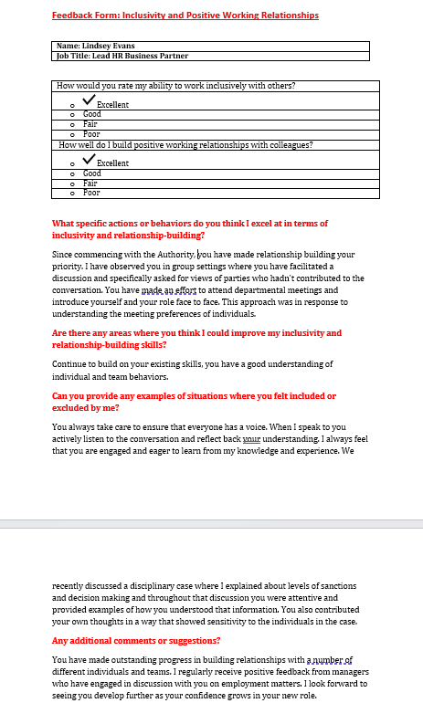

AC3.1 Understand how the people practitioner role is evolving and the implications this has for your ongoing professional development.
Q: Demonstrate your understanding of this with a written response and related entries in your CPD Plan
As stated in the CIPD People Profession 2030 report the responsibilities of a HR professional are constantly adapting to shifts in the workplace, evolving workforce expectations, and external influences for example, new legislation, AI, and societal trends. (Green, Peters and Young, 2020)
As an Assistant HR Business Partner, the council require our roles to move away from a transactional administrative role to becoming more strategic. We are increasingly expected to contribute to strategic decision-making and aligning HR initiatives with the organisation’s goals. To ensure I keep up to date with the evolving role and to continue my professional development I have added entries into my CIPD, CPD plan to reflect this area of development. (People and Link, 2023)
I also feel the concept of an HR professional is changing to have a much greater focus on mental health and employee well-being. For example, holistic employee health-mental, physical, financial well-being. Now, HR professionals are more inclined to develop a supportive work environment to bring out better results in engagement, satisfaction, and retention, and feel valued at every point in their working lives.
Stress and Mental health are one of the main causes of sickness absence in the areas I manage. To ensure I am continually developing my skills and knowledge in this area I have added the relevant development actions in my CIPD CPD Development Plan.

AC3.2. Be able to assess (own) strengths, weaknesses and development areas, based on own considerations and feedback from others
When assessing my current strengths, weaknesses, and development areas against my current job profile (Assistant HR Business Partner) on reflection I feel I excel at building professional relationships. This strength was highlighted by Lindsey Evans Lead HR Business Partner on a recent feedback questionnaire on the 20^{th of} December 2024. Lindsey Evans, Lead HR Business Partner also mentioned that in areas where I have less experience, I tend to lack confidence. However, this is expected to improve as I gain more experience in my role. I agree with this constructive feedback, and I believe my confidence will improve over the next 6 months as I get more involved in the employee relation cases. In terms of development in this area, shadowing colleagues will improve my confidence in complex cases.
I have been involved in various projects since April 2024, such as the waste service change engagement with staff regarding changes to terms and conditions of employment and the green skills 24 project collaborating with Coleg Sir Gar, where I facilitated training for all staff across waste services. I attended a progress meeting with Coleg Sir Gar on Thursday 25th July 2024 and Jemma Parsons Head of the Green Skills Academy / PLA Project Manager informed both myself and the Waste, Head of Service at Carmarthenshire County Council that the successful delivery would not have been possible without my involvement.
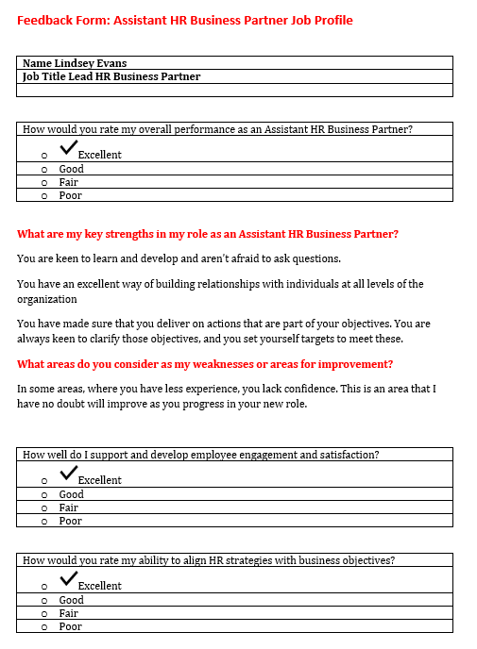
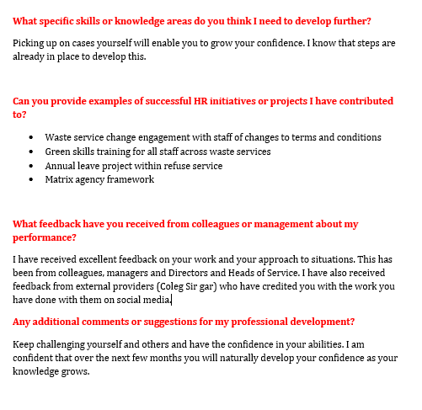
AC 3.3 Be able to formulate a range of appropriate CPD options to support ongoing learning.
Following on from your self-assessment, identify a range of formal or informal development activities and add these to your CPD Plan/document. Provide a brief explanation as to why you have selected these activities.
As identified in my CIPD self-assessment, I acknowledge further development in employee relations. As mentioned on the action plan I will set up a knowledge sharing group with my colleagues to share ideas, practices and case studies on specialist areas of employment law and policy.
People analytics is also an area identified from my CIPD self-assessment, the people analytics courses recommended will equip me with the skills and knowledge to transform HR practices, making them more strategic, data-driven, and impactful.
I will gain the ability to utilise data for making well-informed decisions regarding workforce planning, recruitment, retention, and employee development, resulting in more efficient and impactful HR strategies

AC3.4 Be able to reflect on and draw conclusions about the effectiveness of development activities.
Reflect on three development activities, already undertaken, that have had an impact on your work behaviour or performance, explaining how they have impacted you. (Your reflections should be presented within your CPD Record document.)
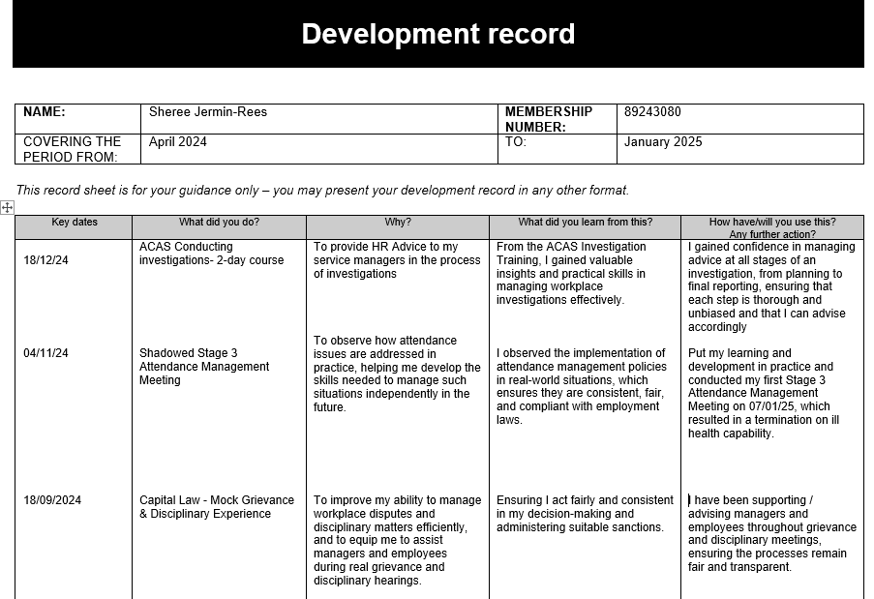

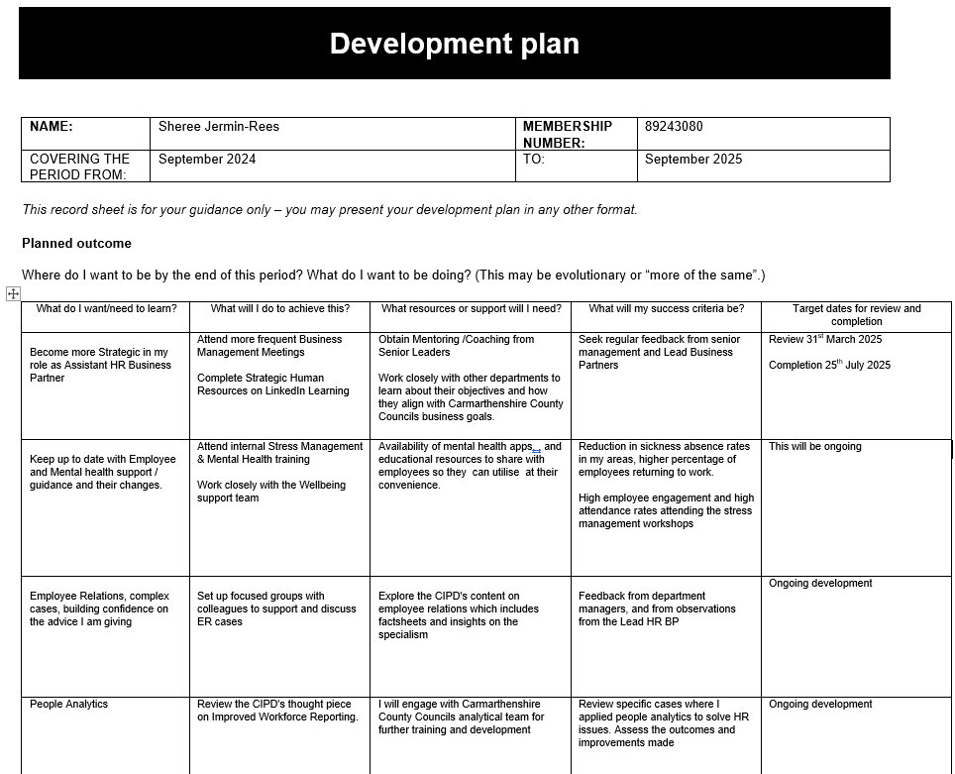

Reference List
ACAS (2022). Investigations for discipline and grievance: step by step | Acas. [online] www.acas.org.uk. Available at: https://www.acas.org.uk/investigations-for-discipline-and-grievance-step-by-step.
Acas. (2021). What consultation is - Consulting employees and representatives - Acas. [online] Available at: https://www.acas.org.uk/consulting-employees? [Accessed 12 Jan. 2025].
An (2021). The Profession Map: An overview. [online] YouTube. Available at: https://youtu.be/YfMIbAol_Jg [Accessed 10 Dec. 2024].
Armstrong, M. (2020). Armstrong’s Handbook of Human Resource Management Practice. 15th ed. S.L.: Kogan Page.
Armstrong, M. and Taylor, S. (2014). Armstrongs Handbook of Human Resource Management Practice [electronic. 13th ed. Kogan Page.
BBC (2016). Sports Direct Staff ‘not Treated as humans’, Says MPs’ Report. BBC News. [online] 22 Jul. Available at: https://www.bbc.co.uk/news/uk-england-derbyshire-36855374.
Bitesize Learning (2024). Maslow’s hierarchy of needs, explained [inc. pyramid diagram]. [online] BiteSize Learning. Available at: https://www.bitesizelearning.co.uk/resources/maslows-hierarchy-of-needs-theory.
Butler, S. (2017). Sports Direct and its staffing agencies paid workers £1m too little. [online] the Guardian. Available at: https://www.theguardian.com/business/2017/dec/08/sports-direct-and-its-staffing-agencies-paid-workers-1m-too-little?v=PPC [Accessed 12 Jan. 2025].
Carr, E.W., Reece, A., Kellerman, G.R. and Robichaux, A. (2019). The Value of Belonging at Work. [online] Harvard Business Review. Available at: https://hbr.org/2019/12/the-value-of-belonging-at-work.
CIPD (2017). CIPD | HR professionalism: what do we stand for? [online] CIPD. Available at: https://www.cipd.org/uk/knowledge/reports/hr-professionalism-report/.
CIPD (2019). CIPD | Ethics at work: an Employer’s Guide. [online] CIPD. Available at: https://www.cipd.org/en/knowledge/guides/ethics-work-guide/.
CIPD (2020). CIPD | New guide set to help make staff representation and meaningful consultation the norm in UK workplaces. [online] CIPD. Available at: https://www.cipd.org/uk/about/news/ice-regulations-guide/.
CIPD (2021). CIPD | The Disability Employment Gap needs closing - on several fronts. [online] CIPD. Available at: https://www.cipd.org/uk/views-and-insights/thought-leadership/cipd-voice/disability-employment-gap-closing-several-fronts/.
CIPD (2022). CIPD’s new Code of Conduct and Ethics | CIPD HR-inform. [online] www.hr-inform.co.uk. Available at: https://www.hr-inform.co.uk/news-article/cipds-new-code-of-conduct-and-ethics.
CIPD (2023). CIPD | the Profession Map / Core Behaviours / Professional Courage and Influence. [online] CIPD. Available at: https://www.cipd.org/en/the-people-profession/the-profession-map/explore-the-profession-map/core-behaviours/professional-courage-influence/.
CIPD (2023). Ethical Practice and the Role of People Professionals. [online] CIPD. Available at: https://www.cipd.org/uk/knowledge/factsheets/ethics-role-hr-factsheet/.
CIPD (2023). Strategic Human Resource Management | Factsheets. [online] CIPD. Available at: https://www.cipd.org/en/knowledge/factsheets/strategic-hrm-factsheet/.
CIPD (2023). The Profession Map / Professional values and purpose. [online] CIPD. Available at: https://www.cipd.org/uk/the-people-profession/the-profession-map/explore-the-profession-map/professional-values-purpose/.
CIPD (2024). CIPD | What Makes the Ideal People professional? [online] CIPD. Available at: https://www.cipd.org/en/knowledge/podcasts/ideal-people-professional/.
CIPD (2024). CIPD | Whistleblowing: Employment Law. [online] CIPD. Available at: https://www.cipd.org/uk/knowledge/employment-law/whistleblowing/.
CIPD (2024). The Profession Map. [online] Available at: https://www.cipd.org/globalassets/media/comms/the-people-profession/profession-map-pdfs/profession-map-nov-2024.pdf.
CIPD (2024). The Profession Map. [online] Available at: https://www.cipd.org/globalassets/media/comms/the-people-profession/profession-map-pdfs/profession-map-nov-2024.pdf.

CIPD | Ethical practice and the role of people professionals | Factsheets. (n.d.). CIPD. https://www.cipd.org/uk/knowledge/factsheets/ethics-role-hr-factsheet/
CPHQ, J.D.B., RN (2023). The Case for Belonging—How Feeling Valued and Included at Work Affects Employee Well-Being. [online] WebMD Health Services. Available at: https://www.webmdhealthservices.com/blog/the-case-for-belonging-how-feeling-valued-and-included-at-work-affects-employee-well-being/.
D’Alessio, D. (2024). Black bin collections in Carmarthenshire could change to every 4 weeks. [online] South Wales Guardian. Available at: https://www.southwalesguardian.co.uk/news/24472299.black-bin-collections-carmarthenshire-change-every-4-weeks/ [Accessed 12 Jan. 2025].
Expert Panel (2025). 20 Tips For Addressing Ethical Breaches. Forbes. [online] 14 Jan. Available at: https://www.forbes.com/councils/forbesbusinessdevelopmentcouncil/2025/01/14/20-tips-for-addressing-ethical-breaches/.

Folkman, J. (2020). How Trust Affects Your Ability To Communicate And How To Fix It. [online] Forbes. Available at: https://www.forbes.com/sites/joefolkman/2020/04/07/how-trust-effects-your-ability-to-communicate-and-how-to-fix-it/.

Green, M., Peters, R. and Young, J. (2020). People Profession 2030 a Collective View of Future Trends. [online] CIPD. CIPD. Available at: https://www.cipd.org/globalassets/media/knowledge/knowledge-hub/reports/234people-profession-2030-report-compressed_tcm18-86095.pdf.

Harper, J. (2023). Talk the Talk: The Importance of Effective Communication in HR Strategy. [online] The HR Digest. Available at: https://www.thehrdigest.com/talk-the-talk-the-importance-of-effective-communication-in-hr-strategy/.
Inclusive Employers (2022). What Is Inclusion? [online] Inclusive Employers. Available at: https://www.inclusiveemployers.co.uk/about/what-is-workplace-inclusion/.
Institute of Directors. (2024). The Post Office Scandal: A failure of governance. [online] Available at: https://www.iod.com/resources/governance/the-post-office-scandal-a-failure-of-governance/.
Investors in People (2019). ‘Feeling valued:’ the dimensions organisations must deliver on. [online] Investors in People. Available at: https://www.investorsinpeople.com/knowledge/feeling-valued-the-dimensions-organisations-must-deliver-on/.
Komninos, A. (2019). Maslow’s Hierarchy of Needs. [online] The Interaction Design Foundation. Available at: https://www.interaction-design.org/literature/article/maslow-s-hierarchy-of-needs.
Leggett, T. (2018). How VW tried to cover up the emissions scandal. BBC News. [online] 5 May. Available at: https://www.bbc.co.uk/news/business-44005844.
Linkedin.com. (2024). How can you ensure all employees are heard in feedback surveys? [online] Available at: https://www.linkedin.com/advice/0/how-can-you-ensure-all-employees-heard-feedback-surveys-2fn0c [Accessed 12 Jan. 2025].
Mind Tools (2008). David Rock’s SCARF Model. [online] www.mindtools.com. Available at: https://www.mindtools.com/akswgc0/david-rocks-scarf-model.
People Management. (2021). How HR can increase its influence and impact in the new world of work. [online] Available at: https://pminsight.cipd.co.uk/how-hr-can-increase-its-influence-and-impact-in-the-new-world-of-work.
People, P.M. and Link, A. (2023). How To Elevate HR As A Strategic Partner Of The Business. [online] People Managing People. Available at: https://peoplemanagingpeople.com/strategy-operations/hr-strategic-partner/.
Plouffe, C.M. and T. (2012). When Your Influence Is Ineffective. [online] Harvard Business Review. Available at: https://hbr.org/2012/03/when-your-influence-is-ineffective.
Roper, J. (2016). HR Magazine - How has HR evolved in the last 25 years? [online] HR Magazine. Available at: https://www.hrmagazine.co.uk/content/features/how-has-hr-evolved-in-the-last-25-years/.
Sayed, Z. (2022). Ethics and integrity in human resource management. [online] HRForecast. Available at: https://hrforecast.com/ethics-and-integrity-in-human-resource-management/.
Seddon, S. (2024). How do the Post Office scandal compensation schemes work? BBC News. [online] 11 Jan. Available at: https://www.bbc.co.uk/news/uk-67942935.
Taylor, S. and Woodhams, C. (2022). Studying Human Resource Management a Guide to the Study, Context and Practice of HR. 3rd ed. Kogan Page.
The HR Dept. (2023). Why you need a code of conduct in the workplace. [online] Available at: https://www.hrdept.co.uk/services/employee-handbook-company-policies/why-you-need-a-code-of-conduct-in-the-workplace/.

