Developing Relationships and Workplace Achievement bmsk5002
Assignments due date 9th August 2019-word count- 4000

Mr SYED MOKSUDUL ISLAM
1709371

Developing Relationships and Workplace Achievement BMSK5002
Student: Mr Syed Moksudul Islam
Student Number: 1709371
Lecturer: Abdullah Al Mamun


(Owen Kenny Solicitors, 2019).

Table of Contents
Introduction 3
What is employee engagement? 3
Figure 1. 5
Figure 2. 7
Figure 3. 8
Figure 4. 9
What is the motivational theory? 10
Figure 5. 11
Figure 6. 12
Figure 7. 12
Figure 8. 13
Figure 9. 14
What is leadership and management development? 15
Figure 10. 17
Figure 11. 18
Figure 12. 19
Figure 13. 20
Figure 14. 21
Conclusion: 21
Reference page 22

Employee engagement, motivational theory and leadership management development in the NHS.

Introduction
This present report depends on considering the job of Human Resource (HR) in the NHS and how they add to organisation efficiency. The report will also question and argue the function of three skills, employee engagement, motivational theory and leadership management development in the NHS. This report will also critically evaluate the potential benefits to the organisation. The report will also look at the needs of individual employees or HR, organisational desires and expectation from the employees. The study will also examine how these drivers influence the level of employee performance and wellbeing at the workplace of the staffs and employees.
The NHS is the largest employer in the UK, a figure released by Gov.UK (2018) there are currently 1.2 million employed in the NHS. The figures updated by The Nuffield Trust (2019) it is also one the largest employer globally, compared to US department of defence employs 2.9 million, China’s liberation army 2.3 million, Walmart employs 2.2 million, McDonalds 1.9 million and NHS at 1.5 million, making it the fifth major employer in the world. Each organisation has various needs that it utilises for its productive function; HR is regarded as the most critical advantages for a business or organisation.

What is employee engagement?
Employee engagement is the degree to which employees feel energetic about their occupations (Parker Follett and Follett, 1924), are focused on the organisation, and put voluntary effort into their work. Many reports have been written by experts and academics, Seijts & Crim (2006) they have argued that an engaging workforce can create a competitive advantage. Many experts believe it is paramount for leaders to recognise the amount of engagement in their organisation and apply behavioural approaches that will allow maximum engagement. (Seijts & Crim, 2006).
Why an organisation use employee engagement:
Bedarkar and Pandita (2014) said that depending on the organisation employee engagement is a concept gaining significant importance; employee engagement can create effective results under certain conditions. Employees can give more in their workplace, be more devoted to their company and their work goals and values. Motivated by company success and a heightened sense of happiness and job security, this will lead to healthier company performance.
Positive benefits of staff engagement in the NHS:
Engaging and getting involved with work colleagues or team will bring individuals closer; this will result in positive output at work. Dues to these facts, Mackay, Allen and Landis (2017) said this could be beneficial to the organisation and the individual who is employed there. Furthermore, this is central to the organisation as it will make more progress, revenues, and reducing costs. However, Behesthi (2018) wrote in Forbes magazine that our current approach to staff engagement is not working, a small number of reports emerged negative towards the engagement theory, but this is overweighed by larger reports.
List of positive outcomes and benefits of engaging with staff:
- Happier employees/staffs.
- Better quality of work and productivity.
- Lower turnover of staffs.
- Better communication between staff and leaders/management.
- Less pressure at work.
- Higher patient and public satisfaction.
- Financial benefits for the organisation.
- Feedback fosters learning.
Negative implications of not engaging with staffs in the NHS:
The negative implications of not engaging with NHS staff can have disruption on services and productivity. This can have a catastrophic result for the patients, employees as this will affect daily NHS services.
List compiled below to give an example of regular disruptions:
- Low morale at work.
- Low quality of work.
- Staff not able to express themselves.
- Unhappy staffs.
- The patient suffers due to lack of communication.
- More significant turn over in staffs.
- Work pressure.
- Effects daily appointments and services.
Macleod (2019) said, motivation is based on having trust, integrity and faith in your staffs is a two-way commitment, having effective communications between an organisation and its stakeholder is an essential part of developing and increasing the chances of success and positive performance. When an individual focus on his work and objectives, realises his role in an organisation, having great ideas and ready to face his team with a smile. Employee engagement is about getting honest feedback, support for skills development, recognised accomplishment and thank the employee for their hard work. This gives leaders and managers chance nurture and develops the teams and employees in the workplace (Sharma ed al. 2009).
IES Model of engagement (2003): An IES survey in the year 2003 has identified ten factors.
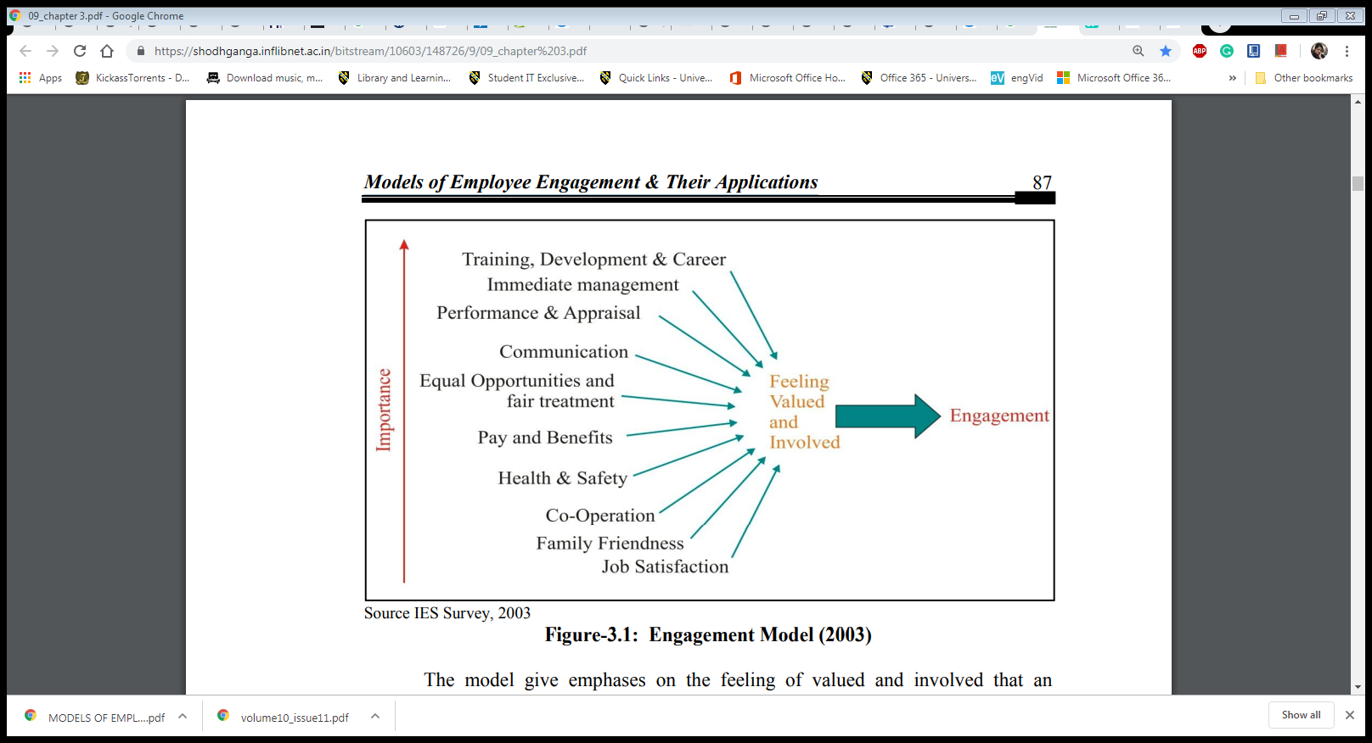

Figure 1.
(IEU Institute for employment studies, 2019).
Engagement model 2003.
The model shows the importance of feeling and being valued at the time of employment. A good feeling of involvement is achieved through cooperation family pleasantness, communication and feeling of appreciation are gained by fair opportunities, training, equal treatment and personal development (IEU Institute for employment studies, 2019). Looking at the model organisation, managers and leaders can have the right approach to developing their workers.

The NHS staff survey and feedback:
In 2012 Institute of Employment Studies (IES) was commissioned by The King’s Fund to write a report on high performing trust in the UK and detailed how employees engaged with patients led to a positive outcome. The results produced by (IES) was documented, and the case studies now can be shared between trusts for staff engagement improvements (West and Dawson, 2012). The NHS Staff Survey and feedback is the most important study of staff opinion in the UK. NHS staff are given a year to share their perspectives on encounters at work. Annually NHS staffs take part in a survey and are one of the most extensive surveys done in the UK. It collects views, opinion and staff experience at work around vital areas of work. This includes, appraisal and development, health and wellbeing, staff engagement and involvement, and raising concerns of staffs and deal with work-related issues (NHS England, 2019), these results would be used to make changes to the organisations.
An example of staff engagement and retention strategy:
Sherwood Forest Hospitals Foundation Trust commissioned a report to implement a plan to reform and improve to its business approach. The consultancy Unipart Expert Practices was selected as a private sector partner to convey best practice information across both operative and cultural dimensions. The results were staggering, 59 per cent reduction in time to treatment in the emergency department, in addition, 35 per cent in the time reduced to employee new staffs, reduced the amount of patients not turning up for booked appointments and savings over 4 million-pound. The reason behind this improvement was, the trust operated closely with the private sector specialist (The consultancy Unipart Expert Practices) to create a new way of working; the trust actively engaged with the employees, this led to greater efficiency and productivity to transform the services (Warder and Hall, 2012).

Bringing change through staff engagement:
The operational and cultural dimension of achieving the best care

Operational dimensions | Cultural dimensions
Business strategy | Patient and staff pledges
Policy deployment  Service line management  Performance management | Policies and practices  Staff accountability  Development  Personal responsibility
Improvement projects  Standardisation  Reduce variation  Reduce waste | Behaviours  Engagement  Ideas and innovation  Customer/patient focus
Achieving the best care
Continuous improvements and sustainable benefits
(Warder and Hall, 2012).

Figure 2.
The above diagram represents how the operation strategy is achieved through staff engagements; it resulted in the reduction of waste, focused on patients and delegating responsibilities.

How the programme was deployed.
The four-stage improvement approach

(Warder and Hall, 2012)

Figure 3.
The diagram above shows how the programme was implemented through four stages; motivation, map and measure, move and maintain and manage.

Staff engagement in the NHS:
Staff commitment is a crucial component expected to enable the NHS to address the scope of difficulties that it faces. By including staff in the decision and discussing plainly with them, the organisation can try to keep up and improve staff spirit, particularly during times of trouble and change. The main aim of the NHS is to provide a good range of resources and tools, information to help and improve the engagement levels.
Staff engagement resource and feedback tools.



Figure 4.
NHS has developed a large number of tools, information and resources to aid HR people and organisation. This will allow organisations and managers alike to help and evolve employee engagement within the establishment they are working for. The tools are very basic and can be operated by any individual who wishes to access information very easily (NHS Employers, 2019). The tools can range from, email, questionnaire forms, feedback forms, helpline, advisory service, and training resource and advice. These tools will allow the organisation to collect data and feedback from the employees.
Method of engaging in the NHS:
- Electronic newsletter.
- Hospitals news bulletin.
- Printed leaflets and flyers.
- Emails and text message.
- Annual meeting.

Engaging for success:
Bakker and Schaufeli (2008) argued that it is essential to encourage Positive Organisational Behaviour (POB), this will result on individuals improved performance, an actual fulfilment, client satisfaction in today’s workplace and growth in professional career development (PCD). Managers and leaders can play a decisive role in helping to foster these growths of their employees and benefit from the growth and outcome. Similarly, Bakker and Demerouti (2008) wrote that are four reasons why engaged staffs perform superior to non-engaged with employees. Staffs who often engage regularly have a feeling of wellbeing, including pleasure, positive emotions and enthusiasm; these experiences can lead to better health, develop their job and individual talents and abilities to share with other members at work.

What is the motivational theory?
The organisation sincerely endeavours to make a robust and positive engagement with their employees. In any case, workers have different contending needs that are driven by various motivators. For instance, a few workers are inspired by rewards, while others centre around accomplishment or security. Along these lines, it is imperative for a corporation and its managers to know what indeed encourages its workers on the off chance that they mean to boost organisation achievement (Stecher and Rosse, 2007).
Reasons organisation use motivation theory:
In this part of the report, the hypotheses of motivation, and how they are utilised to stimulate employees to build up the drive to succeed. The significance of motivation in organisation and employee satisfaction is crucial for the accomplishment of hierarchical objectives and goals. The outcomes of corporations working with no reason for motivation towards their staffs. The negative ramifications, for example, anguish, low turnover, underperforming staff which can impact the success of organisations. Employees are the greatest asset, and there should be a retention plan, motivation ought to be a necessity. The report attempts to support the organisation with recommendations to develop favourable climates and connections for staffs to work under, to encourage inspirational frames of mind towards their work (Lee and Raschke, 2016). The report will also observe some of the motivation theories and tools, how can it be applied to the existing business and organisation.
Motivation theory in the NHS:
Nohria et al., (2008) said it is challenging to contend with scientific proof that encouraged employees to mean better hierarchical achievement. There are a few noteworthy hypotheses that give an understanding of worker motivation and needs. In this part of the report, the study will concentrate mainly on these two motivational theories, Herzberg motivation 2-factor theory and Maslow’s theory. The study will question; how these can be used in the contemporary world, can it implemented in the NHS? Will it serve the employees need well as the organisation’s welfare?
Abraham Maslow’s hierarchy of needs:
Psychologist, Maslow proposed a theory in 1943 based on his hierarchy of five levels needs that an employee working in an organisation would need to fulfil before gradually moving onto the next level as illustrated in the diagram below.
Maslow's hierarchy of needs.

Figure 5.
All the needs are the structure from the lower level; once an individual need is fulfilled in his place of work, only then he can move to the next level. The theory is would an individual or an employee go to the next based on his or her needs. For example, one would be motivated to work for money as this required to buy food and water; this is usually the first level an individual would worries about before seeking a permanent job. As this level is achieved, one will be motivated to move another level up, based on her personal needs and encouraged by different incentives. Managers and leaders should identify that all workers are different, and their needs are diverse so that the organisation can cater to different incentives for workers. There are limitations with this theory, and this lies in the cultural differences, cultures may lead people different of opinion in hierarchies of needs. For example, Muslim workers may look forward to having extra breaks so he may want to do he prays or break his fast. People necessarily may not be content one level to another, needs may not mention in the list and might not be ready to sacrifice some needs for other benefits (Communication Theory, 2019); nonetheless, Maslow’s theory has evolved over the years with the changes of individual needs as illustrated below.
Applying Maslow’s model to the NHS.
Maslow’s Hierarchy | Business examples
Step 5 - Self-actualisation | Opportunities for creativity and personal growth, promotion
Step 4 - Esteem needs | Fancy job title, recognition of achievements
Step 3 – Social needs | Pleasant team atmosphere, friendly supervision
Step 2 – Safety needs | Safe working conditions, job security
Step 1 - Physiological needs | Salary, decent working environment

Figure 6.
Having established positive impacts of work engagements, applying Maslow’s Hierarchy Model in the NHS, it is now possible to see the individual needs and expectation in the NHS.
What the NHS provides.
Self-actualisation | NHS recognises individual talents and offers PDP, promotions, offers education for CCD.
Self-esteem | NHS offers 360-degree feedback, recognition for contribution, and praising accomplishment.
Social needs | Team-working, place of worship like mosques and churches, celebrate cultural dates.
Safety needs | Job contract, pension scheme, sick pay, joining union, health and safety.
Physiological | NHS provides monthly wages, canteen, washroom, toilets and changing room.

Figure 7.
The above chart illustrates how Maslow’s theory works in practice in the NHS, and it shows how individual needs are met through different needs and achievements in the present day.
Herzberg motivation theory 2-factor theory:
Professor Fredrick Herzberg model developed in 1959 was an American psychologist and was an expert in business management. Hertzberg theory is based on non-financial rewards (hygiene factors) he felt that without these factors’ workers would be demotivated. Herzberg believed that people are not always motivated by financial rewards, but there are other factors to consider like, achievement, recognition, a fancy job title and appraisal. Hygiene factors are just as essential, as this to must be fulfilled, good pay, job security, good working condition, company policies and good relationship with the managers. Lawrence and Nohria (2002) agreed that these reward schemes vastly improved employee engagement and fulfilment Herzberg theory was very democratic, and it was focused on workers’ and their wellbeing; the idea would be favoured by unions and workers’ rights in today’s climate. The factors behind Herzberg motivation theory concentrates heavily on job enrichment by delegating more significant challenges and task thus leading to more satisfaction. Empowering the workers by allocation more power and taking part in more decisions.
Herzberg 2-factor theory.
Dissatisfiers  Low salary and benefits.  Bad work conditions.  Company policies.  Bad relationship with co-workers.  Personal circumstances.  Unhappy current job status.  Bad managers and leaders. | Motivators  Recognition for work.  Accomplishment for work.  Room for growth.  Job challenges.  Responsibility.  Advancements.

Figure 8.
Observing the above diagram, the approach taken by Herzberg is the hygiene or dissatisfiers factors must be met first before motivators can be used to inspire a person. That is, one cannot use motivators until all the hygiene factors are materialised. Herzberg’s theory has an excellent approach for the modern-day business and organisations, and it considers a vast amount of workers’ rights and needs.

Maslow’s theory versus Herzberg’s theory.
Comparison chart:
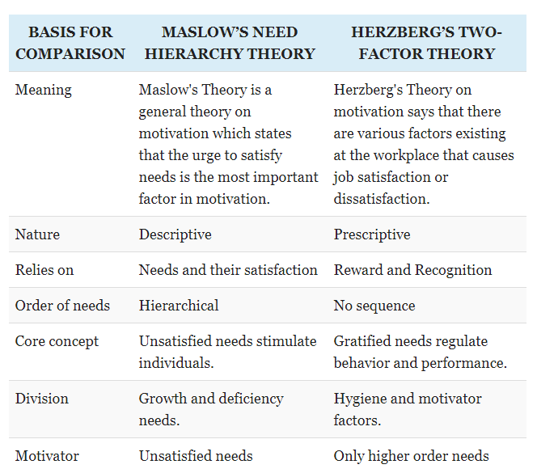

Figure 9.
(Surbhi, 2018).
The two models above created by the two masters goes for explaining the motivational procedure which demonstrated that motivation is a significant factor to improving the achievement level of staffs, Wiley (1997) said, a key strength of Maslow’s hierarchy of needs theory is the identification of individual requirements for the drive of motivating behaviour. By appealing to an employee’s unfulfilled needs, managers may influence performance. Herzberg's hypothesis is an expansion of Maslow's hypothesis. These are not opposing but rather integral to each other (Surbhi, 2018). After observing both theories, it can be said that both can be applied to the NHS to create a motivation model. Maidani (1991) believed, though there is a substantial backing for Herzberg’s theory, few empirical findings disagree with the estimate based on this model, needs for pay, recognition and responsibility, examples have revealed to operate both as motivators, and as hygiene factors, alternatively the others have found success in the theory.

The motivation for success:
Day and Allen (2004) states that a motivated team can have advantages for the organisation well as the employees will benefit; productivity will rise, and cost will be reduced. There will be less absence, and workers will more be devoted to their work, lower staff turnover means less cost of training and recruiting new staffs, relationship with trade unions will be improved. Motivated workers are likely to deliver a better quality of work and services with patients, and this will create the right industrial image. Most of these are beneficial to the organisation as these are money-saving schemes, NHS has minimal funds due to budget cuts, this approach should be very popular.

What is leadership and management development?
Having established the importance of motivational theory, in this part of the report examines leadership and management development, how it impacts workplaces. How relevant is it to the development of an organisation and its benefits towards the employees? The study will examine different development theories for managers and leadership, how it can be utilised in the NHS.
Adair (2007) said, there are various meanings of leadership and management and contentions about whether they are the equivalent or different skills. We see the two skills as connected; leadership is the capacity of a person to impact, drive and empower others to contribute towards the adequacy and accomplishment of the corporation of which they are members or employee. Management portrays the way toward driving and coordinating all or part of an association through the sending of assets, human, physical and funds (University of Aberdeen, 2019).
Why an organisation use management/leadership theory:
Carbery and Garavan (2012) wrote, there has been a massive global shift in how business is run day to day, last decade organisation has witnessed significant development in managerial and leadership techniques and approach theory. Globalisation has change forced significant companies to seek new innovative ways to run their companies in a competitive market. This has influenced the organisation to take proactive development of leaders and managers to create high-performance organisations to safeguard future growth.
Leadership and management challenges in the NHS:
Chief Executive of the NHS in 2009 requested 20 billion saving should be made from 2012 to 2015, and he specified that there are more productive ways of working efficiently. Since funding is an issue, finding ways to save was a must; this was challenging as if targets were not met, the money will not be available. Leadership and management of the NHS have never been increasingly significant as in these challenging times, and this is an example of challenges faced by the leaders and management and how the workforce must evolve with time.
The evolution of clinical leadership in the NHS:
The idea of clinical staff in leadership in the NHS ascended mainly from prescribing the work responsibility to clinical staffs, taking up management roles. Delegating NHS staffs more duty and burden allowed the formulation of clinical leaders. The staffs would actively take on more responsibility, as well as doing their providing treatments and patient care. This has led to small numbers of doctors and other clinical staffs moving towards expertise to managerial and other leadership roles.
A national strategy to radically change clinical leadership and management in 2006, General Medical Council set goals, that working doctors will be accountable for supervising resources/finance, have more responsibility for the patients and other related services. Clinical leadership were given the challenge to, motivate, inspire and encourage NHS values. This will inspire and constant emphasis on the wellbeing of patients care. The role of leadership is to uphold high ethics of care and to take present services to higher quality (West et al., 2014).
Some essential skills required by leaders:
- Caring and aiding people, management and staff engagement.
- Communication skills.
- Education, innovation and quality enhancement in training of all staff.
- Effective team working.
- Having strong, allied objectives for all teams and individual staff.
- Inspiring visions.
- Interpersonal skills.
- Problem-solving/decision making.
Some essential skills required by managers:
- Coaching
- Commercial awareness.
- Emotional Intelligence.
- Mentoring.
- Motivation (Geisler, 2012).
- Organisation and delegation (Jemma, 2018).
- Planning and strategic thinking.
A Comparison of management and leadership competencies.
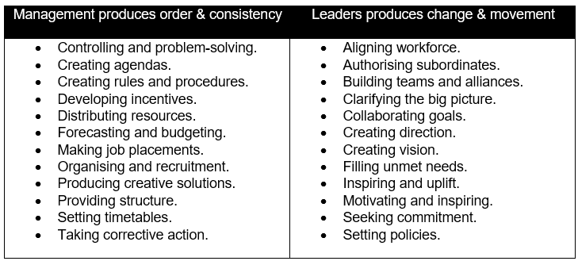

(Wanat and Potkanski 2010)

Figure 10.
The above chart illustrates the difference between leaders and managers, according to Wanat and Potkanski (2010) leaders usually conduct tasks, setting strategies, communicating goals, motivating and Inspire, managers plan, budget, organise and taking action; the two roles are often confused with one and another.

NHS leadership/managers academy:
The NHS Academy offers a scope of assets and projects to help people, institution and nearby foundations to create leaders, celebrating and sharing where exceptional leadership has a genuine effect. A large number of programmes are accessible to anyone considering leadership /management development.
NHS programmes available include:
- e-Learning for Healthcare – This programme is in partnership with NHS to free high quality of e-learning (e-Learning for Healthcare,2019).
- The Edward Jenner programme – those who are new to leadership can gain additional help to make a change to the NHS services.
- The Mary Seacole programme – intended for those who are looking to move into their first official leadership.
- The Nye Bevan programme – program to help executive leaders to achieve better at board level.
NHS leadership Academy runs a variety of scheme, even encouraging black minority and other ethnic groups and for graduate, novices wishing to leaders and managers (Health Careers, 2019). The NHS also encourages SMART goals/objectives, helping an individual pursue a better career and guiding them with the NHS resources and training.
Access to resources:
NHS has many resources and programmes for employees to access, giving help and support. The resources are uniquely designed for staffs who may require additional training and want to top up their skills.
Healthcare leadership model

Talent management

Inclusion, equality and diversity

Coaching and mentoring

Organisation development

Board development

NHS executive search service

Students learning to lead in healthcare

Figure 11.
(NHS Leadership Academy, 2019).
The Queen Elizabeth Hospital Birmingham (QEHB):
Many organisations are committed to training their staffs; they provide onsite education and training, to further develop and improve organisation services, the QE hospital is an example of that. There is a broad range of educational programmes available for clinical and non-clinical staffs, and all this is hosted in UHB’s (University Hospital Birmingham) own services, many free apprenticeships are available through UHB’s hub.
Examples of training and development programme in the QE hospital Birmingham:
- Apprentices.
- Clinical skill suites.
- Education facilities.
- Health and safety.
- International fellowship.
- IT skills.
- Medical education.
- Nurse education.
- Simulation.
- Training development.
- Work experience (University Hospital Birmingham, 2019).
Benefits of training employees.
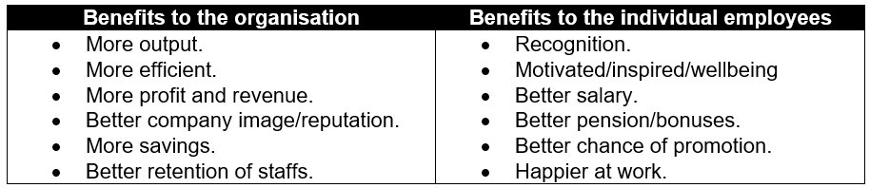

Figure 12.
In (figure 12) it is possible to see the potential organisational benefits of training the staffs, the staffs also benefit immensely.

Organisational employee training/development plan.


Figure 13.

360 Degree feedback plan:
The diagram below illustrates how the feedback plan has evolved through time from the outdated traditional system to the modern feedback plan.

Traditional feedback versus modern 360 feedback plan.

Figure 14.
Tutorials Point. (2019).
360-degree feedback is also known as multi-source feedback given from the place of work, in this case, the NHS. The feedbacks/appraisals are given by, work colleagues, supervisors leaders, managers, peers, suppliers and stakeholders; this may also include self-evaluation (Hosain, 2016). The information that is collected is used to recognise the employee’s strengths and weaknesses; this will help to evaluate the NHS employees’ professional position, abilities and maximise efficiencies (Baroda et al., 2012). The feedbacks are given from different angles and not based on single feedback; this allows a broader impression of the employees’ performance. According to Kouzes and Pozner (1993), the feedback tool 360 is regarded as one the best instrument in the function of an appraisal and professional development plan procedure. In NHS, one can register on the website for feedback, a small fee is required, and employees name, address and email (NHS Leadership Academy 2019). However, not everyone gives fair and honest feedback, may not always agree with the results.

Conclusion:
As stated above many motivational theorists believed it is paramount for leaders and management to recognise their employees/HR needs and aspiration, theorist have implied that employees have their own goals and desires, the drivers may not be money as individuals’ employees are different. Herzberg motivation theory 2-factor theory and Maslow’s motivational theory. Both theorists strongly believed people are not always motivated by financial rewards, but, achievement, recognition, a fancy job title and appraisal. Though both Maslow’s and Herzberg theory are very much alike (figure 9), they both recognised the importance of employee’s individual needs and non-financial rewards. A motivated worker is likely to produce a better quality of work, industrial image, culture and care as illustrated in (Figure 7/8). All these are beneficial to the NHS as these are all based non-financial reward and has minimal cost on the NHS. Having motivated workers means, less absence and more dedicated to work, more savings on training and hiring. To implement a well-motivated team in the NHS, managers/leaders need to engage, adopt the motivation theory in practice and execute them throughout the NHS. The organisation needs to make sure all NHS staff have access to continuing professional development (CPD) plan and feedback programme (figure 11,13 and 14), this will result in growth and improved staff retention as previous research has shown. Leaders and managers are very much like shepherds, using Maslow and Herzberg’s theoretical tools would be ideal in gathering, guiding, mentoring and motivating the employees/HR; all this can be accomplished through engaging with staffs. Therefore, employee engagement, motivational theories and leadership management development in the NHS is an essential obligation and should be recommended.

Reference page

- Adair, J. (2007). Decision making & problem-solving strategies. London, U.K.: Kogan Page.
- Bakker, A. and Demerouti, E. (2008). ‘Towards a model of work engagement’. Career Development International, [online] 13(3), pp.209-223. Available at: https://www.isonderhouden.nl/doc/pdf/arnoldbakker/articles/articles_arnold_bakker_164.pdf [Accessed 18 Jun. 2019].
- Bakker, A. and Schaufeli, W. (2008). ‘Positive organisational behaviour: engaged employees in flourishing organisations’, Journal of organisational behaviour, 29(2), pp.147-154.
- Baroda, S., Sharma, C. and Bhatt, J. K. (2012). “360 Degree feedback appraisals- An innovative approach of performance management system”. International Journal of management & information technology, 1(2), pp. 53-66.
- Bedarkar, M. and Pandita, D. (2014). A Study on the drivers of employee engagement impacting employee performance. Procedia - Social and behavioural sciences, 133, pp.106-115.
- Beheshti, N. (2018). Our approach to employee engagement is not working. [online] Forbes. Available at: https://www.forbes.com/sites/nazbeheshti/2018/09/30/our-approach-to-employee-engagement-is-not-working/#704acd187274 [Accessed 21 Jun. 2019].
- Carbery, R. and Garavan, T. (2012). Leadership and management development. ResearchGate. [online] Available at: https://www.researchgate.net/publication/242392127_Leadership_and_management_development [Accessed 25 Jun. 2019].
- Communication Theory. (2011). Maslow's hierarchy of needs. [online] Available at: https://www.communicationtheory.org/maslow%E2%80%99s-hierarchy-of-needs/ [Accessed 23 Jun. 2019].
- Day, R. and Allen, T. (2004). The relationship between career motivation and self-efficacy with protégé career success. Journal of vocational behaviour, 64(1), pp.72-91.
- e-Learning for Healthcare. (2019). e-Learning for Healthcare. [online] Available at: https://www.e-lfh.org.uk/ [Accessed 29 Jun. 2019].
- Geisler, J. (2012). 10 key skills today's leaders need to succeed in 2013 - Poynter. [online] Poynter. Available at: https://www.poynter.org/reporting-editing/2012/10-key-skills-todays-leaders-need-to-succeed-in-2013/ [Accessed 26 Jun. 2019].
- Gov.UK. (2018). NHS workforce. [online] Available at: https://www.ethnicity-facts-figures.service.gov.uk/workforce-and-business/workforce-diversity/nhs-workforce/latest [Accessed 16 Jun. 2019].
- Health Careers. (2019). NHS Leadership Academy. [online] Available at: https://www.healthcareers.nhs.uk/career-planning/developing-your-health-career/nhs-leadership-academy [Accessed 28 Jun. 2019].
- Hosain, M. (2016). 360 Degree feedback as a technique of performance appraisal: Does it really work? Asian business review, 6(13), pp.21-24.
- IEU Institute for employment studies. (2019). Report Summary: The drivers of employee engagement. [online] Available at: https://www.employment-studies.co.uk/report-summaries/report-summary-drivers-employee-engagement [Accessed 18 Jun. 2019].
- Kouzes, J. H. & Pozner, B. Z. (1993). “Credibility – How leaders gain and lose it, why people demand it”. San Francisco: Jossey – Bass Publishers, pp. 97-98.
- Lawrence, P. R. and Nohria, N. (2002). Driven: How human nature shapes our choices. San Francisco: Jossey-Bass.
- Lee, M. and Raschke, R. (2016). Understanding employee motivation and organisational performance: Arguments for a set-theoretic approach. Journal of innovation & knowledge, 1(3), pp.162-169.
- Mackay, M., Allen, J. and Landis, R. (2017). Investigating the incremental validity of employee engagement in the prediction of employee effectiveness: A meta-analytic path analysis. Human resource management review, 27(1), pp.108-120.
- Macleod, D. (2019). What is employee engagement? [online] Available at: https://engageforsuccess.org/what-is-employee-engagement [Accessed 18 Jun. 2019].
- Maidani, E. (1991). Comparative study of Herzberg's two-factor theory of Job satisfaction among public and private Sectors. Public personnel management, 20(4), pp.441-448.
- Maslow, A. H. (1943). ‘A theory of human motivation’. Psychological Review, 50(4), pp.370–396
- NHS Employers. (2019). Staff engagement resource library. [image] Available at: https://www.nhsemployers.org/retention-and-staff-experience/staff-engagement/staff-engagement-resource-library [Accessed 16 Jun. 2019].
- NHS England (2019). NHS Staff Survey in England. [online] Available at: https://www.england.nhs.uk/statistics/statistical-work-areas/nhs-staff-survey-in-england/ [Accessed 18 Jun. 2019].
- NHS Leadership Academy. (2019). Free resources. [online] Available at: https://www.leadershipacademy.nhs.uk/resources/ [Accessed 28 Jun. 2019].
- NHS Leadership Academy. (2019). Healthcare leadership model 360-degree feedback tool - NHS leadership academy. [online] Available at: https://www.leadershipacademy.nhs.uk/resources/healthcare-leadership-model/supporting-tools-resources/healthcare-leadership-model-360-degree-feedback-tool/ [Accessed 1 Jul. 2019].
- Nohria, N., Groysberg, B. and Lee, L. (2008). Employee motivation: A powerful new model. Harvard Business Review, 86(7/8), 78–83.
- Owen Kenny Solicitors. (2019). Proud to offer a 10% discount to all NHS staff on conveyancing fees - Owen Kenny Solicitors. [image] Available at: https://owenkenny.com/proud-to-offer-a-10-discount-to-all-nhs-staff-on-conveyancing-fees/ [Accessed 11 Jun. 2019].
- Parker Follett, M. and Follett, M. (1924). Creative experience. New York: Longmans Green.
- Seijts, G. & Crim, D. (2006). ‘What engages employees the most or, the ten C's of employee engagement’, Ivey Business Journal, 70. 1-5.
- Sharma, S., Sharma, J. and Devi, A. (2009). ‘Corporate social responsibility: The key role of human resources management’, Business intelligence Journal. 2.
- Smith, J. (2018). 7 skills for a successful management career | Prospects. [online] Available at: https://www.prospects.ac.uk/jobs-and-work-experience/job-sectors/business-consulting-and-management/7-skills-for-a-successful-management-career [Accessed 25 Jun. 2019].
- Stecher, M. and Rosse, J. (2007). Understanding reactions to workplace injustice through process theories of motivation: a Teaching module and simulation. Journal of management education, 31(6), pp.777-796.
- Surbhi, S. (2018). Difference between Maslow and Herzberg's theory of motivation (with comparison Chart) - Key differences. [online] Key differences. Available at: https://keydifferences.com/difference-between-maslow-and-herzberg-theories-of-motivation.html#Conclusion [Accessed 23 Jun. 2019].
- The Nuffield Trust. (2019). The NHS workforce in numbers. [online] Available at: https://www.nuffieldtrust.org.uk/resource/the-nhs-workforce-in-numbers [Accessed 16 Jun. 2019].
- Tutorials Point. (2019). Talent management 360-degree feedback. [image] Available at: https://www.tutorialspoint.com/talent_management/talent_management_360_degree_feedback.htm [Accessed 6 Jul. 2019].
- University Hospital Birmingham. (2019). Education. [online] Available at: https://www.uhb.nhs.uk/education.htm [Accessed 29 Jun. 2019].
- University of Aberdeen. (2019). Leadership and management development | StaffNet | The University of Aberdeen. [online] Abdn.ac.uk. Available at: https://www.abdn.ac.uk/staffnet/working-here/leadership-and-management-development-324.php [Accessed 25 Jun. 2019].
- Wanat, L. and Potkanski, T. (2010). Effective leadership as one of the pillars of development of knowledge - based economy. [image] ResearchGate. Available at: https://www.researchgate.net/publication/321397968_Effective_leadership_as_one_of_the_pillars_of_development_of_knowledge_-_based_economy [Accessed 27 Jun. 2019].
- Warder, J. and Hall, I. (2012). Why engaging staff is a critical component of hospital transformation. [online] Health Service Journal. Available at: https://www.hsj.co.uk/resource-centre/best-practice/qipp-resources/why-engaging-staff-is-a-critical-component-of-hospital-transformation/5040026.article [Accessed 21 Jun. 2019].
- West, M. A., Lyubovnikova, J., Eckert, R., & Denis, J.L. (2014) Collective leadership for cultures of high-quality health care. Journal of organisational effectiveness: people and performance, 1, 240 – 260.
- West, M. and Dawson, J. (2012). Employee engagement and NHS performance. [online] Available at: https://www.kingsfund.org.uk/sites/default/files/employee-engagement-nhs-performance-west-dawson-leadership-review2012-paper.pdf [Accessed 19 Jun. 2019].
- Wiley, C. (1997). What motivates employees according to over 40 years of motivation surveys. International journal of manpower, 18(3), pp.263-280.

