Civil Engineering Technology – Case Study
Name – Tudur Fychan
Student Number - 1910138

Paxton Street Project

We have been tasked with planning out the construction of a 20-storey building situated at Paxton Street car park. The building’s dimensions will be 30 metres by 30 metres and will include three car park underground floors.
Each underground floor will be 3m in height meaning the whole underground car park will be 9m in height. To ensure that there will be enough depth to include space for the foundation and a permanent drainage system we will excavate to a depth of 10m below surface level. We will also be excavating a hole of dimensions of 35m by 35m to leave room for the retaining wall and underground drainage from groundwater.
The excavation for the basement will be done using sheet piling as a temporary solution. This means we would need (35+35+35+35 =) 140 metres of sheet piling to a depth of 11m (extra metre of depth to ensure it can hold back the weight of earth.)
The volume of earth that will need to be excavated will be 35x35x10 = 12,250 m³. The bulking factor of this soil will be 1.1 meaning that the post-excavation volume of earth will be 13,475 m³.
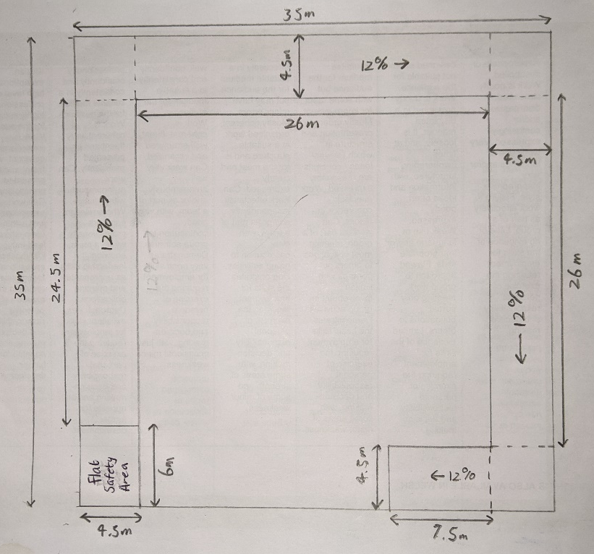
On this project we will use 2 excavators each with a bucket volume of 0.8m³. Their excavation and offload time to a waiting dumper will be 40 seconds meaning they will have a combined time per m³ moved of 25 Seconds/m³ (50 each). The two excavators will be offloading to three circling dumpers which can carry 30m³ of soil each. This means that it takes 12.5 minutes to fill each dumper. The dumpers are able to travel at an average speed of 30mph and will carry the earth to a site 5 miles away. Considering that the time for dropping off the earth is 3 minutes, the total time for the trip there and back will be 23 minutes.
There will be an earth ramp in order for the plant to enter and exit the excavation as shown in the diagram. The downwards ramp sections are made up of 24.5m, 26m, 26m and 7.5m sections adding to 84m. At a gradient of 12% this comes to just over 10m in depth (the depth did not increase during the corners of the ramp).
During the excavation a mobile de-watering pump will be set up that will be situated at the lowest point in the hole and will be powered using a generator.
We will use diaphragm walls as the permanent retaining wall because they work well while constructing basements. They will be inserted behind the temporary sheet piling and once the concrete wall has set, the sheet piling can be removed.
The foundation will be made up of piles due to the poor soil conditions. The piles will be caped with a concrete pad which will then be connected to a number of ring beams reinforced by shear links.
A dewatering tank will be installed at the lowest point along with a pump to pump it out and also a back up pump.

