Turbo Charger Analysis

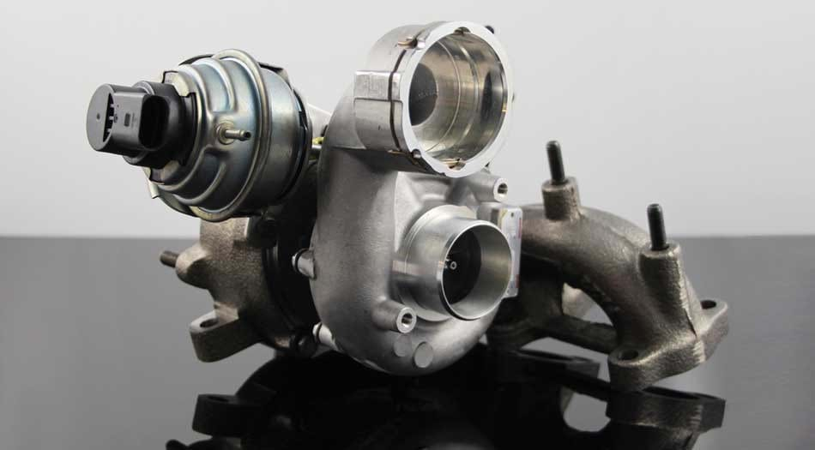

  - Powertrain Technology

Richard Osborne

M5X02200 | 2019

Contents

Contents 1
List of Figures 2
1.0 Introduction 3
2.0 Research/Literature Review 3
3.0 Methodology 5
4.0 Analysis 10
4.1 Turbo Selection 10
Turbo A 13
Turbo B 13
Turbo C 13
Turbo D 14
4.2 Compressor Outlet Temperature 15
4.3 Intercooler Selection 15
4.4 Component Upgrades 16
5.0 Conclusion 18
6.0 References 19

List of Figures
Figure 1 Flow of Air Through Turbocharger System 4
Figure 2 Turbocharger 5
Figure 3 Coolant Lines Removed 5
Figure 4 Coolant Lines 5
Figure 5 Exhaust Manifold Removed 5
Figure 6 Manifold Gasket Removed 6
Figure 7 Oil Return Line Removed 6
Figure 8 Oil Feed Line Removed 6
Figure 9 Oil Return and Feed Lines 6
Figure 10 Boost Control Solenoid and Vacuum Lines Removed 6
Figure 11 Diverter Valve Removed and Stripped 7
Figure 12 Wastegate Actuator 7
Figure 13 Wastegate Actuator Removed 7
Figure 14 Turbocharger, Semi-Disassembled 7
Figure 15 Removal of the Compressor Housing 7
Figure 16 Turbocharger with Compressor Housing Removed 8
Figure 17 Inside of the Compressor Housing 8
Figure 18 Removal of V-Band Clamp 8
Figure 19 Turbocharger with V-Band Removed 8
Figure 20 Turbocharger Core Removed from Exhaust Housing 8
Figure 21 Impeller Retaining Nut (Left Hand Thread) 8
Figure 22 Impeller Shaft Removed 9
Figure 23 View Beneath Compressor Impeller 9
Figure 24 Thrust Bearing and Cap Removed 9
Figure 25 Thrust Bearing and Cap 9
Figure 26 Inside view of Exhaust Housing 9
Figure 27 Component Overview 10
Figure 28 Turbo A Compressor Map 13
Figure 29 Turbo B Compressor Map 13
Figure 30 Turbo C Compressor Map 13
Figure 31 Turbo D Compressor Map 14
Figure 32 Intercooler Internal Area Graph 16

Introduction

This report will look into the careful considerations required in the selection of a turbocharger for a Naturally Aspirated V8 engine. Research will be carried out to identify the benefits of turbocharging, and also the components that will require upgrading in the event of a turbocharger being fitted. Calculations into all aspects of turbo selection will be carried out, as well as, the selection of a suitable intercooler system required to deal with increased intake temperatures. The aim of this report is to obtain an in depth understanding of turbochargers and achieve the ability to select a suitable turbocharger for any engine application.

Research/Literature Review

The basic principle of turbocharging is to increase the volumetric efficiency of a given engine, therefore, smaller engines can produce the same power as larger engines i.e. v6’s and v8’s etc.
“It increases the air/fuel charge density to provide high compression pressure when power is required, but allows the engine to run on lower pressures when additional power is not required.”
“The pumped air pushes, the remaining exhaust from the combustion chamber during intake and exhaust valve overlap (Overlap is when both the intake and exhaust valves are partially open when the piston is near the top at the end of the exhaust stroke and the beginning of the intake stroke).”
“The forced air flow and removal of hot exhaust gasses lowers the temperature of the cylinder head, pistons, and valves, and helps extend the life of the engine.”
As stated by Halderman (2011).
As can be seen in the image below (Figure 1), the exhaust gas from the combustion chamber enters the turbocharger, and then exits through the exhaust and into atmosphere. As Halderman expresses,
“Hot exhaust gasses flow from the combustion chamber to the turbine wheel. The gasses are heated and expanded as they leave the engine. It is not the speed of force of the exhaust gasses that forces the turbine wheel to turn, as it is commonly thought, but the expansion of hot gasses against the turbine wheel’s blades.”
The turbine wheel is connected to the compressor wheel via the impeller shaft that runs through the centre of the turbocharger. The spinning of the compressor wheel compresses the atmospheric intake air and forces it through to the intercooler (charge air cooler). This is called the cold side of a turbo system as the air is cooled in the intercooler before being fed into the intake manifold. The air is mixed with the fuel upon the induction stroke of the engine, combustion then takes place and the exhaust gas exits the engine and into the exhaust side of the turbo in a continuous cycle.

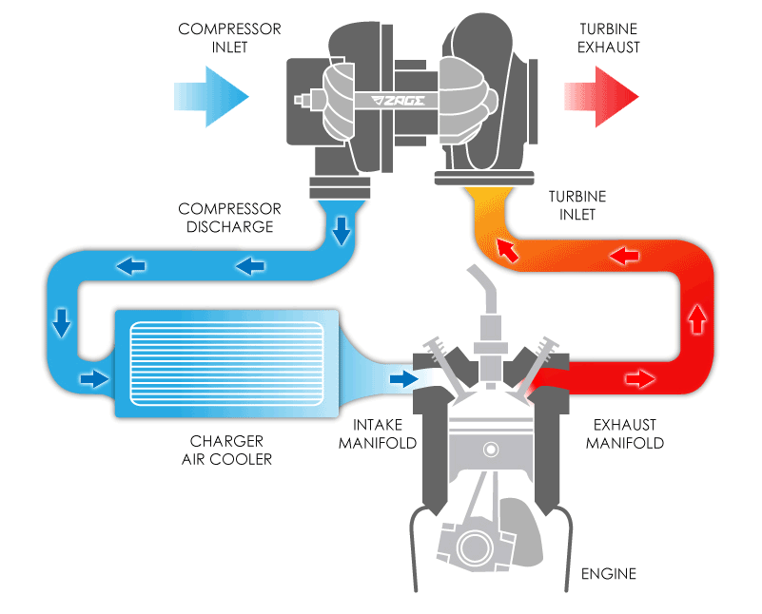
Figure 1 Flow of Air Through Turbocharger System

Methodology

The strip down of a turbo charger was carried out in a work shop environment, full relevant PPE (Personal Protective Equipment) was required, this consisted of, a pair of safety boots with steel toe caps and a dust coat. Any loose clothing or Jewellery had to be removed as well as tying back long hair. The tools required to carry out this task were general hand tools, these consisted of a selection of ratchets, socket sets, screw drivers, spanners, Allen keys and Torx drivers. Richard Osborne and Liam Standing were the technicians carrying out this Turbocharger strip-down.
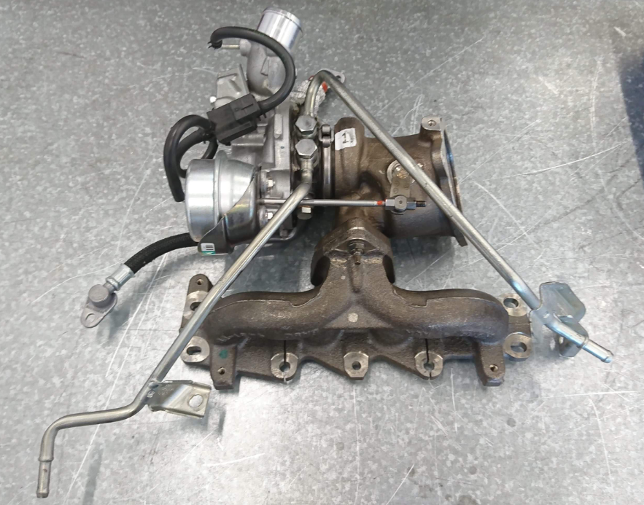
Figure 2 Turbocharger
The first step after removing the turbo from the vehicle is to set up a tidy and spacious work area before beginning strip-down.
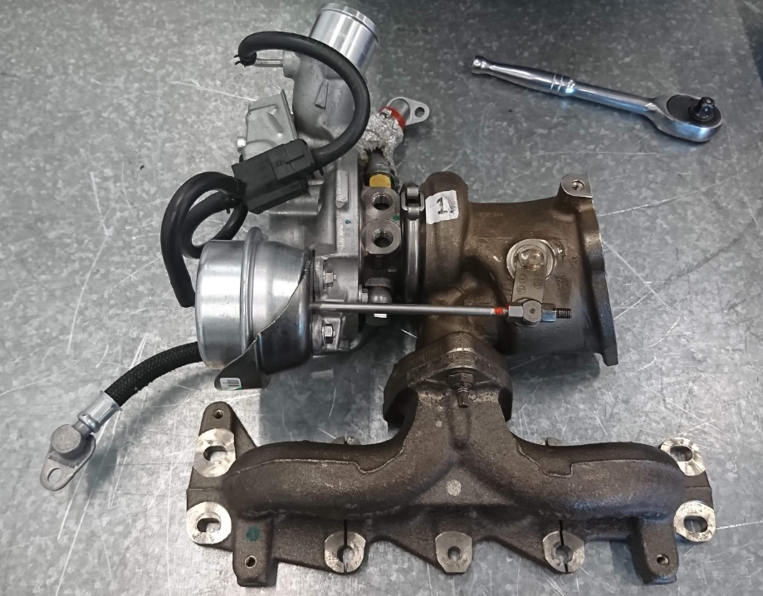
Figure 3 Coolant Lines Removed
As seen in Figure 3. Start by removing the two coolant lines fitted to the top of the Turbocharger.
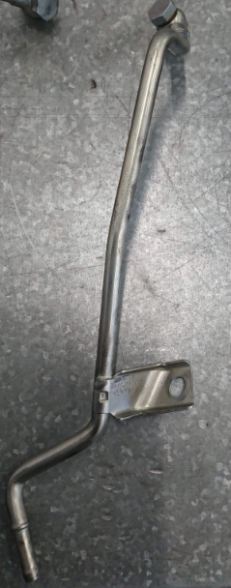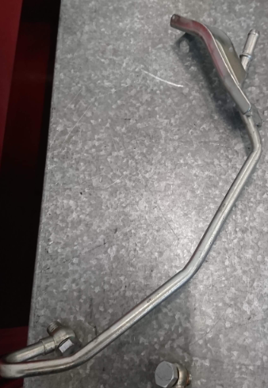
Figure 4 Coolant Lines
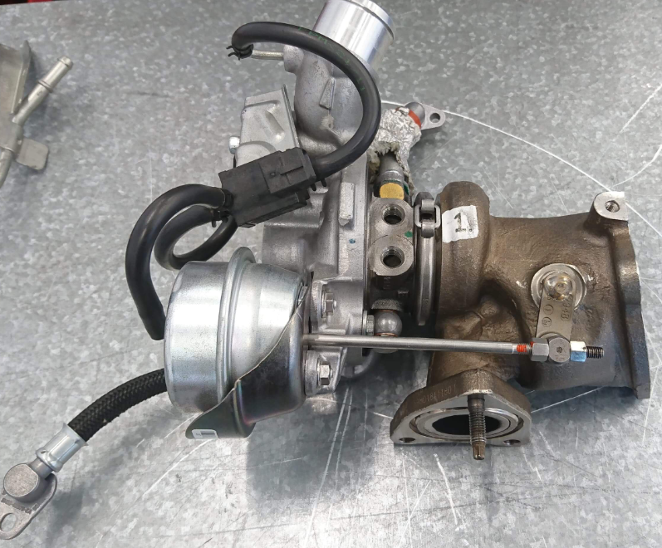
Figure 5 Exhaust Manifold Removed
With the coolant lines removed, the exhaust manifold and gasket can be removed. (Figure 5)
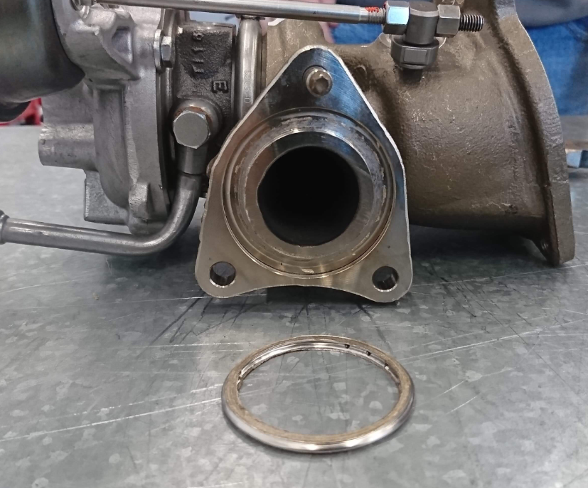
Figure 6 Manifold Gasket Removed
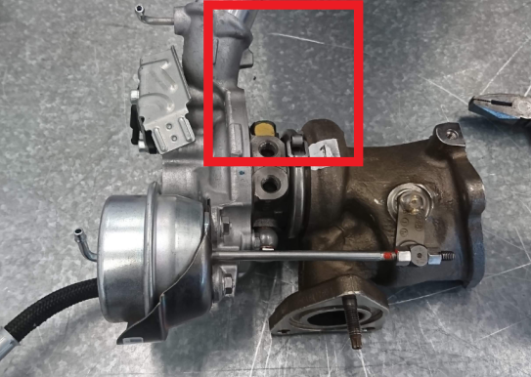
Figure 7 Oil Return Line Removed
Next, remove the Oil Feed and Return Lines. (Figure 7 & Figure 8).
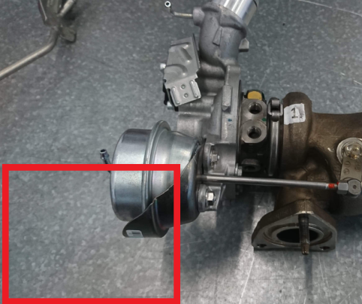
Figure 8 Oil Feed Line Removed
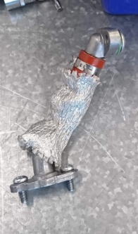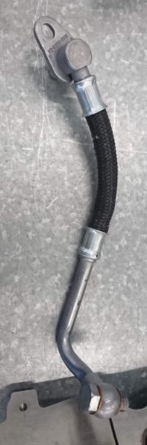
Figure 9 Oil Return and Feed Lines
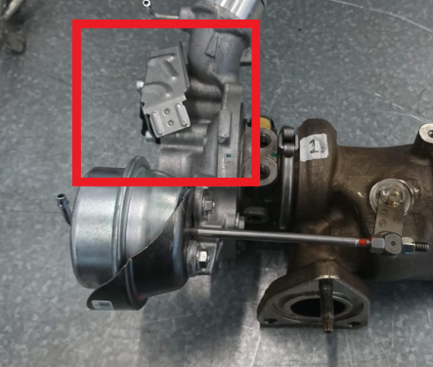
Figure 10 Boost Control Solenoid and Vacuum Lines Removed
Remove the vacuum lines and boost control solenoid. (Figure 10).

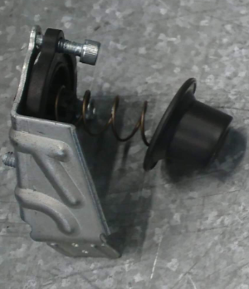
Figure 11 Diverter Valve Removed and Stripped
Then the diverter Valve or Bypass Valve should be removed and inspected. (Figure 11)
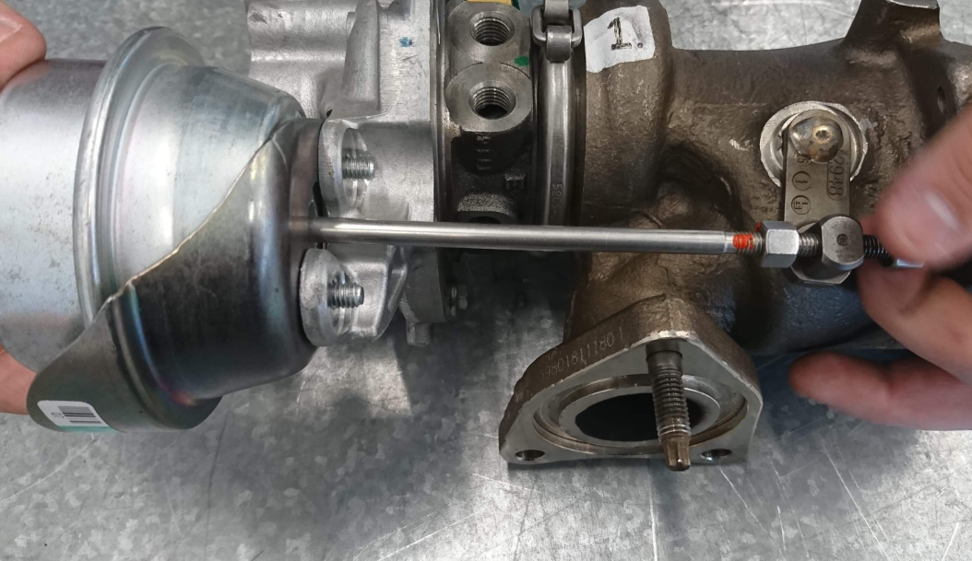
Figure 12 Wastegate Actuator
The Wastegate Actuator can now be removed. CAUTION: The wastegate Actuator has a paint dot on the threads. This is to mark the correct setup. If the actuator is adjusted beyond or below this point, upon rebuilding, the turbo will not function as normal and will require re calibration by a dealer authorised technician. (Figure 12).
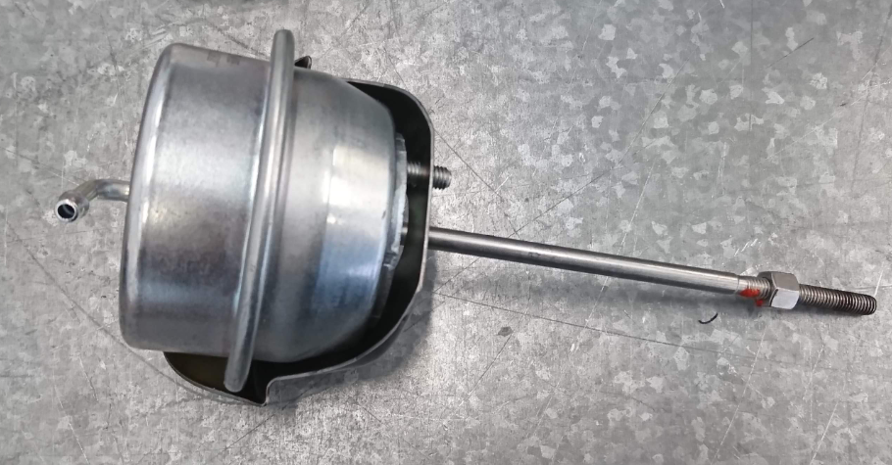
Figure 13 Wastegate Actuator Removed
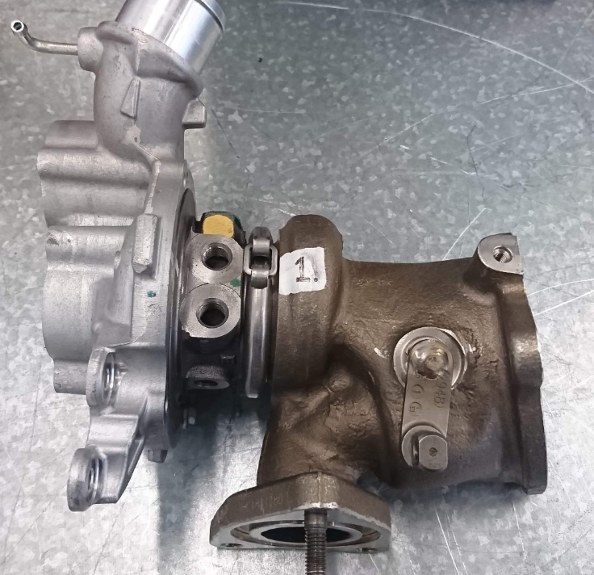
Figure 14 Turbocharger, Semi-Disassembled
At this stage, the turbo should look like the image above. (Figure 14)
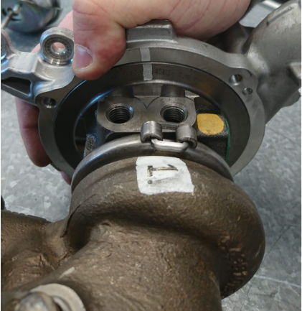
Figure 15 Removal of the Compressor Housing
Now the Compressor Housing can be removed. CAUTION: It is important to mark the housing with a paint pen before removal, as the Compressor Housing can be fitted in the opposite orientation. This will cause issues while rebuilding and may not allow other components to be refitted correctly. (Figure 15).
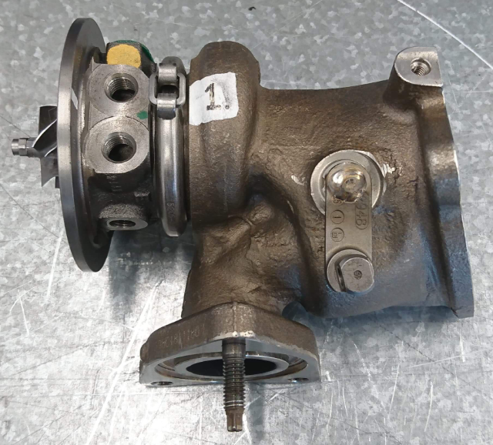
Figure 16 Turbocharger with Compressor Housing Removed
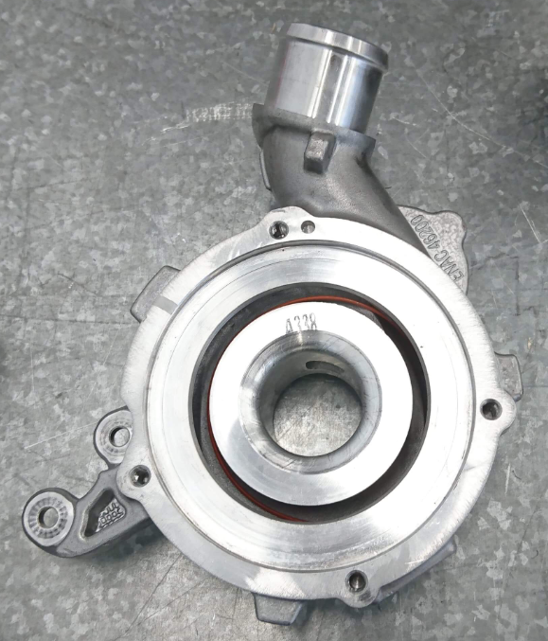
Figure 17 Inside of the Compressor Housing
With the Compressor Housing removed a visual inspection can be carried out for damage or wear. (Figure 17)
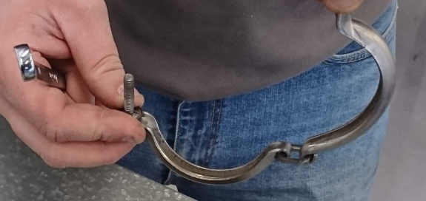
Figure 18 Removal of V-Band Clamp
Next, the V-Band is removed and the Core is removed from the exhaust housing. (Figure 18, Figure 19 & Figure 20)
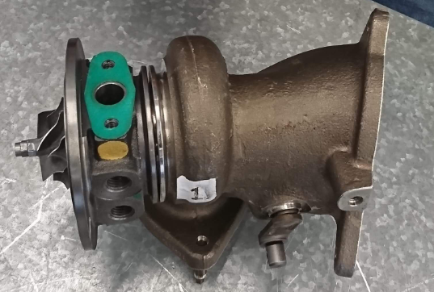
Figure 19 Turbocharger with V-Band Removed
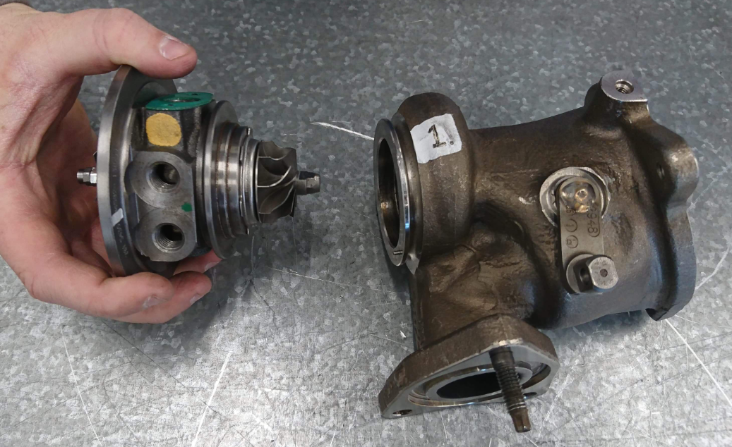
Figure 20 Turbocharger Core Removed from Exhaust Housing
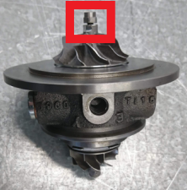
Figure 21 Impeller Retaining Nut (Left Hand Thread)
With the Core removed the Impeller Retaining Hut can be removed. CAUTION: The Impeller Retaining Nut is Left-Hand- Thread, meaning a clockwise rotation must be used to remove it. Using the normal (Anti-Clockwise) method will result in damage to the nut, or worse, snapping of the Impeller Shaft. (Figure 21)
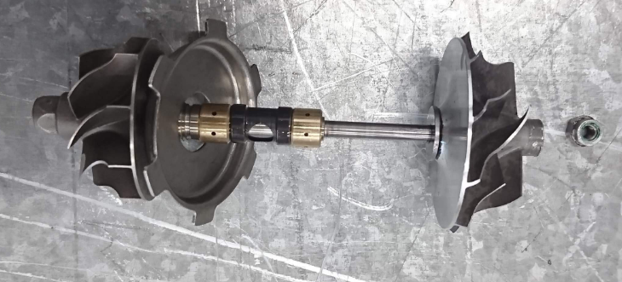
Figure 22 Impeller Shaft Removed
With the impeller shaft removed, the journal bearings can be inspected and replaced if necessary (2 brass coloured collars). (Figure 22)
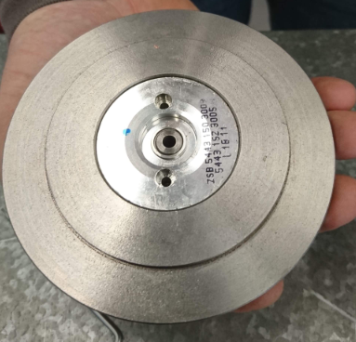
Figure 23 View Beneath Compressor Impeller
Beneath the compressor side impeller, there is a small plate, inside of which, houses the thrust washer, this must also be removed, inspected and replaced if necessary. (Figure 23, Figure 24 & Figure 25)
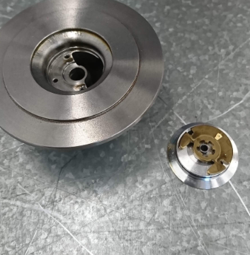
Figure 24 Thrust Bearing and Cap Removed
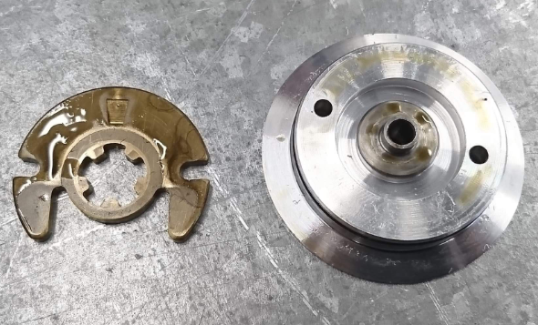
Figure 25 Thrust Bearing and Cap

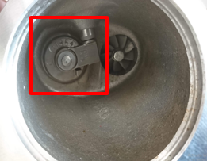
Figure 26 Inside view of Exhaust Housing

Lastly, before reassembly the inside of the Exhaust housing should be inspected for damage to the wastegate, as shown in Figure 26.
Once all parts have been inspected, cleaned and, if necessary, replaced, the turbocharger can be rebuilt in reverse order, making sure to re-grease the necessary moving parts and tightening components to the manufacturer specified torque settings.

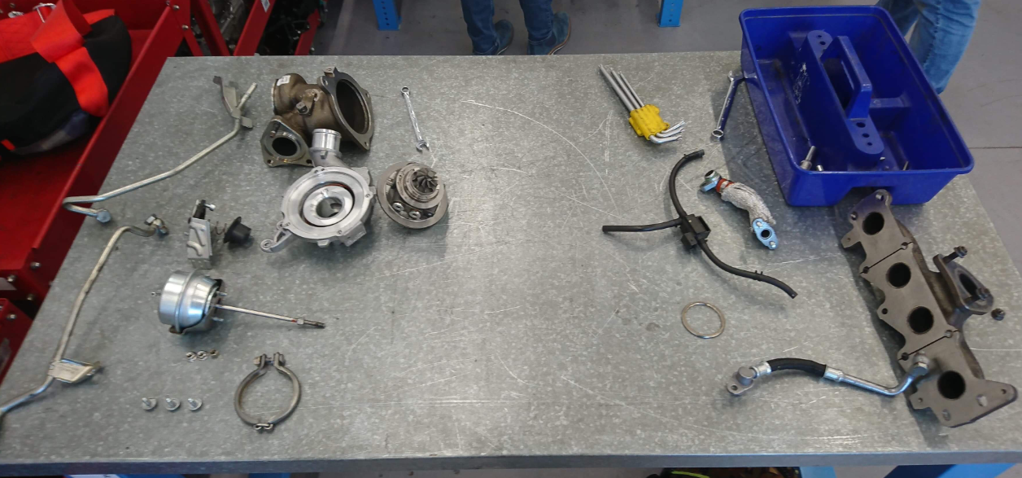
Figure 27 Component Overview
When carrying out a job such as this, with many small parts, it is important to do so in a clean and spacious environment. Always remove components and lay out in an orderly fashion so not to mix up or lose any parts which will, in turn, hinder the rebuilding process. (Figure 27)

Analysis

Turbo Selection
A number of calculations were performed to select a suitable turbocharger that can be installed on a Naturally Aspirated V8 engine. Four turbocharger maps were supplied to test which one will be best suited for the v8 engine. Certain criteria were gathered to aid in the calculations, these are as follows:
- Bore (d) = 95mm – 0.095m
- Stroke (L) = 80mm – 0.08m
- Maximum engine RPM (N) = 9500 RPM
- Volumetric Efficiency ($ɳ_{v}$) = 0.85
- Boost = 12psi
- Number of Cylinders (n) = 8
The Volumetric Efficiency must be found in $m^{3}/sec$ and then converted to cfm and then converted into $Lb/Min$. To calculate these, the following formulas are required:
N/A Calculation
$$V_{N/A}=PR×\frac{v×ɳ_{v}×N}{2×60}$$
Pressure Ratio of a Naturally Aspirated engine is assumed to be 1.
Turbo Calculation
$$V_{T}=PR×\frac{v×ɳ_{v}×N}{2×60}$$
Firstly, the pressure ratio must be found, this is obtained by using the following equation.
$$Pressure Ratio (PR)= \frac{14.7+Boost}{14.7}$$
The boost pressure is known to be 12psi and this figure can be entered into the equation.
$$PR= \frac{14.7+12}{14.7}=1.82Bar$$
With the Pressure Ratio for the turbo setup calculated, the next unknown aspect of the equation was the engines total displacement in $m^{3}$. This was calculated using the formulas below.
$$Area=Volume×Length$$
$$A=V×L$$

To find the area, a cylinder’s Bore and Stroke must be known in meters:
Bore (d) = 0.095m
Stroke (L) = 0.080m
The formula below shows the calculation for cylinder area.
$$Area=\frac{pi×{diameter}^{2}}{4}$$
$$A=\frac{π×d^{2}}{4}$$
$$A=\frac{π×{0.095}^{2}}{4}=7.088×{10}^{-3}$$
By rearranging the original equation to obtain the volume, it becomes:
$$Volume=Area×Length$$
$$V=A×L$$
$$V=7.088×{10}^{-3}×0.080=5.67×{10}^{-4}$$
This figure for Volume is per each separate cylinder. Therefore, to obtain the total displacement, it must be multiplied by the number of cylinders that the engine has, 8.
$$V=5.67×{10}^{-4}×8=4.54×{10}^{-3}m^{3}$$
With the Pressure Ratio and the Total Engine Displacement calculated, the calculations for air flow were carried out.
Naturally Aspirated
$$V_{N/A}=1×\frac{v×ɳ_{v}×N}{2×60}$$
$$V_{N/A}=1×\frac{4.54×{10}^{-3}×0.85×9500}{2×60}=0.30m^{3}/sec$$
Turbocharged
$$V_{T}=PR×\frac{v×ɳ_{v}×N}{2×60}$$
$$V_{T}=1.82×\frac{4.54×{10}^{-3}×0.85×9500}{2×60}=0.556m^{3}/sec$$
Unfortunately, as seen in figures 28 to 31, The horizontal axle states that the figures were in Lbs/Min, so a few conversions were to be made:
$$1m^{3}/sec=2119cfm$$
$$1 cfm=0.07Lb/Min$$
Therefore, our Turbocharged Air Flow is calculated as follows.
$$0.556m^{3}×2119 cfm=1178.164cfm$$
$$1178.164 cfm×0.07Lb/Min=82.47Lb/Min$$
With these calculations carried out, the choice of which turbocharger would work best with the V8 engine was made.

Turbo A
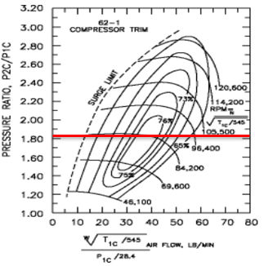
Figure 28 Turbo A Compressor Map

Turbo B
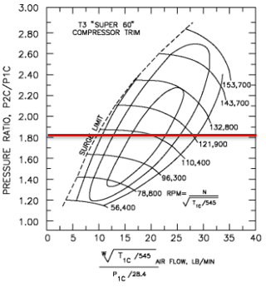
Figure 29 Turbo B Compressor Map

Turbo C
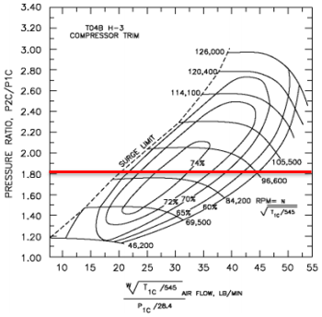
Figure 30 Turbo C Compressor Map
Turbos A, B and C would not be suitable for this setup as the airflow that these turbochargers operate at does not reach the operating air flow required for the V8 engine. Air flow required for the V8 reaches $82.47Lb/Min$. The red line that enters from the vertical axis, displaying the pressure ratio, passes the entire compressor maps of all 3 turbochargers before reaching the $82.47Lb/Min$ required. Therefore, these Turbochargers would be rendered useless before 6321rpm (Turbo A), 3229rpm (Turbo B) and 5074rpm (Turbo C).

Turbo D
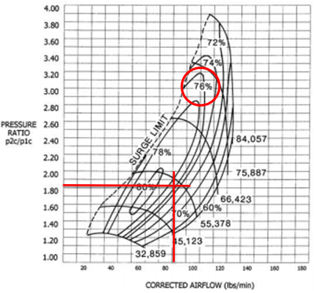
Figure 31 Turbo D Compressor Map
To equip the V8 engine with a turbo that will supply boost through to the rev limiter, turbocharger D is the one that will be required. The downside to this, however, is that early stages of boost don’t become available until 4835RPM. This is calculated by reverse converting the figures for cfm and $m^{3}/sec$, and then rearranging the equation to give the RPM figure as shown below.
$$42Lb/Min÷0.07Lb/Min=600cfm$$
$$600cfm÷2119cfm=0.283m^{3}$$
The equation is rearranged to obtain engine RPM (N):
$$N=\frac{VFR×2×60}{v×ɳ_{v}}÷PR$$
$$N=\frac{0.283×2×60}{4.54×{10}^{-3}×0.85}÷1.82=4835.28RPM$$
With this being the case, the driveability would not be best suited to an everyday road car, for a race car on the other hand, this turbocharger would be ideal. The red lines on the graph represent the Pressure Ratio of 1.82Bar entering from the vertical axis, and the Air Flow of 82.47Lb/Min rising from the horizontal axis. At the intersection of these 2 red lines, the efficiency can be found at approximately 76% at maximum load, this is done by following the rising map lines, from the intersection, to the relevant percentage marked around the upper section of the map.

Compressor Outlet Temperature
The Compressor Outlet Temperature was found by using the following equation.
$$Temperature Out=Pressure Ratio^{0.28}×Temperature In$$
$$Tout=PR^{0.28}×Tin$$
So, as it was known, the:
- Pressure Ratio = 1.82 Bar
- Temperature In (assuming 27$°C$ ambient Temperature) = 300 Degrees Kelvin
$$Tout=1.82^{0.28}×300=354.77K$$
From here the change in temperature was calculated using the following equation.
$$∆T=\frac{\left(PR^{0.28}×Tin\right)-Tin}{ɳ_{c}}$$
- Compressor Efficiency ($ɳ_{c}$) = 0.76
- Temperature In = 300
- Pressure Ratio =1.82
$$∆T=\frac{\left({1.82}^{0.28}×300\right)-300}{0.76}=72.06°K$$
$$Total Temperature Out=345.06°K$$

Intercooler Selection
In the attempt to select an appropriate Intercooler, a few calculations were made. Firstly, with a hypothetical 60% efficient Intercooler system fitted, the improvement to Turbocharger Outlet Temperature could be monitored. The equation required to calculate this is shown below.
$$ɳ_{i}=\frac{T_{co}-T_{io}}{T_{co}-T_{a}}$$
- Intercooler Efficiency ($ɳ_{i}$) = 0.6
- Ambient Temperature ($T_{a}$) = 300
- Compressor Outlet Temperature ($T_{co}$) = 345.06
The equation is then rearranged to make $T_{io}$ the subject.
$$T_{io}=T_{co}-ɳ_{i}(T_{co}-T_{a})$$
$$Tio=345.06-0.6×\left(345.06-300\right)=318.02°K$$
This shows a temperature drop of $27.04°K$
With the knowledge that the charge air temperature has been reduced by $27.04°K$, the Intercooler size is now an important factor, to ensure the most efficient design is obtained. The graph shown below assists in the selection as it is known that the cfm value was $1178.164cfm$.

Figure 32 Intercooler Internal Area Graph
By finding the approximate point on the horizontal axis (cfm), and inserting a vertical line into the graph, an estimation can be made on how large the internal area of the intercooler will need to be in order to obtain the most efficient Intercooler design. Dependant on which intercooler design is required, the internal area will change. If a typical intercooler design is required, following the vertical line, it was found that the approximate internal flow area would be 87sq.in.

Component Upgrades
When installing a turbocharger kit to an engine that wasn’t originally designed to use one, a series of upgraded components are required to ensure the engine remains healthy throughout its lifecycle. As found by Turbodynamics.co.uk (2019), “The fundamental differences between a naturally aspirated and a turbocharged engine are: the compression ratio, camshaft profiles, fueling, ignition timing, type of pistons and the strength of some of the rotating parts”. To start with, a look at the engine itself is paramount, the engines compression ratio should be understood and lowered if necessary. The ideal compression ratio for a turbocharged engine is between 7.5:1 and 8.5:1, this is to allow for any decent amount of boost pressure, as found by Turbodynamics.co.uk (2019). To do this, a number of different techniques can be used, these are the installation of a thicker head gasket, machining to the heads of the original pistons or by replacing the pistons with forged low compression pistons. Checking the profile of the camshafts is also important, this is carried out to understand valve overlap and duration. If the valve is open too long due to high profile cams, at high engine rpm, the valves could be wasting air and fuel due to entering and simultaneously exiting the combustion chamber before combustion takes place, therefore, rendering the turbo useless at higher rpm. Another issue is that the inlet and exhaust valves could hit each other or worse, hit the pistons. A mild cam profile is ideal for a turbo installation. As it is known the main purpose of adding a turbocharger is to increase air flow (Forced Induction). To add to this increase in air entering the engine, fuel levels must also be increased to make the most of the combustion process. To enhance the fuel system a few components must be replaced, these are, a higher Litre Per Hour (L/h) fuel pump, larger flowing injectors and also an upgraded fuel pressure regulator. With these modifications in place a remap of the engines ECU is required, this is primarily to adjust ignition timing for the increased demands of the turbocharger. “The ignition timing needs to be retarded as the boost pressure rises”, as stated by Turbodynamics.co.uk (2019).
Depending on the size of the turbocharger being added to the engine, there are a few other modifications to be carried out, these are:
- Oil Feed and Return lines
- Coolant Feed and Return lines
- Intercooler and space for piping
- Coolant system modifications, such as bigger radiator, fans and potential relocation
- Inlet and Exhaust Manifold modifications
- Cylinder head work
- Further Exhaust system changes
The list could be larger but these are a few examples. Another thing to consider, aside from the engine, are other component assessments that will need to be made, these are:
- Braking systems
- Clutch and transmission systems
- Driveline components
These considerations are to be looked at with higher torque figures and road speeds in mind.

Conclusion

While carrying out the strip down of the turbocharger, it was found that the bearings used were standard journal bearings. This implies that this type of turbo is a ‘mass produced’ turbo as they are cheaper to manufacture. When looking at uprated turbochargers, common bearing types are ‘Ball Bearings’. The benefits to these bearings are,
“Performance - Tests run using the Garrett ball bearing turbo have shown that the ball-bearing system offers up to a 50% reduction of the power consumption of the traditional journal bearings, resulting in faster boost response, improved drivability and quicker acceleration.”
“Reduction in oil flow – the design reduces the amount of oil required for lubrication, which reduces the risk of seal leakages as well as improving oil flow through the rest of the engine.”
“Enhanced Durability and Rotordynamics – The ball bearing cartridge adds more effective damping and additional control over shaft motion, resulting in improved reliability for both normal and extreme driving conditions. The opposed angular contact bearing cartridge remove the need for a thrust bearing, which Garrett consider as a weak link in a performance turbocharger system running high boost pressure.”
As stated by Turbodynamics.co.uk (2019).
Upon completion of the turbo selection, it was found that Turbo D was the only suitable turbocharger for the v8 application. Further study could be carried out to investigate the option of a twin turbo or sequential turbo setup that could be applied. It was also found, via research, that the way in which a turbocharger spools is not just via the flow of exhaust gasses passing the turbine blades but via heat and expansion upon exiting the engine.

References

Halderman, J. (2011). Automotive engines. 7th ed. Boston: Prentice Hall.
MacInnes, H. (1984). Turbochargers. Tucson, Ariz.: HPBooks.
Manning, J. (2012). Internal combustion engine design. Shoreham-by-Sea: Ricardo UK.
Meerkamm, H. (2014). Technical pocket guide. 1st ed. Herzogenaurach: Schaeffler Technologies.
Power boost technology. (2007). Warrendale, PA: Society of Automotive Engineers.
Standardbrand.com. (2019). Turbochargers | Standard. [online] Available at: https://www.standardbrand.com/en/products/turbochargers/overview/about-standard-turbochargers [Accessed 25 Mar. 2019].
Systems, B. (2019). Principles | BorgWarner Turbo Systems. [online] Turbos.bwauto.com. Available at: http://www.turbos.bwauto.com/products/turbochargerPrinciples.aspx [Accessed 31 Mar. 2019].
Turbodynamics.co.uk. (2019). Garrett Ball Bearing Turbochargers by Turbo Dynamics. [online] Available at: https://www.turbodynamics.co.uk/media/blog/garrett-ball-bearing-turbochargers [Accessed 31 Mar. 2019].
Turbodynamics.co.uk. (2019). Turbocharging A Naturally Aspirated Engine? | Turbo Dynamics. [online] Available at: https://www.turbodynamics.co.uk/technical/turbocharging-normally-aspirated-car/ [Accessed 30 Mar. 2019].
Watson, B. (1994). How to build & modify intake & exhaust systems. Osceola: Motorbooks International.

