FATIMA- ZAHRA LEBIED (1602154)

Marketing Management
LCMB7001

TABLE OF CONTENT:

. . . . . . . . . . . . . . . . . . . . . . . . . . . . . . . . . . . . . . . . . . . .

Introduction ...........................................................................................................................................................2
Communication definition ....................................................................................................................................3
Communication Model ..........................................................................................................................................3
Advertising .............................................................................................................................................................3
- Print advertising ........................................................................................................................................4
- Broadcast advertising ................................................................................................................................4
- Outdoor advertising ...................................................................................................................................4
The difference between advertising and sales promotion ...................................................................................6
Push and Pull strategy ...........................................................................................................................................7
Public relation ........................................................................................................................................................8
Publicity ..................................................................................................................................................................9
Sponsorship ..........................................................................................................................................................12
Direct marketing ..................................................................................................................................................13
Digital marketing .................................................................................................................................................14
Integrated marketing communication ...............................................................................................................15
Brand equity .........................................................................................................................................................15
Keller’s Model ......................................................................................................................................................15
- Definition ................................................................................................................................................15
- Related to Coca-Cola ...............................................................................................................................16
Conclusion ............................................................................................................................................................17
Customer journey ................................................................................................................................................18
- Definition ................................................................................................................................................18
- Coca-Cola customer journey ................................................................................................................18
- Coca-Cola customer map ......................................................................................................................19
Customer touchpoint ...........................................................................................................................................20
- Definition ................................................................................................................................................20
- Coca-Cola customer touchpoint ...........................................................................................................20
Conclusion ............................................................................................................................................................21
References ............................................................................................................................................................22

Introduction:
Nowadays the future of a company is a far-reaching belief in the administration world that relies basically upon how the organisation is seen by key partners, for example, investors and financial specialists, clients and purchasers, workers and individuals from the network in which the organization dwells. Globalisation, ongoing bookkeeping and public activism have additionally fortified this conviction by bringing communication specialists, even more, closer. One of the significant studies is communication as it involves a direct/indirect communication aspect in every administrative capacity and activity. Either by communicating with others, leading, arranging, or monitoring wherein both organisational and individual viability is influenced by each individual's relational abilities. One of the most restraining powers to hierarchical effectiveness is the lack of effective communication (Joep, 2008).
This assignment attempts to examine the meaning of integrated marketing communication from advertising, direct and digital marketing, public relations to the customer journey and touchpoint by relating it to the chosen company Coca-Cola.

Communication Definition:

Correspondence can be characterized as the way toward transmitting data and normal comprehension starting with one individual to another. Communication is a Latin word ‘’communis’’ and means that there is no correspondence if a typical understanding outcome from the trading of data. In every communication exchange, there are two basic components the sender and the beneficiary (Fred, 2010).

Communication Model:

The Communication-System model is considered as a model of sign preparing. The transmitter changes the message into a sign however the specific reasonable connection between them is not clear. In the same way, the recipient changes the sign into the message (Sabah, 2012).


Advertising:

Adverts are a piece of people’s everyday lives. Viable administration of the promoting interchanges firm significantly affects its activities in a profoundly competitive condition. Advertising is as a part of the corporate system as the long haul as long as considered as a tool of marketing communication (Radovan et al, 2012).
Advertising is a procedure of correspondence between the dealer and the forthcoming purchaser. Throughout the years, advertising has advanced as a reaction to the development of business and exchange society. To reach out to the targeted gathering of buyers, advertising takes a shot at the basic phenomena of purchasing time in broad communications (Springer, 2007).
There are many promoting media options:

Print advertising:
For promoting, one of the most well-known media is print. It offers a publicist various focal points one of the most significant ones is that print is a self-managed medium empowering the peruse to go through with the commercial as much time as needed, another benefit of print media it is reasonable even by private companies (Petra, 2012).
Newspapers: The Coca-Cola Company is one of the organisations that has featured media notice for over 100 years on its previous stags and use newspapers as one of the most famous types of media promoting.
In 1885, Coca-Cola first's print advert was distributed in The Atlanta Journal (CocacolaGB, 2019).
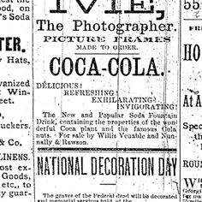
Magazines: Coca-Cola also uses magazines on a worldwide level in order to publicize. Based on the target customer segment of the company, most magazines are picked by their credibility. In order to expand the positive effect of the promoting activities, Coca-Cola generally involves a whole page advert in magazines (Pragya, 2018).

Broadcast advertising:
Radio: Turned into a mainstream method to communicate and publicize to audience members and watchers by using of enormous business publicizing open diversion and data, and broad communications.
The Coca-Cola organization relationship with radio as a mechanism of promoting its brands either as a backer of mainstream appears of broadcast appointment go as far back as the 1930s and 1940s.The organization has been utilizing the radio as the vehicle of arriving at its shoppers for more than 80 years. With the revelation in 2010 of the over, $2.9 billion publicizing consumption and a portion of the cash put resources into radio promoting show that the organization must get a decent profit for its interest and gain advantages through the radio medium. A portion of these advantages incorporate the capacity to target explicit customers, reasonable in contrast with other customary communicate media, and the recurrence can be manufactured rapidly (Fetisova, 2015).

Television: In 1950, was the first supported a TV show for the Coca Cola company in the US, our promoting has shown up on TV screens far and wide in various, frequently noteworthy, structures.
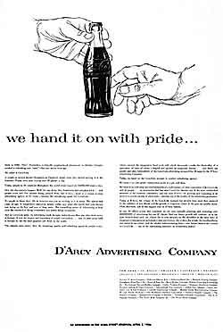

Promoting through TV was a trial medium, as publicists were attempting to create approaches to arrive at shoppers viably. The Coca Cola Company drew closer supported projects as it built up connections and associations.
All through the 60s, Coca Cola promoting mirrored the changing powers in the society. The 1970s were a period of political vulnerability for the United States and the country scrutinized the direction it was going. To cure this, Coca Cola publicized Americans to remain positive and spotlight on the nation's qualities in the "Look Into, America" battle. The business was a major achievement (Marymount, 2019).

Cinema:
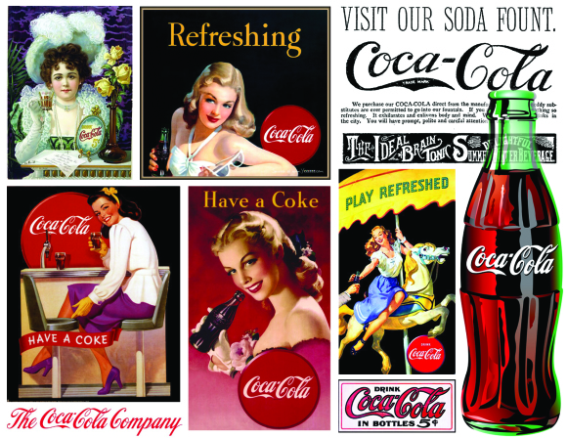
Coca-Cola is additionally publicized in playing Coca-Cola video promotions in films for chosen motion pictures before the film begins (Dudovskiy, 2015).

Outdoor advertising:

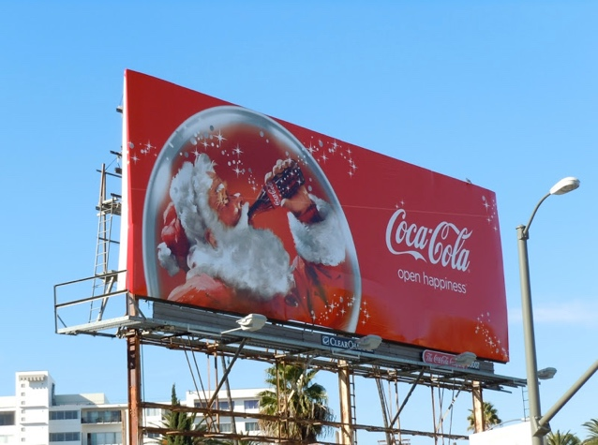 Another advertising tool that Coca-Cola use is billboards and posters as a basic piece of media advancement. Posters are regularly shown in shops and eateries or at the open vehicles. While at the downtown areas and expressways where billboards are normally positioned just as certain pieces of the country zones.
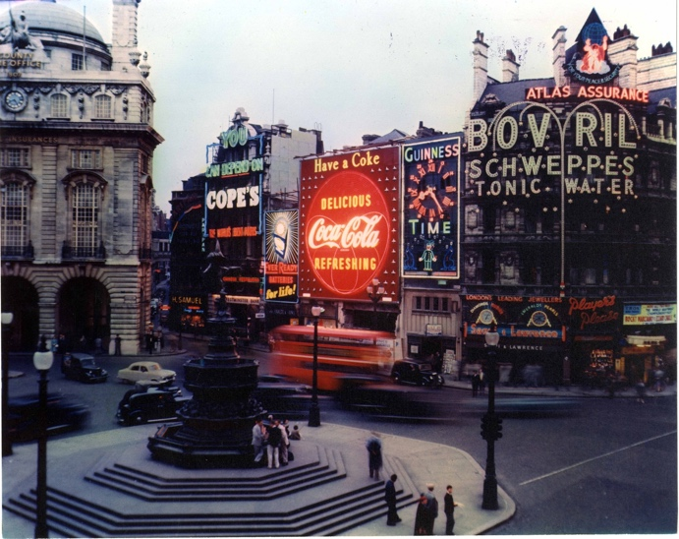 One of the most well-known outdoor adverts for Coca-Cola is the Piccadilly Circus sign wherein has played a host famous for the organisation since 1955 (Cocacola, 2019).

The difference between advertising and sales promotion:

Publicizing and deals advancements are two of the key segments of a business, advertising advancements are done to construct a brand picture, and the outcomes become evident after some time whilst sales promotion focus more about deals and sales of a service or a product. During seasonal periods, plenty of organisations try to push these promotions as the consumer need and demand is higher than usual (Sampson, 2019).

The sales promotion of Coca-Cola company is divided into two classifications.
Foodservice centres around Coke with food matching, to streamline the job of the menu and the attributes of strength refreshments. For instance, all of McDonald's suppers should coordinate Coca-Cola soda pop.
Retail is to get collaboration between the organizations, it incorporates retail location (POS) methods and direct store conveyance. For the point of sale, Coca-Cola has the most well-known structure is a cooler with a brand logo for in-store deals and universal candy machines with an average brand logo and topic (Deakinbusiness,2016).

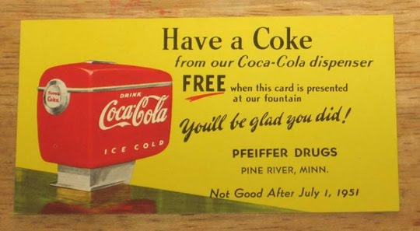 Another fact, where Coca-Cola attempts to attract new clients and motivate its existing customers is by affording tickets to events in the bottle packaging when buying a coke giving them the chance to try and win (Deutch4macys, 2011).

Push and Pull strategy:
The push strategy is where a company invents, creates and proposes an item that is bound to find purchaser, so it is considered as a development process which exudes from the company itself towards the market whilst the pull strategy is where the supply request demand gracefully and pull it out to the organisation. As a result, the pull strategy is the opposite of the push strategy as it alludes the process to start from the market towards the firm (Margherita, 2008).

Coca-Cola operates at two unique yet profoundly connected levels. It utilizes a pull technique by dealing with end customers through promoting, sponsorship, authorizing, truly pulling them into deals outlets and setting them up intellectually to search for and purchase the item. Thus, it utilizes a push technique by utilizing the exchange of combining a major vital union, as a result, items are available in outlets and through alluring merchandising to push sales.
Coca-Cola persuades retailers using sales promotion and personal selling to have a sufficient amount of stock.
Moreover, Coca-Cola works on increasing visibility of its products, by giving unique limits to retailers and furnish them with items at discount rates on the off chance that they stock their item on exceptional racks to draw in client consideration. Both of these strategies are being utilized by the Coca-Cola organization to make their essence felt wherever in the market. They are promoting their item through the retailers which will, thus, influence the purchasing conduct of shoppers.
Another aspect that Coca-Cola has is having contracts with well-known cheap good chains such as Burger King and McDonald. This permits the brand to be available and open to the client with no opposition present. Coca-Cola has consistently trusted in a powerful marketing system and utilises both the pull and push advancement strategies in a compelling way (Fabio, 2001).

Public Relation:

Is a vital communication process that oversees, ensure, and improve the notoriety of an association, its individuals, and its administrations (Kamalludin, 2014).
In 1892, Coca-Cola financial plan committed to publicizing was $11,000 increased to acquire in 2010 more than $2.9 billion in promoting costs. The figures on print, radio, TV and different notices were uncovered in a yearly documenting with the U.S. Protections and Exchange Commission (AJC, 2011).
Year by year, the public relations of Coca-Cola rise. Fruitful promoting and advertising are capable first motivation to win Coca-Cola. Coca-Cola PR includes four activities:

Culture. Coca-Cola Company has many sponsorships with world art exhibitions, for instance, it supported position structure at the Brussels World Exhibition in 1958.
Humanitarian. One of the principal priorities of Coca-Cola is the improvement labourers. The organisation spends a huge amount of its budget on staff training and development. Coca-Cola advances dynamic ways of life among its representatives. The organization routinely sorts out games for workers, for example, title indoor soccer. Additionally, the organization considers the assessment of laborers in settling on vital choices (Radchuk, 2016).
Environmental. Coca-Cola plans to make plastic bottles with 30% comprise of plant material.
By 2030, Coca-Cola has promised to use at any rate half reused material in its bundling. It is additionally banding together with NGOs around the globe to help improve assortment (Thomas, 2020).
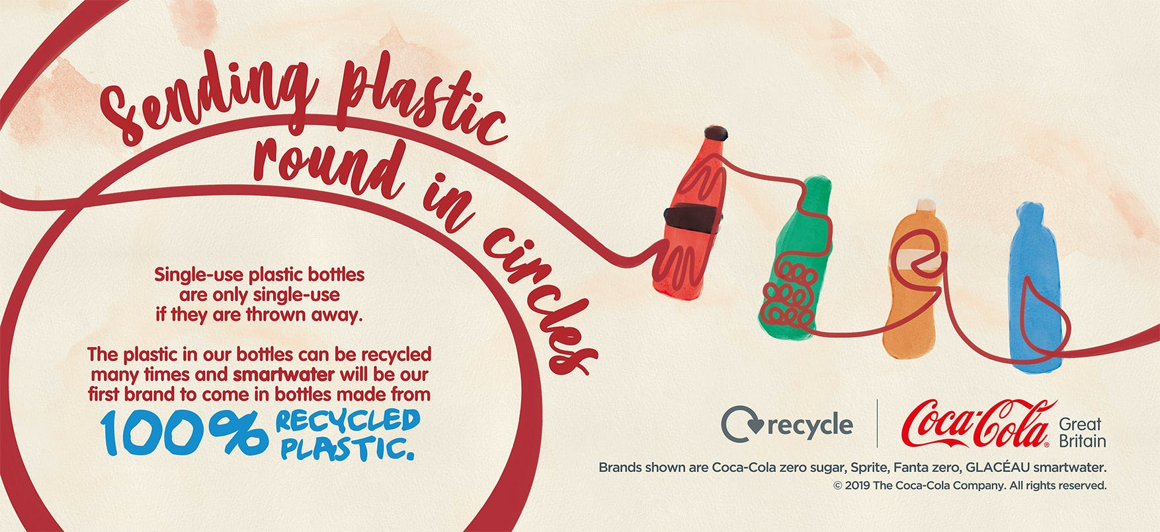

Coca-Cola is propelling an advertising campaign that expects to remind individuals its bottles are recyclable and urge them to reuse to improve the maintainability of its packaging (Vizard, 2019).
Social. Coca-Cola works more than 200 nations. The organization effectively helps out the UN. Along with the United Nations Program on HIV, AIDS.
In the Middle East, Coca-Cola gave back 1.3% of their working pay in 2014, to women's empowerment, water stewardship programs, education and so on (ColaJourney, 2014).

Publicity:

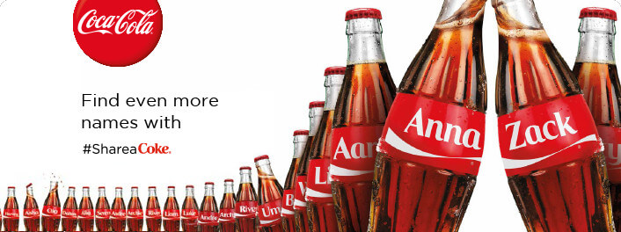
A significant component of PR is publicity. It suggests correspondence about an item or association by the putting of news about it in the media without paying for existence straightforwardly. Publicity is the methods for passing on data to the overall population through the media. The data being exposed could be news, awareness of an item or service. The target audience is one significant factor to consider publicity (Dberiri, 2018).
To expand deals, the campaign of Share a Coke was conceived by Laura Thompson when the firm decided to maintain closer to teenagers that by replacing Coca-Cola with 250well-known high schooler names.
Two components have made this campaign different. The packaging turned into an unfathomably significant bit of possessed media. And the hashtag #ShareaCoke made a profundity and broadness of substance and ways for adolescents to get included using social media o intensify their ideas.
The outcome was that 1.25 million additional adolescents attempted a Coke during the accompanying summer and deals of taking an interest Coca-Cola bundles rose by a marvellous 11% in the US. 'Share a Coke' in the US was more fruitful in driving deals than in any past market that had run the crusade (Luis, 2015).

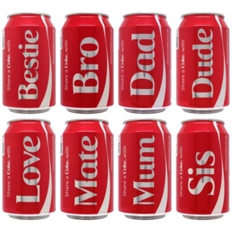 The firm additionally added capacity in the aim of including nonexclusive names like Mom, Dad and Mate. the idea behind this is the estimation of sharing with someone else either family or friends (Richard et al, 2015).
The campaign in different countries:
- IRELAND
The Cola company made a completely marked Tram in Dublin. All the seats had red covers on them, each spread is weaved with a famous name, carrying an individual touch to the suburbanite's excursions
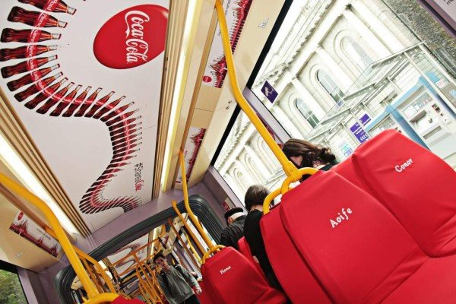
- THE UK
Coca-Cola is at present running a retail battle where more than 1,000 of the most famous British names are shown on containers of Coke, with the name supplanting the Coke name.
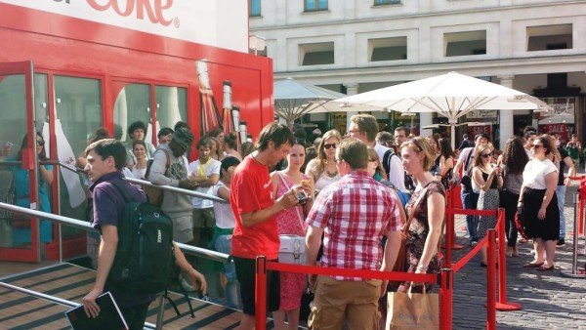
- THE USA
Coca-Cola fabricated a huge 3D Coke bottles on Chicago transport covers. Touchscreens permitted people on foot to enter their name, which at that point was shown on the giant bottle. Their name was shown for a brief timeframe permitting individuals to take pictures on themselves with their own one of a kind customized monster Coke bottle (JCDeceaux, 2014).
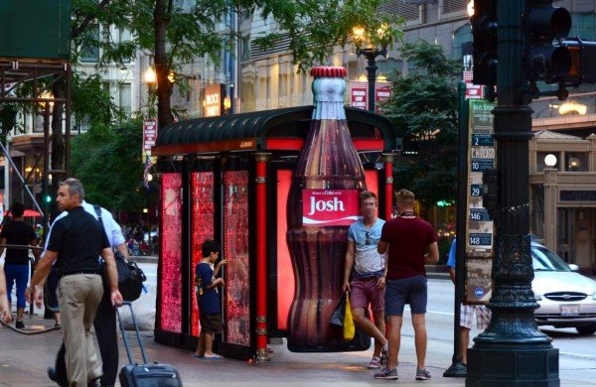

Sponsorship:

Many organisations worldwide use sponsorship which is a marketing tool in the aim of reaching a wide audience globally. Moreover, the objective behind it is to create awareness, gain more profit, and get placed higher than rivalry (Oladunni, 2011).

Coca-Cola company have plenty of sponsorship such as American Idol, NASCAR which has been the official shimmering drink since 1988.
Olympic Games: The Coca-Cola Company is pleased to be the longest nonstop corporate accomplice of the Olympic Games (ColaCompany, 2020).

One of the most significant sponsorships of Coca-Cola is the soccer World Cup Berlin was held in 2010 wherein Coca-Cola gives drinks each game's setting and offers an assortment of authorized items. Furthermore, Coca-Cola interfaces the sponsorship with CSR activities in the aim of improving the existing conditions of individuals in need. This helps Coca-Cola become a brand that is esteemed by individuals (Sebastian et al, 2014).

Direct Marketing:
Direct advertising is significant in making great relations with customers for the introduction of new items or administrations, and meanwhile to accomplish sales. Direct advertising utilizes various methods, for example, messages, phones, fairs, celebrations and different procedures to legitimately communication with customers by being entirely adaptable, and it additionally permits quick feedback (Halit et al, 2016).

The Coca Cola Company utilizes direct advertising in some cinemas and restaurants to only sell their items, dispense with direct rivalry. Besides, portable showcasing is another way direct marketing, Coca-Cola company exposure customized special activities by convey an instant message and depend on informal correspondence from clients. Furthermore, Coca-Cola uses direct marketing in promoting marriage (Wilkin, 2009).
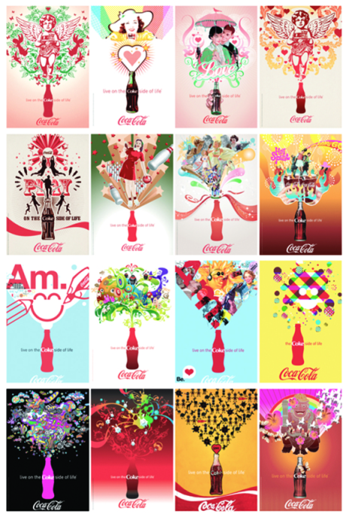

Digital Marketing:
Digital marketing is characterized as a projection of traditional advertising, its instruments and systems, on the Internet (Carolina, 2016).

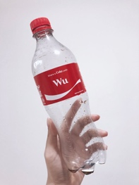The fundamental thought behind the 'share a coke' publicizing effort was to have a mental effect inside the psyche of the customers by furnishing them with an opportunity to turn into a piece of the coke brand bottle. Coca Cola organization realized that on the off chance that the individuals see a bottle having their name, at that point this would put a mental fascination inside their brain and they would in a flash respond to it by taking a selfie with that container and sharing the picture on a person to person communication locales which make Coca-Cola gain 160,000 fans (YouGov, 2013).

Coca-Cola has accomplished noticeable success not only in social media in term of digital marketing but also the different polar bear campaign in 2012 (Enconsultancy, 2018).

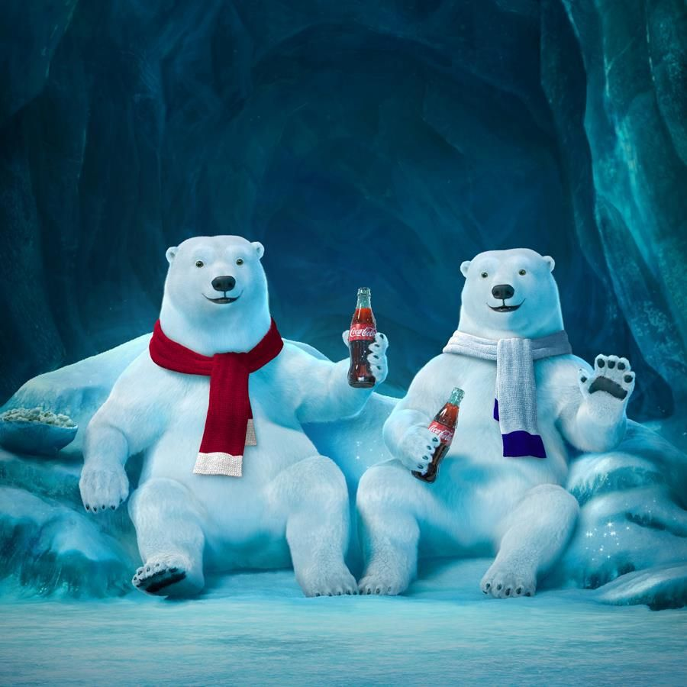

Integrated marketing communication:

An idea of showcasing interchanges arranging that perceives the additional incentive in a program that incorporates an assortment of vital orders such as general publicizing, direct reaction, deals advancement and advertising, also consolidates these controls to give clearness, consistency, and greatest effect (Jerry, 2009).

In the turn of events and execution of an integrated marketing communication plan, Coca-Cola has made an extraordinary job by using a mix of topics and ideas and also through a mix of promoting campaigns and electronic media, Coca-Cola has reached an extensive target audience, build awareness and brand image and drive deals. One the most successful campaign was Share a Coke, toward implementing an lMC strategy (Toni, 2014).

The approach that Coca-Cola took was creative in the aim of build brand image through compelling incorporation of social media and publicizing and to impact the customer experience.
Through this, Coca Cola accomplished a brought together method of advancing interaction, brand awareness and brand satisfaction.
Going past the named bottles, Coca-Cola created intuitive sites and announcements to help the battle by structuring a trip agency stand to carry the brand nearer to the individuals and urged them to get an exceptional and customized name on the coke items.
The Coca-Cola company was using every aspect of the communication channel to convey an intelligible, clear, predictable, durable and serious message about the firm's image and brand identity making it a fruitful way to deal with IMC (Kehinde, 2011).

Brand Equity:
The set of affiliations and conduct concerning to a brand's clients, station individuals and parent partnership that allows the brand to win more prominent volume or more noteworthy edges than it could without the brand name (Shariq, 2018).

Keller’s Model:

- Definition:
The CBBE model was created by Kevin Lane Keller in 1993, a Professor of Marketing, in his book Strategic Brand Management. Through this model, Keller hoped to outline the excursion of clients' associations with brands from acknowledgement at the base, through to resounding with the brand at the peak (Papirfly, 2019).

- Co-cola Keller’s model:
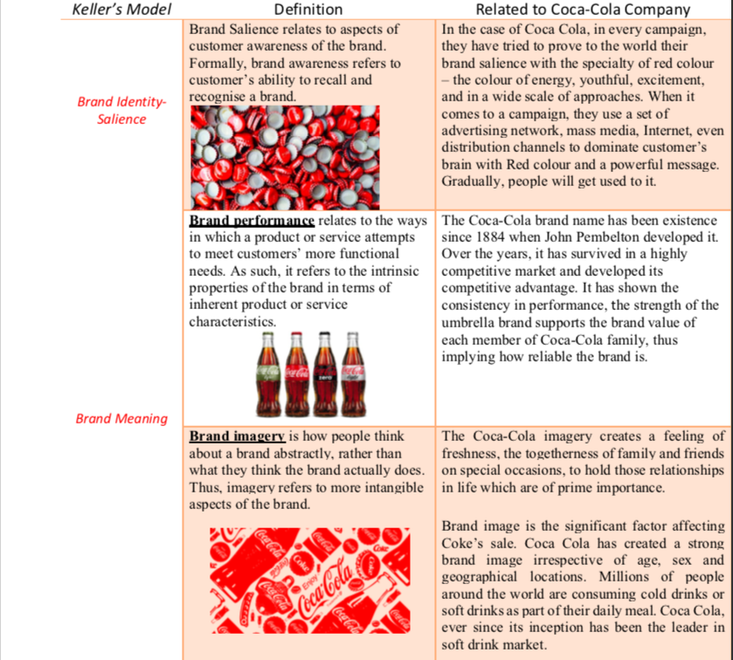

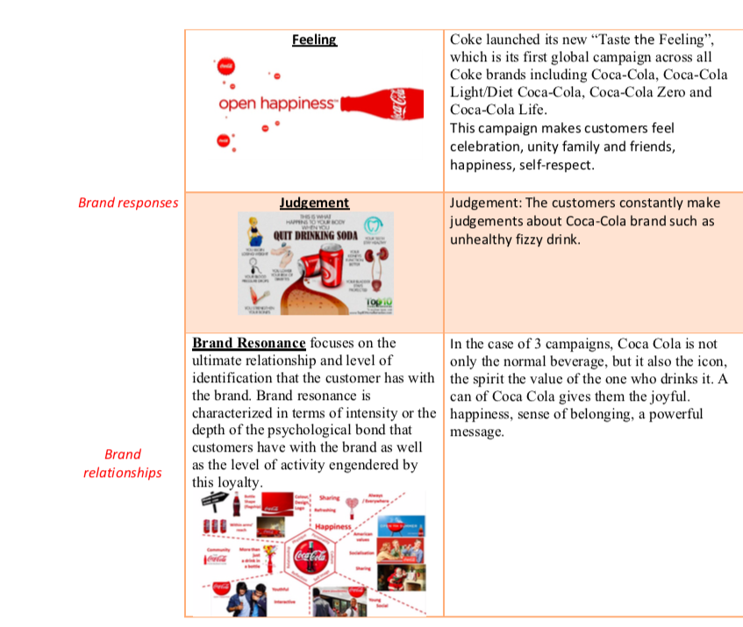

Conclusion:

Powerful IMC plans are expected to give applicable, predictable and correlative messages to clients. The goal of IMC is to give information, create awareness, and make great impressions to accomplish a favoured situation in the client's brains, also to move prospects through the buying channel, to bring sale closer. It's considered as one critical measurement in term of targeting where potential clients are in the buying procedure (Mark, 2018).

Customer Journey:
- Definition:

The customer journey is the key to urging buyers to become clients, and afterwards convincing them to become faithful recurrent buyers (MarketingWeek, 2019).
The customer journey is the key to urging buyers to become clients, and afterwards convincing them to become faithful recurrent buyers.
- Coca-Cola customer journey:

Awareness: The brand that has the most noteworthy brand awareness is Coca-Cola at about 7.1 billion individuals would perceive the Coca-Cola logo.

Orientation: Coca Cola Company stresses on the requirements of shoppers, accomplices, and different clients. Moreover, the organization keeps up over the top interest, showcase astuteness, and have a world perspective on purchaser needs, and how to meet them. In this manner, by understanding the whole flexibly chain of buyers, Coca Cola Company grasps purchaser direction part of market direction (Marketline, 2015).

Consideration: Despite the rise of wellbeing concerns, Coca-Cola burned through expanding its bubbly beverage offering towards more advantageous items, for example, a sans sugar adaptation in 2019, also, the company contribute other products determined low-calorie sugar such as Fanta, Sprite and no artificial refreshment drink such as Glaceau water (Stephan, 2020).
Purchase
- Mental Influence
Before purchasing Coca-Cola, the customer collects the data needed (Lacobucci, 2014).
- Sociological Influence
One significant effect is social-cultural wherein Coca-Cola provides its customers with different categories such as juice, water, low-calorie, low-sodium (Susan&Gruffin, 2014).
Retention:
- Utilizing music:
Coca Cola discharged their advertisement that includes the tune "I'd prefer to show the world to sing" by New Seekers in 1971, which showed up initially after 44 years, on the TV arrangement Mad Men and re-disseminated as a famous bit of American culture for the people to come.
- Use Engagement techniques:
The "Offer a Coke" battle comprised of putting names on Coke leads to improve client commitment and based on client maintenance through personalisation (Virginie, 2016).

Advocacy: Coca-Cola Happiness Machine campaign in 2010 has been successful in creating brand advocacy for the company wherein over than 15 million individuals saw this brand backing effort inside the primary seven day stretch of its discharge (Sela, 2019).

- Coca-Cola Customer journey map:
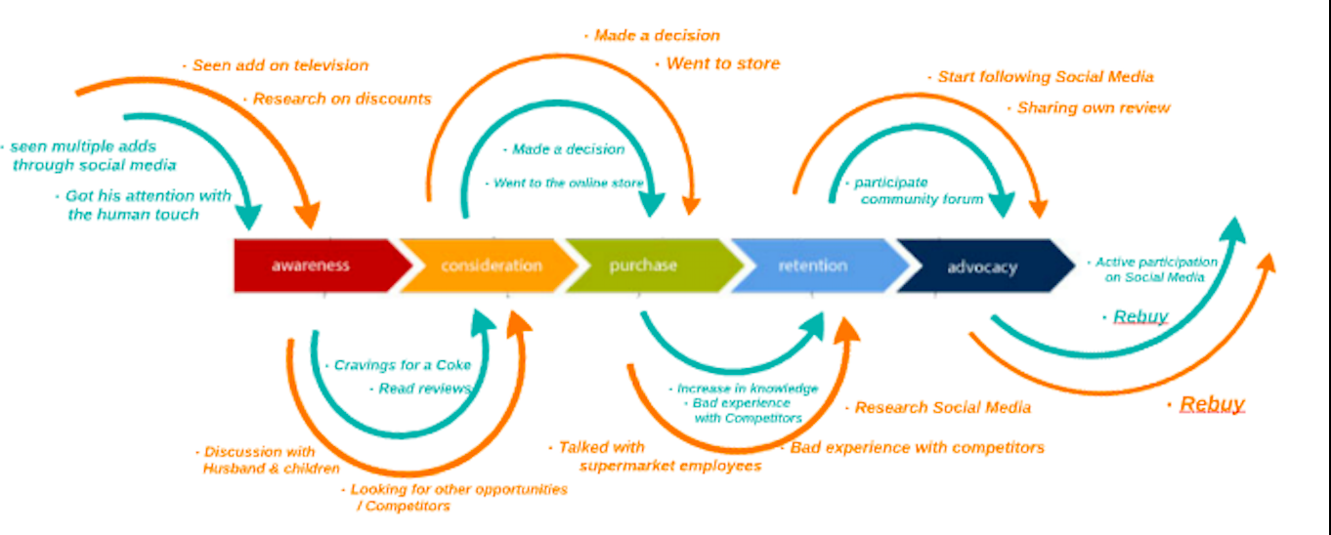

Customer touchpoint:
A touchpoint is any communication counting experiences where there is no physical association, that may adjust the way that the organisation client feels about the item, image, business or administration (DesignFoundation, 2020).

Touchpoint before purchase:
The absolute first publicizing execution system that Coca Cola utilized in their battle was esteem creation through web-based life.

Coca Cola has chosen all media sources like TV, social media, print media, radio channels, announcements, and web. life. Nevertheless, the primary media in share a coke were long range interpersonal communication destinations and the web. Coca Cola realizes that the most famous and trending media is social networking sites as everyone have a smartphone.

Subsequently, Coca Cola attempted to profit by this nature of the basic individual by creating a hashtag to the campaign that improvised the purchasers to share a selfie with the jug having the individual's name on long-range informal communication sites (Glenn, 2014).

Touchpoint during purchase:
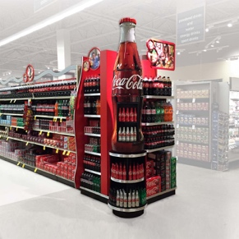Coca-Cola uses POS displays which are fundamental advertising tools for a successful organisation. Point of sales shows attracts the consideration of clients in a wide range of retail conditions.

Touchpoint after purchase:
Coca-Cola utilizes client relationship the executives to handles client support bolster where you can legitimately converse with the individual in the organization for an issue with the item. They have an alternate kind of administration all around the globe. Coca-Cola gives the client the right of feedback, email and phone and also through observing and numerous kinds of examination. By this collective CRM, Coca Cola has given proficient client support to pick up consumer loyalty, for instance, Coca-Cola’s Facebook fan page (ColaCompany, 2020).

Conclusion:

Understanding purchasers' conduct is critical to having a fruitful organization, advertisers need to extend their examination on their shoppers as customers are getting aware of the significant job they play in their consumption design. Organizations should search for approaches to hold their current clients particularly from contenders that are searching for strategies to impact new purchasers, and furthermore focus around pulling in new clients ought to be a need in a recession.
The use of CRM causes Coca Cola to accomplish their objective without losing their market.
Coca-Cola had the option to give offers and began some challenge online to play and win energizing prizes. One of the most renowned campaigns was the free-form vending machine where a client can make his beverage from one hundred blends where the association had the option to do online advancement in one of the top social networking sites and picking up the biggest number of fans. This makes Coca-Cola ready to gather information from a candy machine, portable, customer administration, online system by giving arrangement customized administration to the client.
Coca Cola can win back their client with the new free-form distributing. With the advance of using marketing communication and customer journey, Coca-Cola can deal with its top situation in a refreshment.

References:

Joep P. Cornelissen (2008) Corporate communication. [Online] Available at: https://onlinelibrary.wiley.com/doi/abs/10.1002/9781405186407.wbiecc143 [Accessed 15th April 2020].
Fred C. Lunenburg (2010) ‘Communication: The process, barriers, and improving effectiveness’ Schooling, 1 (1), pp.1-11. [Online] Available at: http://www.nationalforum.com/Electronic%20Journal%20Volumes/Lunenburg,%20Fred%20C,%20Communication%20Schooling%20V1%20N1%202010.pdf [Accessed 15th April 2020].
Sabah Al- Fedaghi (2012) ‘A conceptual foundation for the Shannon-Weaver model of communication’ International journal of soft computing, 7 (1), pp.12-19. [Online] Available at: http://docsdrive.com/pdfs/medwelljournals/ijscomp/2012/12-19.pdf [Accessed 15th April 2020].
Radovan Bacik & Richar Fedorko (2012) ‘Advertising as a tool of marketing communication and its consequent impact on consumers’ Polish journal of management studies, 5 (1), pp.315-319. [Online] Available at https://www.researchgate.net/publication/254440959_Advertising_as_a_tool_of_marketing_communication_and_its_consequent_impact_on_consumers [Accessed 20th April 2020].
Springer (2007) Introduction to advertising. [Online] Available at: https://shodhganga.inflibnet.ac.in/bitstream/10603/75863/6/06_chapter%201.pdf [Accessed 20th April 2020].
Petra (2012) Major shifts in shaping Coca-Cola print advertisement. [Online] Available at: https://is.muni.cz/th/izsme/Plny_text_prace.pdf [Accessed 22th April 2020].
Coca-Cola GB (2019) Coca-Cola TV adverts from our archives. [Online] Available at https://www.coca-cola.co.uk/marketing/campaigns/iconic/coca-cola-tv-adverts-from-our-archives [Accessed 22th April 2020].
Pragya Prafull (2018) Coca-Cola’s marketing communication strategy: A critical analysis [Online] Available at: https://www.linkedin.com/pulse/coca-colas-marketing-communication-strategy-critical-analysis-pragya [Accessed 22th April 2020].
Tatiana Fetisova (2015) Understanding Coca-Cola advertising campaigns: a strategic analysis of the “share a coke” campaign.
Marymount Commons (2019) Advertising Coca-Cola, 50 years of Coke. [Online] Available at: https://commons.marymount.edu/loclee/television-advertising/ [Accessed 24th April 2020].
John Dudovskiy (2019) Coca-Cola marketing communication: A critical analysis. [Online] Available at: https://research-methodology.net/coca-cola-marketing-communications-a-critical-analysis/ [Accessed 24th April 2020].
Sampson Quain (2019) Difference between advertising and sales promotions. [Online] Available at: https://smallbusiness.chron.com/difference-between-advertising-sales-promotions-3377.html [Accessed 24th April 2020].
Deakin Business (2016) Coca-Cola integrated marketing communication. [Online] Available at: https://mpk732t12016clusterb.wordpress.com/2016/05/05/coca-cola-integrated-marketing-communications/ [Accessed 24th April 2020].
Deutch4macys (2011) Chapter 18 – Sales promotion and personal selling. [Online] Available at: http://deutch4macys.blogspot.com/2011/03/chapter-18-sales-promotion-and-personal.html [Accessed 25th April 2020].
Margherita Corniani (2008) ‘Push and Pull policy in market-driven management’ Symphonia emerging issues in management, 1 (1), pp.1-20. [Online] Available at: https://www.researchgate.net/publication/227600123_Push_and_Pull_Policy_in_Market-Driven_Management [Accessed 25th April 2020].
Fabio Albanese (2001) Merchandising and Licensing to improve brand equity. The Coca-Cola Case. [Online] Available at: https://www.researchgate.net/publication/227600123_Push_and_Pull_Policy_in_Market-Driven_Management [Accessed 26th April 2020].
Kamalludin Kamal (2014) PR through print media. [Online] Available at: https://www.researchgate.net/publication/262565627_Public_Relations_Through_Print_Media [Accessed 26th April 2020].
AJC (2011) Coca-Cola spent more than $2.9 billion on advertising in 2010. [Online] Available at: https://www.ajc.com/business/coca-cola-spent-more-than-billion-advertising-2010/v13cDKOysmgHpACx2K8TwI/ [Accessed 26th April 2020].
Radchuk T. (2006) PR activities of Coca-Cola company. [Online] Available at: http://dspace.nuft.edu.ua/jspui/bitstream/123456789/23093/1/201.pdf [Accessed 26th April 2020].
Daniel Thomas (2020) Davos 2020: People still want plastic bottles, says Coca-Cola. [Online] Available at: https://www.bbc.co.uk/news/business-51197463 [Accessed 27th April 2020].
Sarah Vizard (2019) Coca-Cola uses new campaign to encourage more people to recycle. [Online] Available at: https://www.marketingweek.com/coca-cola-sustainability-marketing-campaign/ [Accessed 27th April 2020].
Coca-Cola Journey (2014) Corporate social responsibility: it’s in our DNA. [Online] Available at: https://en.coca-colaarabia.com/our-company/corporate-social-responsibility-it-s-in-our-dna [Accessed 27th April 2020].
Dberiri Destiny Apuke (2018) ‘Understanding the concept of publicity in public relations: A synoptic review’ Arabian journal of business and management review, 7 (2), pp.32-34. [Online] Available at: https://www.researchgate.net/publication/324835716_Understanding_the_Concept_of_Publicity_in_Public_Relations_A_Synoptic_Review [Accessed 28th April 2020].
Luis Mendoza (2015) Persuading teens to ‘Share a Coke’. [Online] Available at: https://www.mrs.org.uk/pdf/US_COCA_COLA_-_FINAL_TWO.pdf [Accessed 28th April 2020].
Richard D. Pace (2015) The difference in PR strategies: Coke vs Pepsi. [Online] Available at: https://everything-pr.com/beverage-pr-marketing-coke-pepsi/ [Accessed 28th April 2020].
JCDeceaux (2014) Campaign showcase Coca-Cola’s share a Coke. [Online] Available at: https://www.jcdecaux.com/blog/campaign-showcase-coca-colas-share-coke [Accessed 28th April 2020].
Oladunni Roselyn Abiodum (2011) The significance of sponsorship as a marketing tool in sport events. [Online] Available at: https://core.ac.uk/download/pdf/38024379.pdf [Accessed 29th April 2020].
Coca-Cola Company (2020) Coca-Cola sponsorship. [Online] Available at: https://www.coca-colacompany.com/news/coca-cola-sponsorships [Accessed 29th April 2020].
Sebastian Uhrich & Jeorg Kenigstofer (2014) ‘Leveraging sponsorship with corporate social responsibility’ Journal of business research, 67 (9), pp.2023-2029. [Online] Available at: https://www.sciencedirect.com/science/article/pii/S0148296313003548 [Accessed 29th April 2020].
Halit Karaxha Tolaj (2016) ‘The role of direct marketing in relation with consumers in Kosovo’ ILIRIA International review, 6 (1), pp.2-8. [Online] Available at: https://www.researchgate.net/publication/305744468_The_Role_of_Direct_Marketing_in_Relation_with_the_Consumers_in_Kosovo [Accessed 30 April 2020].
Wilkin (2009) Coca-Cola’s original Coke: Marketing communication mix. [Online] Available at: http://cocacolasoriginalcoke.blogspot.com/2009/04/marketing-communication-mix.html [Accessed 30 April 2020].
Carolina Machado Theory and application of business and management principle. Switzerland: Springer international publishing, 2016. [e-book] Available at: https://www.researchgate.net/publication/312190728_Understanding_Digital_Marketing-Basics_and_Actions [Accessed 1st May 2020].
YouGov (2013) The 2013 share a Coke campaign. [Online] Available at: http://cdn.yougov.com/cumulus_uploads/document/u7gltkr717/Share-a-coke-report.pdf [Accessed 1st Mat 2020].
Enconsultancy (2018) 10 Inspiring digital marketing campaigns from Coca-Cola. [Online] Available at: https://econsultancy.com/digital-marketing-campaigns-coca-cola/ [Accessed 1st May 2020].
Jerry Khiatchko (2009) IMC 20 years after: A second look at IMC definition. [Online] Available at: https://www.researchgate.net/publication/288596229_IMC_20_years_after_A_second_look_at_IMC_definitions [Accessed 2nd May 2020].
Toni McQuilken (2014) ‘Share a Coke’ campaign grows sales for first time in 10 years, WSJ reports. [Online] Available at: https://www.adweek.com/brand-marketing/coca-colas-share-coke-campaign-grows-sales-first-time-10-years-160433/ [Accessed 2nd May 2020].
Kehinde Oladele Joseph (2011) ‘Integrated marketing communication: A catalyst the growth of e-business management’ Medwell journals, 6 (2), pp.64-73. [Online] Available at: http://eprints.covenantuniversity.edu.ng/6583/1/64-73.pdf [Accessed 2nd May 2020].
Mohammed Shariq (2018) ‘Brand equity dimensions – A literature review’ International research journal of management and commerce, 5 (3), pp.312-330. [Online] Available at: https://www.researchgate.net/publication/326302689_BRAND_EQUITY_DIMENSIONS-A_LITERATURE_REVIEW [Accessed 4th May 2020].
Papirfly (2019) Customer brand equity and understanding Keller’s brand equity model. [Online] Available at: https://www.papirfly.com/knowledge-hub/retail-marketing/customer-brand-equity [Accessed 4th May 2020].
Mark Anthony Camilleri (2018) Integrated marketing communication. [Online] Available at: https://www.researchgate.net/publication/319085740_Integrated_Marketing_Communications [Accessed 5th May 2020].
MarketingWeek (2019) How understanding customer journey helps brand drive more sales. [Online] Available at: https://www.marketingweek.com/https-www-marketingweek-com-customer-journey-mapping/ [Accessed 6th May 2020].
MarketLine (2015) Coca-Cola enterprises, Inc. [Online] Available at: https://www.marketline.com/wp-content/uploads/SWOT_Profile_Sample.pdf [Accessed 6th May 2020].
Stephan Shakespeare (2020) Coca-Cola puts health and environment first to satisfy consumers. [Online] Available at: https://yougov.co.uk/topics/consumer/articles-reports/2020/02/05/coca-cola-puts-health-and-environment-first-satisf [Accessed 6th May 2020].
Lacobucci D. (2014) Marketing management (MM), in customer satisfaction and relationships. 4th Ed. London: Cenage learning.
Susan M. Broniarczyk & Jill G. Griffin (2014) ‘Decision difficulty in the age if consumer empowerment’ Journal of consumer psychology, 24 (4), pp.608-625. [Online] Available at: https://www.sciencedirect.com/science/article/abs/pii/S1057740814000370 [Accessed 6th May 2020].
Virginie Chelles (2016) How Coke improved customer retention & engagement with music. [Online] Available at: https://blog.tunedglobal.com/coke-customer-retention-engagement-music#comments-listing [Accessed 8th May 2020].
Ron Sela (2019) 7 Brand Advocacy campaigns that rocked social media. [Online] Available at: https://www.ronsela.com/brand-advocacy-campaigns/ [Accessed 8th May 2020].
International Design Foundation (2020) Customer touchpoints – The point of interaction between brands, businesses, products and customers. [Online] Available at: https://www.interaction-design.org/literature/article/customer-touchpoints-the-point-of-interaction-between-brands-businesses-products-and-customers [Accessed 8th May 2020].
Glenn Taylor (2014) Coca-Cola drives campaign awareness with testator virtual assistant. [Online] Available at: https://retailtouchpoints.com/features/news-briefs/coca-cola-drives-campaign-awareness-with-tensator-virtual-assistant [Accessed 10th May 2020].
Coca-Cola Company (2020) Communities. [Online] Available at: https://www.coca-colacompany.com/shared-future/communities [Accessed 11th May 2020].

