Sustainable Hospitality & Tourism Management

More and more hotel & hospitality providers are becoming aware of green issues and are acting more responsibly in their business. Some of the benefits of making hotels more eco-friendly include conservation of resources, reduced pollution, and improved operational efficiency. As a result, hotels are increasingly working towards achieving an eco-certified label such as the Green Key certificate.

Student’s Name: Stefano Di Guida
Student’s ID: 2207147
The Module title: BMIH5006 Sustainable Hospitality & Tourism Management
Lecturer’s Name: Ruth Taylor Davies

Table of Contents
1. Introduction 3
2. Needful implementation for hotels to comply sustainable accreditation 3
3. Benefits and challenges associated with integrating sustainability into the daily operations of the hotels 5
4. Future of the Hospitality industry and the hotels 7
5. Further recommendations for improvements 9
6. Conclusion 12
References 13

1. Introduction
This project is based on the attainment of sustainable practices in the hotel industry suggesting the use of different models and an effective understanding of the challenges and the benefits associated with sustainability. This further considers the use of models and projects as related data that can help understand the in-depth integration of the project. With the proper consideration of the topic, understanding the hospitality industry can be effective and potentially informing to apply the knowledge in real-life instances.

2. Needful implementation for hotels to comply with sustainable accreditation
This section outlines the key strategies to attain sustainable certification as well as reconciliation that relates to the principles of sustainability. According to the United Nations (2024), sustainability can be defined as the ability to have sustainable access/usage of resources in the present without depleting or overtly straining the ability of generations to come to access and use the same resources. It encompasses three core principles: concerns like environmental conservation, fairness in sharing resources, and the financial feasibility of the project (Edwin, 2023).
Principles of Sustainability:
Environmental Protection: Sustainability involves the efficient use of natural resources, the prevention of utilization of resources in an unsustainable manner and the protection of species in the ecosystem (Edwin, 2023).
Social Equity: Such as protecting members of the local communities from unfair treatment, discrimination, and prejudice, and denying the equal rights to resources and prospects.
Economic Viability: Stanikzai and Keliwaal (2023) stated that fostering economic growth for all players, profit making forever and with sustainability fully taken into consideration.
Tourism Impacts:
Tourism can have a serious effect on the economy, growth of the community, and the ecology of the ecosystem. According to the data gained from WTTC (2022), in 2022 the global tourism sector contributed 10.4% of the global GDP and generated 334 million jobs, as per the World Travel and Tourism Council (WTTC) report of 2023. It also facilitated the provision of 8% of the world’s greenhouse gas emissions (WTTC, 2022).
Sustainability in Hotels:
Sustainable practices when effectively applied can provide numerous potentials to help in the effective development of the organisational operations and the eminent way to encourage the customers to buy and enjoy the services of the organisation (Alvarado, 2024).
Energy Efficiency: Hotels should ensure that they minimise the use of energy by up to 20% through effective lighting, heating, and cooling syQPml systems put in place (Wu et al., 2022). The use of electricity derived from non-renewable sources should be limited and besides, the laying of other renewable for instance solar systems can still reduce carbon footprints.
Water Conservation: Lifestyle changes that involve water saving such as the use of low showers and toilets can decrease water usage by up to 30% (Watson, 2020). Using grey water to irrigate the gardens would also be an added advantage since water conservation would be enhanced.
Waste Management: According to Huang et al. (2022), promoting extensive recycling programs and avoiding overreliance on plastics that have short life spans can greatly reduce the quantity of garbage that is dumped in a landfill. Some of the measures that can be taken to ensure that hotels attain the encouraged waste reduction: Hotels in the past-generated waste up to 50% more that the present and thus, changing this is necessary (Huang et al., 2022).

3. Benefits and challenges associated with integrating sustainability into the daily operations of the hotels
Implementation of sustainability into consistent operations of hotels presents varied benefits and challenges, which have been signified in further analysis.
Benefits:
Cost Savings:
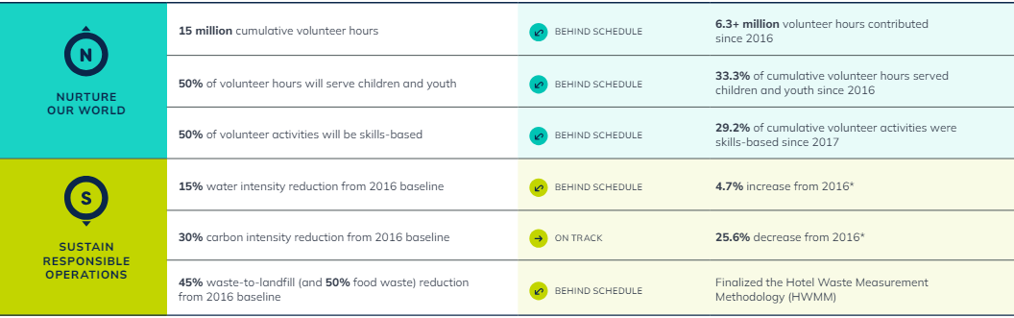
Figure 1: Marriott’s water consumption reduction progress
(Source: Marriott International, 2022)
The application of efficient technologies however has the potential to greatly reduce costs. For instance, the InterContinental Hotels Group (IHG) has for instance able to achieve $67 million annually through their Green Engage program of efficient sources of light and heating and ventilating systems (Better Buildings, 2023). Further, Marriott International has lowered the water consumption of its properties by 15% between 2015 and 2020 through the use of reduced-flow showers and taps and linen reuse programs (Marriott International, 2022).
Enhanced Brand Image:
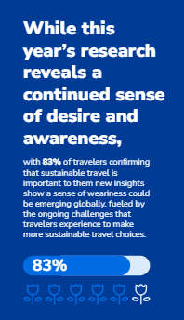
Figure 2: Customer preferences for sustainable tourism
(Source: Booking.com, 2024)
According to Booking.com (2024) survey, 83% of travellers think that sustainable travel is essential, and 61% remarked that COVID-19 has urged them to travel sustainably in the future. Such travellers can be attracted to hotels that strive to be green or sustainable. Further, Hilton has strengthened its LightStay program for sustainability performance metrics, hence comprehensively increasing the brand credibility and customer loyalty; this helped in realising a 22% decrease in carbon emissions per square foot since 2008 (Hilton, 2022).
Regulatory Compliance and Risk Management: Observing environmental laws prevents organisations from penalties and helps make certain that compliance is achieved. For instance, the AccorHotels group implements the Planet 21 program, which complies with many international standards and legal requirements, thus avoiding legal and operational risks (Accor, 2023).
Challenges
Initial Investment Costs: Sustainability practices may incur major initial costs since they need to be managed over the long term (Long et al., 2022). For instance, while installing new systems in buildings, it can be expensive to install energy-efficient systems.
Operational Disruptions: Change and new working methods interfere with the normal organisational process. For instance, Marriott experienced some obstacles in the initial stages of their linen reuse programme because staff received additional training, and working schedules had to be altered to accommodate the changes (Marriott International, 2022).
Measurement and Reporting: Olabi et al. (2022) have denoted that sustainability metrics and their subsequent assessment and reporting are complex and inexpensive to implement. Hilton’s LightStay program was effective; however, it was expensive as it required a huge investment in technology and training to ensure reliable measurements and assessment (Hilton, 2022).
Stakeholder Buy-In: For ensuring the staffs of the Hyatt Hotels were involved in the sustainability process, training and communication programs were inculcated to promote sustainability (Hyatt, 2024).

4. Future of the Hospitality industry and the hotels
Over the years, evolving guest expectations, improved operational efficiency, and the scarcity of labour workforce are compelling reasons that have led to this transformation.
Automation and AI Integration: Hospitality management has turned into one of the most productive industries in the world due to the efficiency of automation. According to Pendrill (2019), another increase in convenience is self-service check-in/check-out kiosks, which are now increasingly introduced to decrease waiting time. Automated language pro-active tools like ChatBot of Marriott offer real-time support, catering to the needs of the guests answering all sorts of questions and facilitating the services (Marriott, 2017).
IoT and Smart Rooms: Smart hotel rooms are being defined through the concept of IoT to comprise communication-enabled devices. Shea (2020) stated that this helps in adjusting the lights and thermostat to their preferred temperature and even controls other appliances and media systems using their mobile phones or even voice control. Hilton’s “Connected Room” is a good example of development work, allowing guests to set scenarios for their room (Karagiannis, 2024).
Robotics: The deployment of robotics in carrying out various operations in the hospitality industry is gradually becoming popular. For instance, New Atlas (2017) reported that at Henn-na Hotel in Japan, robots are used to perform tasks like checking in and checking out, and carrying guest’s luggage among others. These robots not only act as a substitute for human employees and save a lot of money but also give valuable additional experience to the guests (Ivanov, Seyitoğlu and Markova, 2020).
Big Data and Personalisation: Big data analysis can be used in the case of hotels to analyse customer developments and tendencies. For instance, AccorHotels have effectively incorporated big data in its system to make relevant suggestions, and promotions as well as ensure its guests’ loyalty ultimately leading to more conversions (Demirçiftçi and Kızılırmak, 2016).
Sustainability through Technology: As sustainability has become an important subject of discussion in societies today, and organisations in the hospitality business cannot afford to ignore the subject (Jones, Hillier and Comfort, 2016). For example, energy saving applications such as the technology adopted at IHG may also prove useful in achieving significant levels of energy saving (Jones, Hillier and Comfort, 2016). Information from IHG proposed that the small annual reductions of energy usage at their locations were another green living initiative.
Market Growth: According to Statista (2023), the global Hotel Automation market will reach $ 10.75 billion by 2025. According to a recent study, it is estimated that the home health monitoring market is likely to grow from the currently approximately $29 billion to $ 75 billion by the year 2025, with a compound annual growth rate (CAGR) of around 9% (BCC Research, 2023). Wamba-Taguimdje et al. (2020) reported an increase of 1% from 2019 to 2025 was incorporated into the model and this growth is nurtured through the sustained use of Artificial Intelligence, IoT, and other such complicated technologies.

5. Further recommendations for improvements
For improving the efficiency of sustainable approaches in the management of hotels, the application of the Triple Bottom Line (TBL) and the Environmental, Social and Governance (ESG) theories may be used. These theories also stress the need for the integration of economic, social and ecological factors with the view of creating sustainable organisations that will be profitable in the long run.
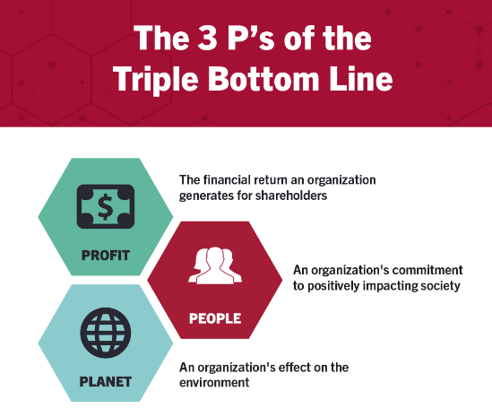
Figure 3: Triple Bottom Line framework
(Source: Miller, 2020)
With regard to this, the TBL framework comprises People, Planet, and Profit, which can help hotels adopt a more responsible business model (Miller, 2020). Putra and Law (2023) annotated that hotels should prioritise the employees, guests and communities surrounding hotels in the international market. It can be suggested to encourage the companies to focus on training the employees on issues of sustainability. This has gone a long way to increase employee involvement and commitment to the organisation, thus the creation of a sustainable culture. Alongside, hotels can support the society of operation by purchasing goods and services from within the region (Zhu and Liu, 2020). This approach can also improve guest experience since the guests can be provided with local and authentic goods and services.
To further reduce environmental effects adopting more advanced technologies and practices, can be implemented in hotels. Other such measures can be extended to decrease the overall effect on the environment even more. Further, hotels can be suggested to adopt power from solar panels, which are relatively cheaper and more effective currently. For instance, in 2021, the JW Marriott Marco Island Beach Resort in Florida embarked on a solar panel system expected to accrue the hotel a saving of $1.3 million in energy costs over 25 years (Pamben, 2018). In addition, it is necessary to implement and improve the best waste management practices to minimise food waste. AI solutions for waste management in hospitality industries like the use of Winnow, a system that makes use of artificial intelligence technology to control the amount of food wastage will serve as a solution (Winnow Solutions, 2019).
Economic sustainability enables hotels to be financially stable, and socially and environmentally friendly. The sustainable practices can be expensive to implement at first but are however efficient in the long run. For instance, the efficient HVAC systems and LED lighting in all of Hyatt's facilities decreased energy expenses by 25% within 5 years (Hyatt, 2024). Constant investment in these technologies is beneficial for both profitability and sustainability.
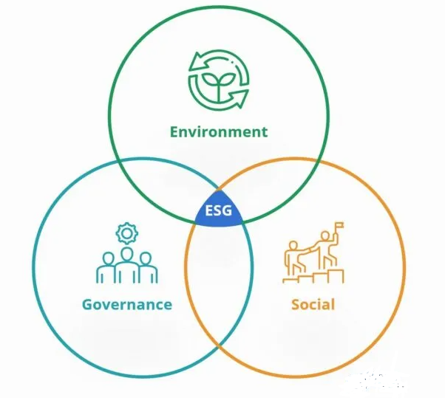
Figure 4: ESG Theory
(Source: Peterdy, 2022)
ESG theory encapsulates Environmental, Social, and Governance factors that need to be considered in the functioning of an organisation (Peterdy, 2022). IHG’s new plan focuses on the goal of achieving net zero carbon emissions, with an aspiration to decrease carbon emissions per occupied room by 15% by 2030 through using carbon offsets and LEED certifications (IHG, 2024). Following this aspect, organisations need to diminish carbon neutrality to maintain their CSR practices and improve their brand image in the market.
On the social aspect, it is imperative to ensure diversity and inclusion as it also considers the career advancement and development programs for minorities are strategic practices, which improve social justice and organisational image. Transparency and ethical behaviour form an essential part of superior governance practices. As exemplified in Accor Hotels' sustainability report complies with GRI standards, which guarantee accountability and transparency with the investors while giving a comprehensive account of performance in sustainability (Accor, 2023).

6. Conclusion
It is advisable to push businesses to concentrate on educating staff members about sustainability-related topics. This has significantly improved worker engagement and loyalty to the company, fostering the development of a long-lasting culture. In addition, hotels may help the community in which they operate by sourcing goods and services locally. Attaining commitment from all the stakeholders such as employees, management and guests may deem to be difficult.

References
Accor (2023) Together, let’s help restore our Earth, group.accor.com. Available at: https://group.accor.com/en/Actualites/2021/04/world-earth-day (Accessed: 22 May 2024).
Alvarado, A. (2024) How to Develop a Sustainable Operations Strategy for Your Business, www.linkedin.com. Available at: https://www.linkedin.com/pulse/how-develop-sustainable-operations-strategy-your-artie-alvarado-sxuac/ (Accessed: 22 May 2024).
BCC Research (2023) Home Health Monitoring Devices Market: Industry Research Report, www.bccresearch.com. Available at: https://www.bccresearch.com/market-research/healthcare/home-health-monitoring-devices-market.html (Accessed: 23 May 2024).
Better Buildings (2023) IHG Hotels & Resorts Green Engage Program | Better Buildings Initiative, Energy.gov. Available at: https://betterbuildingssolutioncenter.energy.gov/implementation-models/ihg-hotels-resorts-green-engage-program#:~:text=For%20example%2C%20in%202018%2C%20hotels (Accessed: 22 May 2024).
Booking.com (2024) Latest Booking.com Sustainable Travel Data Reveals Ongoing Challenges for Consumers & Highlights a Heightened Opportunity for Cross-Industry Collaboration, Latest Booking.com Sustainable Travel Data Reveals Ongoing Challenges for Consumers & Highlights a Heightened Opportunity for Cross-Industry Collaboration. Available at: https://news.booking.com/latest-bookingcom-sustainable-travel-data-reveals-ongoing-challenges-for-consumers--highlights-a-heightened-opportunity-for-cross-industry-collaboration/#:~:text=While%20the%20annual%20research%20reveals (Accessed: 22 May 2024).
Demirçiftçi, T. and Kızılırmak, İ. (2016) ‘Strategic Branding in Hospitality: Case of Accor Hotels’, Journal of Tourismology, 2(1), pp. 1–15. Available at: https://doi.org/10.26650/jot.2016.2.1.0004.
Edwin, C. (2023) ENVIRONMENTAL CONSERVATION AND SUSTAINABILITY, www.linkedin.com. Available at: https://www.linkedin.com/pulse/environmental-conservation-sustainability-edwin-cornelius#:~:text=Sustainability%20is%20the%20practice%20of%20meeting%20the%20needs%20of%20the (Accessed: 22 May 2024).
Hilton (2022) Hilton 2022 Environmental, Social and Governance Report. Available at: https://esg.hilton.com/wp-content/uploads/sites/4/2023/04/Hilton-2022-Environmental-Social-and-Governance-Report.pdf (Accessed: 22 May 2024).
Huang, S., Wang, H., Ahmad, W., Ahmad, A., Ivanovich Vatin, N., Mohamed, A.M., Deifalla, A.F. and Mehmood, I. (2022) ‘Plastic Waste Management Strategies and Their Environmental Aspects: A Scientometric Analysis and Comprehensive Review’, International Journal of Environmental Research and Public Health, 19(8), p. 4556. Available at: https://doi.org/10.3390/ijerph19084556.
Hyatt (2024) Caring for the Planet Caring for People Caring for Responsible Business. Available at: https://about.hyatt.com/content/dam/hyatt/woc/2022WOCHighlights.pdf (Accessed: 22 May 2024).
IHG (2024) Carbon and Energy, InterContinental Hotels Group PLC. Available at: https://www.ihgplc.com/en/responsible-business/carbon-and-energy (Accessed: 23 May 2024).
Ivanov, S., Seyitoğlu, F. and Markova, M. (2020) ‘Hotel managers’ perceptions towards the use of robots: a mixed-methods approach’, Information Technology & Tourism, 22, pp. 505–535. Available at: https://doi.org/10.1007/s40558-020-00187-x.
Jones, P., Hillier, D. and Comfort, D. (2016) ‘Sustainability in the Hospitality Industry’, International Journal of Contemporary Hospitality Management, 28(1), pp. 36–67. Available at: https://doi.org/10.1108/ijchm-11-2014-0572.
Karagiannis, M. (2024) Decoding Guest Psychology with AI: Unlocking the Hidden Motivations Behind Hotel Choices, www.linkedin.com. Available at: https://www.linkedin.com/pulse/decoding-guest-psychology-ai-unlocking-hidden-behind-karagiannis-qt4zf/ (Accessed: 23 May 2024).
Long, W., Luo, L., Sun, H. and Zhong, Q. (2022) ‘Does going abroad lead to going green? Firm outward foreign direct investment and domestic environmental performance’, Business Strategy and the Environment [Preprint]. Available at: https://doi.org/10.1002/bse.3156.
Marriott (2017) Marriott International’s AI-powered Chatbots on Facebook Messenger and Slack, and Aloft’s ChatBotlr, Simplify Travel for Guests Throughout Their Journey, Marriott International Newscenter (US). Available at: https://news.marriott.com/news/2017/09/28/marriott-internationals-ai-powered-chatbots-on-facebook-messenger-and-slack-and-alofts-chatbotlr-simplify-travel-for-guests-throughout-their-journey (Accessed: 23 May 2024).
Marriott International (2022) Environmental, Social, and Governance Progress 2 2022 Serve 360 Report: Environmental, Social, and Governance Progress •I NTRODUCTION •S ERVE 360: DOING GOOD IN EVERY DIRECTION •E NVIRONMENTAL. Available at: https://serve360.marriott.com/wp-content/uploads/2022/10/Marriott-2022-Serve-360-ESG-Report-accessible_F.pdf (Accessed: 22 May 2024).
Miller, K. (2020) The Triple Bottom Line: What It Is & Why It’s Important, Harvard Business School Online. Available at: https://online.hbs.edu/blog/post/what-is-the-triple-bottom-line (Accessed: 22 May 2024).
New Atlas (2017) New Japanese hotel has robot staff and no room keys, New Atlas. Available at: https://newatlas.com/henn-na-hotel-robot-staff/38577/#:~:text=A%20new%20hotel%20that%20is (Accessed: 23 May 2024).
Olabi, A.G., Obaideen, K., Elsaid, K., Wilberforce, T., Sayed, E.T., Maghrabie, H.M. and Abdelkareem, M.A. (2022) ‘Assessment of the pre-combustion carbon capture contribution into sustainable development goals SDGs using novel indicators’, Renewable and Sustainable Energy Reviews, 153, p. 111710. Available at: https://doi.org/10.1016/j.rser.2021.111710.
PAMBEN, D. (2018) Marco Island Beach Resort debuts after $320m JW Marriott makeover, cladglobal.com. Available at: https://www.cladglobal.com/architecture-design-news?codeid=329386 (Accessed: 23 May 2024).
Pendrill, K. (2019) Why Self Ordering Kisoks Are a Secret Weapon for Restaurants, TouchBistro. Available at: https://www.touchbistro.com/blog/why-self-ordering-kiosks-are-becoming-the-secret-weapon-for-successful-restaurants/ (Accessed: 23 May 2024).
Peterdy, K. (2022) ESG (Environmental, Social and Governance), Corporate Finance Institute. Available at: https://corporatefinanceinstitute.com/resources/esg/esg-environmental-social-governance/ (Accessed: 23 May 2024).
Putra, K. and Law, R. (2023) ‘Critical success factors for virtual hotel operator partnership with small- and medium-sized hotels: perspectives of owners and operators’, Journal of hospitality and tourism insights [Preprint]. Available at: https://doi.org/10.1108/jhti-06-2022-0244.
Shea, S. (2020) What is smart home or building (home automation or domotics)? - Definition from WhatIs.com, IoT Agenda. Available at: https://www.techtarget.com/iotagenda/definition/smart-home-or-building (Accessed: 23 May 2024).
Stanikzai, I.U. and Keliwaal, A.N. (2023) Fostering Sustainable Economic Growth: The Role of World Bank and IMF Programs in Developing Countries, ResearchGate. Available at: http://dx.doi.org/10.62345/jads.2023.12.4.73 (Accessed: 22 May 2024).
Statista (2023) Hotels - Worldwide | Statista Market Forecast, Statista. Available at: https://www.statista.com/outlook/mmo/travel-tourism/hotels/worldwide (Accessed: 23 May 2024).
United Nations (2024) Sustainability, United Nations. Available at: https://www.un.org/en/academic-impact/sustainability#:~:text=In%201987%2C%20the%20United%20Nations (Accessed: 22 May 2024).
Wamba-Taguimdje, S.-L., Wamba, S.F., Robert, K.K.J. and Tchatchouang , C.E.W. (2020) (PDF) Influence of Artificial Intelligence (AI) on Firm Performance: The Business Value of AI-based Transformation Projects, ResearchGate. Available at: https://www.researchgate.net/publication/340210939_Influence_of_Artificial_Intelligence_AI_on_Firm_Performance_The_Business_Value_of_AI-based_Transformation_Projects (Accessed: 23 May 2024).
Watson, R. (2020) Reducing water use, YourHome. Available at: https://www.yourhome.gov.au/water/reducing-water-use (Accessed: 22 May 2024).
Winnow Solutions (2019) Winnow | Cutting Food Waste within Hospitality, Winnowsolutions.com. Available at: https://www.winnowsolutions.com/ (Accessed: 23 May 2024).
WTTC (2022) Economic Impact | World Travel & Tourism Council (WTTC), wttc.org. Available at: https://wttc.org/Research/Economic-Impact (Accessed: 22 May 2024).
Wu, Y., Xin, B., Zhu, H. and Ye, Z. (2022) ‘Energy-Saving Operation Strategy for Hotels Considering the Impact of COVID-19 in the Context of Carbon Neutrality’, ProQuest, 14(22), p. 14919. Available at: https://doi.org/10.3390/su142214919.
Zhu, X. and Liu, K. (2020) ‘A systematic review and future directions of the sharing economy: business models, operational insights and environment-based utilities’, Journal of Cleaner Production, 290, p. 125209. Available at: https://doi.org/10.1016/j.jclepro.2020.125209.

