Introduction to Web and Database Concepts
Databases
Thomas Sellwood (2215661)
bsc computing (data and information systems)
2023
Contents
Entity Relationship Diagram 2
Main Menu 3
Customer Menu 4
Cost Per Event Report 4
Attendees Per Event 5
Staff Menu 5
Create Event 6
Create Event Task 6
Create Booking 7
Create Venue 7
Create Customer 7
Create Supplier 8
Create Order 8
Create Invoice 9
Staff Reports Menu 9
Staff in Branch Report 10
Orders Per Event 10
Event Attendees 11
Incomplete Tasks Per Event 11
User Guide 11

Entity Relationship Diagram
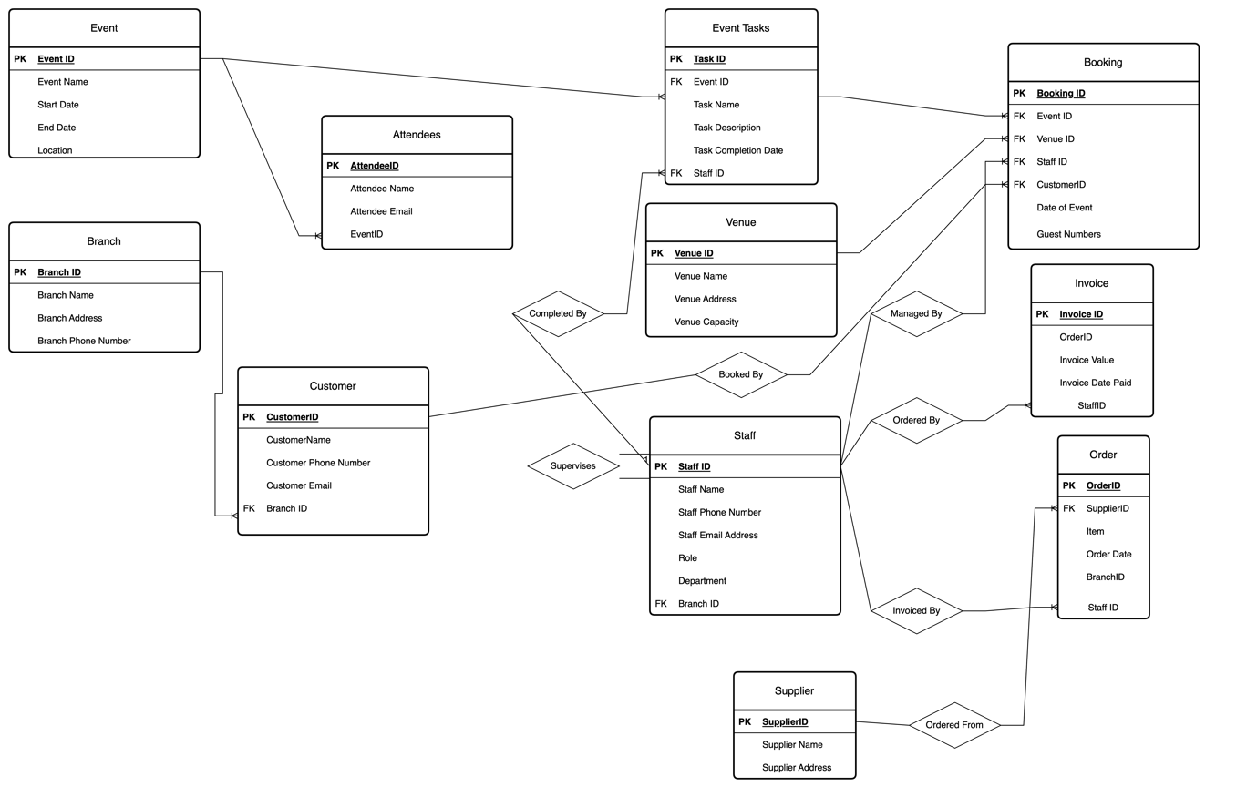
The above diagram details the tables within the DBMS. The diagram details the relationships between tables and the primary and foreign keys for each.

Main Menu
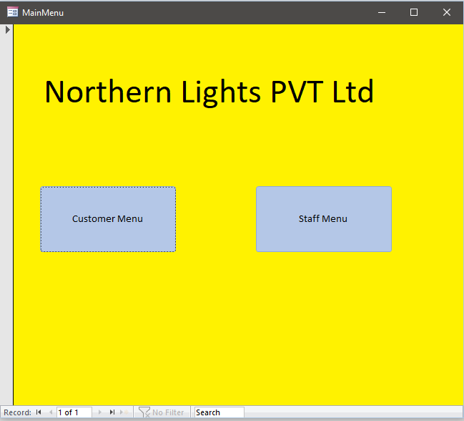

Customer Menu
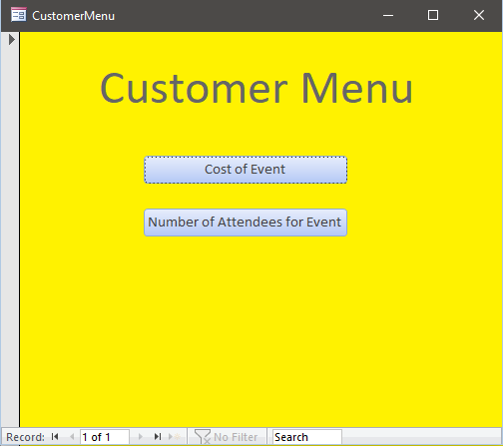

Cost Per Event Report
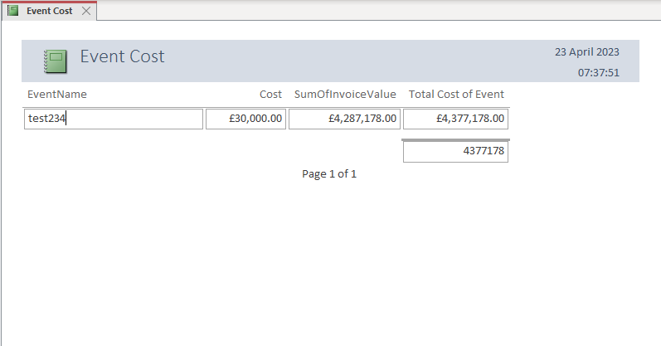

Attendees Per Event

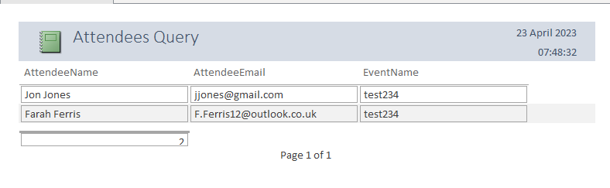

Staff Menu

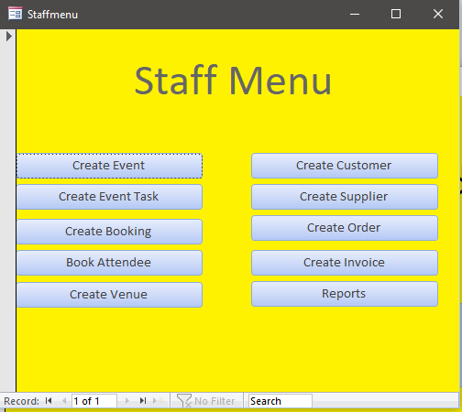

Create Event

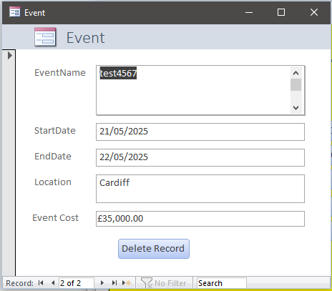

Create Event Task
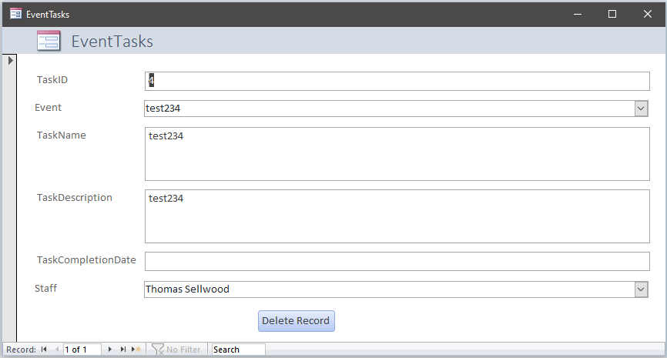

Create Booking

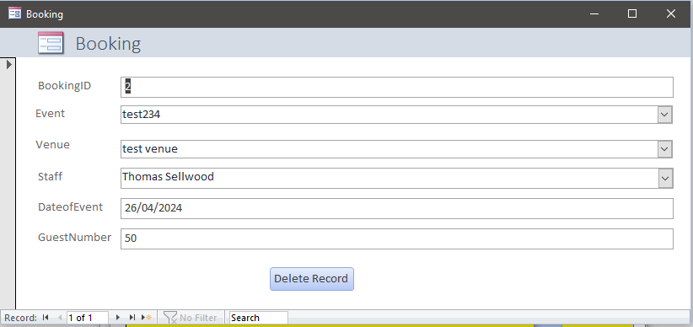

Create Venue

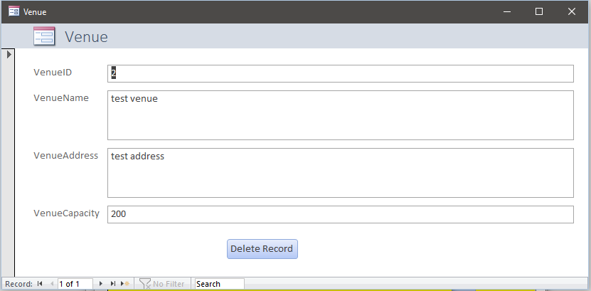

Create Customer

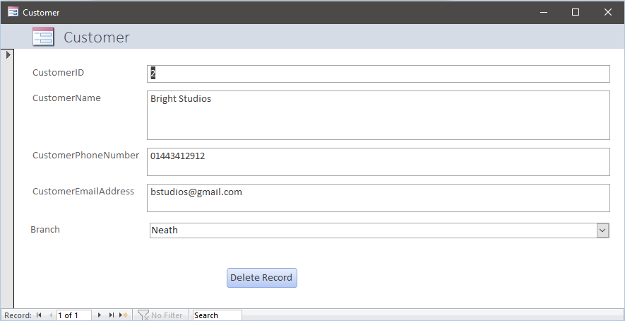

Create Supplier
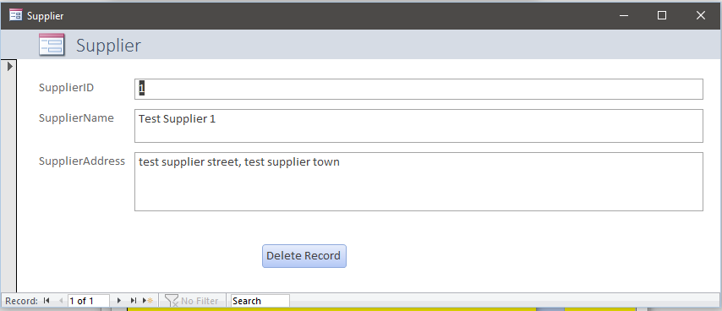

Create Order

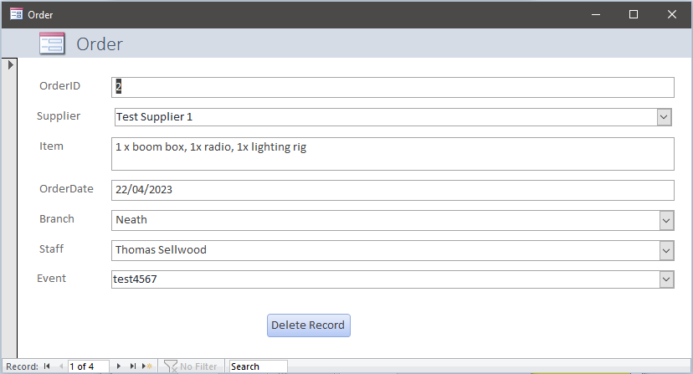

Create Invoice
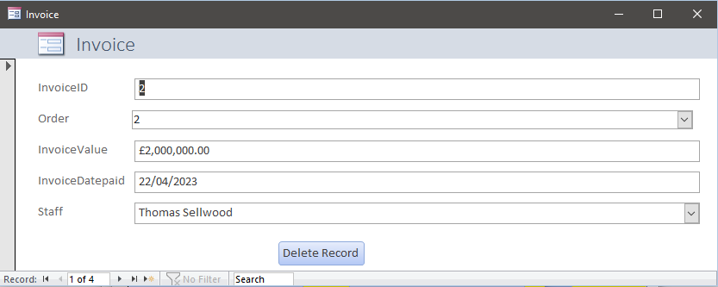

Staff Reports Menu

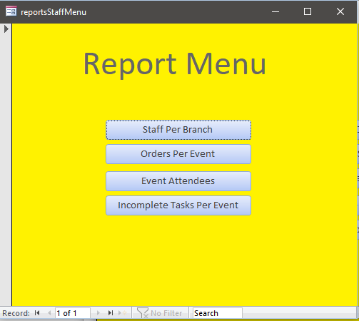

Staff in Branch Report

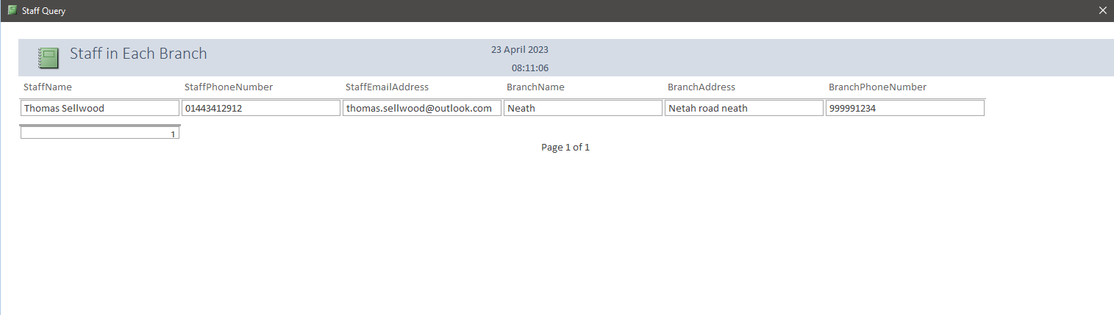

Orders Per Event

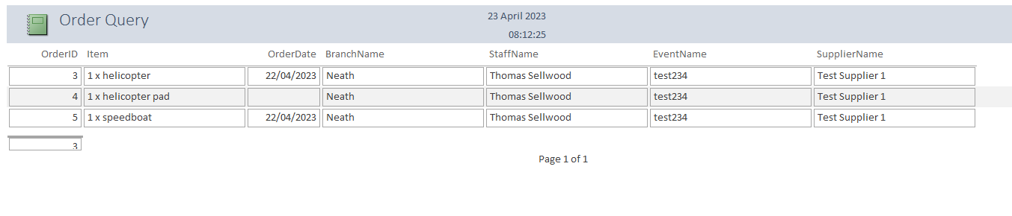

Event Attendees

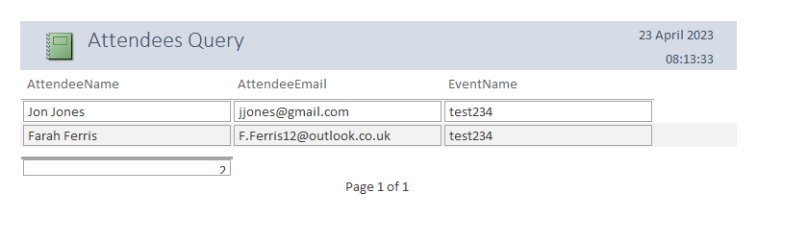

Incomplete Tasks Per Event

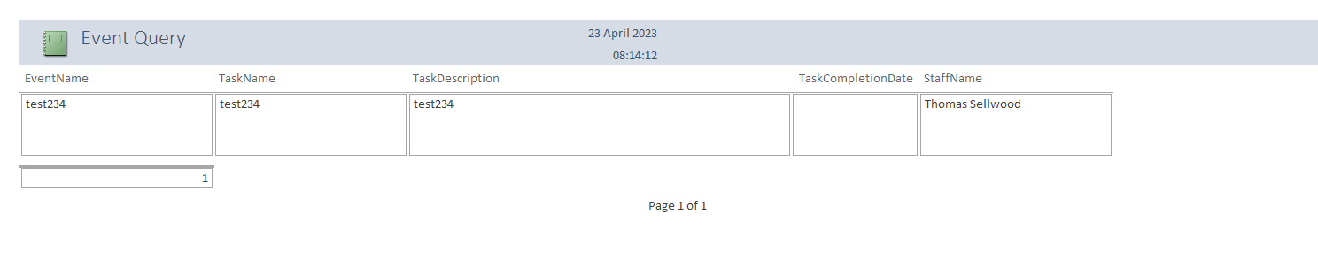

User Guide

On opening of the DBMS solution, the user will be presented with a main menu screen with the option to navigate to the customer section or the staff section.
If the customer section is selected this will take the user to the customer menu. At the customer menu the user will be presented with an option of reports. When the user clicks into these reports they will be presented with a dialog box so that they can specify the event they require the report for.
If the user selects the staff menu they again will be presented with a menu of functions. They have multiple options to create new events, new bookings, new orders, invoices, suppliers and customers. Within the forms inside these options, they have the autonomy to edit old records, delete records and create new records. Where the data is pulled from other tables the user is presented with a typable dropdown box for easy selection of data. Also on the form is the option for a staff reports menu. This will take staff members through to the staff reports section of the DBMS. Inside this section of the DBMS the staff are able to run various reports against the events and the staff, they can check the staff at what branch, what outstanding tasks are left for certain events, the number of attendees that are attending a particular event and the orders per event.

