Student Name: Salima Begum
Student ID: 2128697
Module:BMHP5005
Lecturer: Raheela Shaikh

Abstract
The aim of this study is to understand Autism which now is considered as autism spectrum disorder. It will not only look at the UK but other countries like the USA. The methods, surveys they use to understand and what causes and contributes towards autism symptoms and behaviours. This disorder is widely now accepted around the world. It is a condition that should be respected and identified. The ongoing research and study prove there isn’t an end to knowing everything about this condition, and there are loads to still know and put into knowledge and action towards autism. Autism has always been in question as to why, and how and is early detection proven better, why it happens, the different behaviours, and symptoms contributes to it. Are there any other conditions that can affect this condition, or similar conditions which contribute to it.

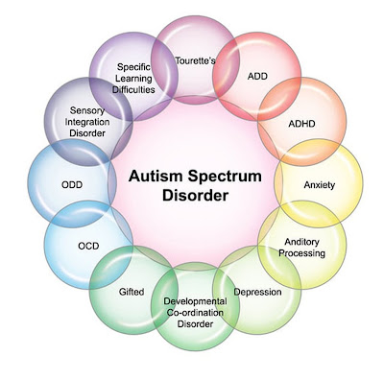

Introduction
Autism or autism spectrum disorder (ASD) is regarded as a neurological and developmental disorder, affecting the interaction with people, communication, how to learn, and behaviours which are associated with this disorder. A child could be diagnosed at any age, and symptoms usually are seen in the first couple of years. (National Institute of Mental Health). Although it is a spectrum disorder, severe symptoms various between everyone. Everyone will have different symptoms whether behaviour, socialising, communication and so on. All backgrounds, race, ethnicity etc could be diagnosed with ASD. It could be a long-lasting disorder. There are symptoms. Which can be treated, and various services could improve everyday life. It is recommended by the American paediatrics that screening should be done early as possible. This literature review will look at understanding autism, with examples from different sources, the knowledge of autism, what can be done, treatments available, summarising and evaluating my findings.

Background
Autism is a condition which the cause is not yet fully known of. But this could be genetical, as known through different studies, it is a pervasive development disorder put in a group of neurodevelopmental disorders which sees impairments in children or adults in communication difficulties, social interactions, repititive restricted behaviours or interests. As more research and study is needed to understand environmental factors which could play a factor in contributing to this. (Faras,et..al, 2010). As this is a worldwide occurrence, recent studies show it is present in 6 per 1000 children. To diagnose autism, disorder the impairments are taken into consideration, which in turn could be categorised into the five pervasive developmental disorders, which are Autistic disorder, Aspergers, Rett disorder, Childhood disintegrative disorder, and Pervasive disorder. These are the other development disorders, which are also link to autism. (Faras, et,al 2010). The Diagnostic and Statistical Manual of American Psychiatric Association says that the healthcare to look out for signs to diagnose and realize that they have difficulty in,
- Communication and interacting with people.
- They have restrictive and repeat behaviours.
- The ability functioning which affects school, work and other areas of their life.
It is called a disorder as there are a range of varieties and different types and severity of the symptoms. Anyone can be diagnosed with ASD. (Mental institute of health). Some of the below lists are some examples in people that have ASD. But not everyone has the same symptoms or behaviours.
Social communication/Interaction behaviours
- Little eye contact or inconsistent
- To appear not looking or listening to who is talking.
- Infrequency of sharing interests, emotions and enjoying objects and activities. (Infrequency to pointing or showing things to others).
- To not respond to their name, being slow, or for attention.
- Having difficulty with conversation.
- Too often have lengthy talks which others are not noticing or interested in and not giving others a chance to talk and respond.
- To displaying movements, expressions that don’t match what is being said.
- To have poor understanding of another person’s view or to predict or understand actions of others.
- Having difficulty to adjust to behaviours or social situations.
- Having difficulty in imaginative play and make friends.
Restrictive/repetitive behaviours could be
- The repetition of certain behaviours or unusual behaviours like repeat of words and phrases.
- Has a lasting interest in certain topics like numbers, details, or facts.
- Shows a high focus interest like moving objects or any parts.
- To be upset by little change in the routine and transitions.
- To being less sensitive or more to sensory input like light, sound, clothes, or temperatures.
They also have sleep problems and are easily irritable. And could also have strengths like
- Learning in detail and remembering certain information for longer periods of time.
- To being strong visuals, and auditory learners.
- To excel in maths, science and music or art.
Causes and related factors.
As primary cause isn’t known but studies show genetics could play a part as well as environment that could lead to ASD. Like the following
- A sibling with ASD.
- To have older parents.
- Genetic conditions like Down syndrome, Fragile X syndrome.
- Having very low birth weight. (Institute of mental health).

Methods and other factors
Epidemology
ASD is more common in boys than girls, with a ratio of 4:1 from male to female. The rates have been increasing over worldwide over the past decades, 4 per 1000 to 6 per 1000 children. The increase is from the wider awareness of these disorders, which broadens the diagnostic concepts, reclassifications, and detections. (Faras et al, 2010). So there is a risk factor involved which needs more research.
Etiologic
The cause is not known, and etiologic has changed over the years. Once it as thought that it could be faulty child rearing. So etiologic research has shown etiology has a strong genetical factor, so psychological theory was rejected. As etiology isn’t so clear minority cases shows about less than 10%, cases where autism could be a part of aa different disorder. These sometimes referred as secondary autism.
Genetic factors
Autism could be both genetical and inherited. The reoccurrence in siblings is 25 to 8% which is generally higher than the general population. Twin studies show that monozygotic twins to have higher rate than the dizygotic twins which is 90% and 10%, and others show the complex range of inheritance, that link studies that suggest genetic loci on the several chromosomes like the chromosome 7 and chromosome x.
(Faras et al, 2010).
Environmental factors
There are a range of factors that are seen as could be possible causes in autism. The epidemiological study showing factors like prenatal infections, which could be rubella and cytomegalovirus which have been said to play a cause in few cases of autism. Heavy metals could play another part.

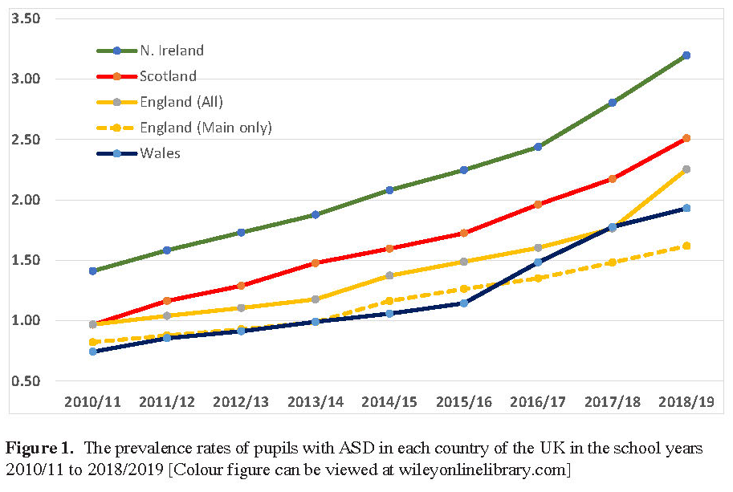
The above chart shows over the years the changing rate within schools in the UK. The rates going up in recent years and is continuing every year. This was pre pandemic times, showing up to the year 2019.

The NHS say people with autism will act differently to other people, like finding it hard to communicate and social. They also find it hard to understand and how other people think and feel. They also find loud noises and bright lights stressful and too overwhelming. They easily get anxious or upset with unfamiliar situations and events. They tend to take in longer time to process information and things are thought repeatedly. (nhs.uk).
As autism is a lifelong disorder it affects communication and social abilities. The recent prevalence of the Autistic Spectrum Disorders suggest 1% in the UK has touched the lives of over 500,00 families. (NAS, 2007). So, 2 to 6 per 1.000 by the centres for the Disease Control and Prevention (2001) and the U.S census figure (2000) has the estimate of 1.5 million children and adults in another 15 million (parents, healthcare professionals, they’re loved ones and so on). Who is directly affected by autism. (Rachna, 2012).
Another review shows that this neurodevelopmental disorder affects at least 2.3%nchildren from the ages of 8 years within the US and 2.2% in adults. Observations show a 1.1% increase 2008 to 2.3% in 2018, in the U.S this could be from diagnostic criteria which has improved performance of screening and tools, and more awareness to the public. So, the common signs are in the early years from the age of 2. So, for treatment is from a comprehensive evaluation. This included multidisciplinary teams of clinicians which did semi structured observations directly of children’s behaviours and semi structured caregiver interviews that focused on their behaviours and development using methods like standardized measures like the Autism Diagnostic Observation schedule second edition and the Autism Diagnostic interviews. They have the sensitivity of 91% and 80% and specific of 76% and 72% respectively. When compared to people with ASD shows people with the disorder had higher rates of depression, (20%-vs 70%), anxiety was (11%-vs 5%), sleep difficulties (13%-vs5%), and epilepsy of (21% that occurs intellectual disability vs 0.8%). ( Hirota, 2023).). It is suggested that the first- line of therapy is having behavioural interventions, and while the occurrence of other conditions like anxiety, aggression is treated by behavioural therapy or medications.
Another method (Italian Journal of Paediatrics) suggests that this condition be detected in early stages, and treatments be targeted early on. They aimed to use methods at the age of onset age, early signs, in about 105 patients with autism spectrum disorder, using correlations with clinic and instrumental variables. (parmeggiani, et. Al 2019). There were five categories split into, the onset, which is language, interaction socially, and relations, stereotype behaviours, and their activities, motor skills, and regulation. Three modes presented and considered in the sample the onset age, category of clinical features, and mode of onset in the whole sample and these were clinical variables. The fisher exact test and Chi square test was used. The results found were the first symptoms in 7 and 12 months were, significant differences at the age onset, which related to the diagnosis obvious in 41.9% of cases and then 13 and 24 months in 27.6%, and there were no, etiopathogenesis, and the early onset of epilepsy and the intelligent quotient level emerged. The social interactions and relationships (93.3%) and language was (92.4
%) which showed early signs represented more in the sample. The delay was spoken language which needs understanding verbal as production and verbal comprehension). This was common as not so specific. Most need medical consults for the diagnosis of spectrum disorder. (Parmeggiani, et..al,2019). Language was less frequent which showed delay or regression of development and motor skills showed cases delay at onset. For paediatrics it was useful in identifying it in early stages.
The cross-section study that came from medical records shows (medical history, neurological exams and observations, psychological tests, analysing hospitalization by videos at home which is recorded by parents. These were from university of Bologna from all over Italy collected from February 2001 to July 2011. Parents give the consents, and this approved by Institutional Review board of Bologna University. 105 patients of which 82 males and 23 females (males/female ratio of 3.6:1) were included. (Parmeggiani, et al 2019). Forty-six (43.8%) out of the 105 had specific pervasive disorder, 4 out of 105 (3.8%) Aspergers and 55 remaining case (52.4%) has some sort of autistic disorder. The mean onset age ASD symptoms 13.6 months (range 3-48 months, median 12 and the standard deviation is 9.1). within the sample 57 case idiopathic (54.3%) while the 48 were no idiopathic (45.7%).
Treatments and Intervention Services
Treatments and plans involve usually different professionals and are planned towards the individuals. Treatments are available within education, health, the community or the home settings, or combinations of settings. It is vital as everyone communicates with everyone with the person who has ASD and families. So that treatments and progress is meeting expectations. Additional support and services will also help with health and daily function and help in social and community engaging. (Centres for Disease Control and Prevention). Treatments are broken down into categories of Behavioural, Developmental, Education, Social, Pharmacological, Complementary and the Alternative. (ABBA). this will encourage good behaviours and discourages bad behaviours, so skills are improved. The progress tracked and is measured. These are Discrete Trial Training (DTT) and Pivotal Response Training (PRT).
- DTT uses step to step instructions which is there to teach the desired behaviour or their response. Lessons are broken to make it simple and then behaviours rewarded. Other answers and behaviours would be ignored.
- PRT will be placed in a natural setting not in a clinical setting. The aim is helping in pivotal skills which helps with every other skill. One such is communication with others.
Developmental approaches
These help in the improvement of specific developmental skills, like language skills or physical skills. Development approach often combines behavioural approaches. Most common therapy speech and language therapy. They help in improving peoples understanding and the use of speech and language, some verbally, others use gestures, pictures, or some sort of electronic communication device. (Centres for Disease Control and Prevention).

Occupational Therapy
This skill teaches a person to live independently as much as possible. Like dressing, eating, or bathing, and it relates to people. Occupational therapy includes.
- Sensory Integration Therapy- it helps improve the responses in sensory input that could be restrictive, or overwhelming.
- Physical Therapy- this is helping physical skills, like the fine movements of fingers or the larger movements like trunk and the body.
The Early Start Denver Model uses developmental approach of which is based on applied behaviour analysis. This is used with children between the ages 12-48 months. Parents alongside therapists will use play, social exchange. And the shared attentions with natural settings. So that this improves language, social and the learning skills. (CDC).
Educational Approaches
G4
These focus on improving social skills and building emotional bonds. Some are involving parents or mentors. Another model the Developmental, Individual Differences, Relationship-Based model also as (floor time), helps in supporting parents and carers to follow their interests and expanding different opportunities of communication. The social Relationship Development Intervention will involve activities in motivation, the interest, and the abilities in shared social interactions. The social stories will provide descriptions as simple to understand what can be expected in social interactions. Social groups will provide skills practise in a structured environment.
Pharmacological approaches
Medications are there, to help in treating ASD. They could help manage high energy level, the inability to focus, self-harm, like the banging of head, or biting. Medication for anxiety depression and epilepsy and so on. And, to work closely with doctors who have the ability and experience in treating ASD.
Psychological approaches
They help with ASD to cope with depression, anxiety, and other mental health. Cognitive behaviour therapy (CBT) focuses on the learning connection like thoughts, feelings, and behaviour. During this therapy the therapist and the individual need to work closely to identify the goal, the thinking, and reactions.
Complementary and Alternative Treatments
These are more traditional types of medicine and approaches. Like diets, herbal, arts, chiropractic care, or relaxation therapy and so on. Anything like this should be consulted by a doctor. (CDC).

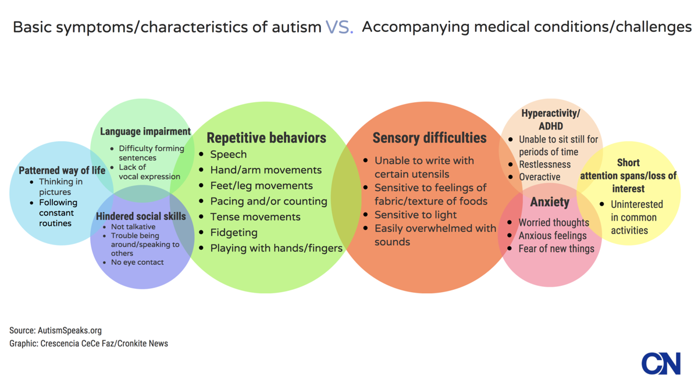

Diagnostic Evaluation
To diagnose this condition lots of examinations are needed like medical and neurological. The child’s cognitive abilities, language abilities, and observations of behaviour. Deep discussions with the caregiver’s about behaviour and their development. The skills that are their age appropriate, that include daily activities independently. Like going toilet, eating, dressing themselves. As it is such a complex condition and comes with other illnesses or learning disorders more evaluation could come with blood tests, and hearing tests. (National Institute of Mental Health). To diagnose this disorder experienced professionals will carry this out like neurologists, development paediatrics, speech and language therapists, child psychologists and psychiatrists, occupational therapists and educational therapists will work together to help the individual and make a care plan to their advantage.

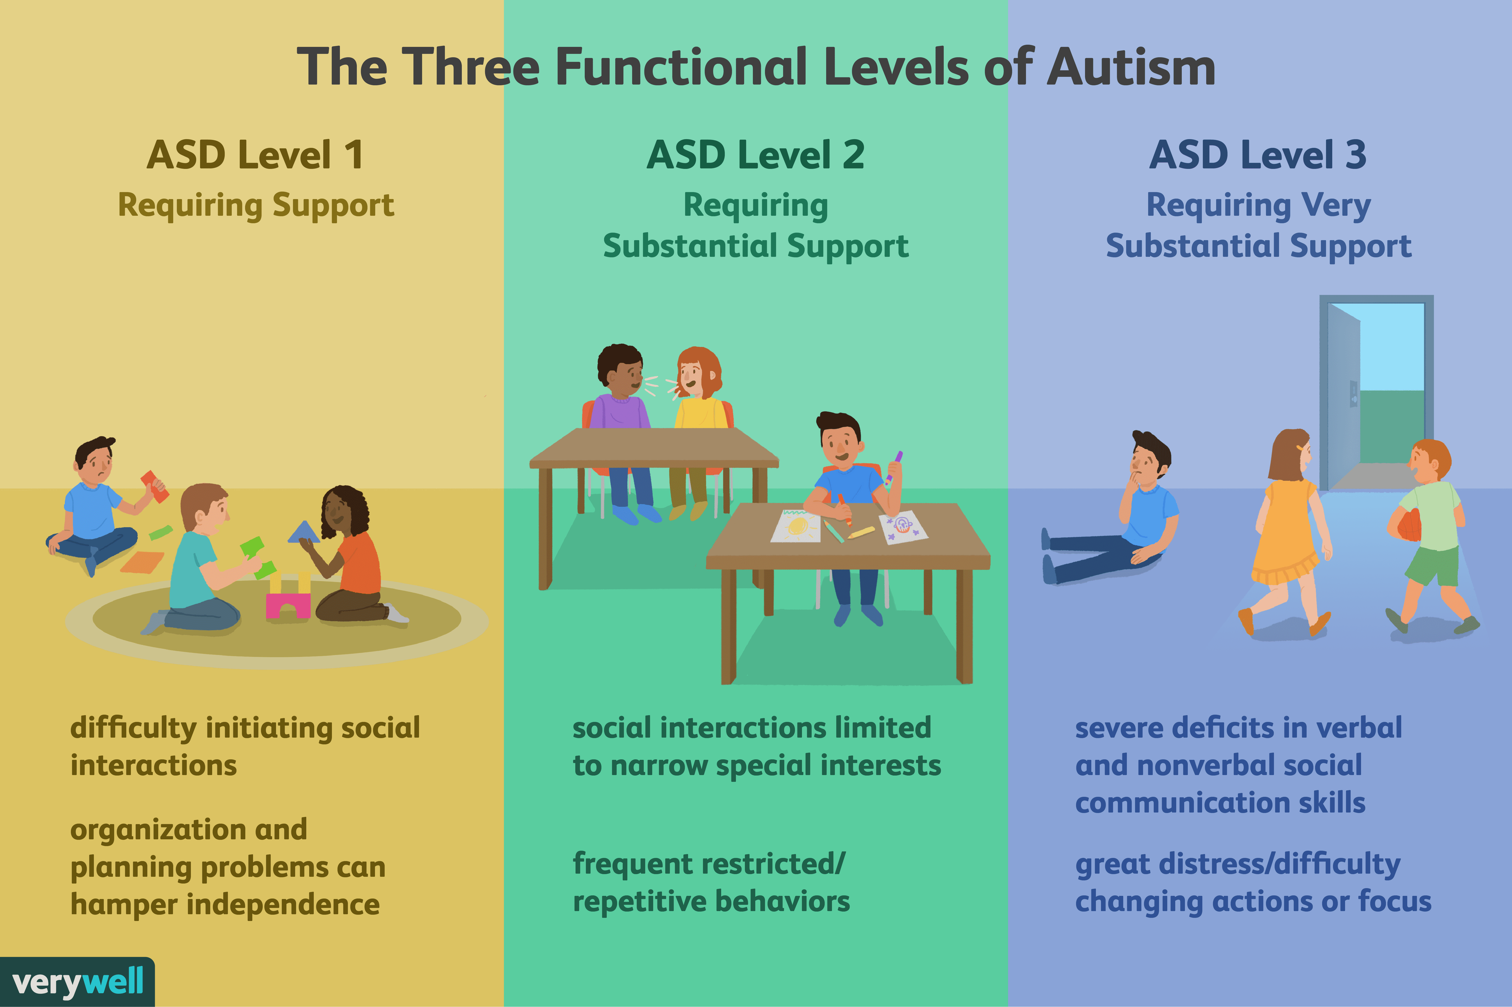

Ethical approach to Autism
Autism is a spectrum condition now, as no agreement is known as to what causes the basic issues of it, or what contributes to it. But the diagnosis is rising, within this rare condition. It is on a large-scale survey shows. Everyone involved in the disorder will face questions, about the right approach to autism. (Hens, et..al 2018). Questions will always be raised about the early detection, the role, consequences of underlying cognitive theories. And whether autism is a disorder to treat or an identity to have their own respect. To what category does it relate to, the first and foremost falls in the psychiatrist diagnosis, that is used in clinical practice. There are various range and varieties of methods, models, treatments, medication out there now to diagnose autism. Although research and study are still out there to understand the relation to autism.

Results
Various methods and surveys are put out there not only within the UK but all over the world are working on finding the cause and fully understanding the disorder, as to why it happens, what contributes to it, the difference in behaviours, restrictive and repetition of the behaviours. And so many more reasons, that relates to autism. The different surveys show the different percentages and ranges in autistic people. It shows the earlier detection the better. Everyone is different, and treatment and interventions could help. Research and studies are still out there and ongoing and I suppose it will never end will still be an ongoing process worldwide. Autism still needs to be known and identified. To be respected, and need to be considered and understood very well by everybody.

Conclusion
Overall conclusion sees that autism spectrum is detected more in males than females. And that studies and research shows the earlier detected the better in getting treatment and diagnosis done. There will be a plan sought out with doctors and other agencies and professionals which could get involved and what is needed could be put into action. It is a worldwide concern and looking for the cause and other factors are still being researched. Closer look at this condition could help everyone understand and live with it in their daily lifestyle and people can deal with it in their own ways and can come to terms with autism disorder. Studies do show that autism symptoms can be supported with different methods, plans, medication depending on how severe, it is in an individual. There are lots of tests available and agencies to support this condition, and everyone like schools, doctors, healthcare, will come together to help and diagnose this in due time.
I

References
Faras H,AL Ateeqi N, Tidmarsh L, Autism spectrum disorders. Ann Saudi Med. 2010 JUL-AUG;30(4):295-300 doi: 10.4103/0256-4947.65261. PMID:20622347;PMCID:PMC2931781.
Hens,K,Robeyns,I,Schaubroeck,K,The ethics of autism.philosophy.compass.2019;14:e12559.https://doi.org/10.1111/phc3.12559
Hirota,T (Hirota,Tomoya);King,BH(King,Bryan H.),Jam-Journal of the American Medical Association.Volume:329 Issue:2 Page 157-168. DOI:1001/jama.2022.23661.JAN 10 2023.
http://www.cdc.gov>ncbddd>treatment and intervention services for Autism spectrum disorder/NCBDDD
https://www.nhs.uk>conditions>autism
https://www.nimh.nih.gov>topics (National Institutes of Health).
https://www.resna.org>2012>other (Resna).
Hyman,S.L,Levy,S.E.,Myers,S.M.,&AAP Council on children with Disabilities, Section on development an behaviour paediatrics.(2020).Identification,evaluation,and management of children with autism spectrum disorder.Paedatrics, 145(1), e20193447.
Parmeggiani,A,corinaldesi,A.&posar,A.Early features of autism spectrum disorder:a cross-sectional study.Ital J Pediatr 45,144(2019).
https://doi.org/10.1186/s13052-019-0733-8

