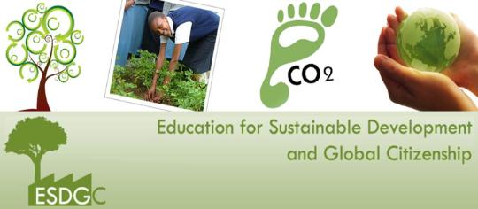
Opportunities and Challenges in Integrating the ESDGC within the Early Years Setting
1501252
Introduction
(Swansea University, no date).
Wales has been endeavouring in promoting Education for Sustainable Development and Global Citizenship (ESDGC) since 1998, after the Government for Wales Act 1998 stated its importance. The Welsh Government aimed to promote the ESDGC within many different sectors throughout Wales and since the ‘Education for Sustainable Development and Global Citizenship- A Strategy for Action’, by the Department for Children, Education, Lifelong Learning and Skills (DCELLS) in 2006 was published, the strategy was taken on board and implemented in full force. The document has since been updated in 2008 (Tinney and Merriman, no date).
What is the ESDGC?
The ESDGC aims for young people to adopt positive values, skills, behaviour and understanding linked to the environment in order to sustain their world and face environmental challenges. The document stresses the importance for the ESDGC to not be taught as a subject, however to embed it through everyday learning in school and life. It also informs schools and the public on how to encourage young people to look at the world and see the impact they, as individuals, can make. (DCELLS, 2008).
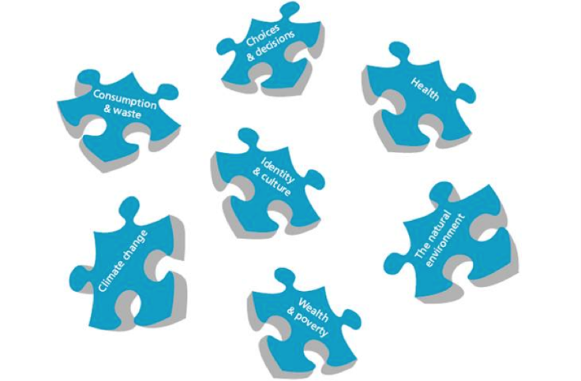
There are seven key themes within the ESDGC:
- Wealth and Poverty
- Choices and Decisions
- Natural Environment
- Climate Change
- Consumption and Waste
- Health
- Identity and Culture
(Ysgol Stanwell School, no date).
These themes create the ESDGC and support practitioners in delivering it (Stevens et al., no date). Practitioners may face challenges when implementing the different themes such as the framework not being a whole school approach and practitioners not engaging children due to lack of training (Governors Wales. No date).
Aim of this article
This article will critically evaluate three different themes of training, outdoor environment and Eco-schools and the opportunities and challenges those themes may face in integrating the ESDGC into the Early Years (EY) practice.

Training
Farrelly (2010) states that training is a way to extend practitioners knowledge, skills and understanding. It enables them to create positive experiences for children and promotes a positive ethos where practitioners are feeling valued and motivated in making a change in children’s learning and development (Earley and Bubb, 2005).
(Australian Workplace Training, 2017).
Training, also known as professional development appears to be an important area for schools being successful. Earley and Porritt (2010) extend on this by stating that in order for schools to develop, practitioners must continuously update their training, as this would ensure a high level of quality teaching provided to children.
Practitioners are pushed to create a ‘learning community’ within their class. Settings, which aim to be so, do not focus on just teaching but place great importance on children understanding what is being taught. By creating a learning community practitioners ensure they are continuously enhancing their professional development and are collaborating closely with their school in order to support children in understanding and learning rather than focus on teaching (DuFour, 2004). The ESDGC links closely with the idea of children being a community of learners, as the Framework informs practitioners to embed the ethos of the ESDGC within the school, rather than it being taught separately (DCELLS, 2008)
Campbell, McNamara and Gilroy (2004) talk about how settings receive funding to train practitioners to improve their professional development. Earley and Bubb (2005) add that in order for practitioners to support children in fully understanding what is being taught, they will have to embark on an ongoing process of training to keep up to date with new strategies and information. However, practitioners are not supported with the appropriate resources to deliver their teaching to a community of learners. Through training, practitioners can create opportunities to integrate the ESDGC ethos. The National Training Federation Wales (no date) states that practitioners should encourage children to think of the present day rather than the future of the environment, as they would struggle to see further than the present. Children should be supported in becoming critical thinkers and being a community of learners in order to take on the ethos of the ESDGC and make a difference. In order to integrate the ESDGC into the current curriculum being used, practitioners must be thoughtful on which areas of their planning they can appropriately link ESDGC within (National Training Federation Wales, no date).
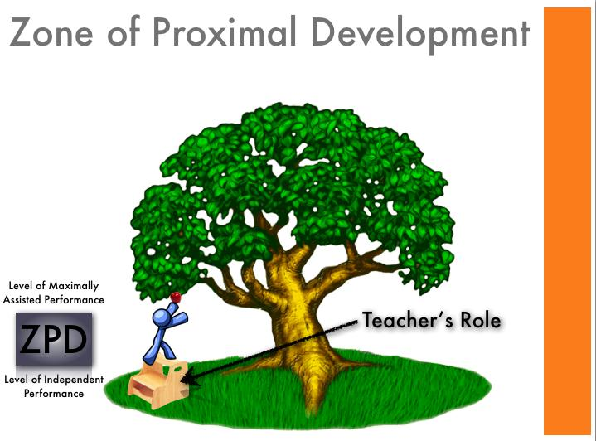
However, practitioners may find it challenging to interlink the ESDGC within their teaching if they are the only ones throughout the school attempting to embed it. DCELLS (2008) state that the ESDGC will not be effective if the whole school is not on board. Practitioners within the school may not have an opportunity to attend training on ESDGC, due to funding and may not understand how to integrate it within their setting therefore not being able to deliver it wholeheartedly. Bourn et al. (2016) states that settings lack the experience and skill to deliver a high quality integration of the ESDGC. Estyn (2014) has suggested practitioners, in particular Wales, to put more priority in their professional development of the ESDGC so they can be more confident in integrating it within their class and school.
A lack of training and knowledge in the ESDGC can prevent children from gaining good quality education in the ESDGC Framework. One of the themes, choices and decisions encourage children in thinking deeply about what their actions may cause to the environment. It also encourages them to make choices that will create a positive outcome for their world and themselves (DCELLS, 2008). Burns and Joyce (2005) state the term ‘scaffolding’ means for an adult to support and enhance the learning and understanding of a person who cannot manage on their own. This term ‘scaffolding’ links heavily with Vygotsky’s theory of the Zone of Proximal Development. Kozulin et al. (2003) looks deeply into how practitioners scaffold children’s learning in order to help them understand a topic or concept. However, in order for practitioners to scaffold children, they must be knowledgeable in their teaching. If they are not sure of how to link the ESDGC within their setting then practitioners will be unable to scaffold children in learning the framework (Kozulin et al. 2003).
(Simply Put Together, 2011).
To integrate the ESDGC within the Early Years successfully, practitioners must understand exactly what they need to be integrating and how to do it. For Schools Education (2015) states the importance of practitioners to train in the area they must teach, as they would then be providing good quality teaching. They must also keep their newfound knowledge up to date and consistently deliver the ESDGC appropriately, as this would ensure children in gaining opportunities to learn and understand how to sustain their environment (For Schools Education, 2015). However not all practitioners have the opportunity to keep their knowledge up to date through training. Horsley and Bauer (2010) state that most newly qualified practitioners would rely on the knowledge, attitude and skills developed from their undergraduate education to help teach the children.
Outdoor environment
Outdoor play/learning has been happening all over the world for a long time, accommodating and providing all children with their individual needs, many learning experiences within their environment (Bilton, 2010). Bilton (2010) states that the outdoors has many benefits as it ensures good health and promotion of holistic development. Outdoor Matters (2007) extends on these benefits by stating that children have the opportunity to connect with the natural environment through outdoor play, children are able to be creative and use their problem solving skills.
The environment links heavily with the ESDGC, as practitioners can be faced with many opportunities in integrating it within the EY. However, practitioners may not have the opportunities if they do not have access to the outdoor environment. The Department for Education and Skills (2015) state that children must have access to both the indoor and outdoor environment and they should be provided with the opportunities to high quality learning set out by the practitioners. Haas and Ashman (2014) discuss how the natural environment is rich in endless opportunities to develop holistically. The importance of having access to a safe outdoor environment is vital for children to have in EY settings as DES (2015), Haas and Ashman (2014) both state the benefits of having access to the environment has on children. Practitioners have the opportunity to integrate and link all seven themes of the ESDGC.
DES (2015) states under the knowledge and understanding of the world, children should have the opportunities to use natural resources in the outdoors to build and play with, to enhance their knowledge. Practitioners here have the opportunity to cover both the
- natural environment theme
- choices and decisions theme
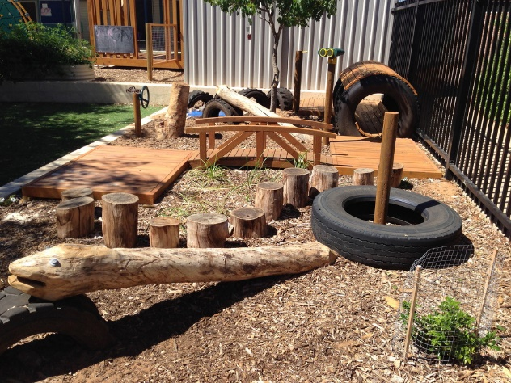
Of the ESDGC as they can extend the children’s play and knowledge by asking the children open questions and informing them of facts linking to the environment. Practitioners can also scaffold children and encourage them to experiment and make their own choices and decisions regarding what they would do with the natural resources they have collected and what they could do to sustain the resources. Children would be able to gain an awareness and an understanding of the environment they live in through discussions with their peers, practitioners and through experimenting themselves (DCELLS, 2008). Engdahl and Rabusicova (2011) state that children are seen as citizens and their participation in reshaping the world is very important as they are the next generation. The research the authors had gathered shows how children have a basic understanding and knowledge of the environment and are able to identify the need to take care of the world by keeping it clean. In comparison to Bourn et al. (2014) where it is stated that children in the UK are aware of the ESDGC however, do they have a direct connection to the environment? Bourn et al. (2014) looks deeply into how children need to have a direct connection to the information practitioners are trying to teach them. Although many authors such as, Engdahl and Rabusicova (2011) and Haas and Ashman (2014) look at the importance of outdoor play and the opportunities it provides, the main point in achieving a successful integration of the ESDGC is for children to fully understand and live by it, making the ESDGC a way of life. Therefore looking into Bourn at al. (2014) research, practitioners must ensure they are not just teaching the ESDGC rather they are making it an experience for children to participate and have a first-hand experience. This could prove to be a challenge for practitioners who are not trained enough on the ESDGC, as they would struggle to provide such first-hand experiences to the children.
(Kids Hub Training and Consultancy, 2015).
Froebel was a theorist who felt passionately about the outdoor environment and children’s first-hand experience in it. He focused on children developing holistically through being in the outdoors and participating in activities such as gardening and free play (Garrick, 2004). Furthermore Cutter-Mackenzie et al. (2014) extends on Froebel’s influence in the environment as the theorist promoted children to explore and have the freedom in experiencing their natural environment. Practitioners can enable children to have the freedom and the choice to experiment in the outdoors as this would ensure children to gain an understanding of how the world works and encourage children to ask questions about the world and the environment. Therefore, practitioners would have successfully integrated the ESDGC within their EY setting (Cutter-Mackenzie et al., 2014).
A challenge practitioners may face could be the weather, they may not be able to integrate the ESDGC within the outdoor environment if they are stopped due to bad weather. Bilton (2014) suggests combating this challenge by providing children with indoor and outdoor access at any time of the day, so children have the freedom to go out when it stops raining. However if practitioners have had good quality training, then they would understand that the weather does not have to stop the children from having access to the outdoors, as it would provide them with new experiences (Clements, 2004).
Living in a deprived area may be a challenge for practitioners when it comes to integrating the ESDGC within the outdoor environment. This could be due to children attending the EY setting unequipped for the outdoors, therefore challenging them to participate in the activities. Practitioners may have to provide these children with extra layers of clothing to enable them to connect with the outdoors. Parents may also not send their child into school on a day where an outdoor trip is taking place, as they may not be able to provide appropriate clothing for their child (Child Poverty Action Group, 2000). This would link to the poverty and wealth section of the ESDGC as practitioners could combat this by providing appropriate clothing and teaching children that not everyone will have everything and as citizens there are certain responsibility in looking after people who are less fortunate (DCELLS, 2008).
Bilton (2010) states that countries such as Sweden and Norway have provided the UK with guidance on how to teach children in the outdoors. Research has suggested that EY settings in countries such as Italy also focus on providing children with learning experiences from the outdoors. Thornton and Brunton (2005) state that the Reggio Emilia settings in Italy allow children to have free access to the outdoor environment, with the permission of their practitioner. The setting also provides opportunities for children to develop a sense of wonder and fascination of the world as the building is adapted to allow children to watch the changing seasons and weather. In comparison to Wales this would be a considerable opportunity in integrating the ESDGC, as children would connect and have more meaningful actions towards their environment. This would also allow practitioners to cross off the integration of the climate change theme from their ESDGC document (Thornton and Brunton, 2005).

Eco-Schools
The United Nations Conference on Environment and Development stated the importance of including young people in overcoming local environmental challenges in order to maintain sustainable development. In Wales, programmes such as
- Foundation for Environmental Education
- Keep Wales Tidy
(Newbridge- on- Wye Church in Wales School, 2017).
Were created to engage children with the matters of ESDGC (Merriman et al., 2014).
Eco-Schools was first created in 1994, it supports children of all ages in making decisions and participating in ensuring that positive changes are made to their environment and school in order to sustain it (Keep Wales Tidy, no date).
Merriman et al. (2014) states that being part of an Eco-School encourages young children in taking the information they have learnt and extending it to outside of the EY setting, to their community and to their homes. Furthermore, Davis (1998) adds that children are able to learn how the natural systems work through Eco-Schools, as they would have full involvement in the programme. It would also allow them to understand and appreciate the environment and the wealth and riches it provides for them unlike some children living in poorer countries.
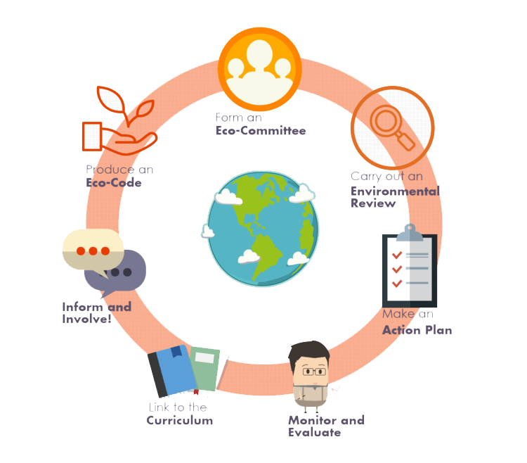
Eco-Schools (no date) state that in order to achieve the green flag, schools must follow these seven steps
- Eco Committee
- Environmental Review
- Action Plan
- Monitoring and Evaluation
- Informing and Involving
- Linking to the Curriculum
(Eco- Schools, no date).
- Eco Code
Article 12 of the UNCRC, states that children have a right to have their views respected (UNICEF, 2016). EY settings that aim to be Eco-Schools provide children with the chance to let their voices be heard through the Eco Committee. A practitioner supports the committee; but children lead it. Eco-Schools (no date) state that Eco Committees must occur often; in order that children have the opportunity to raise any concerns and suggest ideas on how to sustain their school.
Although Eco-Schools focus on children having a voice on sustaining their environment (Eco-Schools, no date). Are children’s voices really heard? Engdahl and Rabusicova (2010) states that under the Convention on the Rights of the Child, children have the right to be involved and informed on matters that concern them. By interviewing children all across the globe, it is noted that children are aware of the environmental implications of the world if it is not taken care of. Therefore, practitioners have a duty to ensure that their voices and suggestions are being heard and put forward within Eco-Schools, as it is their right. This will ensure that children are understanding exactly how they are participating in the reshaping of the world (DCELLS, 2008).
Eco-Schools focus on eight areas in which to sustain their environment, they are
- Litter
- Less waste
- Transport
- Living healthy
- Water
- Energy
- Developing the setting for Biodiversity
- Global Citizenship
(Merriman et al., 2014).
Within the Eco-Committee, children look at ideas given to them by their class regarding the ways to achieve the eight areas. Suggestions such as ‘water and energy monitors’ are used to enable children to be aware of any wastage in settings (Eco-Schools, no date). This provides practitioners with the opportunity to integrate and promote the theme of waste and consumption from the ESDGC, by informing the children as to why they must save water and energy (DCELLS, 2008).
Policies and schemes linking to Eco-Schools support the integration of ESDGC by stating the importance for EY settings to focus on healthy eating. Children are able to follow healthy eating schemes provided by the Welsh Government easily as ‘healthy living’ is one of the eight focused areas of Eco-Schools. Children can suggest ideas on how to be a healthier school and practitioners can support them in ensuring their ideas are implemented (Welsh Government, 2015). However, some schools may struggle to achieve certain areas of the focused eight topics such as healthy living due to deprivation. Over 1 in 5 children live in poverty in Wales, this could have an impact on children attending schools, which promote healthy eating and living, as they may not have enough money to bring a healthy packed lunch or snack to school.
Public Health Wales Observatory (2013) states that the influences children have at a young age carries with them into their adulthood, therefore if they have a healthy well-being when young they should continue to do so as an adult. Merriman et al. (2014) states that practitioners noticed the increase of positive effects of Eco-Schools on children and families as children were going home and sharing the information they had learned at school and ensuring their families were following similar rules at home such as switching off the lights and water when not in use. Bronfenbrenner’s theory of Ecological System links heavily with the involvement of families, children and the EY setting. Leonard (2011) states how children are able to learn better, when multiple of the settings they are in interlink, such as their school and home setting. This allowed families to save energy, money and increase knowledge and opportunities to increase the ethos of ESDGC.

Conclusion
In conclusion, it is seen that practitioners are faced with many opportunities to integrate the ESDGC within their EY setting. Such as providing children with freedom to explore the outdoors and encouraging children to use their voices to make changes. DCELLS (2008) provides guidance to practitioners to ensure they are creating the opportunities to the children. However, as For Schools Education (2015) stated above, practitioners must be knowledgeable on what they are teaching children, as the level of teaching would not be high quality. Which in turn would not be an opportunity for children to live by the ESDGC ethos, as they would not have the adequate information and understanding on how to embed the ethos in their everyday life. School settings provide the opportunity for the ESDGC to be embedded however the main concern would be, are the practitioners trained enough to implement it? If schools want to be successful in integrating the ESDGC, then practitioners must be able to confidently deliver it (Earley and Porritt, 2010).

References
Australian Workplace Training. (2017) VET in Schools. [On-line]. Available at: http://awt.edu.au/vet-in-schools/ [Accessed: 2nd December 2017].
Bilton, H. (ed) (2010) Outdoor Learning in the Early Years: Management and Innovation. London: Routledge Publishers.
Bourn, D., Hunt, F., Blum, N. and Lawson, H. (2016) ‘Primary Education for Global Learning and Sustainability’ http://cprtrust.org.uk/wp-content/uploads/2016/02/Bourn-report-160217-final.pdf [Accessed: 28th November 2017].
Burns, A. and Joyce, DS. H. (2005) ‘Teachers’ voices 8: Explicitly supporting reading and writing in the classroom’ http://www.ameprc.mq.edu.au/docs/research_reports/teachers_voices/Teachers_voices_8.pdf [Accessed: 29th November 2017].
Campbell, A., McNamara, O. and Gilroy, P. (2004) Practitioner research and professional development in education. London: Sage Publications.
Child Poverty Action Group. (2000) ‘The Impact of Poverty’ http://cpag.org.uk/content/impact-poverty [Accessed 1st December 2017].
Clements, R. (2004) ‘An Investigation of the Status of Outdoor Play’, Contemporary Issues in Early Childhood, Volume 5. [On-line]. Available at: http://journals.sagepub.com/doi/pdf/10.2304/ciec.2004.5.1.10 [Accessed: 29th November 2017].
Cole, P. (2004) ‘Professional Development: A great way to avoid change’ http://www.malit.org.uk/wp-content/uploads/Peter-Cole-PD-A-great-way-to-avoid-change.pdf [Accessed: 29th November 2017].
Cutter-Mackenzie et al. (2012) ‘Young Children’s Play and Environmental Education in Early Childhood Education’, Springer Briefs in Education.
Davis, J. (1998) ‘Young children, environmental education and the future’, Education and the Environment. [On-line]. Available at: http://moodle.uwtsd.ac.uk/pluginfile.php/114672/mod_resource/content/2/julia%20%20davies%20paper.pdf [Accessed: 2nd December 2017].
Department for Children, Education, Lifelong Learning and Skills. (2008) Education for Sustainable Development and Global Citizenship- A common understanding for schools. Cardiff: Welsh Assembly Government.
Department for Children, Education, Lifelong Learning and Skills. (2008) Education for Sustainable Development and Global Citizenship- A strategy for action. Cardiff: Welsh Assembly Government.
Department for Education and Skills. (2015) Foundation Phase Framework. Cardiff: Welsh Assembly Government.
DuFour, R. (2004) ‘What is a Professional Learning Community?’, Schools as Learning Communities, Volume 61, May. [On-line]. Available at: http://www.ascd.org/publications/educational-leadership/may04/vol61/num08/What-Is-a-Professional-Learning-Community%C2%A2.aspx [Accessed: 28th November 2017].
Earley, P. and Bubb, S. (2005) Leading and managing continuing professional development. London: Sage Publications.
Earley, P. and Porritt, V. (ed) (2010) Effective practices in continuing professional development. London: Institute of Education, University of London.
Eco-schools. (No date) ‘How it works’ http://www.eco-schools.org.uk/howitworks/seven-steps/eco-code/ [Accessed: 2nd December 2017].
Eco-schools. (No date) How it works. [On-line]. Available at: http://www.eco-schools.org.uk/howitworks/seven-steps/eco-code/ [Accessed: 2nd December 2017].
Engdahl, I. and Rabusicova, M. (2010) ‘Children’s voices about the State of the Earth and Sustainable Development’, World Organisation for Early Childhood Education, July. [On-line]. Available at: file:///C:/Users/1501252/Downloads/1314390_esd-congress-report-child-interviews%20(1).pdf [Accessed: 2nd December 2017].
Engdahl, I. and Rabusicova, M. (2011) ‘Children’s Voices about the State of the Earth’, International Journal of Early Childhood, August. [On-line]. Available at: https://link.springer.com/content/pdf/10.1007/s13158-011-0031-0.pdf [Accessed: 1st December 2017].
Estyn. (2014) ‘ESDGC Progress in education for sustainable development and global citizenship’ https://www.estyn.gov.wales/sites/default/files/documents/ESDGC%3A%20Progress%20in%20education%20for%20sustainable%20development%20and%20global%20citizenship%20-%20June%202014.pdf [Accessed: 1st December 2017].
Farrelly, P. (2010) Early Years Work-Based Learning. Great Britain: Learning Matters Ltd. [e-book]. Available at: https://www-dawsonera-com.ezproxy.uwtsd.ac.uk/readonline/9781844456178 [Accessed: 28th November 2017].
For Schools Education. (2017) ‘Developing and Sustaining High Quality Teaching’ http://www.forschoolseducation.co.uk/teaching-learning/developing-and-sustaining-high-quality-teaching/ [Accessed: 28th November 2017].
Garrick, R. (2004) Playing outdoors in the Early Years. London: Continuum.
Governors Wales. (No date) ‘ESDGC Governor Toolkit’ http://www.governorswales.org.uk/media/files/documents/2013-10-15/ESDGC_Governor_Toolkit_English.pdf [Accessed: 30th November 2017].
Haas, C. and Ashman, G. (2014) ‘Kindergarten children’s introduction to sustainability through transformative, experiential nature play’, Australasian Journal of Early Childhood, Volume 39, June. [On-line]. Available at: file:///C:/Users/1501252/Downloads/Nature%20play.pdf [Accessed: 30th November 2017].
Horsley, W. M. and Bauer, A. K. (2010) ‘Preparing early childhood educators for global education: the implications of prior learning’, European Journal of Teacher Education, Volume 33, November. [On-line]. Available at: file:///C:/Users/1501252/Downloads/arly%20childhood%20prior%20leaning%20of%20early%20childhood%20teachersgood.pdf [Accessed: 30th November 2017].
Joyce, B. and Showers, B. (2002) ‘Student Achievement through Staff Development’ National College for School Leadership. [On- line]. Available at: https://www.unrwa.org/sites/default/files/joyce_and_showers_coaching_as_cpd.pdf [Accessed: 28th November 2017].
Keep Wales Tidy. (No date) ‘Eco- schools’ https://www.keepwalestidy.cymru/Pages/Category/eco-schools [Accessed: 1st December 2017].
Kids Hub Training and Consultancy. (2015) Outdoor Environments. [On-line]. Available at: http://www.kidshubtc.com.au/outdoor-environments-1/ [Accessed: 2nd December 2017].
Kozulin, A., Gindis, B., Ageyev, S. V. and Miller, M. S. (2003) Vygotsky’s Educational Theory in Cultural Context. Cambridge: Cambridge University Press.
Leonard. J. (2011) ‘Using Bronfenbrenner's Ecological Theory to Understand Community Partnerships: An Historical Case Study of One Urban High School’, Leadership in Education. [On-line]. Available at: http://scholarworks.umb.edu/cgi/viewcontent.cgi?article=1000&context=education_faculty_pubs [Accessed: 2nd December 2017].
Macintyre, C. (2002) Enhancing learning through play: A developmental perspective for Early Years settings. London: David Fulton Publishers.
Merriman, E., Rekers-Power, A., Tinney, G. and MacGarry, A. (2014) ‘An Evaluation of the Eco-Schools Programme in Wales’,The University of Wales Trinity St David, June, pp. 1-3.
National Federation Training Wales. (No date) ‘Education for Sustainable Development and Global Citizenship (ESDGC) in Work Based Learning’ https://www.ntfw.org/wp-content/uploads/2011/11/ESDGC-Ebook.pdf [Accessed: 29thNovember 2017].
Newbridge- on- Wye Church in Wales School. (2017) Eco Committee. [On-line]. Available at: http://www.newbridge.powys.sch.uk/Page.aspx?ID=23391 [Accessed: 2nd December 2017].
Outdoor Matters. (2007) ‘Effective practice: Outdoor learning’ http://outdoormatters.co.uk/wp-content/uploads/2011/03/EYFS-Effective-PracticeOutdoor-Learning.pdf [Accessed: 29th November 2017].
Public Health Wales Observatory. (2013) ‘Health of Children and Young People in Wales’ http://www2.nphs.wales.nhs.uk:8080/PubHObservatoryProjDocs.nsf/3653c00e7bb6259d80256f27004900db/fc57159cf0046a8a80257c28004aa6ea/$FILE/Children%20and%20YP%20Profile%20Wales%20report%20-%20low%20res%20(Eng).pdf [Accessed: 2nd December 2017].
Simply Put Together. (2011) Vygotsky- What does he know about kids anyway?. [O-line]. Available at: http://mentoringsimplyput.blogspot.co.uk/2011/10/vygotsky-what-does-he-know-about-kids.html [Accessed: 2nd December 2017].
Stevens, D., Miles, S., Robertson, H., King, H., Revera, C., Glover, R., Neudegg, C. and Lart, S. (no date) ‘ESDGC’ http://resources.hwb.wales.gov.uk/VTC/2008-09/esdgc/getting-you-going/index.html [Accessed: 28th November 2017].
Swansea University. (No date) Education for Sustainable Development and Global Citizenship. [On-line]. Available at: http://www.swansea.ac.uk/sustainability/esdgc/ [Accessed: 2nd December 2017].
Thornton, L. and Brunton, P. (2005) Understanding the Reggio approach reflections on the early childhood experience of Reggio Emilia. London: David Fulton Publishers. [E-book]. Available at: http://web.b.ebscohost.com.ezproxy.uwtsd.ac.uk/ehost/ebookviewer/ebook/bmxlYmtfXzEyNTM3OV9fQU41?sid=1b4f5152-53c1-4f74-8670-a6f5fca450e3@pdc-v-sessmgr01&vid=0&format=EB&rid=1 [Accessed: 1st December 2017].
Tinney, G. and Merriman, E. (no date) ‘Early Years Education and Education for Sustainable Development and Global Citizenship (ESDGC) - Two Sides of the Same Coin?’ School of Early Years: UWTSD.
Unicef. (2016) ‘The United Nations Convention on the Rights of the Child’ http://www.unicef.org.uk/wp-content/uploads/2010/05/UNCRC_PRESS200910web.pdf [Accessed: 28th November 2017].
Welsh Government. (2015) ‘Healthy and Sustainable Pre-School Scheme National Awards Criteria’ http://www.wales.nhs.uk/sitesplus/documents/888/HSPSS-Doc%28E%29.pdf [Accessed: 2nd December 2017].
Ysgol Stanwell School. (No date) ESDGC. [On-line]. Available at: http://www.stanwell.org/school/esdgc/ [Accessed: 2nd December 2017].

