Configure and manage the Virtualised Enterprise Network
UWTSD |
Network Operating Systems and Services ACCA5023
Walter Ernesto Melendez Dominguez (2413597)
2025

Routing configuration

Implementation Details:
To connect the Swansea (192.168.1.0) and London (192.168.2.0) networks, I used a Debian machine as a Router (L-CD). I enabled IP Forwarding by editing the /etc/sysctl.conf file and un-commenting the line net.ipv4.ip_forward=1. I ran sysctl -p to apply the changes immediately. This ensures the routing is persistent even after a reboot. In VirtualBox, I double-checked that the network adapters were set to "Internal Network" and "Allow All" mode to permit traffic flow between the VMs.
Evidence: The screenshot below shows the configuration wizard used to enable the Routing and Remote Access Service on the Server.
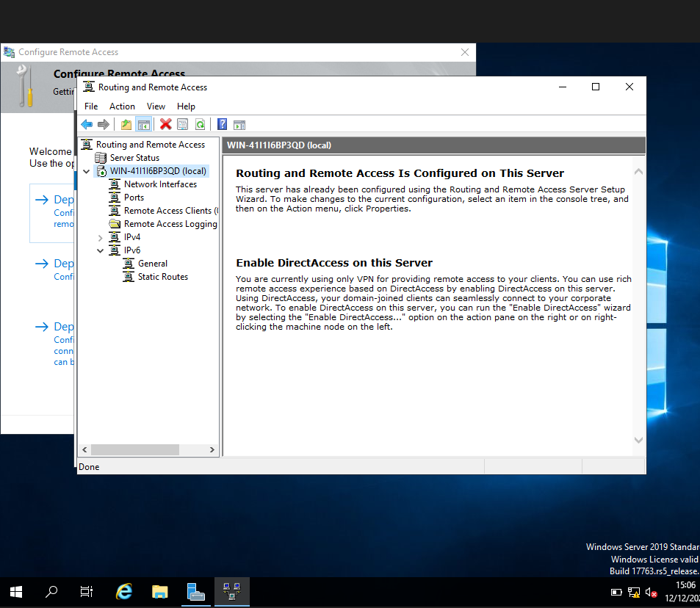

Configuration Evidence: To enable routing capabilities, I modified the kernel parameters. The screenshot below confirms that IPv4 forwarding is active (1):
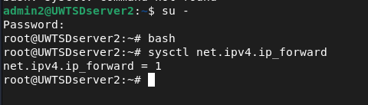

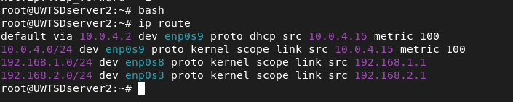
Furthermore, the routing table below shows the router's direct connection to both the Swansea (192.168.1.0) and London (192.168.2.0) subnets:

Domain Controller Setup

Implementation Details: After installing the Windows Server OS, I proceeded to configure the core infrastructure services.
- Static IP: I assigned the static IP 192.168.1.5 to the server to ensure reliable DNS resolution for the network.
- Domain Controller Promotion: I installed the AD DS role and promoted the server to a Domain Controller, creating a new forest named swansea.acca.
- DNS Configuration: During the promotion, the DNS role was automatically installed. I verified that the Forward Lookup Zones were created correctly to map the server hostnames to their IP addresses (A Records).
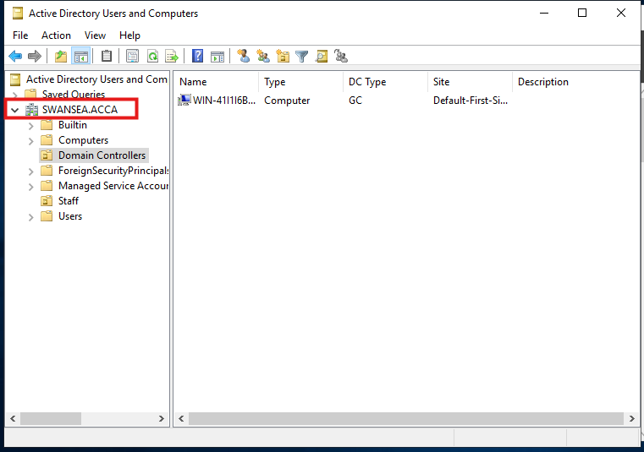
The Active Directory management console below confirms that the domain is active and the Domain Controller is registered in the Domain Controllers Organizational Unit (OU).

Site-to-Site VPN Connection
Implementation Details: To establish a secure communication channel between the Swansea and London networks, I configured the Routing and Remote Access Service (RRAS) on the Windows Server. I set up a VPN Interface (VPN1) to handle the traffic between the sites. This configuration ensures that traffic destined for the remote subnet is correctly routed through the secure tunnel interface rather than the default gateway.
- Service Status: The RRAS service was enabled and configured to start automatically, ensuring a persistent connection.
- Routing: Static routes were added to direct traffic for the remote network through the VPN interface.
Evidence: The screenshot below confirms that the Routing and Remote Access service is active (indicated by the green status icon). Furthermore, the routing table explicitly shows the VPN1 interface handling traffic for the remote network segment.
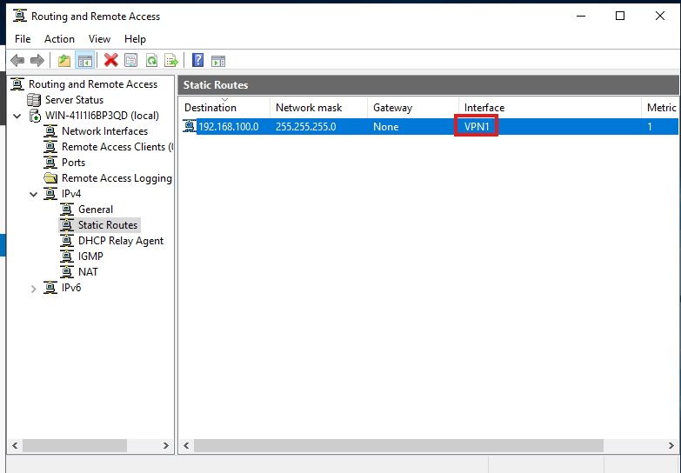

User Accounts Management
Implementation Details: I created the user accounts for the swansea.acca domain following the specific naming convention provided in the requirements ([FirstInitial].[LastName], e.g., a.melendez).
- Creation Method: I used the Active Directory Users and Computers (ADUC) console to create the user objects and ensure they were placed in the correct Organizational Unit (OU).
- Security: I assigned a temporary password to each user and configured the account options to ensure they adhere to the domain's security policies.
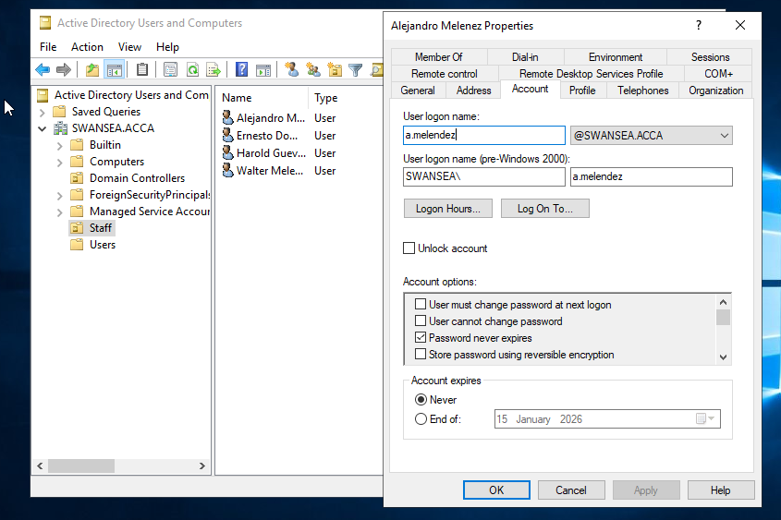
Evidence: The screenshot below displays the created user accounts within the Active Directory management console, verifying that the naming convention was correctly applied.

Domain Membership Integration

Implementation Details: The critical objective of this section was to integrate diverse operating systems into the centralized Active Directory environment. While joining Windows clients is native, joining the Linux Client (ClientL1) required specific configuration:
- DNS Configuration: I manually edited /etc/resolv.conf to point the client to the Domain Controller's DNS (192.168.1.5). Without this, the client could not resolve the SRV records needed to locate the KDC.
- Package Installation: I installed realmd, sssd, adcli, and packagekit to handle the authentication backend.
- Joining the Domain: I utilized the command realm join -v -U Administrator swansea.acca. This command authenticated against the AD server and created the computer account object in the domain.
- Authentication Test: I verified the integration by switching from the local root account to a domain user account using the su - command.
Evidence: The screenshot below serves as definitive proof of the successful integration. It shows the terminal session where I switched to the domain user a.melendez@swansea.acca. The output of the id command confirms that the user's UID and GID groups are being retrieved directly from the Active Directory database, proving that the Linux machine is securely communicating with the Windows Domain Controller.
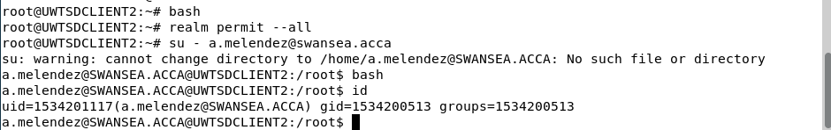

DHCP Infrastructure
Implementation Details: To automate IP address allocation and ensure efficient network management, I deployed a centralized DHCP infrastructure.
6.1 DHCP Server Configuration (S-DC): I installed the DHCP Server role on the main Domain Controller. Following the assignment requirements, I created two distinct scopes to serve both subnets:
- Swansea_LAN: Allocating addresses for the local network (192.168.1.0/24).
- London_Scope: Allocating addresses for the remote network (192.168.2.0/24).
- Address Pool: For both scopes, I strictly limited the address pool range from .10 to .20 (e.g., 192.168.1.10 - 192.168.1.20) as specified in the instructions.
Evidence: The screenshot below shows the DHCP management console with both scopes active and ready to distribute addresses.
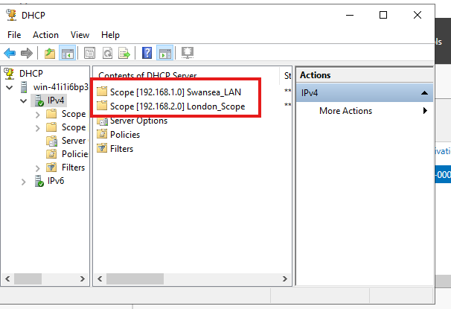

Testing and Troubleshooting

Connectivity Testing After completing the configuration of the Router, Domain Controller, and DHCP services, I performed a comprehensive connectivity test to verify communication between the Swansea (192.168.1.0/24) and London (192.168.2.0/24) networks.
- Methodology: I used the ping command (ICMP) from the Linux Client in London to target the Windows Server in Swansea.
- Result: The test returned 0% packet loss, confirming that the routing table, firewall rules, and physical (virtual) links are functioning correctly.
Evidence: The screenshot below demonstrates the successful ICMP reply from the Server (192.168.1.5), proving end-to-end connectivity.

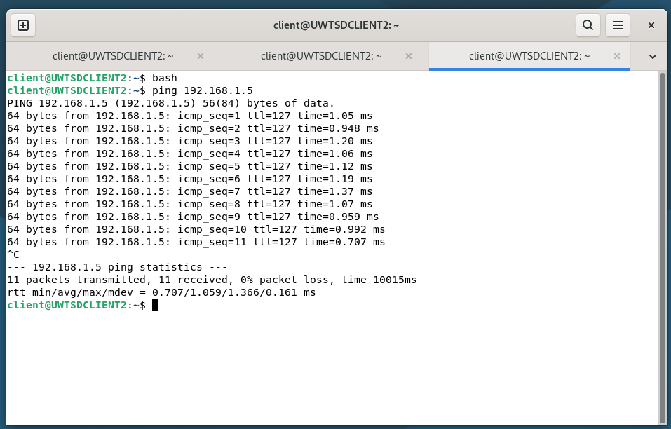

Troubleshooting During the configuration, I faced a few problems that I had to fix to make the network work:
Connection Refused: At the beginning, I could not ping from the Linux client to the Windows Server. I checked the VirtualBox settings and realized that the "Internal Network" names were different on the adapters. I corrected the names to match, and the ping started working.
Server IP Address: The Windows Server suddenly stopped working properly. I checked with ipconfig and saw it had a 169.254.x.x address instead of the correct static IP. I manually re-entered the IP 192.168.1.5 to fix the Domain Controller.
Joining the Domain: When I tried to join the Linux machine to the domain, I got an error saying the domain could not be found. The issue was that the Linux machine didn't know the DNS server address. I edited the /etc/resolv.conf file to point to 192.168.1.5, and then the join command worked.

