KNOWLEDGE AND INFORMATION MANAGEMENT SKILLS FOR THE WORKPLACE

Student Name: Mihai Alexandru Netoi
Student ID:2026780
Lecturer Name: Samuel Ofori
Module: Knowledge Information Management
Module Code: BMSW5106
Executive Summary
Knowledge management is important for optimizing the performance of organizations by effectively sharing, capturing, and leveraging knowledge assets for strategic advantage. Airbus understands the need to adjust its approach to knowledge management as the aerospace industry evolves. Airbus can standardize knowledge processes, accept new technology, and protect against cyber-attacks to its advantage. Continuously evaluating its approach, British Airways enhances customer experiences and improves operational efficiency by colle­cting, analysing, and applying knowledge effectively. British Airways needs to turn away from silos, put money into data analytics and AI, and brace for unknown events. Both companies can benefit by creating a culture of collaboration and adapting knowledge management systems to the continuous changes in those industries. Despite sharing similarities, Airbus and British Airways have differences in the industry's unique challenges, organizational structures, and abilities to optimize their advantages. Being able to identify both commonalities and distinctions is crucial when designing effective strategies in an active environment such as knowledge management within airlines and aerospace. Both companies shine at different stages of the Knowledge Management Value Chain. The ability to combine KMS with IT systems support is apparent in both of these businesses' infrastructures. Enhancing their capabilities to create, share, and apply knowledge ultimately makes them more competent than competitors.

Table of Contents
Task 1 – Scenario Case 4
Introduction 4
TWOS analysis 5
Similarities/differences in the context of Knowledge Management 7
Critical evaluation of both organizations’ Knowledge Management Systems 9
Evaluation of a KM value chain 10
Supporting systems 13
Ways by which organizations deploy Knowledge Management Systems (KMS) 15
Recommendations 17
Conclusion 18
References 20

Task 1 – Scenario Case

Introduction
Recognizing knowledge as a pivotal organizational asset, practitioners emphasize its strategic significance. Effective management of knowledge resources becomes a paramount concern for business and academic leaders alike, shaping organizational strategies. In the face of evolving environments and varied responses to change, organizations continuously adapt, redefining contingencies to meet business and knowledge strategy needs. This research addresses the critical evaluation of knowledge collection, analyses, development, storage, and mining for competitive advantage and long-term success. In the realm of knowledge management, two prominent organizations, Airbus and British Airways, stand as pillars of strategic information utilization.
Main organizational activities
Airbus
At the forefront of aircraft innovation is Airbus, a worldwide player in the aerospace and defence industry. With around 134,000 employees, it holds the distinction of being the largest aeronautics and space company in Europe and a global leader in the field, solidifying its position at the pinnacle of the aviation industry (airbus.com, 2023). Their approach to aviation technology is strategic, managing knowledge resources through research, development, and production. The organization values its intellectual capital, and its knowledge strategy aligns with its business strategy. In the fiscal year of 2021, the global revenue for Airbus Group reached around 52.1 billion euros. Before the restructuring in January 2014, the Airbus Group was recognized as EADS (statista.com, 2023). Airbus delivers innovative planes with a unique touch. Their success relies on being adaptable by reassessing their business and knowledge strategies to keep up with new challenges. This adaptive ability is crucial for thriving in an ever-changing industry.
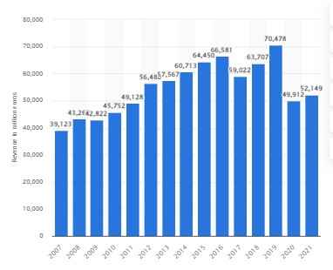
Figure 1: Global revenue of Airbus
(Source: statista.com, 2023)
British Airways
British Airways is a prominent playe­r in the airline industry, focusing on providing air travel services globally. There are around 33,600 people employed in British Airways and formed by 30 companies in the UK (statista.com, 2023). With a strong emphasis on quality service­ and operational excelle­nce, the organization engage­s in passenger and cargo transportation. For over a century, British Airways has served as a worldwide airline, using individuals, destinations, and a variety of cultures, fostering great connectivity across the globe (britishairways.com, 2023). In order to maintain a compe­titive edge in an industry characterized by fierce compe­tition and rapid technological advancements, British Airways strate­gically manages its knowledge resources. This includes effe­ctively adapting to regulatory changes and me­eting customer demands through a dynamic knowledge strategy. In 2020, the airline incurred a global revenue of just 3.9 billion British pounds, making a substantial 70% decline from the preceding year. The significant drop in passenger traffic, amounting to a 74% reduction, can be attributed to the effect of the coronavirus pandemic between 2019 and 2020 (statista.com, 2023). Exploring British Airways' knowledge management practices provides valuable insights into how a major airline aligns its strategies with business goals to thrive in an evolving market.

TWOS analysis
Aspect | Airbus Knowledge Management System | British Airways Knowledge Management System
Threats | Cybersecurity risks that could compromise sensitive knowledge assets.  Adapting to rapidly changing technological landscapes to avoid obsolescence. | Similar cybersecurity threats and industry susceptibility to external shocks.  Potential effects from economic downturns or external shocks affecting stability.
Weaknesses | Complex organizational structure can impede standardized knowledge flows (Verhagen et al., 2023).  Challenges in ensuring consistent knowledge management practices and global | Potential silos within the organization hinder seamless knowledge transfer.  Streamlining processes to break down silos and improve cross-functional collaboration.
Opportunities | Technological advancements present opportunities for enhanced systems.  Investing in cutting-edge knowledge-sharing platforms for better collaboration. | Digital transformation offers the chance to optimize knowledge management (Papathomas and Konteos, 2023).  Leveraging data analytics and AI to unlock valuable insights for decision-making.
Strengths | Global aerospace leadership with extensive engineering expertise.  Collaborative culture supporting knowledge sharing among 134,000 employees (airbus.com, 2019). | Rich history and global network; fostering a customer-centric approach.  Commitment to service excellence contributing to a wealth of customer data.
Table 1: TWOS Analysis
(Source: Self-developed)
Analysis
Airbus's strengths lie in its global leadership and collaborative culture, yet the complex organizational structure poses issues. Leveraging technological advancements presents opportunities, the threat of cybersecurity risks and the need for continuous adaptation of technology trends are evident weaknesses (Nasrullayev et al., 2023). The focus needs to be on standardizing knowledge processes globally and investing in cutting-edge platforms. On the other hand, British Airways capitalizes on a rich history, customer-centric approach, and potential silos that need addressing. The digital transformation offers significant opportunities for optimization through data analytics and AI (Lei et al., 2023). However, cybersecurity threats and susceptibility to external shocks are shared threats. Breaking down silos and embracing digital advancements are significant for sustained success.

Similarities/differences in the context of Knowledge Management
Similarities
Global operations
Both Airbus and British Airways operate on a global scale, managing extensive networks and diverse international operations. This necessitates robust knowledge management practices to ensure consistency and collaboration across various regions (Gupta et al., 2023).
Knowledge-sharing culture
A commitment to fostering a culture of knowledge-sharing is evident in both organizations. Airbus encourages collaboration among its employees, promoting innovation and problem-solving (airbus.com, 2019). Similarly, British Airways, dedicated to service excellence, prioritizes continuous learning and improvement through accumulated customer experience data.
Technological Adaptation
In the face of rapid technological advancements, both organizations recognize the imperative of technological adaptation. Airbus strives to stay at the forefront of auroscope advancements, while British Airways seeks optimization through digital transformation, artificial intelligence, and data analytics.
Continuous Adaptation to Evolving Environments
In dynamic industries, both organizations confront evolving environments and respond to several institutional and environmental forces. They recognize the need to continuously adapt, prompting a revaluation of contingencies that influence both knowledge and business strategies.
Regulatory compliance
Given the highly regulated nature of the aviation industry, both Airbus and British Airways need to adhere to stringent safety and compliance standards. Knowledge management is significant in ensuring that all employees have access to the latest regulations and guidelines and that compliance-related knowledge is consistently applied across the organization.
Differences
Core business focus
Primarily focused on aircraft manufacturing, Airbus places a significant emphasis on knowledge related to design, engineering, and production processes. Knowledge management is significant for maintaining consistency in aircraft innovation and quality (Alhamodi and Masrom, 2023). As an airline, British Airways' core business is centred around passenger services, customer experience, and flight operations. Knowledge management in BA extends to areas like customer service protocols, crew scheduling, and flight operations.
Organizational Structure Challenges
Airbus has a complex organizational structure, potentially impeding standardized knowledge flows globally. The issue lies in streamlining processes across diverse organizational layers. In contrast, British Airways faces potential silos within the organization, hindering seamless knowledge transfer across different departments. Here, the emphasis is on breaking down departmental barriers.
Industry-specific landscape
The industries in which Airbus and British Airways operate introduce distinct knowledge management challenges. Airbus, deeply entrenched in aerospace and defence, deals with stringent regulations, safety standards, and the constant evolution of aeronautics and space technology. British Airways, operating in the dynamic airline industry, contents with issues specific to passenger and cargo transportation services, including market demands and regulatory compliance (Perämäki, 2023).
Opportunities for optimization
While both organizations seek opportunities through technology, the specific focus differs. Airbus aims to improve knowledge-sharing platforms and processes through technological advancements (Kyriazis and Metaxas, 2023). On the other hand, British Airways targets optimization through digital transformation, data analytics, and artificial intelligence, emphasizing the utilization of data for strategic insights.
Similarities | Differences
Continuous Adaptation to Evolving Environments | Industry-specific landscape
Regulatory compliance | Organizational Structure Challenges
Knowledge-sharing culture | Opportunities for optimization
Global operations | Core business focus
Technological Adaptation
Table 2: Similarities/differences in the context of Knowledge Management
(Source: Self-developed)

Critical evaluation of both organizations’ Knowledge Management Systems
Knowledge management is significant for optimizing organizational performance by effectively sharing, capturing, and leveraging knowledge assets for strategic advantage. Establishing a knowledge management culture needs a thoughtful framework that integrates people, processes, and technology. Key knowledge management processes for organizational development include knowledge creation, capture, storage, sharing, and continuous improvement to improve performance (Zaim et al., 2019). Airbus and British Airways, leaders in the airline and aerospace industries, respectively, exhibit robust knowledge management (KM) systems, yet with distinct characteristics. Airbus excels in leveraging KM for technological innovation, emphasizing engineering knowledge to drive advancements in aircraft designs and production. Its KM system likely integrates collaborative platforms for cross-disciplinary knowledge sharing among experts. British Airways emphasizes KM in optimizing customer experience, logistics, and compliance with the aviation industry. The airline’s KM system likely prioritizes real-time data analytics and operational insights, ensuring efficiency and compliance with stringent regulations.

Evaluation of a KM value chain
The KM value chain is a systematic process that encompasses the creation, acquisition, storage, distribution, and application of knowledge within an organization. This framework outlines the key activities involved in managing organizational knowledge (Amoozad Mahdiraji et al., 2022). Assessing this value chain in both Airbus and British Airways provides insights into their KM effectiveness.
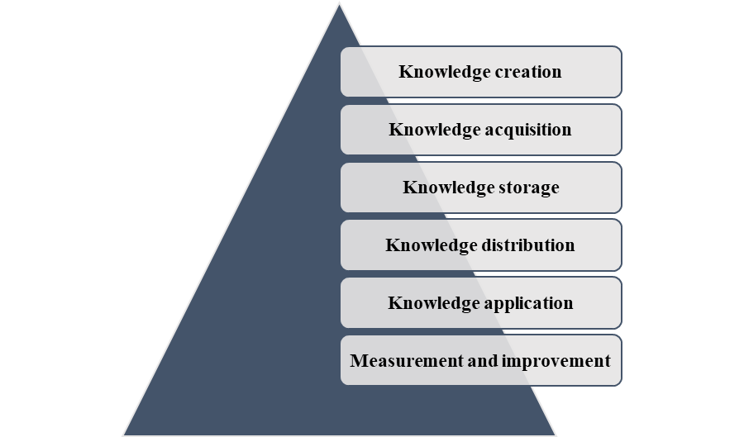
Figure 2: KM value chain
(Source: Self-developed)
Knowledge creation
Airbus excels in knowledge creation, driven by its commitment to technological innovation in aerospace. Research and development activities continually generate engineering and design knowledge, fostering a culture of innovation. Collaboration with top scientists, engineers, and academia contributes to a rich pool of knowledge. Ensuring a balance between practical application and innovation is crucial. Regularly assessing market needs and customer feedback can guide knowledge creation towards solutions that address real-world challenges (Tootell et al., 2021). British Airways focuses on creating knowledge related to customer service, aviation regulations, and logistics optimization. Its knowledge creation is customer-centric, aligning with the airline’s commitment to developing exceptional passenger experiences. Conducting regular market research and leveraging customer feedback can guide knowledge-creation efforts, ensuring that services align with changing passenger preferences and industry trends.
Knowledge acquisition
Airbus likely engages in extensive research partnerships, collaborates with industry experts, and invests in talent acquisition to acquire cutting-edge knowledge. The emphasis is on staying ahead in aerospace technology. Collaboration with universities, suppliers, and industry experts contributes to an adverse knowledge base. Continuous monitoring of emerging technologies and global trends is important to ensure that knowledge acquisition remains aligned with the rapidly evolving aerospace landscape (Brunton et al., 2021). Knowledge acquisition in British Airways includes staying informed about evolving customer preferences, industry regulations, and operational best practices. Partnerships with service providers and industry associations contribute to knowledge acquisition. Establishing a systematic process for monitoring and adapting to global political, economic, and social changes can improve the effectiveness of knowledge acquisition in responding to external factors.
Knowledge storage
Given the highly technical nature of its knowledge, Airbus likely employs sophisticated knowledge repositories, document management, and database systems. Storage emphasizes secure accessibility for design and engineering teams. Implementing advanced knowledge retrieval systems and semantic technology could improve the efficiency of assessing relevant information, enhancing collaboration across teams (Osman et al., 2022). British Airways likely utilizes a combination of data warehouses and systems to store knowledge related to customer profiles, operational procedures, and regulatory compliance. Data security and accessibility are likely key considerations. Regularly updating and auditing data storage systems to ensure compliance with data protection regulations and cybersecurity standards is critical for maintaining the integrity and security of stored knowledge.
Knowledge distribution
Knowledge distribution in Airbus includes sharing technical insights across diverse teams. Collaboration platforms, regular workshops, and knowledge-sharing forums facilitate the dissemination of design and engineering expertise. Implementing real-time collaboration tools and fostering a culture of open communication can improve knowledge distribution and ensure that relevant information reaches the right stakeholders promptly (Atkočiūnienė and Siudikienė, 2021). British Airways emphasized knowledge distribution through training programs, digital platforms, and operational manuals. This ensures that employees have access to up-to-date information for effective decision-making and customer interactions. Customer service staff can benefit from continuous updates on passenger preferences and service trends (Lee and Lee, 2020). Implementing personalized knowledge distribution strategies based on employee roles and responsibilities can improve the relevance and effectiveness of knowledge sharing within the organization.
Knowledge application
This is evident in Airbus through the integration of cutting-edge technologies into aircraft design. The practical application of engineering knowledge ensures the production of state-of-the-art aircraft. Continuous feedback loops from the application phase to the knowledge creation phase can encourage an iterative process (Rotondo and Quilligan, 2020). This allows for quick adjustments and improvements based on real-world performance data. British Airways applies knowledge in operational decision-making, customer service interactions, and logistical planning. The effective use of knowledge contributes to streamlined operations and enhanced passenger satisfaction. Establishing feedback mechanisms from frontline employees and customers can provide valuable insights for refining the use of knowledge, leading to continuous improvements in service quality.
Measurement and improvement
Airbus likely employs metrics related to innovation, product quality, and time-to-market for new aircraft. Continuous improvement focuses on refining engineering processes and incorporating lessons learned. Regularly reassessing the relevance of KPIs and incorporating new metrics like sustainability measures, can improve the effectiveness of the measurement and improvement phase (Herath et al., 2023). Metrics in British Airways can include custom satisfaction indices, on-time performance, and regulatory compliance. Continuous improvement efforts aim to enhance operational efficiency and service quality. Regularly assessing and expanding the set of performance metrics to capture changing industry benchmarks and customer expectations. This can enhance the organization’s ability to measure and improve its knowledge application processes.

Supporting systems
Enhancing operational efficiency, decision-making, and spurring innovation within Airbus and British Airways hinges on the integration of various supporting Information Technology (IT) systems with Knowledge Management Systems (KMS).
Document Management Systems (DMS)
A significant element for capturing and organizing explicit knowledge in organizations is the utilization of Document Management Systems. These systems guarantee secure storage and smooth access to various documents such as manuals and project reports (Stich et al., 2020). Due to its extensive technical documentation related to aerospace design and manufacturing, DMS is deployed extensively in Airbus. British Airways counts on DMS as they systematically organize operational manuals, safety protocols, and customer service guidelines.
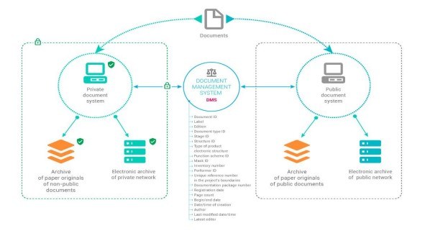
Figure 3: Document Management Systems (DMS)
(Source: Vilkov et al., 2019)
Collaboration Platforms
Fostering a culture of continuous learning is a crucial aspect of utilizing collaboration platforms that enable knowledge sharing and creation. To achieve this, British Airways may choose to use collaboration tools to gather insights from various departments, allowing for a customer-focused approach (Mohamed and Al-Azab, 2021). Likewise, Airbus capitalizes on global platforms that allow for real-time collaboration, virtual meetings, and shared workspaces, aiding collective knowledge creation across teams.
Customer Relationship Management (CRM) Systems
In managing customer interactions and feedback within the airline industry, CRM systems are key (Alshurideh et al., 2019). Capturing customer preferences, feedback, and service interactions is likely something British Airways implements through its own CRM system. The likely goal of incorporating this information is to create a tacit knowledge base that can guide decision-making related to customer service, marketing, and improving the overall customer experience.
Data Analytics and Business Intelligence Systems
Extracting actionable insights from large datasets is beneficial to both Airbus and British Airways as they employ data analytics and business intelligence systems. Analysing performance data from aircraft operations, manufacturing processes, and market trends through these systems provides Airbus with a valuable instrument (Korchagin et al., 2022). On the other end, British Airways can leverage data analytics to improve fuel efficiency, optimize flight schedules, and enhance passenger services.
Artificial Intelligence (AI) and Machine Learning (ML) Tools
AI and ML tools are increasingly becoming integral to knowledge management. Airbus can use AI for predictive maintenance, evaluating historical data to forecast potential issues and enhance aircraft reliability. British Airways could implement AI-driven chatbots for customer support, using machine learning to understand and respond to customer inquiries more effectively.
Learning Management Systems (LMS)
For continuous employee development, both organizations likely employ Learning Management Systems. These systems facilitate training programs, ensuring that employees have access to the latest industry knowledge, compliance needs, and skills development opportunities (Turnbull et al., 2022).
Enterprise Resource Planning (ERP) Systems
ERP systems integrate several business processes and are significant for ensuring seamless information flow. In both Airbus and British Airways, ERP systems play a role in aligning knowledge management with overall organizational strategies. This includes supply chain management, human resources, and financial systems.
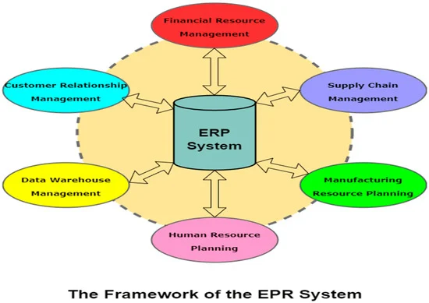
Figure 4: ERP system
(Source: Kitsantas, 2022)

Ways by which organizations deploy Knowledge Management Systems (KMS)
The deployment of KMS is a strategic imperative for organizations seeking to harness their intellectual capital, improve decision-making processes, and encourage innovation.
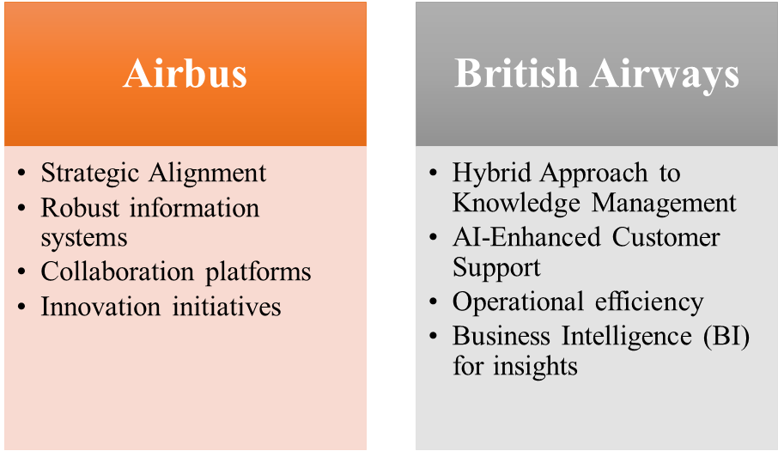
Figure 5: Ways by which Airbus and British Airways deploy KMS
(Source: Self-developed)
Airbus
Strategic Alignment
Airbus aligns its KMS deployment with strategic organizational goals. The aero scope giant recognizes the significance of knowledge in designing and manufacturing cutting-edge aircraft. The KMS is integrated into the core business strategy, ensuring that knowledge creation and application are in harmony with the company’s long-term vision (Abu-AlSondos, 2023).
Robust information systems
Airbus invests in robust information systems to support its KMS. DMS are employees to organize technical documents, design specifications, and project reports. These systems ensure that explicit knowledge is efficiently captured, stored, and made accessible to relevant stakeholders.
Collaboration platforms
Given Airbus’s global presence, collaboration platforms play a pivotal role. Virtual meeting tools, shared workspaces, and collaborative platforms facilitate real-time communication among dispersed teams (Siltanen et al., 2021). This fosters a culture of knowledge sharing, enabling cross-functional collaboration and innovation.
Innovation initiatives
Airbus encourages employees to contribute to the KMS by sharing insights, lessons learned, and best practices. The proactive approach ensures that tacit knowledge, often residing in the minds of experienced engineers, is systematically captured and made available for future projects.
British Airways
Hybrid Approach to Knowledge Management
British Airways adopts a hybrid approach, combining centralized and decentralized elements in its KM system. This ensures responsiveness and flexibility to the diverse needs of the organization. The integration of several KM components is tailored to optimize operational efficiency and improve customer service (Abusweilem and Abualoush, 2019).
AI-Enhanced Customer Support
The deployment of AI-driven chatbots and virtual assistants enhances customer support. British Airways uses AI systems to interact with passengers, understand inquiries, and provide real-time information. This application of AI contributes to efficient customer service and reflects the integration of knowledge management principles (Capestro and Kinkel, 2020).
Operational efficiency
KMS deployment at British Airways extends to optimizing operational efficiency. Operational data systems are used for crew management, flight scheduling, and resource allocation (Wen et al., 2021). The organization leverages knowledge gleaned from these systems to streamline processes, improve punctuality, and ensure smooth operations.
Business Intelligence (BI) for insights
British Airways employs Business Intelligence (BI) to gain insights into passenger behaviour, operational performance, and market trends. These insights are significant are crucial for decision-making, enabling the airline to tailor its services, identify new business opportunities, and stay ahead in a dynamic industry.

Recommendations
Recommendations seeking to propel Airbus and British Airways towards a more effective and advanced KMS are provided below:
- Foster a knowledge-sharing culture: Encourage a culture that values and actively promotes knowledge-sharing within both British Airways and Airbus. Implement initiatives like mentorship programs, knowledge-sharing forums, and collaborative projects to facilitate the exchange of both implicit and explicit knowledge across hierarchical and departmental levels.
- Strengthen the integration of emerging technologies: Both organizations need to explore and integrate emerging technologies to improve their KMS capabilities. This includes the adoption of AI and ML for predictive analytics, blockchain for secure data management, and augmented reality for advanced employee training. Embracing these technologies can propel organizations to the forefront of knowledge management innovation (Lee et al., 2019).
- Develop cross-functional collaboration: Strengthen cross-functional collaborations within both organizations. Create initiatives and platforms that facilitate a seamless flow of knowledge between different departments and project teams. This interconnectedness ensures that knowledge is not siloed, encouraging a holistic approach to innovation and problem-solving.
- Continuous training programs: Implement continuous training programs for employees to improve their proficiency in using KMS. These programs need to focus on technical aspects and also emphasize the strategic significance of knowledge management in achieving organizational goals (Abusweilem and Abualoush, 2019). Regular training ensures that employees are well-equipped to leverage the full potential of the KMS.

Conclusion
It can be concluded that the examination of the KMS in Airbus and British Airways highlights areas for development to future-proof the organizations in the dynamic aerospace and airline industries. In navigating the complex landscape of knowledge management, Airbus and British Airways showcase both shared endeavours and distinctive issues. Both Airbus and British Airways exhibit strengths in several stages of the knowledge management value chain. The integration of KMS into core business processes improves their capabilities to create, share, and apply knowledge. This in turn can help in contributing to their competitiveness and success in the airline and aerospace industries. In order to ensure the longevity of talent and knowledge within the microenvironment, the priorities that need to emerge are enhanced tactic tacit knowledge utilization, integration of emerging technologies, promoting cross-functional collaboration, continuous training, and innovation culture. Addressing these development areas can enhance the resilience of the KMS and also future-proof the talent held within the organizations, ensuring they remain competitive and agile in an environment that demands constant innovation and adaptation.

References
Journals
Abu-AlSondos, I., 2023. An empirical study of critical success factors in implementing knowledge management systems (KMS): The moderating role of culture. Uncertain Supply Chain Management, 11(4), pp.1527-1538.
Abusweilem, M. and Abualoush, S., 2019. The impact of knowledge management process and business intelligence on organizational performance. Management Science Letters, 9(12), pp.2143-2156.
Alhamodi, A.M.K.M.A. and Masrom, A.N., 2023. Developing A Multi-Linear Regression Model of Knowledge Management Factors Influencing Collaborative Projects in the Aviation Industry. International Journal of Sustainable Construction Engineering and Technology, 14(3), pp.277-288.
Alshurideh, M., Alsharari, N.M. and Al Kurdi, B., 2019. Supply chain integration and customer relationship management in the airline logistics. Theoretical Economics Letters, 9(02), p.392.
Amoozad Mahdiraji, H., Beheshti, M., Jafari-Sadeghi, V. and Garcia-Perez, A., 2022. What drives inter-organisational knowledge management? The cause and effect analysis using a multi-layer multi-criteria decision-making framework. Journal of Knowledge Management, 26(9), pp.2195-2221.
Atkočiūnienė, Z.O. and Siudikienė, D., 2021. Communication management in promoting knowledge and creativity in fostering innovations in the creative organizations. Creativity Studies, 14(2), pp.549-576.
Brunton, S.L., Nathan Kutz, J., Manohar, K., Aravkin, A.Y., Morgansen, K., Klemisch, J., Goebel, N., Buttrick, J., Poskin, J., Blom-Schieber, A.W. and Hogan, T., 2021. Data-driven aerospace engineering: reframing the industry with machine learning. AIAA Journal, 59(8), pp.2820-2847.
Capestro, M. and Kinkel, S., 2020. Industry 4.0 and knowledge management: A review of empirical studies. Knowledge Management and Industry 4.0: New Paradigms for Value Creation, pp.19-52.
Gupta, S., Tuunanen, T., Kar, A.K. and Modgil, S., 2023. Managing digital knowledge for ensuring business efficiency and continuity. Journal of Knowledge Management, 27(2), pp.245-263.
Herath, T.C., Herath, H.S. and Cullum, D., 2023. An information security performance measurement tool for senior managers: Balanced scorecard integration for security governance and control frameworks. Information Systems Frontiers, 25(2), pp.681-721.
Kitsantas, T., 2022. Exploring Blockchain Technology and Enterprise Resource Planning System: Business and Technical Aspects, Current Problems, and Future Perspectives. Sustainability, 14(13), p.7633.
Korchagin, A., Deniskin, Y., Pocebneva, I. and Vasilyeva, O., 2022. Lean Maintenance 4.0: Implementation for aviation industry. Transportation Research Procedia, 63, pp.1521-1533.
Kyriazis, V. and Metaxas, T., 2023. Markusen’s Typology with a “European” Twist, the Examples of the French Aerospace Valley Cluster and the Andalucia Aerospace Cluster. World, 4(1), pp.185-201.
Lee, J., Suh, T., Roy, D. and Baucus, M., 2019. Emerging technology and business model innovation: the case of artificial intelligence. Journal of Open Innovation: Technology, Market, and Complexity, 5(3), p.44.
Lee, S.M. and Lee, D., 2020. “Untact”: a new customer service strategy in the digital age. Service Business, 14(1), pp.1-22.
Lei, Y., Liang, Z. and Ruan, P., 2023. Evaluation on the impact of digital transformation on the economic resilience of the energy industry in the context of artificial intelligence. Energy Reports, 9, pp.785-792.
Mohamed, H.A.E.S. and Al-Azab, M.R., 2021. Big Data Analytics in Airlines: Opportunities and Challenges. Journal of Association of Arab Universities for Tourism and Hospitality, 21(4), pp.77-112.
Nasrullayev, E., Zarifova, Z. and Valijonovich, T.O., 2023. A THOROUGH EXPLORATION OF ARTIFICIAL INTELLIGENCE'S ROLE IN CYBERSECURITY THROUGH LITERARY ANALYSIS. International Journal of Advance Scientific Research, 3(10), pp.92-100.
Osman, M.A., Noah, S.A.M. and Saad, S., 2022. Ontology-based knowledge management tools for knowledge sharing in organization—a review. IEEE Access, 10, pp.43267-43283.
Papathomas, A. and Konteos, G., 2023. Financial institutions digital transformation: the stages of the journey and business metrics to follow. Journal of Financial Services Marketing, pp.1-17.
Perämäki, H., 2023. MOTIVES AND CONSEQUENCES OF MERGERS AND ACQUISITIONS IN THE AIRLINE INDUSTRY. International Business Management.
Rotondo, A. and Quilligan, F., 2020. Evolution paths for knowledge discovery and data mining process models. SN Computer Science, 1(2), p.109.
Siltanen, S., Heinonen, H., Burova, A. and Turunen, M., 2021. Reimagining innovation for remote, distributed teams with collaborative virtual reality. In ISPIM Conference Proceedings (pp. 1-14). The International Society for Professional Innovation Management (ISPIM).
Stich, V., Zeller, V., Hicking, J. and Kraut, A., 2020. Measures for a successful digital transformation of SMEs. Procedia Cirp, 93, pp.286-291.
Tootell, A., Kyriazis, E., Billsberry, J., Ambrosini, V., Garrett-Jones, S. and Wallace, G., 2021. Knowledge creation in complex inter-organizational arrangements: understanding the barriers and enablers of university-industry knowledge creation in science-based cooperation. Journal of Knowledge Management, 25(4), pp.743-769.
Turnbull, D., Chugh, R. and Luck, J., 2020. Learning Management Systems, An Overview. Encyclopedia of education and information technologies, pp.1052-1058.
Verhagen, W.J., Santos, B.F., Freeman, F., van Kessel, P., Zarouchas, D., Loutas, T., Yeun, R.C. and Heiets, I., 2023. Condition-Based Maintenance in Aviation: Challenges and Opportunities. Aerospace, 10(9), p.762.
Vilkov, Y.V., Chernysh, B.A., Kartamyshev, A.S., Golovenkin, E.N. and Poturemsky, I.V., 2019, December. The document management system as an integration basis for forming a unified data source of information support of a product life-cycle. In Journal of Physics: Conference Series (Vol. 1399, No. 4, p. 044099). IOP Publishing.
Wen, X., Sun, X., Sun, Y. and Yue, X., 2021. Airline crew scheduling: Models and algorithms. Transportation research part E: logistics and transportation review, 149, p.102304.
Zaim, H., Muhammed, S. and Tarim, M., 2019. Relationship between knowledge management processes and performance: critical role of knowledge utilization in organizations. Knowledge Management Research & Practice, 17(1), pp.24-38.
Websites
airbus.com, 2019, Encouraging innovation and supporting the defence industry with start-up collaboration, Available at: https://www.airbus.com/en/newsroom/stories/2019-02-encouraging-innovation-and-supporting-the-defence-industry-with-start-up [Accessed on: 20.10.23]
airbus.com, 2019, Values - We Are One -Teamwork, Available at: https://www.airbus.com/en/newsroom/news/2019-04-values-we-are-one-teamwork [Accessed on: 20.10.23]
airbus.com, 2023, Who we are, Available at: https://www.airbus.com/en/who-we-are#:~:text=Airbus%20is%20a%20leader%20in,forefront%20of%20the%20aviation%20industry [Accessed on: 20.10.23]
britishairways.com, 2023, About BA, Available at: https://www.britishairways.com/en-us/information/about-ba. [Accessed on: 20.10.23]
statista.com, 2023, Airbus Group's global revenue 2007-2021, Available at: https://www.statista.com/statistics/264357/eads-worldwide-revenue/#:~:text=Airbus%20Group's%20global%20revenue%20amounted,group's%20restructuring%20in%20January%202014. [Accessed on: 20.10.23]
statista.com, 2023, British Airways - statistics & facts – Statista, Available at: https://www.statista.com/topics/5372/british-airways/#:~:text=In%202020%2C%20the%20airline%20generated,pandemic%20between%202019%20and%202020. [Accessed on: 20.10.23]
statista.com, 2023, Number of people employed by the British Airways Group from 2011 to 2022, Available at: https://www.statista.com/statistics/1024207/british-airways-group-employees/#:~:text=In%202022%2C%20British%20Airways%20employed,%2C%20United%20Kingdom%20(UK). [Accessed on: 20.10.23]

