Discuss how the evolution of HRM facilitates the startegic deveopment of an internationl hotel brand through workforce planning, recruitment and selection
Module Title: Personal Resourcing and Developemnt
Module Code: BMIH5005
Lecture’s Name: Scott James
Student Name: Diana Elena Radu
Student ID: 2240776

Table of Contents
1. Introduction 2
2. Disussion 2
3. Conclusion 7
4. References 8
5. Appredix 10

1. Introduction
JW Marriott is an international hotel brand established in 1984 in the United States. The company has expanded their market across the world. Their human resource management strategies are considered as a merit that has helped them to excel in their growth strategies. The company has approximately 148000 employees across the world as of 2023 (Statista, 2024). The report discusses their human resource management strategies and future planning procedures for better improvement. It will help the company to increase their hospitality for their customers. A detailed analysis has been done for the roles, responsibilities and dynamics of the human resource management activities.
Refer to figure 1

2. Disussion
1. Evolution of HRM
Globalisation has impacted the role and responsibilities of human resource management in almost every industry and sector. From small businesses to multinational companies all have observed significant growth and dynamics in the responsibilities of the human resource managers. The transition occurred after the 1980s. In the present era of global business expansion, it contributes a significant role (Kawaguchi and Motegi, 2021). It includes recruitment selection procedures, training and creating opportunities upskilling for the employees, analysing their performances and understanding the benefits of it (Shamaileh et al., 2022). In performance management as well as employee retention, human resource managers try to develop strategies that help a company operate their business activities in domestic as well as international markets. JW Marriott is an international hotel brand which focuses on domestic as well as international strategies of human resource management. The company develops the strengths and weaknesses of their management practices within the organisation to develop its international business strategies. The PESTLE analysis of the countries helps the company to understand and research their employees and incorporate cultural diversity. That is essential to manage the business operations. The organisation understands the significant difference in the domestic and international strategies to train their managers. It somehow impacts the satisfaction of the employees and generates positive outcomes for their hospitality services. The human resource manager is responsible for developing an understanding of the complexities of the employment industry and initiating adjustments according to it (AlDhaheri et al., 2023) Human resource managers after globalisation have been involved in cultural differences, employment laws regulations and their impact on them. The dynamics of the employees in different countries, JW Marriott, tries to specifically address the aspects of employees to strengthen their business operations and focus on future aspirations (jobs.marriott.com, 2024). Being a global band the organisation adequately analysed cultural diversity and laws of the specific country before entering into it. It helps them to identify growth opportunities and improve their existence strategies.
3. Strategic role of HR functions
Today human resource management is considered as a practice that addresses the development of the business by addressing the challenges and achieving the long-term objectives. The human resource managers by analysing the technological advancement innovation cultural diffusion organisational agendas try to develop strategies that contain the growth of the organisation (Coron, 2022). JW Marriott has collected a revenue of around 23.71 billion US Dollars in 2023 internationally (Statista, 2024). They have increased their revenue from the previous through effective human resource strategies. The company has a detailed understanding of their human resource manager to adequately accomplish their responsibilities. The company focuses on developing human resource strategies to retain its employees and increase their knowledge through training. It helps them to manage their performances, increase employee engagement and develop long-term goals for themselves. The human resource manager of JW Marriott manages the paperwork for their employees and documents them properly. They review audits and ensure to implement the privacy policies for their employees. They try to manage communication by developing rules and regulations for their employees. The HR manager tries to ensure the safety of the employees by providing them with a healthy work environment. The HR managers of JW Marriott also tried to assist the employees and help channel their communication regularly. They review the progress of the employees and maintain consistency through their monitoring. Moreover, the company's HRM tries to implement an “open door policy” to acknowledge the problems of the employees and solve them within the time (jobs.marriott.com, 2024). The human resource manager tried to communicate their expectations from the employees and help them to achieve their goals. The human resource managers also perform the responsibilities to ensure employment benefits. The company understands the importance of employee satisfaction which contributes to better services for their customers. The company's strategic approach to ensuring the employee's benefits and securing their property rights while working within the organisation is appreciable (jobs.marriott.com, 2024). Moreover, they try to support their employees through their daily operations by providing them with opportunities for individual growth. The organisation believes in training the employees to increase the knowledge and skills of their employees and develop their global dominance. This approach helps the company to serve its customers across the globe and being in the hospitality industry the company understands the importance of being ethical, moral and considerate towards other perspectives (jobs.marriott.com, 2024). Therefore, they try to manage the operations within the organisation to create a productive environment with the help of their human resource managers.
3. Strategic HR planning process
o Forecasting labour demand and supply
The requirement of employees in the hospitality industry has created the requirement to predict the demand and supply of labourers. It is developed by analysing the seasonal trends as well as the workforce pattern based on the past detail. Human resource managers can develop seasonal analyses and trends to understand the requirements of a higher number of employees (Singh et al., 2021) It helps the company to prepare the planning beforehand and ensure an adequate supply of stuff. With the help of big data and market analytics JW Marriott will be able to analyse their requirement for staff and pre-plan for their recruitment. Human resource managers with the help of the development of technology prepare their analysis. They can develop their analysis based on market research, trend analysis, flow models and utilising various techniques. For Example, human resource managers can incorporate the Delphi method for forecasting the requirements of employees. It is a forecasting process based on structural communication. Questionnaires have been prepared for the experts to take their opinions and implement them in the recruitment process (Strohmeier, 2020). It also helps in adjusting methods for the selection of the employees. The company can also take examples from their competitors to understand the peak and low of employee requirements. It will help them prepare for recruitment strategies.
o Goal setting and strategic planning
Human resource managers can incorporate goal-setting theory into their organisational operations to actively engage the employees' collaboration. It helps them to increase productivity among their employees and motivates them to achieve their shared goals. Goal setting theory was developed by Edwin A. Locke. The American psychologist has developed a theory that will inspire and improve the performance of the employees (Swann et al., 2021). JW Marriott can also incorporate goals-setting theory into the organisational activities to train their employees to work with clarity. It will reduce miscommunication as well as misunderstanding among them. they will be well prepared to face challenges and grow individually in their career (Al-Qudah, Obeidat and Shrouf, 2020). It will contribute to the improvement of the organisational goals and strengthen their commitment towards their responsibilities. Human resource managers should also incorporate strategic planning into their operations to effectively establish their responsibilities.
Refer to figure 2
- They should understand the organisational values and convey them to the employees. For example, JW Marriott should share their leadership agendas with their employees so that they will feel motivated and incorporated. The employees will be accountable for their responsibilities and increase their integrity towards their responses.
- They can also utilise technology to understand the requirements of the employees and prepare them beforehand to reduce the gap between the company and them. It will improve employment retention and increase employee productivity. The employees will be able to understand the requirements of the company and adjust their skills according to them (Mahapatro, 2021).
o Program implementation and evaluation
Human resource managers should implement these strategies and monitor them to understand their results. It will help them to improve these strategies and convey the growth of the company to the higher authorities.
- The human resource manager should timely analyse the performances of the employees and develop a report to understand the trend of their growth (AlQershi, 2021).
- They should also implement programs and events that will strengthen the relationships among the employees. It will improve the retention of the employees and also their productivity will be positively affected (Shrouf et al., 2020).
- The human resource manager should develop planning around the improvement of the employees. They should timely develop performance trends and initiate development programs for the employees. the employees will be able to grow in their careers as well as show their results in their work and complete their responsibilities (Feng et al., 2022).
- The human resource manager should monitor the problems of the employees and settle them within the time. it will help them to create a healthy relationship with the employees and the employees feel secure, understood and valued by the company (Easa and Orra, 2021).
4. Recruitment stages and selection process
The recruitment process involves the identification of different sources to get adequate candidates for accomplishing the goal of the organisation. The human resource managers are responsible for the process of recruitment. It includes preparation sourcing, screening selection hiring and onboarding the employees (Schotter, Meyer and Wood, 2021). The human resource managers first develop the agenda's requirements of a particular position and prepare for boarding. The employee sourcing is done from multiple sources, including social media platforms, traditional modes of advertisements and others (Brunetto and Beattie, 2020). The resumes of the candidates are being screened and their profile has been analysed in the selection process. methods like interviews, and mock tests have been done to understand the capabilities of the employees. based on their performances, hiring and onboarding have been done. JW Marriott has developed certain strategies for their human resource managers to recruit employees. They have developed adequate and clear strategies to well balance the talents of the employees and create opportunities for future improvement (jobs.marriott.com, 2024). The human resource managers participate in interview procedures and analyse the skills of the employees. They try to establish their connection with external recruitment sources. It includes advertising employment, exchange contractors, reference campus, recruitment, social media, advertisement employment agencies and other ways of recruiting employees. It helps them to create an equal opportunity for their employees and maintain the ethical approach within their organisation. The human resource managers of JW Marriott are also trained to attend job fairs and document their procedures to create transparency within the company (jobs.marriott.com, 2024). It helps them to set the standards for their employees and understand the dynamics of the employment industry. The company became able to develop professionalism for its stakeholders (jobs.marriott.com, 2024). The company also establishes relations and connections with local associations and peers to source their candidates. It helps them to keep the flow of present and future job openings for their employees. Moreover, the human resource managers are also accountable for providing performance details of the employees. It helps them to quality control their candidates and identify the ideal candidates for the company. The organisation aims to recruit employees who will help them maintain their growth in the hospitality industry by incorporating innovation into their practices (Murillo-Ramos, Huertas-Valdivia and García-Muiña, 2023). The company provides opportunities for their employees for individual growth and links that with the operational goals of the company. It positively impacts the employees and encourages them to increase their productivity.

3. Conclusion
It can be concluded that JW Marriott is an international hotel brand which has successfully incorporated growth into their business. They have researched the present-day market demands and entered into the countries where they find adequate support and resources for their employees. The human resource managers help the company to understand the ideal candidate for a particular job role. It helps them to save time and recruit employees who will contribute to their growth. Human resource managers help to recruit employees and develop relations with the company. They work as a mediator to maintain the balance within the organisation.

4. References
- AlDhaheri, H., Hilmi, M.F., Abudaqa, A., Alzahmi, R.A. and Ahmed, G., 2023. The relationship between HRM practices, innovation, and employee productivity in UAE public sector: a structural equation modelling approach. International Journal of Process Management and Benchmarking, 13(2), pp.157-176.
- AlQershi, N., 2021. Strategic thinking, strategic planning, strategic innovation and the performance of SMEs: The mediating role of human capital. Management Science Letters, 11(3), pp.1003-1012.
- Al-Qudah, S., Obeidat, A.M. and Shrouf, H., 2020. The impact of strategic human resources planning on the organizational performance of public shareholding companies in Jordan. Problems and Perspectives in Management, 18(1), p.219.
- Brunetto, Y. and Beattie, R., 2020. Changing role of HRM in the public sector. Public Management Review, 22(1), pp.1-5.
- Coron, C., 2022. Quantifying human resource management: a literature review. Personnel Review, 51(4), pp.1386-1409.
- Easa, N.F. and Orra, H.E., 2021. HRM practices and innovation: An empirical systematic review. International Journal of Disruptive Innovation in Government, 1(1), pp.15-35.
- Feng, X., Qu, Y., Sun, K., Luo, T. and Meng, K., 2023. Identifying strategic human resource management ability in the clinical departments of public hospitals in China: a modified Delphi study. BMJ open, 13(3), p.e066599.
- getlucidity.com, 2024 Locke’s goal setting theory: How to set your business goals Lucidity. Available at: https://getlucidity.com/strategy-resources/guide-to-locke-s-goal-setting-theory/ (Accessed: 13 May 2024).
- Greer, C.R., 2021. Strategic human resource management. Pearson Custom Publishing.
- jobs.marriott.com, 2024 Assistant manager Human Resources - JW Marriott Bengaluru prestige golfshire resort & spa in multiple locations: Marriott International (no date a) Assistant Manager Human Resources - JW Marriott Bengaluru Prestige Golfshire Resort & Spa in Multiple Locations | Marriott International. Available at: https://jobs.marriott.com/marriott/jobs/24076191?lang=en-us (Accessed: 13 May 2024)
- Kawaguchi, D. and Motegi, H., 2021. Who can work from home? The roles of job tasks and HRM practices. Works Discussion Paper, 48, pp.1-34.
- Mahapatro, B., 2021. Human resource management. New Age International (P) ltd..
- Murillo-Ramos, L., Huertas-Valdivia, I. and García-Muiña, F.E., 2023. Exploring the cornerstones of green, sustainable and socially responsible human resource management. International Journal of Manpower, 44(3), pp.524-542.
- Schotter, A.P., Meyer, K. and Wood, G., 2021. Organizational and comparative institutionalism in international HRM: Toward an integrative research agenda. Human Resource Management, 60(1), pp.205-227.
- Shamaileh, N., AlHamad, A., Al-Qudah, M., Mohammad, A., Alhalalmeh, M., Al-Azzam, M. and Alshurideh, M., 2022. The effect of e-HRM on organizational performance and talent management: A strategic evolution perspective. International Journal of Data and Network Science, 6(4), pp.1043-1048.
- Shrouf, H., Al-Qudah, S., Khawaldeh, K., Obeidat, A. and Rawashdeh, A.J.M.S.L., 2020. A study on relationship between human resources and strategic performance: The mediating role of productivity. Management Science Letters, 10(13), pp.3189-3196.
- Singh, S.K., Mazzucchelli, A., Vessal, S.R. and Solidoro, A., 2021. Knowledge-based HRM practices and innovation performance: Role of social capital and knowledge sharing. Journal of International Management, 27(1), p.100830.
- Statista, 2024 Published by Statista Research Department and 5, M. (2024) Marriott Employees Worldwide 2023, Statista. Available at: https://www.statista.com/statistics/297269/number-of-marriott-international-employees-worldwide/ (Accessed: 13 May 2024).
- Strohmeier, S., 2020. Smart HRM–a Delphi study on the application and consequences of the Internet of Things in Human Resource Management. The International Journal of Human Resource Management, 31(18), pp.2289-2318.
- Swann, C., Rosenbaum, S., Lawrence, A., Vella, S.A., McEwan, D. and Ekkekakis, P., 2021. Updating goal-setting theory in physical activity promotion: a critical conceptual review. Health Psychology Review, 15(1), pp.34-50.

5. Appredix
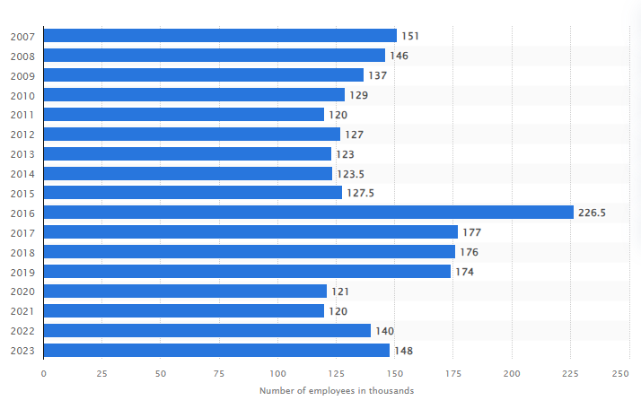
Figure 1: Number of employees of Marriott International across the world from 2007 to 2023 in thousands
(Source: Statista, 2024)
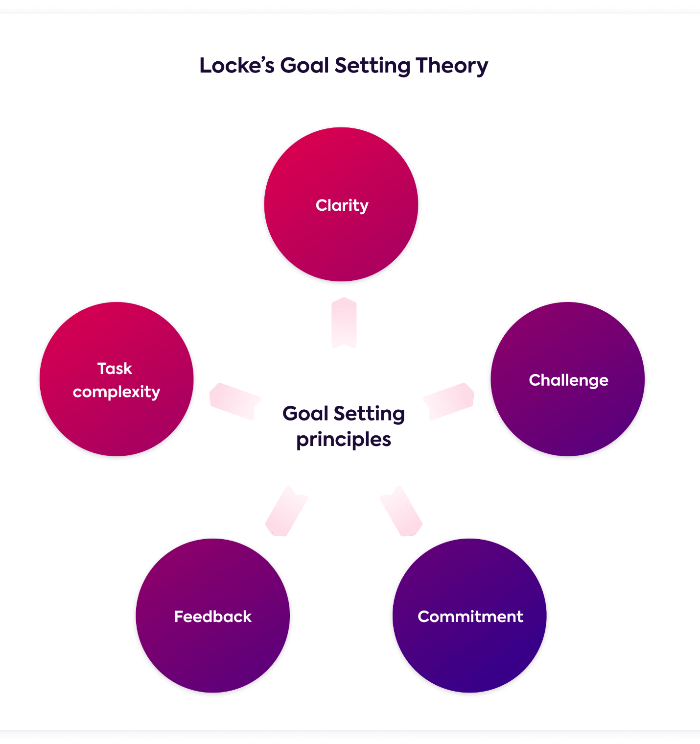
Figure 2: Goal setting theory by Edwin A. Locke
(Source: getlucidity.com, 2024)

