University of Wales Trinity Saint David

Assessment Title: Analysis and Evaluation
Course: Accounting

Module: Marketing Fundementals
Student Name: Brychan John
Student Number: 1706823
Assessment 2

Lecturer: Beth Cummings
Submission Date: 12th January 2018

Contents

1A
Marketing - 2
Marketing Strategy - 4
Marketing Mix - 4
The Four P’s - 4
Marketing Mix in Our Project - 8

1B

Reflection of Tactical Communication Tools - 9

References - 11

1A

Marketing
“Marketing is managing profitable customer relationships” [1]

“Broadly defined, marketing is a social and managerial process by which individuals and organisations obtain what they need and want through creating and exchanging value with others.” [4]

Marketing plays an essential role when trying to promote and develop a product. Marketing ensures that the product meets the customer or the consumers needs. By marketing a product or service effectively it will make sure that the customers will be satisfied, and return or buy again. The key to a successful business is to sell your product or service to the appropriate target audience. Also, a business needs it’s products to be innovative. Marketing involves communicating with the customer and answering the customers needs, wants and demands. The overall goal for successful marketing is to satisfy the customer, and to keep your business’s good reputation.

“If the marketer understands consumer needs; develops products that provide superior customer value; and prices, distributes, and promotes them effectively, these products will sell easily.” [2]


If the company follows these steps, their products will provide a great profit as they would be selling very well, therefore their marketing plan would have been proven successful. If a company does not have a successful marketing campaign, it can have drastic implications on the profits and the reputation of the company.
Fig.1
Take Nike for example: they provide products with great quality, fair prices, has a very recognizable logo and slogan [Fig.1] and their products sold very well in 2017 with a 6% rise in profits. [3]

But marketing is not always a success as proven by The Coca-Cola Company. In 1985, The Coca-Cola Company decided to change the 100 year old formula of their very popular drink, Coke [Fig.2], after numerous taste tests proved that this new flavour, named New Coke [Fig.3], was preferred amongst the taste testers. Even though this new flavour was distributed and promoted effectively, and kept the same low price as Coke, New Coke was a disaster amongst the consumers. Even though this new flavour was statistically “better”, it was not what the consumers wanted and outrage ensued, with the original Coke, now named Coca-Cola [Fig.4], was reintroduced to the market only two months after it was discontinued. The Coca-Cola Company was not prepared for the nostalgia consumers had for the original Coke flavour, proving that this was a marketing failure. New Coke then changed its name to Coke II in 1992 before being discontinued entirely in 2002.

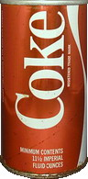
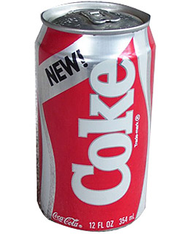
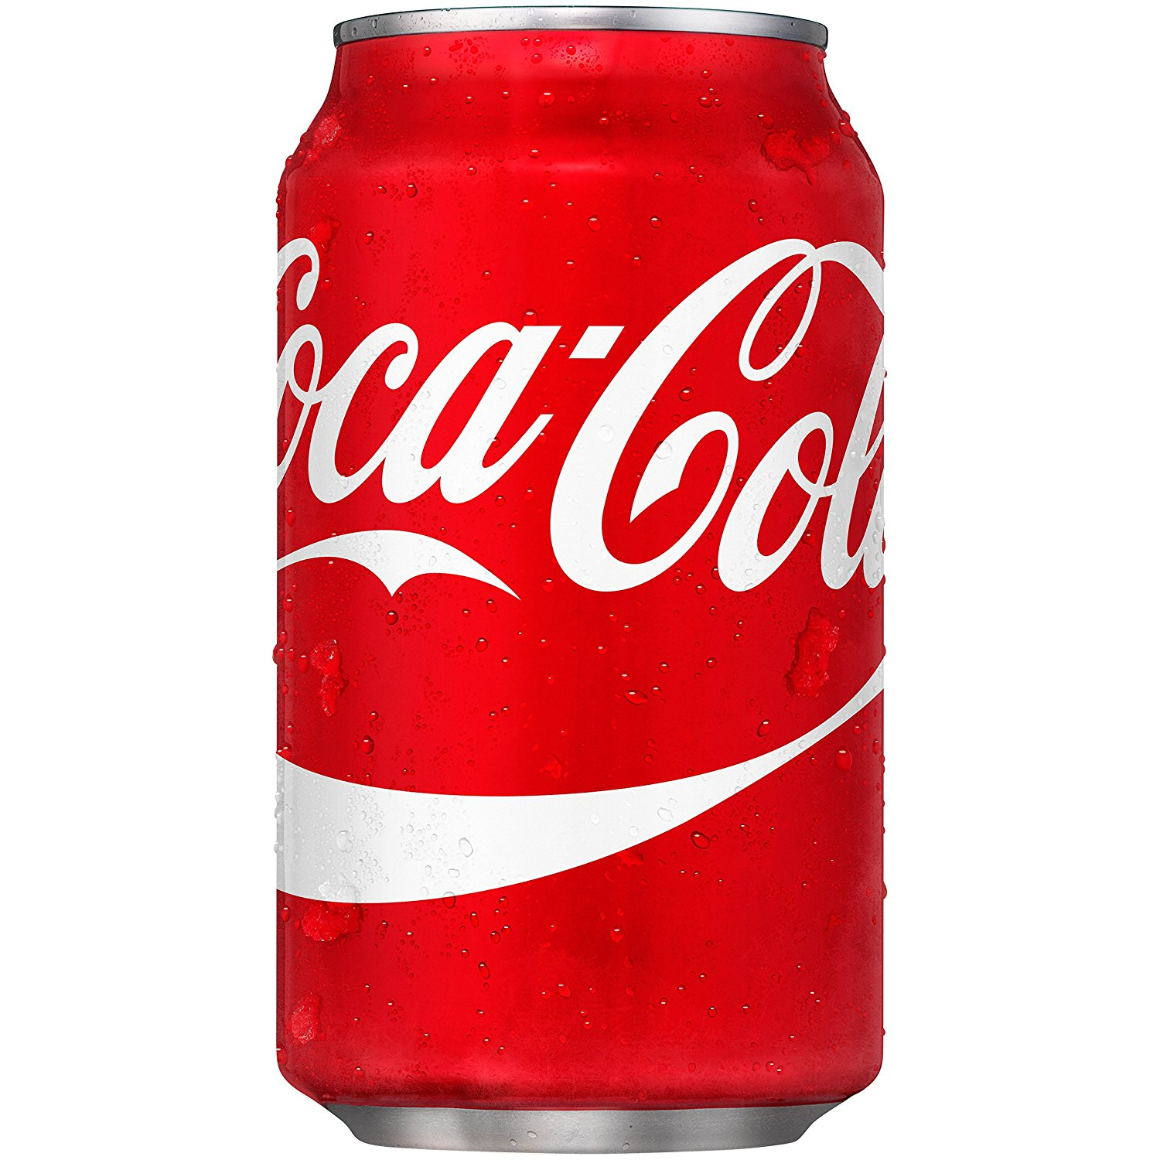

Fig.3
Fig.4
Fig.2

Marketing Strategy
“The art and science of choosing target markets and building profitable relationships with them” [5]

It is important that a company has a good marketing strategy, which includes a target audience and economic factors. Choosing the correct target audience is possibly the most important part of creating a product, otherwise you end up advertising to people who have no interest in your product.

Marketing Mix
The meaning of market mix is when a business uses and applies effective strategies and tactics to promote its product, service or brand in the market. Marketing mix is made up of the Four P’s. The Four P’s are famously known as Place, Price, Promotion and Product. Sometimes a business will apply the less commonly known Seven P’s, which are Price, Product, Promotion, Place, People, Physical evidence and Process. At times, Politics will play an important role in the marketing mix.

The Four P’s
The Four P’s in marketing is a theory that is used in most businesses and services worldwide. It is vital that a company uses the Four P’s, to keep the customer happy by answering it’s needs, and also to create profits for themselves. The Four P’s are four individual aspects of creating a successful product or brand, and once they are collaborated together they will work effectively together to promote and sell the product or brand. It’s thought to be the four main ‘ingredients’, and then when you put them all together they will position the brand or product on the marketplace in a way that attracts customers and consumers. The Four P’s are useful for a business to evaluate existing offers on a product or a business venture, and also when introducing a new product or service into the market.

Below I am going to discuss the main Four P’s of the marketing mix.

Price
Price means the amount of money that is charged for a product or a service. Pricing has to be consistent with the other Four P’s which are the other elements of the marketing mix. This is because the price will be approached by customers that will want to purchase the service or goods.
Pricing is an essential element of the marketing mix. Deciding on the price that a business will charge for their product or service is one of the most important decisions business management will make. Unlike all of the other Four P’s, decisions on the pricing of the product or service will affect revenues, rather than the company’s costs. It is vital for a company to set the right price for their product or service. Setting the price too high or too low will put a limit on the business growing and expanding successfully. Also, if the company sets the price too high or too low, it will cause damage and serious problems in their cash flow and profit and loss accounts. They will also have sales issues, which could potentially damage the company’s good reputation. Setting the right price is very difficult, and has proven to be a challenge for many entrepreneurs and businesses. If they bring their prices up too high, then their customers will usually go elsewhere to another business, to buy a substitute good, or service. This will then have a negative effect on the business’s sales and profits. This usually happens within the ‘Perfect Competition Market’. This is where all companies within the market sell identical goods, and it’s very easy for the customer to go elsewhere as the substitute god will be cheaper, and usually at the original price. This usually happens as the businesses in this type of market cannot control the market price.
There are many factors to consider when making important pricing decisions, because a company will never know the outcome of their actions, and whether or not it will be their desired effect. On the other hand, in some markets, such as Monopolies and Oligopolies, they have total control over the market price. This means that they can raise their prices whenever they want, and it will hardly affect their revenues, sales, and profits. They have total dictatorship over the market. For companies and businesses in these markets, being in control of the price is like a weapon, as they can achieve unnatural profits. This happens because the customer has no where else to go. In monopolistic markets, there are no substitute goods, and the customer has no where else to go, and has to pay the higher price. This goes against the law of demand. The law of demand is a well know theory in the business world, which can be used on nearly most products.indicates that when a business raises their price higher, the demand for their product will fall low. Sales will fall if the prices are put up. An example of going against the law of demand is British Rail, whereas they can put the price as high as they want whenever they want. This is because they have access barriers such as the rail tracks. This is a good example of higher prices meaning higher profits.

Product
Creating the suitable product is very important when trying to achieve high sales and profits in a business. It’s important that a product answers the needs, wants and demands of the customer or consumer. Communication is a key aspect in understanding and having a clear view with what the customer wants in the good. It is important to have feedback from customers, whether it will be from questionnaires, customer reviews online or verbal feedback. This can the help the business create and adapt a better version or a newer version of the product or service that will fit to the customers needs.
Another important aspect is positioning the product appropriately in the market. This means that the business needs to take their product ad pick a target audience. Then, they will have to look at the different segments of the market, and also look into different kinds of markets to place their products into. For example, there are niche markets, which are mostly used for very detailed and specific goods or services, and there are very wide markets, such as food and drink markets. Every business should have a marketing plan for their product, and placing the product in the right market for the right target audience is a vital part of that. This will help the business keep the customer satisfied, meanwhile also making profits.

Promotion
Promotion is an important part in the marketing mix, as it’s the ‘selling point’ to the customers. It is a vital aspect, as promotion is used to attract the attention of customers and consumers for the product or service. The business will need to take important steps, such as researching what market is in, and applying appropriate advertisements and promotions for the targeted audience for the product or service. This is aimed to motivate the customers to take action and purchase the company’s product or service. The role of promoting a product in the marketing mix is to connect with the customers in an effective way, for example radio advertisements, TV advertisements, and magazine or newspaper reviews and advertisements. This means that the business will have to research into data and factors such as age, gender, location and competitive data whilst advertising and promoting a product or service.

Place
Place plays an essential role in the marketing mix. Making the place suitable for the customers and consumers is vital in maximising sales and profits for the business. It is important to sell the product in an appropriate place to distribute it and make it convenient for the customer. It is important for the product to be available for the customer at the right place at the right time. A good example for this being applied is using online marketing. This is when a company sells its product or service online. It is very common for a business to make their own web page or website, which makes it easier for the customers to access. This is usually advertised when they promote the product. Also, this means that the business can expand and sell their products worldwide, as most of the people in our modern world take part in online shopping purchases. It’s a very effective place to sell a product or service, as it can be used twenty-four hours a day, which is a good thing to maximise sales and profits for the business. Also, if a product is available in one certain shop, then a customer is more reliant to go back there, and it’s vital that the product will be in stock, so that the customer doesn’t go elsewhere for a substitute good.

Marketing Mix in Our Project
I am now going to evaluate and discuss how I have applied the marketing mix and the Four P’s in our project. I have divided the Four P’s into my sub-headings below.

Product
Our aim for our product was to provide children from lower income families food over the Christmas period. We collected the food, in boxes, and distributed the food to upper management to give to the children.

Place
We collected the food and put out boxes in both UWTSD Business School and the Guildhall in Swansea. This was a good choice of locations, as it enabled local people from the community to get involved and help the less fortunate at Christmas time. Also, these locations were convenient and easily accessible for the people of Swansea, which was useful in trying to maximise the amount of food that was donated.

Price
Our project was aimed to contribute to charity work, so there was no fixed price, or any costs for us.

Promotion
We effectively promoted the charity ‘Feed a Child Swansea’ by creating posters digitally, and posting to Facebook and Twitter. We also made Twitter and Facebook pages to update the community and share important information, such as dates, times and locations for donating the food. This proved as an effective way of communicating with the local people, as many people in our modern society uses social media as a main form of communication.

1B

As part of our group project, we each wrote at least 2 blog posts on Feed a Child Swansea’s WordPress page [5]. These blogs ranged from describing the situation with poverty in children and how it affects their performance academically, to the planning and reflection of our food collection. We also created a Facebook Page [6] and a Twitter Profile [7] to help share updates on our charity and try to reach out to further audiences not familiar with WordPress and other blog websites. We feel as this was a good decision as as soon we launched both of these new formats, visitors to our WordPress site increased significantly. We feel as though the message our charity tried to share was shared very well, as our food collection, and many other aspects of our work, succeeded expectations.

We attempted to reach as many people to share our message with as we could. We chose the UWTSD Business School as one of our food donation stations as we could reach out to both students and tutors who were willing to give donations. We also chose the Guildhall as a food donation station as we were told that Swansea County Council had an interest in helping our cause. We chose Facebook and Twitter to share our message with some people that would not have heard about our charity otherwise, for example teenagers and the elderly. We also chose verbal communication as a way to convey our message as we made two presentations in front of our class about our charity. We also told family and friends to get involved, with them telling their family and friends, boosting the catchment area for our charity.

In one of the blog posts that I wrote, I described how children could be held back from being “the next big thing” by not having enough food. This is because countless studies have shown that children are proven to be less academically successful if they are not fed enough. The same is true about physical wellbeing, if a child is not given the nutrients they need, they will not perform well in sports and other recreational activities. I also wrote that it is our responsibility as a charity, and everyone’s responsibility as a community, to try and help these children to try and get them the brightest future possible.

We succeeded with our project by helping many children in and around Swansea and gave us all a feel good factor as we now know many children will not go hungry over the Christmas period. We are all very happy that we have given all these children a better Christmas and New Year and we hope all the families are much happier with their children being less hungry and more happy at this important and family-orientated time of year.

References

[1] Kotler, P. and Armstrong, G., 2010. Principles of marketing. Pearson education.
[2] Kotler, P. and Armstrong, G., 2010. Principles of marketing. Pearson education.
[3] Nike Inc, 2017, Nike Inc Reports Fiscal 2017 Fourth Quarter and Full Year Results, Available at https://news.nike.com/news/nike-inc-reports-fiscal-2017-fourth-quarter-and-full-year-results {Accessed 12/01/18}
[4] Kotler, P. and Armstrong, G., 2010. Principles of marketing. Pearson education.
[5] feedachildswansea.wordpress.com
[6] www.facebook.com/feedachildswansea/
[7] https://twitter.com/FeedAChildSwans

[Fig.1] Nike Inc, 1988, Nike Just Do It, Available at http://www.huhmagazine.co.uk/9027/nikes-just-do-it-slogan-was-inspired-by-a-murderers-last-words {Accessed on 12/01/18}
[Fig.2] The Coca-Cola Company, 1969, Coke Can, Available at http://www.coke-cans.com/greatbritain.html# {Accessed on 12/01/18}
[Fig.3] The Coca-Cola Company, 1985, New Coke Can, Available at http://content.time.com/time/specials/packages/article/0,28804,1913612_1913610_1913608,00.html {Accessed on 12/01/18}
[Fig.4] The Coca-Cola Company, 2014, Coca-Cola Can, Available at https://www.amazon.com/Coca-Cola-Fridge-Pack-Cans-Count/dp/B00HZYDW5E {Accessed on 12/01/18}

