1503269
Kirsty Wright
ECAY6004
Assessment 2
Portfolio

Question:
Identify 2 images which represent families in the 21st century. Then compare and contrast these images to explore, in depth, how social media can influence current representations of family within society.

Table of Contents

Introduction 3
Image 1 – Peppa Pig Introduces its First Same-Sex Couple 4
Image 2 – The Simpsons Family in the Kitchen 5
Comparative Analysis 6
Conclusion 11
References 12

Introduction

The 21st century has witnessed significant shifts in societal norms and family composition, with increased recognition and acceptance of diverse family structures (Walsh, 2012). Some academics, such as Giddens & Sutton (2013) and Esping-Andersen (2016), argue that widespread changes across society in the modern-day can be attributed to technological advancements and changing cultural perspectives. An example of this is social media, which provides a platform that gives individuals the ability to connect, learn, and engage with diverse content and communities (Bohn, 2021). This prolonged exposure to varying ways of life alters an individual's outlook and values, eventually creating changes in cultural perspective (Manago et al, 2021).
Krause and Meyer (2002) claim that until approximately the final third of the 20th century, marriage was considered a general life goal, as was raising a family, and homosexuality was a criminal offense. However, the 21st century has seen vast changes in family structures. Adler and Lenz (2023), claim that the, once idyllically portrayed, traditional, nuclear family, consisting of two married parents of the opposite sex and their dependent children (Scott, 2014), is no longer the norm, with the past 20 years witnessing rises in divorce rates, cohabiting couples, lone parent families and other newly recognised family types, such as same-sex couples of which since 2015 has increased 40.5% (Fflag, 2022). It is important to note that, as stated by The Office for National Statistics (ONS) (2019), a family does not have to include children. However, despite an increase in childless families in the United Kingdom (UK) since the beginning of the century (ONS, 2022), this family type is commonly left out of family studies. As argued by Walsh (2012), no matter the tradition, ultimately family normality is a social construct.
To explore this phenomenon, this portfolio presents two images that represent families in the 21st century in popular children’s television programs. Often described as a ‘window on the world’ (Larson, 1984; Rivera, 2017), it has been argued that everyday television reflects popular culture within our society (Tomoiagă, 2019). This understanding is expanded upon by The University of Minnesota (2010), which describes the relationship between television and society as being reciprocal, by both reflecting and nurturing the values of society. Therefore, as television media reflects and affects society’s views and values, it also portrays representations of individuals or groups in society which may reinforce or contest stereotypes (Aspler, Harding & Cascio, 2022). Media portrayals that avoid negative stereotypes can provide a sense of belonging and reinforcement of identity for an individual (Kjærgaard, Morsing & Ravasi, 2011). Trivette (2022) explains that portrayals of members of minority groups impact not only how greater society views these members, but also how these members view themselves. Studies that have explored this concept using social identity theory, which claims that individuals derive a certain portion of their identity from the groups they belong to (Waldkirch, 2015), found that members of marginalised groups in society prefer to watch television programs that include characters that they can personally relate to (Ramasubramanian & Murphy, 2014).
Since the end of the 20th century, there has been an increased focus on the positive and relatable representation of marginalised groups in the media (Fisher et al, 2007; Deerwater, 2022). Now in the 21st century that focus is beginning to shift to children’s television and the positive portrayals of diverse families (Stevens, 2022). To further explore these concepts, the two images presented in this portfolio depict one same-sex parent family, as an example of diverse family representation, and in contrast one traditional nuclear family. By highlighting certain aspects of these images, and applying relevant theories, the diversity of families in the 21st century will be demonstrated, as will the need for a multitude of diverse perspectives to theorise and understand this modern-day unit. Additionally, to further analyse these images through a 21st-century viewpoint, this submission will consider the reaction to these representations of families on social media.

Image 1 – Peppa Pig Introduces its First Same-Sex Couple

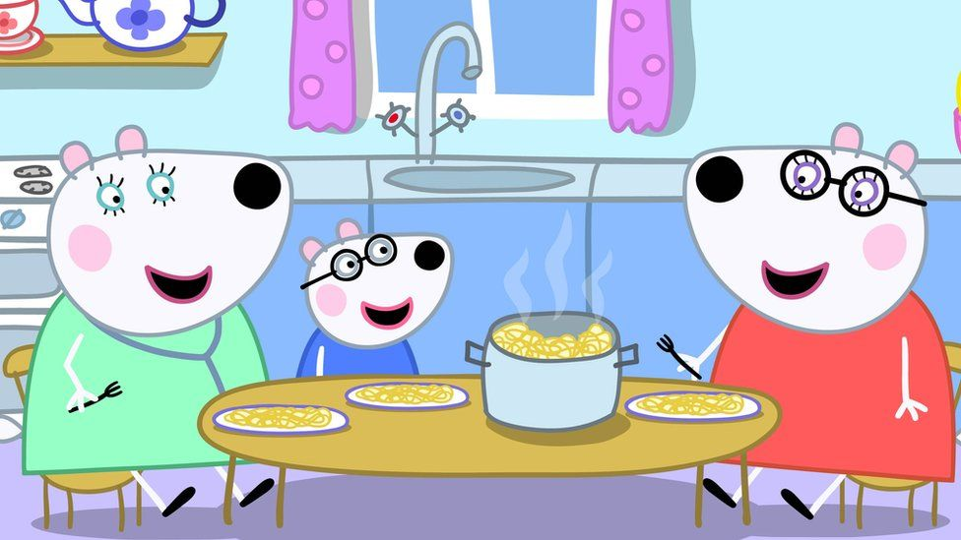
Figure 1: Penny the Polar Bear and her Two Mothers (Channel 5, as cited by Duggins, 2022),

This computer-generated image depicts the first same-sex parent family to be portrayed in the popular, current children’s television program Peppa Pig, consisting of two female characters, illustrated with longer eyelashes, and their daughter (Duggins, 2022). The bright colours used in this image suggest that it has been designed to be appealing to children (Boyatzis &Varghese, 1994). The subjects of the image are situated around a table in a kitchen conversing and sharing a meal, which is considered common family practice (Middleton et al, 2022). One of the female characters is wearing what appears to be a stethoscope which suggests that this character has a medical occupation. All the characters in this image are smiling, implying they are happy and that this is a comfortable everyday interaction (Zhang et al, 2021).

Image 2 – The Simpsons Family in the Kitchen

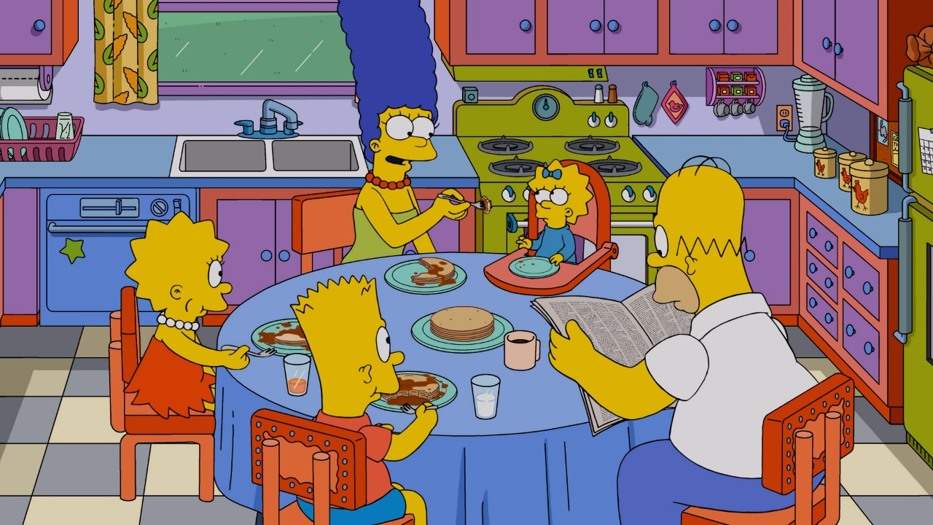
Figure 2. All Aboard the Pancake Express (The Simpsons, 2023).

This second computer-generated image is taken from a scene in another popular children’s television show, The Simpsons (The Simpsons, 2023), and shows the Simpsons family in the kitchen of their home. Once again, the colours used in this image are bright which indicates it has been designed to be appealing to children (Boyatzis &Varghese, 1994). The Simpsons are a traditional nuclear family, which as previously explained consists of two married opposite-sex parents and their children (Scott, 2014). The female characters in this image are clearly identifiable, due to being illustrated with longer eyelashes and jewellery or hair accessories (Sá & Tavares, 2017). The two older children in this image are eating food, while their mother appears to be feeding the baby and their father reads a newspaper. The characters in this image appear comfortable, implying this is an everyday situation (Zhang et al, 2021).

Comparative Analysis

When considering Image 1, it can be argued that the most apparent element of this picture is the depiction of a same-sex parent family, this is because the inclusion of same-sex parents in children’s television is a new phenomenon (Wells, 2022). Whereas, when considering Image 2, the representation of a nuclear family is of very little significance. The nuclear family is used as a baseline of comparison for any other family structure, and families differentiating from this perceived norm are often described as non-nuclear (Santín & Sicilia, 2016). To understand this from a theoretical perspective, we can compare structural functionalism’s, often referred to as functionalism view of the family with that of queer theory. The main basis of structural functionalism is an emphasis on the necessity for a moral and value consensus among members of society for society to function efficiently (Giddens & Sutton, 2013). In terms of family, functionalism upholds heteronormativity, a belief that heterosexuality and traditional gender identities are morally the social norm (Rubin, 2011 as cited by Boe, 2019). Furthermore, functionalism argues that marriage and the nuclear family act as an ideal foundation for society (Haralambos & Holborn, 2013). Whereas, queer theory directly contests this understanding of society, as stated by Jagose (1996, as cited by Longstaff, 2022, p.235), by challenging ‘the model of stability – which claims heterosexuality as its origin’. Boe (2019), links this to the family by claiming that just as queer theory rejects the notion that heterosexuality is the norm, it also rejects the belief that the family is biologically binary, by stating that diverse family structures are normative and not deviant. The inclusion of a same-sex parent family on a children’s mainstream television program, supports the queer theory perspective of family and indicates a progressive step in the portrayal of diverse family structures in the media. As argued by the World Economic Forum (2021, p.5) ‘Progress starts by acknowledging that diverse societies deserve diverse and inclusive media and entertainment.’. This statement offers an example of the previously discussed relationship between television and society, specifically the way that society can influence the media (The University of Minnesota, 2010).
An additional consideration of these two images is the portrayal of gender. Slatterley (2003, p.113), refers to gender as ‘’social’ and ‘cultural differences in behaviour and roles, in the personal attributes we call masculinity and femininity’. The World Health Organization’s (2023) definition expands upon this by asserting that gender, although related to it, is different from sex, which can be understood as the physical, biological characteristics of being male or female, and that the gender an individual may identify with does not always correspond with their sex at birth.
In the first image presented the adult female characters have been depicted with longer eyelashes to indicate their gender, although, it should be noted that indications of gender have been omitted from the illustration of the daughter. In the second image, portrayals of gender are more obvious as all three female characters are depicted with longer eyelashes, and either jewellery or hair accessories. Following a study conducted to explore portrayals of gender in children’s animated media, Coyne et al (2016) reported that female characters are six times more likely to be portrayed as attractive than male characters. Findings shared by González et al (2020) confirmed that gender stereotypes are indeed present in children’s media, claiming that female characters' physical appearance is often intended to be attractive. It could also be argued that the mother feeding the baby while the father reads a newspaper in Image 2, portrays further gender constructs, such as the idea that childcare within the family is primarily the mother’s responsibility. Gender and identity theory, socialisation theory, and gendered social role theory offer explanations for the basis of these implications.
Gender identity theory dictates that people have an inherent need to identify gender, as our gender identity is our sense and expression of self (Cosker-Rowland, 2023). Furthermore, people possess a need to understand the gender identity of others, as gender is part of all our social interactions (Council of Europe, 2023). This stems from the socialisation we have all experienced from birth. As argued by Carter (2014) people are socialised into gender from a young age, primarily within their families, secondarily within the education system and their peer groups, and continuously by the mass media (Giddens & Sutton, 2013). Examples of this include the clothes we are dressed in as a child, the sports we are permitted to play at school, the peer groups we associate with, and the television programs we watch (Balvin, 2017). Eventually, all these notions become internalised as social gender norms (Gintis & Bowles, 2011). This process of learning social norms, values, behaviour, and culture is the central understanding of socialisation theory (McCarthy & Edwards, 2011). To further link this concept to gender, social role theory recognises that this process creates gendered roles within society, such as the idea that labour-heavy work and positions of power are jobs for men, and childcare and cleaning roles are the responsibilities of women (Eagly & Wood, 2016).
Gender roles are commonly present in family units - often referred to as the gendered division of labour within a family (Qypi, 2017; Mavrokonstantis, 2015) - particularly in the traditional nuclear family, with fathers often taking the role of main breadwinner whilst mothers adopt the role of the primary caregiver (as portrayed in Image 2) and home keeper (Park et al, 2013). Feminist perspectives would argue that the gender roles present within a family, reinforce the gender roles present within society (Qypi, 2017). However, Park et al (2013) argue that gender roles are less prevalent in modern families, partially due to the inability of many families to survive the current economic climate with a single breadwinner, and partially due to the diversity of family compositions in the 21st century. Image 1 provides an example of this. As this depiction of a modern family is made up of two same-sex parents, two women, and their daughter, gender roles cannot be present within this unit. However, it could be argued that as one of these characters is illustrated wearing a stethoscope, which as earlier mentioned could suggest she has a medical profession, she is the main breadwinner for this family.
No matter the structure and roles, some things are common practice in families across a multitude of cultures, such as the sharing of a family meal (Davidson & Gauthier, 2010). The practice of food sharing between a social group is referred to as commensality (Jönsson, Michaud & Neuman 2021), and is claimed by Ochs and Shohet (2006) to be, as previously stated, universally practiced, maintaining familial social bonds. Ochs and Shohet (2006, p.37) further reinforce the importance of the family meal when stating that, ‘In ancient Greece, for example, oikos (family) was stipulated as “those who feed together”’.
Considering then that both above images include the characters situated around a table eating food, it could be argued that this is a deliberate media portrayal of a family unit. This is perhaps less significant for the representation of a nuclear family in Image 2, than it is for the modern, same-sex parent, representation of a family depicted in Image 1, as the nuclear family is a long-accepted, traditional family form, whereas the same-sex parent family is still seeking recognition and acceptance in the 21st century (Siegal et al, 2021). Couple this with the happy faces included in this image, then it can be claimed that this image is intended to utilise the aforementioned influence of the media as an agent of socialisation, to influence social norms and values, by demonstrating the normality of diverse families (University of Minnesota, 2010). The utilisation of television’s influence in this way can be further understood in terms of cultivation theory, which explains the long-term impact that television and its portrayals of the social world. can have on an individual’s concept of social reality (Stack, Li & Spaulding, 2015; Morgan, Shanahan & Signorielli, 2009).
Despite the intentions of the portrayal of a same-sex parent family on the children’s television program Peppa Pig shown in Image 1, many news reports claim that the reactions of the public on social media were divided (Fuller, 2022; Luckhurst, 2022; Owoseje, 2022). All three news reports include posts claimed to have been made on various social media platforms that express personal feelings and opinions regarding the television show’s decision to include this expression of a diverse modern family. It is common knowledge that opinions portrayed in news reports are often unreliable, specifically as biases that may be held by news outlets and reporters are not publicly stated (van der Linden, Panagopoulos & Roozenbeek, 2020). Also, people tend to express negative opinions on social media more frequently than positive ones, and follow the trend of comments already made (Senz, 2021). Additionally, due to programmed algorithms, comments that receive more attention will be visible to a wider audience and will appear to be the majority opinion (Rim & Song, 2016). Therefore, ironically, in a world with an ever-growing number of online platforms for opinions to be expressed, it is difficult to know what real public opinion is and to measure the progress of the fight for recognition and acceptance of diverse family structures.

Conclusion

In conclusion, the 21st century has witnessed a profound evolution in family structures, with diverse representations challenging traditional norms (Walsh, 2012). Comparing particular aspects of these images from popular television programs has highlighted the shifting dynamics. The inclusion of a same-sex parent family in children’s media signifies a progressive step away from conventional portrayals of family, aligning with queer theory and promoting inclusivity (Longstaff, 2022). In contrast, the image taken from The Simpsons representing a traditional nuclear family serves as a baseline that further emphasises the evolving family norms (Santín & Sicilia, 2016). Gender portrayals in these images reveal nuanced perspectives, challenging traditional roles in Image 1 and adhering more closely to traditional roles in Image 2. With an understanding of the prominent impact that gender and gender identity have in our society and the process in which binary gender concepts are socialised into us from birth (Carter, 2014), it is easy to see how these are repeatedly challenged in the changing landscape of the 21st century. While media strives to reflect and cultivate evolving societal norms (Stack, Li & Spaulding, 2015), reactions on social media illustrate the ongoing debate and diverse perspectives surrounding these representations, which further highlight the challenges faced by marginalised groups in society. In this era of evolving family norms, the media’s role in shaping perceptions become more crucial than ever. As children’s television becomes a platform for inclusivity, it has the potential to challenge and reshape societal norms for future generations.

References

Adler, M.A. and Lenz, Karl. (2023) ‘Beyond Standard Families in Advanced Countries’, The Changing Faces of Families: Diverse Family Forms in Various Policy Contexts. Milton: Taylor & Francis Group.
Aspler, J., Harding, K. D. and Cascio, M. A. (2022), ‘Representation Matters: Race, Gender, Class, and Intersectional Representations of Autistic and Disabled Characters on Television’, Studies in Social Justice, Vol. 16 (2), pp. 323-348. Available: file:///C:/Users/kirst/Downloads/Aspler+-+final.pdf (Accessed: 19th November 2023).
Balvin, N. (2017), ‘What is Gender Socialization and Why Does it Matter?’, Unicef Office of Research-Innocenti. Available at: https://www.unicef-irc.org/evidence-for-action/what-is-gender-socialization-and-why-does-it-matter/ (Accessed: 21st November 2023).
Boe, J. L. (2019), ‘A Look Back to Move Forward: Expanding Queer Potentiality in Family Science’, Journal of Critical Thought and Praxis, Vol. 8 (2), Iowa State University Digital Press. Available at: https://www.iastatedigitalpress.com/jctp/article/8204/galley/7904/view/#:~:text=The%20family%20binary%20positions%20biological,between%20queer%20and%20heteronormative%20processes. (Accessed: 20th November 2023).
Bohn, K. (2021) ‘How Social Media is Changing the way People get to Know One Another’, Research, Penn State University. Available at: https://www.psu.edu/news/research/story/how-social-media-changing-way-people-get-know-one-another/ (Accessed: 18th November 2023).
Boyatzis, C. and Varghese, R. (1994), ‘Children’s Emotional Associations with Colors’, Journal of Genetic Psychology, vol. 155 (1), pp. 77-85. Available at: https://www.researchgate.net/publication/15176872_Children's_Emotional_Associations_with_Colors (Accessed: 19th November 2023).
Carter, M. J. (2014), ‘Gender Socialization and Identity Theory’, Social Sciences, vol. 3 (2), pp. 242-263. Available at: https://doi.org/10.3390/socsci3020242 (Accessed: 21st November 2023).
Cosker-Rowland, R. (2023), ‘Recent Work on Gender and Gender Identity’, Analysis, Oxford Academic. Available at: https://academic.oup.com/analysis/advance-article/doi/10.1093/analys/anad027/7204699 (Accessed: 20th November 2023).
Council of Europe (2023), ‘Exploring Gender and Gender Identity’, Gender Matters. Available at: 20th November 2023).
Coyne, S. M., Linder, J. R., Rasmussen, E. E., Nelson, D. A., and Birkbeck, V. (2016), ‘Pretty as a Princess: Longitudinal Effects of Engagement with Disney Princesses on Gender Stereotypes, Body Esteem, and Prosocial Behavior in Children’, Child Development, vol. 87 (6), pp. 1909–1925. Available at: https://doi:10.1111/cdev.12569 (Accessed: 21st November 2023).
Davidson, R. and Gauthier, A. (2010), ‘A Cross National Multi-Level Study of Family Meals’, International Journal of Comparative Sociology, vol. 51 (5), pp. 349-365, SAGE. Available at: https://journals.sagepub.com/doi/epdf/10.1177/0020715210376853 (Accessed: 21st November 2023).
Deerwater, R. (2022), GLAAD’S 2021-2022 Where We Are on TV Report: LGBTQ Representation Reaches New Record Highs, GLAAD. Available at: https://glaad.org/glaads-2021-2022-where-we-are-tv-report-lgbtq-representation-reaches-new-record-highs/ (Accessed: 14th November 2023).
Duggins A. (2022), ‘Peppa Pig Introduces its First Same-Sex Couple’, Penny the Polar Bear and her Two Mothers, The Guardian. Available at: https://www.theguardian.com/tv-and-radio/2022/sep/08/peppa-pig-introduces-its-first-same-sex-couple (Accessed: 16th November 2016).
Eagly, A. H. and Wood, W. (2016), ‘Social Role Theory of Sex Differences’, The Wiley Blackwell Encyclopedia of Gender and Sexuality Studies, Wiley Online Library. Available at: https://onlinelibrary.wiley.com/doi/10.1002/9781118663219.wbegss183 (Accessed: 21st November 2023).
Esping-Andersen, G. (2016), Families in the 21st Century, SNS Förlag, p.13. Available at: https://www.rainews.it/ran24/speciali/2018/byebyebabies/docs/families-in-the-21st-century.pdf (Accessed: 05th November 2023).
Fisher D. A., Hill D. L., Grube J. W. and Gruber E. L. (2007), ‘Gay, Lesbian, and Bisexual Content on Television: A Quantitative Analysis Across Two Seasons’, Journal of Homosexuality, Vol. 52 (3-4), pp.167-188. Available at: https://www.ncbi.nlm.nih.gov/pmc/articles/PMC2000838/ (Accessed: 14th November 2023).
Flagg (2022), LGBT+ Parenting. Available at: https://www.fflag.org.uk/portfolio-item/lgbtplus-parenting/#:~:text=Figures%20released%20by%20the%20Office,12%2C000%20couples%20were%20doing%20so. (Accessed: 18th November 2023).
Fuller, P. (2022), ‘ITV Good Morning Britain Viewers Find Show ‘Hard to Watch’ After Discussion About Peppa Pig’s First Lesbian Couple’, Leeds Live. Available at: https://www.leeds-live.co.uk/news/celebs-tv/itv-good-morning-britain-viewers-24950091 (Accessed: 21st November 2023).
Giddens A. and Sutton, P. (2013), ‘Families and Intimate Relationships’, Sociology, 7th edn., Cambridge: Polity Press, p. 379-432.
Gintis, H. and Bowles, S. (2011) ‘Socialization’, A Cooperative Species., pp. 167-, United States: Princeton University Press.
González, M., Infantes-Paniagua, Á., Thornborrow, T. and Jordán, O. (2020), ‘Associations Between Media Representations of Physical, Personality, and Social Attributes by Gender: A Content Analysis of Children’s Animated Film Characters’, International Journal of Communication, Vol. 14. Available at: file:///C:/Users/kirst/Downloads/16149-50216-1-PB.pdf (Accessed: 20th November 2020).
Haralambos, M. and Holborn, M. (2013) Sociology: Themes and Perspectives. 8th edition. London: Collins Educational.
Jönsson, H., Michaud, N. and Neuman, M. (2021), ‘What is Commensality? A Critical Discussion of an Expanding Research Field’, International Journal of Environmental Research and Public Health, vol. 18 (12), PubMed. Available at: https://pubmed.ncbi.nlm.nih.gov/34207626/ (Accessed: 21st November 2023).
Kjærgaard, A., Morsing, M. and Ravasi, D. (2011). ‘Mediating Identity: A Study of Media Influence on Organizational Identity Construction in a Celebrity Firm’, Journal of Management Studies, vol. 48 (3), pp. 514-543. Available at: https://openaccess.city.ac.uk/id/eprint/4608/3/JMS_Oticon_final_version.pdf (Accessed: 19th November 2023).
Krause, H. D., and Meyer, D. D. (2002). ‘What Family for the 21st Century?’ The American Journal of Comparative Law, vol. 50, pp. 101–120. Available at: https://doi.org/10.2307/840873 (Accessed: 21st November 2023).
Larson, J. F. (1984), ‘Television’s Window on the World’, American Political Science Association, Vol. 80 (1), Cambridge University Press. Available at: https://www.researchgate.net/publication/275777862_Television's_Window_on_the_World (Accessed: 19th November 2023).
Longstaff, G. (2022), ‘Queer Theory’, The Edinburgh Companion to Critical Theory, p.235, Edinburgh: Edinburgh University Press. Available at: https://doi.org/10.1515/9780748693405-022 (Accessed: 20th November 2023).
Luckhurst, J. (2022), ‘Peppa Pig Introduces First Same-Sex Couple to the Popular Children’s TV Show’, The Mirror. Available at: https://www.mirror.co.uk/tv/tv-news/peppa-pig-introduces-first-same-27926104 (Accessed: 21st November 2023).
Manago, A. M., Santer, N. D., Barsigian, L. L. and Walsh, A. (2021), ‘5 Social Media as Tools for Cultural Change in the Transition to Adulthood’, Cultural Methods in Psychology: Describing and Transforming Cultures, Oxford University Press.
Mavrokonstantis, P. (2015), Modern Family: Female Breadwinners and the Intergenerational Transmission of Gender Norms. STICERD and Department of Economics, London School of Economics Available at: https://sticerd.lse.ac.uk/dps/pep/pep27.pdf (Accessed: 21st November 2023).
McCarthy, J. R. and Edwards, R. (2011), ‘Socialization’, Key Concepts in Family Studies, pp. 184-187, London: SAGE Publications Ltd.
Middleton, G., Golley, R. K., Patterson, K. A. and Coveney, J. (2022), ‘The Family Meal Framework: A Grounded Theory Study Conceptualising the Work that Underpins the Family Meal’, Appetite, Vol. 175, Elsevier. Available at: https://www.sciencedirect.com/science/article/pii/S0195666322001623 (Accessed: 16th November 2023).
Morgan, M., Shanahan, J. and Signorielli, N. (2009), ‘Growing up with Television: Cultivation Processes’, Media Effects, pp. 50-6, Routledge.
Ochs, E. and Shohet, M. (2006), ‘The Cultural Structuring of Mealtime Socialization’, New Directions for Child and Adolescent Development, pp. 35-49, Wiley Online Library. Available at: https://onlinelibrary.wiley.com/doi/epdf/10.1002/cd.154?saml_referrer (Accessed: 21st November 2023).
Office for National Statistics (2023), Families and Households. Available at: https://www.ons.gov.uk/peoplepopulationandcommunity/birthsdeathsandmarriages/families/datasets/familiesandhouseholdsfamiliesandhouseholds (Accessed: 18th November 2023).
Office for National Statistics (2019), Families and Households in the UK: 2018. Available at: https://www.ons.gov.uk/peoplepopulationandcommunity/birthsdeathsandmarriages/families/bulletins/familiesandhouseholds/2018 (Accessed: 18th November 2023).
Owoseje, T. (2022), ‘’Peppa Pig’ Gets its First Same-Sex Couple – Two Polar Bear Mummies’, CNN. Available at: https://edition.cnn.com/2022/09/07/entertainment/peppa-pig-same-sex-couple-intl-scli-gbr/index.html (Accessed: 21st November 2023).
Park, A., Bryson, C., Clery, E., Curtice, J. and Phillips, M. (Eds) (2013), British Social Attitudes: the 30th Report, London: NatCen Social Research. Available at: https://bsa.natcen.ac.uk/media/38457/bsa30_gender_roles_final.pdf (Accessed: 21st November 2023).
Qypi, K. (2017) ‘The Impact of the Nuclear Family in the Establishment of Gender Roles in Children Between 3 and 7 Years Age. European Journal of Social Sciences Studies. Available at: https://oapub.org/soc/index.php/EJSSS/article/view/87 (Accessed: 21st November 2023).
Ramasubramanian, S. and Murphy, S. J. (2014), ‘Experimental Studies of Media Stereotyping Effects’, Laboratory Experiments in the Social Sciences, 2nd ed., pp. 385-402, Academic Press. Available at: https://www.sciencedirect.com/science/article/abs/pii/B9780124046818000170 (Accessed: 19th November 2023).
Rim, H. and Song, D. (2016), ‘”How Negative Becomes Less Negative”: Understanding the Effects of Comment Valence and Response Sidedness in Social Media’, Journal of Communication, Vol. 66, (3), pp. 475–495. Available at: https://doi.org/10.1111/jcom.12205 (Accessed: 21st November 2023).
Rivera, R. (2017), ‘The Television’, The Significance of the Evolution of Technological Forms of News Media for the War News Consumption in the Home. Available at: https://sites.middlebury.edu/newsinthehome/the-television/ (Accessed: 19th November 2023).
Sá, G. and Tavares, P. (2017), Female Character Design in Today’s Cartoons: The Typical and the Alternative “Girl Squad”. Available at: https://www.researchgate.net/publication/322103130_Female_Character_Design_in_Today's_Cartoons_The_typical_and_the_alternative_girl_squad (Accessed: 19th November 2023).
Santín, D. and Sicilia, G. (2016), ‘Does Family Structure Affect Children's Academic Outcomes? Evidence for Spain’, The Social Science Journal, Vol. 53 (4), pp. 555-572. Available at: https://doi.org/10.1016/j.soscij.2016.04.001 (Accessed: 20th November 2023).
Scott, J. (2014) ‘Family, Nuclear’, A Dictionary of Sociology, 4th ed., Oxford: Oxford University Press.
Senz, K. (2021), ‘Outrage Spreads Faster on Twitter: Evidence from 44 News Outlets’, Working Knowledge, Harvard Business School. Available at: https://hbswk.hbs.edu/item/hate-spreads-faster-on-twitter-evidence-from-44-news-outlets (Accessed: 21st November 2023).
Siegal, M., Assenmacher, C., Meuwly, N. and Zemp, M. (2021), ‘The Legal Vulnerability Model for Same-Sex Parent Families: A Mixed Methods Systematic Review and Theoretical Integration’, Frontiers in Psychology, vol. 12, PubMed Central. Available at: https://www.ncbi.nlm.nih.gov/pmc/articles/PMC8007880/ (Accessed: 21st November 2023).
Slatterley, M. (2003), ‘Gender’, Key Ideas in Sociology, p.113, Cheltenham: Nelson Thornes Ltd.
Stacks, D., Li, Z. and Spaulding, C. (2015), ‘Media Effects’, International Encyclopedia of the Social & Behavioral Sciences, 2nd ed., pp. 29-34, Elsevier. Available at: https://www.sciencedirect.com/topics/social-sciences/cultivation-theory (Accessed: 10th November 2023).
Stevens, S. (2022), ‘Kids, Culture, and Queerness: The Progression of LGBTQ+ Representation in Children's Media’, Mahurin Honors College Capstone Experience/Thesis Projects, Paper 987. Available at: https://digitalcommons.wku.edu/stu_hon_theses/987/ (Accessed: 21st November 2023).
The Simpsons (2023), All Aboard the Pancake Express. Available at: https://twitter.com/TheSimpsons/status/1655361878154002432 (Accessed: 16th November 2023).
Tomoiagă, L. (2019), ‘That’s Entertainment! A Short History of American Television Series’, Television Series as Mirrors of Contemporary Life, Cambridge Scholars Publishing.
Trivette, E. (2022), The Views of LGBTQ+ Individuals on LGBTQ+ Representation in UK and US Television Media, University of Birmingham. Available at: https://etheses.bham.ac.uk//id/eprint/12865/7/Trivette2023PhD.pdf (Accessed: 14th November 2023).
The University of Minnesota (2010), ‘9.2 Understanding the Relationship Between Television and Culture’, Understanding Media and Culture. Available at: https://open.lib.umn.edu/mediaandculture/chapter/9-2-the-relationship-between-television-and-culture/ (Accessed: 21st November 2023).
van der Linden, S., Panagopoulos, C., and Roozenbeek, J. (2020), ‘You are Fake News: Political Bias in Perceptions of Fake News’, Media, Culture & Society, vol. 42 (3), pp. 460-470. Available at: https://doi.org/10.1177/0163443720906992 (Accessed: 21st November 2023).
Waldkirch, M. (2015) ‘Social Identity Theory and the Family Business’, in Theoretical Perspectives on Family Businesses, pp. 137-. Available at: https://doi.org/10.4337/9781783479665.00015 (Accessed: 19th November 2023).
Walsh, F. (2012), ‘The New Normal: Diversity and Complexity in 21st-century Families’, Normal Family Processes, 4th ed., pp. 3-27, New York: Guilford Press.
Wells, T. (2022), ‘The Gay Agenda: Being Accepted in Children’s Media’, Honors College Theses, 685, Georgia Southern University. Available at: https://digitalcommons.georgiasouthern.edu/cgi/viewcontent.cgi?article=1769&context=honors-theses (Accessed: 20th November 2023).
World Economic Forum (2021), Reflecting Society: The State of Diverse Representation in Media and Entertainment, p.5. Available at : https://www3.weforum.org/docs/WEF_The_State_of_Diverse_Representation_in_Media_and_Entertainment_2021.pdf (Accessed: 10th November 2023).
World Health Organization (2023), Gender and Health. Available at: https://www.who.int/health-topics/gender#tab=tab_1 (Accessed: 20th November 2023).
Zhang, S., Xinge, L., Yang, X., Shu, Y., Liu, N., Zhang, D. and Liy, Y. (2021), ‘The Influence of Key Facial Features on Recognition of Emotion in Cartoon Faces’, Frontiers in Psychology, Vol. 12. Available at: https://www.frontiersin.org/articles/10.3389/fpsyg.2021.687974/full (Accessed: 16th November 2023).

