

Name : | Meetkumar Sureshbhai Patel
Id number : | 2241855
Module name: | Strategic Management
Module code: | LCMB7003
Lecturer : | Dr. Jayalakshmi Gopalkrishnan

STRATEGIC MANAGEMENT OF THE TASTE OF BRITAIN RESTAURANT
Table of Contents
Introduction 4
Vision 4
Mission 5
Objectives 5
Internal and External environmental audit 6
External Environment Analysis: PESTLE analysis 6
Internal Environmental Analysis: Porter’s 5 Forces 9
Industry Attractiveness and Market Strategies 11
Sustainable Competitive Advantage 11
BCG Matrix 11
Ansoff Matrix 13
VRIO analysis 14
SWOT Analysis 16
Value Chain Analysis 17
Evaluation 18
Ways to implement and execute the strategy 19
Strategy 19
Structure 19
Systems 20
Critical Analysis 22
Critical Evaluation of Green Strategy, Sustainability, and CSR activities that can be undertaken by The Taste of Britain restaurant 23
Green Strategy 23
Sustainability and CSR activities 23
Sustainability Initiatives 23
CSR Activities 23
Conclusion 24
References 26

Introduction
A crucial instrument for organizations to navigate the complicated and changing business environment, strategic management is a vital part of contemporary corporate operations. Strategic planning is the process by which an organization achieves its long-term goals via the creation, execution, and assessment of cross-functional choices. To keep up with the ever-changing demands of consumers, new technologies, and the market, strategic management is essential. It offers a methodical way to coordinate and synchronize efforts toward long-term development and competitiveness by coordinating and aligning resources, competencies, and activities with the organization's vision and objectives (Collins, 2021). Additionally, with the help of strategic management, companies may foresee potential dangers and opportunities, make well-informed choices, and hold on to their competitive edge. It's a thorough procedure that helps a firm succeed in the present while also positioning it for future success in a dynamic business environment.
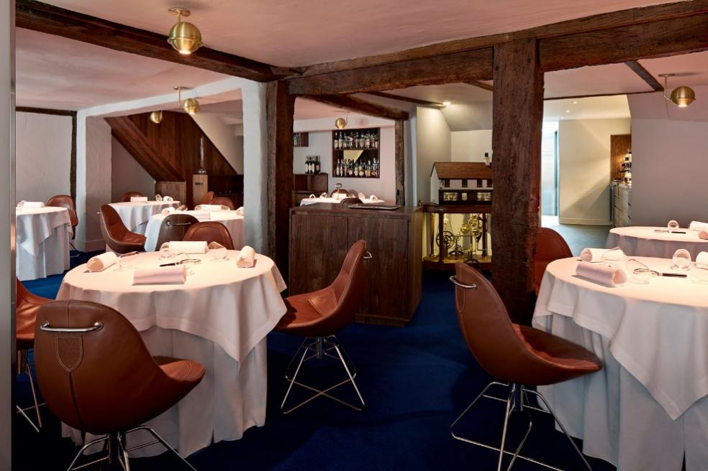
Figure 1: The Taste of Britain Restaurant

Vision
The Taste of Britain Restaurant aspires to be a worldwide icon of culinary innovation and gourmet excellence. By fusing time-honored methods with cutting-edge culinary innovations, they want to elevate eating to the level of an art form, where every bite is a new revelation. Offering their customers, a one-of-a-kind combination of sensory stimulation, emotional connection, and gastronomic pleasure is their aim, going beyond the usual confines of eating. At The Taste of Britain, they want their guests to have an unforgettable experience where they may delve into the world of culture, science, and creativity via the medium of food.

Mission
Providing their patrons with an unforgettable dining experience is their number one priority at The Taste of Britain Restaurant. They are dedicated to using only the highest quality ingredients in their dishes, which are prepared using cutting-edge methods and a dash of artistic flair. Exploring uncharted territory in terms of taste, texture, and presentation is fundamental to our mission to challenge the status quo of traditional cuisine. They want to provide a dining experience that captivates every sense, weaving together flavors, scents, and visual treats that convey a narrative with each dish. Providing outstanding service is fundamental to everything we do. From the moment you contact them to the moment you say goodbye, their staff is committed to providing an exceptional dining experience in every way. Their activities are built around a foundation of sustainability and ethical standards. Their commitment to ethical ingredient sourcing, promoting regional businesses, and reducing their carbon footprint is unwavering. Education and innovation are essential parts of our goal. The Taste of Britain's primary goal is to provide more than simply food; they want every customer experience to be a joyous occasion marked by exceptional service and delectable dishes.

Objectives
- To consistently provide outstanding culinary experiences, ensuring that every dish meets the highest standards of quality, creativity, and taste.
- To remain at the forefront of culinary innovation, regularly introducing new techniques, Flavors, and presentation styles.
- To create an unforgettable dining experience for every guest, focusing on personalized service, ambiance, and attention to detail.
- To prioritize sustainability in our sourcing and operations, ensuring ethical practices in every aspect of their business.
- To invest in the continuous development and well-being of our staff, fostering a culture of learning, creativity, and excellence.

Internal and External environmental audit

External Environment Analysis: PESTLE analysis
A thorough PESTLE study is necessary to comprehend the macro-environmental elements that may impact the strategic planning and decision-making process of The Taste of Britain restaurant about its development inside the UK. Factors about politics, economics, society, technology, law, and the environment will all be considered in this examination.
Political Factors: The hotel industry is quite sensitive to the political atmosphere in the UK. The COVID-19 rules, government laws on food safety, and health requirements all affect how restaurants run (George, 2021). As it plans to grow, The Taste of Britain must take into account the challenges that BREXIT has added to supply chains, which impact the import of ingredients. Changes to immigration regulations may also affect the accessibility of trained workers, who are essential to the operation of high-end restaurants.
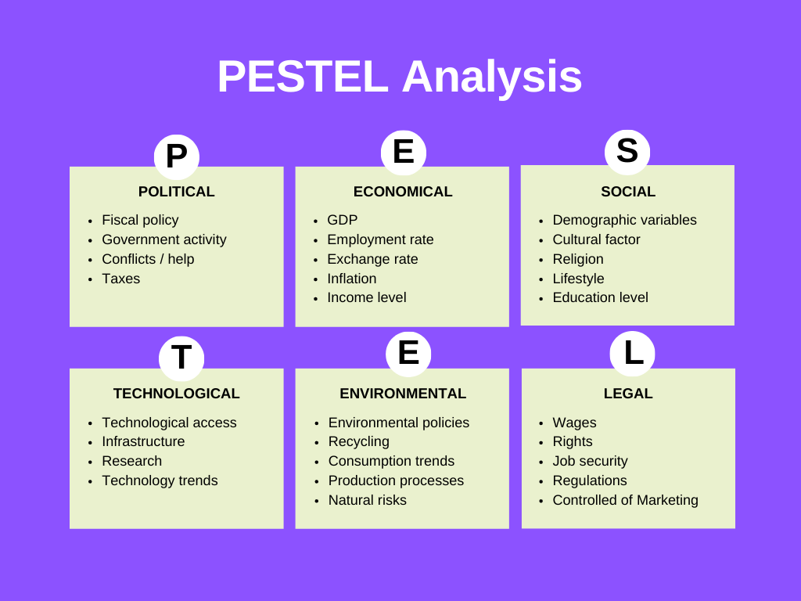
Figure 2: PESTLE Analysis
Source: (VanZandt, 2023)
Economic Factors: The state of the economy has a disproportionate impact on high-end restaurant expenditure. Spending on splurges like fancy restaurants may fall when people are nervous about the economy (George, 2021). Potential growth regions should have their discretionary income and unemployment rates evaluated by The Taste of Britain. Post-BREXIT currency swings can potentially affect pricing strategies and expenses. Customers' purchasing power and eating habits are affected by the local economic climate, thus the restaurant should think about this while expanding to new areas.
Social Factors: Sustainable eating, one-of-a-kind restaurant experiences, and regional cuisines are becoming more popular in the UK (Foskett et al., 2021). Due to its reputation for originality and fun, The Taste of Britain is well-positioned to profit from current fads. Regional food choices and cultural diversity within the UK must also be considered. It may be necessary to adjust the menu to accommodate a varied range of client tastes due to the growing concern for health, wellness, and ethical eating.
Technological Factors: There has been a steady rise in the importance of technology in the food service sector. Consumers are swayed to make purchases based on internet booking systems, social media, and reviews (Foskett et al., 2021). To improve the client experience, streamline operations, and execute efficient marketing initiatives, The Taste of Britain should use new technology. The logistical issues brought on by BREXIT highlight the importance of technology's potential role in supply chain management.
Legal Factors: The Taste of Britain is subject to several rules and regulations, such as those about food safety, licensing, employment, and the COVID-19 safety procedure (Foskett et al., 2021). Compliance with regional legislation, which may range somewhat, is essential for any expansion inside the UK. To keep the restaurant's excellent reputation and high standards, it is essential to ensure compliance.
Environmental Factors: The hotel sector is beginning to place a greater emphasis on environmental sustainability. Sustainable approaches in ingredient procurement, waste reduction, and carbon footprint minimizing should be seriously considered by The Taste of Britain. Environmentally concerned customers are more likely to frequent restaurants that actively seek out ways to reduce their impact on the planet (Foskett et al., 2021). Strategic planning must prioritize sustainability in light of the reality that legislative demands on environmental practices are only going to grow.

Figure 3: Market Size of Restaurant Industry in the UK
Source: (statista.com, 2022)

Internal Environmental Analysis: Porter’s 5 Forces
The Taste of Britain restaurant's competitive dynamics in the high-end dining market may be better understood by doing a thorough Porter's Five Forces study. The competitive rivalry, new entrant threat, substitute product or service threat, supplier negotiating power, and consumer bargaining power are all examined within this framework.
Competitive Rivalry: Intense competition characterizes the fine dining industry, where The Taste of Britain works. There are a lot of fancy restaurants in this field, and they all want to be the best at what they do and provide their customers with memorable experiences (Frederick and Parappagoudar, 2021). The Taste of Britain competes with other high-end restaurants for the same wealthy customers, yet stands out due to its innovative cuisine and reputation. When it comes to cuisine, service, and atmosphere, this industry is known for its high standards. Reviews and ratings play a crucial part in shaping consumer decisions and industry reputation, adding to the competitive pressure.
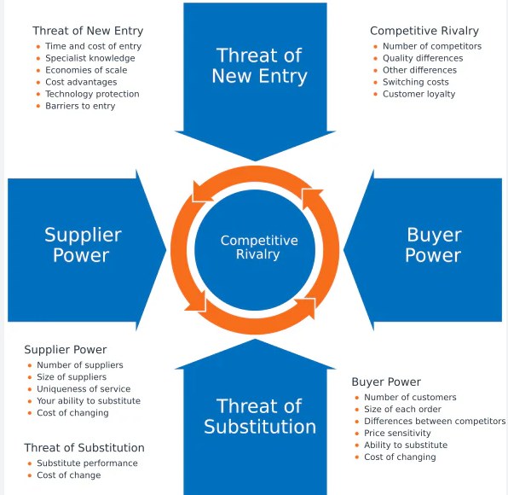
Figure 4: Porter’s Five Forces
Source: (mindtools.com, 2023)
Threat of New Entrants: The substantial capital outlay needed to launch a high-end restaurant, hire competent employees, and establish a solid reputation makes the fine dining industry an extremely difficult one to get into (Frederick and Parappagoudar, 2021). Still, long-standing eateries face constant competition from up-and-coming chefs and culinary trends. To avoid losing customers to upstarts who provide unique food experiences or focus on certain demographics, The Taste of Britain has to keep innovating and setting high standards.
Threat of Substitute Products or Services: The Taste of Britain's competitors include not just other upscale eateries, but also fast-food joints, mobile eateries, delivery services for gourmet cuisine, and even experiences where customers prepare high-end meals in the comfort of their own homes. The Taste of Britain's one-of-a-kind and immersive eating experience mitigates the danger of alternatives. But if consumer tastes change for example, if people want more convenient choices or lean towards more informal dining then these alternatives might become even more of a threat (Frederick and Parappagoudar, 2021).
Bargaining Power of Suppliers: Suppliers may have considerable negotiating power since The Taste of Britain uses high-quality, often specialized ingredients. There may be fewer supplier possibilities, leading to increased reliance, due to the necessity for unique and top-quality ingredients (Beckmann, 2021). On the other hand, being linked with such a famous restaurant as The Taste of Britain and its illustrious history might mitigate this influence. Crucial initiatives for The Taste of Britain include investigating alternate sourcing sources and maintaining solid connections with suppliers.
Bargaining Power of Customers: Diners have high expectations for the food, service, and ambience of restaurants like The Taste of Britain. Social media and online reviews have increased consumer power. A single negative review may completely destroy a business's reputation (Beckmann, 2021). The Taste of Britain's devoted clientele and culinary experts are drawn to the event by its unique eating experience, which somewhat mitigates this negotiating strength. The Taste of Britain operates in a highly competitive field where new entrants vying for customers with identical or superior products are a continual threat. Maintaining the restaurant's unique offerings and high standards will assist in managing suppliers' and customers' significant negotiation leverage.
Industry Attractiveness and Market Strategies
The Taste of Britain restaurant's PESTLE and Porter's Five Forces studies show a complicated situation when it comes to industry attractiveness and marketing techniques.
Industry Attractiveness: Despite the fierce competition, the high-end dining industry continues to draw in customers who value status and are prepared to spend more for one-of-a-kind experiences. The situation is further complicated by factors such as shifting societal attitudes towards sustainability and health awareness, economic volatility, and political unpredictability. Innovations in customer involvement are made possible by technological improvements, but customers' expectations are also raised by these innovations. Strict compliance with rules and sustainable practices is required by legal and environmental considerations, which may operate as both a limitation and an advantage.
Market Strategies: Keeping its one-of-a-kind culinary experience front and center should be The Taste of Britain's priority if it wants to succeed in this market. The cuisine and service must be constantly improved and innovated. Boosting the prestige of the brand and using its reputation to build barriers is one way to deal with the danger of new competitors. The eatery should make the most of its distinctive ingredient sourcing capabilities while also working to diversify its suppliers to balance out their influence. To counteract the influence of powerful customers, strategies should focus on providing outstanding customer experiences and carefully monitoring their internet reputation. Taking into account the PESTLE analysis, The Taste of Britain has to maintain its flexibility in the face of ever-changing political and economic climates, adopt environmentally friendly and moral business practices, and make good use of technology to improve its advertising and operations.

Sustainable Competitive Advantage

BCG Matrix
As part of its strategy to grow in the UK, The Taste of Britain restaurant has decided to use the Boston Consulting Group's (BCG) Matrix to classify its many business units. These units will be placed into four categories: Stars, Cash Cows, Question Marks, and Dogs. The Taste of Britain's use of this concept is unusual for a single upscale restaurant, but its several strategic components allow it to be understood.
Stars: The Taste of Britain's innovative culinary experiences and its prestigious reputation position it as a 'Star' in the fine dining sector. These elements are key growth drivers, attracting a global clientele and commanding premium pricing. To maintain this status, continued innovation and maintaining exclusivity are crucial (Crab, 2020).
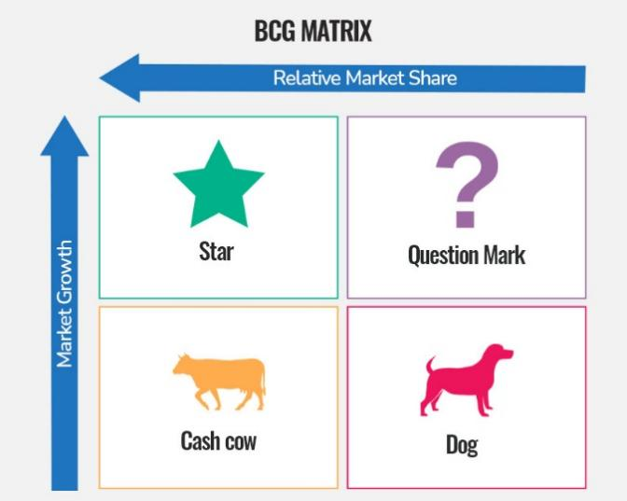
Figure 5: BCG Matrix
Source: (speakingnerd.com, 2021)
Cash Cows: Certain signature dishes or experiences that have consistently attracted customers and garnered acclaim can be seen as 'Cash Cows.' These elements provide stable revenue and are essential to fund experimental culinary ventures and expansion efforts (Crab, 2020).
Question Marks: New initiatives, such as expansion plans or introducing new culinary concepts, fall into this category. These ventures require investment and carry risk, but they also hold growth potential and could eventually become 'Stars.' Their success depends on market reception and effective execution (Crab, 2020).
Dogs: Aspects of the business that underperform or are less aligned with The Taste of Britain's core value proposition, such as potentially less popular menu items or less efficient operational practices, could be considered 'Dogs.' These areas might require revaluation or discontinuation to allocate resources more effectively (Crab, 2020).

Ansoff Matrix
Market Penetration, Market Development, Product Development, and Diversification are the four growth methods that The Taste of Britain restaurant aims to analyze using the Ansoff Matrix as it expands inside the UK.
Market Penetration: Currently, The Taste of Britain's primary strategy seems to be market penetration. It aims to increase its share in the existing high-end dining market by continuing to offer unique culinary experiences (Ferdous and Mim, 2021). However, given the saturated nature of the fine dining market in the UK and The Taste of Britain's already strong presence, significant growth through this strategy may be limited.
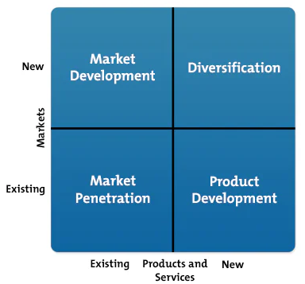
Figure 6: Ansoff Matrix
Source: (mindtools.com, 2023)
Market Development: The planned expansion within the UK represents a market development strategy. By opening new locations, The Taste of Britain seeks to attract new customers in different geographical areas. The success of this strategy will depend on effectively adapting to local tastes while maintaining the brand's unique value proposition.
Product Development: This strategy involves introducing new culinary experiences or menu items. Given The Taste of Britain's reputation for innovation, further developing its product offerings could attract both existing and new customers (Ferdous and Mim, 2021). However, this requires continuous investment in creativity and research.
Diversification: Diversification might involve The Taste of Britain stepping into new business areas, such as launching a line of gourmet products or a culinary school (Ferdous and Mim, 2021). This strategy carries higher risk due to moving into potentially unfamiliar territory, but it could also open up new revenue streams.
Taste of Britain's present expansion strategy is mostly focused on developing the market, but there is also great growth potential in capitalizing on its strong brand for product development.
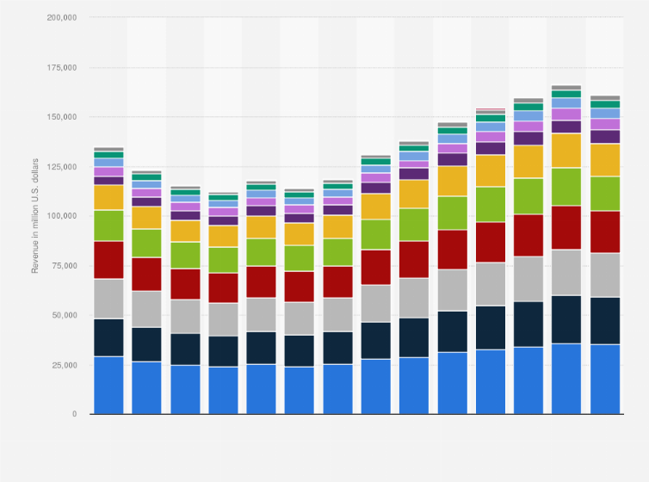
Figure 7: Food market revenue generation in UK
Source: (statista.com, 2022)

VRIO analysis
Strategically, a business may assess its strengths and weaknesses using the VRIO (Value, Rarity, Imitability, Organization) model. The Taste of Britain restaurant's competitive edge may be better understood by applying VRIO to it, particularly in light of its aspirations to expand into the UK market.
Value: The Taste of Britain's unique culinary experience, including its innovative dishes and immersive dining atmosphere, provides immense value. Its reputation as a culinary innovator and its Michelin-star status attract global clients. This value is instrumental in differentiating The Taste of Britain in the competitive fine dining market (Yun et al., 2020).
Rarity: The restaurant's distinctive approach to gastronomy, developed by chef Heston Blumenthal, is rare and sets it apart in the industry. The combination of culinary art and scientific methods to create unique dining experiences is not commonly found in other establishments, which adds to its rarity.
Imitability: The Taste of Britain's concept and execution are challenging to imitate due to the unique skills, creativity, and reputation of its chef, as well as its established brand. The specialized knowledge and experience required to replicate such an innovative dining experience create a barrier to imitation (Yun et al., 2020).
Organization: The Taste of Britain is well-organized to capitalize on its resources and capabilities. The restaurant is adept at managing its unique culinary talents, maintaining high standards, and constantly innovating its offerings. Its organizational structure supports the creativity and excellence required to sustain its prestigious position (Yun et al., 2020).
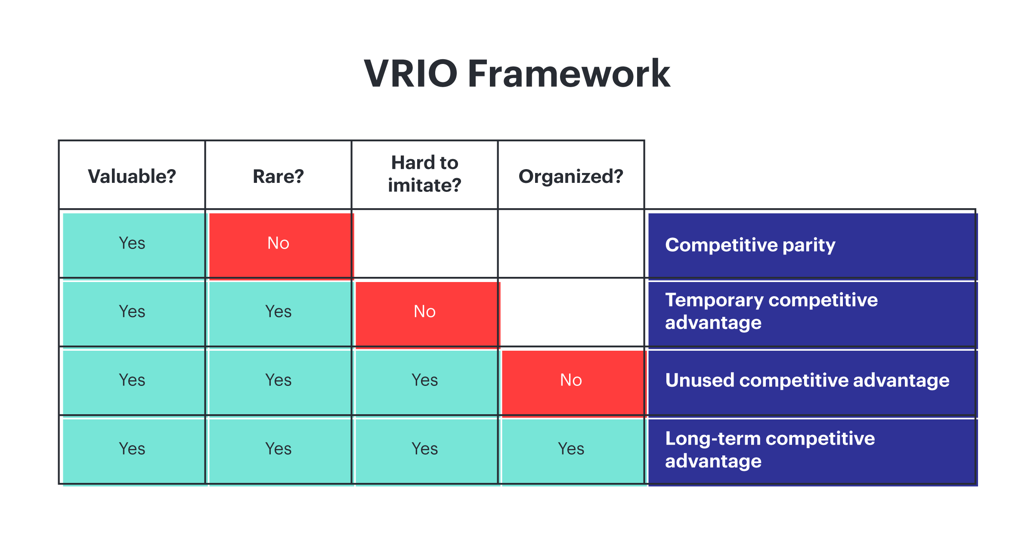
Figure 8: VRIO Analysis
Source: (Yun et al., 2020)

SWOT Analysis
The Taste of Britain restaurant's development plans in the UK may be better understood by doing a SWOT analysis, which is a framework for assessing opportunities and threats from the outside and internal factors.
Strengths:
The Taste of Britain's major strength lies in its prestigious reputation as a pioneer in innovative, experiential dining, spearheaded by renowned chef Heston Blumenthal. Its Michelin-star status, unique culinary creations, and exceptional dining experience are unparalleled assets (Soegoto, 2021). The restaurant’s established brand and loyal customer base are also significant strengths, providing a solid foundation for expansion.
Weaknesses:
The Taste of Britain's high-end, niche market positioning might limit its customer base, particularly in areas with lower demand for luxury dining. The complexity and cost of replicating its unique dining experience could pose challenges in maintaining consistency across multiple locations (Soegoto, 2021). Furthermore, the restaurant’s reliance on its reputation and a specific culinary style may make adaptability to local preferences challenging.
Opportunities:
Expansion presents opportunities to tap into new markets and demographics, potentially increasing brand visibility and revenue (Soegoto, 2021). Collaboration with local suppliers and incorporation of regional culinary influences could enrich The Taste of Britain’s menu offerings. The growing trend towards experiential dining aligns well with The Taste of Britain’s unique proposition.
Threats:
The fine dining sector is highly competitive, with new and established players constantly elevating industry standards. Economic fluctuations and changing consumer spending habits could impact the luxury dining segment (Soegoto, 2021). Additionally, operational challenges in scaling up and maintaining quality across multiple locations are potential threats.
Ultimately, the innovative spirit and stellar reputation of The Taste of Britain provide strong foundations for future growth. Nevertheless, there are also concerns about its narrow market positioning and the intricacy of its operations.

Figure 9: SWOT analysis
Source: (Shaw, 2017)

Value Chain Analysis
Primary Activities:
- Inbound Logistics: The Taste of Britain's sourcing of high-quality, often rare ingredients is crucial. Its ability to secure the best produce contributes significantly to its culinary excellence. However, as it expands, maintaining this standard across multiple locations will be a challenge.
- Operations: The restaurant’s operational efficiency, kitchen management, and the unique culinary techniques employed are central to its success. Replicating these operations effectively in new locations is vital to maintain quality and consistency.
- Outbound Logistics: This aspect is less significant for The Taste of Britain, as it primarily delivers its service directly to customers on-premise. However, managing reservations and customer flow efficiently is key.
- Marketing and Sales: The Taste of Britain's brand reputation and marketing are driven largely by word-of-mouth and its status in the culinary world. Expansion offers an opportunity to broaden its marketing strategy to attract new customer segments.
- Service: Exceptional customer service is a hallmark of The Taste of Britain. The customer experience, from booking to dining, is carefully curated, and this high standard must be upheld as the business grows.
Support Activities:
- Procurement: Efficient procurement is vital for securing quality ingredients, a cornerstone of The Taste of Britain's offering.
- Technology Development: Leveraging technology in kitchen equipment, reservation systems, and customer experience (like augmented reality menus) can add value.
- Human Resource Management: Recruiting, training, and retaining top culinary and service talent is essential, especially as the business scales.
- Firm Infrastructure: Strong managerial practices, financial control, and compliance are critical, particularly as expansion adds complexity to the business.

Evaluation
Numerous strategic assessments have demonstrated that "The Taste of Britain" holds a distinct place in the industry, mostly because of its commitment to providing only authentic and superior British cuisine. Because of the revenue and growth that their signature dishes—like fish and chips—provide due to their consumers' adoration, the BCG matrix ranks these meals as Stars (Kankam-Kwarteng et al., 2020). VRIO claims that the restaurant has a significant competitive edge over its competitors since its authentically British dining experience is hard to match. These gastronomic pleasures are difficult to replicate due to the dining experience's cultural immersion and the staff's specialised understanding.

The restaurant has challenges from price sensitivity and specialised market limitations, as shown by the SWOT analysis results, but it also has ample opportunity to expand through creative menu items and astute marketing. The Value Chain Analysis emphasises the importance of efficient operations and top-notch customer service to maintain high quality and satisfied consumers. Because to its unique positioning, effective operations, and astute application of strategic strengths, "The Taste of Britain" is well-positioned to maintain its competitive edge. The aforementioned benefits enable it to distinguish itself in a congested market and attract loyal customers seeking authentic British cuisine. To succeed, Taste of Britain must manage its supplier relationships and adapt to its consumers' shifting preferences. It also has to improve its culinary offerings and overall customer experience. According to the Five Forces research, Taste of Britain must sustain its competitive edge in the premium dining market with continual innovation and great service.

Ways to implement and execute the strategy

Strategy
The growth plan of The Taste of Britain needs to be established on the foundation of its key qualities, which include excellent culinary experiences, innovation, and exclusivity. The plan for the restaurant needs to include market penetration in high-value areas as well as diversification into new eating ideas that are consistent with the brand. It is of the utmost importance to carry out exhaustive market research to find demographic clusters that correspond precisely with the audience of the brand. The company must make use of the reputation it already has to generate excitement and expectations concerning future vacancies. To ensure that The Taste of Britain stands out in the fine dining industry, not just for its culinary expertise but also for its distinctive dining story, it will be necessary to implement a differentiation strategy (kitchen-theory.com, 2021). This approach might include incorporating elements of local culture and ingredients into the restaurant's menu to provide a dining experience that is both luxurious and rooted in the local culture.

Structure
The organizational structure of The Taste of Britain needs to be flexible while also being sturdy enough to ensure that the restaurant's high standards are maintained throughout several different locations. It could be advantageous to have a decentralized structure, which would provide each site some degree of autonomy to adjust to the circumstances of the local market while still sticking to the basic values and standards of the brand. In each new site, there should be a head chef who has a distinct vision that is by the ideal of Heston Blumenthal, and this head chef should be backed by a staff that is capable of providing an extraordinary dining experience (kitchen-theory.com, 2021). Audits and training programs should be implemented regularly to guarantee that each new site will continue to uphold the same standards that gave the first location its reputation for excellence.
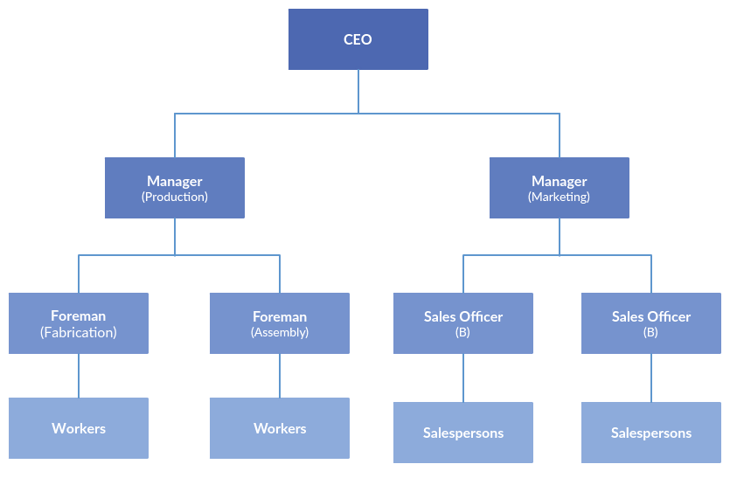
Figure 10: Organizational Structure
Source: (kitchen-theory.com, 2021)

Systems
The Taste of Britain’s operational systems must be optimized for efficiency and consistency. This includes reservation systems, customer relationship management (CRM) software, and supply chain management. A centralized system for procurement could help maintain quality across all locations while taking advantage of bulk purchasing for cost efficiency (kitchen-theory.com, 2021). Implementing a state-of-the-art kitchen technology system across all locations can help standardize cooking techniques and quality. A unified IT system can provide real-time data analytics to inform menu adjustments, staff performance, and customer satisfaction, allowing for agile responses to operational challenges.
Marketing and Promotion:
A strategy for marketing should be taken that celebrates the history of the brand and its growth while also emphasizing the distinctive characteristics of each new location. To generate interest and attract the target customers, exclusive events, partnerships with well-known chefs, and a robust digital marketing campaign are all viable options. There is the possibility to establish an emotional connection with prospective consumers by establishing a robust web presence via the use of storytelling, spotlighting the dining experience, and providing insights behind the scenes.
Human Resources:
It is essential to recruit the appropriate abilities and the staff must not only be equipped with the necessary talents, but they must also be compatible with the culture of The Taste of Britain. The development of training programs is necessary to guarantee a constant level of service quality and to instill in the workers the restaurant's core values and overall dining philosophy.
Financial Management:
For every new site, strict budgeting, financial forecasting, and investment analysis are all essential components of the financial plans that must be implemented. As a means of mitigating the financial risks connected with growth, The Taste of Britain needs to take into consideration any potential strategic alliances or investors.
Risk Management:
In consideration of the unpredictability of the market, it is very necessary to have a thorough risk management strategy. This involves keeping an eye on the developments in the market, the preferences of customers, and economic data. Contingency plans must be developed by The Taste of Britain to prepare for a variety of potential outcomes, including shifts in customer purchasing habits and interruptions in supply chain operations.
Ethics and Sustainability:
The Taste of Britain, which is a well-known brand, needs to include ethical principles and sustainable practices in its business plan. This involves morally obtaining ingredients, minimizing waste, and making contributions to the communities in which they are located.
Legal Compliance:
The importance of ensuring legal compliance in every business cannot be overstated. This includes legislation about food safety, employment laws, licensing, and intellectual property rights, especially because The Taste of Britain's culinary inventions constitute a substantial component of the company's corporate identity.

Critical Analysis
The created strategy plan makes advantage of The Taste of Britain's assets and aims for controlled but ambitious expansion; nonetheless, there are several critical challenges that must be addressed along the process. Scaling is difficult since good dining experiences are personalised. As a result, each new restaurant must maintain the uniqueness and personal touch that define The Taste of Britain brand. Market saturation and increasing customer preferences towards casual eating pose considerable risks. It is critical that the growth strategy be flexible and adaptable to the ever-changing market conditions. Furthermore, maintaining a balance between innovation and tradition is crucial. While neglecting to adapt might result in the brand becoming outdated, excessive deviation from the core brand could drive away present customers. When it comes right down to it, The Taste of Britain's expansion has to be carefully thought out and executed, with a clear vision that aligns with its unique brand and is simultaneously open to new opportunities and challenges within the vibrant fine dining scene in the United Kingdom.
KPI as monitoring tool to monitor the strategy
To monitor the strategy of The Taste of Britain Restaurant effectively using Key Performance Indicators (KPIs), several specific metrics can be employed:
Customer Satisfaction Scores: Regular surveys and feedback mechanisms to gauge diner satisfaction, focusing on food quality, service excellence, and overall experience.
Table Turnover Rate: Measuring the frequency at which tables are occupied and then made available again to new diners, indicating operational efficiency and customer demand.
Average Spend per Customer: Tracking the average amount spent per diner to assess pricing strategies and menu appeal (Fernandes et al., 2021).

Critical Evaluation of Green Strategy, Sustainability, and CSR activities that can be undertaken by The Taste of Britain restaurant

Green Strategy
The Taste of Britain can integrate a green strategy by minimizing waste, reducing energy consumption, and sourcing ingredients sustainably. For instance, the restaurant can implement a comprehensive recycling program, invest in energy-efficient kitchen equipment, and opt for renewable energy sources where feasible (Chaturvedi et al., 2022). Furthermore, reducing the carbon footprint through local sourcing not only supports sustainability but also aligns with the culinary trend of using fresh, local ingredients.
Critically, while these practices contribute to environmental stewardship, they must be balanced with the restaurant's high standards for quality and innovation. Energy-efficient equipment must meet the rigorous demands of a top-tier kitchen, and locally sourced ingredients must not limit the restaurant's creative potential. Additionally, such strategies may incur higher upfront costs, requiring careful financial consideration (Chaturvedi et al., 2022).

Sustainability and CSR activities

Sustainability Initiatives
Sustainability in fine dining extends beyond environmental impact to include social and economic aspects. The Taste of Britain can lead by example in promoting fair labor practices, supporting local farmers and producers, and fostering a culture of sustainability within its workforce (Chaturvedi et al., 2022). By implementing sustainable fishery and farming practices, the restaurant not only contributes to the conservation of resources but also educates its clientele on the importance of sustainability in gastronomy.
A critical evaluation, however, reveals challenges in consistently sourcing sustainable ingredients that meet The Taste of Britain's caliber, potentially affecting menu flexibility. Moreover, there is a delicate balance between upholding sustainability and maintaining profitability, as sustainable practices can sometimes result in higher operational costs (Han et al., 2020).

CSR Activities
CSR activities for The Taste of Britain could involve community engagement, charitable contributions, and educational initiatives. The restaurant might establish apprenticeship programs for aspiring chefs from underserved communities, host charity dinners to support local causes or participate in food education programs in schools to promote healthy eating habits (Han et al., 2020).
While such activities can enhance the restaurant's reputation and give back to the community, they must be chosen and implemented thoughtfully to align with the brand's values and expertise. CSR initiatives need to be genuine and not just for show, as today's consumers are adept at distinguishing between heartfelt efforts and mere publicity stunts.
Critical Evaluation
When assessing these strategies, it's vital to weigh their benefits and drawbacks. While green practices can make The Taste of Britain stand out, they may also raise costs and complexities. Their advantages, like improved brand image and loyalty, often take time to materialize, needing patience. Sustainability and CSR are evolving fields, demanding constant adaptation (Han et al., 2020). What's sustainable today may shift with new research, and CSR activities may vary in impact across communities. Hence, ongoing evaluation and adjustment are crucial. In contrast to many CSR programmes, which are meant to be inclusive, the fine dining industry is particularly vulnerable to the idea of exclusivity. Aiming to make its CSR initiatives accessible and worthy of the Taste of Britain's reputation, the organisation must carefully manage these impressions. It's also necessary to inform customers about sustainability, CSR, and green plan implementation. According to Chaturvedi et al. (2022), transparency is essential since patrons should be aware of the restaurant's policies and how they work. But in order to prevent coming across as boastful or taking away from the eating experience, this communication needs to be well-crafted.

Conclusion
While the incorporation of a green strategy, sustainability, and corporate social responsibility into The Taste of Britain's operations gives chances for market distinction and ethical operations, it also requires a considered approach that is in line with the restaurant's dedication to quality and innovation. These tactics must be meticulously planned and carried out to guarantee that they will favorably impact the restaurant's reputation, the overall experience of its customers, as well as the community and the environment as a whole. By demonstrating that excellent dining and ethical and environmentally responsible business practices are not mutually exclusive, The Taste of Britain's leadership in these areas has the potential to establish a new standard for the industry.

References
Beckmann, A., 2021. Scenario analysis of online food supply chains. In Adapting to the Future: How Digitalization Shapes Sustainable Logistics and Resilient Supply Chain Management. Proceedings of the Hamburg International Conference of Logistics (HICL), Vol. 31 (pp. 585-609). Berlin: epubli GmbH.
Chaturvedi, P., Kulshreshtha, K., Tripathi, V. and Agnihotri, D., 2022. Investigating the impact of restaurants' sustainable practices on consumers' satisfaction and revisit intentions: a study on leading green restaurants. Asia-Pacific Journal of Business Administration.
Collins, C.J., 2021. Expanding the resource based view model of strategic human resource management. The International Journal of Human Resource Management, 32(2), pp.331-358.
Crab, M.A., 2020. Customer Experience in a Hungarian Fine Dining Restaurant: A Marketing Perspektive (Doctoral dissertation, Universidade do Algarve (Portugal)).
Ferdous, M.A. and Mim, S., 2021. Factors Influencing Customers Satisfaction in Hospitality Industry: Fine Dining Restaurants.
Fernandes, E., Moro, S., Cortez, P., Batista, F. and Ribeiro, R., 2021. A data-driven approach to measure restaurant performance by combining online reviews with historical sales data. International Journal of Hospitality Management, 94, p.102830.
Foskett, D., Paskins, P., Pennington, A. and Rippington, N., 2021. The theory of hospitality and catering. Hachette UK.
Frederick, D.P. and Parappagoudar, S.K., 2021. A Descriptive Analysis on Sustainable Business Strategy of Online Food Service Industry. International Research Journal of Modernization in Engineering Technology and Science, 3(3), pp.545-554.
George, R., 2021. The Tourism and Hospitality Marketing Environment. In Marketing Tourism and Hospitality: Concepts and Cases (pp. 183-219). Cham: Springer International Publishing.
Han, H., Chua, B.L., Ariza‐Montes, A. and Untaru, E.N., 2020. Effect of environmental corporate social responsibility on green attitude and norm activation process for sustainable consumption: Airline versus restaurant. Corporate Social Responsibility and Environmental Management, 27(4), pp.1851-1864.
Kankam-Kwarteng, C., Osman, B. and Acheampong, S., 2020. Performance of restaurants: Recognizing competitive intensity and differentiation strategies. Journal of Tourism, Heritage & Services Marketing (JTHSM), 6(3), pp.25-34.
managementmania.com, 2020. VRIO Analysis. [Online]
Available at: https://managementmania.com/en/vrio-analysis
mindtools.com, 2023. Porter's Five Forces - The Framework Explained. [Online]
Available at: https://www.mindtools.com/at7k8my/porter-s-five-forces
Shaw, J., 2017. How to Complete a Personal SWOT Analysis. [Online]
Available at: https://medium.com/thrive-global/how-to-complete-a-personal-swot-analysis-2f8769aebd5e
Soegoto, F.A., 2021. Product development using SWOT analysis. International Journal of Entrepreneurship & Technopreneur (INJETECH), 1, pp.1-10.
speakingnerd.com, 2021. How to use BCG Matrix for strategic planning. [Online]
Available at: https://speakingnerd.com/strategy/strategy-models/bcg-matrix
statista.com, 2022. Market size of the restaurant industry in the United Kingdom in 2021, with a forecast for 2022. [Online]
Available at: https://www.statista.com/statistics/1318869/restaurant-industry-market-size-uk/
VanZandt, P., 2023. What is PESTEL Analysis? Definition, Benefits, Examples, Strategic Management and Best Practices. [Online]
Available at: https://ideascale.com/blog/what-is-pestel-analysis/
Yun, J.J., Park, K., Gaudio, G.D. and Corte, V.D., 2020. Open innovation ecosystems of restaurants: Geographical economics of successful restaurants from three cities. European Planning Studies, 28(12), pp.2348-2367.

