Course: Inclusive Education
Module: SJIE5004- Celebrating Language and Culture- Belonging to Wales

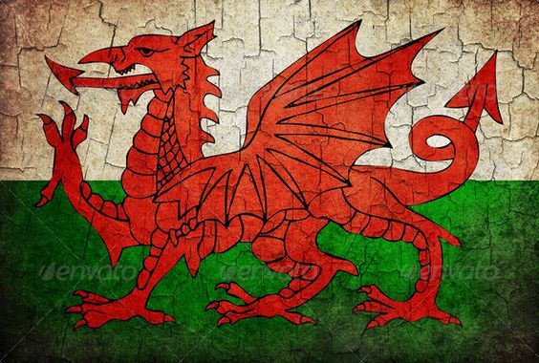

Contents
Rationale 3-4
Overview of activities 4-6
Evaluation 7-8
Appendices 9-13

References 14

Schools throughout Wales have introduced teaching Welsh through a variety of different methods. Wales is a country made of two languages which means teaching and learning in both English and Welsh. There are schools in Wales that are Welsh medium schools which teach and communicate in Welsh language. Pupils who attend Welsh speaking schools are introduced English as a second language. However, some pupils who attend Welsh speaking schools are introduced to the Welsh language when they start nursery and may not use the language outside school, this could be due to their parents being non-Welsh speaking or are bi-lingual and use English language more than they do Welsh. Welsh medium schools tend to teach most of their lessons in Welsh but also teach some lessons bi-lingually as they believe some topics are international so will teach these in both Welsh and English. Edwards, I (2017) highlights that
“With the planned introduction of a new Curriculum for Wales it is important that adequate and relevant Welsh medium and bilingual education resources are available to ensure that pupils that are educated through the medium of Welsh are not in anyway being disadvantaged.”
This explains that Welsh speakers shouldn’t be excluded from education in Welsh medium. The Welsh language plays a huge part of Wales and the culture and therefore should be able to have access to Welsh education. The National Curriculum for Wales has similarities to England’s National Curriculum, but the Welsh Curriculum has added elements to teach in Welsh. BBC Wales (2014) states that “The Curriculum cover what children must be taught with a strong focus on literacy and numeracy. An interesting addition to the curriculum in Wales is ‘Oracy’, a focus on the tradition of the spoken word in Welsh culture.” The new Welsh Curriculum 2022 covers six areas of learning which are Health and Wellbeing, Science and Technology, Mathematics, Expressive Arts, Humanities and lastly, Literacy, Communication and Language. Welsh is made to be a compulsory subject under the Literacy, Communication and Language area of learning. The Curriculum is in place to support and improve pupils’ education development.
The Welsh Government (2020) highlight “Improving education is our national mission. Nothing is so essential as universal access to, and acquisition of, the experiences, knowledge and skills and that our young people need for employment, lifelong learning and active citizenship.” This suggests that the Curriculum is important to follow in aid to support learners’ development through many factors of learning to prepare them for adulthood. A teaching role has an important part in supporting children’s learning and development. It is important for teaching staff to plan and carry out activities which follows elements of the Curriculum.
Most schools today use Welsh language daily through greetings and commands. School A’s Welsh policy states that “Welsh contributes to the Curriculum Cwmreig by giving learners an awareness of the literacy and cultural heritage of Wales, through songs, stories and legends, and it gives them the opportunity to use Welsh as a means of communication.” This explains that Welsh is not exclusively taught in School A but is incorporated into the wider curriculum and whole school life.
Donaldson, G (2015) believes “The National Curriculum sought to establish an entitlement for all children and young people in state schools to an education that would include exposure to nationally specified knowledge and skills.” This statement shows that the National Curriculum is an important and essential part of education whether it be teaching or learning. The Curriculum allows learners to access and develop their knowledge and skills through their education.

School A is a special school which support learners aged 3 to 19 years old who have additional needs and disabilities. School A follow the National Curriculum but, in some cases, it is adapted to meet the needs of the pupils. The pupils are given individual education plans (IEPs) to set them targets which are individual to them and are adapted to cater their needs. In one’s own setting, the pupils learn and develop from having activities where they can interact and participate with a sensory and fun element to them. The Schools Welsh Policy states that the pupils should be given the opportunity to learn and enjoy the Welsh language and culture. It explains that the aim of learning Welsh in School A is to make it an interesting, pleasurable, and lively experience through song, dance, drama, games, stories, and activities that they participate in daily. At School A, Welsh language and Culture is delivered through Welsh week which is based around St David’s Day celebrations.
A lot of the activities or work tasks that are given to pupils are often completed with support and prompting. For pupils who aren’t quite able to complete tasks independently always have a member of staff next to them to show them how to or to support them while completing the task. The prompts are often commands with actions for example, when showing the pupil how to do an action, it would be given with a command saying ‘do this’ which is an easy instruction to follow as they copy the action by the support staff. Mcloed, S (2019) states that according to Vygotsky “much important learning by the child occurs through social interaction with a skilful tutor. The tutor may model behaviours and/or provide verbal instructions for the child. Vygotsky refers to this as the cooperative or collaborative dialogue.” This explains why modelling the actions and giving the instruction ‘do this’ helps to support pupils in their learning and completing a task. Mcloed, S (2019) highlights that “Bruner, like Vygotsky, emphasized the social nature of learning, citing that other people should help a child develop skills through the process of scaffolding.” The term scaffolding suggests that having a helpful and structured interaction between the teacher and learner supports the development of reaching the learners targets and goals.
To develop on pupils’ literacy, communication, and language skills (See Appendix 1) there is a lotto board with matching cards to help pupils to match colours and words in Welsh. This activity can develop their communication skills whilst matching colours and learning the colours in the Welsh language. Having the word in the Welsh language and the colour enables the pupils to match the colour as well as the written word. The pupils are supported during this activity with the use of physical prompts and reinforcers. Makaton is also a helpful support method when supporting the pupils with activities like these as Makaton can be used in both languages, but the signs are the same.
Another activity which has a link between literacy and numeracy is a sensory story. (See Appendix 2) There is a bi-lingual story book which involves counting dinosaurs. This enables learners to develop both literacy and numeracy skills whilst enjoying a sensory story. The story book can be read whilst using props and objects. The book is in English and Welsh language which allows pupils to hear the story in both languages.
Some of the pupils in one’s setting are very sensory and need sensory feedback. Having sensory activities where the pupils are able to learn and develop are an important part of their learning and meeting their needs. There are many sensory activities that can be linked to the Welsh language and culture such as water trays, sensory trays, painting, and food tasting. During Welsh week, there are daily sensory sessions where the pupils can use their senses to learn and interact with the activities. Mcloed, S (2018) highlights that Piaget believed “Discovery learning- the idea that children learn best through doing and actively exploring- was seen as central to the transformation of the primary school curriculum.” This explains why children need fun and enjoyable activities for them to actively learn.
All of these sensory activities can be linked to the Welsh language and culture during Welsh week. There are activities that can be used across curriculum for different learning topics. Staff at School A plan and prepare activities that are linked to different elements of the curriculum while meeting the pupils’ individual education plans. Sensory trays are a fun and sensory activity which can be linked to different parts of the curriculum. (see Appendix 3) The sensory tray can be filled with water, porridge oats, rice, sand, and foam and can be used for various activities and learning objectives. Different objects are added to the tray and have numbers on the objects, these may be number cards, balls etc. These numbered objects are used alongside flash cards or lotto boards with the number or word. The aim of this activity is to match or recognise the number using Welsh language whilst using their fine motor skills to pick up the objects. This activity also encourages pupils to use their senses to touch the different textures in the water tray.
During Welsh week, the pupils have the opportunity to taste and cook traditional Welsh food. During cookery sessions, the pupils use a task board which requires literacy and communication skills as well as numeracy. (See Appendix 4) The task board states what they are going to be making, a picture of the finished item and 1 step instructions. The instructions ‘give me’ are adapted to what ingredients the pupil needs to complete the action for example ‘give me 3 biscuits’. This gives the pupil the instruction to give the staff member what ingredients they need. This requires literacy and communication skills to be able to listen to and read the instruction and also numeracy skills to be able to identify the number and count the ingredients needed. Alongside cooking and baking, the pupils are encouraged to try traditional foods and experience the Welsh culture through tasting.
Art activities are a fun and enjoyable way to introduce any topic into learning. During Welsh week, the pupils participate in many Art activities which usually involve painting. There are a variety of ways to create a picture using paints, this may be with hands, vegetables or fruit, sponges, and brushes. The pupils create pictures that relate to the Welsh culture such as the Welsh flag or daffodils. (See Appendix 5) This activity required paint and the pupils’ hands to create daffodil flowers. This activity promotes both the Welsh language and culture. Pupils will be asked to identify the colours of the materials or paint using the Welsh language. There will also be prompts to support pupils when identifying the colours in Welsh, this could be the Welsh colour written on a flashcard or a coloured shape to help them match the colour.

Having completing these activities with one’s class in School A, I feel there is no need for improvement as these activities are planned in order to meet the pupils’ individual targets and therefore will complete some activities a few times in order to meet their target. Some activities could be adapted to meet the needs of the pupils and could be altered to change the activity slightly but with the same learning outcome.
Looking at Appendix 1, the work task could be changed by using a coloured shape to match to the written Welsh colour. This type of activity depends on the pupils’ learning ability and their learning targets. This activity works well for pupils who are able to match words and recognise colours. This could also be adapted and changed to use Welsh words, pictures, and numbers for the pupils to match.
Appendix 2 is a fun and interactive way to learn and count in Welsh. The story involves counting dinosaurs which can be used alongside pictures or objects to count along with. The story book is available to read with English and Welsh language, pupils are able to hear the story and count along with both languages. I believe this activity works well with promoting the Welsh language as it is an enjoyable activity and one’s class particularly enjoy having story time. There could be follow on activities after the story which could involve retelling the story or sequencing it. Art activities can be another follow on activity which could involve painting or colouring dinosaurs. Also, there could be worksheets where the pupils can add or subtract dinosaurs, this can be adapted for each individual’s learning ability.
When completing activities in Appendix 3, this is a very popular and enjoyed activity at School A. The pupils enjoy feeling the different textures while learning. The trays can be adapted to the pupil’s learning abilities. The textures can be changed, and the colours can be to match the Welsh flag colours. The objects hidden amongst the textures can be changed depending on the learning objective. There could be hidden Welsh words for them to match to a lotto board. There also could be Welsh objects and pictures for them to identify. This particular activity encourages pupils to use their fine motor skills while picking up the hidden objects which shows it not only develops their intellectual skills but other skills too.
Appendix 4 is used when pupils are completing a cookery activity. In this case the pupils are making and tasting traditional Welsh foods during Welsh week. The task board is used to support communication which shows the pupils what ingredients they need on a step by step basis. The pupils are able to identify the symbols and pictures and are able to give what they need. This task can be adapted depending on the pupils’ learning ability. It could be changed to having a write up where the pupils can read an ingredients list and a list of instructions on how to complete the task. Due to the pupils in one’s class having very low learning abilities, this task board is the best way to communicate and give instructions and works exceptionally well.
The art activity which was completed in Appendix 5 promotes the Welsh culture. During Welsh week, the pupils take part in completing numerous art activities which promotes the Welsh culture, whether it will be the Welsh flag or other elements which represent the culture. This activity can be altered by using different objects to paint with or different materials to create a picture. This activity could have a finished example for the pupils to copy or one step instructions for them to follow to complete the task. This would be for a pupil who is able to complete this task independently. Another way to alter this activity could be to complete the activity as a group of pupils working together. Some pupils have targets which require working alongside other pupils and turn taking so this would be a good group exercise for them to complete the art activity with their peers.

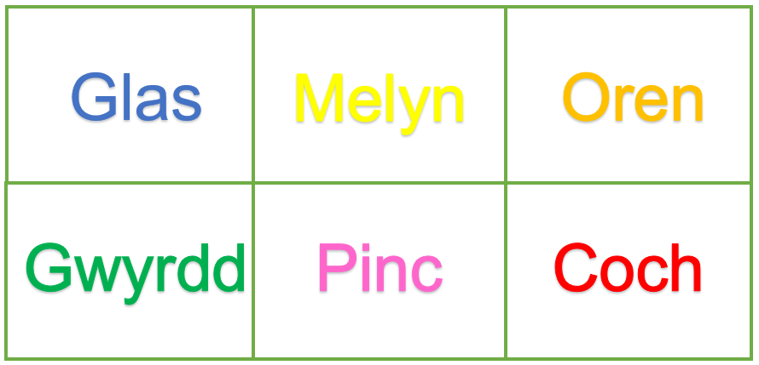
Appendix 1

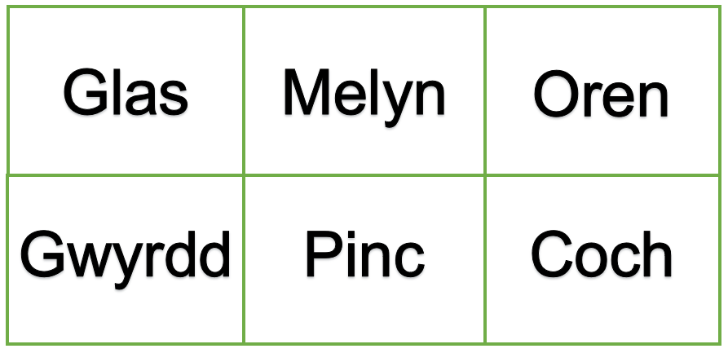

Appendix 2
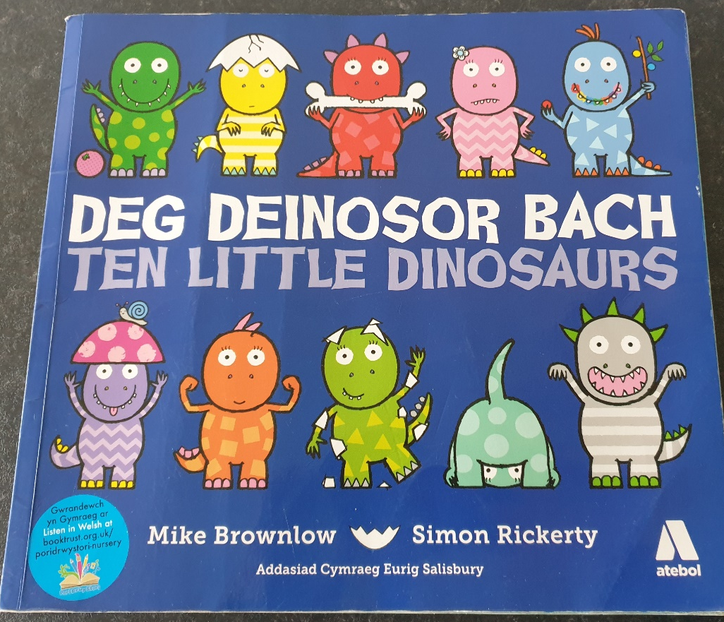
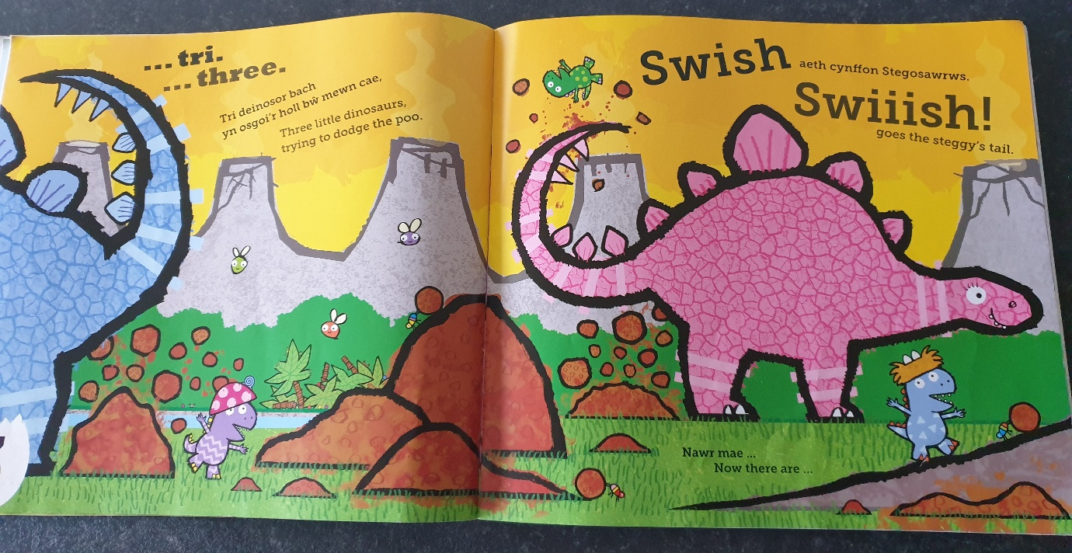

Appendix 3
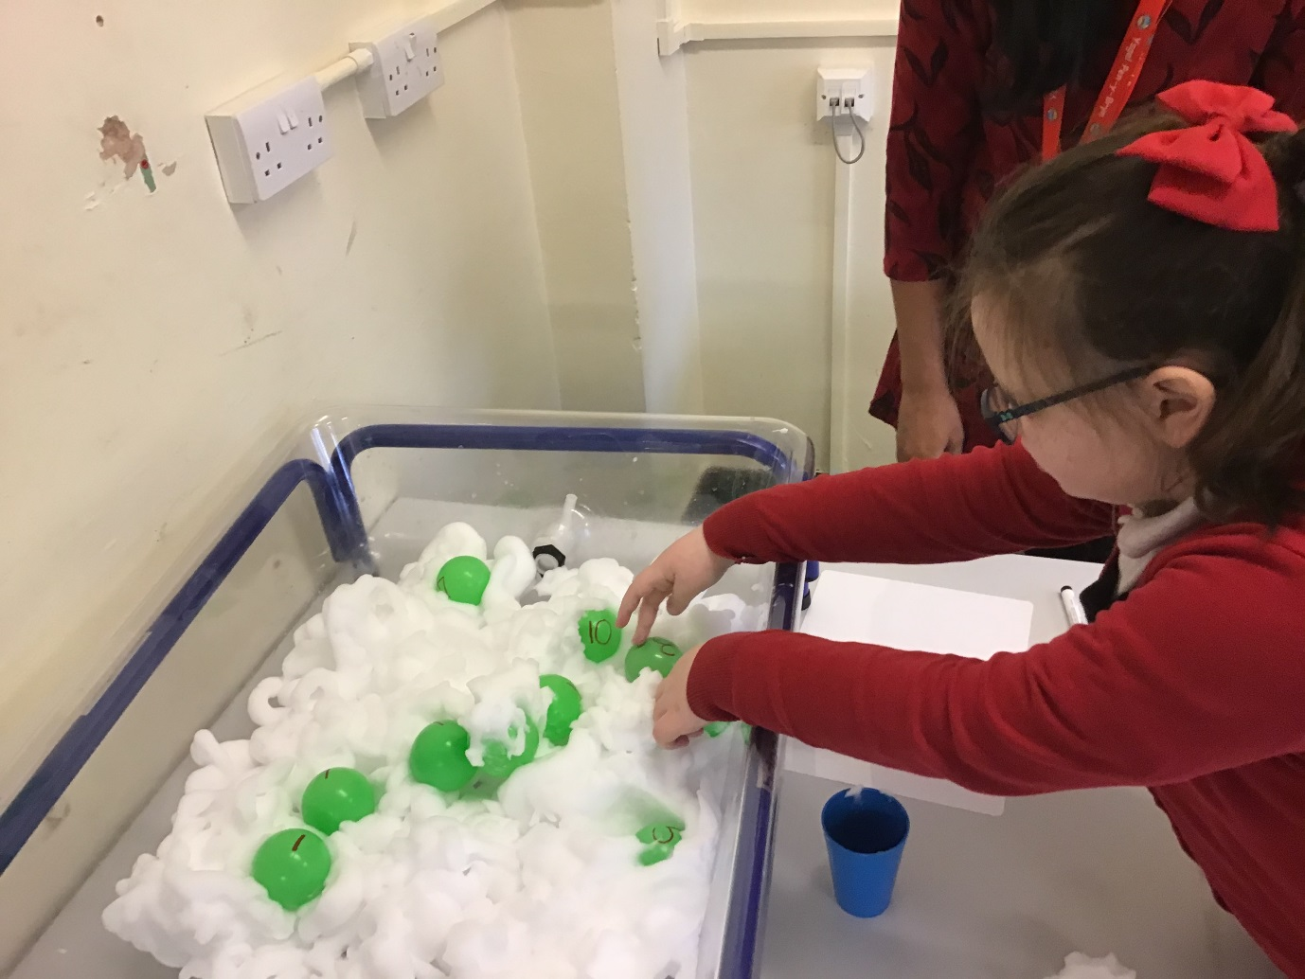
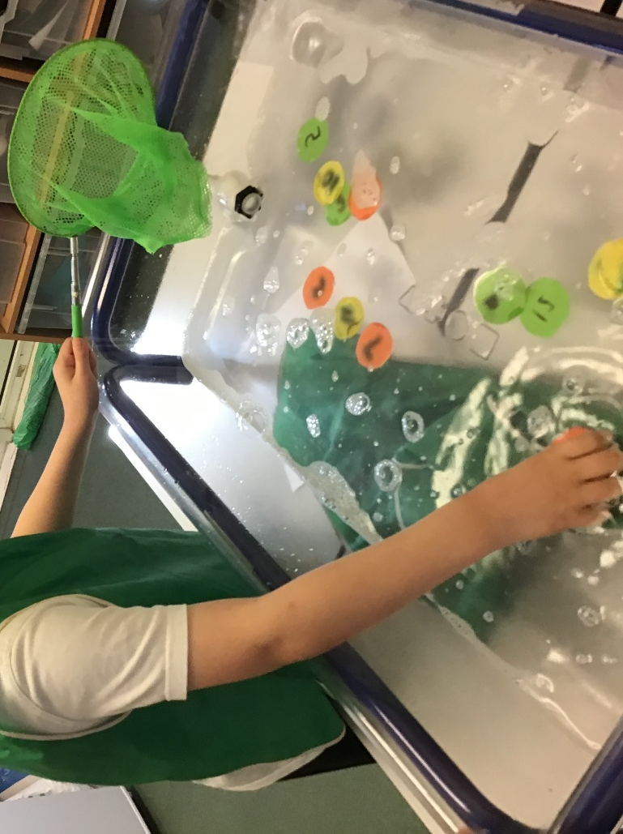

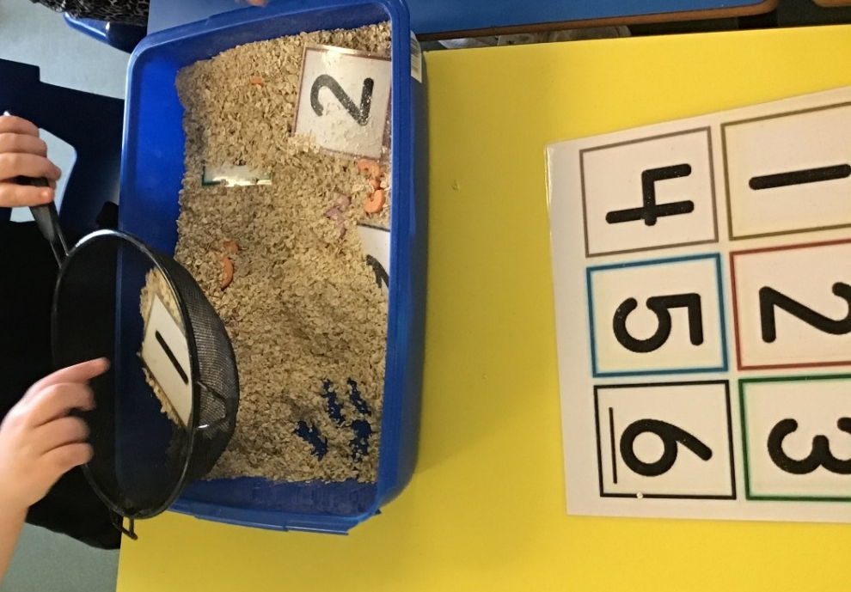

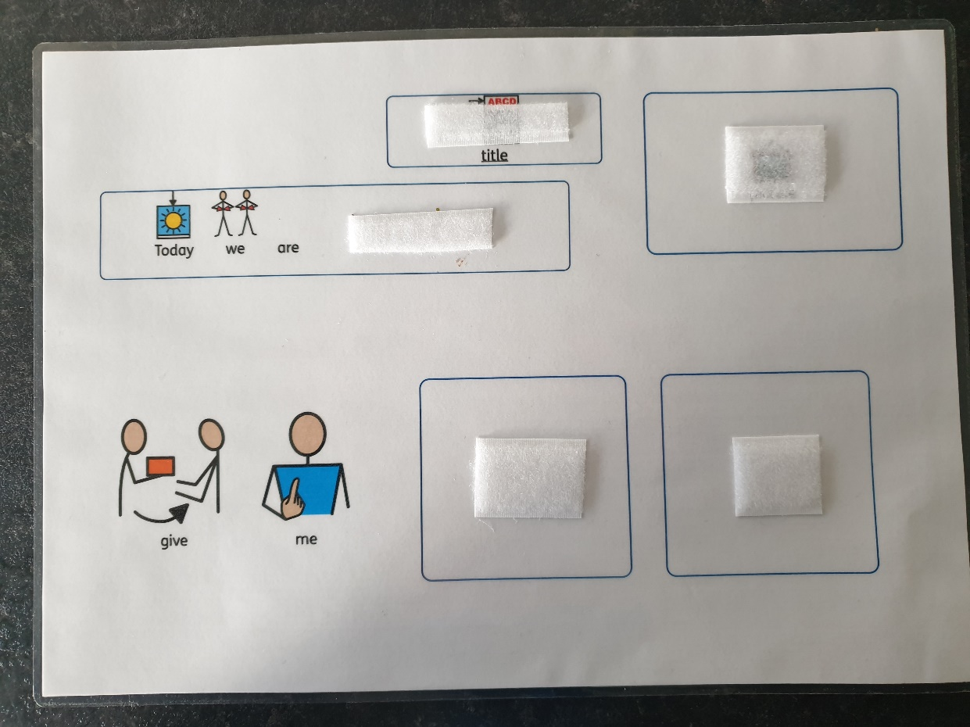
Appendix 4
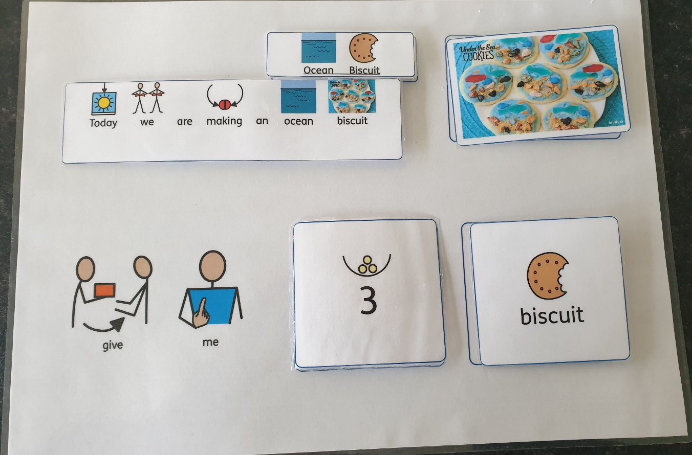

Appendix 5
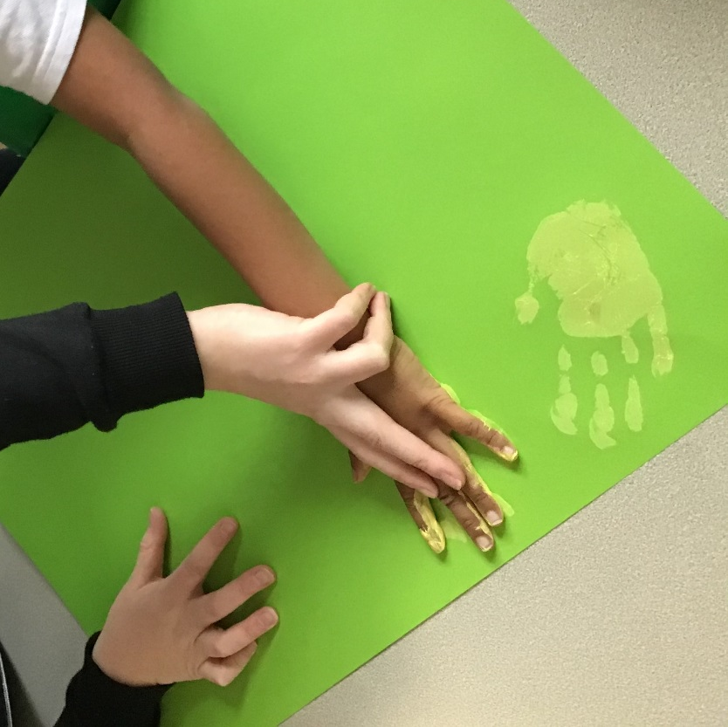

References
BBC Wales. 2014. About Wales. Available at: https://www.bbc.co.uk/wales/livinginwales/sites/aboutwales/pages/education.shtml (Accessed: 06/11/2020)
Daffodil image. 2020. Available at: https://www.wales.com/about/culture/national-symbols-wales (Accessed: 06/11/2020)
Edwards, I. 2017. Working for Equality in Wales. P.2
G, Donaldson. 2015. Successful Futures: Independent Review of Curriculum and Assessment Arrangements in Wales. P.8.
Gov.Wales. 2020. Introduction to Curriculum for Wales guidance. Available at: https://hwb.gov.wales/curriculum-for-wales/introduction/ (Accessed: 07/11/2020)
Mcloed, S. 2018. Jean Piaget’s Theory and Stages of Cognitive Development. Available at: https://www.simplypsychology.org/piaget.html (Accessed: 14/11/2020)
Mcloed, S. 2019. Bruner- Learning Theory in Education. Available at: https://www.simplypsychology.org/bruner.html (Accessed: 15/11/2020)
Mcloed, S. 2019. The Zone of Proximal Development and Scaffolding. Available at: https://www.simplypsychology.org/Zone-of-Proximal-Development.html (Accessed: 15/11/2020)
School A. Welsh Policy. 2019.
Tes Editorial. 2019. A complete guide to the new Welsh national Curriculum. Available at: https://www.tes.com/news/complete-guide-new-welsh-national-curriculum (Accessed: 07/11/2020)
Welsh flag image. (no date). Available at: https://www.pinterest.co.uk/pin/355362226825621316/ (Accessed: 06/11/2020)

