

Student Name: Nanga Pedro

Student ID: 2247167

Module Name: Marketing Management

Module Code: LCMB7024

Lecturer’s Name: Laila Maazouz

Work Count: 2500
Brand Development Strategy Portfolio
ReGen by Travis Perkins: A Sustainable Brand Extension

Term 1

Table of Contents
Element 1: Sustainable Brand Extension Poster 3
Element 2: Segmentation, Targeting, Differentiation and Positioning (STDP) Analysis 4
Element 3: Marketing Mix (7Ps) 7
Element 4: Reflection 11
References: 14

Element 1: Sustainable Brand Extension Poster
The poster overleaf presents the ReGen brand extension: its sustainability rationale, market appeal, investor/customer case, and alignment with Travis Perkins' sustainability goals, in line with Kotler et al.'s (2024) brand development framework.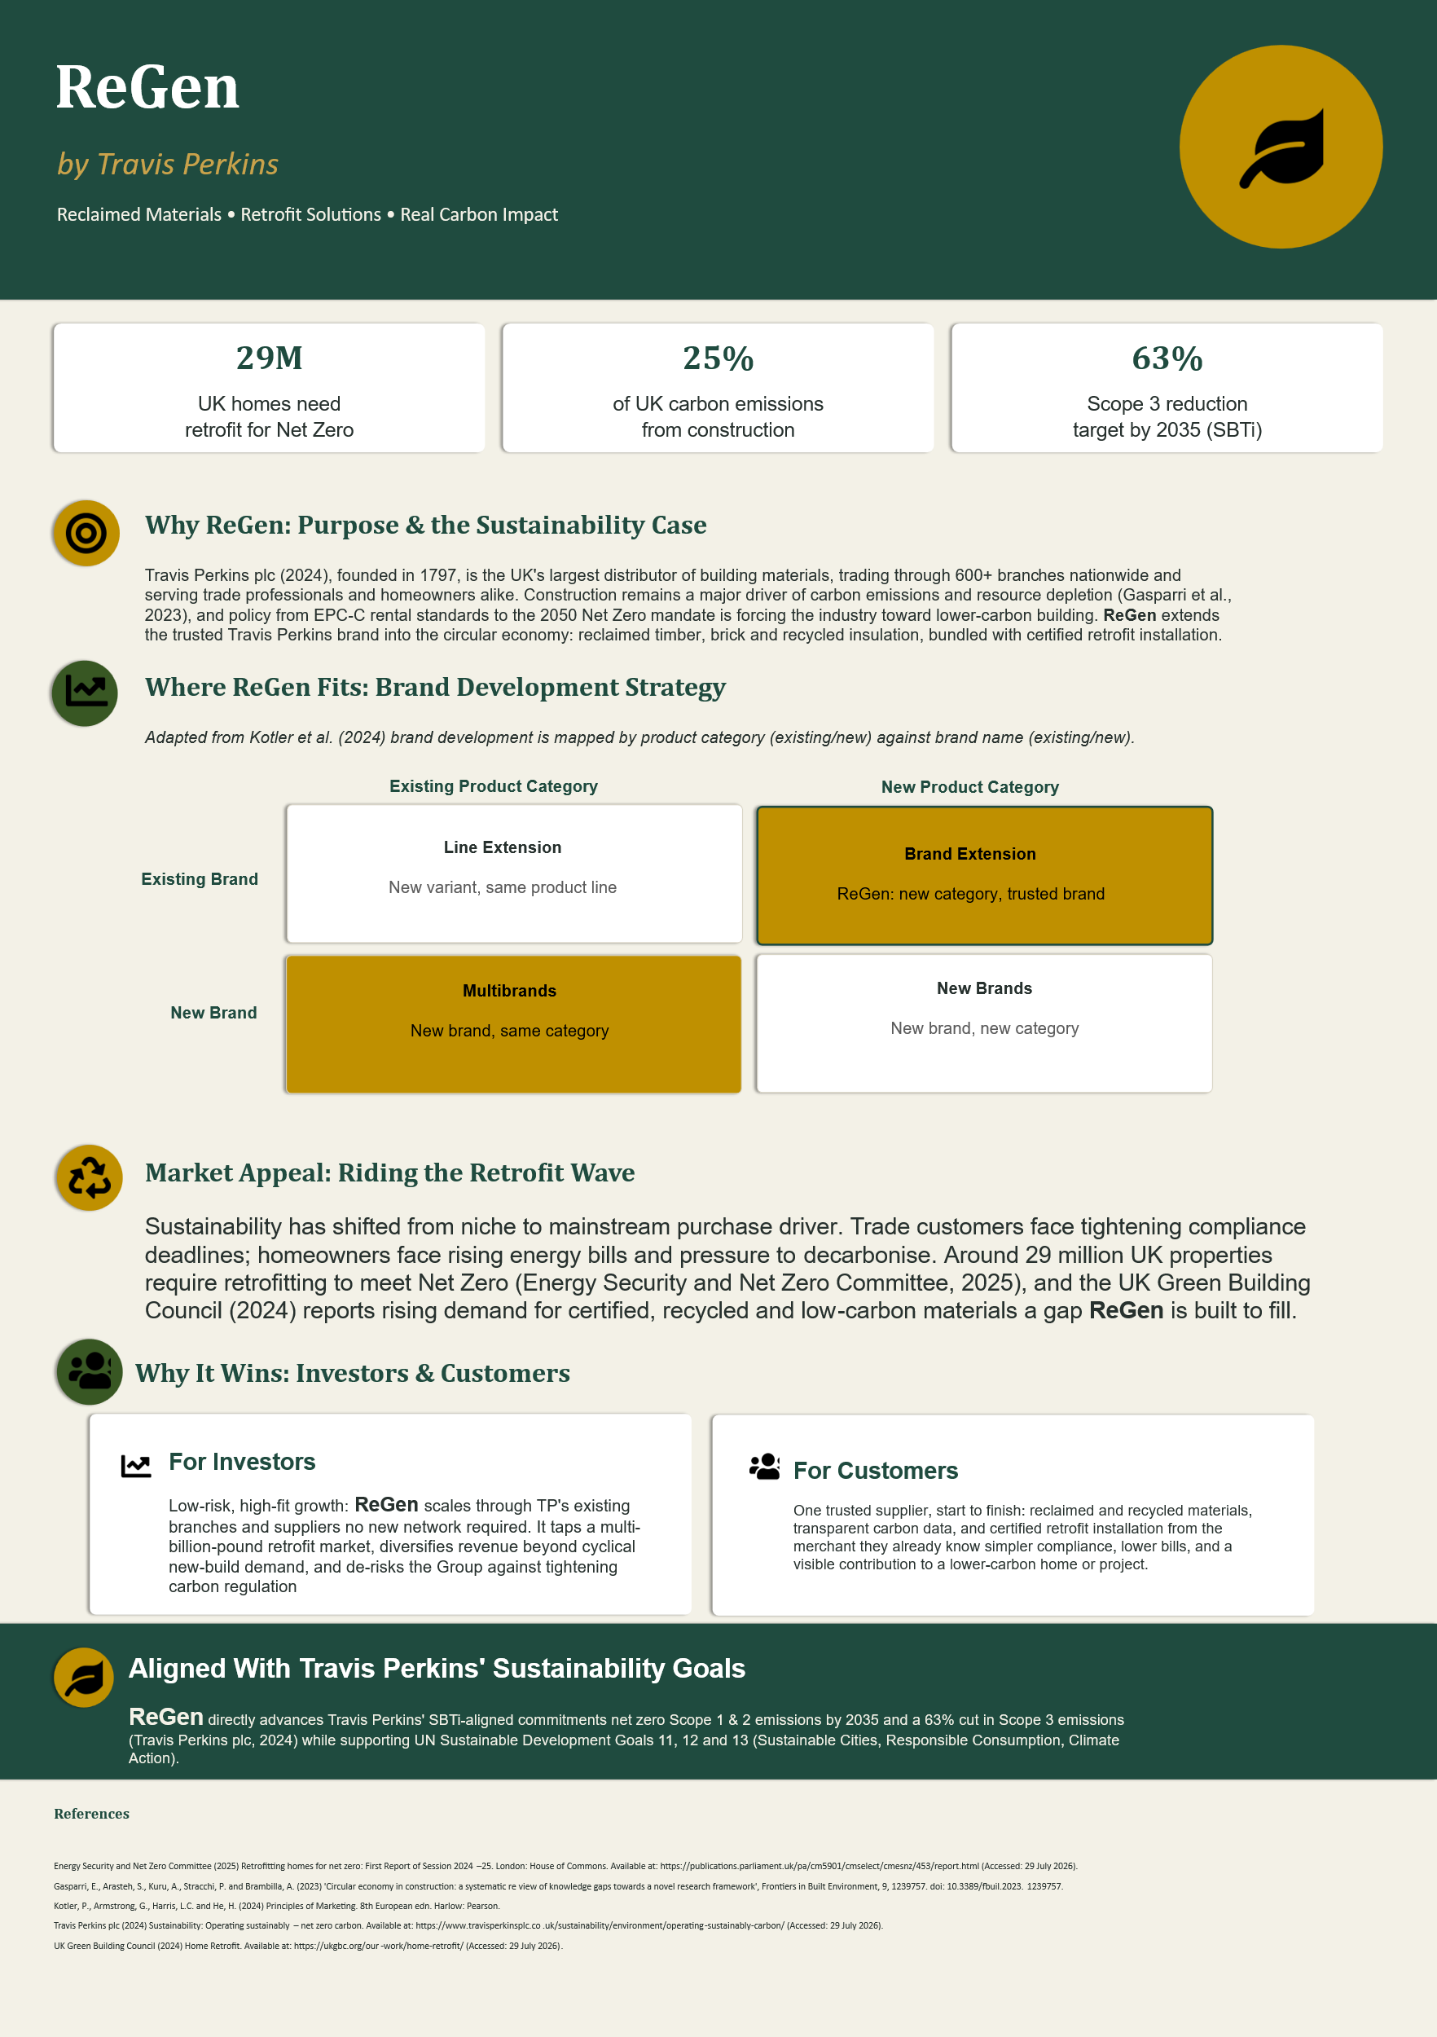

Element 2: Segmentation, Targeting, Differentiation and Positioning (STDP) Analysis

Segmentation
Brands are powerful assets that must be carefully developed and managed, building strong brands involves many challenging decisions.
Because ReGen extends Travis Perkins into both trade and retail channels, the market must be segmented on geographic, demographic, psychographic and behavioural bases (Kotler et al., 2024). Geographically, primary demand concentrates in the UK, and within it in regions with the oldest and least efficient housing stock, notably London, the South East and other pre-1919-dense urban centres, though Travis Perkins' 600+ branch network supports nationwide reach (Travis Perkins plc, 2024; Energy Security and Net Zero Committee, 2025). Demographically, the consumer segment centres on homeowners aged 35 to 65, in socio-economic groups ABC1, who own older, EPC D-to-G rated properties and have discretionary income for renovation; the parallel B2B segment covers SME builders, retrofit installers and housing associations who purchase materials at volume to fulfil compliance-driven contracts (British Standards Institution, 2023). Psychographically, the consumer base spans a spectrum from "LOHAS" (Lifestyles of Health and Sustainability) consumers, who actively prioritise environmental criteria in every purchase, through to a broader "sustainable mainstream" that is price-sensitive but increasingly values transparency and provenance (Maťová et al., 2024). Behaviourally, segments can be distinguished by renovation intent (active planners versus long-term considerers), compliance obligation (landlords facing EPC-C deadlines versus voluntary improvers), purchase channel loyalty (existing Travis Perkins trade account holders versus new prospects), and price sensitivity, since willingness to pay a sustainability premium varies markedly across the customer base: recent survey evidence puts the average premium consumers will accept at under ten per cent, meaning ReGen's pricing and messaging cannot assume blanket willingness to pay more (PwC, 2024). Landlords facing the EPC-C rental deadline represent a particularly time-pressured, high-urgency behavioural segment, since non-compliance risks their ability to legally let a property at all (Energy Security and Net Zero Committee, 2025).

Targeting
ReGen adopts a differentiated targeting strategy, pursuing two primary segments simultaneously rather than a single mass-market approach (Kotler and Keller, 2021). The first is the B2B trade segment: SME builders and PAS 2035-accredited retrofit installers who need a reliable, compliant supply of reclaimed and low-carbon materials at trade volume and pricing (British Standards Institution, 2023). The second is the "eco-conscious renovator": a private homeowner aged 35 to 65, ABC1, living in an older property, who is either voluntarily upgrading their home's efficiency or is compelled to by looming EPC-C rental standards. Both segments are large, growing and reachable through Travis Perkins' existing branch and account infrastructure, satisfying standard targeting criteria of size, accessibility and strategic fit (Kotler et al., 2024). A differentiated strategy is justified because the two segments have distinct purchase drivers, compliance versus lifestyle, but share the same channel, allowing shared infrastructure to serve both without disproportionate cost. Secondary segments, such as fully committed LOHAS consumers and housing associations managing large retrofit portfolios, remain commercially attractive but are treated as growth segments for later phases rather than the initial launch focus, keeping the proposition sharp rather than diluted across too many audiences at once (Kotler and Keller, 2021).

Differentiation
Competitors fall into two camps: large generalist merchants (Wickes, B&Q, Selco) with scale and trust but no dedicated circular-economy proposition, and boutique retrofit or reclamation specialists with sustainability credibility but limited reach, stock depth and brand recognition. ReGen differentiates by combining what neither camp offers alone: over two centuries of brand trust and a 600+ branch network, paired with reclaimed materials, transparent carbon data and certified PAS 2035-aligned installation under one roof (Travis Perkins plc, 2024; British Standards Institution, 2023). This reflects a differentiation strategy in Porter's terms, competing on uniqueness of the combined offer rather than on price (Ismawan and Wandebori, 2024), while avoiding the credibility risk that greenwashing poses to less substantiated green claims (Zhang, 2024). Crucially, this differentiation is defensible rather than cosmetic: heritage and scale are difficult for a start-up to replicate quickly, and genuine circular-economy expertise, in materials sourcing, carbon reporting and PAS 2035 compliance, is difficult for a generalist merchant to build overnight (Gasparri et al., 2023).

Positioning
ReGen is positioned as "the trusted partner for compliant, lower-carbon retrofit" — the merchant customers already use, now solving the sustainability problem they did not know how to start solving alone. On a perceptual map plotting brand trust and scale against sustainability specialism, generalist merchants sit high on trust but low on sustainability credentials, while boutique green start-ups sit high on sustainability but low on trust and availability; ReGen is positioned in the high-trust, high-sustainability quadrant that neither competitor set occupies. This positioning is reinforced consistently across the marketing mix, from certified product claims to transparent carbon reporting, which research shows is essential to sustaining credibility and avoiding the erosion of trust associated with unsubstantiated sustainability claims (Zhang, 2024; PwC, 2024).

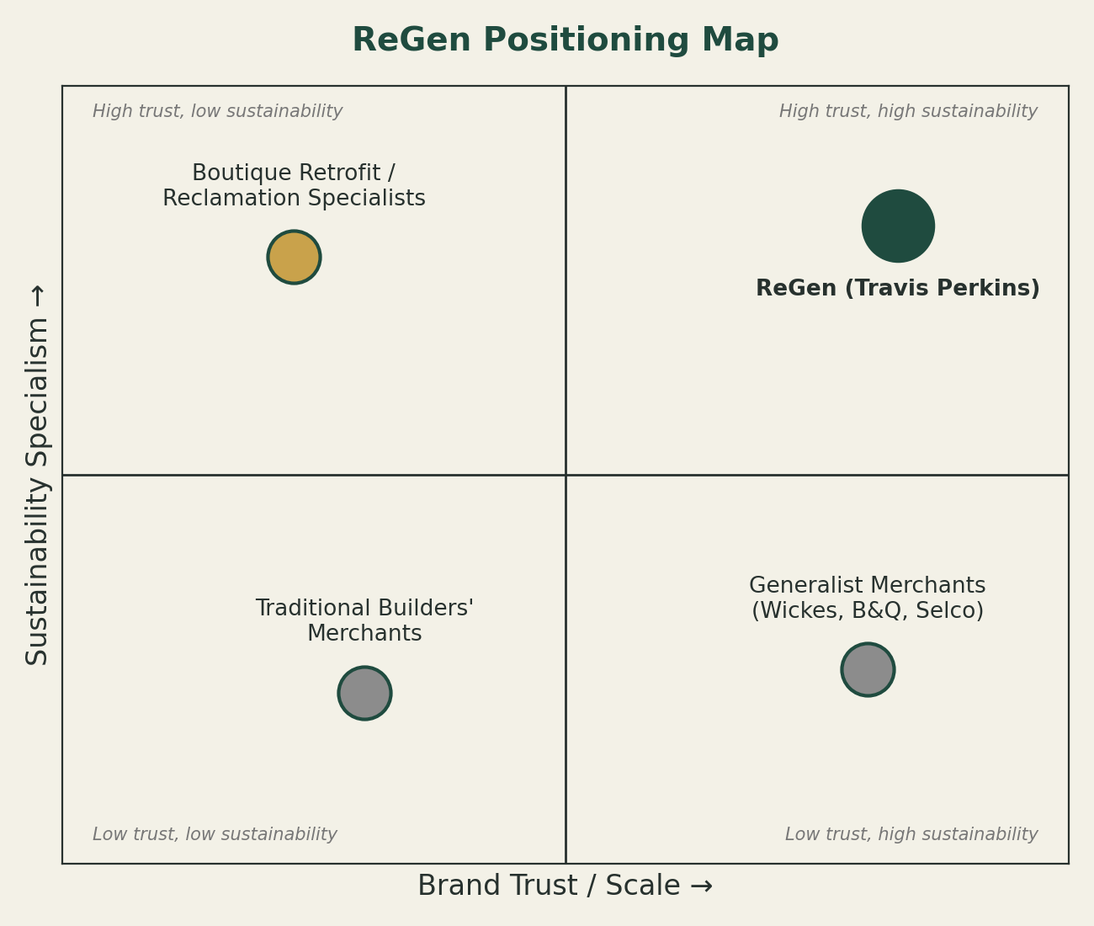
Figure 1: ReGen positioning map, plotting brand trust/scale against sustainability specialism (author's own, adapted from Kotler and Keller, 2021).

STDP Summary
Basis | Key Variables for ReGen
Geographic | UK-wide via 600+ Travis Perkins branches; concentrated demand in London, the South East and other regions with older, pre-1919 housing stock (Travis Perkins plc, 2024; Energy Security and Net Zero Committee, 2025).
Demographic | Homeowners aged 35–65, ABC1, owning EPC D–G properties; SME builders, PAS 2035 installers and housing associations (British Standards Institution, 2023).
Psychographic | Spectrum from committed LOHAS consumers to the sustainable mainstream, valuing transparency and provenance (Maťová et al., 2024).
Behavioural | Renovation intent, compliance urgency (EPC-C deadlines), channel loyalty, and price sensitivity around a sub-10% sustainability premium (PwC, 2024).

Element 3: Marketing Mix (7Ps)

Product
ReGen's core product is a dual offering: reclaimed and recycled building materials (timber, brick, insulation) sold alongside certified retrofit installation services. Bundling a tangible good with an intangible service reflects the logic of the extended marketing mix, which recognises that service elements shape the customer's overall value perception as much as the physical product itself (Rathi, 2022). Every material carries transparent carbon and provenance data, directly addressing the circular economy's promotion of resource-efficient, low-embodied-carbon construction (Gasparri et al., 2023). This product depth is what allows ReGen to occupy the high-trust, high-sustainability position established in the STDP analysis: without genuine product substance, sustainability claims risk being dismissed as greenwashing, which independent research shows measurably damages consumer trust and brand loyalty (Zhang, 2024). The product range is also deliberately tiered, from budget reclaimed materials for cost-conscious trade buyers through to fully specified, PAS 2035-assessed whole-house retrofit packages for homeowners, so that the same core proposition can flex to the differing needs identified for each target segment rather than offering a single undifferentiated product (Kotler et al., 2024).

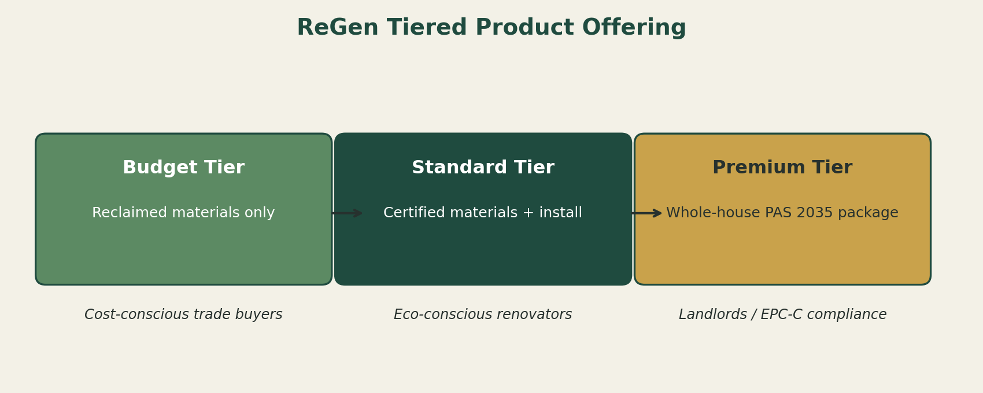
Figure 2: ReGen's tiered product offering, mapped to target segments (author's own).

Price
Pricing must balance two pressures: research shows a majority of consumers are now willing to pay a sustainability premium, but the average accepted premium remains under ten per cent, and price sensitivity rises sharply beyond that threshold (PwC, 2024). ReGen therefore adopts value-based pricing rather than a blanket premium: reclaimed materials are priced competitively against virgin equivalents where circularity reduces input costs, while bundled installation services carry a modest premium justified by PAS 2035 compliance, certification and reduced compliance risk for landlords facing EPC-C deadlines (British Standards Institution, 2023; Energy Security and Net Zero Committee, 2025). For trade customers, existing Travis Perkins account and volume pricing structures are extended to ReGen lines, lowering the switching cost for a segment already primed to trust the brand.
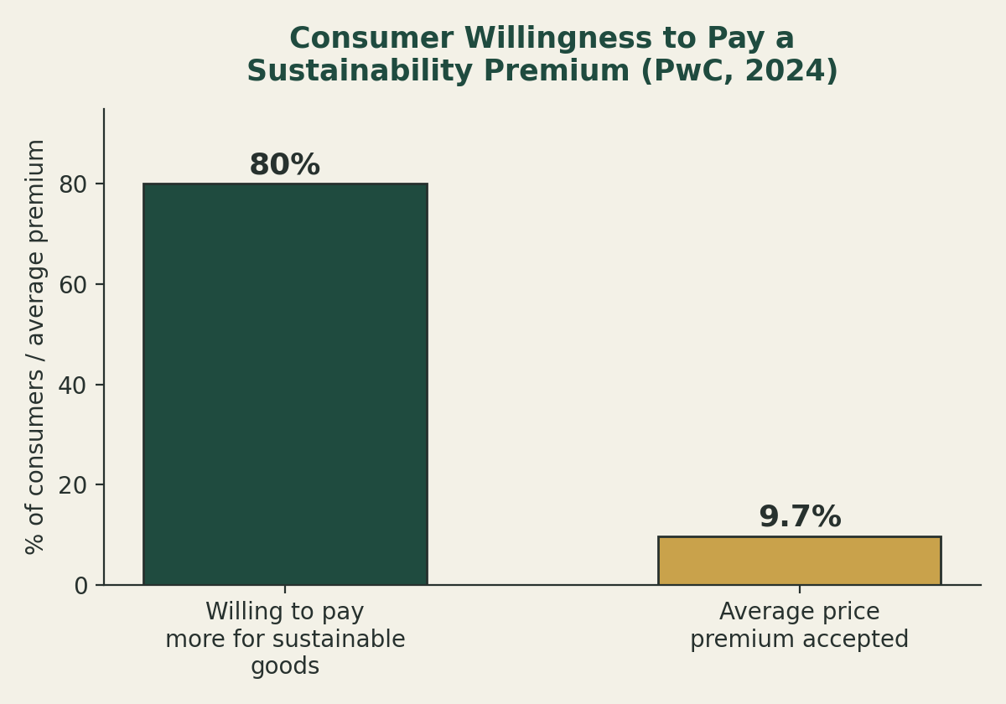
Figure 3: Consumer willingness to pay a sustainability premium (author's own, data from PwC, 2024).

Place
Distribution leverages Travis Perkins' existing 600+ branch network, avoiding the capital cost and time lag of building new physical or digital infrastructure from scratch (Travis Perkins plc, 2024). This is a deliberate low-risk distribution strategy: rather than launching ReGen as a stand-alone retail proposition, it is integrated into existing branch layouts, trade counters and the Travis Perkins e-commerce platform, supported by installer partner networks certified under TrustMark and PAS 2035 (British Standards Institution, 2023). This omnichannel approach meets both target segments where they already transact, trade professionals at the counter, homeowners online and in-branch, which is consistent with STP theory's emphasis on aligning the marketing mix with how each chosen segment actually buys (Kotler and Keller, 2021).

Promotion
Promotion must build category awareness (many customers do not yet know reclaimed and low-carbon retrofit materials are available through a mainstream merchant) while avoiding the credibility pitfalls of greenwashing. Messaging leads with verifiable facts: SBTi-aligned emissions targets, PAS 2035 certification, and the scale of the UK retrofit need, rather than vague environmental language (Science Based Targets initiative, 2023; Energy Security and Net Zero Committee, 2025). Channels are segment-specific: trade press, account manager briefings and CPD-style content for the B2B trade segment; social and search content, in-branch signage and partnership content with retrofit installers for the eco-conscious renovator segment. This evidence-led approach is supported by research showing that concrete, verifiable claims strengthen credibility and reduce consumer skepticism, whereas exaggerated or vague claims erode the very trust the positioning depends on (Zhang, 2024). Promotion is also sequenced deliberately: initial campaigns focus on category education, explaining what circular-economy retrofit materials are and why they matter, before moving to conversion-focused messaging once awareness is established, reflecting standard STP guidance that communication must match the target audience's starting level of category knowledge (Kotler and Keller, 2021).

People
Because retrofit is a trust-sensitive, technically complex purchase, the "people" element is central rather than peripheral. Branch staff and trade counter teams require training in retrofit product knowledge and PAS 2035 requirements so they can advise credibly rather than simply sell, while retrofit installers operating under the ReGen banner must hold recognised accreditation (British Standards Institution, 2023). This matters because service marketing literature consistently identifies frontline staff competence and confidence as a primary driver of customer satisfaction and trust in service-inclusive offers (Rathi, 2022).

Process
The customer journey is designed to remove the complexity that currently deters retrofit action: a single point of contact for assessment, material sourcing and certified installation, mirroring the structured, risk-managed approach mandated by PAS 2035 (assessment, design, installation, evaluation) (British Standards Institution, 2023). For trade customers, this integrates with existing account and ordering processes; for homeowners, a simplified enquiry-to-installation pathway reduces the perceived hassle that the literature identifies as a major barrier to green purchase conversion even among willing consumers (PwC, 2024).
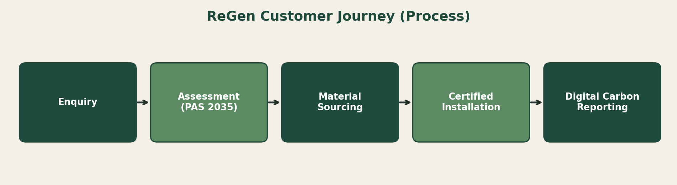
Figure 4: ReGen customer journey, aligned to the PAS 2035 retrofit process (author's own, adapted from British Standards Institution, 2023).

Physical Evidence
Tangible cues reassure customers that ReGen's claims are real. In-branch, this includes visible carbon labelling on materials, PAS 2035 and TrustMark certification displays, and dedicated ReGen bays distinct from standard stock. Digitally, it includes transparent carbon reporting tools and installer accreditation badges on the Travis Perkins platform. These physical evidence points matter because they provide the "concrete, verifiable" signals that research identifies as the antidote to greenwashing scepticism, converting an intangible sustainability promise into something customers and investors can see and check for themselves (Zhang, 2024; Science Based Targets initiative, 2023). Together, the seven elements reinforce a single strategic logic: ReGen only works as a brand extension if every element of the mix, not just the marketing message, visibly earns the trust that the STDP positioning claims. Each P is therefore justified not only by its own literature but by its consistency with the others, from verifiable pricing and certified people through to physical evidence that closes the credibility gap greenwashing research consistently identifies as sustainable marketing's biggest risk (Zhang, 2024; Kotler et al., 2024).

7Ps Summary
Element | Application to ReGen
Product | Reclaimed/recycled materials + certified retrofit installation, tiered by segment, with transparent carbon data.
Price | Value-based pricing; competitive on reclaimed materials, modest premium on certified installation; trade account pricing extended to ReGen.
Place | Distributed through existing 600+ branches, trade counters and the Travis Perkins e-commerce platform; TrustMark-certified installer partners.
Promotion | Evidence-led messaging (SBTi targets, PAS 2035 certification); segment-specific channels; awareness-first sequencing.
People | Trained branch/trade staff; PAS 2035-accredited installers under the ReGen banner.
Process | Single point of contact from assessment to certified installation, mirroring the PAS 2035 process.
Physical Evidence | In-branch carbon labelling, certification displays, dedicated ReGen bays; digital carbon reporting tools.

Element 4: Reflection
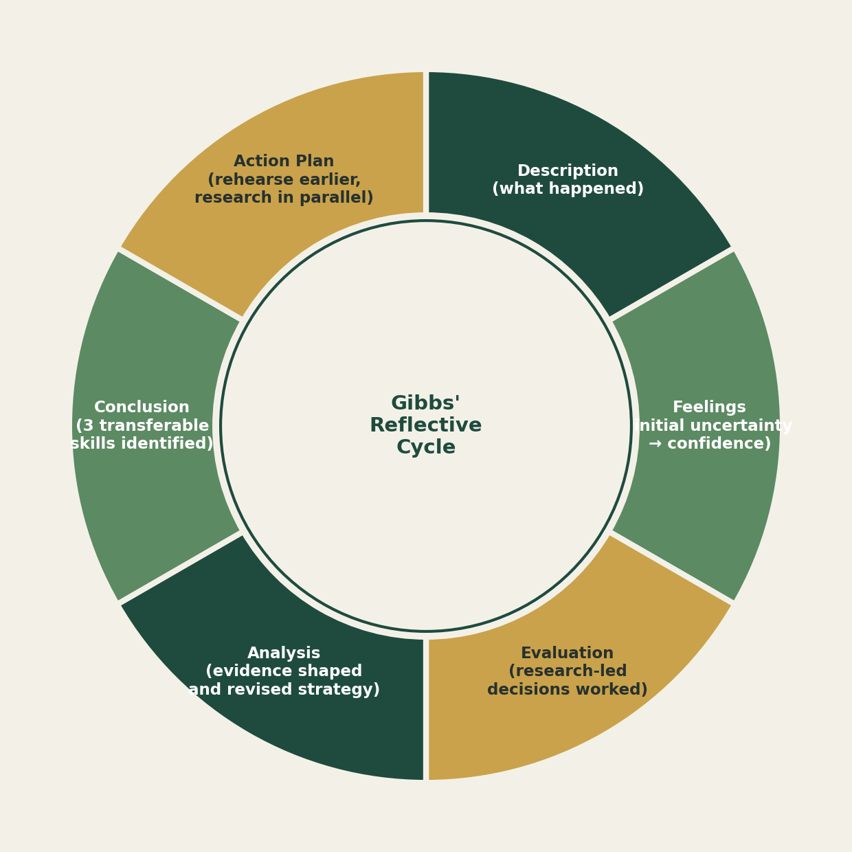
Figure 5: Gibbs' (1988) reflective cycle applied to this project, as structured by Barnard, Dhollande and Shepheard (2026).
Reflecting using Gibbs' (1988) reflective cycle, as recently revisited in the nursing and professional education literature (Barnard, Dhollande and Shepheard, 2026), provides a useful structure for reviewing this project across description, feelings, evaluation, analysis, conclusion and action plan.
Description and feelings. Developing a sustainable brand extension for Travis Perkins required moving from an abstract theoretical framework, Kotler et al.'s (2024) brand development matrix, to a concrete, evidence-based proposition. Early on, I felt uncertain about how to balance creative brand-building with the rigour of academic referencing; by the time I was defending pricing and positioning decisions against real market data, that uncertainty had shifted into confidence.
Evaluation and analysis. The strongest part of the process was research-led decision making. Rather than asserting that "sustainability sells," I had to locate and interrogate evidence, UK retrofit statistics, willingness-to-pay data, and greenwashing research, and let it shape the strategy, which sometimes meant revising assumptions I started with, such as expecting a much higher acceptable price premium than the literature actually supports (PwC, 2024). Preparing and delivering the poster presentation was a distinct and valuable challenge in its own right. Compressing an 800-word STDP analysis and a 1,000-word marketing mix into a 200-word, three-to-five-minute spoken poster pitch forced a different skill: prioritising the single most persuasive argument for each section rather than including everything I knew. Timing the script and rehearsing pacing highlighted how differently written and spoken communication need to be structured, a gap I had underestimated going in.
Conclusions. Across the project I developed three skills I would highlight as most transferable to professional practice: critical use of academic and market evidence to justify strategic choices rather than assertion; the ability to translate a dense strategic analysis into a concise, persuasive visual and verbal pitch for a non-specialist or investor audience; and a more disciplined approach to referencing and academic integrity under Harvard convention, particularly the discipline of citing recent, credible sources rather than convenient ones. These map closely onto the skills employers consistently rank highest in graduate marketing roles, evidence-based reasoning, communication, and adaptability across formats (Tushar and Sooraksa, 2023).
Action plan. For similar projects in future, I would build in an earlier rehearsal stage for any spoken component, since the gap between written fluency and confident, well-paced delivery only became fully visible once I was timing myself aloud. I would also start the literature search earlier and in parallel with strategy development, rather than largely after it, so that evidence shapes the strategy from the outset rather than being retrofitted to justify decisions already made. Finally, I intend to keep using structured reflection, in the manner of Gibbs' cycle, at the end of future modules and projects, since it surfaced concrete, actionable lessons, such as the rehearsal gap, that a less structured after-the-fact review would likely have missed (Barnard, Dhollande and Shepheard, 2026).

Skills, Challenges and Actions Summary
Skill Gained | Challenge Faced | Action for Future Projects
Evidence-based strategic reasoning | Balancing creative brand-building with academic rigour | Source and interrogate data before asserting a claim (e.g. PwC, 2024)
Concise persuasive communication | Compressing 1,800+ words into a 200-word, 3–5 minute spoken pitch | Rehearse spoken delivery earlier and separately from writing
Academic referencing discipline | Applying Harvard convention consistently across 15+ recent sources | Build a running reference log from the start of research, not after

References
Barnard, C., Dhollande, S. and Shepheard, J. (2026) 'Gibbs' reflective cycle', Nurse Researcher, 34(1), p. 11.
British Standards Institution (2023) PAS 2035:2023 Retrofitting Dwellings for Improved Energy Efficiency – Specification and Guidance. London: BSI.
Energy Security and Net Zero Committee (2025) Retrofitting Homes for Net Zero: First Report of Session 2024–25. London: House of Commons. Available at: https://publications.parliament.uk/pa/cm5901/cmselect/cmesnz/453/report.html (Accessed: 31 July 2026).
Gasparri, E., Arasteh, S., Kuru, A., Stracchi, P. and Brambilla, A. (2023) 'Circular economy in construction: a systematic review of knowledge gaps towards a novel research framework', Frontiers in Built Environment, 9, 1239757. doi: 10.3389/fbuil.2023.1239757.
Ismawan, D.J. and Wandebori, H. (2024) 'Porter’s generic strategies', International Journal on Electrical Engineering and Informatics, 16(1), p. 35.
Kotler, P., Armstrong, G., Harris, L.C. and He, H. (2024) Principles of Marketing. 8th European edn. Harlow: Pearson.
Kotler, P. and Keller, K.L. (2021) Marketing Management. 16th global edn. Harlow: Pearson.
Maťová, H., Oravcová Triznová, M., Kaputa, V., Loučanová, E. and Vlosky, R.P. (2024) 'Strategic environmental consumer segmentation: an exploratory case study in Slovakia', SAGE Open, 14(2). doi: 10.1177/21582440241240638.
PwC (2024) PwC's 2024 Voice of the Consumer Survey. Available at: https://www.pwc.com/gx/en/news-room/press-releases/2024/pwc-2024-voice-of-consumer-survey.html (Accessed: 2 August 2026).
Rathi, A. (2022) '7 P's of marketing mix: the core elements', International Journal of Advanced Research in Commerce, Management and Social Science, 5(4-II), pp. 119–124.
Science Based Targets initiative (2023) The Corporate Net-Zero Standard. Version 1.1. Available at: https://sciencebasedtargets.org/corporate-net-zero (Accessed: 30 July 2026).
Travis Perkins plc (2024) Sustainability: Operating Sustainably – Net Zero Carbon. Available at: https://www.travisperkinsplc.co.uk/sustainability/environment/operating-sustainably-carbon/ (Accessed: 29 July 2026).
Tushar, H. and Sooraksa, N. (2023) 'Global employability skills in the 21st century workplace: a semi-systematic literature review', Heliyon, 9(11).
UK Green Building Council (2024) Home Retrofit. Available at: https://ukgbc.org/our-work/home-retrofit/ (Accessed: 29 July 2026).
Zhang, Y. (2024) 'In the clash between consumer green values and company greenwashing', Journal of Business Ethics, 179(2), pp. 345–359. doi: 10.1007/s10551-024-05188-4.

