Brexit

The risk and the strategic challenges for the financial firms

Submission date:

6th January 2023

Student name:

Yani Yanakiev

Student ID:

1920744

Supervisor name:

Amare Desta

Module code: LCBB6000

Dissertation Proposal


Contents

Introduction 2
Research aims 2
Objectives 3
Research questions 3
Literature review 3
Research methods 3
Research philosophy 4
Research paradigm 4
Research approach 5
Research strategy 5
Sampling method 5
Data collection method 5
Analysing data 6
Research timeline 6
Ethics in researching 6
Conclusion 7
References 8

Introduction

On 23rd June 2016, the United Kingdom held a referendum to withdraw the country from the European Union. Some of the main reasons Britain decided to split from the EU was under the influence of the prime minister at that time James Cameron. The Prime minister explained in multiple conferences that the money invested in the EU every year could be used to stabilise the UK economy, limit the free movement of labourers, and stop following European walls over the UK once and others.
However, after the vote, Britain's decision to leave the European Union, and a lengthy discussion between the parties, the official withdrawal took place on 1st January 2021. Both parties have signed a Trade and Cooperation Agreement, which has been in power since the leaving day. At the same time, this situation affects mainly the citizens, companies and public authorities of both sides.
But how does Brexit affect companies?
During the trade agreement talks between the EU and UK, global trade was seriously affected by Brexit and the COVID-19 pandemic. A lot of factories were shut down because of lockdowns, many people, good and skilled workers, were forced to return to their countries, and all that situation around the pandemic helped Brexit get even more complicated than what the government was thinking.
As the EU and the UK agreed after 1st January 2021, there was a grace period where the companies could continue trade as usual. That wasn't enough because many manufacturers, producers and buyers were forced to close their businesses or move their production overseas because of the steep administrative costs when it comes to import and export. Many EU companies decide to pull out from the UK market because of the complication with all the additional paperwork that must be filled out and taxes for their customers.
Brexit didn't affect only manufacturers and producers, which were importing and exporting goods but affect and the finance firms. Many finance companies moved their jobs out of the United Kingdom for the first few months after Brexit. This movement from the financial firm's side allows over £900 billion to flee into the European Union instead of staying in the UK. A report based on research made in the 1st quarter of 2021 shows that insurers and banks shifted thousands of staff, legal entities, and assets to Europe because of Brexit.
This study will observe Brexit and the financial challenges as a social problem. Social problem are those aspects of social life that caused private unhappiness or public friction and are identified by those in power as needing some kind of social policy to deal with them. (Chapman & McNeill, 2005)

Research aim
- This research aims are to analyse how Brexit impact financial firms, what is the risk and challenges for them and what are their plans
Objectives
- To be clarified the risks and challenges for the financial firms before and after the Brexit deal.
- To analyse how the financial sector can manage to deal with all new regulations after Brexit and what it will cost them in order to survive
- To determine what will be the aftermath of Brexit to the financial firms in long-term

Research questions
- What is the impact of Brexit on the Financial Services Sector?
- Is Brexit a change trading method, and what are the issues every financial firm has to deal with?
- How did Brexit affect banks and the insurance industry and their operation method?
- The Big Bang or how UK financial services are in post-Brexit?
- Will foreign banks leave the UK after Brexit, and what can be their benefits?
- How UK Government will help the financial sector, and is it not too late?

Literature review
A study (Hamre & Wright, 2021) from April 2021 shows that 440 companies were moving or planning to move part of their business outside the UK toward the EU. That includes staff, legal entities or assets. The report estimated that around 7,400 workers had been relocated outside London since the Brexit vote in 2016. The staff relocations were most likely made to Dublin, Paris, Frankfurt, Amsterdam and Luxemburg. This situation will have a long-term impact on the UK economy not because of the staff leaving the UK, but because the companies are going to the EU, which in future will create new jobs instead of being done in the UK. For example, in January 2021, the Bank of France governor reported that at the end of 2020, at least €170 billion in assets and nearly 2500 staff had been moved from the United Kingdom to France.
Five years after Article 50 Negotiations with the United Kingdom were triggered, almost 44% of the most extensive financial services announced that they planned to move some UK operations and staff to the European Union, or 97 financial firms out of 222. Between March 2017 and March 2021, the companies decided to move their assets to the EU, which doubled from 53 in 2017 to 95 in 2021 out of 222.

Research Methods
The researchers' approach to describing how they propose to carry out the research is known as the research methodology. It is an approach to problem-solving in research that is both rational and systematic. The researcher's methodology is used in this study to guarantee accurate and legitimate results that align with aims and objectives. (Indeed Editorial Team, 2022)
The research onion framework in "Figure 1" explains the different aspects of the study that need to be researched and prepared before a credible research design can be developed. In other words, the research onion acts as a strategic plan for the researcher, leading them in stages to process of building a technique for doing research.

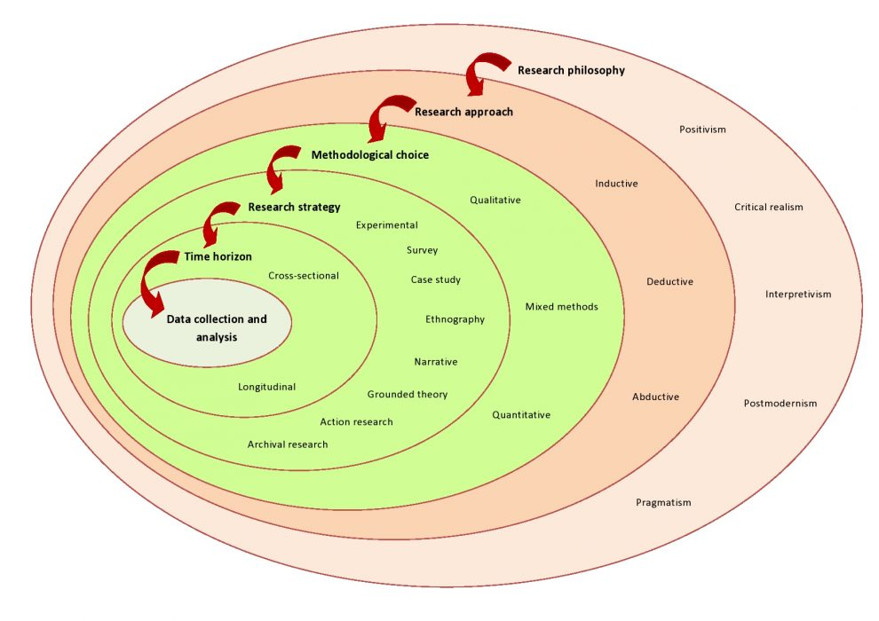
Figure 1 (Tengli, 2020)

Research Philosophy
The research will use a quantitative research method based on positivism. The underlying principle of the positivistic research philosophy is that trustworthy information can only be obtained via the accumulation of factual knowledge through sensory observation. My responsibility is to include the collection of data and its evaluation in accordance with objective procedures. Because of this, the research findings are observable and can be quantified. Positivism is the leading philosophy which believes in and focuses on examining sensible and concrete phenomena.

Research Paradigm
The research paradigm of post-positivism is a quantitative methodology focused on conclusion and reality with quantitative data. The research methodology will be separated into a few steps. The sampling is based on a questionnaire where the collected data will be observed and pragmatically analysed.
The source, nature, and origin of knowledge are the topics that are investigated by the philosophy of research. A research philosophy may be defined as a set of beliefs on collecting, analysing, and applying evidence pertaining to a topic.

Research approach
One way to characterise a research approach is as a series of stages and strategies that direct the research process. A research approach determines how data is collected, analysed, and interpreted. The concept of the research approach applies to the entire research process. Choosing a research approach depends on many factors, including research objectives, research experience, and subjects of the research study.
This study will use a deductive approach to research a few hypotheses based on existing theories. Will be observed past and present theories concerning the topic of this research. The current information will be layered to determine the hypothesis in order to achieve the research objectives.

Research strategy
A research strategy helps researchers choose appropriate data collection and analysis techniques. Therefore, selecting the suitable method when conducting research is of utmost importance. This study will use a survey to collect data via social media platforms as a research strategy.
This research will be examined through primary and secondary research. The primary research data in this study will be collected through a survey. The secondary research, which is also known as desk research, will review the primary research information and the literature review.

Sampling method
Sampling is the method of selecting a group of people or subsets of a population to reach conclusions based on statistical evidence and to make the best guesses about the characteristics of the population as a whole. It is not required to do research on the full population in order to gain valuable insights while conducting market research because researchers often use a variety of sampling strategies. (Fleetwood, 2023)
It is also the foundation of every research design because it is an efficient strategy that saves time and money. In order to derive the most accurate results possible from research survey software, sampling methods might be utilised.
The sample size in this research will be between 50 to 100 respondents with social media accounts on Instagram, Facebook, Twitter and even TikTok. Some primary respondents will share the survey through their daily social media stories, so they will have data collected from the respondents and their social followers. The respondents will be males and females with different sexual orientations, ages, and nationalities, but all of them will be over 18.

Data collection method
Quantitative research focuses on numerical data, such as variations in the products offered by competitors. In contrast, qualitative research focuses on the "narrative," such as the social attitude of an audience in relation to a specific brand. This article offers ways to gather desired data points rapidly and efficiently, as well as outlines all of the essential distinctions between the two.
The survey will contain between 6 to 8 questions. The questions will be closed and with few possible answers. The collected data from the survey will be carefully analysed and will determine which issues are most important for the respondents.
Analysing data
The collected data in this research will be input into a Microsoft Excel or Google Sheet to be visualised graphics and tables. Quantitative data analysis is just putting the numbers into formats that make sense and are easy to read. Quantitative data analysis focuses on the statistical, mathematical, or numerical analysis of datasets. It uses computational and statistical methods.

Research timeline
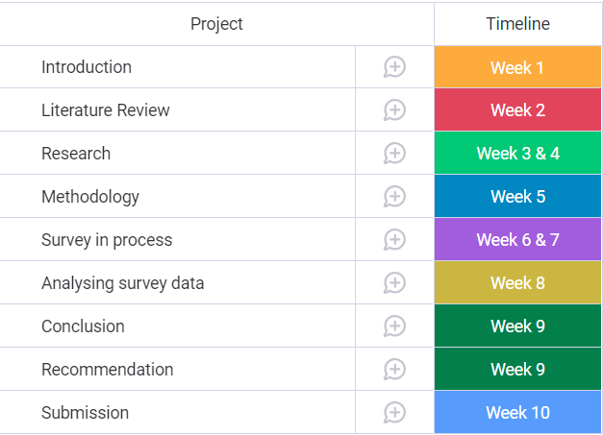

Ethics in researching
It is important to have ethics in research in order to preserve the integrity of analytical research, defend human rights and dignity, and encourage cooperation between the scientific community and the general public. By sticking to these standards, study volunteers will feel secure knowing their participation is voluntary, informative, and risk-free. (Resnik, 2020)
As a researcher, I must assure participants that they are free to withdraw from the research at any moment. The confidentiality of all survey responses is guaranteed.
Conclusion
There was no way the financial sector not be impacted after Brexit. Immediately after the Brexit vote, there was an effect on the stock market and consumer confidence and not on the last time the sterling started its suffering period.
The main aims of this research will be to track and understand how the financial sector was affected by Brexit, the challenges that financial firms had, and the risk they took to stay in the UK.
The research strives to show that the changes after Brexit, which financial firms experienced, are positive or negative for the city of London, one of the world's most significant global financial sectors.

References
Bermingham, R. (2020) Study designs: secondary research.
Available at: https://post.parliament.uk/study-designs-secondary-research/
(Accessed: 04 January 2023).
Bhandari, P. (2022) Ethical Considerations in Research | Types & Examples.
Available at: https://www.scribbr.co.uk/research-methods/ethical-considerations/
(Accessed: 04 January 2023).
Boyle, C. (2015) Just what is the UK's problem with Europe?.
Available at: https://www.cnbc.com/2015/05/27/why-would-the-uk-want-to-leave-the-eu.html
(Accessed: 17 December 2022).
Caproasia, (2021) The 2021 Global Financial Centres Index 29 – Full Ranking.
Available at: https://www.caproasia.com/2021/03/18/the-2021-global-financial-centres-index-29-full-ranking/
(Accessed: 05 January 2023).
Chapman, S. & McNeill, P. (2005) Research Methods. 3rd ed. Abingdon: Routledge - Taylor & Francis Group.
Clarence-Smith, T. (2017) The Impact of Brexit on the Financial Services Sector.
Available at: https://www.toptal.com/finance/market-research-analysts/brexit-and-its-effect-on-the-uk-european-and-global-financial-sector
(Accessed: 13 December 2022).
Cote, C. (2021) 7 DATA COLLECTION METHODS IN BUSINESS ANALYTICS.
Available at: https://online.hbs.edu/blog/post/data-collection-methods
(Accessed: 27 December 2022).
David, J. (2021) Differences between deductive and inductive approaches to research.
Available at: https://www.howandwhat.net/differences-deductive-inductive/
(Accessed: 04 January 2023).
Eteng , O. (2022) Quantitative Data Analysis: Methods & Techniques Simplified 101.
Available at: https://hevodata.com/learn/quantitative-data-analysis/#:~:text=Quantitative%20data%20analysis%20techniques%20typically,%2C%20questionnaires%2C%20polls%2C%20etc.
(Accessed: 05 January 2023).
Fleetwood, D. (2023) Types of Sampling: Sampling Methods with Examples.
Available at: https://www.questionpro.com/blog/types-of-sampling-for-social-research/
(Accessed: 04 January 2023).
Graham, S. (2022). EY Financial Services Brexit Tracker: Movement within UK financial services sector stabilises five years on from Article 50 trigger.
Available at: https://www.ey.com/en_uk/news/2022/03/ey-financial-services-brexit-tracker-movement-within-uk-financial-services-sector-stabilises-five-years-on-from-article-50-trigger
(Accessed: 22 December 2022).
Hall, P. S. (2020) What does the Breit trade deal mean for financial services?.
Available at: https://ukandeu.ac.uk/what-does-the-brexit-trade-deal-mean-for-financial-services/
(Accessed: 27 December 2022).
Hamre, E. F. & Wright, W. (2021) Brexit & The City: The Impact So Far.
Available at: https://newfinancial.org/brexit-the-city-the-impact-so-far/
(Accessed: 08 December 2022).
Hutton, R. (2020) The Roots of Brexit.
Available at: https://www.bloomberg.com/quicktake/will-uk-leave-eu?leadSource=uverify%20wall
(Accessed: 01 December 2022).
Indeed Editorial Team, (2022) What Is Research Methodology? (Why It's Important and Types).
Available at: https://www.indeed.com/career-advice/career-development/research-methodology#:~:text=Research%20methodology%20is%20a%20way,address%20their%20aims%20and%20objectives.
(Accessed: 04 January 2023).
Jones, H. (2022) EY Brexit tracker finds 7,000 finance jobs have left London for EU.
Available at: https://www.reuters.com/world/uk/ey-brexit-tracker-finds-7000-finance-jobs-have-left-london-eu-2022-03-28/
(Accessed: 13 December 2022).
Norton Rose Fulbright, (2021) Impact of Brexit on financial institutions.
Available at: https://www.nortonrosefulbright.com/en/knowledge/publications/e47d24f4/impact-of-brexit-on-financial-institutions#section2
(Accessed: 27 December 2022).
O'Toole, E. (2021) Brexit forces more than 400 businesses to move from UK to Europe.
Available at: https://www.thenational.scot/news/19238315.brexit-forces-400-business-move-uk-europe/
(Accessed: 08 December 2022).
Pirlichata, P. (2021) Brexit pushes 440 financial services firms to move some UK business to Europe.
Available at: https://www.pionline.com/brexit/brexit-pushes-440-financial-services-firms-move-some-uk-business-europe
(Accessed: 17 December 2022).
Resnik, D. B. (2020) What Is Ethics in Research & Why Is It Important?.
Available at: https://www.niehs.nih.gov/research/resources/bioethics/whatis/index.cfm
(Accessed: 04 January 2023).
Reuters, (2022) Brexit: more than 7,000 finance jobs have left London for EU, EY finds.
Available at: https://www.theguardian.com/business/2022/mar/29/brexit-finance-jobs-london-eu-ey-paris-frankfurt-dublin
(Accessed: 22 December 2022).
Saunders, M., Lewis, P. & Thornhill, A. (2019) Research Methods for Business Students. 8th ed. London: Pearson Education.
Solanki, K. (2022) What is Research Approaches ? | Meaning and Types of Research Approaches.
Available at: https://www.toppers4u.com/2022/01/what-is-research-approaches-meaning-and.html#point1
(Accessed: 04 January 2023).
Tengli, M. B. (2020) Blog 132-Research Onion: A Systematic Approach to Designing Research Methodology.
Available at: https://www.aesanetwork.org/research-onion-a-systematic-approach-to-designing-research-methodology/
(Accessed: 04 Jannuary 2023).
Tetteh Kuwornu-Adjaottor, J. E. (2020) Research Philosophies and Approaches.
Available at: https://blog.noyam.org/research-philosophies-and-approaches/
(Accessed: 28 December 2022).
Walia, A. & Chetty, P. (2020) How to formulate a research strategy?.
Available at: https://www.projectguru.in/how-to-formulate-a-research-strategy/
(Accessed: 04 January 2023).

