

BA Business Management
Data Handling and Business Intelligence
Assessment 1

Lecturer : Sadeque Shaikh
Module code: LCBB5000
Student: Emanuel-Georgian Puiu
Student ID: 2130778

Executive summary
The report has been entirely based on business intelligence and its multilayered impact on business decision-making. Business intelligence promotes data-driven decision-making in various organisations. The report has described the components of BI such as data warehousing, and data mining, and how they function. The analysis has majorly been focussed on the banking and finance industry of the UK, which has been adopting these technologies for their improvements. It has also displayed the growth of the BI market in the UK and has anticipated its growing demand in the finance and banking sector.

Table of Contents
Introduction 4
1.Definition and Architecture of Business Intelligence 5
1.1 Definition of business intelligence 5
1.2 The architecture of business intelligence 5
2.Application of Business Intelligence 7
3.Impact of Business Intelligence 8
4.Conclusion 9
References 10

Introduction
Business intelligence refers to the process of analysing business data and turning those into meaningful and actionable insights. It comprehensively helps an organisation to make informed decisions. It analyses both current and historical data and presents it in a simpler form before the management of the organisation. The following report is going to elucidate the business intelligence concept and its various components such as data warehouse, data mining, and predictive analysis. This advanced data analysis concept has a pivotal role in various industries including banking and finance. The industry manages a huge set of data regarding multiple aspects, and integration of this tool is quite ideal for the banking and finance sector. The report will thoroughly examine the application of business intelligence in such sector and how the banking sector can be transformed through business intelligence. Impact of Business Intelligence in the banking and financial sector in performing aspects such as customer service, strategic business decisions and excel in the overall operation. The whole analysis will comprise relevant pictures to generate a comprehensive idea about the concept.

1.Definition and Architecture of Business Intelligence

1.1 Definition of business intelligence
Business intelligence is such a capability that enables an organisation to make better and more informed decisions and implement the entire business process more effectively. Data is one of the most vital aspects for any business organisation, it needs to be analysed in a simple and presentable format (Negro and Mesia, 2020) Business intelligence serves that purpose for organisations by allowing them to collect up-to-date data and present those in an easy-to-understand format. Business analytics data mining and data infrastructure to guide the organisation in making more data-driven decisions.

1.2 The architecture of business intelligence
Business intelligence or BI architecture is the foundation of data-driven decision-making. Integrating various elements and technologies it transforms raw data into meaningful pieces of information. This architecture is a framework of technologies tools and various procedures to collect, store, and manage data (Phillips-Wren et al., 2021). There are some core components of business intelligence such as data sources, data storage, and data integration. Data sources are the origin of pure and raw data where the data integration combines the gathered data into a consolidated format. The business intelligence architecture or framework can be understood from the following diagram
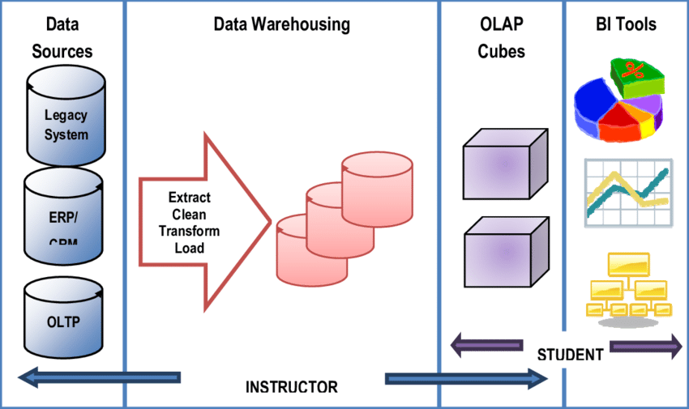
Figure 1: Business Intelligence Architecture
Source: (Antunes et al., 2022)
From the above shown BI architecture diagram, various components of the business intelligence framework such as data source, data warehousing have been quite clearly highlighted.
Analysis of some components of business intelligence
The business intelligence framework has some key components that combine and develop the whole process of data-driven decision-making and run the entire framework comprehensively. Some of the key components are:
Data warehousing
Data warehousing is a data management system that stores a huge amount of data for subsequent use for being processed and analysed (Antunes et al., 2022). It is a kind of central repository of data that can be explored and analysed for deriving valuable business insights. Business intelligence deals with complex and multiple sets of data that are stored by the data warehousing process and it can be termed as the backbone of the business intelligence framework.
Data mining
Data mining is another vital aspect of business intelligence. This process is the subset of data analysis and is predominantly involved in searching for patterns, and correlations in large data sets (Dogan and Birant, 2021). In the business intelligence process, this component is extremely crucial as it uncovers hidden patterns and relationships. Through such hidden insights, the business can optimise its operations, market trends, and consumer behavior and can enhance its overall performance.
Predictive analytics
Predictive analytics is an outcome of business intelligence where this advanced branch of data analytics makes predictions about future outcomes (Puklavec et al., 2017) Historical data, and statistical modeling are the principal way of such analytics techniques.

2.Application of Business Intelligence
Business intelligence has a presence and role across various industries in the modern era. Applying the BI tools and various industries are improving its operations and revenue pictures. In this context, the application of business intelligence in the banking and finance industry are examined here. It has been an integral part of the banking and finance industry. Following are some key aspects of this industry that can be reshaped by applying the BI tools:
Meaningful information from the raw data set
Technology-driven process of business intelligence conducts more specific and accurate scrutinization of data and helps banking entities to make more informed decisions (Eidizadeh et al., 2017). In the financial services sector, business intelligence tools can be applied to derive accurate and meaningful insights from a plethora of datasets.
Transformation of customer relationship
Providing high-quality customer support is the prime concern for the entire banking and financial services industry (Cavallo et al., 2021). The application of business intelligence can transform and enrich customer relationships in the banking sector. Through the integration of such technology transaction histories and account balances can be quickly and accurately analysed. This can tailor customer service and strengthen customer loyalty.
Evaluation of performance
The performance assessment of the employees of the banking and finance sector can be more accurately performed by integrating business intelligence. Besides the performance of the employees key performance indicators of the bank, such as loan approvals rates of investment and customer satisfaction. Data-based scrutinisation of those KPIs helps the bank to improve their performances and also can identify the underperforming portions.

3.Impact of Business Intelligence
The business intelligence market is rapidly growing in UK, especially in the banking and finance industry. Better operational efficiency by optimising the resources and enhancing customer service quality is the key aspects which is improved by the integration of Business intelligence. Additionally, automation of customer service is also strengthening the customer loyalty to the banks and financial services industry of the country. The finance market of UK is majorly fulfilling the real time data analytics, and making quick and accurate decisions.
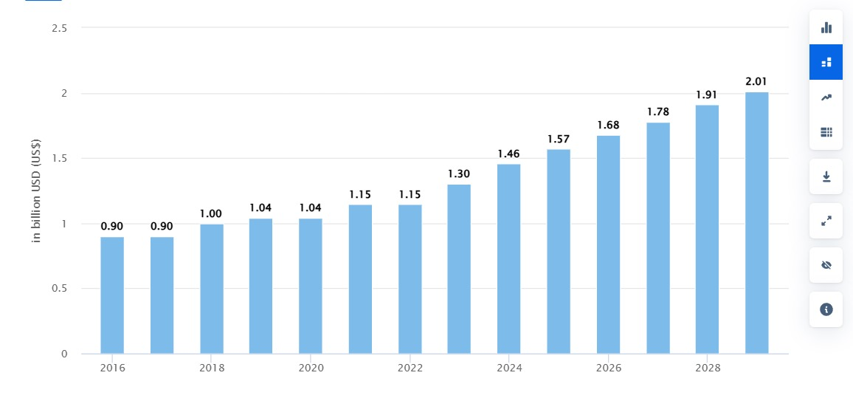
Figure 2: Business Intelligence Growth Trend
Source: (statista, 2024)
The above graph showcases the business intelligence growth in the UK market especially in the finance sector. The growth of BI software in the UK market has been projected £1.58 billion by 2029. The comprehensive impact of Business intelligence in UK market especially in the finance sector is explicit from this data (statista, 2024). Apart from informed decision-making supported by data the demand of BI in UK is increasing to achieve a competitive edge.

4.Conclusion
Integration of business intelligence technologies in any organisation can bring revolutionary change. Especially it can elevate its decision-making abilities in a different level by totally supported by data. Various components of these advanced technologies meticulously analyse different layers of data and present it in the most useful way. Apart from it, business intelligence brings as fastness and accuracy to every business in their operations. This particular report has provided in in-depth analysis of the business intelligence concept along with describing its various components. Data warehousing, data mining, and predictive analysis are those components that have been addressed in the report. The banking and financial industry has been taken in the report to illustrate the application of this in that sector. The finance industry as deals with a huge set of data is ideal for showcasing the use of BI and utilise the advanced technology of data analytics. Further, the impact of business intelligence has also been illustrated here, with its market growth. The whole discussion has been a comprehensive mirror to understanding the idea of business intelligence and its multiple use cases.

References
Antunes, A.L., Cardoso, E. and Barateiro, J., (2022). Incorporation of ontologies in data warehouse/business intelligence systems-a systematic literature review. International Journal of Information Management Data Insights, 2(2), p.100131.
Cavallo, A., Sanasi, S., Ghezzi, A. and Rangone, A., (2021). Competitive intelligence and strategy formulation: connecting the dots. Competitiveness Review: An International Business Journal, 31(2), pp.250-275.
Dogan, A. and Birant, D., (2021). Machine learning and data mining in manufacturing. Expert Systems with Applications, 166, p.114060.
Eidizadeh, R., Salehzadeh, R. and Chitsaz Esfahani, A. (2017), Analysing the role ofbusiness intelligence, knowledge sharing and organisational innovation on gainingcompetitive advantage, Journal of Workplace Learning, Vol. 29 No. 4, pp. 250-267.
Negro, A.R. and Mesia, R., (2020). The Business Intelligence and its influence on decision making. Journal of Applied Business and Economics, 22(2).
Phillips-Wren, G., Daly, M. and Burstein, F., (2021). Reconciling business intelligence, analytics and decision support systems: More data, deeper insight. Decision Support Systems, 146, p.113560.
Puklavec, B., Oliveira, T. and Popovič, A. (2018), Understanding the determinants ofbusiness intelligence system adoption stages: An empirical study of SMEs, IndustrialManagement &Data Systems, Vol. 118 No. 1, pp. 236-261.
statista, (2024). Business Intelligence Software - United Kingdom. [Online] Available at: https://www.statista.com/outlook/tmo/software/enterprise-software/business-intelligence-software/united-kingdom [Accessed 8 November 2024].

