Student name – Jannat dad
Student number – 2309162
Module name – Changemakers: Building your Personal Brand for Sustainable Employment
Module code – BMPH 5015
Lecturer name- Raheela Shaikh

Component 2 – written report

Introduction
The job role I want to do in the future is working with children in a nursery as I have always wanted to work with babys, working with infants in a nursery inspires me. Their innocence, curiosity, and quick development serve as a constant reminder of the value of caring care. Seeing a baby smile, sit up, or recognise a familiar voice is a new milestone that makes me proud and confirms why I love what I do. Every second presents an opportunity to foster their growth and establish a cosy, secure space where they can flourish. Families' faith in me motivates me to be kind, patient, and perceptive. I am motivated to continue learning and doing my best since I am aware of how my care shapes their early experiences.
Job advertisement
The job role I have chosen is working with babies in nursery.
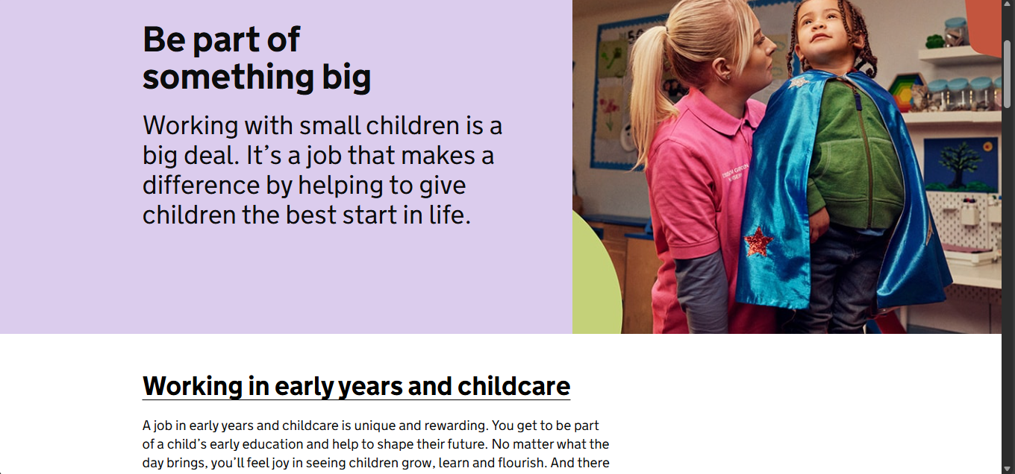

UK Government (n.d.) Early Years Careers. Available at: https://earlyyearscareers.campaign.gov.uk/ (Accessed: 10 November 2025).

Job role employability skills
Working with infants in a nursery naturally enhances many talents that employers look for across a wide range of careers, making it an ideal opportunity to develop job employability skills. Communication is one of the most important abilities acquired. Even though infants cannot speak, nursery workers can learn to communicate through gestures, tone, facial expressions, and observation. This improves their capacity to decipher nonverbal clues, listen intently, and modify communication styles all of which are critical in any line of work involving collaboration or client involvement.
The development of patience is another important employability skill. Calm, constancy, and the capacity to maintain composure in the face of crying, feeding difficulties, or erratic routines are all necessary when caring for infants. This patience helps professionals deal with pressure, resolve disputes, and assist others in the job.
Problem-solving abilities are further strengthened by working in a nursery. There are new challenges every day, like calming an agitated infant, changing activities according to developmental needs, or reacting swiftly to unexpected events. Gaining the ability to think quickly and make safe, well-informed decisions increases self-assurance and sound judgement.
nursery practitioners work closely with colleagues to maintain consistent care; the profession also fosters teamwork. Effective working relationships are built on trust and cooperation, which are fostered by sharing observations, organising routines, and offering support to one another.
Lastly, the work fosters high emotional intelligence and empathy.
Communication abilities are enhanced, and loving relationships are fostered by being aware of babies' needs and reacting to them with tact. Employers who are looking for employees who can maintain pleasant settings, connect with others, and demonstrate compassion place a high value on these qualities. In general, working with infants in a nursery enhances a variety of relevant employability skills that promote personal development and get people ready for a variety of future occupations.
Evaluate your own skills
Self-assessment
Health and social care related experience and qualifications I have so far to consider this job is that I believe I have a strong foundation for pursuing a role as a nursery teacher. As I have experience from college and school in nurseries, I have obtained practical experiences supporting babies care routines, including feeding, nappy changing, and creating safe, stimulating play activities. This hands-on involvement has helped me understand early childhood development and the importance of building secure attachments, which is essential in health and social care settings.
Through my everyday interactions with kids, colleagues, and parents, I have also strengthened my communication abilities. Even though babies are unable to speak, I have learnt to decipher nonverbal clues including body language, facial expressions, and various sounds. This has improved my capacity to react appropriately and compassionately, exhibiting emotional intelligence a crucial trait for anyone working in the early years. I have 3 nephews, one is two and two are 6 months so my experience working with babies is a lot stronger, as I know their needs and wants. I also have more experience and knowledge in health and social care as I have done safeguarding training in children and babies, how to keep them safe, what documentations must be in safe places, if anything happened at home report it to the teacher present. The qualifications I have are health and social care diploma level 1,2,4 and 5 (finishing my level 5 course yet).
Key personal qualities that help me in my career are my patience, empathy, and dependability. Calm, consistency, and the capability to maintain composure under pressure are all necessary for caring for young children, and I have proven these qualities in my current position. I also feel comfortable contributing to shared routines, working as a team, and upholding strict safety and hygiene requirements.
Strengths
My strong points in this job role is that I understand baby’s needs and what they need. In my previous experience in a nursery I would play their activities, give their fruits and peel them if they needed help. I would escort them to toilets, there was one with special needs, he was two years the boy had autism so I understood and got more knowledge every day for what he needed as he was non-verbal, it was a good experience as now when I work in the setting I know what to expect and what to do.
I am dependable, well-organised, and capable of collaborating effectively with others. I am dedicated to upholding the highest standards of professionalism, safety, and hygiene because I take safeguarding seriously. I can make a significant contribution to the organisation of activities that promote physical, social, and cognitive development because of my knowledge of early childhood development and health and social care concepts.
Areas for improvement
Even though I am familiar with the fundamentals of early development, I could improve my work by knowing more about newborns' cognitive, emotional, and physical developmental milestones
During group or sensory activities, I occasionally rely on others to take the initiative. I would be able to contribute more fully if I had greater self-assurance and inventiveness while organising and conducting baby-appropriate activities, including music sessions, sensory play, or tummy time routines. As I have trouble communicating, I would need to put it aside and communicate with the babies and toddlers so I can know what they need or want.
Who can help
Staff have years of expertise and can mentor, critique, and demonstrate the best ways to care for babies, senior practitioners or nursery managers can help me enhance my skills. They can also help you reflect on your development and set goals. Colleagues and peers can also help by teaching me new techniques for managing routines, talking with parents, and interacting with infants as they see other early childhood educators.
Through peer discussions, I could share ideas and learn from challenges. Providers of training and courses By enrolling in childcare, safeguarding, first aid, and early years development courses from nearby institutions, online resources, or organisations like NCFE or Twinkl, I can improve my skills.

Action plan
I'll learn from the staff and colleagues and enquire about their methods and justifications for care decisions in order to prepare my talents. Talk about feeding, sleeping, and routines to better understand each baby's needs. Find out how the babies are responding to your care.
When working with infants in a nursery, developing a well-structured action plan with a clear timeline is essential to improving your skills and confidence. This action plan's short-, medium-, and long-term objectives allow you to track your progress in small sections.
in the near future (0–3 months). During this period, it is crucial to observe seasoned practitioners. Observing coworkers can teach you how to securely and easily carry out feeding, changing nappies, and sleeping habits. By documenting the behaviour, moods, and developmental progress of newborns on a regular basis, you can begin to spot special needs and nonverbal cues. Developing communication skills is especially important since, even though babies cannot speak, it is still necessary to understand their signals in order to give them continuous, focused care. Engaging with parents at drop-off and pick-up times will increase your sense of self-worth and promote kindness.
The medium-term goals (3–12 months) focus on being more independent and confident in your role. At this stage, you should begin planning and leading simple activities for babies and young children, such sensory play, music sessions, or early motor skills exercises. These experiences can help you understand how play fosters emotional, physical, and cognitive development. you should also focus on using training to broaden your professional knowledge. If you finish courses like paediatric first aid, safeguarding, and early years development, you will have a better understanding of the needs of children under two and be able to take on greater responsibilities in the nursery.
Developing into a confident, highly skilled practitioner with leadership potential is the long-term (one to three years) goal. You should be able to plan organised activities, manage routines independently, and adapt your techniques to each child's particular needs. With greater confidence, you can begin coaching new hires, sharing your knowledge, and assisting others in developing their careers. Another component of long-term development is earning higher-level credentials, such as a Level 3 Diploma in Early Years or specific courses aimed at young children. These certifications help you advance into senior roles in early childhood settings and professional advancement.
Building my own personal brand
Empathy, tolerance, and a commitment to providing babies with the finest care possible during the most crucial stage of their development are the foundation of my personal brand. I present myself as a calm, kind, and reliable professional who prioritises the development, welfare, and emotional stability of every kid. My approach is based on the principles of empathy, respect, and responsive ideas in both early childhood education and the broader health and social care sector.
My goal is to create engaging, safe spaces where infants can explore, learn, and develop at their own speed. These characteristics help me define my professional identity and demonstrate to families and coworkers that I am a reliable person when it comes to the most sensitive aspects of early childhood care.
A key element of my personal brand is my commitment to lifelong learning. I frequently seek out chances to deepen my knowledge of child development, early learning, bonding, and safety. This way of thinking reflects my long-term goal of becoming a highly certified early childhood educator and progressing in the health and social care sectors. Whether it's through formal training, observing seasoned pros, or engaging with parents, I'm always looking for ways to improve my work and contribute significantly to my nursery team.
Elfer, P. & Page, J. (2015) “Pedagogy with babies: Perspectives of eight nursery managers.” Early Child Development and Care, 185(11-12), pp. 1762–1782. This study investigates how nursery managers plan and structure their teaching methods with infants. It emphasises the value of sensitive, emotionally consistent interactions and points out that managers view infants as both independent and vulnerable.

Promoting your professional identity
Highlight your familiarity with the EYFS, particularly how you use it with children aged 0 to 2. Candidates who can demonstrate how they use observations to understand children's interests and design appropriate activities are highly valued by employers. Soft skills are just as crucial. Talk about your teamwork in a nursery setting, your ability to work closely with parents, and your communication abilities.
In a nursery setting, you must demonstrate both your practical talents and your comprehension of early childhood care to effectively communicate your experience and expertise to employers. Start by outlining your practical experience working with infants and young children, emphasising important duties such encouraging early growth, establishing routines, and upholding a secure, caring atmosphere. Give concrete instances, such as how you helped newborns settle in, developed close relationships with important people, or responded to their cues to meet their physical and emotional requirements.

Building a network for successful employment
Developing a strong support system is a great way to get a job in a nursery because early childhood settings often favour trustworthy referrals and relationships. Start by engaging with the early years community locally and virtually. Attending training sessions, workshops, and childcare conferences can introduce you to practitioners, nursery managers, and trainers who can offer guidance, share job leads, or even recommend you for positions. Continuing professional development events are especially helpful because they show your commitment to high-quality work and help you build strong professional relationships.
Your network can be strengthened by online platforms as well. Become a member of early childhood groups on Facebook, LinkedIn, or professional forums, where professionals frequently exchange job openings, guidance, and thoughts regarding working with infants and young children. Engaging in active participation, such as leaving comments, posing queries, and sharing your experiences, enables others to acknowledge your abilities and enthusiasm for the field.
Another effective networking strategy is volunteering or completing work placements. These experiences provide you the chance to show off your skills, establish relationships with employees, and frequently result in paid employment. Keeping up positive connections with former coworkers, mentors, and employers also improves your chances of learning about open positions early.

conclusion
in conclusion obtaining a successful job in a nursery setting requires a combination of good networking, solid professional communication, and a clear awareness of what early years employers value. Employers can better understand your capacity to deliver high-quality care, especially for infants and young children who need attentive, responsive, and developmentally aware care, if you confidently demonstrate your abilities and expertise. You come across as a competent and driven practitioner when you can articulate your strengths, such as your familiarity with the EYFS, your ability to foster strong relationships with families, and your ability to establish supportive learning settings.
Building a professional network significantly improves your chances of getting the job you want. Developing a professional network greatly increases your chances of landing the ideal position. You can establish significant connections within the early years community by taking advantage of training options, interacting with practitioners online, and looking for volunteer or placement opportunities. In addition to giving you access to employment prospects, these relationships help you continue to grow as you gain insight from the experiences and viewpoints of others.
You can build solid foundations for a fulfilling career in nursery education and care by actively marketing your skills and cultivating your professional network which is why this is a good way.

Reference
Cooling-Smith, K. (n.d.) Brand identity – Make your setting stand out. Early Years Management, Teach Early Years. Available at: https://www.teachearlyyears.com/nursery-management/view/brand-identity-setting-stand-out (Accessed: 11 November 2025).
Elfer, P. & Page, J. (2015) “Pedagogy with babies: Perspectives of eight nursery managers.” Early Child Development and Care, 185(11-12), pp. 1762–1782.
NCFE (n.d.) Raising the bar for baby care: how specialist training can help practitioners meet the needs of under twos. Available at: https://www.ncfe.org.uk/all-articles/how-specialist-training-can-help-practitioners-meet-the-needs-of-under-twos/ (Accessed: 9 November 2025).
UK Government (n.d.) Early Years Careers. Available at: https://earlyyearscareers.campaign.gov.uk/ (Accessed: 11 November 2025).
Warrington Borough Council (2023) Early Years Employability Support Pack. Warrington: Warrington Borough Council. Available at: https://www.warrington.gov.uk/sites/default/files/2023-05/Early%20years%20Employability%20support%20pack.pdf (Accessed: 12 November 2025).
Stubbs, F. (2023) ‘10 Skills Every Early Years Practitioner Needs’, Twinkl Blog, 5 May. Available at: https://www.twinkl.co.uk/blog/10-skills-every-early-years-practitioner-needs-pviblog (Accessed: 9 November 2025).
The Early Years Network (n.d.) The Early Years Network. Available at: https://theearlyyearsnetwork.co.uk (Accessed: 11 November 2025).
Teach Early Years (n.d.) Teach Early Years. Available at: https://www.teachearlyyears.com (Accessed:13 November 2025).
Bloomsbury Early Years (n.d.) Bloomsbury Early Years. Available at: https://www.bloomsburyearlyyears.com (Accessed: 13 November 2025).
Early Learning HQ (n.d.) Early Learning HQ. Available at: https://www.earlylearninghq.org.uk (Accessed: 13 November 2025).

