
Mind map A3 in-class: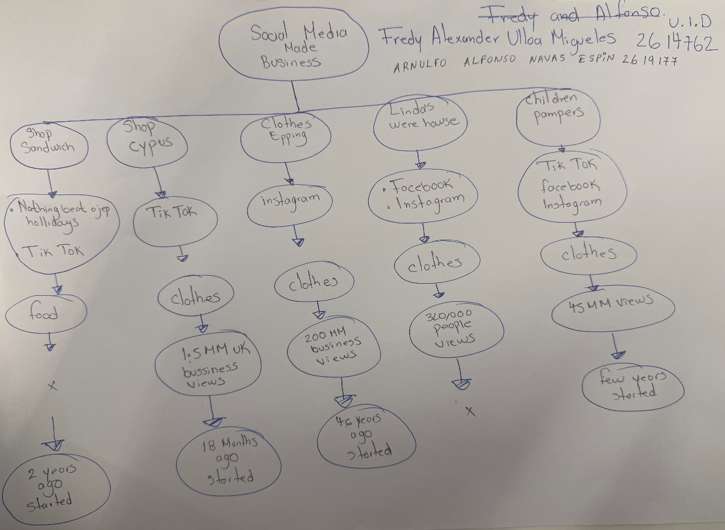

- What is the main idea of the whole text?
I think the main idea it’s how small business in Essex are using short videos and converting in of viral trend in TikTok, Instagram and Facebook for made business to get more customers and grow.
The people traveling for long distances for buy the items because saw the videos online. The customers prefer to buy from a real person not just from a brand.

- What is one key point that supports the main idea, and which specific example from the text shows this?
For example, food Business it’s how one Sandwich shop became a famous because regular customers uploader posted videos of their food on TikTok use the trend. After at this videos the Sandwich shop got many views about the trend video, and they receive more customers from far away 2 years ago.

- What is a different key point that supports the main idea, and which specific example from the text shows this?

Another key point is that showing a real personality and authentic help very much that the traditional publicity.
For example, in the business de Chole Huggins from Little Love’s Pamper Bus started filming in her living room during lockdown and now she uploads content five times a day and has 320,000 followers and 45 million views.

If them become viral with customer help and sell more this form the shop grow up.

- Which part of the text do you think is most important, and why?
I think it is how use the marketing how we can use the social media for get a benefit in our life and we have a good impact on the community we have a success then the people buy from people.
We need to create connection in one video our product (food, and clothes) because most people use that for make more video and we get more views and business.

- What did you find difficult in this task (including in-class components), and why was it difficult?

I think the task it was most difficult in this task is uses correctly form that reading skill because I need to use the skimming for finding the main idea and identify of the scanning for to find specific fact quickly. And it’s really easy to be confused.

And class we understood how find the main idea Keys point who do connexion, but writing in our own works is difficult because the text have many details that become confusing when we have to read.

- What helped you with this difficulty, and how did it help you?

I read the slides two- three times the presentation for make the task I need to read carefully the text about every case and this one help me very much for did this task.

I think that working in pairs and working small group and every example we use on class help me for did this task. As well as every example the teacher she did in class.

