Employability

Table of Contents
Introduction 3
Task1 – Within recruitment and selection processes, explain the purpose of 4
1) Job Description 4
2) A Person Specification 6
Task 2 - Prepare a CV for a specific job role. Within your CV, you should demonstrate an understanding of the importance of skills and knowledge for working effectively. The focus of your CV to the specific role should enable you to do this. 7
Task 3 – Select 2 competencies from the list: 9
Team Working 9
Decision Making: 11
Conclusion 13
References 14

Introduction
In this study, the importance of job description and person specification in the recruitment and selection process has been discussed with a brief introduction to Human Resource management. In the second part the CV has been created specifying the role as HR manager which has all the required fields such as educational qualification and relevant experience that is required for the job and in the last part, the topics that are discussed are a team working and decision making. Organisation cannot work in isolation and hence, the management designs the structure in such a way that there is coordination among the workers and the tasks are divided among the various teams to increase the efficiency and quality of the processes. The different types of teams and their composition are discussed. Also, the process decision making has been discussed along with the procedure of making a decision and the different challenges that the management encounters during decision-making process.

Task1 – Within recruitment and selection processes, explain the purpose of

Job Description
Human Resource Management:
Human resource management is one of the key functional areas of any organisation since the entire life cycle of the employee within the organisation is planned and controlled by the Human Resource department. Among the various activities, the main function of the Human Resource department is recruitment and selection of the employee, which is illustrated below:
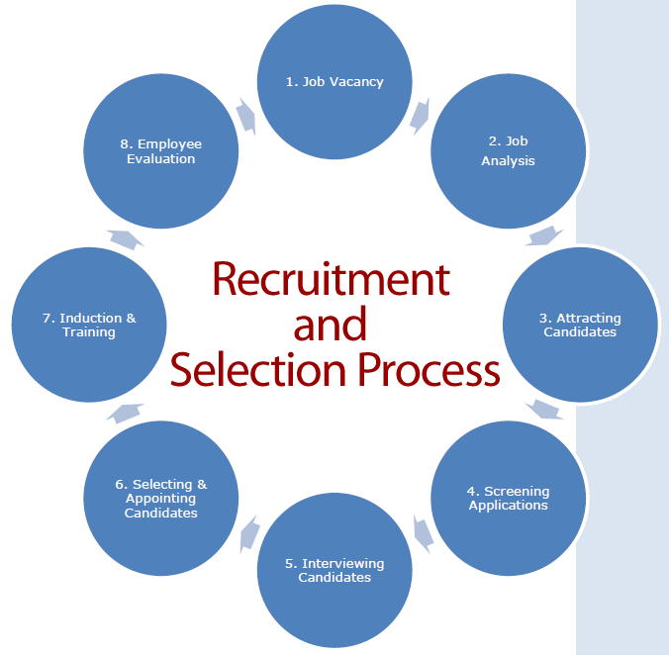
Image Source: Human Resource Management Practice, 2017.

The main function of the Human Resource Department is to select the appropriate candidate so that the training and development cost of the company is minimised. Also, selecting the right candidate ensures that the organisation is benefited by the employee’s experience and expertise to achieve the overall objectives of the company. As per Bogatova, (2017), the recruitment process involves attracting prospective candidates and selecting the candidates based on their expertise and knowledge. In order to select the best among the various aspirants, the job profile has to be clearly stated.
The importance of job description is described as under:
- Defining Roles and Responsibilities: The candidates should be well aware of the job that they are applying for since the required job profile must match with the qualification and level of expertise of the job aspirant. This is the first stage of screening the candidates since only the qualified candidate will be allowed to take further interviews (Bodnarchuk, 2012).
- Criteria for Selection: A well-defined job description helps the Human resource department while screening the CV’s of the candidates since the less qualified candidates are rejected at the initial level.
- Training and Development Needs: In order to get the best results, the employees are trained before starting the production and hence, the job description outlines the training module and the knowledge sharing process that has to be followed (Goto HR., 2017).
Hence, a clear and well-defined job description helps the management to achieve its overall objectives.

A Person Specification
The selection of the candidate is based on the level of competency and expertise that the candidate has to perform the required job (Bodnarchuk, 2012). The person specification is the detailed description of the level of education and other required essentials such as experience, expertise, and knowledge of the required job profile. In order to select the best suitable candidate, an ideal person specification should be:
- Specific Selection Criteria: The skills required for the job has to be in detail and not just the general specifications. For example: excellent communication skill becomes very common profile. However, if the job requirement is for a reporting or MIS then skills such as internal reporting, mail drafting, and professional correspondence skills can be mentioned.
- Selection criteria must be justified: The criteria of selection must be scientific and logical. The various that are conducted and the qualification that has been specified should be as per the nature of the job profile.
- Assessment: The criteria of assessment of the candidate should be measurable and the questions must be related to the work experience of the candidate (Itika, 2011).
- Equal opportunity: The selection has to be unbiased and there should not be any distinction based on nationality, colour, ethnicity, and religion. This ensures that the ablest and capable candidates are selected based on their knowledge and ability. This ensures a healthy environment in the organisation.
The detailed description helps to select the best candidate by scrutinising the best applicants. The advantages of providing detailed person specifications are:
- It avoids confusion for the Human Resource department and selection of the right candidate for the right job is ensured (Bogatova, 2017).
- It helps the management to plan the various training needs of the selected candidates.
- The training cost is reduced since the selection criteria are strictly followed.
- With the required experience, the employee may help in upgrading the process or he may give new ideas to perform the task better.

Task 2 - Prepare a CV for a specific job role. Within your CV, you should demonstrate an understanding of the importance of skills and knowledge for working effectively. The focus of your CV to the specific role should enable you to do this.
CV for the post of HR Manager:
Justin Thomas
14 High Street london UK Phone: 020 4432156 star@gmail.com

HR Manager

As a suitable candidate for HR and Finance department, I have worked with Norton Finance as a HR Supervisor for 2 years and have all the relevant knowledge and expertise in handling the HR team. I now look forward to exploring new challenges for my professional growth.
______________________________________________________________________________

Professional Experience
HR Supervisor Norton Finance london , UK 2015 – Present
HR Activities:
- Handling payroll and related activities including full and final settlement.
- Maintaining Employee Records in BrightPay
- Handling the recruitment team of 6 employees and supervising the team’s work
- Monthly and Yearly manpower reconciliation
- Maintaining all the statutory requirements.
- Designing the training modules.
- Finalising all the MIS reports as per the requirement of the management
Education: Bcom in Accountancy from University of South Wales
M.B.A. in HR from London University
Diploma in Computer Science (University of South Wales)
Skills

- Basic Knowledge of MS (Word, Excel, Powerpoint)
- Strong working knowledge of MS Excel (VLLOKUP, IF CONDITIONS, HYPERLINK)
- Strong working knowledge of BrightPay
- Excellent communication skills and Organising skills

Profile Summary:
- Expert in implementation of new projects.
- Excellent Communication skills in written and verbal both.
- Strong working knowledge of the entire Life Cycle of the employees as well as Statutory Compliances
- Extensive Knowledge Of MS Excel and BrightPay
- Experience of handling the recruitment team.

Declaration
I confirm that the information provided by me is true to the best of my knowledge and belief.
Date
Place

Task 3 – Select 2 competencies from the list:

Team Working
The success of the business organization depends upon the functioning of the whole organisation and not just a particular department. The complex business structures are so designed so that the work-flow is maintained and hence, coordination among the various departments is very important. An individual employee can achieve the target but the whole organisation achieves the objectives of a company.

Image Source: (Sorenson, 2014)

The importance of team can be studied as under:
- Responsibility: The members of the team know each other very well and hence, the assigned tasks are divided among the team based on the skills and competency levels of its members. This helps to achieve the objectives of the organisation.
- Efficiency: Since the tasks are divided as per the ability of the team members, the job assigned to the team is easily achieved. This improves the work efficiency.
- Sharing of new ideas: Working in a team ensures that the knowledge of the team members can be easily shared and together, the team can come with an efficient way of performing certain tasks (Root, 2017).
- Supporting a Team Member: The various challenges that are faced by the team can be shared among the team members and the whole team supports in getting the problem solved. This improves coordination and employees trust each other.
From the above points, it can be noted that working as a team not only helps the organisation to achieve its objectives but also to know the individual skills and the ability of each individual. In order to achieve the overall objectives of the management, there can be various teams that are formed in an organisation. Such as:
- Interdependent Teams: In this, the performance of the team is dependent on the cooperation and coordination of each of its members (Matthews & McLees, 2015).
- Independent Team: Here, the same functions are performed by every team member and the success of each employee depends on his own efforts. For example: Targets to be achieved by the sales team.
- Self-Managed teams: The various activities in the company such as research and development, process improvement, etc. are the examples where the team manager does not act with authority (Sharma, et. al. 2012).

Decision Making:
The decision-making process is the primary job of leaders and managers. As per Ahmed & Omotunde, (2012), the process of decision making is the act of selecting the best possible option form various alternatives that are put forth. It reduces uncertainty and a selected alternative is considered to solve the various business issues. The managers ensure that the decisions are taken with absolute certainty so that there are no doubts in future. In order to make the correct decisions, the decision-making process that is followed as given below:
- Identification of the decision: This is the first step in which the objective is to recognise the issue and a decision to resolve it.
- Gathering Information: Since the decision that has to be made has to be accurate, the facts and reports that are available have to be considered and hence, all the required details have to be taken before taking the decision.
- Identifying the Alternatives: After understanding the actual issue, the different available solution has to be found out.
- Weighing the evidence: All the available information has to be carefully studied and the alternative which gives the maximum output has to be identified.
- Selecting the Best Alternative: This involves choosing the best options. Sometimes, a combination of different alternatives may give the desired results.
- Implementation: The decision has to be converted to action and hence, managers have to look for the resources and support from the employees and senior management.
- Decision review: This is an important part of the decision making since it may help to improve the managers while taking decisions (Concordia, 2017).
The decision-making process is a very challenging job since if the alternatives are not considered correctly, the organisation may suffer losses. The various challenges that are faced while decision-making process is:
- Managing the information: It is very well established that in order to select the best alternatives, all the required information must be collected. However, in case if the managers get only a small amount of data, the decision making becomes very difficult. This hampers the confidence and decision making ability of the management.
- Wrong Identification of Problem: In some cases, the problem that is faced by the company may be different and hence, proper evaluation has to be done. Managers may opt to conduct various researches to identify the problem.
- Wrong Evaluation of the Outcome: Even after following the decision-making process, still the desired output may not be achieved. Hence, overconfidence has to be avoided by carefully studying the available alternatives (Ahmed & Omotunde, 2012.)

Conclusion
From this study, we can conclude that in order to select the right candidate, management always plan the criteria for selection and this ensures that there are no hindrances and the selection process becomes very easy. In order to get the best candidate selected, the job description and person specification are made. The job description defines the roles and responsibilities of the job profile, whereas, person specification prescribes the skills and knowledge required to perform the job. The organization can only succeed if there is proper coordination between different departments and the various functions work as a team to achieve the overall objectives of the organisation. The decision-making process involves the managers to evaluate all the possible alternatives so that the best option can be selected to resolve the issue.

References
- Ahmed, M.T., & Omotunde, H., 2012. Theories And Strategies of Good Decision Making, International Journal Of Scientific & Technology Research, Volume 1, Issue 10, November 2012, ISSN 2277-8616
- Anayim, F.C., Ekwoaba, J.O., and Anthony, I.D., 2012. The Role Of Human Resource Planning In Recruitment And Selection Process, British Journal of Humanities and Social Sciences, Vol. 6 (2), ISSN 2048-1268
- Bodnarchuk, M., 2012. The Role of Job Descriptions and Competencies in an International Organization, Savonia University, Savonia University Of Applied Sciences Thesis.
- Bogatova, M., 2017. Improving Recruitment, Selection And Retention Of Employees, South-Eastern Finalnd University of Applied Sciences, Bachelor’s Thesis Business Management
- Concordia., 2017. 7 Steps of the Decision Making Process, [Online] Concordia, Also available at https://online.csp.edu/blog/business/decision-making-process, [Last Accessed on 19 December 2017].
- Go2HR, 2017., Why You Need Job Descriptions. [Online] Also available at https://www.go2hr.ca/articles/why-you-need-job-descriptions, [Last Accessed on 19 December 19, 2017].
- Human Resource Management Practice, 2017. Recruitment and Selection Process, [Online] Human Resource Management Practice, Also available at http://hrmpractice.com/recruitment-and-selection-process/, [Last Accessed on 19 December 19, 2017].
- Itika, J.S., 2011, Fundamentals of human resource management, African Studies Centre, African Public Administration and Management series, vol. 2, ISSN 2211-8284
- Mangaleswaran, T & Kirushanthan, K., 2015, Job Description And Job Specification: A Study Of Selected Organizations In Sri Lanka, International Journal of Information Technology and Business Management, Vol. 41 No.1
- Matthews, R., & McLees, J., 2015. Building Effective Projects Teams and Teamwork, Project Management Program, Journal of IT and Economic Development 6(2), 20-30,
- Sharma, R., Kansal, M & Paliwal, P., 2012. Effective And Efficient Team Work: Makes Things Happen More Than Anything Else In Organizations, International Journal of Social Science & Interdisciplinary Research, Vol.1 Issue 8, August 2012, ISSN 2277 3630
- Susan. S., 2014, Teamwork Is What Separates the Good From Great Companies, [Online], Huffpost, Also available at https://www.huffingtonpost.com/entry/teamwork-is-what-separates-the-good-from-great-companies_us_58e3c783e4b09deecf0e1a88, [Last Accessed on 19 December 19, 2017].

