Case Study of Pegasus Airlines: Delighting a New Type of Customers
Organisation’s quality systems and customer relationship management
Module Name: Understanding and Engaging in the Customer Experience
Module Code: BMSW 5103
Name: Silviu Marius Tanasa
Student ID:2028900
Lecturer name: Nishi Ramsurrun
Contents
Introduction 1
2. Company Context 2
3. Models Review 5
4. Model Selection 8
5. Model Application 9
CRM Value Chain Model 9
Primary Activities 9
Support Activities 10
CRM Lifecycle Model 11
IDIC Model 11
Marketing Mix 12
Porter’s Five Forces Model 12
6. Recommendations 13
7. Conclusion 14
References 15

List of Figures:
Figure 1: CRM value chain model 5
Figure 2: IDIC model 6
Figure 3: Recommendations 13

1. Introduction
The repeated purchase of the customer depends on their first-time experience and the subsequent customer relationship that the organization maintains. It is quite cheaper to retain the existing customers rather than trying to acquire new customers (Jones and Ranchhod, 2021). The lifetime customer value should be maximized rather than just trying to make a profitable sale, which indicates the importance of quality processes and CRM (customer relationship management). This report purposes to examine the case study of Pegasus Airlines and identify the CRM problem the company is facing. The internal and external factors are identified in the first part of the report along with introducing the key marketing theories that will underpin the report. The second section analyses the strengths and weaknesses of the models and the third section justifies the selection of the model. In the fifth sections, all the models are applied to address the CRM problem facing the company. Lastly, some recommendations are given for the company to implement.

2. Company Context
Pegasus Airlines is the most popular domestic airlines of Turkey, which was established in December 1989 (CAPA, 2022). The headquarter of the company is located in Istanbul, Turkey. Initially, the company started its journey as a charter plane by partnering with Aer Lingus and provided all-inclusive holidays. Two of the major historical events are that the company was acquired by the Turkish Investment Fund in 2004 and then, again acquired by Ali Sabanci. Ali Sabanci, a family-owned business organization in Turkey, changed the fundamentals of the airlines and transformed the charter plane into a low-cost airline. Though the company initially operates as a domestic airline, it started international flights as well so that it could serve a larger customer base (CAPA, 2022). The company has been awarded many times for its extraordinary services, on-time departure, etc. The company is one of the very few airlines that ensured high-quality customer service while operating as a low-cost carrier. As of 2010, the company owned a fleet of 27 airlines (Boeing) and placed an order for another 24 airlines to extend its fleet range and increase its capacity so that it could meet the burgeoning demand for low-cost airlines.
There are many internal and external factors affecting the company, which need to be shed light on. Among the external factors, the political instability of Turkey has been proved to be a negative factor because it decreased the quality of the Turkish passport, which caused difficulty for the Turkish people to travel to many foreign countries. Besides, the political turmoil discouraged many tourists from visiting Turkey (David and David, 2020). The economic factors presented many positive factors; for example, the Turkish economy was an emerging one, which caused the lifestyle of the people to change. Eventually, the demand for airline tickets among consumers increased, which benefitted the company and provided it with an opportunity to tap this huge emerging market (Kelly and Ashwin, 2021). Among the social factors, customer behaviour was gradually changing because a tour/trip had become a part of their lifestyle, which contributed to higher demand for air tickets. Furthermore, the price sensitivity among the customers had increased because the customers started prioritizing cost over luxurious services (Cunningham and David, 2020). The company has been provided an opportunity as there is an emerging customer base (expatriates and new migrants or integrated second- or third-generation migrants), who can be attracted by the company if it is able to address their needs and wants the way it has addressed its current customer base’s needs and expectations.
Technological factors like increasing social media penetration and digital literacy drove the customers to demand better services and more connectivity (Worthington, Britton and Thompson, 2021). This opened up many avenues for the company to differentiate its brand and sustain its competitive advantage in the market. The company started many social media contests to engage the customers so that it could harness the digital platforms to establish and maintain better relationships with the customers (Sheehan, 2018). In addition, the company leveraged the opportunity to invest in modern technologies like electronic ticket policy to enhance the customer experience. Pegasus also offered an in-flight bulletin for which it did not charge the customers, but it generated revenue from advertising. Hence, in addition to engaging the customers, and ensuring multi-channel engagement, the company has ensured modern technology to augment the traveling experience of the customers (Gentle and Thompson, 2021). Among the legal factors, the company was legally bound to abide by the laws and regulations of the country, the airline regulator of Turkey, and regulators of foreign destinations so that the health and safety of the customers can be ensured. In order to address the environmental factors, the company attempted to reduce food waste by offering discounts on fixating the food menu 48 hours before the take-off. The environmental factors like rising concern over environmental pollution because of carbon emission, noise pollution, water shortage, etc. had been pushing the company to be innovative in its approach moving away from the traditional practices (Kelly and Ashwin, 2021).
There are many internal factors as well affecting the company, which need to be discussed as well. The company has many weaknesses; for example, its profit margin is quite thin and hence, any change in fuel prices or taxes can turn the profits of the company into losses (Worthington, Britton and Thompson, 2021). In addition, the company has not been able to meet the customer expectation regarding social media engagement. The customers of the organization want more than just social media contests to win free tickets, which the company failed to address. This has been spotted as one of the CRM problems that the company has been facing. Due to the nature of the industry, the company is dependent on a few suppliers, which is another factor impacting the company. The company has many strengths as well, which allow the company to attain and sustain a competitive advantage in the market (Kelly and Ashwin, 2021). One of the major strengths of Pegasus is that it has been able to provide extraordinary onboard and other services while keeping the ticket prices low. In addition, the organization has a dedicated and trained employee base, which made it possible for the company to deliver such high-quality services (David and David, 2020). Furthermore, it offers great destinations and easy access to international hubs, which allures a large number of passengers. Also, the company uses creative communication channels to reach and communicate with the passenger, which is another strength of the organization that differentiated it from the rest of the competition.
In order to underpin the analysis of the report, two marketing models: marketing mix and porter’s five forces model will be used in this report. The porter five forces model involves analysing the micro factors, specific to the airline industry and these factors affect all the companies operating in the sector. The focus of the model is on three stakeholders: customers (bargaining power of the clients), suppliers (bargaining power of the suppliers), and competitors (direct competitors-competitive rivalry, indirect competitors-threat of substitute, and future competitors-threat of new entrants). The marketing mix model is one of the most used marketing models that takes a holistic approach to analysing the product offering of the company. The four components of the model are product, price, place, and promotion. The application of the model allows the organization to find any weaknesses so that they can be dealt with and value proposition can be integrated with the product offering.

3. Models Review
Customer relationship management (CRM) means identifying, analysing, and mainitaining the needs, expectations, behaviour, and expectations of the customers over the lifetime of the customer relationship (Buttle and Burke, 2021). The purpose of CRM is to facilitate the customer experience by continuously improving the relationship of the client with the organization. In addition, the knowledge of customer acquisition and sharing must be used while integrating the marketing, sales, and activities relating to the customer support system (Sturdy and White, 2020). The different CRM models that will be applied in this report are the CRM lifecycle model, CRM value chain, and the IDIC model. In addition, the marketing 4P model and porter’s five forces model will also be reviewed in this section of the report.
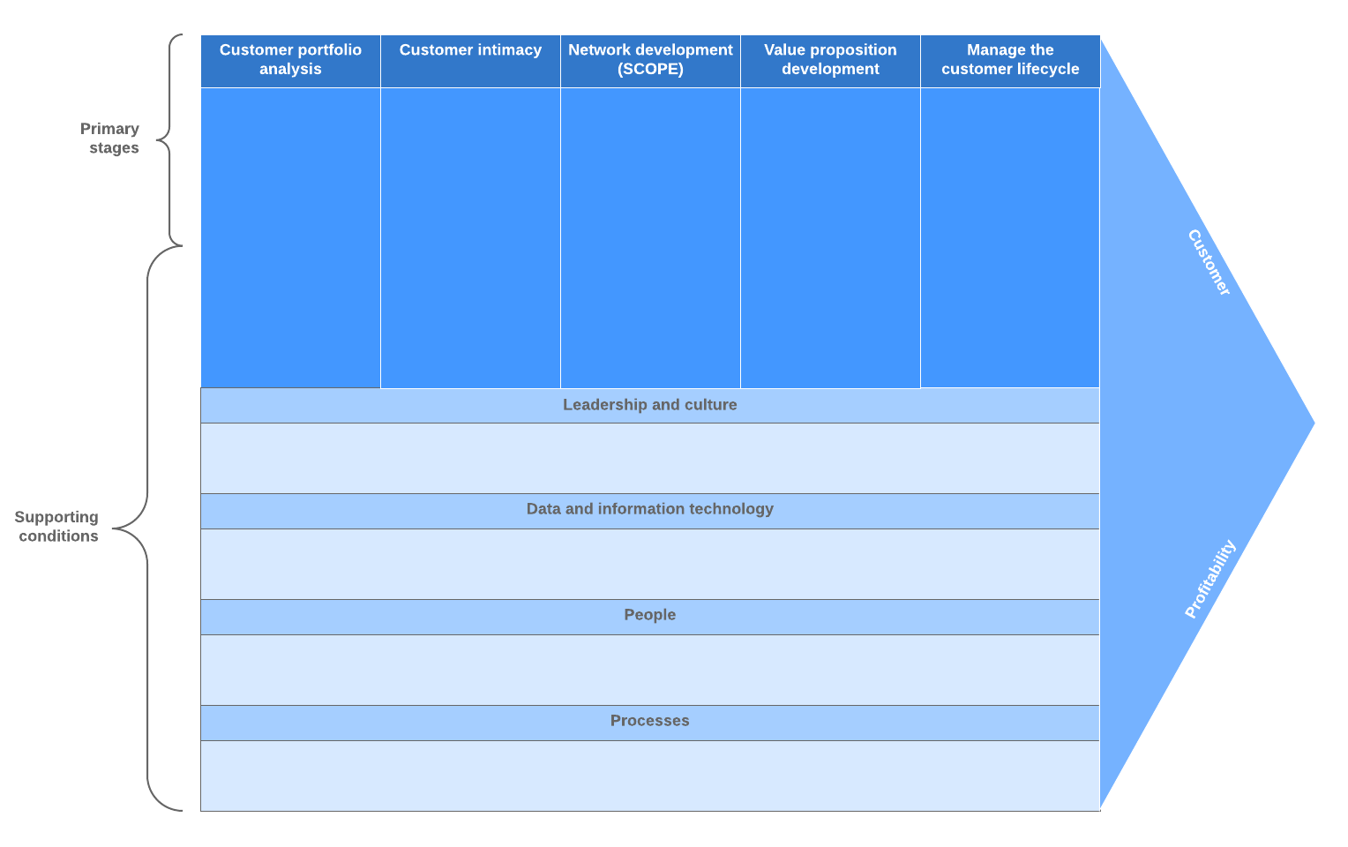
Figure 1: CRM value chain model; Source: (Meyliana and Budiardjo, 2022)
The CRM value chain model is developed by Michael Porters, who proposed that a good CRM system should have some primary activities, which need to be supported by some secondary CRM activities (Gebert, Kolbe and Brenner, 2018). The model has several advantages and one of them is that the model takes an organized step-by-step process from analyzing the customer portfolio to developing the customer relationship. Also, the model is entirely focused on the customers, which allows the company to develop a customer-centric CRM strategy (Meyliana and Budiardjo, 2022). However, the scope of the model is quite wide rather than being just focused on the customer relationship. In addition, the model also suffers from the same limitation, that is, there is no scope for customization.
One of the major benefits of applying the CRM lifecycle model is that it takes a holistic approach to developing and designing the CRM system of the company (Baran and Galka, 2021). Besides, the model considers the functional requirements before reaching a decision on the architecture of the CRM system of the company. In addition, the model identifies and integrates the corporate goals, culture, etc. with the customer relationship management, which is another strength of the model (Meyliana and Budiardjo, 2022). However, the model has some weaknesses as well, which need to be pinpointed. One of the significant drawbacks of the model is that it provides a strategic solution rather than a technical solution. Besides, it does not consider the need for customization because a particular CRM system may not suit the different customer bases a company may serve.
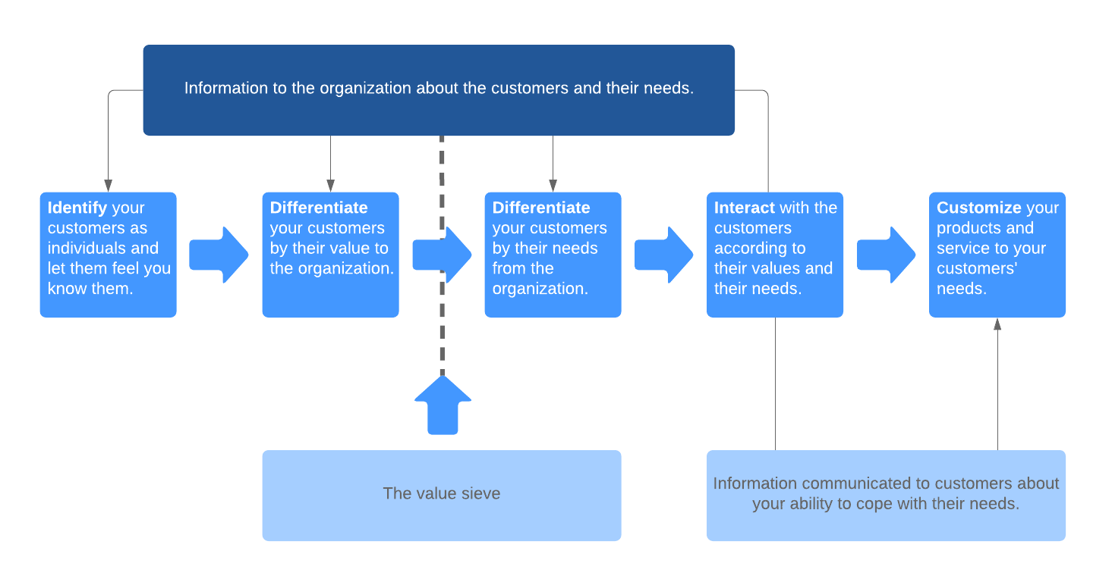
Figure 2: IDIC model; Source: (Walls and Zahay, 2020)
The IDIC model stands for identify, differentiate, interact, and customize (Gentle and Thompson, 2021). This model overcomes the weakness of the other models; that is, it provides the opportunity to customize the customer relationship management system. In addition, the model is specifically developed to address the CRM problems and provide solutions that cater to each problem rather than providing an umbrella solution. However, this model is not without its weaknesses as well. One of the major weaknesses of the model is that the CRM strategy is not integrated with the marketing, sales, and customer support activities of the company (Walls and Zahay, 2020). Hence, this model does not take a holistic approach to customer relationship management.
The marketing mix model comprises of four components: product, price, place, and promotion. One of the advantages of the model is that it is easy to apply and explain (Bagozzi and Harper, 2017). However, the biggest strength of the model is that it takes a proactive approach rather than a reactive one. The application of the model allows the organization to evaluate the product offering and ensure that its product/service delivery is in line with the value proposition of the company (Sheehan, 2018). The model has some drawbacks as well. The model cannot be implemented independently; for example, the company has to consider whether the company follows the cost-leadership or differentiation strategy while designing the marketing mix. Lastly, porter’s five forces model allows the organization to analyse the market attractiveness to decide whether the company will continue to operate in a particular industry (David and David, 2020). The model has some weaknesses; for example, the model does not consider the industry regulators and other micro factors.

4. Model Selection
The models are not selected based on simple intuition rather the context of the case study has been considered while choosing the models. In this section of the report, the reasons why the particular models are selected, are discussed below. However, the CRM problem of the case study will be discussed first.
- The case study of Pegasus Airlines has been selected for the analysis of the report. One of the main CRM problems of the case study is that the company has seen the rise of a new customer base (expatriates and new migrants or integrated second- or third-generation migrants), the needs and expectations of whom have to be understood to develop and maintain customer relationship (Walls and Zahay, 2020). This will be a challenge for the company. Another major CRM problem of the company is that it has failed to satisfy the social media engagement needs of the customers properly.
- The CRM lifecycle model has been selected so that the CRM system can be designed in a way that will allow the company to address the CRM problems facing Pegasus Airlines. The model will pinpoint any changes that need to be brought in the people, leadership, goals, and technology so that a strong relationship can be developed with the emerging customer base (Buttle and Burke, 2021). This will ensure that the company fuels the future growth of the company and supports its future sustainability.
- The CRM value chain model has been selected so that different processes relating to customer relationship management can be developed. This will make sure that the customer relationship processes are well-organised and supported so that the customer needs and expectations can be met and managed properly (Sturdy and White, 2020).
The IDIC model has been selected mainly for the customization component of the model. As the problem is unique to the case study of Pegasus Airlines, the model will help to develop tailored solution to the CRM problem of the company.

5. Model Application
The models that have been justified in the previous section of the report, will be applied here to the context of the case study of Pegasus Airlines. The application of the CRM models will be comprehensive, whereas the marketing models will be applied to a very limited extent.

CRM Value Chain Model

Primary Activities
1. The first activity in the model relates to identifying the needs and requirements of the customer group (Baran and Galka, 2021). The new customer group that has not been tapped yet, has different needs and expectations. The expatriates and new migrants or integrated second- or third-generation migrants are more sensitive to prices and often, they require the organization to reach them via traditional channels rather than heavily depending on social media (Woodcock, Stone and Foss, 2021). These customers mainly use the airlines for international travel and hence, the company can attract them by offering flexible tour packages. For example, the company can offer them a range of dates on which they can book tickets beforehand. In this way, the company will get bookings while providing them the convenience that they require. In addition, the existing customer base has raised concerns over their social media engagement, which is a new need that the company needs to consider.
2. The second task is to engage the customers so that the basis/foundation of the relationship can be built. Pegasus Airlines need to collect data at each touchpoint so that it can understand the customer group better. As the company does not have adequate data on the new customer group, the more data it collects, the better (Gebert, Kolbe and Brenner, 2018). Besides, the company needs to analyse the social media activities of the company more closely to understand the type of engagement they expect.
3. Network development is the third primary activity in the value chain, which requires the organization to develop a network with different stakeholders including suppliers, partners, travel agencies, etc. so that the company can offer support services to enhance its CRM program (Sturdy and White, 2020).
4. The fourth activity is the development of the value proposition. Upon having understood the needs and demands of the clients, the company needs to modify its value proposition before trying to develop a tailored marketing mix for the new customer base (Cunningham and David, 2020). Besides, the existing customers should be delighted by increasing their engagement on social media.
5. The last primary activity in the value chain is relationship management. In this stage, Pegasus Airlines will develop the business processes to manage customer acquisition, retention, and relation (Gong, Liu and Xiao, 2022). In order to ensure that the lifetime value of the customer is maximized, the company needs to continue meeting the expectation of the customers and engage them via the communication media they prefer.

Support Activities
The support activities include leadership and culture, procurement practices, HR processes, IT/data management processes, and organizational design (Shihab, Sukrisna and Hidayanto, 2021). Firstly, the commitment from the leaders should be ensured, without which appropriate CRM processes cannot be developed. It should be instilled into the culture that the company strives to satisfy the customer and maintain a long-term relationship with the customers (Meyliana and Budiardjo, 2022). The procurement process involves identifying the human resources, technology, devices, etc. that the company needs to ensure to support its CRM system. For example, if the company wants automated customer service at the initial stage, it needs to invest in AI technology. This action of the company supports the low-cost strategy as well as ensures high-quality and responsive customer service. The HRM processes like recruitment, training, employee retention, employee engagement, etc. activities should be aligned such that the company’s workforce can deliver the service expected from them (Jones and Ranchhod, 2021). The data management process ensures that the company’s CRM processes are designed based on insights collected from analysing a large set of data (Gebert, Kolbe and Brenner, 2018). Lastly, the organizational design should support the selected CRM system of the company.
A careful design or modification of the CRM system of Pegasus Airlines can address the CRM problem experienced by the company.

CRM Lifecyle Model
The application of the model takes a comprehensive approach towards designing the CRM system that can address the CRM problems of the case study. Firstly, the leaders of the company have to direct the effort of the whole workforce, dedicated to the CRM department, towards understanding and meeting the customer needs and requirements along with communicating with them and engaging them so that a good relationship can be developed and maintained (Baran and Galka, 2021). The CRM goals are one of the major components that the leader considers while developing the CRM system. As the goal of the CRM is to maintain a good relationship by providing high-quality services at lower costs, the company needs to develop processes that are cheap but of good quality. The people or employees of the company played the most vital role here. The effort could only be driven and motivated by communicating the philosophy of the company (Tsikriktsis and Zamil, 2020). Though the onboard amenities were not superior compared to some competitors; the company realized that good behaviour with an attitude to help the passengers out could go a long way. All these activities of the company have to be supported by technology. The company has already developed an electronic ticketing system. However, in order to attract a new customer base, the company can harness the mobile device, which the new customer base is comfortable with (Woodcock, Stone and Foss, 2021). For example, a mobile app can be developed, and designed in a user-friendly way, so that the booking experience of the customers can be enhanced as well as they can be continuously engaged with the brand.

IDIC Model
1. The first stage of the mode is all about collecting data about the customers. The demands, expectations, and behaviour of the new customers are yet to be understood by the organization, which requires the company to analyse the emerging customer base (Gentle and Thompson, 2021). The company would try to collect as much as possible in this stage of the model. In addition, the company needs to collect data on which social media activity the existing customers would like to be engaged in.
2. The second stage of the model involves differentiating the customer segment based on their lifetime value (Buttle and Burke, 2021). The emerging customer base has a huge lifetime value, which propels the company to place special emphasis on acquiring these customers.
3. The company needs to be interacted with, which is the third stage of the model. The company needs to assess whether the current loyalty program appeals to the new customer base and according to the findings, the loyalty program should be tailored to meet their expectations. The company should continue with social media contests, which are more likely to appeal to this price-sensitive customer base (Sturdy and White, 2020). The existing customer base wants to belong to a group and hence, the company should engage them in social media in a way that provides them the feeling of attachment and belongingness to a community.
4. Lastly, the CRM processes should be customized according to the needs and requirements of the different customer bases (Walls and Zahay, 2020). The company can continue with the current CRM processes for the existing customer base; however, for attracting the new customer base, the company needs to include traditional and more convenient platforms.

Marketing Mix
The product refers to the tangible and intangible products and services that the company provides to its clients (Bagozzi and Harper, 2017). Pegasus Airlines need not modify the products and services while offering them to the new customer base; however, the company can consider extending its no-frills strategy to further cut the price for the new customer base. The pricing strategy of the company should be continued; however, the penetration pricing strategy can be undertaken to initially tap the new/emerging market. For the placement strategy, the multichannel strategy will suit the purpose of the company (Sheehan, 2018). The company should make the booking of the tickets available via the website, mobile app, phone calls, etc. As far as the promotion is considered, the company needs to understand the importance of print media along with digital media. In addition, there are some agencies via which these migrants came to Turkey in the first place, and hence, it would be an effective strategy to establish a relationship with these agencies.

Porter’s Five Forces Model
The bargaining power of the customers is high because there are many airlines offering similar packages (Gong, Liu and Xiao, 2022). However, the fact that differentiates Pegasus is that it was able to ensure excellent service along with lower price ranges. The bargaining power of the suppliers is high because there are a few suppliers and they provide differentiated products and services (David and David, 2020). The entry barriers are high because of the capital-intensive nature of the market, learning curve, economies of scale, stringent regulations, etc. The threat of substitutes is moderate to high for the domestic route because coaches, trains, etc. provide good quality transportation service at lower costs. Lastly, the competitive rivalry is high and competitors engage in price because of lower industry growth, high fixed costs, etc.

6. Recommendations
There are some recommendations that the company should follow, which are provided below:
SL No
The company should support the formation of an online community by opening and boosting social media pages and groups. In addition to running contexts and offering gifts, the customers want to attach to the brand. The belongingness to the online community will meet the social needs of the customers and strengthen the customer relationship (Sturdy, and White, 2020). Besides, it will give the immigrants a feeling of attachment that they miss coming to a foreign country.

Pegasus should provide flexible return tickets for the immigrants, who are certain about the date they leave Turkey but are not certain about the date they will return. This will solve their problem and they may become loyal to the brand, which will allow the company to maintain a long-term relationship that will continue for generations.

Pegasus should launch a mobile app along with facilitating the ticket-booking by phone calls to help the immigrants avail the services of the airlines (Bagozzi, and Harper, 2017).
The company should launch a tier-based loyalty program, where the customers will be ranked based on their lifetime value and some other criteria and the benefits will be customized according to their rank levels (Gentle and Thompson, 2021).
Figure 3: Recommendations; Source: Own

7. Conclusion
The justification section explained the reason why the particular model would suit the context of the case study and allow to address the CRM problem outlined in the case study. The major CRM problems related to delighting a new customer base and meeting the social media engagement needs of the customers. The application of the three CRM model indicated that the company needs to modify its offering while customising the CRM processes so that the varying needs of the different customer group can be met. The data collection process is the most important part of any process because without understanding the needs, the company cannot manage the expectations of the customer and maintain good relationship. Lastly, the recommendation section provided some suggestions how the company can solve the issues and drive the business forward to support the future sustainability of the airlines.

References
Bagozzi, R. and Harper, A., 2017. Marketing management. Upper Saddle River, N.J.: Prentice Hall.
Baran, R. and Galka, R., 2021. CRM. London: Routledge.
Buttle, F. and Burke, R., 2021. Customer Relationship Management. Taylor and Francis.
CAPA, R., 2022. Pegasus Airlines Group Airline Group Profile | CAPA. [online] Centreforaviation.com. Available at: <https://centreforaviation.com/data/profiles/airline-groups/pegasus-airlines-group#:~:text=Originally%20founded%20in%20Dec%2D1989,equity%20firm%20Esas%20Holding%20AS.> [Accessed 20 August 2022].
Cunningham, M. and David, E., 2020. Customer Relationship Management. Chichester: Capstone Pub.
David, F. and David, F., 2020. Strategic Management. Pearson Education UK.
Gebert, H., Kolbe, L. and Brenner, W., 2018. Knowledge‐enabled customer relationship management: integrating customer relationship management and knowledge management concepts[1]. Journal of Knowledge Management, 7(5), pp.107-123.
Gentle, M. and Thompson, F., 2021. The CRM handbook. London: Kogan Page.
Gong, X., Liu, X. and Xiao, Z., 2022. A dedication-constraint model of consumer switching behavior in mobile applications. Information &amp; Management, 59(4), p.103640.
Jones, S. and Ranchhod, A., 2021. Marketing strategies through customer attention: beyond technology-enabled Customer Relationship Management. International Journal of Electronic Customer Relationship Management, 1(3), p.279.
Kelly, P. and Ashwin, A., 2021. The business environment. Andover: Cengage Learning.
Meyliana, K. and Budiardjo, E., 2022. Building social CRM framework on enterprise architecture framework using value chain process approach. Contemporary Engineering Sciences, 7, pp.671-676.
Sheehan, B., 2018. Marketing management. Lausanne: AVA Publishing SA.
Shihab, M., Sukrisna, I. and Hidayanto, A., 2021. Investigating customer relationship management systems involvement towards customer knowledge creation processes. International Journal of Electronic Customer Relationship Management, 9(1), p.56.
Sturdy, G. and White, D., 2020. Customer Relationship Management using Business Intelligence. Newcastle upon Tyne: Cambridge Scholars Publishing.
Tsikriktsis, N. and Zamil, T., 2020. Does Culture Influence Customer Service Quality?. Journal of Service Research, 5(2), pp.101-112.
Walls, S. and Zahay, D., 2020. Managing customer relationships. Cambridge, MA: Marketing Science Institute.
Woodcock, N., Stone, M. and Foss, B., 2021. The customer management scorecard. [Farmington Hills, Mich.]: Thomson Gale.
Worthington, I., Britton, C. and Thompson, E., 2021. The Business Environment. Harlow, United Kingdom: Pearson Education Canada.

