Tyler Jenkins

Student no-2004748
Portfolio of writing
Ways of thinking ( ADAD4018 )
Tutor: Jonathan Pugh

Task 1- Manifesto Writing
Task 2- Practice based writing
Task 3- Observational writing

Word count
Task 1 – 456
Task 2 – 493
Task 3 - 463

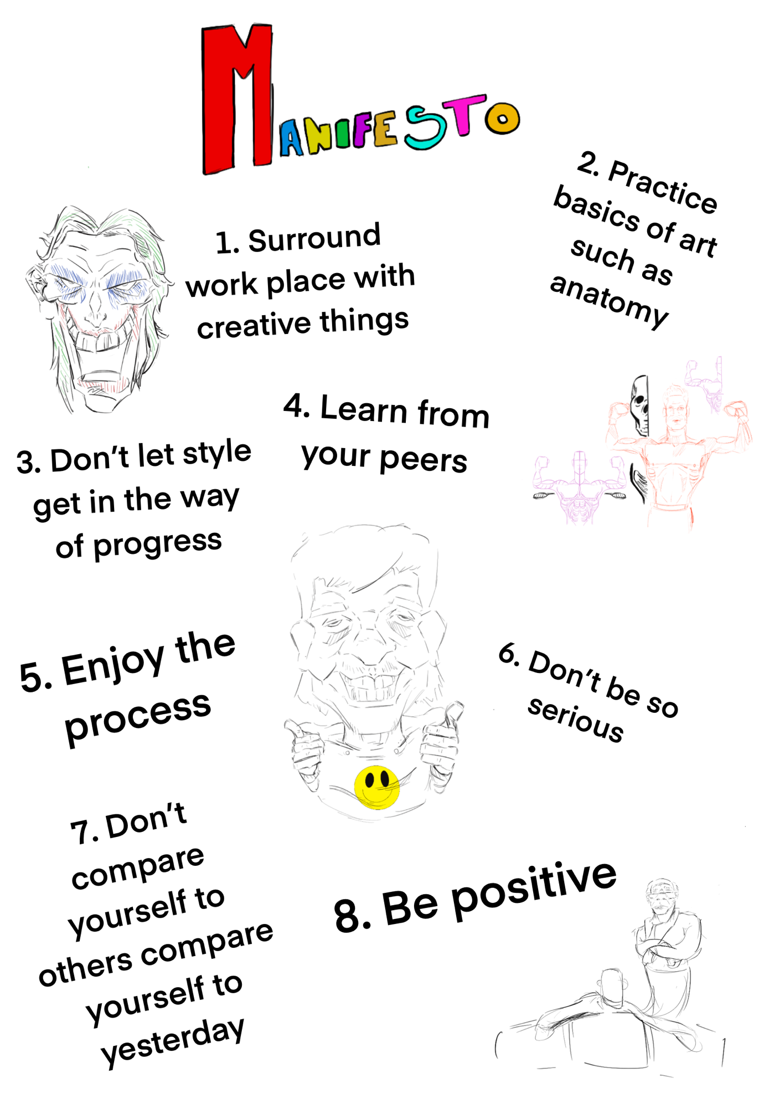
Ways of Thinking Manifesto
Tyler Jenkins Student Number: 2004748
Word count - 456
Task 1 – Manifesto writing

- Surround workplace in creative things: I believe the key to a good workplace is surrounding yourself in creative things for example past work, artwork from artists you like this can get you in a creative mindset, another way to surround yourself with creative inspiration, for example, move outside of your comfort zone and hang around creative people a good article for this is, [1]Crissi Langwell: May 9, 2020, 6 ways to surround yourself with creative inspiration.

- Practice the basics of art: For example anatomy, I believe if you have a great understanding of anatomy all forms of art become that much easier to understand, A great book to look at is Michael Hampton, 2010, Figure Drawing: Design and invention.

- Don’t let style get in the way of progress: although it is important to discover your style that will come naturally I believe it is more important progress as an artist by practicing your fundamentals.

- Learn from your peers: If you have the money and time I believe online classes are your best bet for learning from an artist you respect a good online lesson is class 101, Bryce Kho,

- Enjoy the process: although art is tense at times and can be very stressful it is important to make sure you enjoy the process because it is the best way to learn and improve, remember all though it might be a job to some people it was once a hobby that you did for fun and that’s why I believe you should keep that mindset.

- Don’t be so serious: Art is all about having fun and although when working it can seem to slip away from you this is why I believe you should take some time out of your schedule to draw something you wouldn’t usually do be creative with it and have fun, I believe it’s a great way to keep things fresh and you might just discover something new.

- Don’t compare yourself to others compare yourself to yesterday: this is a well-known quote from Canadian philosopher Jordan Peterson although he says some controversial I believe it is important to separate the words from the person and this is why I resonate with me although I said to learn from your peers I also believe you shouldn’t compare yourself to them as it can have a negative impact on your progress and wellbeing, a good tip to reflect on your art is to date your work.

- Be positive: I think the best advice to live by is to just keep positive although it seems like a very Sarcee comment sometimes you just need to take a breath relax and realise there is no point stressing over it.

Bibliography

Author: Jordan Peterson Published: January 23rd,2018
Rule 4: "Compare yourself with who you were yesterday, not with who someone else is today"

Author: Crissi Langwell Published: May 9th,2020
[1] https://medium.com/swlh/6-ways-to-surround-yourself-with-creative-inspiration-720bd9eb664f

Author: Michael Hampton published: August 2009 Info: http://www.figuredrawing.info/book/

Task 2 – Practice based writing – my journey on learning anatomy

After looking back on my work for my Editorial project my tutor Tracy Thompson had made me realise although my ability is strongest in my use of line and depth I was still lacking in the basic parts of art especially the human form this is what led me down my path of trying to teach myself the basic, I first started to do as much living drawing as I possibly could concentrating on every curve and shape of the human form but sadly due to covid restriction I was stuck on how much live drawing I could do this led me to use sites such as [1]line of action. Although the site was helpful for the time being I realised I wasn’t able to continue without properly learning the secrets of anatomy so I looked up books from authors such as Micheal Hampton, I was able to find some help from a website called [2]Figure drawing.info, I also decided to use a passion of money to help the progress stay a little more interesting for this I used images of famous boxing matches to practice live form and work on more dynamic poses. After all this, I decided to try implementing my new-found knowledge into my work and style but before doing this I decided to look up comic book artist who have done similar things and used boxing as there influence, in my research I found a comic book called [3]“The boxer” which was released in 2011 by the artist [4][5]Reinhard Kleist, the dark tone of his art style helped realise the contours of the body can be exposed with nothing more than the outline of light, this helped add a dark undertone to the comic a choice that could have altered the whole outcome of the graphic novel. Another artist I looked at was George Morikawa who was the author of a famous manga [6]Hajime no Ippo, the style of George Morikawa is almost a caricature of the human form exposing each muscle to show the power of the boxer I believe his style is a great example to study as it shows the human form in a more detailed light I think if you stop and look at how each muscle works it becomes a lot easier to manipulate it this ties in perfectly to my manifesto it isn’t only important to study the basics of art but equally important not to let style get in the way, to many times I have heard or seen people make errors and call it there style I struggled for it a lot but now I realise being honest is the best way to learn, since I have started researching human form I have seen my art improve greatly and I look forward to progressing more further into the future, after looking back on my whole project I have defiantly learnt how everything directly applies towards the 8 rules of my manifesto.

Bibliography
[1] https://line-of-action.com/

[2] http://www.figuredrawing.info/

[3] https://www.selfmadehero.com/books/the-boxer

[4] https://en.wikipedia.org/wiki/Reinhard_Kleist

[5] https://www.reinhard-kleist.de/en/

[6] https://en.wikipedia.org/wiki/Hajime_no_Ippo

Task 3 – Observational writing
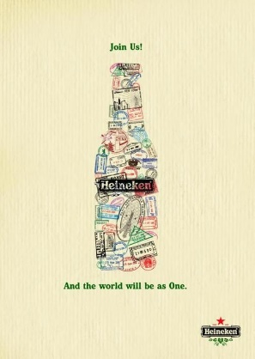
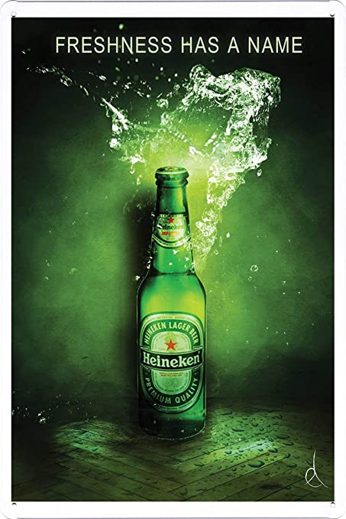
Gender: I think the ‘ Join us ‘ poster is aimed towards both genders my reason I believe this is due to the inclusive message of the poster it seems to be aimed at a wider audience.
Gender: looking at the classic style of Heinekens advertisement I believe it was aimed towards the male gender my reason for this is the dark subtle tone and harsh use of green although the drinking comes across a lot more refreshing I don’t think it looks more appealing compared to the ‘ join us ‘ poster.

Message: The texture of the background looks very similar to a cardboard box, their reasoning for this could be too add a subtle touch that applies to the message of “worldwide“, compared to Heineken usual use of the signature colour green the choice of colour in this one is a lot softer on the eyes which makes the image a lot more welcoming.
Message: The text is in the signature colour Heineken.

Message: The use of the word join us adds to the theme of the poster almost making anyone who views it feel welcomed and invited in, it makes the viewer feel like it’s a private guest to an exclusive party

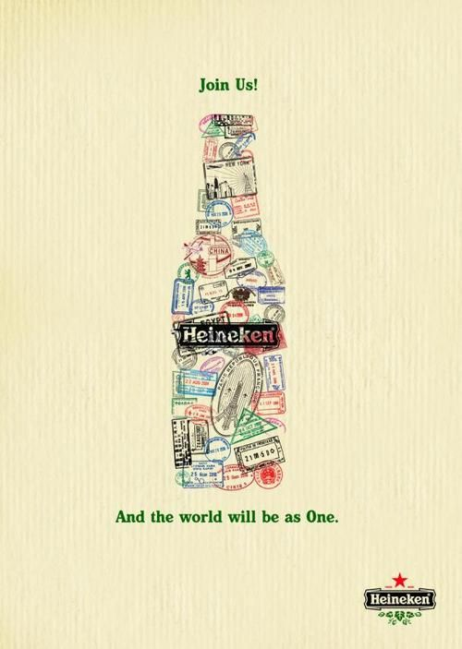
Reason for choosing: When looking at this piece in the mindset of an artist I couldn’t help but be drawn in, although Heineken can be considered a more classy style of beer compared to the likes of brands such as Budweiser or desperados, yet the advertising gives off a modern vibe almost a piece you could hang up on the wall the use of passport stamps shows how the beer is worldwide although the design might seem simplistic compared to their prior design I think it is a lot more eye-catching and friendly.
Reason for choosing: Looking at this piece of work makes me notice the difference between illustration and graphic design the “join us” uses simplistic design and use a lot of subtle message to hide what they are trying to get across to the viewer it really grabs your attention and makes you think about it a lot more this was the initial reason I chose this image.
Message: The use of the word “World” pushes the message across that this beer is known worldwide and only strengthens my prior comment that the main point of this advertising is to show the global reach of this beverage.
Overall: I think a lot of companies should take this approach to their posters and hire more illustrators to make the designs.
Message: Although the message “and the world will be as one“ may be an indication of the brand's global reach it could also be used to add emphasis on the fact that this beer is best-enjoyed friends.

