University of Wales Trinity Saint David
School of Engineering



Technical Report
ACHA4009
Introduction to Automotive, Motorcycle
& Motorsport Foundation Engineering
Charlie Jones
2103718
April 2023

Contents
Contents
Contents 2
Chapter 1 - Introduction 3
Aims 4
Chapter 2 – Impact of the Topics 4
Topic 1: Crash & Safety Testing 4
FIA Types of Crash & Safety Testing in formula one 4
How does crash & safety testing impact the design of the W11? 6
How does crash & safety testing impact the development of the W11? 7
Topic 2: Materials 7
How did the materials affect the design of the W11? 9
How did the materials affect the development of the W11? 10
Topic 3: Engine and Hybrid Technologies 10
How did the Engine/Power Unit impact the design of the W11? 11
How did the Engine/Power Unit affect the development of the W11? 11
Topic 4: Manufacturing 11
How did the manufacturing impact the design of the W11? 12
How did manufacturing affect the development of the W11? 12
Topic 5: Interoperation of rules and problems 13
How did the rules and problems impact the design of the W11? 13
How did the rules and problems affect the development of the W11? 14
Topic 6: Holistic Forethought of Failure 15
How did the forethought of failure affect the design of the W11? 15
How did the forethought of failure affect the development of the W11? 15
How successful was the Mercedes W11? 16
Technological advances after the Mercedes W11 competed? 16
Chapter 3 - Current State of the Automotive Industry? 16
What have been the largest areas of contention in the automotive industry over the past 30 years? 16
What is the future of the automotive industry? 17
Chapter 4 – Conclusion 18
References 19

Chapter 1 - Introduction

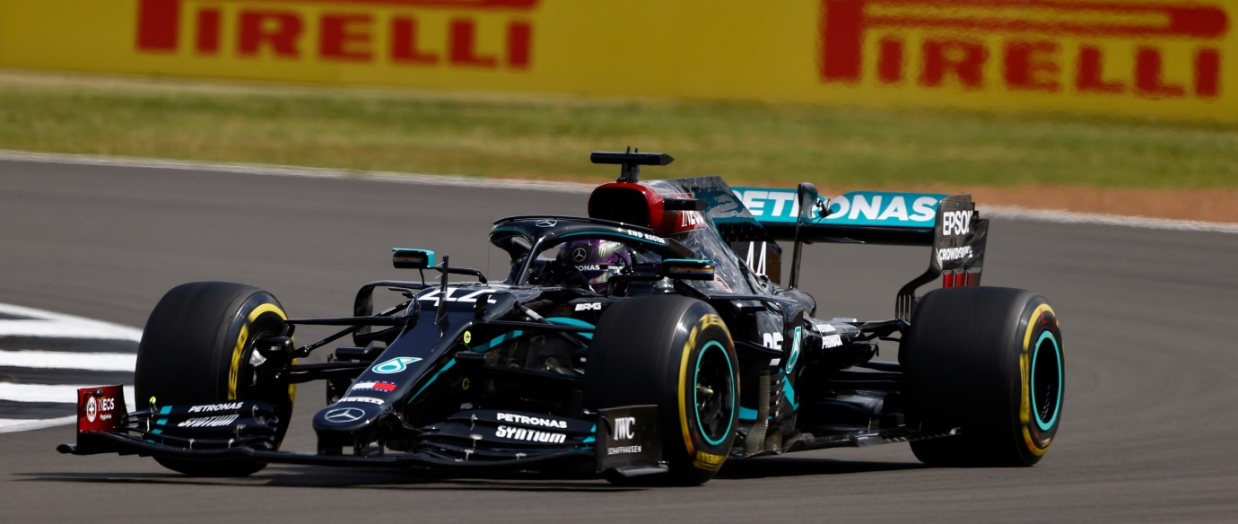
For my Automotive Engineering Technical Report, I will base my report on the 2020 Mercedes-AMG F1 W11 EQ Performance Formula 1 car. So, which is the fastest-ever car in Formula One history and had many innovations never seen in Formula 1 before? This car was driven by seven times world champion Lewis Hamilton and Finn Valtteri Bottas. The W11 is very much an evolution of the previous car, which competed in the 2019 world championship with that car being the Mercedes AMG F1 W10 EQ Power+
Figure 1: Mercedes-AMG F1 W11 EQ Performance at the 2020 British GP (Mercedes-AMG F1, 2020)
I chose this car because, as I have already said, this car had innovations that I have never seen in Formula 1, such as DAS (Dual Axis Steering) and the very innovative designed rear suspension.

Mercedes’ W11 has some of the best aerodynamics ever, balanced to perfection and, at times, looks like the car is glued to the road. An example of this is Lewis Hamilton’s pole position lap at the Belgian Grand Prix during the 2020 season.

Figure 2 Lewis Hamilton’s 2020 Belgian GP pole lap (Formula 1, 2020)
And this car, compared to its competitors, was about to run more downforce by running more giant wings at circuits like Spa Francorchamps and still had the identical low amounts of drag and high straight-line speed as other teams with their low downforce rear wings.

Aims
- To find out how the six topics I have chosen affected the design and the development of the Mercedes-AMG F1 W11 EQ Performance during the competition in 2020.
- To find the most reliable and correct information about the Mercedes-AMG F1 W11 EQ Performance from sources within Mercedes or the world of Formula 1.
- To discuss how successful the Mercedes-AMG F1 W11 EQ Performance was during the 2020 Formula 1 season and how advances in the technology of the year helped shape the design and use of this car in 2020.

Chapter 2 – Impact of the Topics

Topic 1: Crash & Safety Testing
Crash & safety testing is a very rigorous and essential process every year. Teams will have their new cars subjected to the tests set by the Fédération Internationale de l’Automobile (FIA) in the Technical Regulations to homologate and be allowed to compete in the Formula 1 World Championship. These crash and safety tests are constantly changing and improving to make the sport of Formula 1 safer.
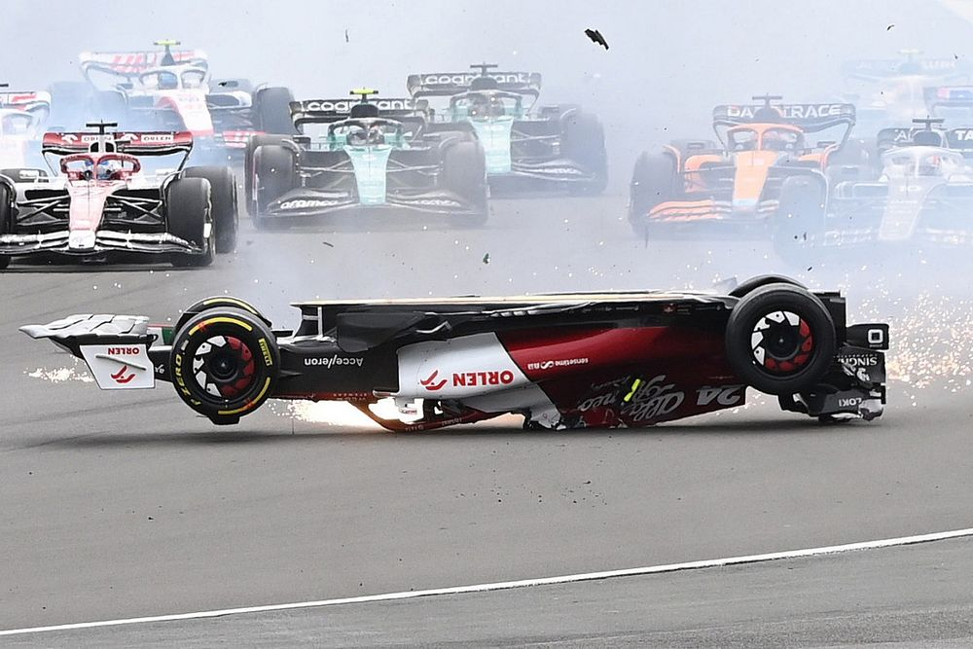
But there will always be missed in these tests, and when crashes happen, flaws are exposed. Notable examples are in 2022 At the British Grand Prix, where driver Zhou Guanyu was flipped upside down and sent into the tyre barriers and catch fencing at a rate of speed. But this crash saw his Roll Over Hoop fail, and if his car did not have the vital halo, this could have been a lot different, which could have seen Zhou’s head drag along the ground and hit the barriers first instead of the halo.

Figure 3 Zhou Guanyu's crash at 2022 British GP (Cobb, 2022)
Following those incidents in 2022, for 2023 saw, the FIA revised tests and designs of the Roll Over Hoop by analysing the crash, parts, and data from the collision to reduce the likelihood of this happening again.
These tests are set by the FIA in categories into three distinct types of testing with those three specific types.

FIA Types of Crash & Safety Testing in formula one
- Impact Testing
  - Frontal Test 1
  - Frontal Test 2
  - Rear Test
  - Steering Column Test
- Roll Structure Testing
  - Principal Roll Structure Test
  - Second Roll Structure Attachments Tests
- Static Load Testing
  - Survival Cell Side Tests
  - Survival Cell Floor test
  - Cockpit Floor Test
  - Cockpit Rim Test
  - Nose Push-Off Test
  - Side Intrusion Test
  - Rear Impact Structure Push-Off Test
  - Side Impact Structure Push-Off Tests
  - Side Impact Structure Squeeze Tests
(Fédération Internationale de l'Automobile, 2020)

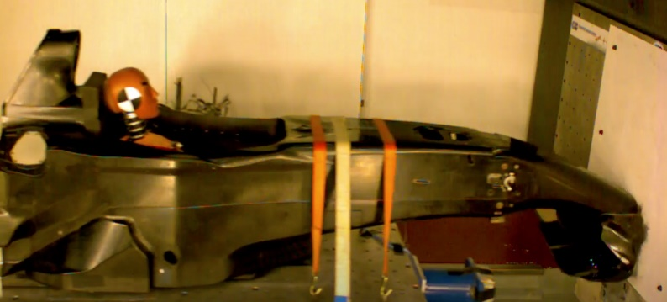

Figure 4 Red Bull Racing testing front impact structure for RB9 chassis for 2013 (Anderson, 2022)
Also, for any Impact and Static Load Testing, all the tests must be carried out according to the FIA Test procedure. They must be conducted in the presence of an FIA Technical Delegate and by using measuring equipment calibrated to the satisfaction of the FIA technical delegate. (Anderson, 2022)
And with any significant modification of a certain will require a further test to pass.
But for static load testing, there are a few more conditions required to complete these tests, as seen below:
  - The tests described in Articles 3.1, 3.2, 3.3 and 3.4 must be conducted on every survival cell intended for use. During these tests (on deflections greater than 3.0mm), the deflection across the inner surfaces must not exceed 120% of the deflection obtained on the survival cell used for the tests described in Articles 2.1 and 2.2.
  - Deflections and deformations will be measured at the centre of the area of circular load pads and the top of rectangular pads.
  - Deflections and deformations will be measured at the centre of the area of circular load pads and the top of rectangular pads.
  - Following the tests described in 3.1, 3.2, 3.3 and 3.4, permanent deformation must be less than 1.0mm (0.5mm in 3.2 and 3.3) after the load has been released for 1 minute.
  - A radius of 3mm is permissible on the edges of all load pads, and rubber 3mm thick may be placed between them and the test structure.
  - For the tests described in 3.1, 3.2, 3.3 and 3.4, the survival cells must always be produced in an identical condition to compare their weights. If the weight differs by more than 5% from the one subjected to the impact tests described in Articles 1.1 and 1.2, further frontal and side-impact tests and roll structure tests must be carried out.
  - All static and dynamic load tests must be performed with the secondary roll structure (whether dummy or otherwise) removed.
(Fédération Internationale de l'Automobile, 2020)

How does crash & safety testing impact the design of the W11?
Crash and & Safety Testing can significantly impact a design of an F1 car because if the design fails only 1 of the many tests set by the FIA. Then, the team must revise the design to try and make that failed part more robust without gaining extra weight on the car and losing potential performance.
But teams must think in two ways of creating the best car they can with the set regulations to try to find more performance through loopholes as well as designing the W11 around the dimensions and requirements set by the FIA in the rules for safety and protection of the vehicle including the driver inside, by having robust structures on the front, rear, sides and above the car. Especially around the monocoque with safety equipment like the ‘Halo.’
One example of where cars have failed the crash test was in 2003 when the McLaren MP4/18 failed its first attempt at the crash test due to damage sustained to the monocoque, but this car never raced due to the many problems with reliability.
An example of poor reliability was when Alex Wurz, during testing at Circuito de Jerez – Ángel Nieto, suffered a crash in the MP4/18 due to delamination of the floor, which caused the crash. (Wilkins, 2003)

How does crash & safety testing impact the development of the W11?
During the 2020 season, Mercedes upgraded the W11 to improve performance. Still, half of the upgrades brought to the car will not have been subjected to crash tests as they would have affected the original homologated structure at the start of the season. But suppose an upgrade to FIA significantly modifies the original homologated part. In that case, the new upgraded parts require a test to allow the car to compete. But because the base W11 was superior to its competitors, there were not many upgrades brought to the W11 in 2020.
One example of a team that would have had to conduct another crash test in 2020 would have been McLaren. Who changed their nose design and shaped mid-way through the season, which would mean a change in structure at the front of the car, which requires another test as it was quite a significant modification to the front nose cone and frontal impact structure.

Topic 2: Materials
In Formula 1 and motorsport in general, weight is one of the areas on which teams focus when designing and manufacturing their cars.
Most parts are manufactured and used on a Formula 1 car made from Carbon Fibre, or Fibre reinforced composites. (Shortland, 2023)
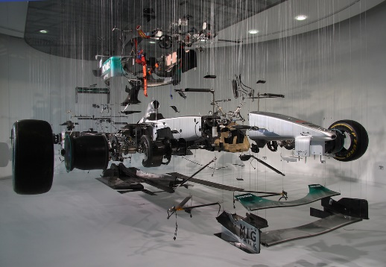
There are around 14,500 individual components designed and manufactured for a single Formula 1 car, and these 14,500 parts comprise various materials. (Motorsport.com, 2022)

Figure 5 Mercedes W01 car in parts on display (Snelson, 2012)
Carbon fibre composites make parts such as the monocoque, suspension, floor, wings etc.
Carbon Fibre, exceptionally light, stiff, and strong, is used on cars like the W11 to keep the vehicle to the minimum weight limit set by the FIA.
But the issue with carbon fibre is that it is only strong in one direction or motion, with this being down to how the carbon fibre is woven together and how much it will use can determine how strong it will be in an accident. As well as this, carbon fibre is one of the most expensive materials that will be used in a Formula 1 car.
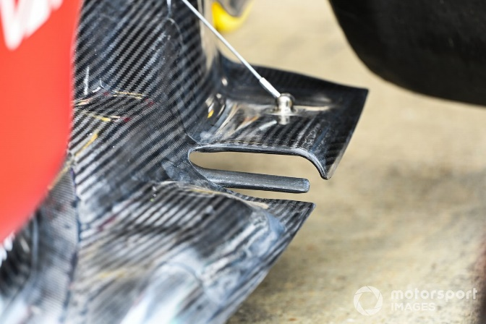
In 2020 Mercedes were not capped on how much they used on developing the W11, but for 2021 onwards, they were with the cost cap.

Figure 6 Ferrari F1-75 floor detail (Noble, 2022)
But in terms of the used materials to build a formula one car is:
- Carbon Fibre
- Zylon
- Magnesium
- Feedstocks
- Rayon
- Pitch
- Polyacrylonitrile
- Acrylics
- Aramids
- highly oriented polyethene filaments (Dyneema & Spectra)
- thermoplastic toughened epoxies
- aluminium
- nickel
- cobalt
- iron
- titanium
- tungsten
- ceramics
- beryllium
- Ruthenium
- Iridium
- Rhenium
- Copper
- Gold
- Silicon
- Thermoplastics
- Thermosets
- Polypropylene fibres
- Nomax
- Kevlar
- Sandwich panel cores: Aluminium, Nomex, polymer foams, syntactic foams, balsa wood, carbon foam.
- The matrix system utilised in all pre-impregnated materials must be epoxy, cyanate ester, phenolic, bismaleimide, polyurethane, polyester or polyimide based.
- Rubber


(Fédération Internationale de l'Automobile, 2020)

Figure 7 Kevlar (Easy Composites, 2023) Figure 8 Cobalt (Britannica, 2023)

How did the materials affect the design of the W11?
The materials used on the W11, as stated in the list above, were for all parts of the car, including the engine and the gearbox. And with a Formula 1 car being a high-performance vehicle, a lot of these materials that are created into parts and components are built to the highest standard but do not last as long as the elements you would see on your road car due to tolerances and the highest amount of dedicated care required for these parts.
After every race weekend, all the parts used are serviced by the team to check & assess how they are and if they require any repairs or need to be replaced. E.g., Suspension Components
Cost is another factor in how materials can affect the design of the W11 because lots of these parts are in short supply meaning their prices inflate. Also, how much of a particular material you can get can affect the design of Formula 1, especially the W11.
Can the materials work in all wet, dry, hot, and cold conditions? Because F1 travels around the world and competes in various amounts of different climates.
Examples: Singapore (hot & humid), Britain (Variety of conditions)

How did the materials affect the development of the W11?
Materials could have affected the development of the W11 because if materials were scarce could cause a delay or a complete change in design to suit varied materials. And especially during 2020 with covid would have very much done to some extent. And this would be in terms of the upgrades the team brought to the car during the 2020 season, but for the base car, it would have been in the works as soon as the regulations for the 2020 season, which was on 30 April 2019.

Topic 3: Engine and Hybrid Technologies
The W11 was a Mercedes works car with a Mercedes-AMG M11 EQ Performance, a 1.6L 90 V6 Turbo Hybrid produced around 764 kW (1,025 hp) at 15,000 rpm (Kiz, 2021).
And this Mercedes engine/power unit is split into six primary areas. With those areas being
- Internal Combustion Engine (ICE)
- Turbocharger (TC)
- Energy Store (ES)
- Control Electronics (CE)
- Motor Generator Unit Kinetic (MGU-K)
- Motor Generator Unit Heat (MGU-H)
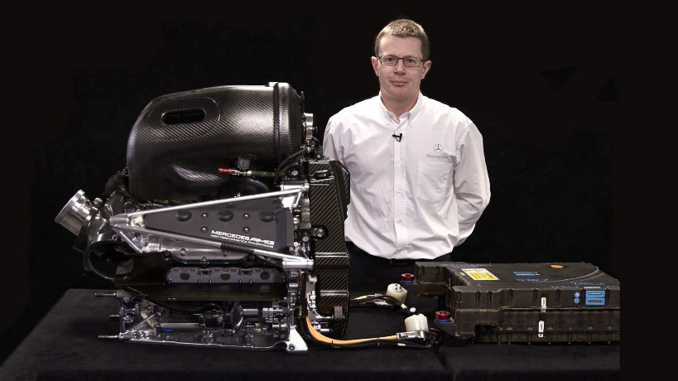

Figure 9 Mercedes-AMG M09 EQ Power+ (Saward, 2018)
And if you would include the gearbox, the W11 had a:
- 8 Speed Semi-Automatic seamless-shift sequential gearbox with one reserve gear.

How did the Engine/Power Unit impact the design of the W11?
The Power Unit in the W11 has quite an impact on the design of the W11 because the designers of the car must design the car around the power unit and gearbox as well as the monocoque because the engine and gearbox do not fit the chassis and mount to the monocoque, well you are in trouble.
Also, the Aerodynamicists must try and mould the car’s bodywork around the power unit to the tightest way possible to help the aero efficiency of the vehicle. And in terms of the W11, it was the most aero-efficient car on the 2020 grid.
Cooling is another significant factor for the power unit because as the aerodynamicists want to pack the bodywork tightly, you must consider the cooling. After all, if the engine overheats, it will lose power, but if it gets worse, it can lead to a power unit failure, as Carlos Sainz discovered in 2022 at the Austrian Grand Prix. So, teams might run wider bodywork to help the cooling issues that may occur at Grand Prix, where conditions are hot. Notable examples are at the Mexican Grand Prix at the Autódromo Hermanos Rodríguez in Mexico City, located at a high altitude of 7,200 feet above sea level. And this lack of air density causes the engines to work harder due to the lack of oxygen. This can also be seen at the Red Bull Ring in Austria.

How did the Engine/Power Unit affect the development of the W11?
Throughout 2020 Mercedes brought upgrades to their power unit when they changed their power units at the scheduled Grand Prix during the season to help improve both power, electrical deployment from the MGU-K, ES, and reliability of all the components within the power unit. And these became more important from the Italian Grand Prix in 2020 because the FIA brought in new regulations, stating that once the cars left the pits in Q1 in qualifying, whatever engine mode they were in, they must stay in that engine mode for all both qualifying and the race. But teams could go into lower power modes from the set mode from the start of qualifying but no higher.

Topic 4: Manufacturing
The manufacturing process of building the W11 would have started at the end of 2019. They began with small parts and progressed to more extensive features during the winter of 2019 and into early 2020. Most parts of the W11 were made in-house, with others made with third-party manufacturer companies like Xtrac, who collaborated with Mercedes on the gearbox for the W11.
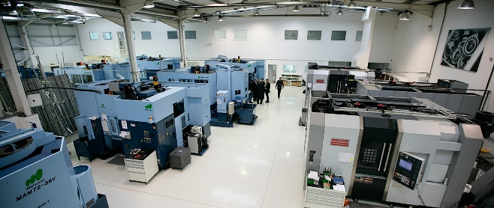

Figure 10 Mercedes-AMG’s machine shop at their factory in Brackley (Mercedes-AMG Petronas Formula 1 Team, 2020)

How did the manufacturing impact the design of the W11?
As I have mentioned above, the manufacturing of the W11 starts in late 2019. But usually, manufacturing stops during the summer due to the summer break. But in 2020, Covid caused havoc worldwide, including in motorsport, which ceased manufacturing in March 2020. This shutdown was brought forward to 21 days in March and April. And after this period, manufacturing was still dramatically reduced due to rules and restrictions, especially social distancing. This would have reduced the manufacturing times of parts due to fewer people allowed in the workshops. And This would also lead to the team bringing more periodic minor upgrades and instead bringing 1 or 2 significant upgrades during the 17-race season in 2020.

How did manufacturing affect the development of the W11?
As I mentioned, Covid 19 caused a massive problem developing the W11. But because the W11 was such a superior car, the reduced amount of manufacturing on parts for upgrades was not as affected as the lower teams like Williams and Haas. And because Mercedes was so far ahead in 2020, by the halfway point of the season, they had already moved their focus on development and manufacturing on to the 2021 season and their car, the W12, as there were a few regulation changes brought in for that season as the massive regulations that were supposed to arrive in 2021 got pushed back to 2022 due to Covid 19.
Also, Covid 19 would have caused problems & issues with importing and delivering materials needed for the manufacturing of the W11. Examples of materials are titanium, gold, cobalt etc.
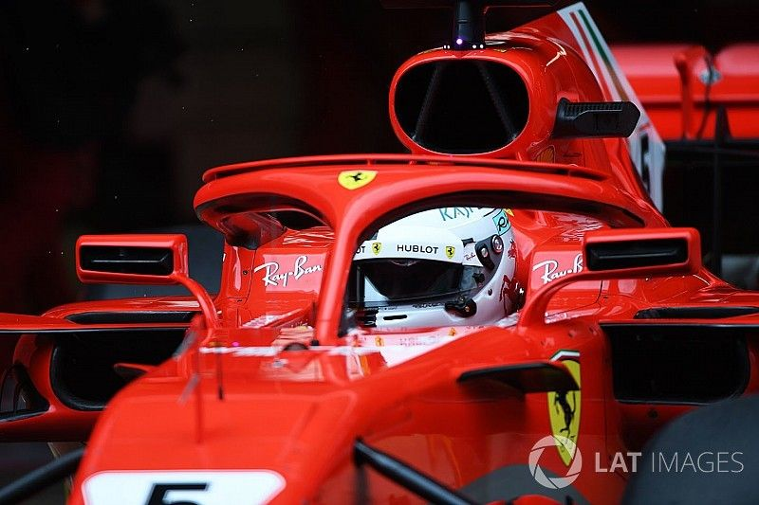

Figure 11 The Halo on the Ferrari SF71H, which is made from titanium. (Somerfield & Piola, 2018)

Also, teams can make their car’s components out of the lightest and strongest possible with teams using materials like titanium for structural parts. But if teams’ cars are under the weight limit must have ballast added to the vehicle at any point of the car to reach the minimum weight.

Topic 5: Interoperation of rules and problems
In Formula 1, the rule makers, the Fédération Internationale de l’Automobile (FIA), set regulations that teams must follow. There are three types of rules in formula one set by the FIA, with those regulations being Technical, sporting, and financial.
Technical regulations are the regulations that teams must follow when designing and manufacturing their cars. And teams try loopholes to find extra performance in these set regulations. And this can be done by reworking their exploits in separate ways in the design or looking in extreme depth at how the regulations are written to justify what teams have done and can do with their design. This includes Mercedes with the Dual Axis Steering (DAS) on the W11 in 2020.
In terms of sporting regulations, there are many regulations that teams are required to follow during any official sessions across a Grand Prix weekend & testing.
And for the financial regulations were not introduced into formula one until 2021, so it was not enforced when the W11 was competing in 2020.

How did the rules and problems impact the design of the W11?
The rules would have had a massive impact on the design of the W11. For example, one rule that would have affected the creation of the W11 was that the FIA set restrictions on the metals on the front wing.
The FIA stated that the first 50mm of the front wing endplates had to be made from only carbon fibre in 2020 to help reduce the result of punctures when the endplates of one of the cars contact the rear wheel of another car. And metal components like fasteners used to attach the front wing to the nose cone must be at least 30mm away from the leading edge of the front wing endplates. (Formula 1 , 2020).
For the 2020 season, Mercedes also brought in a radical design of DAS, as mentioned above, which mechanically changed the toe of the front wheels of the W11 by pulling the steering wheel back through the steering column, and this would help the driver generate heat in their front tyre without having to weave putting more stress on the tyre and wearing them out more also.
Teams are also restricted in many ways through weight limits, how many power units they can use etc.
And the reason why the FIA also set weight limits is to stop teams from making very flimsy and low-mass cars using costly exotic materials for the whole car, like gold, titanium, and carbon for significant and fundamental parts of the vehicle like the chassis and the engine. Because a lighter and low-mass car will accelerate better out of the corners down the fact of newtons second law of F = ma (James, 2023)

How did the rules and problems affect the development of the W11?
Well, the 2020 season brought in new regulations which stopped teams changed engine modes in terms of internal combustion power during qualifying and races, now means teams as soon as their drivers leave the pit lane for Q1, they have then locked in their highest power mode they can use for both qualifying and the race. And this was done because Mercedes and their W11 car were so fast compared to the rest. For example, at the 2020 British Grand Prix, Lewis Hamilton was in pole position by over a second to the next non-Mercedes car, Max Verstappen, in his Red Bull RB16. (Formula 1 and FIA, 2020). These rules did not work in 2020 because Mercedes could run higher engine modes than their non-Mercedes powered cars rivals, keeping their dominance of the 2020 season right to the end, winning thirteen of the seventeen races during that season.



Figure 12 FIA Technical Delegate Jo Bauer (Paddock Magazine, 2015)
And the way this affects the development of W11 because Mercedes would have to work harder developing their engines so they can run the car in higher engine modes without having any concerns with reliability while outputting optimal performance from the vehicle and the power unit. And this would have put strain and more stress on Mercedes AMG High-Performance Powertrains to produce these high-level demands required to keep their advantage over the other Power unit manufacturers all season and into the future as the teams are capped on how many power unit components they can use in a season before incurring a penalty. So, these engine mode rules are essential to a car’s overall performance. So, power unit development is one of the key areas to succeed in formula one with these rules.

Topic 6: Holistic Forethought of Failure

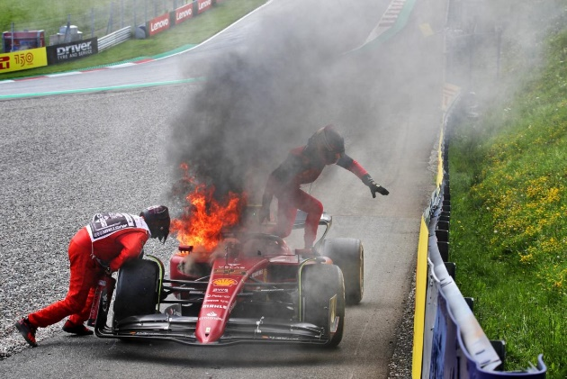
During the design process of Formula 1 cars, the W11 team will incorporate the placement of sensors around the vehicle, which all feed back into the car’s ECU, a standard listed part set and manufactured by an FIA Approved supplier. And the ECU is coded by the team to connect the sensors around the car and make them compatible with the ECU. And these sensors around the vehicle can detect the initial stages of problems and issues occurring within the car. The most common times you will see these failure modes occur is to do with the engine. An example of this was during preseason testing for the 2020 season, where on day five of the test, the W11 shut its power unit down due to an issue with the oil pressure. (Formula 1, 2020)

Figure 13 Carlos Sainz’s Ferrari F1-75 on fire after engine failure (Larkam, 2022) Figure 14 McLaren Applied Technologies ECU (Veart, 2014)

How did the forethought of failure affect the design of the W11?
Reliability and the thought of the failure of parts is a crucial part of designing an F1 car making sure parts can live with the stress and force being put through the laterally and vertically through corners. And when these failures occur, they are mostly seen from the internals like the gearbox and power unit. Quite common issues seen on F1 cars is loss of hydraulic pressure or fluid in the system, and the sensors will alert the driver and the engineers in the pits. And tell the drivers not to shift on the gearbox or do anything drastic because the gearbox, power steering, DRS, differential, throttle, brake by wire, and parts in the engine like the inlet valves and turbo wastegate are all controlled by hydraulics. And any done drastically with these components can lead to severe damage. (Scarborough, 2019)

How did the forethought of failure affect the development of the W11?
In 2020 Mercedes pushed the bounds with innovation on the W11, with them having a different configuration and layout of rear suspension compared to the other nine teams. It was innovative because they moved the lower wishbone of the suspension back as far as they could and connected it to the car’s rear crash structure. And this was done to help enhance the airflow at the rear of the vehicle to essentially seal the floor around the rear wheels and get more performance from the diffuser to create more rear downforce and more downforce is generated because be essentially ‘sealing’ the floor creates more low air pressure at the rear of the car around the diffuser and helps reduce the amount of wake coming from the rear tyres over the body of the vehicle. (Hughes & Piola , 2020)
But this design had its risk, as Mercedes found out at the Austrian Grand Prix in 2020 that the line around the Red Bull Ring requires the car to use many exit curbs around the circuit. And this caused an issue with the sensors in the gearbox, which is attached to the rear suspension and these high spikes in suspension loads of the curbs created concerns for Mercedes, which they managed to fix for the next Grand Prix at the Red Bull Ring. By rearranging the wiring loom of the sensor better at the rear of the car. (Hughes & Piola , 2020)

How successful was the Mercedes W11?
So, during its only season of competition in Formula 1, the Mercedes W11 managed to win 13 out of the 17 races during that season and 5 of them also being 1-2 finishes. And regarding qualifying and fastest laps, the W11 took 15 pole positions between both drivers, Lewis Hamilton and Valtteri Bottas. And for the fastest laps during the season, the Mercedes W11 took 8 Fastest laps. And to top all this success off. Mercedes and their W11 won both the Drivers World Championships, with Lewis Hamilton with teammate Bottas finishing second. And this also means that Mercedes also won the Constructors Championship, and this was the seven time in a row that Mercedes won the championship, and for Hamilton, this was his 4th Drivers title in a row and his 7th overall. Hamilton and Mercedes dominated both championships, with Hamilton winning the championship by a margin of 124 points over his teammate Bottas and Hamilton winning the title three races early. And Mercedes won the championship by a margin of 254 points and won this championship four races early.

Technological advances after the Mercedes W11 competed?
In terms of technological advances after the 2020 season, they have been minimal to nothing because whenever teams bring in new advancements, the FIA tend to clamp down on it straight away or for the next season. So, it’s rare to see advances naked to the eye while the car is out on the circuit.

Chapter 3 - Current State of the Automotive Industry?

What have been the largest areas of contention in the automotive industry over the past 30 years?
The conventional internal combustion engine is one of the most extensive areas of contention. How much co2 emission both petroleum and diesel engines produce, and governments like the UK government are trying to phase out the purchase of new petrol and diesel vehicles by 2030. But manufacturers and other groups don’t think it can be sorted that quickly. And in some ways, the automotive industry is transitioning from conventional fossil fuel to more synthetic fuels like biodiesel, bio-petrol, etc., introducing hybrid engines, fully electric vehicles, etc.
Another area of contention for the automotive industry is money and finance. And a time when finance affected the automotive industry was in 2008 with the global financial crisis, which saw all areas of everyday life struggle. But the automotive industry was hit hard. An example of this is in the world of Formula 1, car manufacturers Honda left at the end of 2008, and Toyota left at the end of 2009 because of the global financial crisis, with the Japanese car manufacturer having its first-ever operating loss in March 2009 (Beer, 2009).
And third challenge that the automotive industry is going through now is the aftereffects of Covid 19 and the current effects of the war in Ukraine, causing issues in finance and supply and shipment worldwide. These effects are causing problems for manufacturers because of the complete standstill that happened back in 2020 in terms of the production of new vehicles from manufacturers due to Covid 19 (Iyer, 2022), and this can lead to a reduction in the purchase of cars as well because people couldn’t go and see new vehicles they might want to purchase but couldn’t due to restrictions.
And because manufacturers weren’t making as much money and profit as pre covid, many manufacturers laid off a lot of their staff due to being unable to afford as large a workforce as previously. (Iyer, 2022)

What is the future of the automotive industry?
For the future of the automotive industry, the hurdles that will need to be overcome first will be the ongoing supply chain shortages worldwide in the automotive industry. And these shortages are a handful of factors for various reasons. (Hitchcock, 2023) Some of those factors are:
- Increase demand for vehicles.
- Supply chain bottlenecks
- Disruptions in global trade
- Covid 19
Other hurdles to overcome for the automotive industry are finance and the economy. Especially in the UK, the automotive industry is a significant part of the economy. Still, Brexit and Covid 19 are forcing car manufacturers to move their production lines to mainland Europe from the UK due to these two issues, which is a massive hit for the UK Economy. It will continue to happen in the future due to cost. An example is Ford’s engine plant in Bridgend, which closed in 2020. Production moved as they could manufacture the batteries in Bridgend for the hybrid vehicles due to the primary production plants where the cars are assembled too far away in mainland Europe to transport. (ITV Wales, 2020)
3 area of the Automotive Industry that will see a change in the future is the cost of used cars because, between 2021 and 2022, the prices of used vehicles jumped up massively due to the issues in the production of new cars. (Hitchcock, 2023). But since April 2022, the prices on average for a used vehicle are coming back down again. But it could take a few years to see a considerable decrease in the average price for used cars, especially petrol vehicles. (Hitchcock, 2023).

Chapter 4 – Conclusion
To conclude, this technical report on the Mercedes-AMG F1 W11 EQ Performance regards where this car fits into the automotive industry. Well, I feel it provides the high-performance and industry-leading vehicle with its innovations and features that the car has which can make their way across into the production of road vehicles, with examples of this being the hybrid technologies and systems which are currently seen and how they can improve the hybrid systems in production vehicles and make them more sustainable and reliable. And along with the sustainability of the hybrid technology, you also have the development and research of more sustainable fuels from engine manufacturers competing in Formula 1. And these fuels developed can make their way over to production vehicles over time.
With the same can be said about crash testing. Even though it isn’t compulsory for production vehicles to have a crash test, formula one testing has been more rigorous, which could make its way across to production vehicle testing with companies and organisations like Euro NCAP.
With the Mercedes W11 being a high-performance vehicle, the materials and manufacturing are expensive, with most of the parts used created by exotic components like carbon fibre and titanium, etc. the only times you will see materials and very high-detail manufacturing is for limited edition vehicles with examples of this being the Mercedes-AMG One. With there only 275 of these cars put into production (Padeanu, 2023), a specific list of people accepted to be allowed one of the 275 cars built.
The Mercedes W11 has various features and sensors that protect the car 99% of the time from failures and issues by putting the car into a ‘limp home mode’ or will shut itself down to protect itself. And these types of features are now on production vehicles, especially with hybrid cars, with how dangerous a battery can get when it has issues and can potentially become live. Or an Internal combustion engine failure and could catch fire.
And the final topic is rules, with Formula 1 having many regulations they must follow when designing, building and running their cars. Which somewhat makes its way down to production vehicles regarding emissions, safety, security and fuel efficiency. But certain parts of the world have different rules and regulations and what must be used in the car’s design. These components are coded by countries or unique economic and political unions like the EU.
With all these topics show that Formula 1 with the Mercedes W11 fits into the automotive industry as a leader with the innovations, systems and features that have been brought from cars like the W11 into the primary production side of the automotive industry, making consumers and their vehicles safer, more efficient and reliable. As well as, bringing some of the high-performance components seen from cars like the W11 helps production cars have a better performance, like a semi-automatic gearbox, even though the earliest versions were invented and developed by Amédée-Ernest Bollée (Hergault, 2011). Furthermore, most semi-automatic gearboxes from manufacturers are now all robotic, making it easier for mechanical components to last longer than previous system interactions.

References
Anderson, G., 2022. What happens in an F1 crash test? Gary Anderson’s guide. [Online]
Available at: https://the-race.com/formula-1/what-happens-in-an-f1-crash-test-gary-andersons-guide/
Atlas F1, 2003. McLaren Reveal MP4-18 Failed Crash Test. [Online]
Available at: https://www.autosport.com/f1/news/mclaren-reveal-mp4-18-failed-crash-test-5063404/5063404/
[Accessed April 2023].
Beer, M., 2009. Toyota pulls out of Formula 1. [Online]
Available at: https://www.autosport.com/f1/news/toyota-pulls-out-of-formula-1-4433866/4433866/
Britannica, 2023. Cobalt. [Online]
Available at: https://www.britannica.com/science/cobalt-chemical-element
[Accessed April 2023].
Clifford, J., 2015. History of the Toyota Prius. [Online]
Available at: https://mag.toyota.co.uk/history-toyota-prius/
Easy Composites, 2023. 188g Plain Weave 3k Carbon Kevlar Cloth (1000mm). [Online]
Available at: https://www.easycomposites.co.uk/188g-plain-weave-carbon-kevlar
[Accessed April 2023].
Fédération Internationale de l'Automobile, 2020. FIA Formula 1 Regulations. [Online]
Available at: https://www.fia.com/regulation/category/110
[Accessed April 2023].
Formula 1, 2020. F1 RULES & REGULATIONS: What’s new for 2020? [Online]
Available at: https://www.formula1.com/en/latest/article.f1-rules-and-regulations-whats-new-for-2020.6bjmeHbyNBKVA70f4ntN64.html#:~:text=The%202020%20Technical%20Regulations%20limit,%E2%80%9D%2C%20according%20to%20the%20regs.
Formula 1 and FIA, 2020. FORMULA 1 PIRELLI BRITISH GRAND PRIX 2020 - QUALIFYING. [Online]
Available at: https://www.formula1.com/en/results.html/2020/races/1048/great-britain/qualifying.html
Formula 1, 2020. 2020 Preseason Testing: Day 5 Highlights, s.l.: s.n.
Formula 1, 2020. Lewis Hamilton’s Pole Lap | 2020 Belgian Grand Prix | Pirelli. [Online]
Available at: https://youtu.be/4JiYOvCHwFY
[Accessed April 2023].
Hergault, J., 2011. THE HISTORY OF THE ‘PADDLE SHIFT’. [Online]
Available at: https://www.24h-lemans.com/en/news/the-history-of-the-paddle-shift-2922
Hitchcock, S., 2023. 2023 & Beyond: The Future of the Automotive Industry. [Online]
Available at: https://wda-automotive.com/the-future-of-the-automotive-industry/
Hughes, M. & Piola, G., 2020. TECH TUESDAY: Why DAS is only the second most impressive innovation on the Mercedes W11. [Online]
Available at: https://www.formula1.com/en/latest/article.tech-tuesday-why-das-is-only-the-second-most-impressive-innovation-on-the.2EfeudguxvleJcSV7GJ2TZ.html
ITV Wales, 2020. Workers leave Bridgend Ford factory for the final time as production stops for good after 40 years. [Online]
Available at: https://www.itv.com/news/wales/2020-09-25/ford-will-shut-its-bridgend-factory-after-40-years-on-friday
Iyer, S., 2022. Top 6 Challenges Faced by the Automotive Industry: The Post-COVID-19 Era. [Online]
Available at: https://www.gminsights.com/blogs/top-challenges-in-the-automotive-industry-pre-COVID
James, R., 2023. Engineering Interpretation Powerpoint for Automotive Engineering Lecture, s.l.: s.n.
Kiz, K., 2021. MERCEDES NEW ENGINE IN 2021 WITH MORE 25 HORSEPOWER – “PARTY MODE WHOLE RACE”! [Online]
Available at: https://f1lead.com/2021/01/05/mercedes-new-engine-in-2021-with-more-25-horsepower-party-mode-whole-race/
[Accessed April 2023].
Larkam, L., 2022. Carlos Sainz heartbroken by “very sudden” engine blow-up at F1 Austrian Grand Prix - “a lot of fire!”. [Online]
Available at: https://www.crash.net/f1/news/1007845/1/lot-fire-sainz-had-no-warning-very-sudden-engine-blow
[Accessed April 2023].
Mercedes-AMG F1, 2020. Lewis Wins British Grand Prix. [Online]
Available at: https://www.mercedesamgf1.com/news/lewis-wins-british-grand-prix
Mercedes-AMG Petronas Formula 1 Team, 2020. UK-Based F1 Teams Unite Around’ Project Pitlane’ to Assist with Ventilator Production. [Online]
Available at: https://www.mercedesamgf1.com/news/uk-based-f1-teams-unite-around-project-pitlane-to-assist-with-ventilator-production
[Accessed April 2023].
Mercedes-Benz Group Media, 2020. Formula One - Mercedes-AMG Petronas Motorsport, Italian GP 2020. Valtteri Bottas. [Online]
Available at: https://group-media.mercedes-benz.com/marsMediaSite/en/instance/picture.xhtml?oid=47344214&filename=&ls=L2VuL2luc3RhbmNlL2tvLzIwMjAtSXRhbGlhbi1HcmFuZC1Qcml4LS0tRnJpZGF5LnhodG1sP29pZD00NzE4NzgwMCZyZWxJZD0xMDAxJmZyb21PaWQ9NDcxODc4MDAmcmVzdWx0SW5mb1R5cGVJZD0
Motorsport.com, 2022. Insider’s guide: How is an F1 car made?. [Online]
Available at: https://www.motorsport.com/f1/news/how-is-an-f1-car-made/7626323/
Noble, J., 2022. How carbon fibre technology is shaping F1’s new era. [Online]
Available at: https://www.autosport.com/f1/news/how-carbon-fibre-technology-is-shaping-f1s-new-era/10386270/
[Accessed April 2023].
Paddock Magazine, 2015. 66. Jo Bauer. [Online]
Available at: https://www.thepaddockmagazine.com/66-jo-bauer/
[Accessed April 2023].
Padeanu, A., 2023. Mercedes-AMG One Deliveries Start: See The Very First Car. [Online]
Available at: https://www.motor1.com/news/631246/mercedes-amg-deliveries-start/
Saward, J., 2018. Mercedes F1 engine is a true modern marvel. [Online]
Available at: https://www.autoweek.com/racing/formula-1/a1697406/mercedes-f1-engine-true-modern-marvel/
[Accessed April 2023].
Scarborough, C., 2019. The fundamentals of Formula 1 hydraulics systems explained. [Online]
Available at: https://motorsport.tech/formula-1/formula-1-hydraulics-explained
Shortland, R., 2023. Speed, Strength, and Safety: The Importance of Plastics in Formula One. [Online]
Available at: https://www.bpf.co.uk/article/plastics-in-formula-one-3292.aspx#:~:text=What%20Are%20Formula%20One%20Cars,fibre%2Dreinforced%2Dcomposites).
Snelson, B., 2012. Mercedes AMG Petronas F1 car parts. [Online]
Available at: https://www.flickr.com/photos/exfordy/7036863417
[Accessed April 2023].
Somerfield, M. & Piola, G., 2018. How the halo has opened up new aero possibilities. [Online]
Available at: https://us.motorsport.com/f1/news/how-the-halo-has-opened-up-new-aero-possibilities-1011542/1394666/
[Accessed April 2023].
Spaulding, T., 2023. Did You Know That Not All Cars Are Independently Crash Tested? [Online]
Available at: https://www.spauldinginjurylaw.com/blog/did-you-know-that-not-all-cars-are-independently-crash-tested#:~:text=About%2097%20percent%20of%20all,All%20Land%20Rover%20vehicles
Thomas, G., 2013. Materials Used In Formula One (F1) Cars. [Online]
Available at: https://www.azom.com/article.aspx?ArticleID=8194
Veart, T., 2014. F1 Engine Control Unit (ECU) | In-Detail. [Online]
Available at: https://formula1technical.weebly.com/articles/f1-engine-control-unit-ecu-in-detail
[Accessed April 2023].
Wilkins, R., 2003. MP4-18 crash setback for McLaren. [Online]
Available at: https://www.crash.net/f1/news/46139/1/mp4-18-crash-set-back-for-mclaren
[Accessed April 2023].

Figure 1: Mercedes-AMG F1 W11 EQ Performance at the 2020 British GP (Mercedes-AMG F1, 2020) 3
Figure 2 Lewis Hamilton’s 2020 Belgian GP pole lap (Formula 1, 2020) 3
Figure 3 Red Bull Racing testing front impact structure for RB9 chassis for 2013 (Anderson, 2022) 5
Figure 4 Mercedes W01 car in parts on display (Snelson, 2012) 7
Figure 5 Ferrari F1-75 floor detail (Noble, 2022) 8
Figure 6 Kevlar (Easy Composites, 2023) Figure 7 Cobalt (Britannica, 2023) 9
Figure 8 Mercedes-AMG M09 EQ Power+ (Saward, 2018) 10
Figure 9 Mercedes-AMG’s machine shop at their factory in Brackley (Mercedes-AMG Petronas Formula 1 Team, 2020) 12
Figure 10 The Halo on the Ferrari SF71H, which is made from titanium. (Somerfield & Piola, 2018) 12
Figure 11 FIA Technical Delegate Jo Bauer (Paddock Magazine, 2015) 14
Figure 12 Carlos Sainz’s Ferrari F1-75 on fire after engine failure (Larkam, 2022) Figure 13 McLaren Applied Technologies ECU (Veart, 2014) 15

