

Are the public supportive of police pursuits? An investigation into public perception on police pursuits and an identification whether opinions have changed over time.

Harvey Sparrow
BA Professional Police Practice
January 2024

Acknowledgements
I would like to thank my extraordinary network of friends, colleagues and importantly the staff at UWTSD and my dissertation supervisor for their support and allowing me to have the opportunity to complete this dissertation and degree.

Most importantly, I would like to thank my mother Andrea and my girlfriend Megan for supporting me and pushing me to complete this dissertation when it became difficult and overwhelming at times. I would not have been able to complete this without their support.

Declaration
This work has not previously been accepted in substance for any degree and is not being concurrently submitted in candidature for any degree.
Signed: H. Sparrow

Date: 05/01/24

STATEMENT 1

This dissertation is being submitted in partial fulfilment of the requirements for the degree of BA.
Signed: H. Sparrow

Date: 05/01/24

STATEMENT 2

This dissertation is the result of my own independent work/investigation, except where otherwise stated.
Other sources are acknowledged by footnotes giving explicit references. A bibliography is appended.
Signed: H. Sparrow

Date: 05/01/24

STATEMENT 3

I hereby give consent for my dissertation, if accepted, to be available for photocopying and for interlibrary loan, and for the title and summary to be made available to outside organisations.
Signed: H. Sparrow

Date: 05/01/24

STATEMENT 4

I hereby give consent for my dissertation, if accepted, to be available on the university’s IT system to those who have consent to use the system.
Signed: H. Sparrow

Date: 05/01/24

Abstract

The purpose of this dissertation was to identify the current public support and perception of police pursuits and compare this to antecedent papers and research on the topic to identify if there has been a quantifiable change in public support toward police pursuits.

In order to achieve this, the researcher undertook a critical literature review around current existing academic literature specifically on the topic of police pursuits and public support of policing in general, from the United Kingdom and from an international standpoint of the United States. This literature review was compared with research undertaken as part of this dissertation, as online surveys were undertaken as part of the research collated from this investigation.

The findings from this research have been presented and compared in the later chapters of this dissertation, with themes utilised to present findings from the qualitative results.

From the work set out in this dissertation, the aims and objectives have been achieved and an answer to the question presented in the title of the dissertation has been answered, linking with all the research and comparison completed within this paper.

Table of Contents
Introduction 6
Background 6
Research Rationale 6
Aims and objectives ……………………………………………………………………………………………………………. 7
Conclusion ……………………………………………………………………………………………………………………… 7
Literature Review 8
Introduction ………………………………………………………………………………………………………………………………… 8
Public Perception 9
Conclusion 11
Methodology 13
Introduction 13
Strategies 13
Conclusion …………..……………………………………………………………………………………………………………. 15
Results 16
Introduction 16
Results presentation 16
Analysis and Conclusion …………………………………………………………………………………………………….21
Findings and Conclusion 23
Introduction 23
Comparison and Analysis 23
Conclusion …………..……………………………………………………………………………………………………………. 25
Bibliography 27
Appendix 30

Chapter 1 - Introduction
This proposal has been chosen as it is a topic which is of high national scrutiny by the public and the media, as there have been numerous pursuits within the last few years which have unfortunately ended in fatalities, that have had a profound impact around the country, leading to discussion around the proportionality of police pursuits. This discussion has undoubtedly entered the public discourse due to a much higher level of police scrutiny and accountability that is prevalent in the media today, as all police incidents that lead to a fatality or serious injury are usually subject to massive investigations from outside bodies, with a large amount of public discussion around them.
1.1 Background
The topic of police pursuits and the publics opinion on them is a large enough topic for that to be the sole discussion around this dissertation and is especially relevant in a world where public scrutiny on policing is at an all-time high, with more and more publicity in the media around poor policing decisions and risks being taken by officers that the public may deem no longer necessary (Lamont, 2019). From this increase in public scrutiny, the hypothesis is that public perception and support of police pursuits in the modern day has decreased from what it was around 20 years ago.
1.2 Research Rationale
There are multiple reasons to support the rationale for researching this topic. Chiefly, the main justification is in fact the lack of contemporary research and academic sources around the topic. One of the most utilised pieces of literature within this dissertation will be Macdonald and Alpert (1998), but this source is over 25 years old. This allows the researcher to establish modern, up to date research around the topic question and establish new source material to identify public perception and ascertain if there has in fact been a change over the years in public support.

Furthermore, the researcher has identified that while there are journalistic and academic sources around police pursuits, the grey area extends to that of the reasons behind why the public may or may not support them, as most of these sources to not delve into the reasons that the public hold the views they do. As such, the research set out within this paper will have the aim of establishing the publics opinion on their support of police pursuits, but specifically the reasons why they may hold these views.
1.3 Aims and Objectives
The aim of this dissertation is directly linked to the question set out. It is to identify the current level of support the public has toward police pursuits and clarify the reasons behind why they hold that view. The final aim will be to compare the results of the research to antecedent literature. To achieve these aims, the following objectives have been set out:
- Assess antecedent research surrounding public perception and support on police pursuits and identify the level of support the public holds relating to pursuits in these sources.
- Establish the level of support or lack thereof the public has for police pursuits by use of research methods, such as surveys, and clarify the reasons these views are held by use of qualitative questions.
- Contrast and compare results from the research results from this paper to that of the antecedent and historical literature that has been reviewed from this paper and identify there has been a significant change and identify possible causes.
Conclusion
From this introduction, the paper has established the aims and objectives that have been set out to be achieved within the later chapters of the paper. It has also established the reasons why the topic has been chosen and set out a justification for the research that will be undertaken, and how that research may benefit the literature currently available to the researcher and the public at the time of publication.

Chapter 2 – Literature Review
2.1 Introduction
Within this chapter we will analyse available academic literature, journals, articles, new sources and reviews around the central question posed in this dissertation. It is important to critically analyse as much relevant research and sources as possible so that we can ascertain the level of research available around the chosen topic, and hyper-focus the objectives and research methodology within this dissertation around areas that are lacking in research, or perhaps areas that have not been previously covered whatsoever. If these are identified, it will allow this review to hyperfocus research on areas that are lacking in previous research.
To achieve this goal, sources that are relevant to the central question posed at the start of this review, will be chosen and their authenticity, credibility and contents will be critically evaluated to establish what research can be trusted and, what it tells us about police pursuits and the public perception around them, and identify if there is a clear pattern of change since an increase in public scrutiny toward the police, both nationally and internationally.
To review literature around pursuits, it must first establish exactly what a pursuit is within a definition. The College of Policing (2013) tells us that a police driver is deemed to be in a pursuit when the driver fails to stop when requested and continues to drive when the officer believes they are aware of the request to stop. Within the (College of Policing, 2013) it also lists the numerous different types of pursuits, and tactics available to bring them to a safe stop. It will be important to constantly refer to this within this review as it will allow the research to assess if there are differing views on different types of pursuits.
The objective that will be achieved in this chapter is objective one:
- Assess antecedent research surrounding public perception and support on police pursuits and identify the level of support the public holds relating to pursuits in these sources.

2.2 Public perception
Whilst effectiveness of police pursuit tactics has been studied in detail since their introduction (Police Executive Research Forum, 2023), the study around the public perception of pursuits has been fairly limited, with few studies actually covering the specific question set out in this dissertation. One of the earliest studies into public perception around pursuits is from (Macdonald and Albert, 1998). Indeed, they set out within their introduction that little was known about the public’s perception of pursuit (Macdonald and Albert, 1998). They lay a foundation for early research into the central topic, as the paper examined attitudes held by citizens in a wide range of towns and cities, asking two closed questions about support around high and low risk individuals being pursued (Macdonald and Albert, 1998). It is important to note that this research was carried out in America and whilst it at first glance it may appear to answer the question set out in this dissertation, it is now 26 years old and does not reflect the views of a British audience, which is the target demographic that this paper will focus on.
Academic Papers that solely focus on the public perception of pursuits are limited, meaning the primary sources we do have are of great value. Kranick (2015) sets out in his research that the influence of public perception on pursuits has directly impacted police pursuits and is almost singlehandedly the direct cause of restrictions placed on them, which mainly came about in the 1980s and 1990s. However, it is again important to note that the limitation of this research is that it is solely relating to American policing, and the findings do not necessarily translate over to a British setting, due to differences in policing methods, infrastructure, ability and training. This identifies yet another shortcoming of the sources that has already been identified in this chapter.
If public perception is directly responsible for a change in policy and implementation of restrictions on pursuits (Kranick, 2015), then it would be fair to hypothesise that pursuits are incredibly high risk, placing the public at an unnecessary level of risk. This does not appear to be backed up in recent studies, as Christie (2020) set out to statistically analyse police pursuits within the metropolitan police, between the years of 2016 until 2018. Her study found that, of all the recorded pursuits in the MPS area for this time, only 1% ended up with a form of injury to an uninvolved member of the public (Christie 2020). From this we can identify that there is a clear discrepancy in sources and the information that they present to us, as (Kranick, 2015) makes the direct claim that public perception of pursuits changing is directly responsible for more limitations on pursuits, but (Christie 2020) finds that injuries to members of the public are less than 1%. The reasons for this could be that Kranick (2015) is purely focused on American policing and their pursuits within the 1980s and 1990s, and that Christie (2020) is hyper-focused on pursuits within London during the last decade. Modern pursuits have incredibly stringent and clear risk assessments and practices that have reduced the risk involved with them leading to less serious injury caused to the subject, officers and bystanders (Hurd, 2018).
A clear limitation of available research has already become apparent throughout the review, as aforementioned, sources directly related to the analysis of public opinion and perception of pursuits are limited and of those sources available, they are usually American in origin. It does not diminish the quality of the research that has been undertaken, as the research methodology behind the sources is acceptable. The limitation comes from the fact that an American audience does not necessarily hold the same opinions of that of a British audience, and that the styles of policing do not translate very well, as the is a substantial difference in policing techniques, policies and procedures between the two nations (Clark 1965).
This difference in policing policies and procedures can be analysed from deaths directly linked to police pursuits in the UK and the USA. Over a period of 15 years in the UK, specifically between 2004 and 2020, there was a total of 253 deaths directly linked to police pursuits (Statista, n,d). In comparison over a 9-year time period in the USA between 1994 and 2004, there was 3147 fatalities (Rivara, 2004), a drastic difference. To analyse this statistic difference, we must first establish reasons for it. The first and most obvious causation for the drastically different statistics is the population difference between the two countries. America’s population is around five times larger than that of the UK, so more incidents of police pursuits are likely to be expected. The dates of the two studies are also important to note, as the UK study is somewhat more recent, and there was likely an improvement in risk assessment and pursuit procedures, leading to less fatalities and less pursuits in general compared to that of the American study. However, with these two issues established it can still be inferred that public perception of pursuits is likely to be worse in the United Stated due to the higher fatalities and risk-related incidents present than those in the UK, showing that any American source has clear weaknesses when utilised in this review.

The question can be somewhat broadened to study public perception around police within the UK in general, and whether or not it has changed in recent years due to highly publicised and scrutinised police errors and controversies, such as Sarah Everards murder in 2021. This has led to numerous reviews into the metropolitan police service as a whole, damaging the polices’ public perception (Rhoden-Paul, 2024). If public support for the police service faulters in general, which it seems to be in recent years, under the idea of policing with consent the ability of the police to carry out their role would be severely diminished, which my extension would include pursuits. Without public support for policing, the police would lose its authority (Tudor, 2023). With this in mind, it’s clear that public perception is key to policing within the UK and it forms an historical foundation of the service, being set out by Robert Peel during the founding of the MPS (Tudor, 2023). This source, being a report on police culture, shows that there is clearly a change in public opinion around the service in recent years due to the fact that there is even a necessity for the report in the first place. Tudor (2023) makes reference to studies within London in 2022 that showed a statistic fall in trust of the police, dropping 7% between 2021 and 2022. Whilst this is not in direct relation to the central question of public perception around police pursuits and changes around this, it can again be inferred that a drop in overall trust in the police is likely to lead to a change in public opinion around pursuits.
Whilst public trust of the police service appears to have fallen in recent years, there is still a wish of the public to see police acting against offenders and more visible in public, rather than appearing to take on the roles of other agencies (The Police Federation, 2020). This source has utilised a large range of public opinion surveys across half the forces in England And Wales, showing that a large subject group has been utilised to come to this conclusion (The Police Federation, 2020). However, the research within the paper does not cover any topics relating specifically to police pursuits, rather stating that the demands of the public are due to a deterioration of town centres and concern for knife crime.

2.2 Conclusion
Whilst there appears to be a wide range of source available that relate to or reference public perception of policing, and the trust or lack thereof that the public have in the police, there is an overarching focus on police misconduct and scandals around current ongoing investigations into corrupt and criminal officers (Dodd, 2024). The sources and literature that relate to police pursuits are normally focused on the risk assessments and outcomes of them, with a tendency to miss out the public perception element that is all too important in today’s world of policing, and also key to the title posed in this paper. Whilst there are sources available on the topic, with (MacDonald and Alpert, 1998) perhaps having the most relevant focus on the objectives set out within the dissertation, there are still limitations to this source as previously discussed, such as concern around the American audience and the age of the paper being two factors of limitation of the literature.
A clear gap in the research has been identified from the literature available. Whilst few sources exist referencing the public perception of police pursuits, those that do tend to be either dated in their publishing, normally around the late 90s to early 2000s, or they are limited in their research focus as they are American in origin and do not translate well to a British social space. The third identified gap is the lack of continuous, generational studies around the question of changing public perceptions. Of the relevant literature, the majority focus on short opinion surveys with limited questions (MacDonald and Alpert, 1998), rather than a focus group of people over a longer period of time. Without these long-term studies whereby the same focus group is asked the same question over a set period of time, it is difficult to establish from available research if the perception has changed with time, and what the causes might be for any identified change.
From critical analysis of available literature and identification of the gaps in the research, it has allowed this paper to establish the areas that need further research, specifically targeting groups within the public and their opinions of the matter of police pursuits. This will be achieved through Chapter 3 within the Research methodology, whereby primary research will be conducted into the question which hope to establish this paper as a contemporary source to be utilised when further research is conducted into this topic and those relating to it.

Chapter 3 - Methodology
3.1 - Introduction
Within the literature review chapter topics which were well-researched have been identified, as well as the type of research that was completed on them. Because of this, numerous topics have been identified that are either weak on relevant and up to date research, or perhaps have very little to no academically accredited research. These areas, which will be identified within the goals of this research chapter, will be the priority and focus of the research set out within the subject topic. The objective this will aim to partially achieve is objective two:
“Establish the level of support or lack thereof the public has for police pursuits by use of research methods, such as surveys, and clarify the reasons these views are held by use of qualitative questions.”
This chapter will also aim to focus and highlight new information and surveys that have recently been undertaken around the title of the essay, as most of the relevant and utilised papers are, as mentioned in the literature review, over 10 to 20 years old (MacDonald and Alpert, 1998), and more modern sources are not entirely relevant to the question at hand, with shortfalls identified in their topic area.

3.2 - Strategies
There are many research strategies available for the objectives set out in this dissertation, such as a research diary, a qualitative method to gather information into how the subject group interacts with the area under research (Salazar, 2016). However, for the objectives of the paper, this style of research isn’t appropriate as research diaries tend to have a long timeframe to allow for a wide array of data to be collected and studied.
For this paper, there are two suitable strategies that will be utilised to allow for the collection of data, both quantitative and qualitative. The first strategy that will be utilised is interviews of experts within the field of police pursuits, such as initial pursuit phase trained drivers, tactical phase trained drivers, pursuit commanders and force incident managers within the control room, who are all key in managing pursuits (College of Policing, 2013). This data will be qualitative, as it will look to gauge information from these experts about what risks and information is taken into account when undertaking a pursuit and personal opinion on whether or not they think that the risk is properly managed. Within these interviews, questions will also be asked regarding their personal opinions around pursuits and whether or not they think that pursuits are affective in apprehending offenders and minimising risk to the public. A semi-structured interview is the ideal strategy to gain this information, as it allows the interviewer to ask open-ended questions to the experts, gaining valuable quantitative data (Jamshed, 2014).
The second strategy that will be utilised is online surveys over a wide subject group, which will be posted on social media. The survey will ask closed questions around opinions on police pursuits, and if they believe they are an effective way of dealing with risk. There will also be a few quantitative questions in the survey around when they think pursuits are justified in their opinions, if ever. Within the questions, it will also be important to establish the interviewee’s general opinion on policing, to allow the paper to identify and bias that may be present in the answers collected and consider this in the wider responses.
The reason that this strategy will be effective in achieving the objective of the paper is because it allows for a large subject group to be reached quickly, and for a large amount of quantitative data to be gathered, with some qualitative questions to expand on the quantitative data (Ponto, 2015). This is important to the question presented as the general public has to be reached in order for an effective base to be established around their opinions on police pursuits.
After both strategies have been completed, the next key objective will be to analyse all the available data and identify and themes and trends that the research presents. Whilst the majority of data collected in the research will be quantitative data from the survey’s closed-ended questions, there will also be qualitative data collected from some questions in the survey, as well as the semi-structured interviews undertaken as part of this research. This allows for the research results to have the necessary context needed in a question based around opinions with both types of data collected, which allows for a more precise and reliable set of results (Verhoef and Casebeer, 1997)
The data will be separated into these two areas, qualitative and quantitative, before it will be analysed using data analysis tools and presented into graphs for the quantitative research, and trends and topics identified in the qualitative. A limitation that will be present however is due to the nature of the question posed in the dissertation, namely around “has public perception changed around police pursuits?” Whilst the research will be able to identify and visualise current public perceptions and support around pursuits, it will not be able to gather historical information and statistics. As aforementioned in the paper, the main research that can be compared with the results gathered in this paper is over 25 years old (MacDonald and Alpert, 1998). This isn’t the only limitation either, as MacDonald’s research was undertaken in America so it cannot be directly contrasted with a modern paper undertaken in the United Kingdom. To attempt to overcome this limitation, a question will be added into the survey to ascertain if the interviewees have always held the opinion they give in the survey, however this is not a perfect fix as there is still a small amount of total research available around this topic and it will always be a limitation until more research is completed. Another limitation may be subject size, as it is difficult to reach large amounts of people online, let alone get people to complete the survey as it is voluntary, and people may not wish to complete the survey.
The sample group will be members of the general public as already established, by use of online surveys. This is due to the fact that surveys can reach large members of the public quickly when posted on social media. This is also a reliable way of reaching the target group of the research method as the paper wishes to collect opinions of the general public. The researcher will also maintain an ethical approach to this research as no personal questions will be asked as they are not deemed relevant to the gathering of information. The survey will also be anonymous, and no personal data of any kind will be collated. The only question asked relating to the individual participants will be regarding whether or not they are a current serving member of any police force, as this question allows the researcher to identify how reliable submissions are and identify any bias from police officers who may also complete the survey, increasing the reliability of the results achieved.
3.3 - Conclusion
To summarise, there are two styles of research strategies that will be utilised, and qualitative and quantitative data will be taken from these. There is a limitation on completed research to compare with, but this limitation may be reduced by thorough questions around the topic. The results from the research set out in this chapter will be discussed in the next chapter and presented in figures and graphs.

Chapter 4 - Results Chapter
4.1 - Introduction
Within the research methodology chapter previously the methods of analysis were outlined for how this essay would achieve results to be analysed in line with the question presented. Following an anonymous survey which was completed by 31 people, this chapter will present the results and identify any themes present within the qualitative research.
Within the Research Methodology chapter, it was outlined that one of the strategies that would be utilised were interviews of experts within the field of police pursuits and other trained individuals. However, throughout the progression of this essay the question has become more focused on public perception rather than pursuit risk assessments and as such, interviews were not utilised in the research method.
4.2 – Results Presentation
This chapter will present the results from the survey conducted utilising Google forms, which accepted anonymous results as set out in the research methodology chapter.

Question 1 – Are you a current serving member of the police serve?
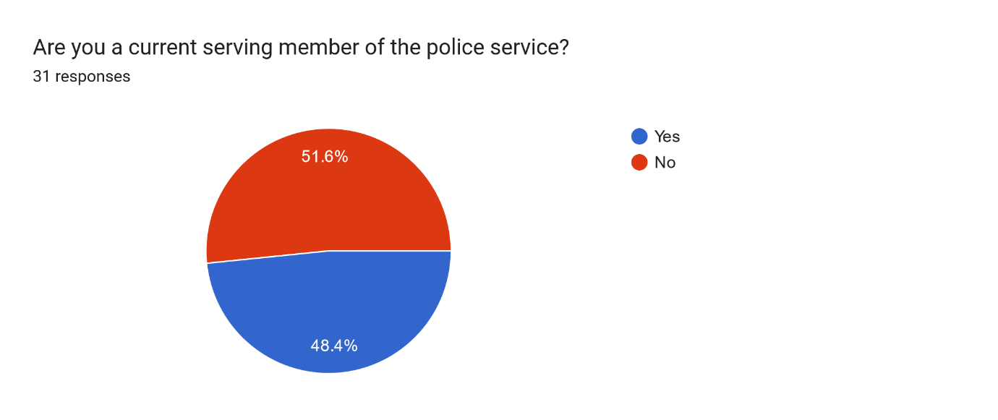
Figure 1 – responses to members of public or the police.
This question was posed to gauge any bias that may arise from questions answered by serving members of the police, the hypothesis being that current police members are more likely to be supportive of police pursuits. Within figure 1, the split is almost even, with 51.6% of respondents being members of the public, whilst 48.4% are.

Question 2 – In general, are you supportive of the Police?
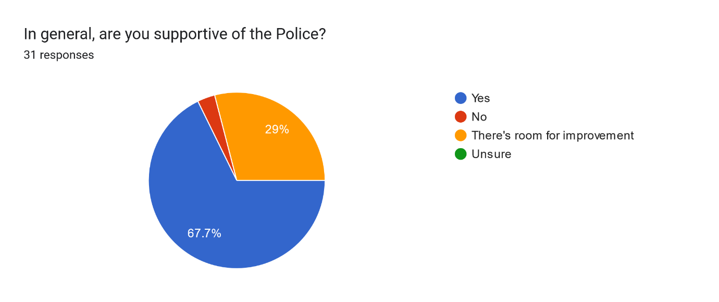
Figure 2 – Support of the Police
This question sets out to establish if respondents are supportive of the police. This question is key to the research objective of ascertaining the public current level of support in the police. From this question, 67.7% of respondents were supportive of the police, with 9 stating that there is room for improvement. 3.2% of respondents were not supportive of the police.
Question 3 – Do you think police pursuits are necessary in the modern day?
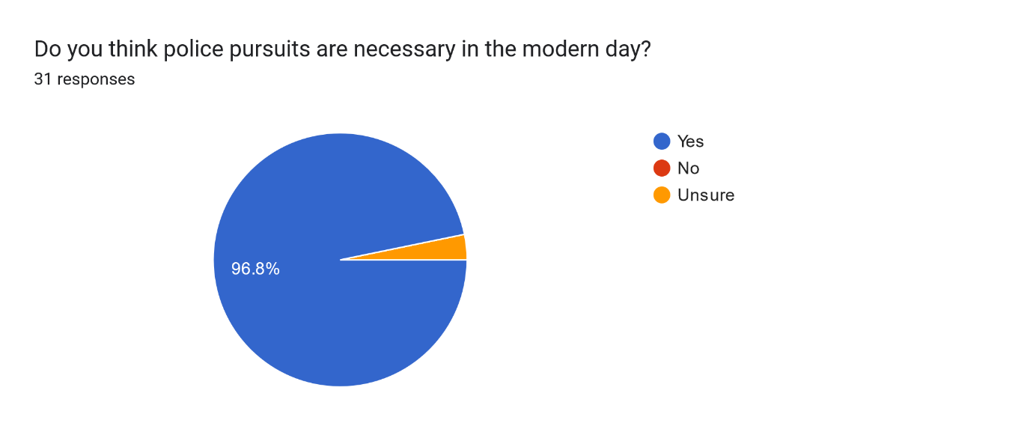
Figure 3 – Necessity of police pursuits
Question three set out the respondents’ beliefs on the necessity of police pursuits. In contrast to the prior question, almost all respondents agreed that pursuits had necessity in the modern day, with only 3.2% of respondents being unsure if they were. Question four was set out to clarify more detail around the reasons why the individual respondents had their opinion, which was an open-ended question. From that question, the following themes have been identified from the qualitative question. For clarification, some answers fell into two or more themes.
- Crime deterrence and public safety – 51.6%
Crime deterrence and public safety was a theme identified as a reason police pursuit, with respondents suggesting that pursuits were essential to prevent serious crime and safeguard the public from violent offenders. 51% of respondents gave an answer fell within this theme
- Accountability and Justice – 25.8%
Accountability and Justice was the second theme identified. Respondents emphasised a need to catch offenders and seek justice for victims and to prevent their reoffending by letting them abscond from officers. 25.8% of respondents’ answers fell within this theme
- Risks assessment and Safety Precautions – 22.6%
The third theme emphasised that their whilst police pursuits may be necessary, they must have fully conducted risk assessments and officers should take risk into account before initiating pursuits. 22.6% of respondents’ answers were identified as being related to this theme.
- Modern Technology Alternatives – 9.7%
Few answers fell within the theme of highlighting alternative means of pursuance of suspects and advocating for catching criminals at a later date if it lowered the risk to the public, and for dealing with less serious offences. 9.7% of respondents fell within this theme.
- Increasing use of vehicles in crime – 12.9%
The fifth theme identified was the increasing use of vehicles in crimes, stating that it was a necessity for police pursuits in the modern day as if they were not utilised, offenders could just get into their vehicle and expect to get away. 12.9% of respondents fell in this category.
- Availability of trained officers – 6.5%
The final identified theme was the highlighting of police resources as an issue in conducting pursuits, stating that if few officers were available the risk is greatly increased and not justifiable. 6.5% of respondents were grouped into this theme.

Question 5 – Are you supportive of police pursuits in general?
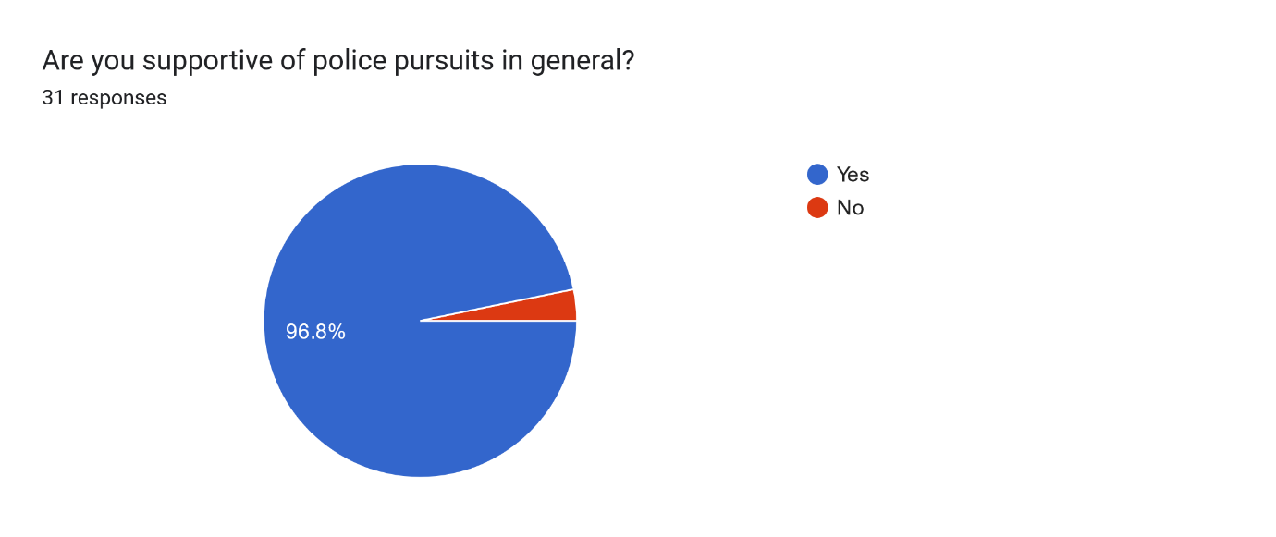
Figure 4 – Supportive of police pursuits
Question 5 is key to the essay as it directly relates to the research objective of identifying the publics’ support of police pursuits in the modern day. 96.8% of respondents were supportive of pursuits, with only 3.2% stating they were not.
Question 6 – Would you support a police pursuit for a suspect who is wanted for a less-serious offence, such as shoplifting or public order?
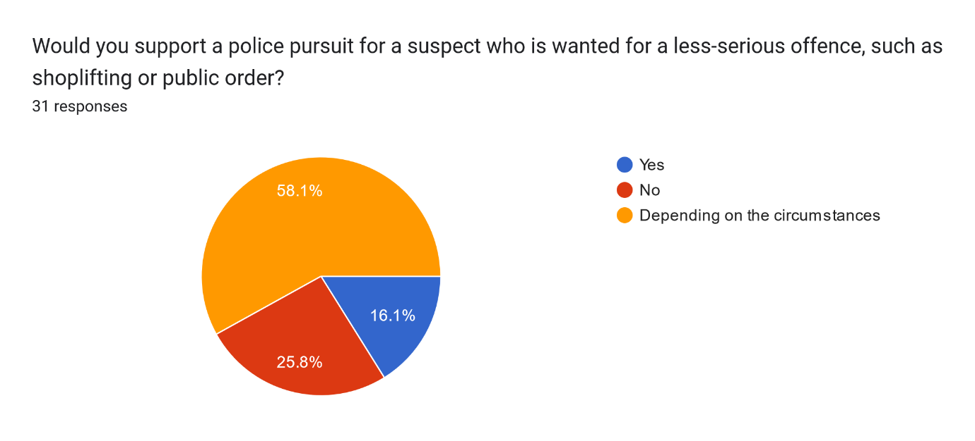
Figure 5 – Support of pursuits over less-serious offences
This question was asked to establish if pursuit support is dependent on circumstances and the type of offences the subject was wanted for. 58.1% of respondents answered depending on the circumstances, 25.8% of respondents were not supportive of a pursuit for less-serious offences, and 16.1% were.

Question 7 – Would you support a police pursuit for a suspect who is wanted for a serious offence, such as murder?
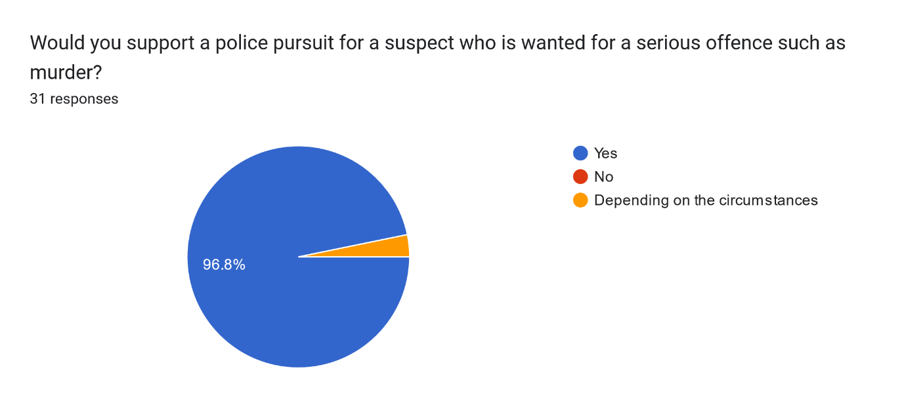
Figure 6 – Support of pursuits for serious crime
This question was asked to corroborate with question 6 regarding support of pursuits for the specific types of crime and their severity to identify if there is a link present between support of pursuits and the reason for it. 96.8% of respondents were supportive of pursuits for serious crime, with 3.2% of respondents stating it was dependent on the circumstance.
Question 8 – Do you believe that the risk to the public from a police pursuit can ever be justified?
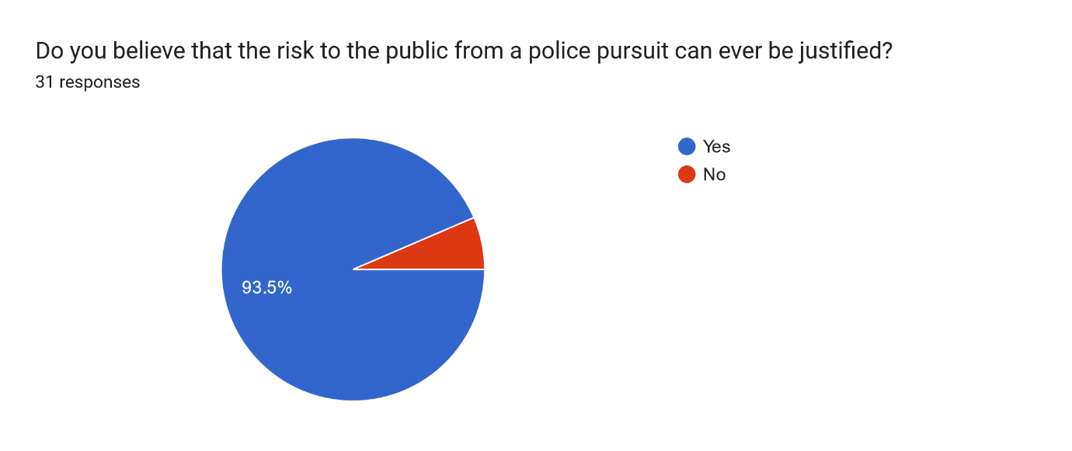
Figure 7 – Can risk to public be justified?
Question 8 was asked to clarify if respondents believed that the public could be subjected to the risk of a police pursuit, and if said risk could be justified. 93.5% of respondents stated that the risk couldn't be justified, with 6.5% of respondents answering no.

Question 9 – Who should be responsible if a pursuit goes wrong?
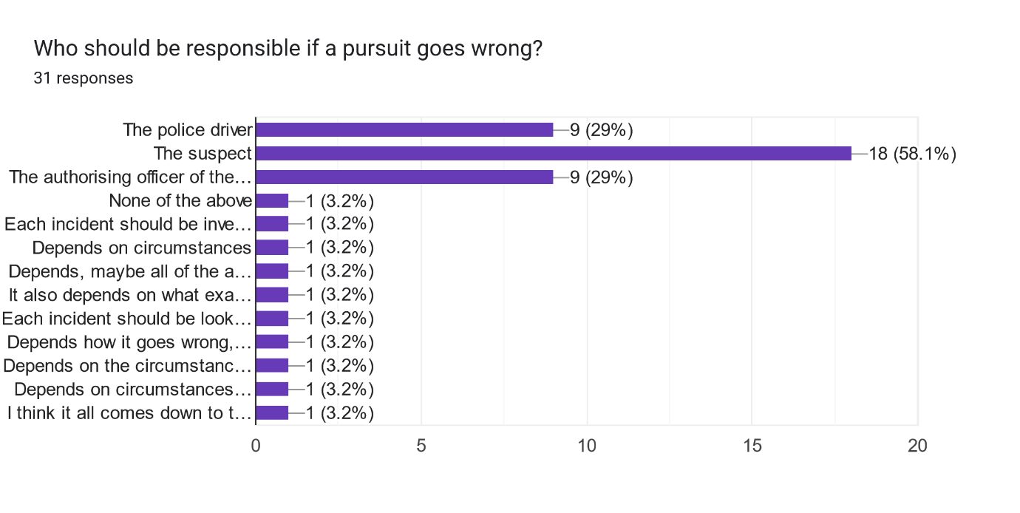
Figure 8 – Responsibility of errors
The final question posed to respondents was who should be held accountable if a police pursuit goes wrong. This question allowed for multiple choices to be entered. Respondents were also able to enter their own answer to the question if they so wished.

4.3 – Analysis and Conclusion
From the results gathered by the research set out within this paper it is clear that in general, the public do support police pursuits. It has been identified however that this support is not unconditional and does appear to depend on a variety of factors relating to the pursuit and the reasons behind it, such as why the pursuit was started, the severity of the crime and the risk to the public all being factors taken into consideration by the public.

From the results gathered, there does not appear to be a large, quantifiable difference in the public support of pursuits that the research has established compared to that of the antecedent research undertaken with the literature review chapter of this paper. In previous literature analysed, such as Tudor (2023), drops in public trust of the police were recorded but this does not seem to correlate to a drop in support of police pursuits as initially hypothesised. This would indicate that public support of pursuits is perhaps not directly linked to public trust and support in policing. This may be linked directly to the fact that police pursuits in the United Kingdom are incredibly risk-averse and that public deaths or fatalities as a direct result of pursuits are incredibly low (Christie, 2020) and undermine the idea that police need to have public confidence in order to have support in all their endeavours.

Chapter 5 - Findings and Conclusions
5.1 - Introduction
One of the main concerns around the established research that this paper identified was the lack of current research around public perception statistics. One of the main objectives of this paper was the help alleviate that shortfall by targeting that lack of previous research with a survey directed towards the general public, as per objective two set out in the introduction. This chapter aims to achieve both objective two and three.

5.2 – Comparison and analysis
The findings form the survey revealed an overall pattern of public support for police pursuits, as outlined within the results chapter. This gives a basic answer to the question posed by this essay, as there is now further research in the area that this paper has focused on. In general, over 90% of respondents were supportive of police action, which aligns with the previous studies analysed within the literature review, such as McDonald and Alpert (1988), which highlighted the publics expectation that police officers should take decisive action to deter criminal activity, as well as research by Lum et al (2009), which underscores that visible policing actions reinforces public confidence in law enforcement. Whilst the general question was answered there was some caveats and specification identified to the answers, as most members of the public were not supportive of pursuits for less-serious offences, such as shoplifting or minor public order offences. These results were expected and link back to the policy recommendations from the Home office (2018), which highlighted that police pursuits should be assessed based on the risk posed by the suspect, which is the same for policing in general, as the code of ethics states within the national decision-making model

This set of results does introduce a somewhat contrasting picture, as respondents were in general supportive of pursuits, but not when they were for minor offences. However, they were supportive of a risk to a public if the offence was serious. This reflects the findings from Wells and Wills (2009), which identified that public trust in policing is undermined when pursuits result in high-profile accidents, particularly when the offence being pursued are seen as trivial offences, or less serious as identified in the results chapter. This aligns with the pattern of increasing public scrutiny towards policing as well, as police accidents caused by pursuits or police driving usually take front-page news.
The findings of the study in this paper are broadly consistent with the existing research analysed within the paper. One of the weaknesses identified of current existing research was the lack of up-to-date research, as the majority of academic sources were identified as being around 20 years old. Whilst that research was of high-quality, the age of it means that it is not a current source and comparisons to more modern research would allow for a pattern to be established as to whether or not public support has increased, decreased or stayed consistent. From comparison with the survey this essay utilised, it appears that overall, public support and opinion of the necessity of police pursuits has remained fairly consistent, as the majority of the public do believe that pursuits are necessary and support them as a tactic for officers to utilise. Whilst limitations were identified prior to the survey, there are still limitations that remain. Whilst this paper adds to the list of available research, the subject group was of a limited size, with less than 40 results gathered from the public. In order to address and prevent this problem, future studies could address this by posting the survey in more forums and social groups, as well as considering utilising public spaces such as libraries and town hall meetings to get publicity for the survey, or engaging with local community groups who may be able to help reach people not previously reachable through the use of online surveys.
To conclude, the research this paper has achieved as illuminated a complex and somewhat contrasting public opinion on police pursuits, showing that there is a direct correlation to the risk of a pursuit and the severity of the offence. The public are still supportive of policing in general, specifically supportive toward pursuits but only if certain criteria are met. Public trust seems to reduce when pursuits are not necessary, or reckless, which is directly linked to the vast majority of papers analysed within the literature review, with some exceptions such as Lamont (2019), who outlines the dangers of pursuits and argues their irrelevance in modern-day policing. This paper has also determined that there is an apparent stagnation in public opinion on police pursuits, as unlike the general trust of the public in policing, which appears to have reduced over time as scrutiny in policing has increased (Tudor, 2023), public support of pursuits has not. This is only in comparison to the limited research available on this topic, with the main source of reference being the work of MacDonald and Alpert (1988), which as already mentioned is nearly 40 years old. Future papers may find success in bridging the still-resent gap in the research by undertaking long-term research on a focus group, such as utilising surveys over a set period of years with the same group to ascertain if opinion changes, and whether or not this is due to external or internal factors of the group.

Conclusion
The overall objectives of this paper have been achieved. Objective one, which was to “Assess antecedent research surrounding public perception and support on police pursuits and identify the level of support the public holds relating to pursuits in these sources” has been achieved within the literature review chapter of this paper, as available sources have been analysed and reviewed around the topic and a general basis of available research was
Identified.
Objective two, which was to:
“Establish the level of support or lack thereof the public has for police pursuits by use of research methods, such as surveys, and clarify the reasons these views are held by use of qualitative questions” has also been achieved, as research was completed around the central question with qualitative questions as well as quantitative, and results presented in a clear way. Unfortunately, there was limitations to this survey, such as the small subject sample size, which may impact the reliability as there is a chance the subject group may hold similar opinions, and a real reflection of the general public is not properly identified. The second limitation of this research was the limited time frame to undertake it, which directly links to the subject sample size as if more time was available, more results may have been gathered.
Objective three, which was “Contrast and compare results from the research results from this paper to that of the antecedent and historical literature that has been reviewed from this paper and identify there has been a significant change and identify possible causes” has also been achieved within this paper, as the results from the research have been compared with the sources previously analysed within the literature review, and a comparison has been established and clear links identified with the main question of this paper answered.
This shows that the paper has, in the most part, achieved its goals and established modern contemporary research into a subject area that lacks in a large amount of research and understanding. However, as more research has been completed on an area lacking coverage, a survey has been conducted and completed and results analysed and compared with existing research within the subject area. This study achieved its objectives by revealing strong public support for police pursuits, particularly for serious crimes, while highlighting significant concerns the public has about safety and proportionality for lesser offenses. Public perception has shifted subtly in recent years, influenced by media coverage and a growing emphasis on accountability. These findings underscore the need for transparent, proportionate pursuit policies and continued investment in technology and training to balance effective enforcement with public safety concerns, as well as highlighting the need for further research.

Bibliography
Ali, Z. and Bhaskar, Sb. (2016) ‘Basic Statistical Tools in Research and Data Analysis’, Indian Journal of Anaesthesia, 60(9), p. 662.
Christie, N (2020) Managing the safety of police pursuits: A mixed method case study of the Metropolitan Police Service, London. Safety Science

Clark, J.P. (1965). Isolation of the Police: A Comparison of the British and American Situations. Journal of Criminal Law, Criminology and Police Science, [online] 56, p.307. Available at: https://heinonline.org/HOL/LandingPage?handle=hein.journals/jclc56&div=49&id=&page=

College of Policing (2013) Police pursuits. Available at: https://www.college.police.uk/app/roads-policing/police-pursuits.

DODD, V. (2024). Only 40% of people in England trust their police force, research reveals. The Guardian. [online] 18 Apr. Available at: https://www.theguardian.com/uk-news/2024/apr/18/only-40-of-people-in-england-trust-their-police-force-research-reveals.

GOV.UK. (2018). Consultation to give police greater confidence to pursue suspects. [online] Available at: https://www.gov.uk/government/news/consultation-to-give-police-greater-confidence-to-pursue-suspects.

Hurd, N. (2018) The Law, Guidance and Training Governing Police Pursuits: Current Position and Proposals for Change. Home Office.

Jamshed, S. (2014) ‘Qualitative research method-interviewing and observation’, Journal of Basic and Clinical Pharmacy, 5(4), pp. 87–88.

Kranick, L. (2015). Pursuits, Use of Force, and the Influence of Public Perceptions. [online] Edge. Available at: https://amuedge.com/pursuits-use-of-force-and-the-influence-of-public-perceptions-on-policing/ [Accessed 29 Jul. 2024].
‌
Lamont, T. (2019) Speed kills: are police chases out of control?, The Guardian. Available at: https://www.theguardian.com/news/2019/jul/02/deaths-uk-police-pursuits-chases.
Liao, C.-H. (2023) ‘Exploring the Influence of Public Perception of Mass Media Usage and Attitudes towards Mass Media News on Altruistic Behavior’, Behavioral sciences, 13(8), pp. 1–22. Available at: https://doi.org/10.3390/bs13080621.

MacDonald, J.M. and Alpert, G.P. (1998) Public attitudes toward police pursuit driving, Journal of Criminal Justice, 26(3). .

Police Executive Research Forum (2023). Vehicular Pursuits: A guide for Law Enfrocement Executives on Managing the Associated Risks.

Ponto, J. (2015) ‘Understanding and Evaluating Survey Research’, Journal of the Advanced Practitioner in Oncology, 6(2), pp. 168–171.

Pynes, J (2002) The Effects of Police Pursuits and our Public's Perception. Should Law Enforcement have more restrictive Policies

Rhoden-Paul, A. (2024). Sarah Everard: BBC documentary recalls police learning killer was Met officer. BBC News. [online] 4 Mar. Available at: https://www.bbc.co.uk/news/uk-england-london-68466660.
Rivara, F.P. (2004). Motor vehicle crash deaths related to police pursuits in the United States. Injury Prevention, 10(2), pp.93–95. doi:https://doi.org/10.1136/ip.2003.004853.

Salazar, K. (2016) Diary Studies: Understanding Long-Term User Behavior and Experiences, Nielsen Norman Group.

Statista. (n.d.). Police related deaths: road pursuits England/Wales 2019. [online] Available at: https://www.statista.com/statistics/319294/deaths-during-or-following-police-contact-police-pursuit-in-england-and-wales/.

The Police Foundation (2020). The public want the police to be more visible and to focus on core tasks, according to new research. [online] The Police Foundation. Available at: https://www.police-foundation.org.uk/news/the-public-want-the-police-to-be-more-visible-and-to-focus-on-core-tasks-according-to-new-research/.
Tudor, S (2023) Police standards and culture: Restoring public trust. House of Lords Library.

Verhoef, M.J. and Casebeer, A.L. (1997) ‘Broadening horizons: Integrating quantitative and qualitative research’, The Canadian Journal of Infectious Diseases, 8(2), pp. 65–66.

Appendix A – Questions from the survey
Please see below the list of questions posed in this papers research method:

Q1 – Are you a current serving member of the police service?
Q2 – In general, are you supportive of the Police?
Q3 – Do you think police pursuits are necessary in the modern day?
Q4 – why do you feel this way?
Q5 – Are you supportive of police pursuits in general?
Q6 – Would you support a police pursuit for a suspect who is wanted for a less-serious offence, such as shoplifting or public order?
Q7 – Would you support a police pursuit for a suspect who is wanted for a serious offence, such as murder?
Q8 – If you answered “Depending on circumstances” for either question above, please explain why?
Q9 – Do you believe that the risk to the public from a police pursuit can ever be justified?
Q10 – In what circumstances do you feel it can be justified?
Q11 – Who should be responsible if a pursuit goes wrong?

