
(Asma khadim 2524670)
Assessment 1 – Reading Task Template
PART 1: Upload your photo of your A3 in-class notes here:
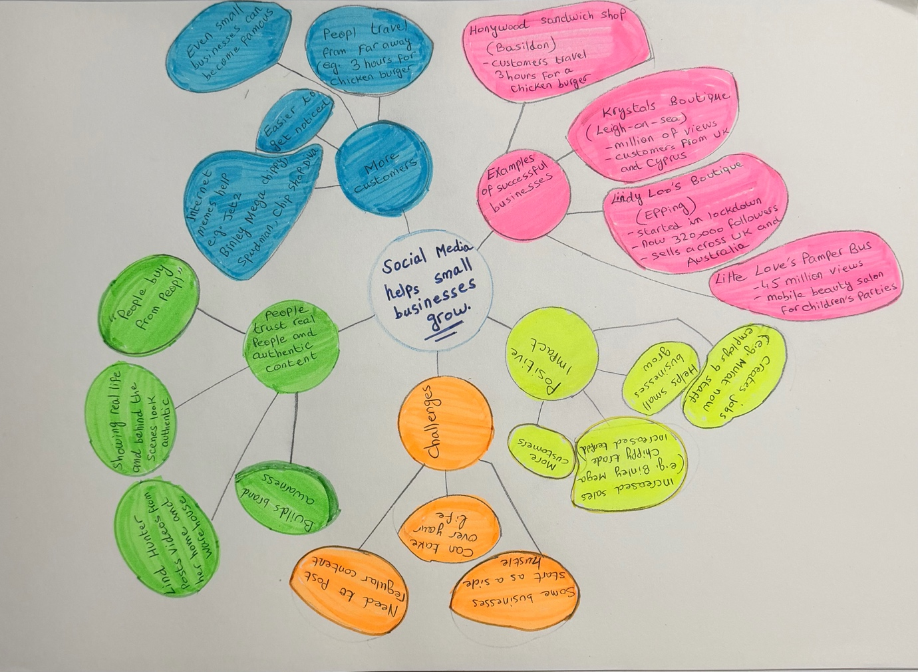

PART 2:
- Answer every question below in 1-3 full sentences.
- Use your own words. Do not use generative AI to answer these questions.
- Include a specific detail from the text when asked.
REMINDER
- The main idea is the overall message of the whole text.
- A key point helps to explain the main idea.
- A specific detail or example from the text shows that the key point is true.

- What is the main idea of the whole text?

The main idea of the whole text is social media helps small businesses grow by bringing more customers and increasing sales.

- What is one key point that supports the main idea, and which specific example from the text shows this?

Key point: social media can bring more customers to small businesses.
Example: Honeywood Sandwich shop had customers travelling three hours just to buy a chicken burger.

- What is a different key point that supports the main idea, and which specific example from the text shows this?

Key point: social media can increase sales for small businesses.
Example: Binley Mega Chippy’s trade increased tenfold because of social media videos.

- Which part of the text do you think is most important, and why?
The most important part is how social media helps small businesses get more customers. This is important because it can increase sales and help businesses grow.

Reflection:
- What did you find difficult in this task (including in-class components), and why was it difficult?

I found making the mind map most difficult because it was hard to choose and organise the important information. I also found the main idea and key details a little difficult because there was a lot of information in the text.

- What helped you with this difficulty, and how did it help you?

The mind map helped me because it helped me organise the information and choose the most important points. Reading the text more than once also helped me understand the main idea and key details.

