Academic Essay

Programme: BA International Hotel Management
Module: Management & Organisational Behaviour
Module code: BMIH5004
Module Tutor: Lola-Coles
Student: Andreea Gama
Student ID: 2219781
Word Count: 2005

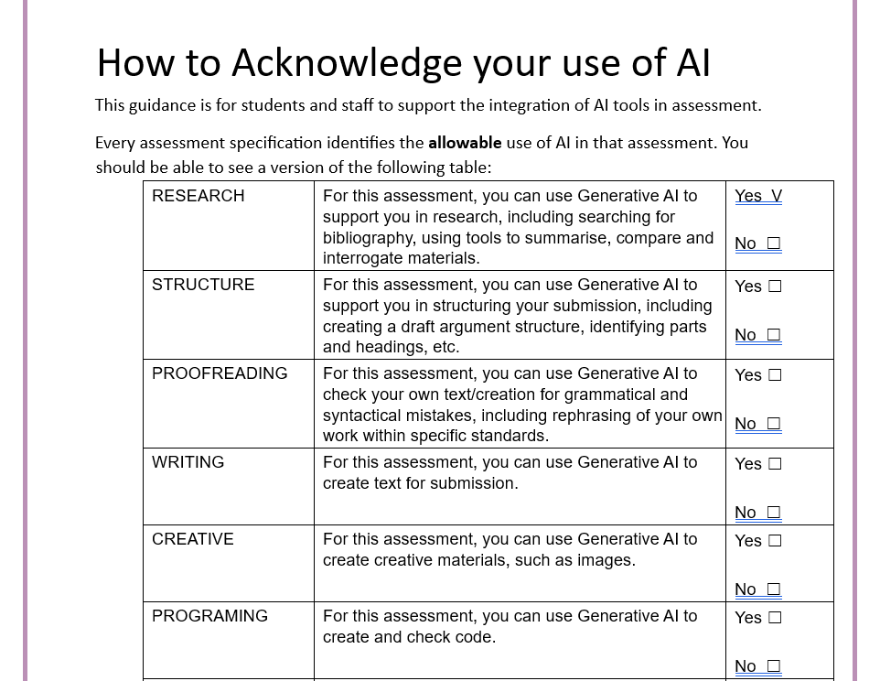
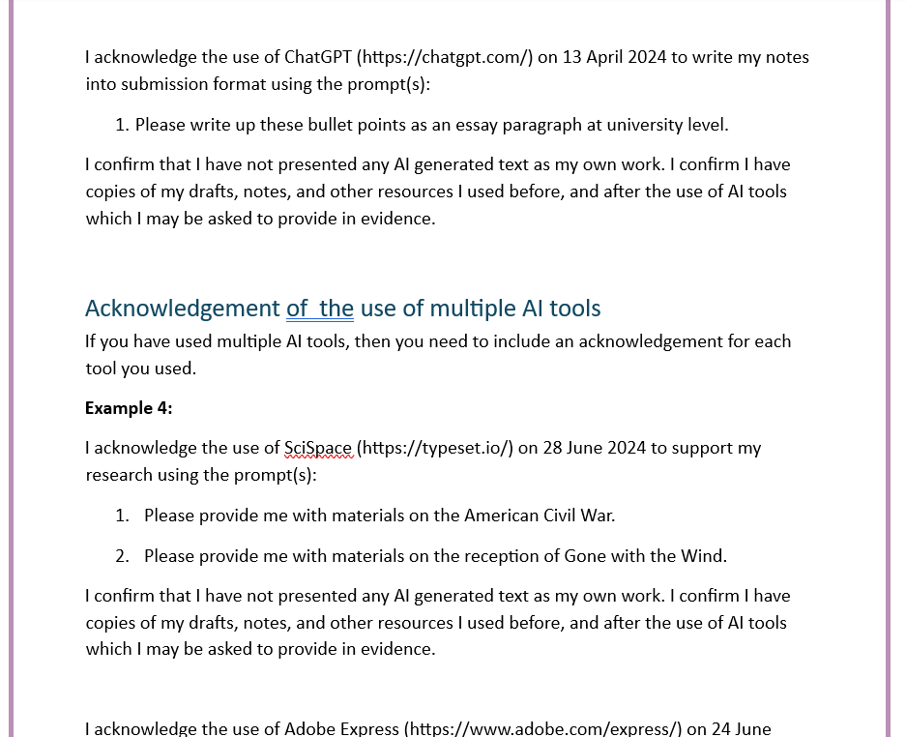

Assessing the Impact of Different Leadership Styles on Team Effectiveness and Employee Morale in the Hospitality Industry
The nature of the hospitality industry, especially in the United Kingdom is fast-paced and customer-driven. In such a dynamic environment, the focus moves from decision-making to creating a culture where team effectiveness and employee morale are rooted. Leadership styles can have dramatic effects on how teams work and the feelings of those employees who are deeply engaged (Armstrong, 2021). This essay is to review how different leadership styles affect team effectiveness and team morale in the UK hospitality industry using leadership theories, and comparing the styles through UK case studies such as Premier Inn, Whitbread, and The Savoy Hotel.
Many leadership theories were created over time to explain how leaders affect their teams. Trait theory is one of the earliest leadership frameworks in which it is assumed that everyone is born with certain traits that make individuals natural leaders. Success traits of great leaders are often mentioned (Mullins, 2019) such as confidence, assertiveness, and decisiveness. Despite this, Trait Theory has been criticised for failing to take into account the development of leadership skills through experience and learning. Today, the UK hospitality industry, employing different types of workers, needs leaders who will change their style to adapt to various team dynamics and Trait theory tends to be less relevant (Arnold, 2020).
Behavioral Theories concentrate on the deeds of leaders, rather than their natural gifts (Bloisi et al., 2007). Leadership is viewed as behaviour that can be learned and developed, with many behaviours linked to the more effective leaders. These behaviors typically fall into two categories: People-oriented leadership coupled with task-oriented leadership. Task-oriented leaders are concerned with setting clear goals, giving direction and the completion of those tasks in an efficient manner (Boddy, 2017).
Mullins (2023) suggested that people-oriented leaders place team cohesion, and employee happiness, and create a positive work environment. In particular, the people-oriented leadership approach is widely used in the hospitality industry where people are integrated into teamwork and the interrelationships are significant in keeping the levels of employees' morale and customer satisfaction.
Mullins and Dosser (2013) stated that contingency theories further refine our understanding of leadership by suggesting that there is no one-size-fits-all approach. Effective leadership, however, is a function of the situation and various situational factors, e.g. the specific task, team composition and the organisational environment (Mullins, 2019). In the hospitality sector, this is of course especially relevant, where, a leader is forced to handle a plethora of issues such as peak seasons, and customer complaints. For instance, a hotel manager may have to adopt a more authoritarian style when there are people in the hotel for a busy period. So that it all goes smoothly, while democratic style would make sense to gain staff’s views on how to improve guest services (Yukl, 2013).
One of the most prominent modern leadership models is Transformational Leadership, which emphasizes the leader’s ability to inspire and motivate their team through a shared vision and goals (Zopiatis and Constanti, 2010). Transformational leaders are well known for inspiring innovation, encouraging employee development as well as establishing an atmosphere of engagement and job satisfaction at work. However, it is particularly useful for the UK hospitality industry where guest experience and service excellence are the key differentiators of the organisation. Empowering employees to take responsibility for their roles transforms the leader into a transformational leader who can cultivate an accountability culture and innovation culture that brings about both team effectiveness and employee morale (Wang, 2016).
Mullins (2019) stated that transactional Leadership focuses on maintaining control through clear structures, rewards, and penalties. Transactional leaders focus more on making sure that team members stick to the rules and hit performance benchmarks. While this approach works in terms of order and short-term goals, it has been criticised for missing the opportunity to create long-term employee engagement and creativity (Mullins and Dosser, 2013). In a high-pressure environment like hospitality, where innovation and guest satisfaction are key, transactional leadership may fall short in promoting employee morale.
The effect of the two leadership styles in the hospitality industry of the UK is that both are effective according to the scenario (Gursoy et al., 2017). For example, Premier Inn, a budget hotel chain owned by Whitbread, relies heavily on transactional leadership to maintain consistency across its numerous locations. When it comes to performance, standard operating procedures, clear performance targets, and adherence to brand guidelines the Premier Inn experience stays the same, no matter which of the hotel’s guests are staying in (Clegg et al., 2016). A transactional approach has worked well here because the implication is to ensure operational efficiency: during busy periods or for large-scale events. While this leadership style may maintain consistency, it will not produce the same employee engagement or satisfaction as a more transformational approach.
By contrast, The Savoy Hotel in London offers a clear example of transformational leadership in action (The Savoy, 2023). The Savoy is a luxury hotel, which prides itself on its service and attention to detail, and one that puts a great deal of importance on empowerment and development of employees (The Savoy, 2023). Guest service is fostered with employees encouraged to take ownership of their roles and make decisions that will mutually benefit guests' experiences and continue the success of the hotel (Gursoy et al., 2017). For this reason, this level of empowerment combined with a heavy focus on personal development, makes for a positive work environment for employees who feel valued and motivated. As such, the hotel consistently has high levels of employee satisfaction which is directly accountable for the hotel's reputation for excellence.
Before the pros and cons of these types of leadership are understood, there are definite effects on team dynamics and employee morale (Judge and Piccolo, 2017). Transformational leadership is widely regarded as being highly effective in fostering collaboration, creativity, and employee satisfaction. Transformational leaders develop a work environment that encourages open communication, and offers opportunities for professional development. It motivates and engages employees by creating a sense of purpose and encouraging open communication (Patiar and Wang, 2016). However, transformational leadership is not without its challenges. However, one of the chief complaints about this style occurs due to the fact this style demands that leaders commit considerable time and energy to cultivating effective relationships with their people (Tourish, 2013).
On the other hand, transactional leadership offers a more structured and efficient approach to managing teams, particularly in situations where consistency and adherence to procedures are crucial (Yukl, 2013). Sometimes this leadership style can be fantastic, for instance when they operate on a larger hotel chain scale, like Whitbread’s Premier Inn who need to maintain brand consistency across as many locations as possible (Whitbread Group PLC, 2023). Transactional leadership ensures that employees are clear on their roles and responsibilities, and that performance is measured against specific targets. It can help create a feeling of accountability, and help make sure that tasks get done on time and to a great standard (Dinc et al., 2022).
The way in which leadership style can affect the working environment of a UK hospitality business is illustrated well by the management techniques employed by Whitbread the subsequent parent company of Premier Inn and Costa Coffee. In recent years, Whitbread has been putting a lot more effort into being a more transformational leader and this has mainly manifested itself through employee engagement and personal development in Costa Coffee stores. Whitbread’s leadership strategy factored in is creating a positive work environment where the employees feel empowered and able to make decisions and contribute towards the success of the business. This shift towards a more transformational leadership style has been credited with improving employee morale and increasing job satisfaction (Dinc et al., 2022). It has led to better team performance and higher levels of customer satisfaction across the company’s operations.
Leading affects morale and teamwork. This is also shown in the Savoy Hotel. The Savoy is a luxury hotel, yet delivers personalised service to its guest, so it needs a committed and motivated staff, and this is important to add. Hotel leadership aligns with a transformational approach: engaging staff to take accountability for their role and helping to take the hotel to success. Such a level of empowerment creates a positive work atmosphere where employees are empowered to go the extra mile for guests (Buchanan and Huczynski, 2007). The Savoy’s reputation as one of London’s premier luxury hotels depends on a highly effective team of today, which habitually delivers great service.
The leadership styles influence the effectiveness of a team and employee morale in the UK hospitality industry cannot be undermined. Both transformational and transactional leadership styles have their strengths and weaknesses, and their effectiveness depends largely on the specific context in which they are applied. Transformational leadership, with its focus on empowerment, motivation, and personal development, is particularly effective in enhancing employee morale and fostering a positive work environment (Caldwell and Dixon, 2010). As seen in examples such as The Savoy Hotel and Whitbread's Costa Coffee operations. This leadership style creates a situation in which their employees are creative, engaged, and unified as a team, and that is exactly what is required to keep those high service standards in the hospitality industry. Transformational leaders develop and empower employees to create a positive work environment where the employees are valued, motivated, and feel connected to the goals the organisation sets (Mullins & Dosser, 2013). This will yield increased team effectiveness and higher guest’ satisfaction.
Within organisations such as Whitbread, there is a blend of leadership styles, which reflect the importance of situational leadership (Whitbread Group PLC, 2023). Situational leadership is the idea that leaders need to adapt what they do as leaders depending upon the needs of the team (Mullins, 2023). Such as the tasks and the organisational context in the broader sense. Optimum leaders in the hospitality industry where customer service is 'numero uno' and the morale of the employees has its effect on the satisfaction of that guest, are those who can achieve the appropriate balance between structure and empowerment. If the contributions of the employees are not seen as important, there may be the result of employee disengagement even though the underlying effort in the company may be purely transactional and leads to operational efficiency (Gursoy et al., 2017). On the other hand, a purely transformational approach, paving the way for innovation and motivation, may not offer the required structure requisite for attaining consistency and accomplishing set targets tied to performance.
In assessing the impact of different leadership styles on team effectiveness and employee morale in the UK hospitality industry, it is clear that both transformational and transactional leadership have a role to play. Those who can adjust their style to what their team and organisation require are the most successful leaders (Zopiatis & Constanti, 2010). As an example, service at hotels, such as The Savoy, is very much personalised towards the guest and it is vital for employee engagement to deliver this service. A transformational leadership approach is particularly efficient in motivating employees and an improvement of service quality in such environments (Zhu et al., 2009). Whereas in budget hotel chains such as Premier Inn, consistency and efficiency became paramount to meet the standard of the brand and to make them profitable, a transactional approach may better be suited.
To summarise, this essay discussed to what extent leadership styles are influencing team effectiveness and employee morale in the UK hospitality industry. Both transformational and transactional leadership are appropriate in varying situations drawn from Mullins (2019). Examples of Transformational Leadership like The Savoy and Whitbread's Costa Coffee foster innovation, empowerment and a great place to work. However, transactional leadership is focused on consistency and operational efficiency - both of which are necessary for chains such as Premier Inn. By adapting leadership styles to the services of the organisation and team, employee morale and overall team effectiveness improve, leading to a better quality of service and better customer satisfaction in the hospitality industry.

References
Armstong, M. (2021) Armstrong's handbook of performance management (7th Ed), London: Kogan Page
Arnold, J. (2020) Work Psychology (7th edition) Harlow: Pearson Education Limited.
Bloisi, W. et al (2007) Management and Organisational Behaviour, (2nd edition) Maidenhead: McGraw-Hill.
Boddy, D. (2017) Management: An Introduction (7th Ed), Harlow, Pearson
Buchanan, D. and Huczynski, A. (2007) Organisational Behaviour: An Introductory Text (6th edition), Harlow: Prentice Hall.
Caldwell, C., & Dixon, R. D. (2010) Love, forgiveness, and trust: Critical values of the transformational leader. Journal of Business Ethics, 93(1), 91–101. https://doi.org/10.1007/s10551-009-0184-z
Clegg, S., Kornberger, M., & Pitsis, T. (2016) Managing and Organizations: An Introduction to Theory and Practice (4th ed.). Sage Publications.
Dinc, M. S., Zaim, H., Hassanin, M., & Alzoubi, Y. I. (2022) The effects of transformational leadership on perceived organizational support and organizational identity. Human Systems Management, 41(6), 699-716.https://doi.org/10.3233/HSM-211563
Gursoy, D., Chi, C. G., & Karadag, E. (2017) Generational differences in work values and attitudes among frontline and service contact employees. International Journal of Hospitality Management, 32(3), 40–48. https://doi.org/10.1016/j.ijhm.2016.03.002
Judge, T. A., & Piccolo, R. F. (2017) Transformational and transactional leadership: A meta-analytic test of their relative validity. Journal of Applied Psychology, 102(5), 755–768. https://doi.org/10.1037/0021-9010.89.5.755
Mullins, L & Dosser, P. (2013) Hospitality Management and Organisational Behaviour (5th Ed) Harlow, Pearson.
Mullins, L. (2019) Organisational Behaviour in the Workplace (12th edition) Harlow: Pearson
Mullins, L. (2023) Management and Organisational Behaviour (13th edition) Harlow: Pearson
Patiar, A., & Wang, Y. (2016) The effects of transformational leadership and organizational commitment on hotel departmental performance. International Journal of Contemporary Hospitality Management, 28(3), 586-608. https://doi.org/10.1108/IJCHM-01-2014-0050
The Savoy. (2023) About The Savoy Hotel. Retrieved from https://www.thesavoylondon.com/about-us/
Tourish, D. (2013) The Dark Side of Transformational Leadership: A Critical Perspective. Routledge.
Wang, C. J. (2016) Does leader-member exchange enhance performance in the hospitality industry? The mediating roles of task motivation and creativity. International Journal of Contemporary Hospitality Management, 28(5), 969-987. https://doi.org/10.1108/IJCHM-10-2014-0513
Whitbread Group PLC. (2023) Annual Report and Accounts 2023. Retrieved from https://www.whitbread.co.uk/investors/results-reports-and-presentations/
Yukl, G. (2013) Leadership in Organizations (8th ed.). Pearson.
Zhu, W., Avolio, B. J., & Walumbwa, F. O. (2009) Moderating role of follower characteristics with transformational leadership and follower work engagement. Group & Organization Management, 34(5), 590–619. https://doi.org/10.1177/1059601108331242
Zopiatis, A., & Constanti, P. (2010) Leadership styles and burnout: Is there an association? International Journal of Contemporary Hospitality Management, 22(3), 300–320. https://doi.org/10.1108/09596111011035927

