Ways of Perceiving

Name: Sophie Allen
Student Number: 1901822
Course Title: BA Surface Pattern Design
Tutor: Julia Lockheart

Word Count: 1027

I will be curating a Fashion Show event based on the carbon footprint that the fashion industry creates (CBS News, 2019). I will show this by using designers who have used recycled materials to create new, environmentally aware collections to allow the fashion industry to become slower and more sustainable to benefit our future. I have chosen the location to be at Oxwich beach as it is surrounded by the beautiful nature of our planet, it is out in the open and by the ocean. This event will be a statement to show how much humans damage the planet. As a surface pattern student, this is something that I feel strongly about and am really interested in as it is a highly relevant topic in not just art but also everywhere and I personally believe that putting a statement out as big as our climate will be more recognised if you do it for a bigger audience through art. Indeed artist, Peter Finnemore has inspired me to create a fashion show as he says in his short film clip
“To actually see photography, it has to be taken off the wall”. - Peter Finnemore.
This suggests that for an audience to actually see and take in a piece of art that it has to be more interactive and grasp the audience’s attention instead of being a painting on the wall as it has been shown that people spend less than 10 seconds looking at artwork. “We seem to have forgotten how to live at one with our Earth and instead have become lost in our own greed”. (Olivia, 2020, P.13)

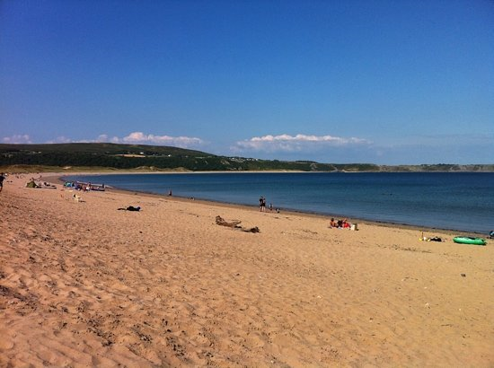
Figure 1- Trip Advisor (2020) Beach [Oxwich Bay] Swansea.

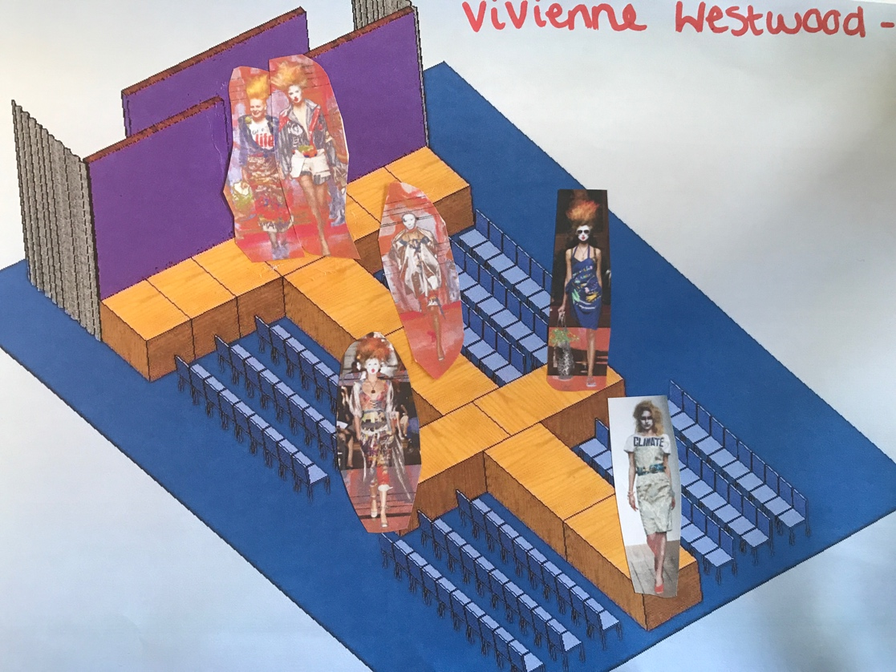

There will be a stage runway set up on the beach to allow the models to walk down the runway. In total there will be 4 artists or designers used throughout the event. Please see below (Fig.2) the map design for each designer:
Figure 2

In this photograph you can see the first designer I have used is Vivienne Westwood. The Westwood’s looks chosen come from her book, ‘get a life’ (2010). Westwood uses her work as a way of showing her beliefs and interests towards many things such as human rights, climate change, sustainability and feminism. Westwood’s book ‘get a life’ (2010) is a diary she has written about her life and personal experiences as an alternative way to express her feelings towards our planet other than through her designs. In her book Westwood says: “What’s good for the planet is good for the economy. What’s bad for the planet is bad for the economy. What’s good for people is good for the planet.” (Westwood,2010, P.16)

Her words show that she as a designer feels strongly about fast fashion and that everybody buys way too many clothes- that we should all be willing to spend more money for good quality clothing so that therefore we won’t need to buy as many clothes to help reduce our carbon footprint. Below I have included images of all the looks I will be using:

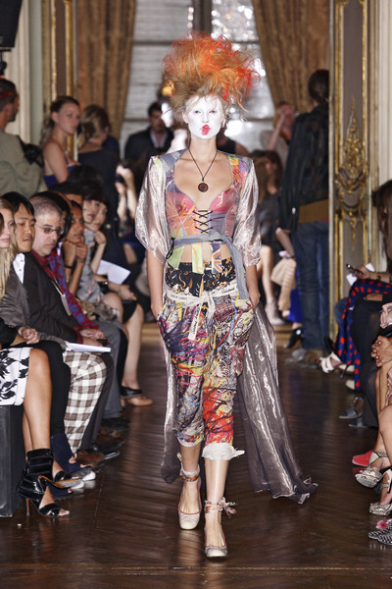
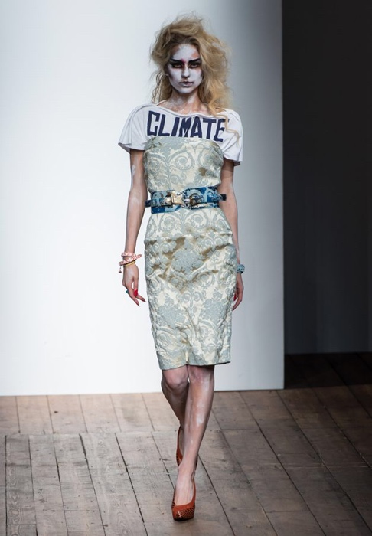
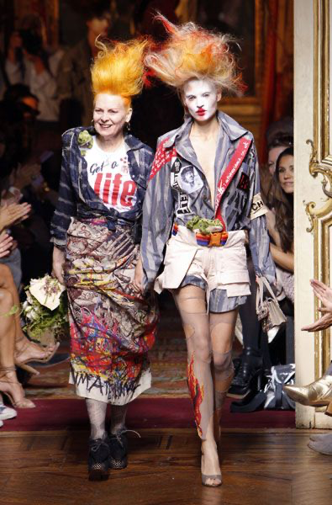

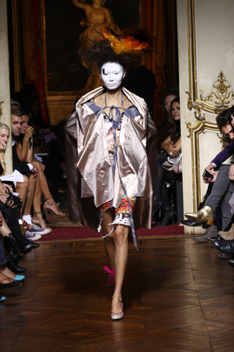
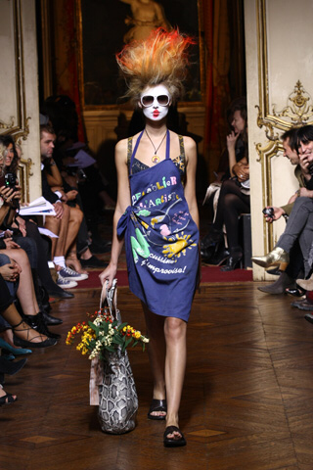
Figure 7
Figure 6
Figure 5
Figure 4
Figure 3

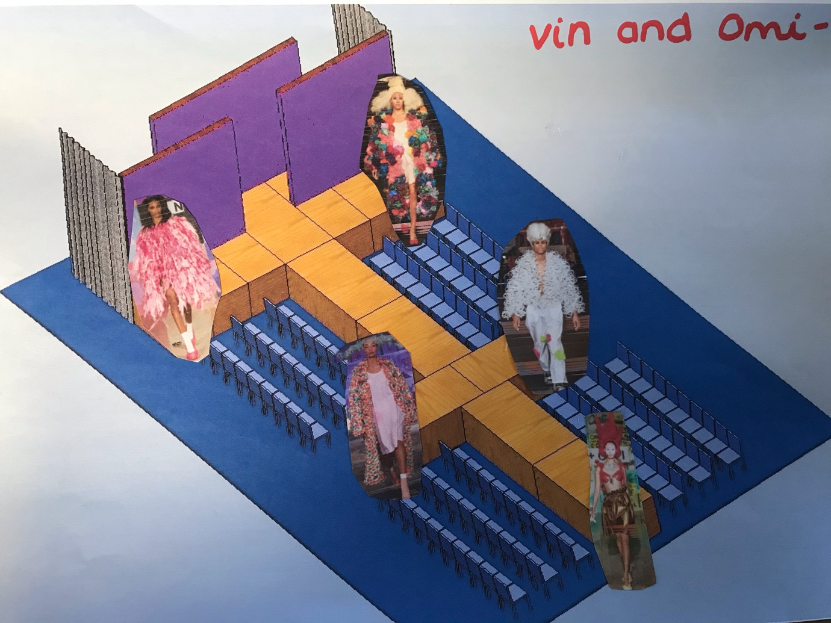
Figure 8

For a second collection I have decided to use ‘Vin and Omi’. Vin and Omi are designers who work all around the world to create and release new looks throughout the years that are all made from sustainable materials such as plants, old plastic bottles and chestnuts. “We are not just a fashion label; we are an ideology”- Vin & Omi. (Forbes, 2019)

This is a strong statement which suggests that they ensure that all their work is created to not damage our environment and shows that we don’t have to damage the planet just to dress good or make money. In addition, these looks are big and bold which means they will catch the audience's attention, each of these pieces are different to one another but also work well together as the colour palettes are all similar in tones of pinks, reds, greens and blues. These colours are all bold strong shades and work great when presenting meaningful art to an audience other than pastel, calming shades.

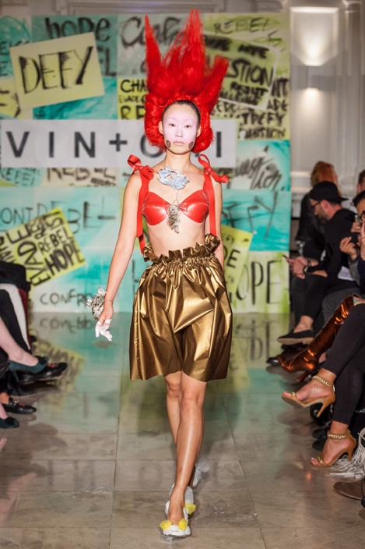
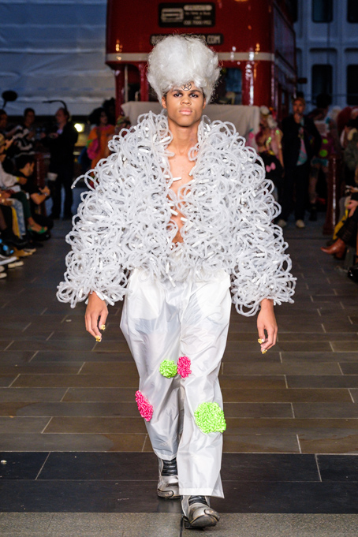
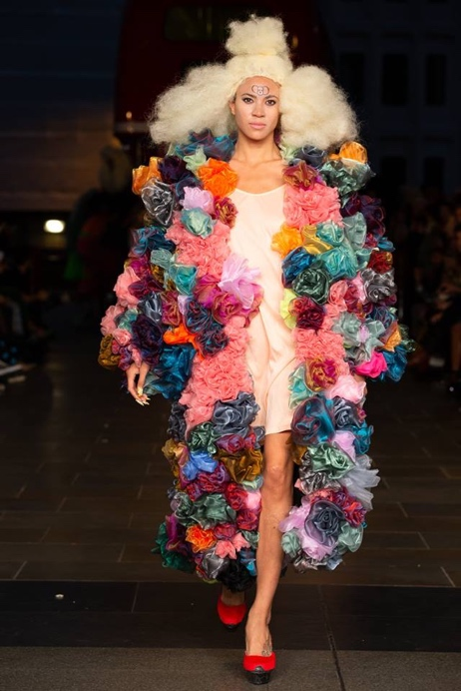

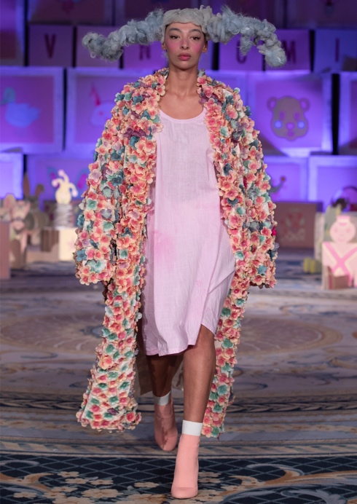
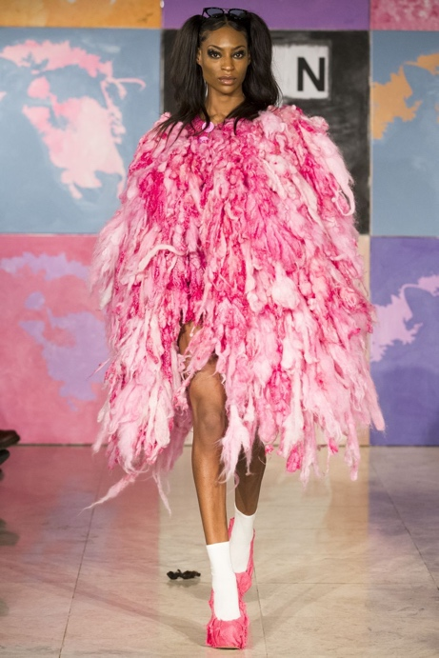
Figure 13
Figure 12
Figure 11
Figure 10
Figure 9

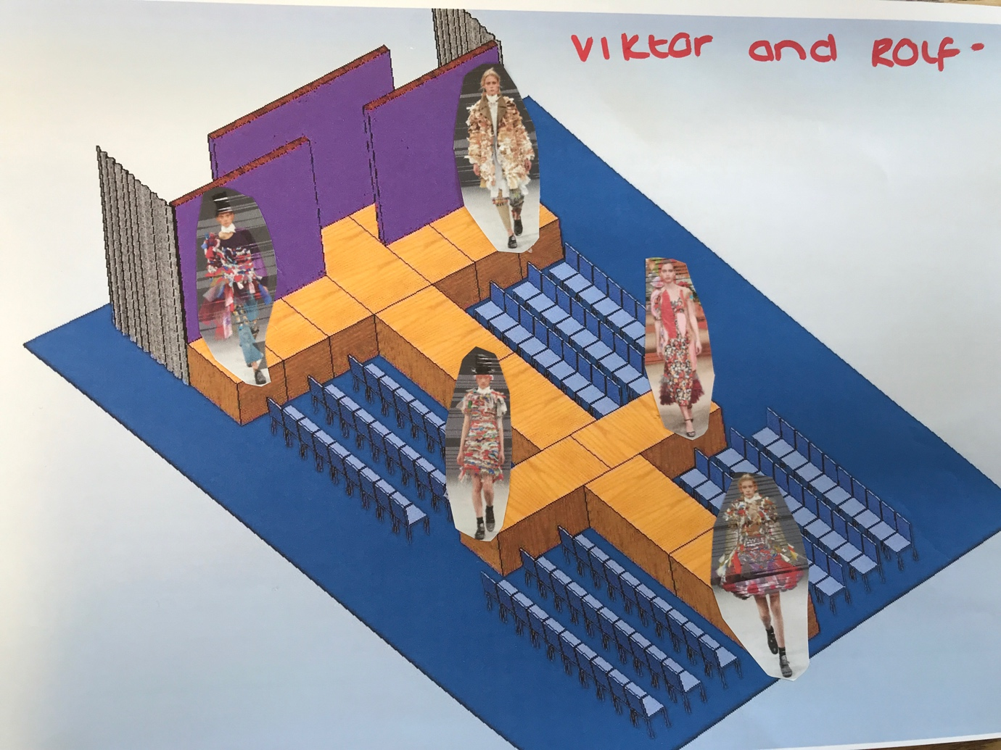
Figure 14

Viktor Horsting and Rolf Snoeren use scrap fabric from old collections in previous seasons and reuse them in their new garments by tearing up the fabric and re attaching them all together to create new designs to reduce the amount of material used. I have chosen to add these designers in to my fashion show because it will influence many people to up cycle their old clothes when they are tired of them instead of purchasing new clothes all the time. "Fabrics are torn, mixed up and woven by hand to create new voluminous shapes and textures," - Viktor & Rolf. Howarth (2016) was a useful source of information.

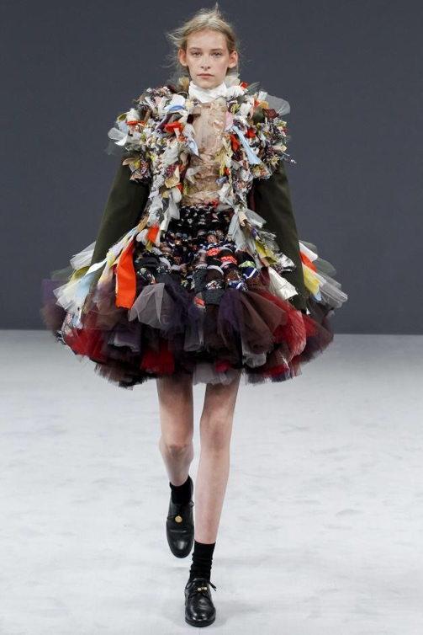
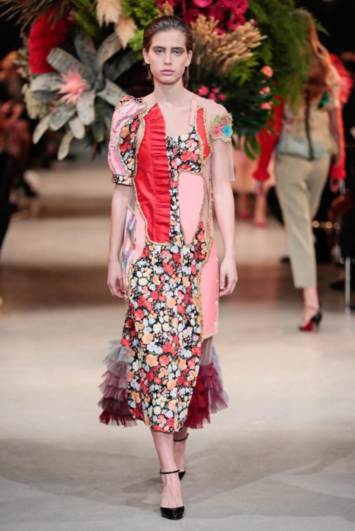
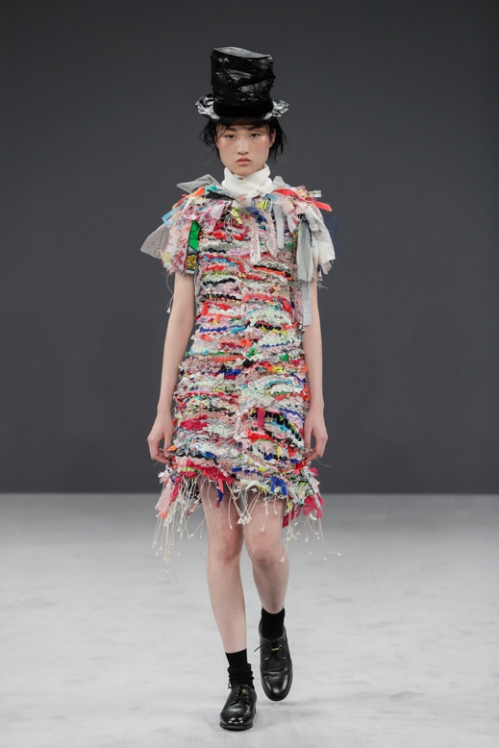
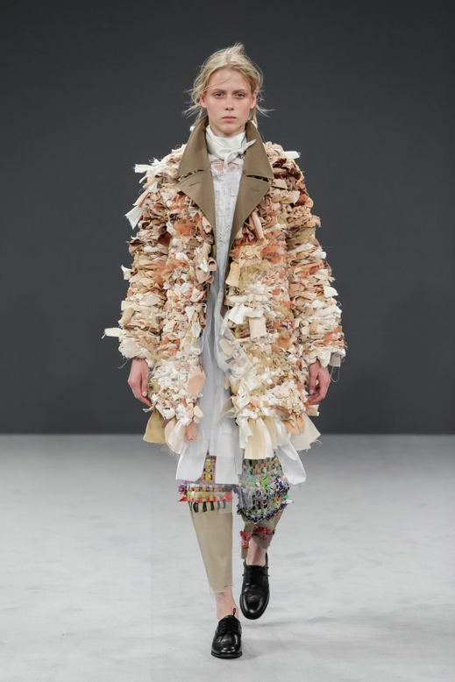
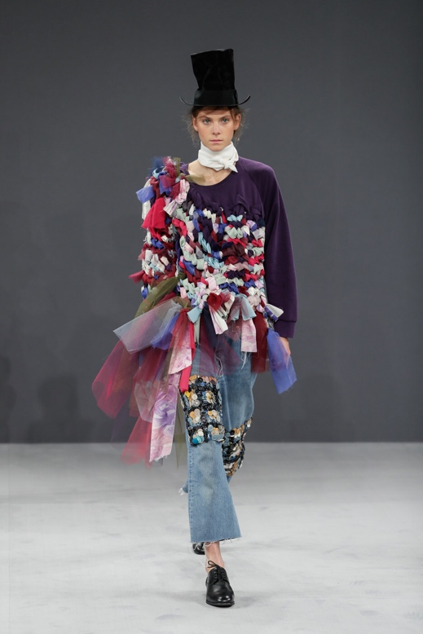
Figure 19
Figure 18
Figure 17
Figure 16
Figure 15

For the 4th designer I have decided to use Katie Jones, Katie Jones is a UK based designer who is well known for her eco-friendly fashion pieces. This designer uses left over fabrics and wools from other companies that are donated to her so she can re-use them to create her very own beautiful and abstract knitted garments. This artist hand crafts all her pieces by crochet and knitting, this really caught my attention as it symbolises to me that she is unwinding old collections from people and bringing them back to life in her own creative way to save them and this is what we all need to do in order to save our planet and bring it back to life. Hendriksz (2014) was a useful source of information.

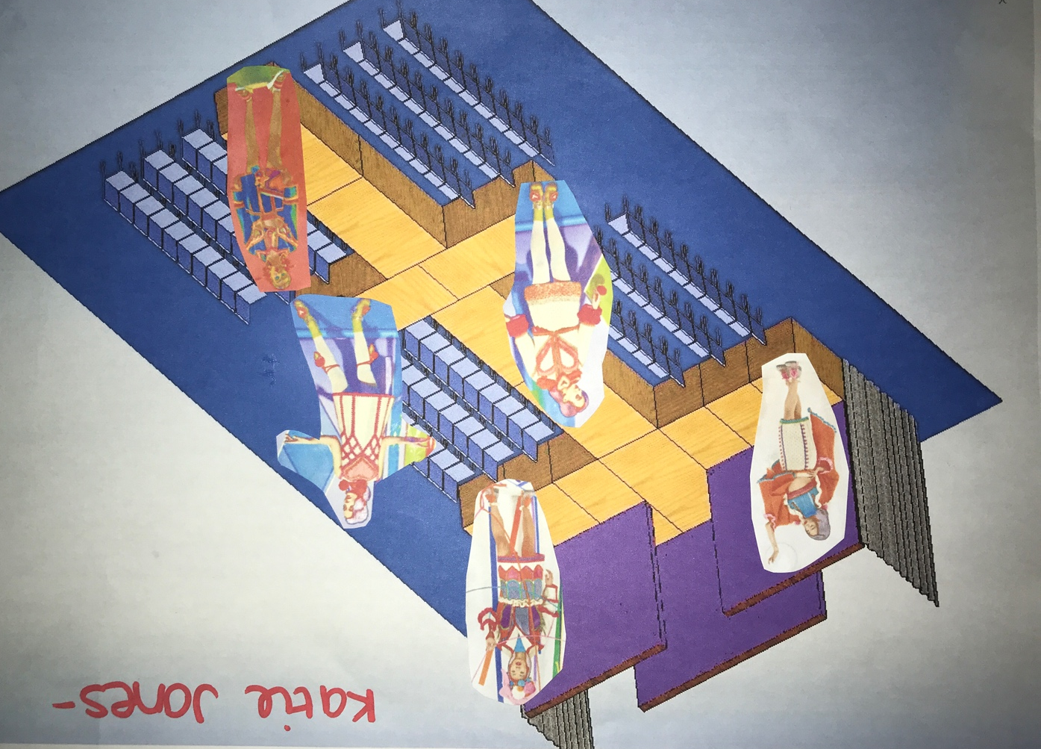
Figure 20

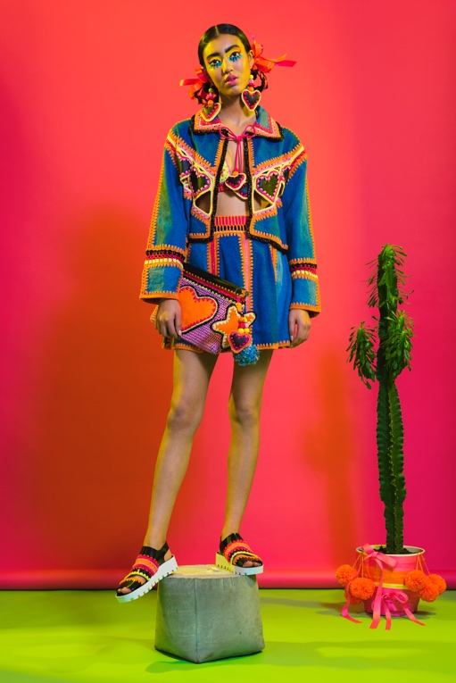
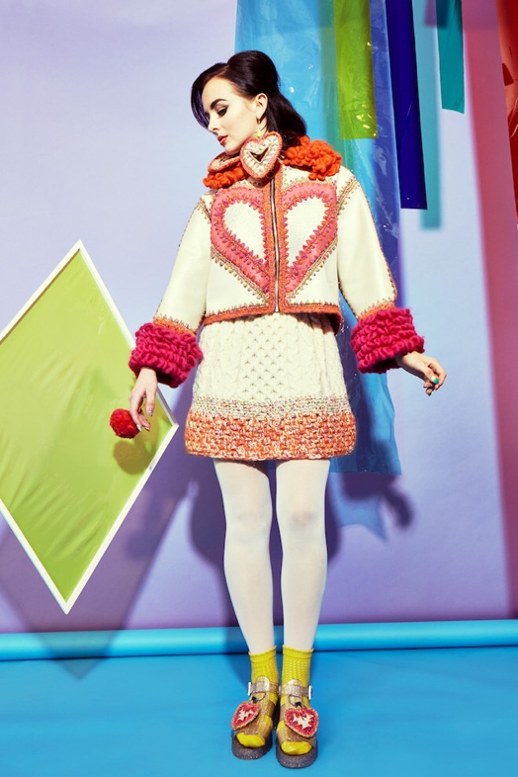
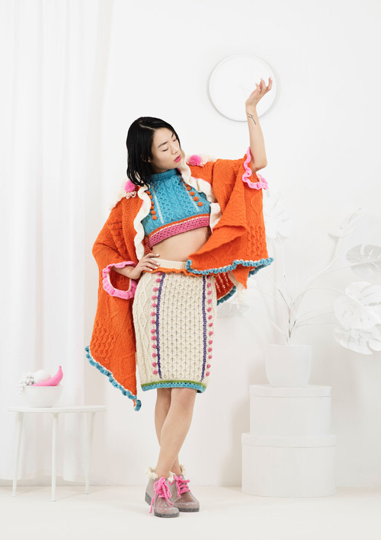
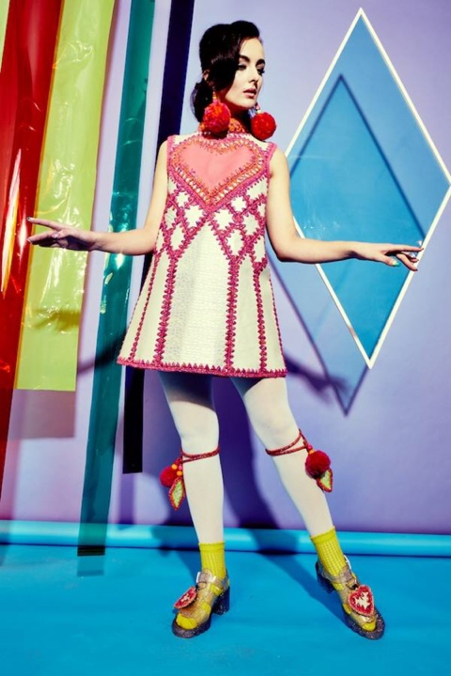
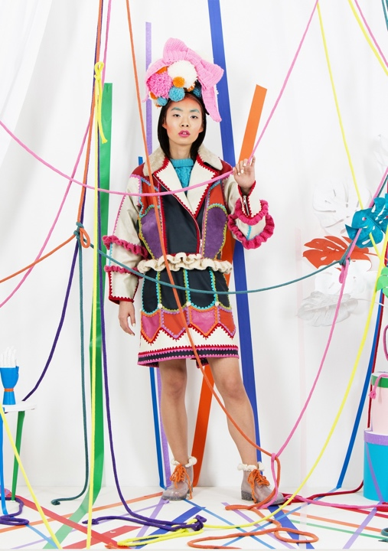
Figure 25
Figure 24
Figure 23
Figure 22
Figure 21

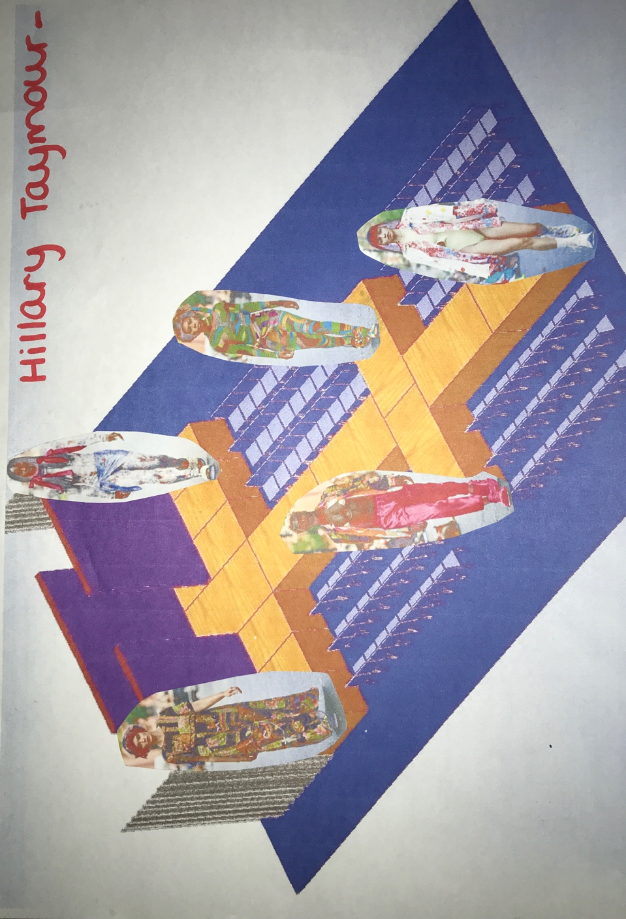
To finalise my curation, the last designer I will be using is Hillary Taymour’s collection also known as ‘Collina Strada’. Collina Strada is a label that Taymour produced to show awareness for climate change, she created an event show where people wore her collection and walked down the street in NYC almost like a protest which is really similar to the purpose of my fashion show so I feel this collection will have an outstanding final act alongside all the other designers I have chosen to participate. (Refinery29, 2019).

Figure 26

“Just like everyone deserves fashion, everyone should take responsibility for making it more sustainable” – Hillary Taymour.

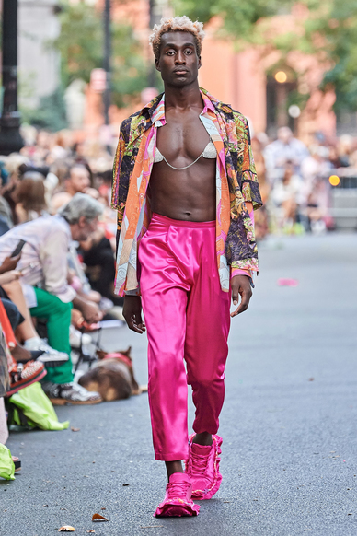
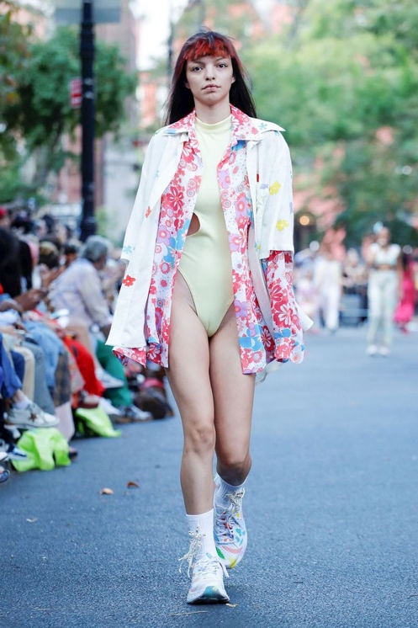
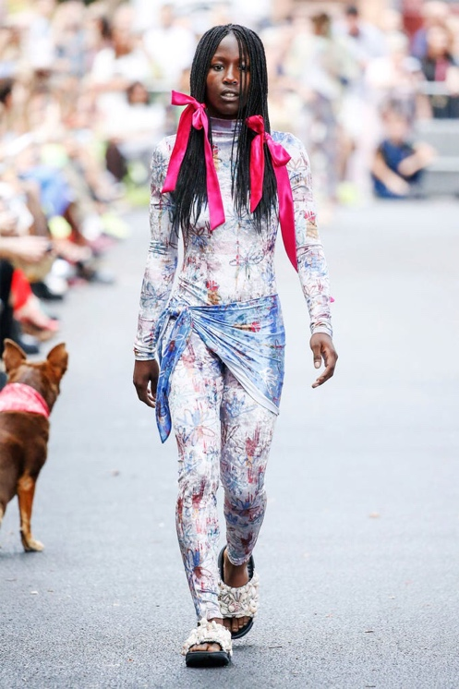
Figure 29
Figure 28
Figure 27

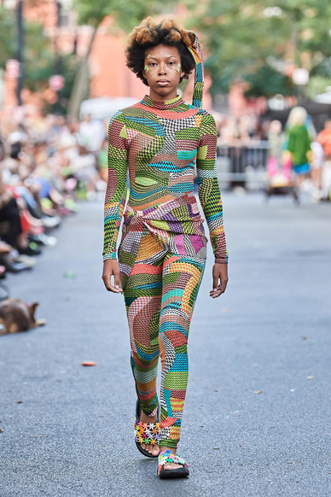
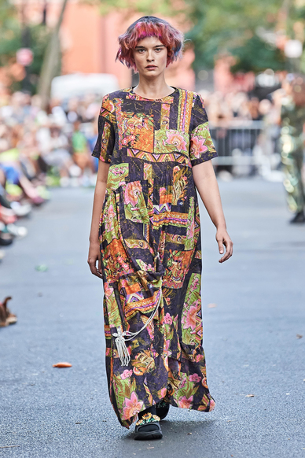

Figure 31
Figure 30

Figures

Figure 1- Trip Advisor (2020) Beach [Oxwich Bay] Swansea.
https://www.tripadvisor.co.uk/Attraction_Review-g186466-d215411-Reviews-Oxwich_Bay-Swansea_Swansea_County_South_Wales_Wales.html

Figure 2- Google Search (2019) Fashion show layout [Willis Tower].

https://www.google.co.uk/search?q=catwalk+layouts&client=safari&rls=en&biw=995&bih=660&source=lnms&tbm=isch&sa=X&ei=D91lVeL7FYGxUpSDgcAD&ved=0CAYQ_AUoAQ&dpr=2#rls=en&tbm=isch&q=fashion+show+layout+plan&imgrc=xLdgHx87qgEQkM%253A;p8sDdSLndJfzzM;http%253A%252F%252Fwww.jimpreston.us.com%252Fengineer%252FShowLayout2.jpg;http%253A%252F%252Fwww.jimpreston.us.com%252Fengineer%252Ffashionshow.htm;1095;858

Figure 3- Google Search, Tree Hugger (2013) Sustainable Fashion [Margret Badore].

https://www.treehugger.com/sustainable-fashion/vivienne-westwood-says-buy-less.html

Figure 4,5,6 and 7- British Vogue (2010) Spring Collection [Dolly Jones]

https://www.vogue.co.uk/shows/spring-summer-2010-ready-to-wear/vivienne-westwood

Figure 9- Fashion Capital (2020) Fashion Week [Sophie Lau].

https://www.fashioncapital.co.uk/insights/vin-omi-open-fashion-week-with-a-collection-high-on-innovation-sustainability/

Figure 10- Fashion Capital (2020) Fashion Week [Sophie Lau].

https://www.fashioncapital.co.uk/insights/vin-omi-open-fashion-week-with-a-collection-high-on-innovation-sustainability/

Figure 11- Fashion Capital (2020) Plastic waste with Blondie [Chris Daw].

https://www.fashioncapital.co.uk/industry/16013-vin-omi-highlight-plastic-waste-with-a-little-help-from-blondie/

Figure 12- Google Search (2018) Vin&Omi [Vouge].

https://www.vogue.co.uk/brand/vin-omi

Figure 13- The fashion plate mag (2020) Vin&Omi Eco only [Chris Yates].

https://thefashionplatemag.com/modern-culture/fashion-week/vinomi-fall-2020-collection-with-prince-charles-upcycles-materials-from-the-royal-estate/#jp-carousel-99896

Figure 15,16,17 and 19- Unhinged Group (2016) Vagabonds [unknown]

https://unhingedgroup.wordpress.com/2016/07/07/viktor-rolfs-vagabonds-wear-haute-couture-garments-made-from-scraps-of-recycled-fabrics/

Figure 18- Luxiders (2017) the imaginative upcycle [Viktor and Rolf]

https://luxiders.com/haute-upcycling-viktor-rolf/

Figure 21,22,23,24 and 25- Not just a label (2020) Collections [Katie Jones]

https://www.notjustalabel.com/katie-jones

Figure 27- Refinery29 (2019) the future of fashion [Gabrielle Korn]
https://www.refinery29.com/en-us/2019/09/8370369/collina-strada-nyfw-review

Figure 28,29,30,31- M.A.P (2019) Fashion Show [Charlie Engman]
https://www.mapltd.com/post/charlieengman/stylescollinastradaspring2020fashio/

Bibliography

CBS News (2019) 19th April.
https://www.cbsnews.com/news/earth-day-2019-fashion-industrys-carbon-impact-is-bigger-than-airline-industrys/

Olivia,M. (2020) Minimal how to simplify your life and live sustainably. Unknown.

Westwood,V. (2010) Get a Life. London.

Forbes (2019) ‘How Vin and Omi Became Sustainable Designers’, Contributor, 14th October. Available at:http://www.vinandomi.com/bio/4594291683 (Accessed 5th April 2020)

BBC, H.M. (2018) ‘London Fashion Week: Clothes made from recycled plastic’, Newsbeat, 16th February. Available at: https://www.bbc.co.uk/news/newsbeat-43074644 (Accessed: 5th April 2020).

Howarth, D.H. (2016) Viktor & Rolf’s Vagabonds wear haute-couture garments made from scraps of recycled fabrics. Available at: https://www.dezeen.com/2016/07/07/viktor-rolf-vagabonds-autumn-winter-2016-haute-couture-garments-recycled-fabrics/ (Accessed 16th April 2020).

Hendriksz,V. (2014) Katie Jones sustainable knitwear- Handmade in London with Love. Available at:https://fashionunited.uk/v1/fashion/katie-jones-sustainable-knitwear-handmade-in-london-with-love/2014092613829 (Accessed: 18th April 2020).

Jones, K. (unknown) About Katie Jones. Available at http://www.katiejonesknit.co.uk/about (Accessed 18th April 2020).

Refinery29, G.K. (2019) ‘Collina Strada Finds Joy in Sustainable Nod to The Future of Fashion’, unknown, 9th September. Available at:
https://www.refinery29.com/en-us/2019/09/8370369/collina-strada-nyfw-review (Accessed: 20th April)

