Introduction.

This report will provide a series of material choices for the proposed multi storey commercial hotel development in the SA2 area adjacent to Sketty park boating lake. The report will provide choices for the substructure and superstructure of the building and prioritising, fire safety, aesthetics, environmental impact and sustainability for these choices. Justifications for these choices over other materials will be provided within the report.

Location and desktop survey

Historical records indicate that the area was originally woodland, according to maps dated 1870 see Appendix 1, and later turned into a recreational area, according to maps dated 1940, see Appendix 2, with no further development of the site after this date as the site remains a playing field.

https://digimap.edina.ac.uk/roam/map/historic

According to geological data the proposed site comprises of landscaped ground with the substrate comprising of beach sand and gravel deposits, see appendix 3. This data is confirmed by bore hole data taken near to the site that indicates the area mainly comprises of sand and clay deposits, see appendix 4 and figure 1. below.

https://digimap.edina.ac.uk/roam/map/geology
https://api.bgs.ac.uk/sobi-scans/v1/borehole/scans/items/370520

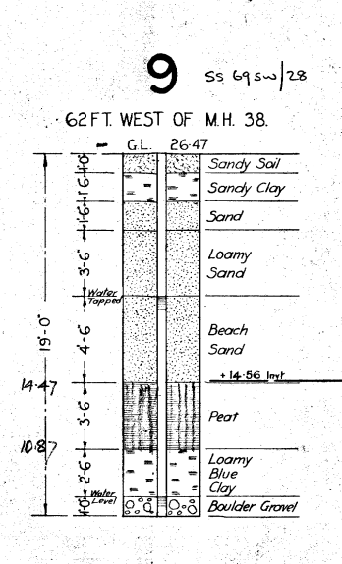
Figure 1.

The proposed area is located within the Swansea locality, historical climatic data shows that this area has a higher than average, for the UK in general, wind speed and double the rainfall when compares to England in general. Refer to Appendix 5. & 6. For reference.

https://www.metoffice.gov.uk/research/climate/maps-and-data/location-specific-long-term-averages/gcjjm7j5g

The geophysical data obtained will directly impact the material choice suitability, as an example, certain foundation types, such as shallow foundations, may not be suitable for soil unstable soil types, like the sand deposits at this location, this may in turn cause differential settlement when the loads from the building are placed upon them. The Climatic data for the proposed site will also affect material choice suitability requiring a more durable selection to cope with the wind loading and the amount of rainfall that the building will receive.

EAN – 9781119024989 ISBN – 9781119024989 CONSTRUCTION TECHNOLOGY – ANALYSIS AND CHOICE pg 369

Foundations & substructures

Since the proposed site is quite large and not restricted we recommend that the building does not incorporate any basement substructures such as underground parking, by building the parking facilities at ground level the building does not need to incorporate any basement construction as shown in figure 2.

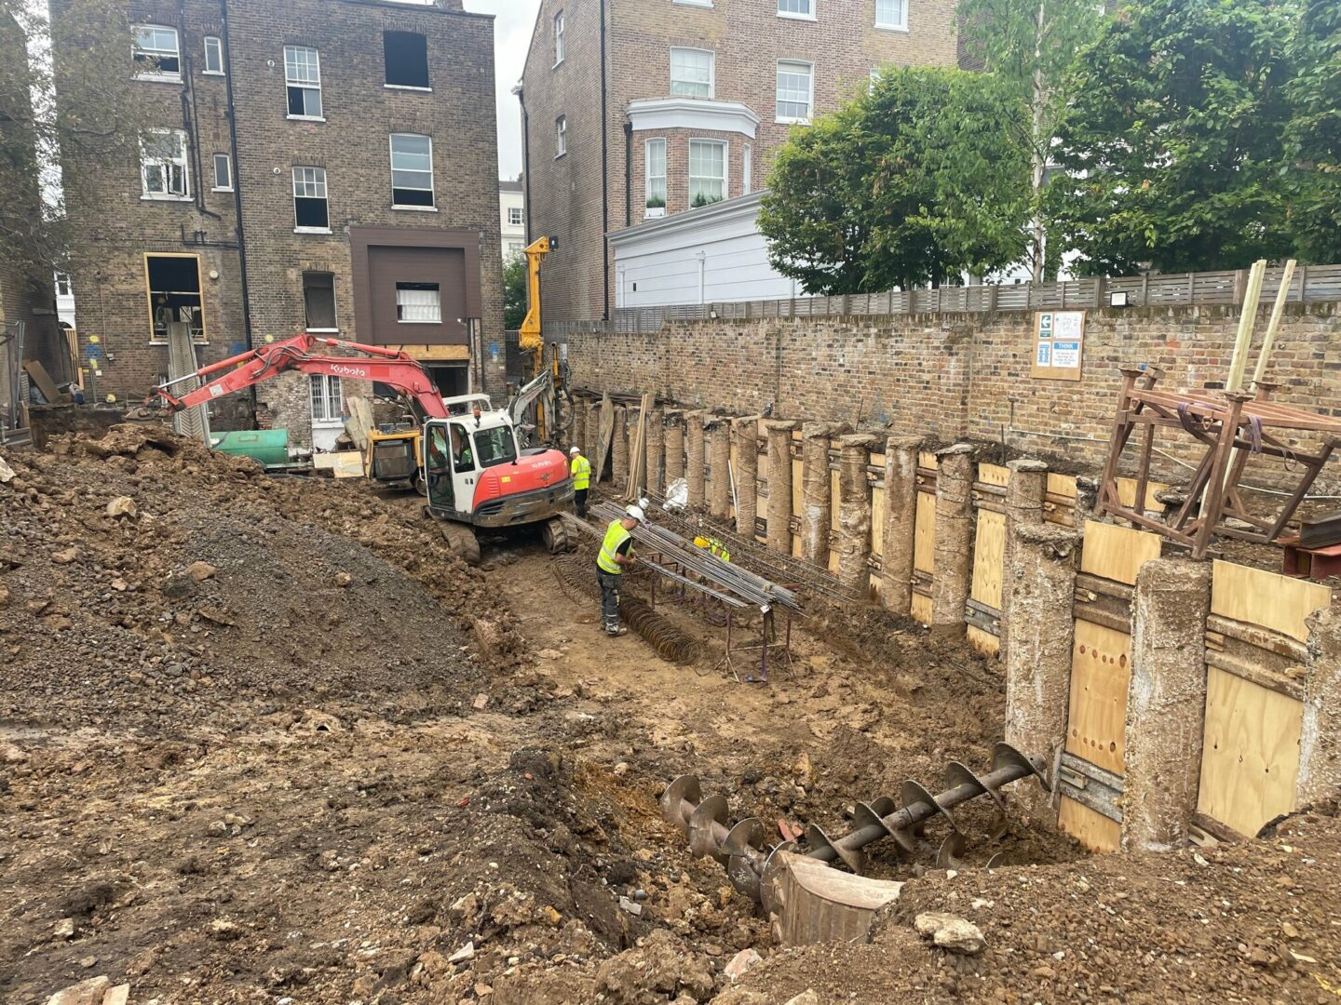
Figure 2.
bh-basements-hamilton-terrace-5-1440x1080.jpg (1440×1080)

By eliminating this feature, the amount of waste material due to excavations the construction of retaining walls can be eliminated along with the overall duration of the project reducing the project labour hours required to complete the building.
Reducing these will assist in reducing the overall embodied carbon of construction and reducing waste resulting in less environmental impact and making the building more sustainable. LETI embodied carbon 1 Pager, UKGBC PDF.

Due to the geophysical data available showing that the soils are made up of sand, clay and gravel and the depths of this deposits along with the heavy loads, kN, of a multistorey that will require significant support to prevent movement, for the proposed site we recommend the use of deep piling method of foundation to support the superstructure of the building.

Chudley and greeno 10th edition Pg 111

Deep piling is a method of producing a foundation for a building where columns, made of concrete, steel, or wood, are inserted into the existing soils deep into the ground to transfer the loads of the building into more stable substrata. Deep piling methods will provide sufficient load bearing properties for the multistorey building and giving sufficient resistance to movement in the soil type for this area.

EAN – 9781119024989 ISBN – 9781119024989 CONSTRUCTION TECHNOLOGY – ANALYSIS AND CHOICE pg 369

There are a range of piling methods available for use that mainly consist of either prefabricated, precast, sections that can be driven into place called displacement piles or cast in situ, bored pile called replacement piles, where a hole is drilled and the pile is formed on sit by pouring of concrete or other material into the hole forming the pile. Figures 3 & 4. Below show the two methods mentioned.
Chudley and greeno 10th edition Pg 112, 113
Construction technology 2 mike riley Pg110

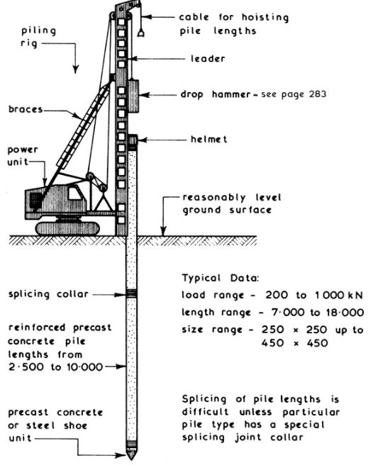
Figure 3. Driven pile.
Chudley and greeno 10th edition Pg 113

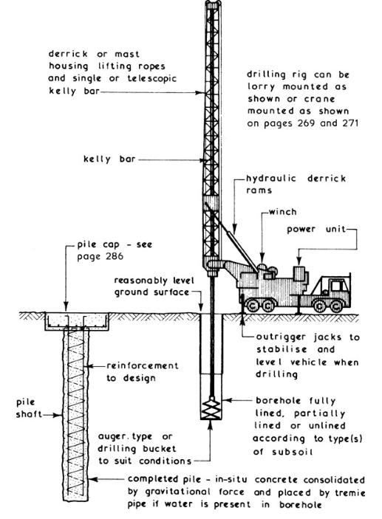
Figure 4. bored pile.
Chudley and greeno 10th edition Pg 112

By using a precast method, the amount of offsite construction is increased and there is minimal waste produced when compared to cast in situ.
There are several manufacturers that are producing more low carbon or recycled material piles than traditionally used, again reducing the environmental impact of the construction and the embodied carbon within the building.
Innovative Hollow Pile technology to reduce carbon emissions - Knowledge Transfer Partnerships
Driven Steel Tube Piles - Aarsleff Ground Engineering
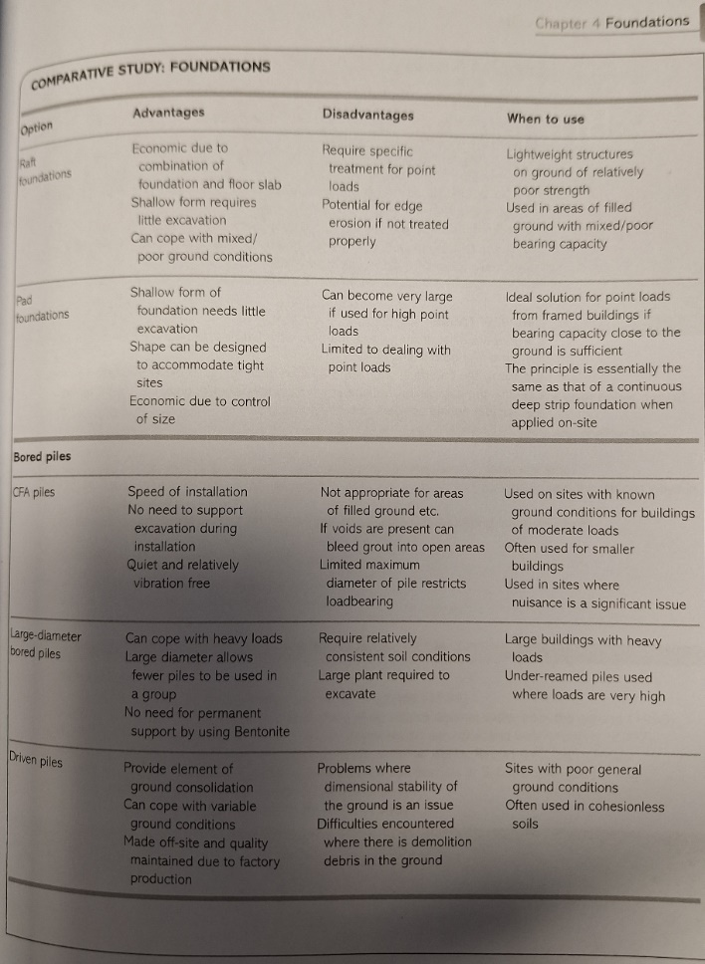
Figure 5. Foundation comparison.

Figure 5. above compares foundation types showing applications and advantages and disadvantages. After comparing this table, we propose the use of a displacement recycled pipe pile for the building, rather than using a replacement pile. Construction technology 2 mike riley Pg121
When reviewing the desktop survey of the site the ground is artificially levelled and when referring to the table if figure 5. This rules out the use of CFA piles on the basis that there may be voids in the ground, these displacement piles were used in sheerness docks in similar strata. Sheerness Docks - Aarsleff Ground Engineering
One of the disadvantages of using the driven piles is that they will produce significant noise when compared to a bored pile method however the proposed site is not in a residential area, and the risk of nuisance is negligible. The use of recycled piles will also improve the sustainability of the project by reducing the embodied carbon and by using a material that is easily recyclable when looking at the whole lifecycle of the building.
The exact specification of the pile will need to be determined after a structural design calculation, and ground investigation on site to determine the loads of the building and confirm the soil makeup.

Superstructure

The superstructure of the building comprises of the structural elements of the building from the ground up, this will transfer the loads imparted on the building from the materials used, the environmental conditions, and the from the users of the building to the foundations. This structure needs to be strong enough to withstand these, dead loads, previously mentioned along with being durable enough to withstand the climate conditions and the intended usage of the building, live loads.

There are two types of construction available for the proposed building, framed superstructure and traditional load bearing structure. Figure 6. Below shows the difference between these types of structure.

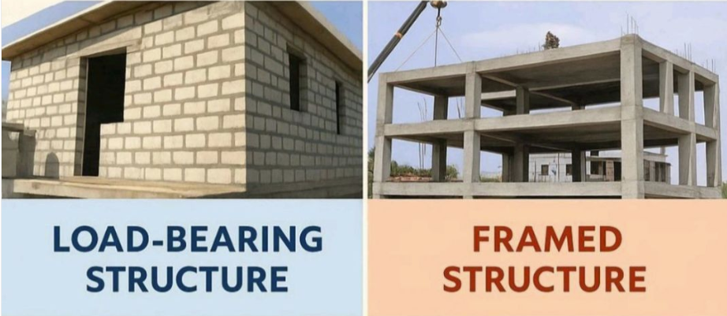
Figure 6.
Comparative Study: Load-Bearing vs Framed Structures | Md Kashif Hasan posted on the topic | LinkedIn

The traditional load bearing structure will require the elements of the building, such as walls, to transfer the loads to the foundations, this limits the range of materials that can be used in the construction process relying on brick, stone, or block walls and requires more on site construction than a framed superstructure raising the embodied carbon of the building.
The Monadnock building, shown in Figure 7. Below, in Chicago shows that high rise buildings can be constructed with a traditional load bearing structure although to be strong enough to withstand the loads the walls of this building reach 6ft thick at the base. This type of construction leads to restrictions on the buildings internal spaces with difficulty in creating large open plan spaces. This type of construction would increase the cost to complete in terms of extra materials required and the amount of time to complete the construction by not being modular in design.

About | Monadnock Building | Historic Office Building in Downtown Chicago

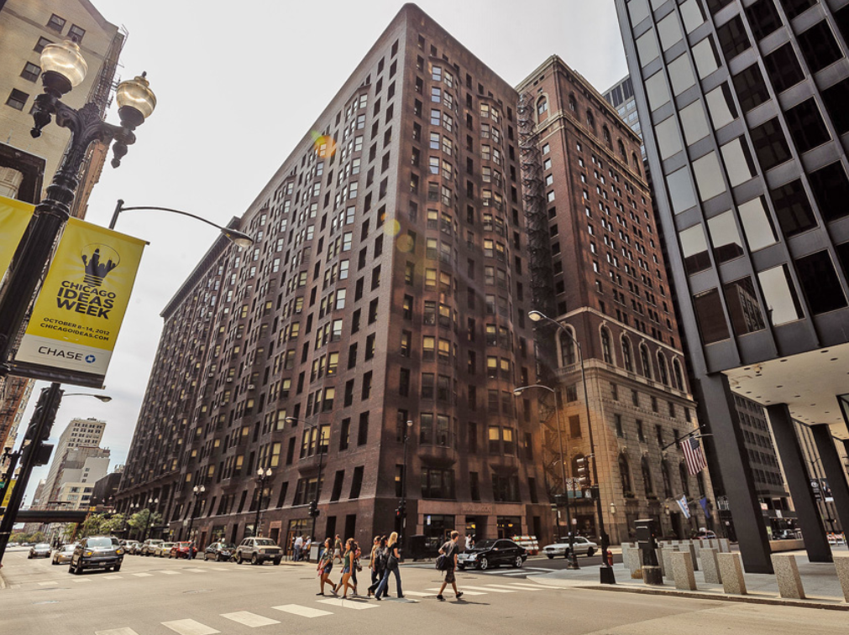
Figure 7.

Monadnock Building: The Last Brick Skyscraper | Amusing Planet

A Framed building will transfer the loads through the frame rather than the walls in traditional load bearing buildings. The use of a frame superstructure minimises the amount of space taken up by the superstructure in turn maximising the available internal space available, unlike the load bearing structure the thickness of the frame does not need to increase towards the base of the building to support the loads, as highlighted in the Monadnock building. This Frame can also be adapted to create large open plan spaces that can be adapted for different building purposes. The exterior of a framed building acts as the wind tightness layer only.
Construction technology 2 mike riley Pg172

For the proposed building we recommend the use of a skeleton framed superstructure because of the previously highlighted points. There are a range of materials available for the building framework. Frames are typically made from concrete, steel, and wood and can be a mixture of the above materials.

Steel and concrete are typically used for framed buildings but by combining the together to form reinforced concrete that uses the strengths of both materials, the compressive strength of concrete and the tensile strength of steel, you create a material that is incredible strong reducing the amount of material required to support loads. By using reinforced concrete and employing pre or post tensioning of the steel the material strength can be greatly increased. Both reinforced and tensioned concrete have excellent fire resistance providing a fire-resistant barrier with low thermal conductivity that will protect the steel within the concrete. Steel on its own can will increase in plasticity as it is heated reducing its mechanical properties and can require application of fire-retardant materials to protect in the event of a fire, to conform to approved document B, dependant on building size, application and firre suppression measures used. Construction technology 2 mike riley Pg 22 Approved Document B Volume 2 2020
Reinforced or tensioned concrete materials can either be formed on site, cast in situ, much like the replacement pilings, using formwork to create the shapes required or by using precast sections connected on site. By using precast, much like the displacement piling, there are several benefits.
The offsite construction process improves quality, reduces the amount of time on site to construct and the number of materials required to complete the building, almost eliminating the need for formwork construction except potentially the plinth and column connections. Again, this is the more sustainable building choice when compared to cast in situ framework because of the reduced material, and labour and site.

For the proposed building we recommend the skeleton framework be constructed from cross laminated timber, CLT, with reinforced precast concrete. Figure 8. Below shows the interior of a CLT framed building, the material consists of opposing layers of wood bound together to form panels, columns and beams this material can be classed as a modern method of construction.

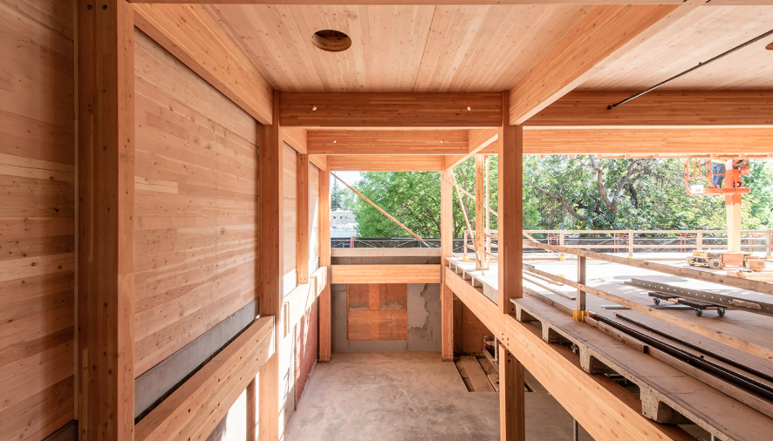
Figure 8.
The Big Picture: Building with Mass Timber | DPR Construction

CLT can be used to create multistorey buildings it has been used in multiple medium to high rise buildings, such as the Limnologen apartment complex, Växjö,
Sweden. & Brock commons student residence, Vancouver, Canada. Mass timber article
Inside Vancouver's Brock Commons, the World's Tallest Mass Timber Building | ArchDaily

The Limnologen apartment complex, Växjö Sweden. As shown in figure 9. incorporates the use of concrete ground floor to provide stability and the frame including lift shafts are constructed in wood, with a wooden façade and the use of
Limnologen - Arkitektbolaget

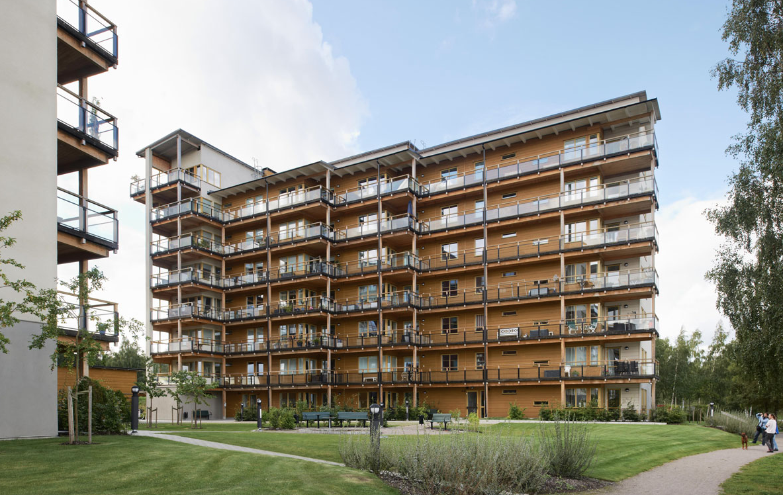
Figure 9.
Limnologen - Arkitektbolaget

Brock commons student residence, Vancouver, Canada. As shown in figure 10. Like The Limnologen apartment complex utilises wood frame and concrete elements to comply with fire safety regulations, this case study demonstrates that using this type of modular system can also be quicker when compared to erecting the same building in concrete. Inside Vancouver's Brock Commons, the World's Tallest Mass Timber Building | ArchDaily

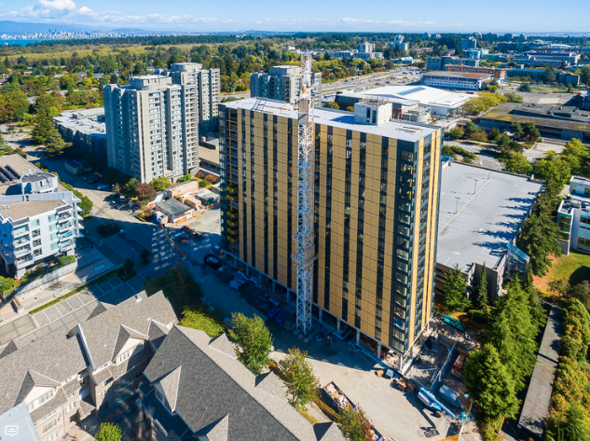
Figure 10.

CLT like precast and steel is manufactured offsite and is modular reducing the time to construct and just like concrete is resistant to fire due to the greater mass of the wood and the ability to form a fire-resistant char skin on exposure to fire, although the sections required to withstand the load and fire may be thicker than those of concrete and steel. It also has several advantages over these materials; it is more sustainable being a renewable material and has greater sequestered carbon due to the material being composed of wood. It can also be more visually appealing than concrete and steel and promote greater connection to the surrounding environment.
For the proposed building by combining CLT with elements comprised of tensioned concrete such as the stairwells the frame of the building can be sufficiently strong, fire proof, sustainable and visually appealing.
Construction technology 2 pg 202
Mass timber article.

Building envelope

The building envelope on a framed building is essentially the building outer wind tightness layer that protects the interior of the building and acts as the exterior visual appearance of the building. There are a range of different envelopes for a framed building infill panel, non-load bearing cladding, rainscreen, and curtain walls.
Each of these envelopes offers advantages and disadvantages, some of these are listed in the table below, figure 11. These systems can come in a range of natural and synthetic materials including brick, timber, aluminium and glass.

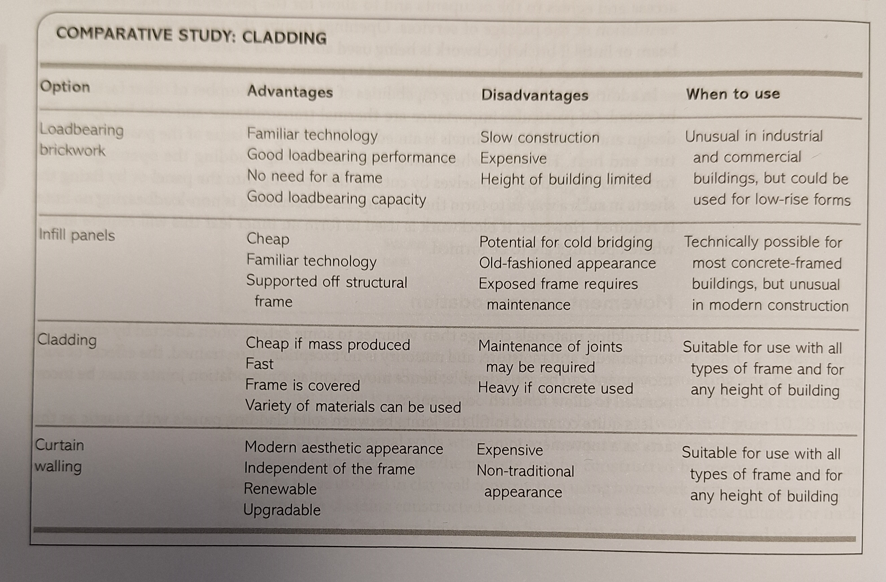
Figure 11.
Construction technology 2. Pg 280

Figure 12. Below shows a typical cross section of a rainscreen, system that is attached to the building this system can incorporate insulation and a weatherproof wind tightness layer, this type of building envelope system can also incorporate systems to allow for differential settlement, a range of material options are available for use.

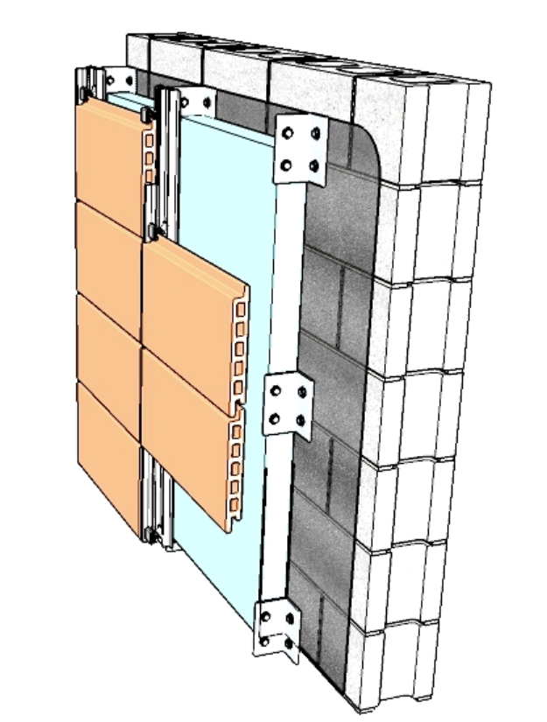
Figure 12.
https://www.designingbuildings.co.uk/wiki/Rainscreen
construction tech pg 269

For the proposed building we recommend the use of both a non-load bearing cladding system and a glazed curtain walling system. By combining these together in one building the advantages of both can be achieved, Brock commons student residence, Vancouver, Canada used non load bearing panels to seal the building envelope which allowed for quick completion of the project, the panels being modular and coming pre-assembled with glazing, figure 13. Below shows these being installed. The choice of finishes, including timber, are available and can match the proposed frame design to emphasis the timber frame construction and improve the aesthetics of the building.

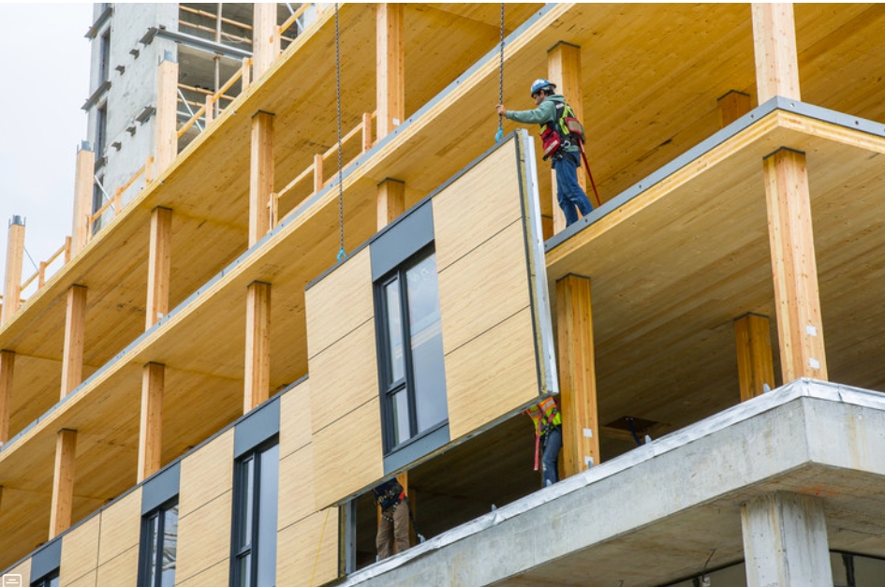
Figure 13.
https://www.archdaily.com/879625/inside-vancouvers-brock-commons-the-worlds-tallest-timber-structured-building

Case study: The Passive House | A&DS

By combining this with a glazed curtain walling systems the building can be designed in such a way the this can be incorporated into a passive heating and ventilation strategy making use of solar gains by maximising the use of glazing on aspect that benefits from the sun and using the cladding to insulate on aspects with the least amount of solar gains, the glazed systems can enhance the light withing the building and promote a connection between the interior of the building and the exterior environment.

Solar gain in buildings - Designing Buildings

Conclusion

By careful selection of material choices and building design buildings can be sustainable, they can meet the expectations of all stakeholders by being constructed quickly, efficiently and to better standards, be environmentally responsible lowering carbon emissions by using more renewable materials and offsite modular construction and minimise the impact the building has on the local environment.
By incorporating modern methods of construction, we are able to construct buildings that are resilient to the present day requirements and adaptable to future changing needs and environmental conditions.

Appendix.

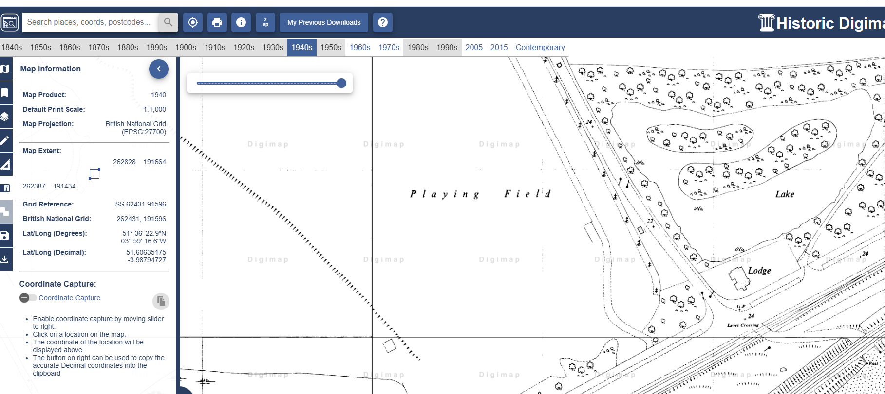
Appendix 1.

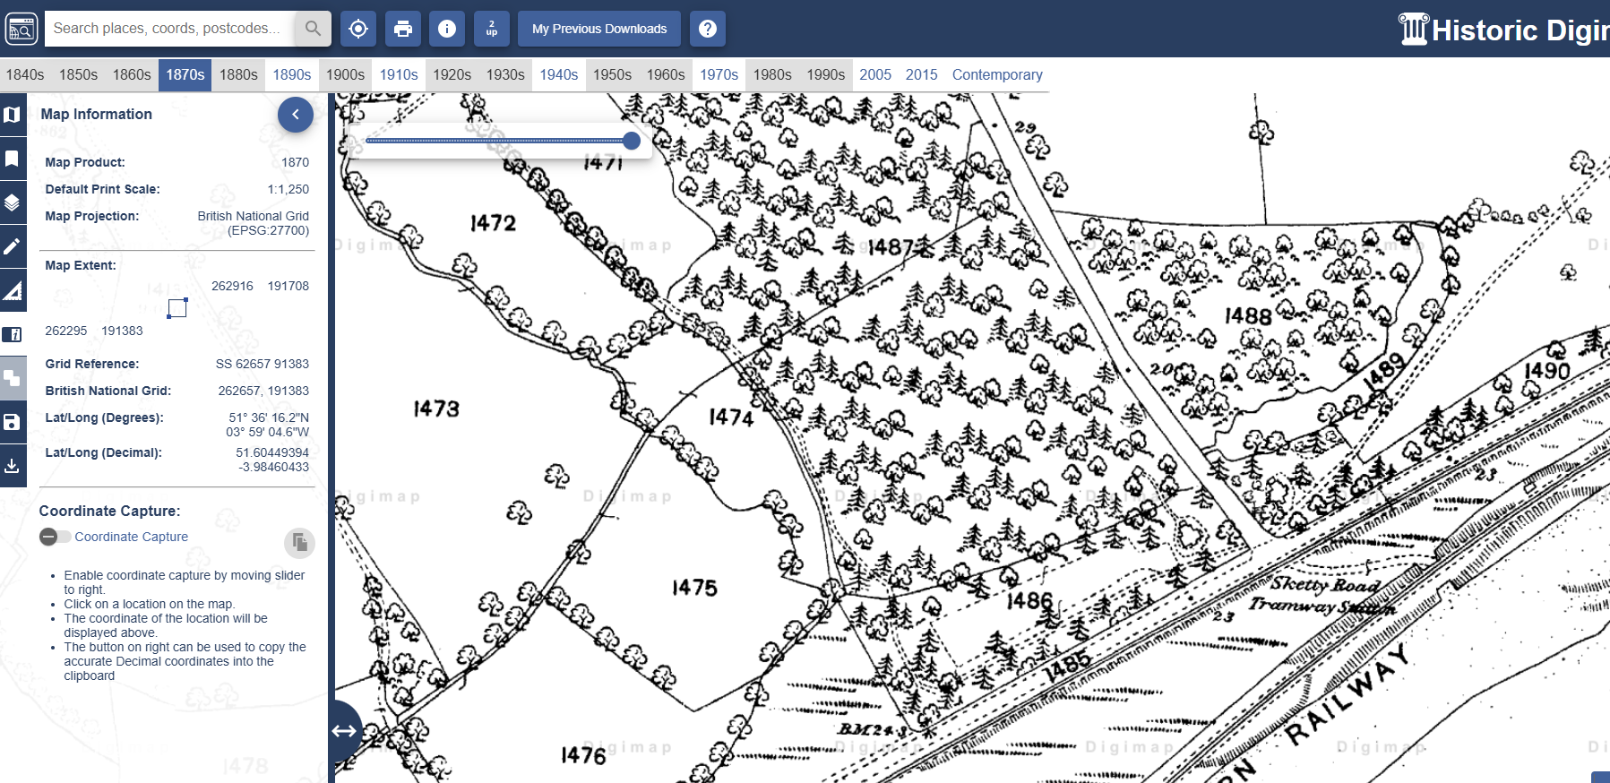
Appendix 2.

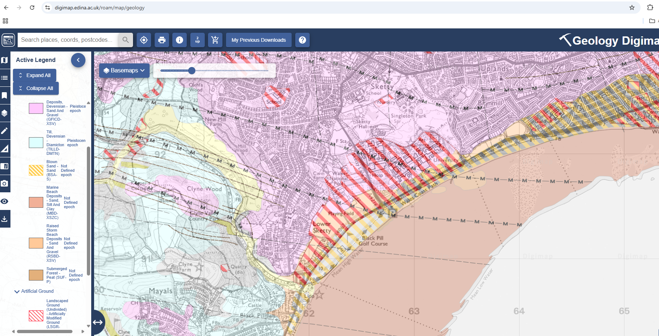
Appendix 3.

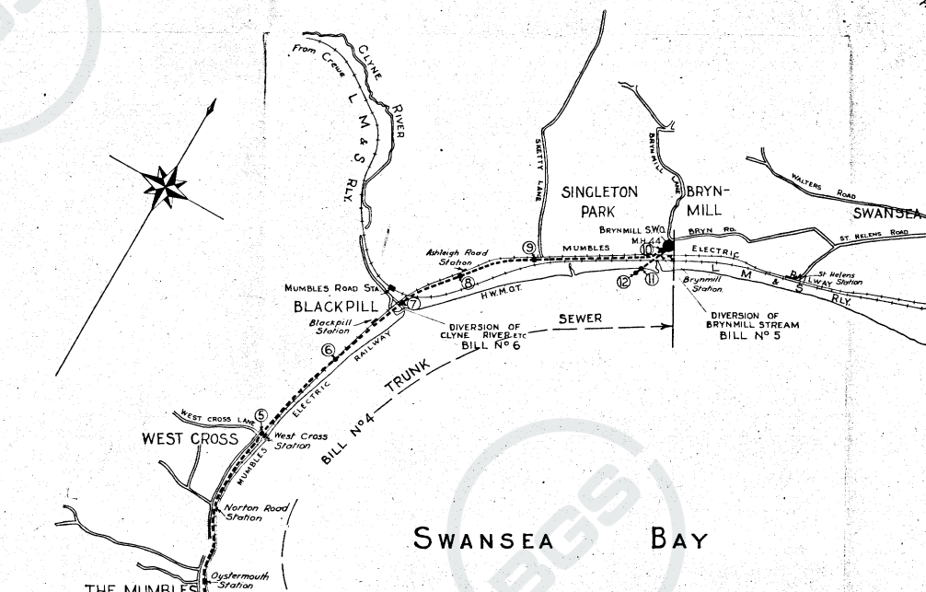
Appendix 4.

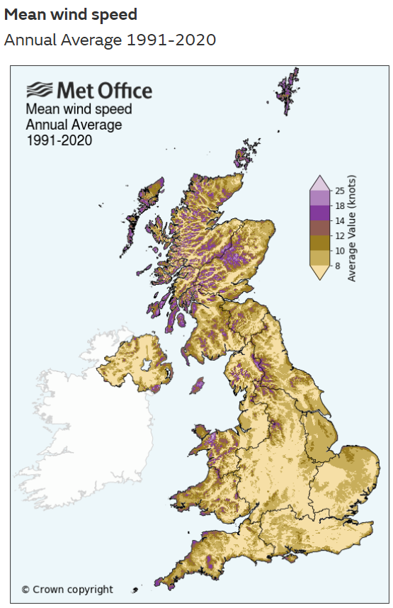
Appendix 5.

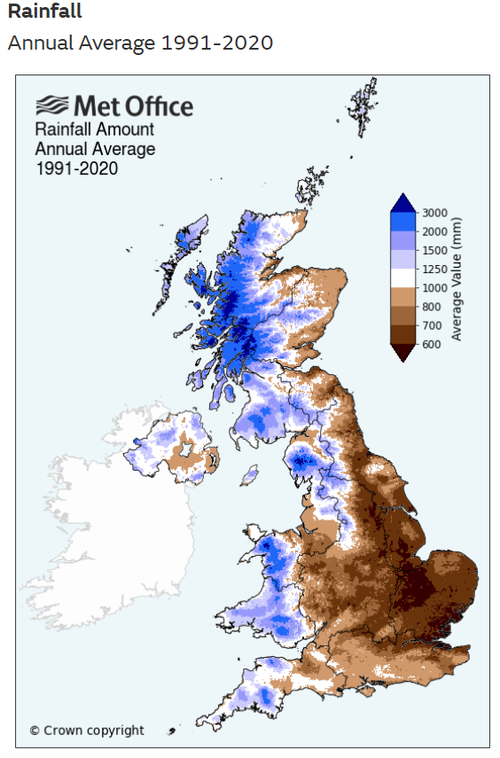
Appendix 6.

