LCBB4004
Samsung Company
“Focusing on Electronic Devices”
Ionela Filip-Datcu

Student id : 1922490
Lecturer : Efua Adams

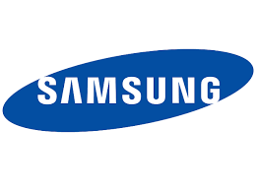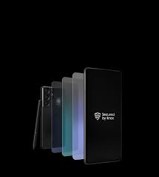


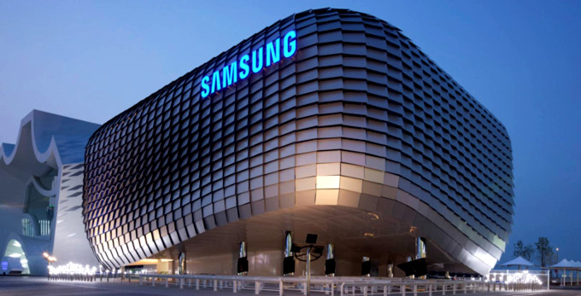
Background of the Samsung Company

Samsung is a company operating in Seoul, South Korea develops various types of products like- apparels, electronic devices, telecommunication devices, flash memory, chips, hardware drives, etc. After Apple Inc, Samsung is trending in the market as the second-largest company in the UK market with a profit of 221.6 US$. The company is in the second position among Apple Inc, Dell Technologies, Huawei telecommunications, Hitachi, and Sony electronics (Lamb, 2018).

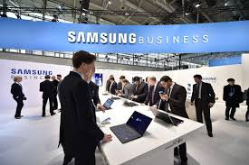
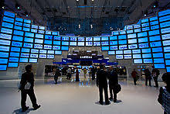
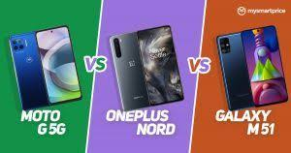
In 1938 Lee Byung -Chul who is the founder of Samsung developed the business with a small trading company. in 1947 it was spread into various other countries. He merged with another new company Samsung Electronics Corporation and together they formed today’s Samsung C& T Corporation. From 1960 it entered into the electronics industry and invented various electronic devices named by Samsung electro machines, semiconductor, and telecommunication.

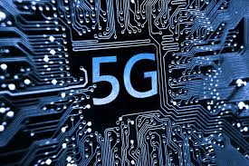
In 1970 it entered into the telecommunication and hardware market to develop telephone and manufacturing systems and produced 800 million. Though from 1980 the Samsung group began to so investment research and development activities in the industry. And introduced various of their work in England, Texas, Portugal, etc.

At that time, it became the largest foreign investment company in the USA.
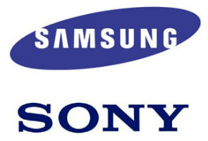
In 1990 Samsung started to operate as an international al corporation by establishes various projects in other countries. in 1992 it introduced memory chips and became the world, second chipmaker seller, after Intel. Though the innovation of liquid crystal display screen in 1995 has increased their market position in competition with Sony. Though in 2011 the Samsung had acquired the stocks of Sony as a joint venture.

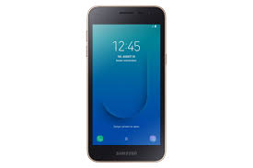
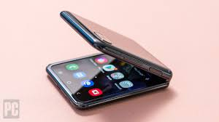
In 2000 it developed a center in Warsaw with digital TV and smartphones though they have developed it with partners involvement, and after that, it was developed the Samsung Galaxy in selling various devices. Though in 2010 it ensured a growth strategy in the market with 100 million of investment and with that it became the world's largest mobile phone maker company. When they took over Nokia its unit of sales increased with that (Blackstone, 2010).
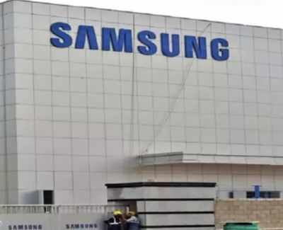
Though in 2015 it gained various patents in the USA like- Googles, IBM, Microsoft, Apple and receives 7679 patents. In 2016 it sold a high amount of Galaxy Note 7.
Through because of various reasons they had to stop the production of the phone in that year. Since 2018 it is developing in the Indian market with its new brands called Noida which has increased its business profit.

Marketing Mix of the Samsung Company

Product of Samsung Company
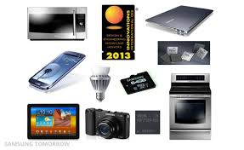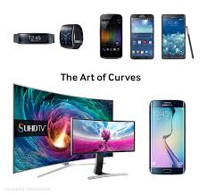

LCD and LED panels
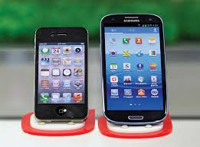
In 2004 Samsung became the world's largest manufactures of OLED with 40% of the market share which generated 100.2 million out of 475 million dollars. LCD television panels ensured the thickness of its sustainability of products. It ensured the company’s performance by maintaining its thickness in the business. With assuring flexible display it ensured its efficiency with the explanation to time and battery life of the tv.

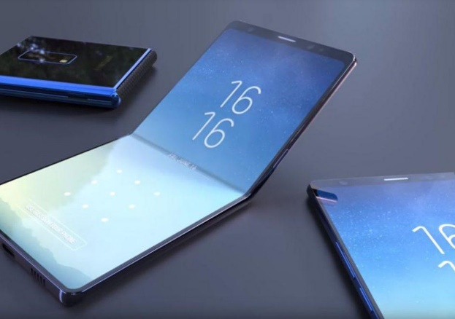
Mobile phones
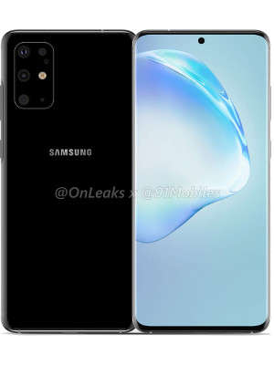
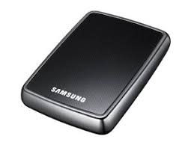
Samsung developed its mobile phones and manufactures them in various countries. it has a flagship mobile started named the Samsung Galaxy X series. It has a long-time battery which gained a large market. It's special it's long better and less charge consumption. Though with time various series of phones came into force. With Nokia and other brands, it became popular in the world.

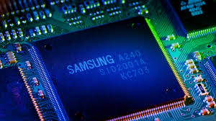
Semiconductor

Samsung has developed the largest memory chip with the largest semiconductor nodes, transistors, circuit chips, memory. It ensures large data capacity and data can be in a protected form (Van der Westhuyzen, 2017). With ultraviolet rays, the company is planning to develop the chips and increase its process.
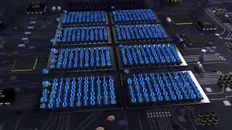
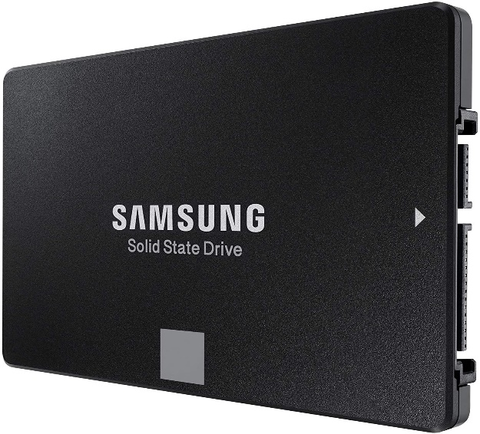
It can store a high amount of data in its flash memory, SDRAM, and can ensure mass production.
Solid-state drive
Portable hard drive with 15.36 GB capacity to store data with a thickness of 3,5 inches. With it, the first time SSD has generated this capacity availed in HDD. Though 2018 it was ensured 30.72 TB SSD with a SAS interface to allow them to continue to gather more information.
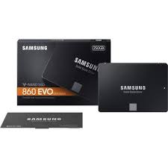
These devices use flash memory with them. And consumer portable USB devices have increased the device’s capacity to hold data (Mindtools.com. 2021).
Hard drive
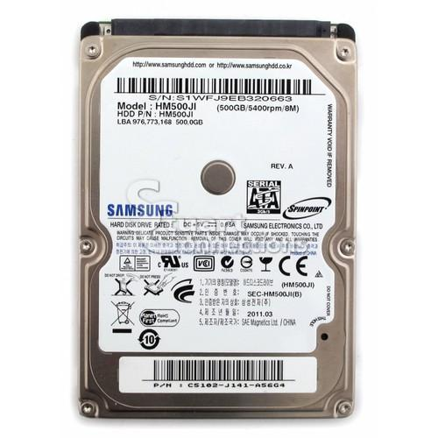
Samsung developed the hardware with 320 GB capacity in the marker with 2.5 inches of thickness in their disks. It owns 9.6% of the stake in the Seagate. In the hard drive, high data with various mathematical involvement can be stored so that the research work can be easier. In the various companies, it is used to ensure their business data separate hard disk for their data safety. With large data capacity, it can ensure the data position.
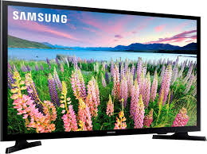
Television
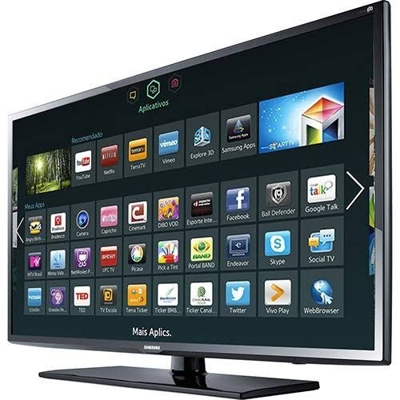
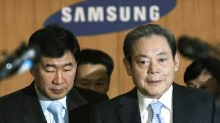
Samsung LED tv had generated much attention as it was 3D in 2010. Through internet technology with tv connection, it developed the TV first (Van der Westhuyzen, 2017). With the upgrade on the internet in their business, they used the features 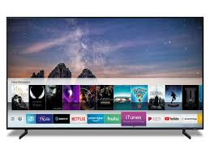of the TV. their television largest in size with eye protection monitor is used for the customers. And the combination of internet technology with it has ensured the capacity to use it in large motion.

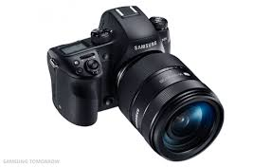
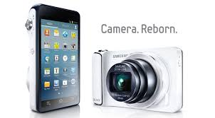
Camera

Samsung has introduced a digital camera and camera orders with ST550 dual-LCD mounted camera. It took third place in the camera segment. The focused of the product is clear conductor lenses which will help consumers to get a clear view.
The company launched NX10 as a next-generation lens camera with a higher capacity.
Speakers

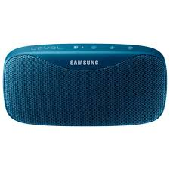
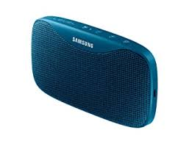
Since 2017 Samsung is selling speakers in the market in various types. These speakers are of many brands like- AMX, Crown, Revel, Sound craft, BSS audio, etc. The speakers have long sustainability with high volume and various other features. They also sell speakers which can be carried in the way by people to ensure the customer's satisfaction.

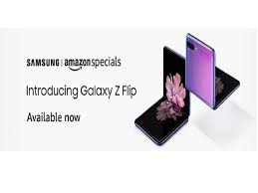
Prices of Samsung Products
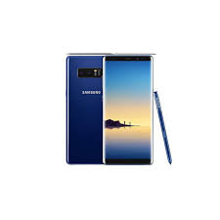
Products | Prices based on Specific Model
Mobile Phone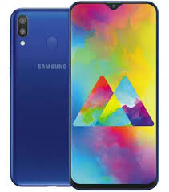 | Samsung Galaxy S6  Features: Edge SM- G925  32 GB LTF White  Price-$5499  Samsung Galaxy $6 64 GB LTE Gold  Price- $5299  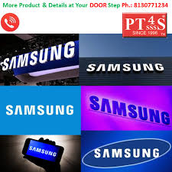
Samsung TV  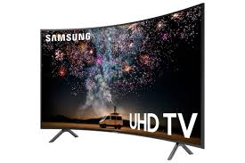 | Samsung Q90/Q90 T  4K model with Samsung Q800T QLED  Price-$ 7500  Samsung TU 800  VA panel with a high contrast ratio  Price- $ 6599
Camera  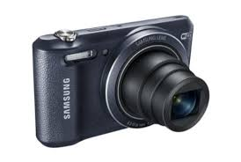 | Samsung Galaxy NX camera  18-55mm Lens  Prices-$3000  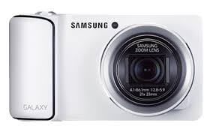
Speakers  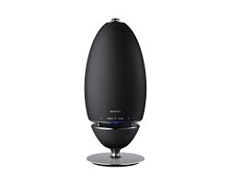 | Speaker HW-Q 60T with 51 channels, 360 Black HW-60T with wireless 160W  Price-$ 3999  Speakers- W Black HW-S40T, 2.0 channels, 100 W  Price-$4999
Hard drives | SSD 860 EVO 250 GB 1 TB with internet facility  Price- $74.99-$ 129.99  Samsung T5 Portable SSD 1TB, 100 GB, 22.39 inches  Price- $ 115.23
I pad  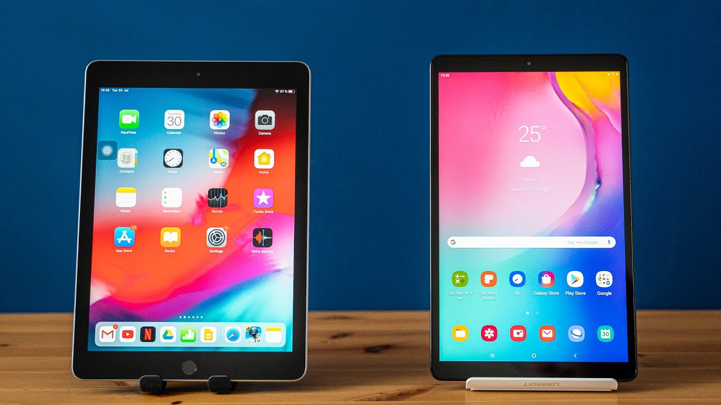 | Samsung WD Black SN750 NV Me SSD M. 2 500 GB  Price-$158.17  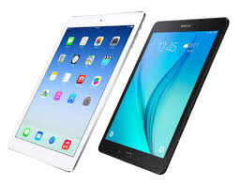
Samsung Panel | Samsung Q 95T QLED TV, 8K QLED TV  Price- $5900  With the features to 28 inches and high monitor protein with ultra-violate rays.
Semiconductor  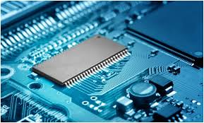 | Samsung PM133 conductor with Samsung Exons with 2 TB capacity to hold data  Price- $3499  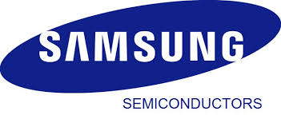
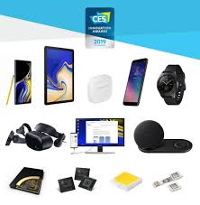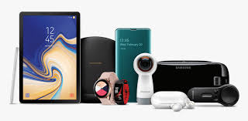

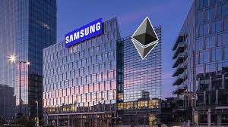
Place of Samsung Company

Samsung Store Location
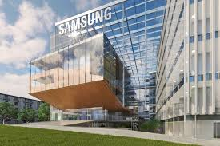
The company started its business in South Korea, Seoul first after that it invested in the various market in foreign countries- The UK, the USA, Portugal, England, etc. And with these set up the company has ensured the physical store in brick and motor development. In where they sell their every type of products. With various features, their production capacity is maintained (Investopedia. 2021).

Samsung Website and Online Stores
www. Samsung electronic.com
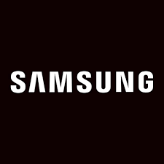
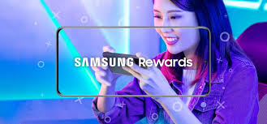

Samsung has set up its business in the online media where various websites of them have been developed to ensure the features of their products to the customers. through which the company can generate enough profit for the company (Opresnik, 2017). customers can order online from the website and they have added payment options in the websites for its strategy so that it can ensure the customer's time flexibility. With that various websites with Samsung games, I phone, tv, electronic media have been developed in the separate platform to reduce the customer traffic in one website.

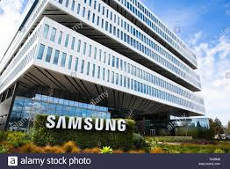

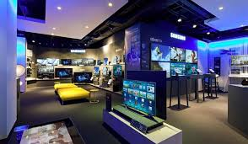
Authorized Sellers

For Samsung’s products to sell in the market with the highest distribution plan, the company has established relations with other companies. In other shops of various other companies like- Sony, Nokia, Apple, etc., they sell their products.

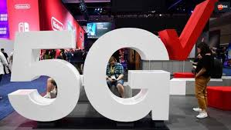
In various markets in shops, they have established a B2B relationship with the intermediaries who will sell their products to a large number of cu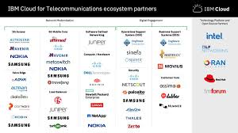stomers.
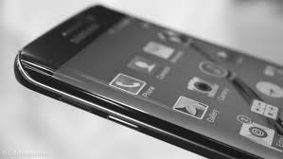
Telecommunication Strategies
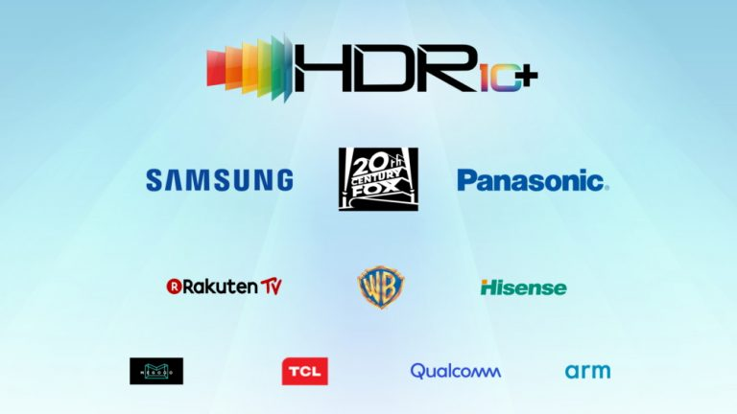
The Samsung company has established relationships with partnerships with other telecommunications companies (Lamb, 2018). Sprinters, Nokia has been partnered with the Samsung company so that’s they can operate in the international market without any barriers.


Because of ensuring partnerships they have reduced their entry barriers and created a place for them in the domestic and international market with the sustainable partnership agreement.
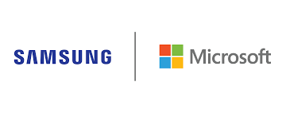
It has developed a partnership with Microsoft which has ensured its place more in the foreign market. And they have ensured their place with partnership and franchising agreement.
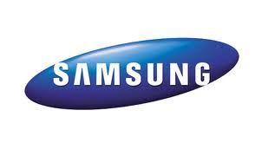

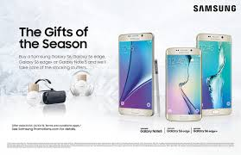
Promotions of Samsung Company

Advertising
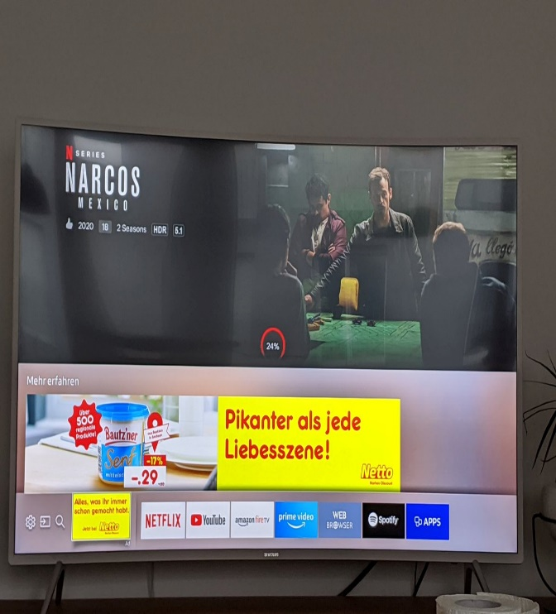
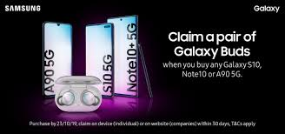
For the advertising activities, the Samsung company has developed relations with various other websites of various companies (Blackstone, 2010). So that those websites can advertise the products of Samsung with their websites. Google, Sony, Apple, Nokia in their online website develop their advertising strategies so that they can do the business effectively to generate more customer attraction. For advertising, they invest in the national media, tv with the online mobile application.
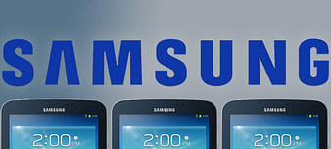

Personal Store Selling
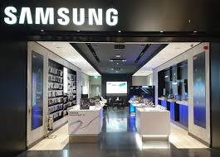
Samsung company sale their products in their stores established into various shopping. They can sell through other stores and can sell on social media (Blackstone, 2010). In their stores they have set up various products of them like- tv, I pad, mobiles phone and other electronics by which they can establish their business in the own shop. Without intermediaries in the shop, it can establish its business profit for business so no sharing is required.

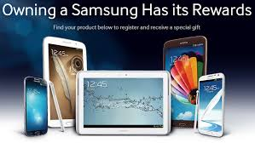
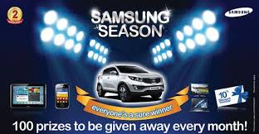
Sales promotion

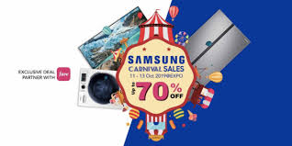
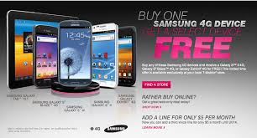
For sales promotion, Samsung company has developed various marketing strategies in their business environment. With sale promotion, the business advertises their products in the online media. They should invest in other areas to promote their business like- with outlets, podcasts, templates are added when customers are entered into the market. And to get more attraction they add discounts and gifts for their customers.
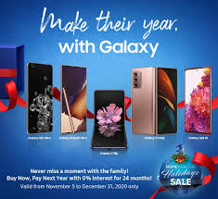

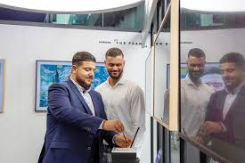
Public Relations

To ensure the public relation the Samsung has established in the market various strategies with other companies so that they can establish relationships with the domestic and foreign companies (Armstrong, 2017). And with these relations, they can eradicate their competitive advantage and get various ideas to operate in the market.
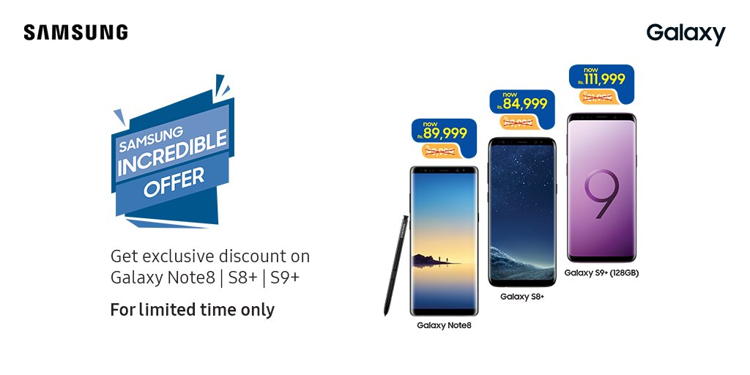
The market strategies will help them to determine the business growth. Public relations in the business can establish their high operating and financial performance to promote their business.
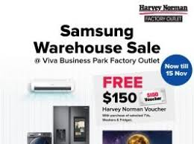
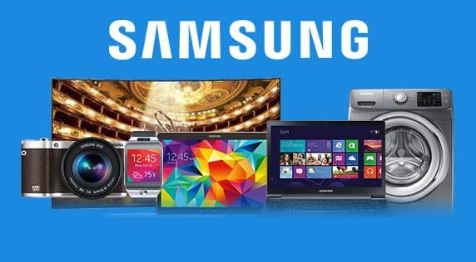

References
1991. Marketing mix. Madrid: Ediciones Díaz de Santos.
Armstrong, G., Kotler, P. and Opresnik, M., 2017 Marketing.
Blackstone, W., 2010. Commentaries on the laws of England, in four books. [Place of publication not identified]: Nabu Press.
Blackstone, W., 2010. Commentaries on the laws of England, in four books. [Place of publication not identified]: Nabu Press.
Investopedia. 2021. Marketing Mix. [online] Available at: <https://www.investopedia.com/terms/m/marketing-mix.asp>
Lamb, C., Hair, J., McDaniel, C., Boshoff, C., Terblanch©♭, N., Elliott, R. and Klopper, H., 2018 Marketing.
Mindtools.com. 2021. The Marketing Mix and the 4Ps: Understanding How to Position Your Market Offering. [online] Available at: <https://www.mindtools.com/pages/article/newSTR_94.htm>
Van der Westhuyzen, B. and Van der Merwe, J., 2017. The marketing mix. Mowbray, South Africa: Future Managers.

