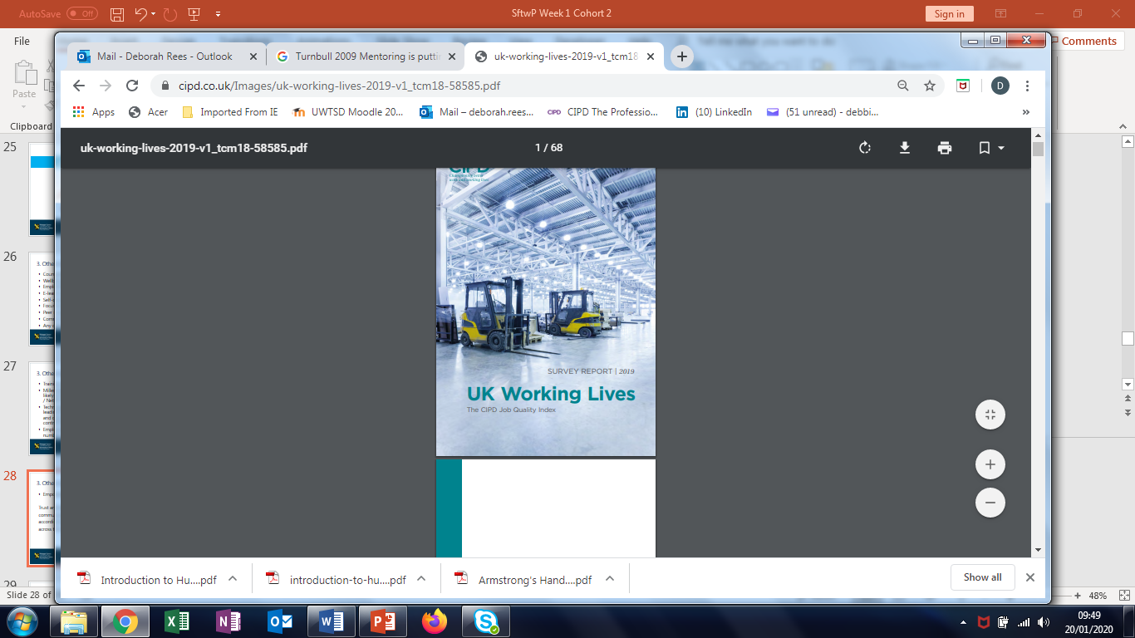

UK working Lives – The CIPD Job Quality Index: June 2019
Good work and jobs - this principle has been called out amongst the UN sustainability development goals for the world by 2030.
For example, for work–life balance, our ranking puts the UK 24th out of 25 comparator economies.
The CIPD is co-chairing the Government’s Flexible Working Task Force, with the aim of understanding and promoting the broader take-up of flexible work in all its forms.
The CIPD describes good work as follows: Good work is fairly rewarded. Good work gives people the means to securely make a living. Good work gives opportunities to develop skills and a career and ideally gives a sense of fulfilment. Good work provides a supportive environment with constructive relationships. Good work allows for work–life balance. Good work is physically and mentally healthy. Good work gives employees the voice and choice they need to shape their working lives. Good work should be accessible to all.

Work-Life Balance

- Considering working hours, we find that three in five employees work longer hours than they would like to, taking into account their need to make a living.
- Overwork is most common among managerial and professional workers.
- It is also more common among those who work from home, showing that flexible working may not always solve tensions between work and personal life and may even contribute to the blurring of the boundaries between them.
- More than half of UK employees (54%) worked flexibly in some way in the last year
- The main drivers for flexible work arrangements are caring responsibilities (especially for women) and increasing leisure time (especially for men).
- Our survey finds that, excluding the self-employed, one in five employees has no flexible working arrangements available to them in their current job.
- two-thirds of UK employees (68%) would like to work flexibly in at least one form that is not currently available to them.
Pay and Benefits
- Just under half of workers consider themselves to be paid appropriately, considering their responsibilities and achievements, and over a third do not. Those who are happier with their pay are also happier with their job overall.
- According to an OECD measure, the UK is slightly below average in ‘earnings quality’, a measure that accounts for both the level of earnings and their distribution across the workforce. The UK sits 15th out of our 25 comparator countries, alongside the United States and New Zealand
- 7 in 10 employees saving for a pension
Contracts
- More than three-quarters of UK workers have a permanent employment contract, whether full- or part-time.
- Other contingent or ‘non-standard’ contracts are relatively uncommon: these include temporary (2.5%) and zero-hours contracts (2.4%) and work in the gig economy (3.5%).
- Workers on non-standard contracts and those reporting underemployment are also more likely to have more than one job. This suggests that financial necessity may be a key driver for holding multiple jobs.
- UK workers fare better than average in contractual stability, based on international measures of part-time and temporary employment. The UK sits 8th out of 25 comparator countries, alongside the United States and Slovenia. Estonia, Hungary and Norway come top, and France and Spain come bottom.

Job Design and Nature of Work
- Workload is a serious problem in the UK. A third of workers feel they have too much work, one in five workers say they cannot complete their tasks in their allocated hours, and one in twenty feel completely overloaded by their jobs.
- However, the great majority of workers report having adequate work resources (other than time).
- Another factor that affects people’s ability to cope with pressure is work autonomy, that is, how much they can control what work they do and how and when they do it. Most people have at least some autonomy over their work – for example, 45% have ‘a lot’ of control over how they do their work, with a further 32% having ‘some’ control.
- Meaningful work Around three-quarters of workers feel their jobs are meaningful in that they make a useful contribution to their organisations; just 9% of workers, or one in ten, do not.
- However, when we look at a higher order of meaningfulness, we see a less positive picture: almost one in four workers feels that their work does not offer a useful contribution to society.
- Skills Most workers consider themselves to have the correct qualifications for their job (64%) and half feel they have the right skills (51%). This means that almost half of workers report a skills mismatch. Here, overqualification (reported by 32%) and over-skilling (37%) are greater than lacking qualifications and skills.
- Around half of workers consider their job to offer good opportunities to develop their skills, but only three in ten workers see this translate to good prospects for career advancement.
- Younger workers tend to have more opportunities to develop, reinforcing the CIPD’s view that UK skills policy needs to do more beyond apprenticeships to help all workers, at all stages of their working lives, to develop.

Relationships at Work
- Incidence of blame from management (19% of workers) and being excluded for being different (22%) is not uncommon.
- Three in ten workers report at least one form of bullying or harassment in the workplace in the last 12 months.
- For one in seven workers, a case remains unresolved. Forms of conflict at work differ in particular by gender.
- Women record more cases of being undermined or humiliated and unwanted sexual attention or harassment
- Men report more physical threats and false allegations.
- We also note differences according to race and sexual orientation or gender identity, with BAME and LGBT+ workers more likely to face discrimination or being undermined or humiliated
- The consequences of conflict are clear to see. More than one in four workers reporting workplace conflict in the last 12 months say they are likely to quit their job in the next year (almost double than for workers who experienced no conflict
- The quality of work relationships in the UK is average by international standards, according to a measure of relations between management and employees. The UK sits 12th out of 25 comparator countries, alongside the United States and Hungary

Voice and Representation
- Although workers tend to have a range of channels for voice, there is a concern about the willingness of managers to genuinely consult them on decisions and even to keep them informed about organisational developments.
- For example, three in ten workers say their managers are poor at responding to suggestions, and only four in ten say that they are good.
- Direct methods of voice are the most common, including one-to-one meetings, team meetings and employee surveys. There are considerable differences between sectors in the channels available to workers, with employee surveys and trade union representation less common in the private sector.
- Employees who have union or non-union representation, on average, are positive about their representatives, although about one in four employees feel their representative’s performance is poor.
- Internationally, levels of trade union density in the UK are slightly above average, according to an international measure for 25 comparator countries. The UK comes 10th out of 25, alongside Austria, Slovenia and Chile.

Health and Wellbeing
- UK workers tend to believe that their jobs have a positive impact on their physical and mental health
- Mental health benefits are especially pronounced.
- Workers also tend to report positive feelings about their job, such as enthusiasm.
- However, work acts as a considerable stressor for a worrying proportion of us, and notable proportions report boredom in their job.
- Intense and stressful working conditions – including feeling exhausted, miserable or under excessive pressure – are reported by up to one in four workers.
- Two in five workers report having experienced some form of work-related health condition in the last 12 months.
- The most common health problems resulting from work are musculoskeletal, anxiety and sleep problems.
- Internationally, UK workers have slightly worse health and well-being at work than average, according to measures of job strain and stress. The UK sits 16th in a list of 25 comparator countries, alongside Hungary and Austria. Israel, Switzerland and New Zealand rank top

National Readership Survey Social Grade Groups
A – Higher managerial, administrative and professional
B – Intermediate managerial, administrative and professional
C1 – Supervisory, clerical and junior managerial, administrative and professional
C2 – Skilled manual workers
D – Semi-skilled and unskilled manual workers
E – State pensioners, casual and lowest grade workers, unemployed with state benefits

- Higher-grade occupations are defined above all by more skilled and complex work and better paid jobs. But we also find clear trends in other aspects of job quality. In particular, those in higher-grade jobs tend to have more control over what work they do and how and when they do it, more meaningful and motivating work, and more opportunities to develop their skills and careers. We see these differences reflected to a degree in general levels of job satisfaction.
- However, those in higher-grade jobs also tend to commute more and, despite making greater use of flexible working, find it harder to switch off from work and are more likely to feel overloaded and not have enough time to do their work. The net effect of this can be summed up in the fact that, compared with those in lower-grade occupations, their jobs are more likely to lead to stress and negatively affect both their mental and physical health.
Public / Private Sector
- Meanwhile, although working in the public sector generally appears to be associated with better job quality, public sector workers fare worse in some respects, including lower quality of relationships and greater incidence of conflict at work. We also find key differences between traditional and other forms of work, with workers in temporary, zero-hours and short-hours employment subject to lower-quality jobs in a number of dimensions.
Realistic Perspective
- it is not realistic to expect all jobs to be equal in all ways. Moreover, if we look at broad categories of occupations – such as the NRS social grades – we see that they all contain some characteristics of good work and characteristics of poor-quality work. It seems most of us make some trade-offs;
The Future
- These broad associations between good-quality work and productive organisations need to be unpacked and analysed in more detail, yet it is clear that within them there lies a huge opportunity to improve job quality. Some improvements will bring immediate mutual gains for workers and employers alike – for example, certain flexible working arrangements may be ‘no brainers’ for organisations to implement.
- Other improvements will undoubtedly have cost implications in the short run, but may deliver longer-term returns for employers through more productive and committed workers. But all improvements must be encouraged where possible

https://www.cipd.co.uk/knowledge/work/trends/labour-market-outlook - Labour Market Outlook Report – November 2019
Introduction
- This Autumn, employment confidence remains high. BREXIT -Businesses expressed an intention to take a business as usual approach to staff resourcing.
- The proportion of employers expecting to increase staff levels has grown, particularly in the public sector, and pay expectations remain steady. Despite uncertainty, this shows that orders still need to be filled and talent pipelines staffed.
- Increased confidence among public sector employers suggests that constraints on pay in the sector have eased. Pay expectations in the sector for the next 12 months have increased, and more employers are prepared to raise salaries in response to recruitment and retention difficulties.

Labour demand
- Demand for labour among employers remains strong. This quarter’s net employment balance – the difference between the proportion of employers expecting to increase or decrease staff levels – grew from +18 to +22.
- Employment confidence saw a particularly large increase in the public sector, rising from +2 to +14.
- Industries that registered high confidence included construction (+38), healthcare (+30) and administrative and other service activities (+30).

Labour supply
- A number of employers have reported hiring difficulties due to an increasingly tight labour market. Just over two-in-five (43%) of the employers recorded that it’s become more difficult to fill vacancies over the last 12-months.
- 67% of the organisations currently hiring report that at least some of these vacancies are proving hard-to-fill.
- Public sector employers in particular recorded recruitment difficulties. In healthcare, 75% of hiring employers recorded hard-to-fill vacancies. In public administration and defence this figure was 71%.

Wages and salaries
- Basic pay expectations for the next 12 months to August 2020 remain at 2%. Expectations in the public sector trended upwards, rising from 1.5% to 2%. However, in the private sector expectations dropped slightly – decreasing from 2.5% last quarter to 2.2% – therefore closing the gap between the sectors.
- Inflation remained the most common reason for pay increases above 2%. Other top reasons included movement in market rates and in response to recruitment and retention difficulties.

