Haverfordwest Regeneration Report
By Alyssia Frampton, 2327857
Word Count: 2359

Executive Summary:
This report explores the once vibrant and medieval town of Haverfordwest, Pembrokeshire. The town has seen a decline in retail and civil prominence over recent years, particularly due to affects of COVID-19 and inflation; this has changed surrounding and more rural areas of Pembrokeshire. Regeneration efforts, funded mostly by the UK and Welsh Government’s ‘Levelling Up Scheme’, are beginning to reshape the towns future. Developments such as, Western Quayside, Haverfordwest Castle restoration and a new transport hub, aim to reinvest into the town's economic activity and visitor experience. Alongside these initiatives, this report finds areas that Haverfordwest could improve on further to support the already ongoing projects. The key proposals include a dedicated green space for young people and children, a homeless shelter to address urgent social care needs and the reuse of empty retail spaces into more communal and social spaces to promote the towns wellbeing and inclusivity. Overall, the report concludes that while Haverfordwest has faced significant challenges, there is now a clear opportunity to make headway into harnessing the towns historical, cultural, environmental, and social assets and re-establish itself as a thriving and modern town.

Contents Page:
Introduction | 4
History and Community | 5
Regeneration | 8
Conclusion | 10
Appendix | 11
References | 13

Introduction:
Haverfordwest is a historic market town located in the heart of Pembrokeshire. As the administrative centre of the county, it has played a vital role in the regions cultural, political, and economic life. Like many traditional towns across the UK, Haverfordwest, despite the rich heritage and scenic surrounds, has faced economic hardship and underutilisation of assets. However, with many opportunities for unique regeneration, Haverfordwest stays a significant area for the community and for tourism. This report aims to cover all background and character of the town and find ways to improve Haverfordwest with sustainable development to enrich the culture for all stakeholders to use.

1. History and Community
  - Historical Development
Haverfordwest, found in the Southwest of Wales, began to populate in the early 12th century after Haverfordwest Castle was built around 1120 to guard the route to Ireland and protect English and Flemish settlers in the area. King Henry the 1st gave the town its first charter, and an Augustinian priory was founded around the year 1200, including three churches that are still standing today. Haverfordwest Castle was partly destroyed during the English Civil Wars over the mid 17th century. Haverfordwest also lost some of its importance to Milford Haven due to its improved deepwater harbour. With an increase in population of over 2000 between 2001 and 2011, Haverfordwest is a vital part of the Pembrokeshire community, with surrounding scenic areas and popular tourist destination (Britannica, 2025).
  - Changing Fortunes
Haverfordwest has faced increased challenges over recent decades. Such as, the decline of the high street and the closure of important financial institutions. The closure of in-person banks across the town has led to elderly residents, to be unable to manage their finances and struggle with the online banking system. Used as an example on international news, Haverfordwest has redevelopment plans in place to help with issues such as these that affect key demographics of the community (Sinclair, 2025). With 3078 residents over the age of 60 in 2021, it is important for our town to reflect all stakeholders (City Population, 2021).
In 2020, the UK saw the COVID-19 pandemic. Haverfordwest saw many retail closures due to lack of footfall and the rise of inflation over the following years, especially in the Riverside Shopping area. This led to Haverfordwest being rated within the top 10 worst welsh high streets in 2021. Overall, the town saw a huge change within shopping patterns and consumer spending (Sinclair, 2021). This has continued into the present day, where majority of Haverfordwest high street is currently food places, charity stores and opticians. A move to a more retail focused high street is needed by Haverfordwest residents, much alike to the town in pre-pandemic times.
  - Existing Assets, Structures and Economic Characters
There are many assets within Haverfordwest town; Architectural landmarks enrich the towns history like Haverfordwest Castle and St Mary’s Church. Currently the redevelopment of Haverfordwest Castle means that the Castle and surrounding car park is closed until the spring of 2027 for redevelopments. The scheme is being funded by the UK Government’s ‘Levelling Up Fund’ (Pembrokeshire County Council, 2024).
Economically, the town is a regional hub from surrounding towns. This is due to the better retail, healthcare, and educational services as most surrounding towns are small and more rural. Developments such as Riverside Shopping Centre, Withybush Retail Park and Pembrokeshire college are a key staple within the community (Wikipedia, 2025).
In terms of transport there are direct train lines to Swansea and Cardiff as well as regular buses as quick as every 30 minutes, however, due to welsh weather conditions, transport is consistently interrupted and can be considered unreliable during winter months. However, the Welsh Government have improved on this feedback from many residents across rural parts of Wales and implemented a Transport for Wales Fflecsi bus. This bus allows you to travel by a bookable bus via an app for a set fee and can pick and drop customers off wherever they need within the county (Transport for Wales, 2020). This has been a huge hit, particular with residents who live rurally and young people who cannot yet drive.
Finally, a key drive for tourism within Pembrokeshire, is the attractions located in Tenby (Heatherton, Folly Farm, and the Dinosaur Park) as well as the nature attractions such as the coastline and Cleddau river. This makes Haverfordwest the perfect place to be able to advertise those attractions, however this is not the case.
Other amenities include a town library and a leisure centre. The leisure centre service, run by the council, has become increasing expensive, leading to more privately owned gyms popping up in other areas of the county.
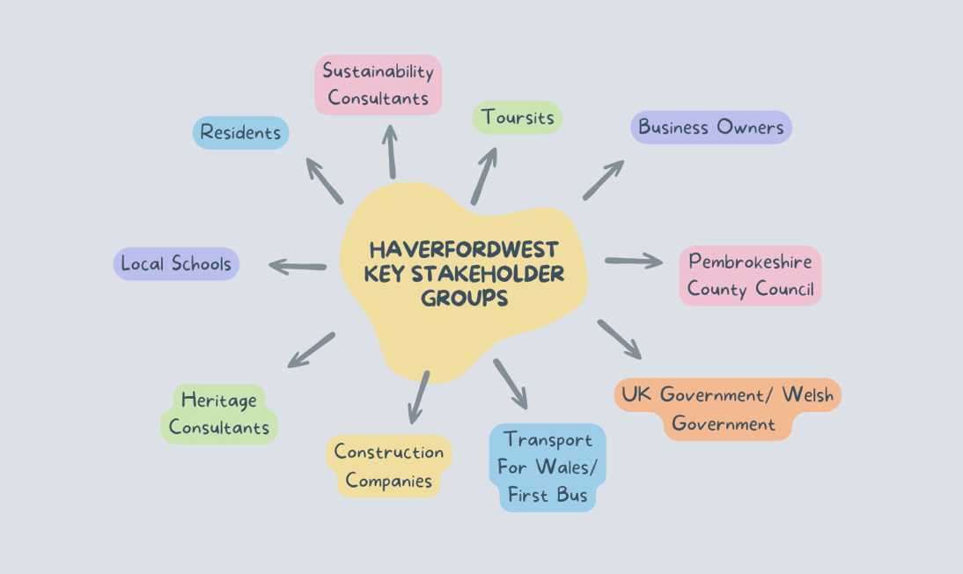
  - Key Stakeholders
(Canva, 2025)
As shown in the above image, there are many groups to consider when implementing new facilities within a community. For example, the Haverfordwest Castle redevelopment would involve the council, heritage consultants, the UK government and construction companies.
  - Local and Regional Development
There are many current plans to develop Haverfordwest, however they are big and expensive projects.
The Western Quayside development is currently being developed to turn an empty and unused department store building into a three-storey building into a multi-use area for new restaurants, bars, and a rooftop terrace. The project is costing £11.6 million and has already been delayed due to the finding of historical remains. While the project was supposed to have been completed in 2023, there is currently still no finish date in place due to the rise in material costs from inflation (Sinclair, 2023). Many residents are excited about the project, but the lack of parking in the area means it may not attract as many customers during the week as it would on the weekend, when most people in the area would go on to enjoy the nightlife before getting a taxi home.
Haverfordwest Castle is currently under construction on after plans were drawn up in the beginning of 2024 after the council received £17.7 million as part of the UK Governments ‘Levelling Up Scheme’ (GOV UK, 2023). The redevelopment includes better pedestrian routes to and from the castle, better transport links as well as the restructuring and preservation of the 13th century castle (Pembrokeshire County Council, 2024). Another page from the Pembrokeshire County Council, 2024, suggests that 88% of surveyed residents are happy with the funding being used on the Castle. The castle opening is scheduled for spring 2027.
Finally, Haverfordwest development plans are also in place for a new transport hub. These plans have been in place since 2020, and the original structure of the multi-storey car park has been closed since 2021. This has caused a lack of parking over the past few years, delays for bus routes and school buses as the temporary system is confusing and not well thought out. While this has been an on and off neglected project, the sustainable structure is finally on its way to construction. The structure is to have EV charging points, 280 parking bays, 7 bus stops and inclusive public toilets, as well as solar panels to offer electricity for other buildings within the town. This is part of the council’s plan to be net zero by 2030 (Booth, 2025). The Welsh Government is funding the project; however, there is no set dates for when the car park will open or even completed. Considering there are many projects currently happening, there is a chance that it will be after previously mentioned developments.

2. Regeneration Ideas
2.1 Reuse Empty Spaces
Throughout Haverfordwest, there are many empty and unkept buildings (see figures 1-4), this makes the town look like an eyesore to public members and means that as a community we are not utilising the space we have effectively. To help regenerate the town effectively, Pembrokeshire County council should take steps such as discounting the building price or offering funding for those those spaces to be reused for a suitable purpose. For example, figure 1 could include a pool table and snooker place- this would be a successful business due to the lack of these amenities over Haverfordwest and also become a local hotspot for children over the school holidays and adults who go out and enjoy the nightlife. Another idea would be to make a community sports hub, where classes such as yoga, pilates and kickboxing could take place and be run by private instructors to maximise access to wellbeing across town. Many towns are taking this initiative, for example the repurpose of St Davids Church in Carmarthen. The church was recycled to become a climbing centre, known as Overhang in 2020; which is a huge staple of the Carmarthen community as it is recognised for being one of the best climbing centres in Wales (Lewis, 2020). Bringing this concept into Haverfordwest is an effective way to become attractive to tourists as well as bring new excitement for residents. This also ensures a more sustainable approach to introducing modernisation to a historic town.
2.2 Homeless Shelter
While Haverfordwest has a small population, there are at least 10 homeless people that reside around the town centre. There was an incident a few weeks ago where a homeless man living in a tent in the woods passed away and was found a few days later (Sinclair, 2025). Welfare concerns like this should be taken seriously and more should be done to support our towns homeless. The council and community should set up a homeless care centre or shelter for those who are sleeping rough, particularly during the harsh winter months. This would help Pembrokeshire meet their sustainable goals while also helping the social sustainability of the town. Manchester is a fitting example of an area taking strides to reduce levels of homelessness, as Peel Waters and Capital & Centric aim to provide 40 temporary homes for rough sleepers near the area of Salford. While providing private ‘pod’ homes and communal areas, they also plan to include mini allotment plots and a multi-use sports area, as well as all around support with skills like paying rent, cooking, and going to job interviews (Valentine, 2024). While this is a huge project for somewhere like Haverfordwest to take on, the idea of giving temporary homes to rough sleepers as well as providing a regime of set skills could be something that would benefit the community and bring those individuals back into part-time or even full-time work. It would also bring them back into society feeling well prepared and supported.
2.3 Improved Green Areas for Young People
Young people make up approximately 22.6% of the Haverfordwest population. Therefore, the amenities available need to reflect this. While there are various children parks across larger housing estates, the skatepark is a key part of most children’s childhood. The skatepark currently looks old and boring (see figure 5), as well as the fact that it is used for antisocial behaviour amongst older teenagers. By redesigning and improving this space, we can make a place suitable and fun for children of all ages. For example, adding a children’s park alongside or including a bike and running path, not to mention somewhere for adults to sit and socialise. Research shows that girls in particular want swings, dance spaces and trampolines to use, while boys want facilities such as outdoor gyms, trampolines, and nature parks (Make Space for Girls, 2024). By making a bigger and improved space, we can make more diverse changes and create a green space where everyone is welcome. We could also utilise the green space by holding kids' clubs and special events within the area. An example of when this has been successful is ‘Make Space For Girls’ project that designed a green space within the area of Bradford as a safe area in the community for girls, costing £45,000. The project was designed to be inclusive too all resident young people and be a place where everyone can enjoy the outdoors and feel a part of the community (Lota, 2023). Using the method of gathering up local children and teenagers to make a difference in the way that they feel their town needs is something that could make Haverfordwest stand out.

Conclusion:
Haverfordwest is a forward-thinking town that has suffered over a change in fortunes, particularly with the effects of inflation and COVID-19. However, the resilient and medieval town is looking at strategic and substantial investment to make the area vibrant and appealing once again. The regeneration strategy is currently to preserve the historic personality of the town as well as appease to the modern shift of the community; we can see these efforts through the Western Quayside and Transport hub projects. Although these developments are mostly private funded or through government bursaries, the projects are taking significantly longer than projected- leaving the town with constant ongoing construction and confusion for tourists. Not to mention, the regeneration plans currently do not focus on wellbeing, neither are they fully sustainable. To be able to regenerate Haverfordwest in a way that is suitable for all age groups and demographics, we need to curate more social and activity spaces, such as diversifying the towns offerings with a sports hub or snooker hall for example. Reusing the currently run down spaces mean we can boost the local economy. Also, the further improvement of the green areas for the use of young people and children will benefit the community in terms of mental health. Giving a more inclusive space to the areas that surrounds the skate park for example will hopefully bring more of the community together and give young people an appropriate place to socialise. Finally, a big conversation continuing over the town is the need for a homeless shelter, particularly after the death of a very well known and loved homeless individual. Taking care of the homeless within our town means a social and ethical development in line with the UN goals. Overall, Haverfordwest’s fortunes are changing for the better, however, there is always more and potentially more small-scale things a town can do to provide for residents and promote tourism. By continuing to invest in infrastructure, people, and places, Haverfordwest can return to a prosperous, dynamic, and sustainable town.

Appendix:
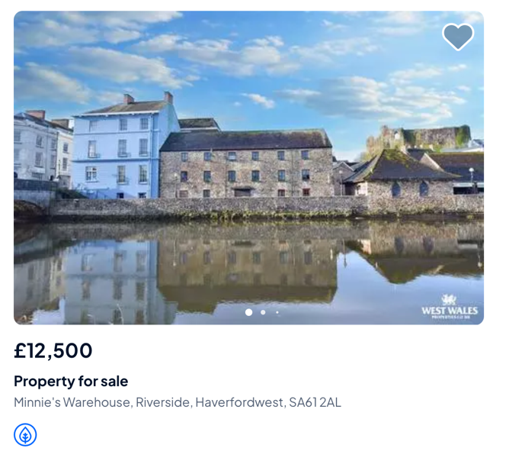
Figure 1: (On The Market, 2025)
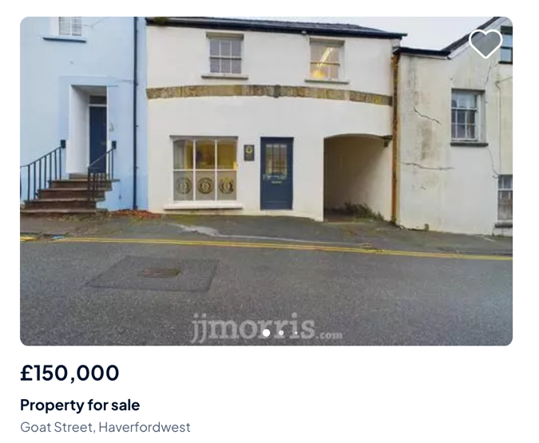
Figure 2: (On The Market, 2025)
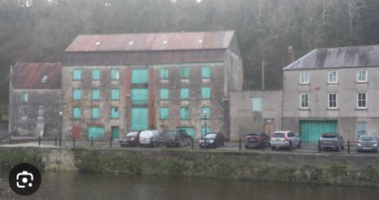
Figure 3: (Jenkins, 2019)

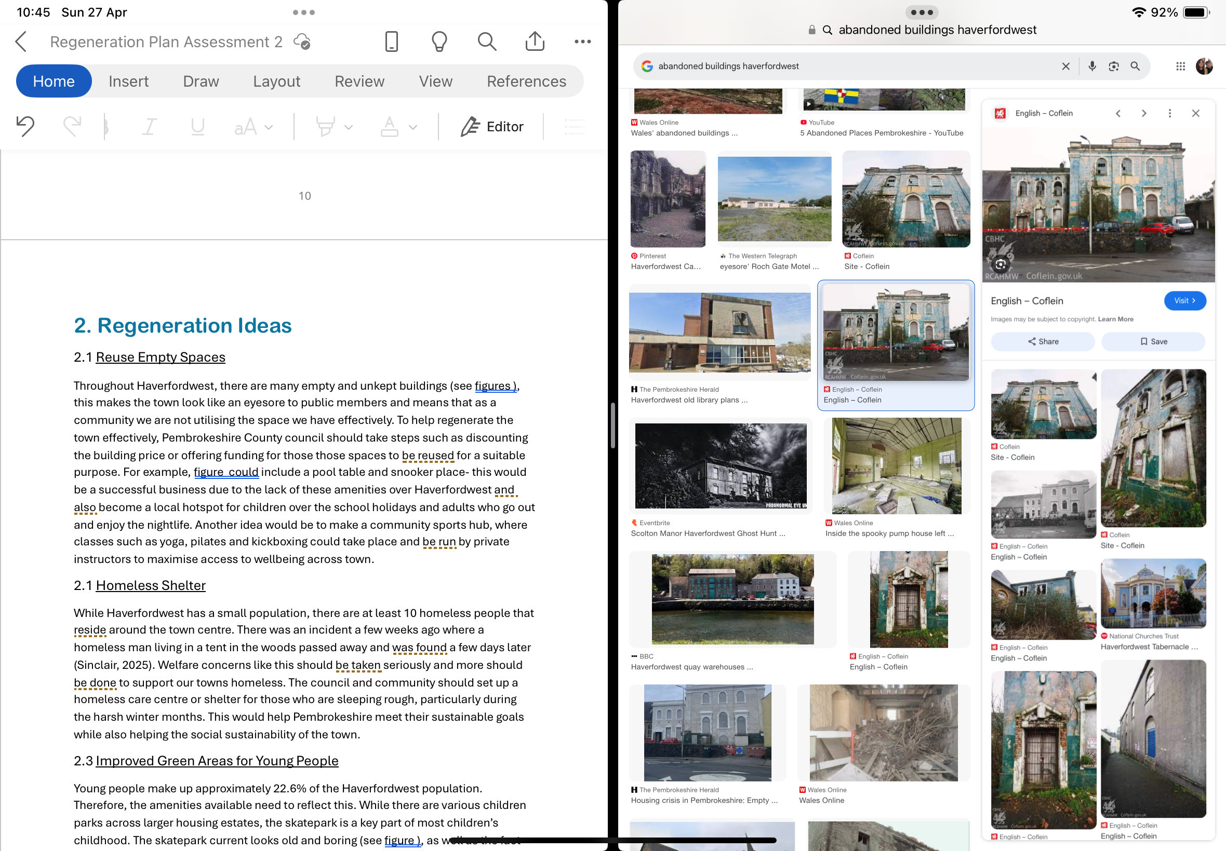
Figure 4: (Coflein, 2021)

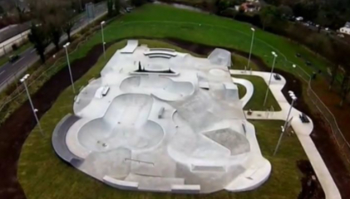
Figure 5: (Pinterest, 2015)

References:
Britannica. (2025). Haverfordwest.
https://www.britannica.com/place/Haverfordwest.
Booth, K. (2025). Work Begins on Major Public Transport Hub for Haverfordwest Wales. https://bdcmagazine.com/2025/04/work-begins-on-major-public-transport-hub-for-haverfordwest-wales/?utm.
Canva. (2025). [Image created by Alyssia Frampton].
City Population. (2021). Haverfordwest. https://citypopulation.de/en/uk/wales/pembrokeshire/W45000318__haverfordwest/.
Coflein. (2021). Perrot Road. https://coflein.gov.uk/en/site/11045/images/.
GOV.UK. (2023). £17.7 Million Awarded to Regenerate Haverfordwest. https://www.gov.uk/government/case-studies/177-million-awarded-to-regenerate-haverfordwest?utm.
Jenkins, K. (2019). Former Haverfordwest Snooker Hall. https://www.westerntelegraph.co.uk/news/17649084.former-haverfordwest-snooker-hall-frame-apartment-conversion/.
Lewis, I. (2020). Carmarthen Church Reopening for First Time in 17 Years. https://www.inyourarea.co.uk/news/carmarthen-church-opening-soon-as-new-climbing-centre.
Lota, S. (2023). Proud to Support Bradford’s First ‘Make Space for Girls’ Outdoor Space. https://www.incommunities.co.uk/news/proud-to-support-bradfords-first-make-space-for-girls-outdoor-space-1191/.
Make Space for Girls. (2024). How Teenagers Experience Public Space. https://www.makespaceforgirls.co.uk/blog/how-teenagers-experience-public-space.
On The Market. (2025). Commercial Property for Sale in Pembrokeshire. https://www.onthemarket.com/for-sale/commercial/property/pembrokeshire/?gad_source=1&gbraid=0AAAAAqpRXFumHsvPXqYGZKn5Xhw3llODP&gclid=CjwKCAjwq7fABhB2EiwAwk-YbFEsXuP9-4TaxPhfeH2Z5vNRuFtAEhS2q9_dwR1VhOxfcsT3VlH8kRoCRJsQAvD_BwE.
Pembrokeshire County Council. (2024). Haverfordwest Castle Redevelopment. https://newsroom.pembrokeshire.gov.uk/news/redevelopment-will-breathe-new-life-into-historic-town-square-and-pedestrian-routes-to-haverfordwest-castle?utm.
Pembrokeshire County Council. (2024). Regeneration Project Plans. https://www.pembrokeshire.gov.uk/regeneration-project-plans/haverfordwest-castle-redevelopment?utm.
Pinterest. (2025). Skate Culture. https://uk.pinterest.com/pin/525162006521094947/.
Sinclair, B. (2023). Haverfordwest Development ‘Will Change Fortune of the Town’. https://www.westerntelegraph.co.uk/news/23634835.haverfordwest-development-will-change-fortune-town/.
Sinclair, B. (2023). £11.6m Redevelopment Will ‘Change the Fortune’ Of Haverfordwest. https://nation.cymru/news/11-6m-redevelopment-will-change-the-fortune-of-haverfordwest/?utm.
Sinclair, T. (2025). Body Found in Tent in Pembrokeshire. https://pembrokeshire-herald.com/111264/body-found-in-tent-in-pembrokeshire-woodland/.
Sinclair, T. (2021). Haverfordwest and Cardigan High Streets. https://pembrokeshire-herald.com/66648/haverfordwest-and-cardigan-high-streets-listed-as-among-the-ten-worst-in-britain/.
Sinclair, T. (2025). Haverfordwest’s Decline Now International News. https://pembrokeshire-herald.com/106345/haverfordwests-decline-now-international-news/?utm.
Transport For Wales. (2020). Fflecsi Bus Service Now in Pembrokeshire. https://news.tfw.wales/news/fflecsi-bus-service-now-in-pembrokeshire-localised-copy.
Valentine, C. (2024). Embassy Village to Provide 40 Homes for Rough Sleepers. https://www.placenorthwest.co.uk/embassy-village-to-provide-40-homes-for-rough-sleepers-as-work-starts/.
Wikipedia. (2025). Haverfordwest. https://en.wikipedia.org/wiki/Haverfordwest?utm.

