This article will discuss the first technique for data mining: regression, which transforms existing data into a numerical prediction for future data.

What is data mining?
Data mining, at its core, is the transformation of large amounts of data into meaningful patterns and rules.
For our purposes, modern data mining started in the mid-1990s, as the power of computing, and the cost of computing and storage finally reached a level where it was possible for companies to do it in-house, without having to look to outside computer powerhouses.
Additionally, the term data mining is all-encompassing, referring to dozens of techniques and procedures used to examine and transform data. That may leave you with the impression that data mining is something only big companies can afford. (Discuss!)
The ultimate goal of data mining is to create a model, a model that can improve the way you read and interpret your existing data and your future data. Since there are so many techniques with data mining, the major step to creating a good model is to determine what type of technique to use. That will come with practice and experience, and some guidance. From there, the model needs to be refined to make it even more useful.

Regression
Regression model can be as easy as one input variable and one output variable (called a Scatter diagram in Excel, or an XYDiagram in OpenOffice.org). Of course, it can get more complex than that, including dozens of input variables. In effect, regression models all fit the same general pattern. There are a number of independent variables, which, when taken together, produce a result — a dependent variable. The regression model is then used to predict the result of an unknown dependent variable, given the values of the independent variables.
A regression example that immediately comes to mind is pricing a house. The price of the house (the dependent variable) is the result of many independent variables — the square footage of the house, the size of the lot, whether granite is in the kitchen, bathrooms are upgraded, etc. So, if you've ever bought a house or sold a house, you've likely created a regression model to price the house. You created the model based on other comparable houses in the locality and what they sold for (the model), then put the values of your own house into this model to produce an expected price.
For this example of a house price-based regression model, some data has been created to examine. These are actual numbers from houses for sale in a particular locality, and we will be trying to find the value for a particular house.

Table 1. House values for regression model
House size (square feet) | Lot size |  | Bedrooms |  | Granite |  | Upgraded bathroom? | Selling price
3529 | 9191 | 6 |  | 0 |  | 0 |  | £205,000
3247 | 10061 | 5 |  | 1 |  | 1 |  | £224,900
4032 | 10150 | 5 |  | 0 |  | 1 |  | £197,900
2397 | 14156 | 4 |  | 1 |  | 0 |  | £189,900
2200 | 9600 | 4 |  | 0 |  | 1` |  | £195,000
3536 | 19994 | 6 |  | 1 |  | 1 |  | £325,000
2983 | 9365 | 5 |  | 0 |  | 1 |  | £230,000
3198 | 9669 | 5 |  | 1 |  | 1 |  | ????

Building the data set for WEKA
To load data into WEKA, we have to put it into a format that will be understood. WEKA's preferred method for loading data is in the Attribute-Relation File Format (ARFF), where you can define the type of data being loaded, then supply the data itself. In the file, you define each column and what each column contains. In the case of the regression model, you are limited to a NUMERIC or a DATE column. Finally, you supply each row of data in a comma-delimited format. The ARFF file we'll be using (houses.arff) with WEKA appears below. Notice in the rows of data that we've left out my house. Since we are creating the model, we cannot input my house into it since the selling price is unknown. Listing 1. WEKA file format
@RELATION house
@ATTRIBUTE houseSize NUMERIC
@ATTRIBUTE lotSize NUMERIC
@ATTRIBUTE bedrooms NUMERIC
@ATTRIBUTE granite NUMERIC
@ATTRIBUTE bathroom NUMERIC
@ATTRIBUTE sellingPrice NUMERIC
@DATA
3529,9191,6,0,0,205000
3247,10061,5,1,1,224900
4032,10150,5,0,1,197900
2397,14156,4,1,0,189900
2200,9600,4,0,1,195000
3536,19994,6,1,1,325000
2983,9365,5,0,1,230000

Loading the data into WEKA
Now that the data file has been created, it's time to create our regression model. Start WEKA, then choose the Explorer. You'll be taken to the Explorer screen, with the Preprocess tab selected. Select the Open File button and select the ARFF file. After selecting the file, your WEKA Explorer should look similar to the screenshot in Figure 3.

Figure 3. WEKA with house data loaded
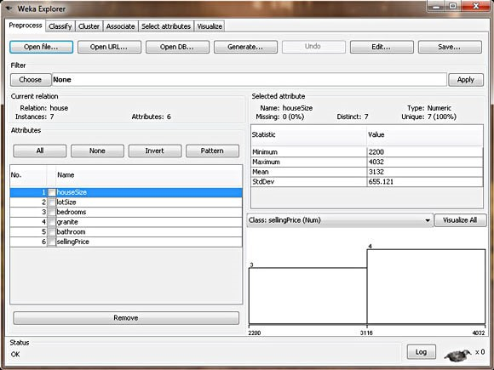
In this view, WEKA allows you to review the data you're working with. In the left section of the Explorer window, it outlines all of the columns in your data (Attributes) and the number of rows of data supplied (Instances). By selecting each column, the right section of the Explorer window will also give you information about the data in that column of your data set. For example, by selecting the houseSize column in the left section (which should be selected by default), the rightsection should change to show you additional statistical information about the column. It shows the maximum value in the data set for this column is 4,032 square feet, and the minimum is 2,200 square feet. The average size is 3,131 square feet, with a standard deviation of 655 square feet. (Standard deviation is a statistical measure of variance.) Finally, there's a visual way of examining the data, which you can see by clicking the Visualize All button. Due to our limited number of rows in this data set, the visualization is not as powerful as it would be if there were more data points (in the hundreds, for example).
Enough looking at the data. Let's create a model and get a price for my house.

Creating the regression model with WEKA
To create the model, click on the Classify tab. The first step is to select the model we want to build, so WEKA knows how to work with the data, and how to create the appropriate model:
- Click the Choose button, then expand the functions branch.
- Select the LinearRegression leaf.
This tells WEKA that we want to build a regression model. As you can see from the other choices, though, there are lots of possible models to build. Lots! This should give you a good indication of how we are only touching the surface of this subject. Also of note: There is another choice called SimpleLinearRegression in the same branch. Do not choose this because simple regression only looks at one variable, and we have six. When you've selected the right model, your WEKA Explorer should look like Figure 4.

Figure 4. Linear regression model in WEKA
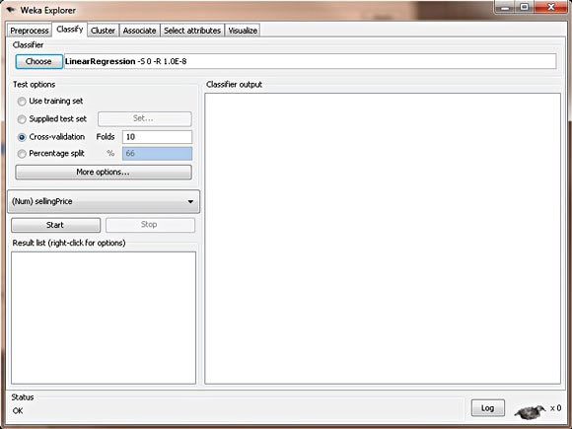
Can I do this with a spreadsheet?
Short answer: No. Long answer: Yes. Most popular spreadsheet programs cannot easily do what we did with WEKA, which was defining a linear regression model with multiple independent variables. However, you can do a Simple Linear Regression model (one independent variable) pretty easily. If you're feeling brave, it can do multi-variable regression, though it's quite confusing and difficult, definitely not as easy as WEKA.
Now that the desired model has been chosen, we have to tell WEKA where the data is that it should use to build the model. Though it may be obvious to us that we want to use the data we supplied in the ARFF file, there are actually different options, some more advanced than what we'll be using. The other three choices are Supplied test set, where you can supply a different set of data to build the model; Cross-validation, which lets WEKA build a model based on subsets of the supplied data and then average them out to create a final model; and Percentage split, where WEKA takes a percentile subset of the supplied data to build a final model. These other choices are useful with different models. With regression, we can simply choose Use training set. This tells WEKA that to build our desired model, we can simply use the data set we supplied in our ARFF file.
Finally, the last step to creating our model is to choose the dependent variable (the column we are looking to predict). We know this should be the selling price, since that's what we're trying to determine for my house. Right below the test options, there's a combo box that lets you choose the dependent variable. The column sellingPrice should be selected by default. If it's not, please select it.
Now we are ready to create our model. Click Start. Figure 5 shows what the output should look like.

Figure 5. House price regression model in WEKA
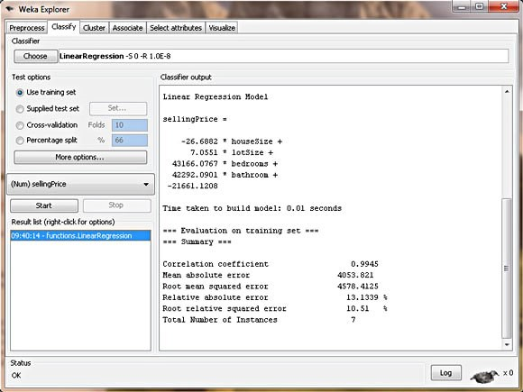

Interpreting the regression model
WEKA doesn't mess around. It puts the regression model right there in the output, as shown in Listing 2.

Listing 2. Regression output
sellingPrice = (-26.6882 * houseSize) + (7.0551 * lotSize) +
(43166.0767 * bedrooms) +
(42292.0901 * bathroom)
- 21661.1208
Listing 3 shows the results, plugging in the values for my house.

Listing 3. House value using regression model
sellingPrice = (-26.6882 * 3198) + (7.0551 * 9669) +
(43166.0767 * 5) +
(42292.0901 * 1)
- 21661.1208 sellingPrice = 219,328
However, looking back to the top of the article, data mining isn't just about outputting a single number: It's about identifying patterns and rules. It's not strictly used to produce an absolute number but rather to create a model that lets you detect patterns, predict output, and come up with conclusions backed by the data. Let's take another step and interpret the patterns and conclusions that our model tells us, besides just a strict house value:
- Granite doesn't matter— WEKA will only use columns that statistically contribute to the accuracy of the model (measured in R-squared, but beyond the scope of this article). It will throw out and ignore columns that don't help in creating a good model. So this regression model is telling us that granite in your kitchen doesn't affect the house's value.
- Bathrooms do matter— Since we use a simple 0 or 1 value for an upgraded bathroom, we can use the coefficient from the regression model to determine the value of an upgraded bathroom on the house value. The model tells us it adds £42,292 to the house value.
- Bigger houses reduce the value— WEKA is telling us that the bigger our house is, the lower the selling price? This can be seen by the negative coefficient in front of the houseSize variable. The model is telling us that every additional square foot of the house reduces its price by £26? That doesn't make any sense at all. How should we interpret this? This is a good example of garbage in, garbage out. The house size, unfortunately, isn't an independent variable because it's related to the bedrooms variable, which makes sense, since bigger houses tend to have more bedrooms. So our model isn't perfect. But we can fix this. Remember: On the Preprocess tab, you can remove columns from the data set. For your own practice, remove the houseSize column and create another model. How does it affect the price of my house? How does this new model make more sense? (My amended house value: £217,895).

Exercise 2

To take this simple example to the next level, let's take a look at a data file that the WEKA Web site supplies to us as a regression example. Theoretically, this should be much more complex than our simple example with seven houses. This sample data file (AutoMPG.arff) attempts to create a regression model to predict the miles per gallon (MPG) for a car based on several attributes of the car (this data is from 1970 to 1982, so keep that in mind). The model includes these possible attributes of the car: cylinders, displacement, horsepower, weight, acceleration, model year, origin, and car make. Further, this data set has 398 rows of data and meets many of the statistical requirements that our earlier house price model didn't. In theory, this should be a much more complex regression model, and perhaps WEKA might have a hard time creating a model with this much data (though I'm sure you can predict at this point that WEKA will handle this just fine).
To produce the regression model with this data set, you should follow the exact same steps you followed for the house data, so I won't repeat it. So go ahead and create the regression model. It should produce the output shown in Listing 4.

Listing 4. MPG data regression model
class (aka MPG) =
-2.2744 * cylinders=6,3,5,4 +
-4.4421 * cylinders=3,5,4 +
6.74 * cylinders=5,4 +
0.012 * displacement + -0.0359 * horsepower +
-0.0056 * weight +
1.6184 * model=75,71,76,74,77,78,79,81,82,80 +
1.8307 * model=77,78,79,81,82,80 +
1.8958 * model=79,81,82,80 +
1.7754 * model=81,82,80 +
1.167 * model=82,80 +
1.2522 * model=80 +
2.1363 * origin=2,3 +
37.9165

When you do it yourself, you'll see that WEKA flies through the model in less than a second. So it's not a problem, computationally, to create a powerful regression model from a lot of data. This model may also appear much more complex than the house data, but it isn't. For example, the first line of the regression model, -2.2744 * cylinders=6,3,5,4 means that if the car has six cylinders, you would place a 1 in this column, and if it has eight cylinders, you would place a 0.

