Do Incremental Theory interventions improve pupils’ academic resilience?

Lucy Le Masurier
1251415
EdD ECDE7013

Contents
Chapter 1- Introduction 5
1.1 Rationale 5
1.2 School Context 7
Chapter 2- Literature Review 8
2.1 ACEs Affect Learning 8
2.2 Resilience as a Protective Factor against the Impact of ACEs on Learning 9
2.3 Academic Resilience Characteristics 10
2.4 Incremental Theory Interventions 13
2.5 Interventions in Welsh Primary Schools 14
2.6 Research Questions, Aims and Objectives 15
Chapter 3- Research Design and Methodology 16
3.1 Research Design 16
3.1.1 Epistemology and Ontology 16
3.1.2 Deweyan Pragmatism 16
3.1.3 Theoretical Frame 19
3.1.4 Incremental Theory Programme 20
3.1.5 Academic Resilience Measures 21
3.2 Methodology 23
3.2.1 Equal Status Mixed Methods 24
3.2.2 Inside Action Research 25
3.2.3 Research Question 1: 25
3.2.3.1 Research Question 1 Sampling 26
3.2.3.2 Research Question 1 Data Collection Methods 26
3.2.3.3. Question 1: Data Analysis 27
3.2.4 Research Question 2 28
3.2.4.1 Research Question 2 Sampling 28
3.2.4.2 Research Question 2 Data Collection Methods 28
3.2.4.3 Research Question 2: Data Analysis 29
3.2.6 Ethical Considerations 30
3.2.6.1 Consent 30
3.2.6.2 Power Relations/Risks 31
3.2.6.3 Confidentiality and anonymity 32
Chapter 4- Findings/Data Analysis 33
4.1 Research Question 1 33
4.1.1 Sample 33
4.1.2 Intervention 33
4.1.3 Data Analysis 34
4.1.4 Paired t-Test Findings 34
4.1.5 Academic Resilience Characteristics Paired t-Test Findings 37
4.2 Research Question 2 39
4.2.1 Sample/Intervention/Data Collection 39
4.2.2 Data Analysis 40
4.2.2.3 Braun & Clarke (2006) Step 6 Write Report 42
Chapter 5- Discussion 49
5.1 Research Question Summary 49
5.2 Overall Intervention Impact 49
5.3. Individual Academic Resilience Characteristics 50
5.3.1 Self-Efficacy 51
5.3.2 Fear of Failure 52
5.3.3 Motivation 52
5.3.4 Goal Setting 53
5.3.5 Setbacks 53
5.4 Summary 54
5.5 Limitations in Data Collection 54
5.5.1 Questionnaire 55
5.5.2 Interview 55
5.5.3 Effect Size 56
5.6 Contributions to the Field 56
Chapter 6- Recommendations 58
6.1 Implications for Future Research 58
6.2 Final Reflections 58
References 59
Appendices 64
Appendix A: Five Intervention Lessons and Examples 64
Appendix B: Questionnaire 65
Appendix C: Semi Structured Interview 67
Appendix D: Participants Consent Form 68
Appendix E: Ethics Form 0

Table of Figures
Figure 1Synthesis of Academic Resilience and Incremental Theory Characteristics 19
Figure 2 Incremental Theory Intervention Lesson Topic and Objectives 21
Figure 3 Synthesis of Academic Resilience Characteristics and Responding Questionnaire Statements 23
Figure 4 Synthesis of Academic Resilience Characteristics and Responding Interview Questions 23
Figure 5 t-Test Academic Resilience Scores 34
Figure 6 Wilcoxon Signed Rank Test Pre and Post Test Academic Resilience Scores 35
Figure 7 Cohen's d Effect Sizes (adapted from Cohen et al. 2011) 37
Figure 8 Paired Sample t-Test Academic Resilience Characteristics Pre and Post Test Scores 37
Figure 9 Pre and Post Test Academic Resilience Characteristic Scores 39
Figure 10 Initial Codes NVIVO 40
Figure 11 Academic Resilience Themes NVIVO 41
Figure 12 Step 4 Revision of Themes 42
Figure 13 NVIVO Autocodes Sentiment for Codes by Academic Resilience Characteristics 43
Figure 14 NVIVO Proportion of Negative and Positive Code Sentiments 50
Figure 15 Paired t-Test Academic Resilience d. and p. Values 51

Chapter 1- Introduction

1.1 Rationale
Barton et al. (2018) define Adverse Childhood Experiences (ACEs) as adverse experiences that can affect children directly or indirectly. ACEs can include all types of abuse, suffering or witnessing domestic violence, substance misuse or caregivers are in prison or have mental health issues. These experiences are more likely to suffer diseases, illness and poorer well-being throughout their lives (Welsh Government, 2021). In a Welsh study (PHW, Bellisi et al., 2015), it was reported that over 50% of adults self-reported at least one ACE and 14% self-reported four or more ACEs. The study also found correlational data between the variable of ACEs and the likely risk of adverse outcomes throughout their lives. This was exemplified by the prediction of these increased risks. For example, where four or more ACEs are reported, the individual is 20 times more likely to go to prison than individuals who report no ACEs. As a result, the Welsh Government (WG) prioritised the mitigation and prevention of the impact of ACEs on individuals within their social policies. The Welsh Government recommend the for children, there should be a focus on developing and fostering relationships with a trusted adult as a way of buffering the effects of ACEs (Ashton et al. 2016)
The rationale of this research stemmed from the observations and discussions of primary school teachers within a cluster of schools. Many of these teachers observed pupils displaying behaviours and attitudes to learning which were identified as lower academic resilience. Indeed, they observed pupils’ dysregulation and the lower adaption, application of effort and perseverance when facing difficulties or challenge in learning tasks in addition to the pupils’ presentation of neurological and psych emotional ACE effects.
On the one hand, the sensitive nature and the expertise of measuring ACEs puts identifying pupils’ ACE score beyond the professional capacity of teachers. On the other, as pupils spend a large proportion of their time at school, teachers are best placed to support pupils in developing resilience to buffer the effect of ACEs.
Nevertheless, Smith (2018) suggests that teachers who adopt an ACE lens, through the knowledge of the impact of ACEs on pupils, can address these impacts more effectively despite not having the professional authority to determine whether pupils have ACEs or the magnitude of their ACEs.
More recently, the COVID-19 pandemic brought about lockdown which resulted in pupils moving to online learning rather than going to their schools. This resulted in the increased likelihood that pupils would be more exposed to ACEs that were brought about by the pandemic or exacerbated by the existing ACEs within their homes. Authors have claimed that during lockdown there were increased levels of child abuse injuries and domestic abuse cases and this was likely the result of increased stress levels at the time (Srivastav et al. 2021). In a similar study, the researchers concluded that lockdown had worsened existing ACEs and considers COVID-19 pandemic as an ACE (Sanders, 2020).
During lockdown, Wales specifically saw increased levels of reporting relating to abuse and a 54% in domestic abuse reports with the research concluding that schools have a vital responsibility in supporting pupils in the recovery of COVID-19 through preparation for increased levels of pupil disclosures, supporting pupils’ mental health and well-being. The researchers claim that this may prove difficult as pupils may present as disengaged, withdrawn and agitated (Newbury et al., 2020).

1.2 School Context
The school is small English-medium primary school within a small community in South Wales. The school has 121 pupils on roll and serves an area of socio-economic disadvantage with a higher number than the national average of 24.1% eligible for free school meals and 12.4% identified as having ALN.

Chapter 2- Literature Review

2.1 ACEs Affect Learning
A review of 98 studies pertaining the impact of ACEs on children’s social, emotional and intellectual development found that ACEs significantly affected the cognitive functioning, attention, behaviour and educational achievement (Perfect et al., 2016). Additional studies found similar results and reported that the number of ACEs were correlated with learning difficulties (Hunt et al., 2017), dysregulation and difficulty expressing emotions (Bellis et al., 2019) poorer behaviour and, social and emotional competencies (Dee et al., 2020) and lower academic achievement (Jimenez et al. 2016; McDowell. 2017; Houtepen et al. 2020).
Children’s positive and negative interactions and experience with others impact on their development. This includes their nervous, immune and endocrine systems. The Centre for Controlled Diseases (CDC, 2020) add to this, stating that these negative interactions can have epigenetic effects by altering the structure of the prefrontal cortex, basal cortisol levels and weakening the immune system. When these interactions and effects are repeated they bring about Toxic Stress (CDC, 2020) as they prolong the allostatic systems required for dealing with immediate threat (Danese and McEwen, 2012) which can impact socio-emotional regulation (Dee et al.2020).
This affects pupils in two ways. Firstly, as Petchell and Pizzagalli, 2012) pupils’ attitudes towards learning may be impacted as toxic stress affects the stress sensitive regions of the brain responsible executive functioning. This important as this part of the brain is responsible for memory, attention and cognitive flexibility required for academic resilience. Secondly, when pupils are dysregulated and have higher baseline allostatic systems in learning, they may interpret challenges as threats which prompts the limbic system to secrete chemical responses which are not conducive to effective executive functioning.

2.2 Resilience as a Protective Factor against the Impact of ACEs on Learning
Yavuz and Kutlu (2016) state that cognitive flexibility is the adaption and belief that difficulties have several solutions and applying greater effort will enable the individual to be successful with overcoming the problem. Cognitive flexibility is seen as fundamental to achieving academic resilience. That is, cognitive flexibility enables executive functioning to control brain functions when learning. When this happens, it is seen as a predictor of academic resilience (Pearce and Davis, 2021;Traub and Boynton-Jarrett, 2017). Notably, the time sensitive periods in brain development that are responsible for executive functioning is at growth spurts at ages 2,9 and adolescence. (Hays-Grudo and Morris, 2020). Importantly, the age of entry into UKS2 is 9 years old. Authors claim that resilience is a can act to mitigate and prevent ACE effects on learning (Ashton et al, 2016; Barton et al, 2018; Estyn, 2020) as it builds strong dispositions (NSCDC, 2105) and illustrating an interplay between negative interactions and the tools changing it into a positive experience by balancing the risk factors (Pearce and Davis, 2021). Notably, pupils who have higher ACE scores have lower resilience as well as not having the resilience to cope with learning challenges (Romero et al. 2018). According to Poole et al. (2017) resilience is modifiable, multidimensional, and dynamic. However, pupils do not develop resilience independently and that schools were seen as crucial in supporting pupils to develop their resilience (McCormick, 2019) and that teachers are vital in this process (Doll, 2014; NHS Scotland, 2017).
2.3 Academic Resilience Characteristics
Schoon (2006) defines resilience as an individual’s capacity to overcome environmental challenges that risk or hinder the accomplishment of developmental objectives at specific ages. Similarly, Truebridge (2016) described resilience as the dynamic process within individuals and between individuals and their external environments for the resources and support to adapt amid adversity, threat and everyday stress. Both Avci (2022) and Jowkar et al. (2014) claim that resilience relates to different areas of an individual’s life and therefore it comes in various forms i.e., psychological resilience, physical resilience, emotional resilience and academic resilience. Academic resilience is defined as the pupil’s ability to overcome difficulties that prevent academic development (Martin, 2013) and the increased likelihood of success despite adversity (Cassidy, 2016) that may be brought about by early traits, conditions and experience (Wang et al., 1994).
In their literature review study, Gafoor and Kottalil (2011) found that academically resilient individuals had similar characteristics, and these were categorised in four domains. These included within-family, within-school, within-community and within-child protective factors. The latter exemplified by characteristics such as motivational, cognitive and meta-cognitive factors and self-belief.
In exploring the links between individual academic resilience factors and levels of academic resilience, Martin and Marsh (2006) discovered that research that had been conducted into academic resilience domains (i.e. academic, family, peer, sociodemographic and psychological) had given less detailed focus given to any particular domain. The researchers note that this is most apparent in the psychological domain, where the focus tends to be just on self-esteem and locus of control. This therefore restricts how much psychologists and educators may do to improve students' psychological resilience through more multifaceted approaches.
Numerous studies have aimed to identify individual characteristics which improve academic resilience. In their most recent international testing findings, PISA (OECD, 2018) identified several characteristics. This included meta-cognition which enables learners to evaluate when problem solving and plan and allocate learning resources; motivation to master tasks; minimum or non-existent fear or failure; self-efficacy which is the individual’s belief in their own capacity to be successful in tasks despite difficulties; mastery goal orientation which refers to the individual’s aspiration and intrinsic motivation to set and complete goals; and cognitive flexibility which is the individual’s capacity for adjusting, developing and coping with novel and different tasks using their knowledge and experience.
In their study, Martin and Marsh (2006) concluded that there are five distinct characteristics connected with academic resilience and presented these as a 5-Cs model. The model consisting of confidence (self-efficacy), co-ordination (planning), control, composure and commitment. The researchers state that academic self-efficacy is a significant predictor of academic resilience as it addresses and enhances pupil’s negative beliefs about themselves and their academic capabilities and supports the development of effective goal setting. In addition, the researchers claim that two other key characteristics that enhance pupil’s academic resilience is planning and persistence brought about by self-regulation and goal setting. Planning refers to the setting of effective goals whilst persistence refers to the way in which they are achieved, particularly when pupils find tasks challenging and achieving the goal is not immediate. Pupil’s sense of control refers to their understanding of the relationship between their effort and strategy and their outcomes.
Similarly, in their research, Wang et al. (1994) found that in the psychological domain there is a correlation between academic resilience and specific characteristics i.e., motivation and self-efficacy. Indeed, self-efficacy is a key characteristic of developing academic resilience (Cheung, 2017., Rachmawati et al., 2021).
Dweck (2000) argues that it is pupils’ perception of academic adversity that affects achievement rather than the academic adversity itself. In this research, Dweck (2000) identifies two theories about mindsets and referred to these in conjunction with the malleability of the brain. The first, Incremental Theory is the pupil’s belief that can improve their intelligence through practice and effort whereas an Entity Theory is where a pupil believes that intelligence is innate and unmodifiable. Dweck concluded that if pupils change their mindsets this can result in ‘striking effects on resilience’. Indeed, Spitzer and Aronson (2015) claim that the altering mindsets support the pupil’s response to their perception of threats to improve academic achievement.
Dweck and Yeager (2012) define academic resilience as any behavioural, attributional or emotional response to academic challenge that is positive for development and refer to any response to challenge that is negative or not beneficial for development as not resilient. In addition, the researchers identified several characteristics that develop Growth Mindset (Incremental Theory) and explored ways in which this could be developed, fostered and enhanced in education settings. The researchers state that pupils who have an incremental theory or a growth mindset set goals that are eager to achieve they care less about looking ‘dumb’. Furthermore, these pupils believe that effort is the key to success and growth rather than innate capabilities, they adjust or try new strategies and put forth greater effort in the face of difficulties and setbacks and they persevere rather than feeling a sense of helplessness, emotional dysregulation or giving up. Supporting pupils to change their implicit theory is intended to prevent the exacerbation of a pupil’s adverse situations by interrupting the negative interpretations of the situation. However, this does not deny the complexity of the pupil’s but instead highlights the psychological factors within the student that can be more readily changed.

2.4 Incremental Theory Interventions
Boullion et al. (2020) claimed that prior to their study, there was no research which explored the relationship between implicit theories, resilience and ACEs. The researchers found that pupils with ACEs Incremental Theory was important in applying psychological resilience within their learning. On the whole, Incremental Theory interventions have been found to impact positively on academic resilience.
Overall, Incremental Theory interventions have impacted positively on academic resilience. This is evident in seminal studies (Aronson et al. 2002 and Blackwell et al. 2007) and in more recent studies (Costa and Farier, 2018; Orosz et al. 2017; Paunesku et al. 2015). The effects sizes of 48 studies which examined the relationship between Incremental Theory inventions and educational achievement. While the researchers (Costa and Farier, 2018) found that there was a positive correlation, they concluded that more should be done to ensure that is deployed interdisciplinary.
Aronson et al. (2002) conducted an experimental study with 109 US undergraduates which delivered an Incremental Theory intervention and resulted in a significant improvement in academic attainment compared to the control group. The participants had an increased value of education, exerted more effort in tasks and viewed intelligence as modifiable. Likewise, Blackwell et al. (2007) conducted a longitutinal study with 373 12–13-year-old participants, delivering an Incremental Theory intervention in one school. They found that the participants were still resilient and had more comparable academic success up to two years post intervention. In addition, Paunesku et al. (2015) delivered an Incremental Theory intervention over 5 months with 1,594 learners in 13 high schools. The researchers found that there was improvement in academic performance, a more positive approach to challenges and developed resilience. Orosz et al. (2017) examined how mindset interventions impacted the motivation of 129 15-16 year old learners. The researchers found that th learners had more of an incremental theory of intelligence compared to a control group. However, in a follow up assessment, these improvements had reverted to baseline data. In addition, the researchers noted that there was a lack of change in the school climate or pedagogies and recommend that it is ‘important to measure the perceived change reported by teachers’ (Orosz et al. 2017, p.5).

2.5 Interventions in Welsh Primary Schools
The reviewed research provides evidence of a positive relationship between Incremental Theory interventions and academic resilience, particularly when implemented in the daily classroom and as part of a school-wide strategy. Despite this, current school guidance recommends that resilience-building interventions be conducted outside of the classroom. For instance, Estyn (2020) identifies best practises for implementing interventions, such as identifying learners using pre-existing assessments (Pupil Vulnerability Profile, Thrive Assessments, Attachment Assessments, Boxall Profile, and ELSA) and implementing interventions outside of the classroom. There is little guidance or research on the effectiveness of "in-class and in-task" resilience interventions at this time.

2.6 Research Questions, Aims and Objectives
In response to the literature and research reviewed, this study is guided by the overall research question: ‘Do Incremental Theory interventions improve pupils’ academic resilience?’. This is divided into two further research questions: To what extent do Incremental Theory interventions impact on UKS2 pupils’ academic resilience? and to what extent do UKS2 Teachers perceive that Incremental Theory interventions impact on UKS2 pupils’ academic resilience?
Therefore, the aim of this study is to determine whether implementing Incremental Theory interventions within KS2 classrooms can improve learners’ academic resilience. Several objectives have been determined to achieve this aim.
- To define the characteristics of academic resilience to enable measurement pre and post interventions.
- To determine a scale which measures the characteristics set out in objective 1.
- To deliver and measure the impact of the intervention with KS2 learners.
- To explore teacher’s perceptions of the impact of the intervention on KS2 learner’s academic resilience.

Chapter 3- Research Design and Methodology

3.1 Research Design

3.1.1 Epistemology and Ontology
Positivism and Interpretivism dominate research paradigms. Realism underpins positivism. The world is external and phenomena exist in a single objective reality. Researchers may utilise rules in a logical method led by a scientific theory hypothesis to find truth elsewhere since reality and truth are context-independent. Experiments quantify causality (Wyse et al., 2016). Interpretivist ontology denies the assumption that there is a single, verifiable universe outside of our senses and instead believes in many realities. Epistemologically, interpretivists think truth is subjective, context-dependent, and socially generated. Reality and truth are found, not made (Gray, 2018).

3.1.2 Deweyan Pragmatism
Flick (2018) argues pragmatism opposes traditional ideas of reality and truth, while Morgan (2013) suggests it can overcome the difference. Rorty (1991 in Morgan, 2013) claims that pragmatism's 'method to inquiry' integrates epistemologically and ontologically the duality of classic philosophical perspectives. Morgan (2013) asserts Deweyan pragmatism seeks to reconcile reality and idealism (Felizer, 2010). Kaushik and Walsh (2019) explain that Deweyan Pragmatism is concerned with a deep sense of justice, resulting in a set of philosophical tools rather than a position applied practically to address and solve social issues and improve practise, such as inequality, power, and politics. This research aim is to solve a societal problem, and its research questions are pragmatic.
Deweyan pragmatism replaces epistemology with inquiry theory (Wyse et al., 2016). The Theory of Inquiry describes knowledge as individual experiences of the world within socially shared meanings. Thus, socially created reality improves societal results. Dewey believed knowing and action were interconnected (Kaushik and Walsh, 2019). This reality perspective guides this study as it aims to understand participant experiences via practical application to identify its social effect. These inquiries also come from observations that identify a problem and study it to discover remedies by changing its components in a feed-forward loop. This research was rationalised by cluster KS2 classroom observations showing disengagement and academic resilience. An intervention will be implemented and its results examined to guide the following cycle. Thus, pragmatic action research will uncover the truth. Since the present cycle is closest to the truth, this approach considers truth provisional.
According to Maarouf (2019), Deweyan pragmatism emphasises experience and action above abstract ontology, Dewey felt that repeated experiences help us comprehend social environments and guide our behaviour. Reality involves cycles of nature-experience exchanges (Wyse et al., 2016) that cannot be defined definitively (Kaushik and Walsh, 2019). Tashakkori and Teddlie (2008) suggest pragmatic research chooses the reality that best suits its objective. This does not suggest that anything is true just because it works; rather, it means that there is no final response to problems since meaning is inextricable from experience and context-dependent (Kaushik and Walsh, 2019). Reality is intersubjective, according to pragmatism (Tashakkori and Teddlie, 2008). Thus, there are numerous realities (Morgan, 2007). This ontological position influences intersubjective research. The first research question examines the association between academic resilience and intervention. The second research question determines how practitioners understand this fact, showing different realities.
Pragmatism may need a "anything goes" research approach (Hathcoat and Meixell, 2017). Morgan (2013) argues that calling this method "what works" is incorrect and highlights that it is inquiry-based. Research questions identify the issue and discover the best solution. Punch (2009) suggests that research should be driven by issues and questions rather than paradigms. The author maintains that the philosophical or methodological approach is chosen to successfully handle the study topic and questions. This research's questions were chosen to solve the issue most effectively, however they are philosophically opposed. Gray (2018) argues that integrating quantitative and qualitative research epistemologies is conceptually irreconcilable. Some writers argue that pragmatism favours positivist and interpretivist methods to inquiry and that blending them may be complimentary and important (Mitches, 2018; Morgan, 2013).
Pragmatism supports mixed methods research, although it is often attacked for failing to account for the assumptions of interpretivist and positivist paradigms (Sale et al., 2002). However, it is seen as using and integrating tools from different methodologies to best answer research issues (Maarouf, 2019). Pragmatic mixed methods research understands knowledge both as existing in the world and discoverable through scientific inquiry, but truth of this knowledge is socially constructed (Johnson Onwuegbuzie and Turner, 2007). In this investigation, abduction reveals the truth.

3.1.3 Theoretical Frame
The table synthesises the academic resilience characteristics from the literature and Dweck and Yeager’s (2012) Incremental Theory characteristics. Five key characteristics emerged from the literature that identify pupils as academically resilient: Self-efficacious, have limited fear of failure; Set goals, motivated and have positive responses to setbacks). Dweck and Yeager’s (2012) Incremental Theory incorporates all five characteristics, and they form the basis of Incremental Theory interventions which endeavour to improve pupil’s academic resilience by supporting the adoption and fostering of a ‘Growth Mindset’.

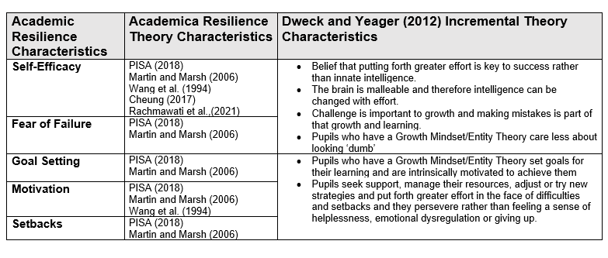
Figure 1Synthesis of Academic Resilience and Incremental Theory Characteristics

Indeed, Dweck and Blackwell (2007) founded Brainology which is a blended learning curriculum which supports pupils in developing a ‘Growth Mindset’ (Incremental Theory) through understanding that intelligence is not fixed and can be developed with effort. Within this programme, the five key characteristics are targeted and developed in addition to supporting pupil’s neuroscientific understanding in relation to brain malleability through age-appropriate activities.

3.1.4 Incremental Theory Programme
Yeager and Walton (2011) explain that Incremental Theory interventions are effective because they teach pupils how a Growth Mindset affects them in specific contexts and are delivered in a way that supports pupils in quickly internalising this. The researchers emphasise that Incremental Theory interventions require the retention of these two features. They add that to do this, these interventions require customisation for the specific pupils. They further emphasise that whilst neuroscientific information facilitates the incremental theory effect, just teaching pupils about the brain structure and its potential to change may lose sight of the required development of academic resilience.
Therefore, the principles of Brainology, which target the development of the five characteristics, are customised within an Incremental Theory intervention (Appendix A) and used to develop academic resilience in an age-appropriate delivery.
Figure 2 Incremental Theory Intervention Lesson Topic and Objectives
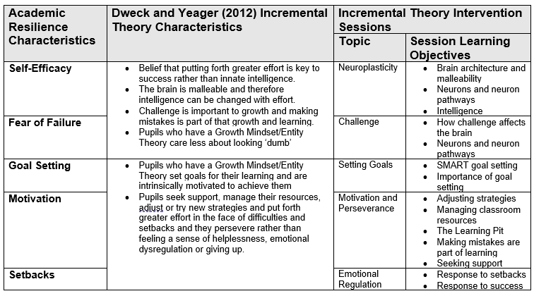

3.1.5 Academic Resilience Measures
Despite recent research interest in academic resilience in relation to incremental theory in education, there is a lack of valid and reliable measures for certain age groups and for incremental theory interventions. Indeed, Yilmaz (2021) claims that the ‘lack of a comprehensive measurement tool that measures the Mindset Theory in a valid and reliable way is considered as a major gap in the field’ (p.3). Similarly, Rammstedt et al. (2022) explain that given the attention growth mindset has received and the vast body of academic and theoretical research, there is an assumption that this would be based on reliable and validated growth mindset scales. However, there are two established scales which measure growth mindset: a six- to eight-item scale (Dweck, 1999) and a three-item scale (Dweck et al., 1995).
Rudd et al (2021) conducted a systematic literature review of 127 studies to explore the approaches to measurement and analysis of quantitative academic resilience research over the past 20 years. The researchers found that whilst there is a ‘consensus as to the definition and broad conceptualisation of academic resilience, there is no standard approach to its measurement’. Tudor and Spray (2018) add that the variability of these approaches makes estimating the occurrence of academic resilience and evaluating the effectiveness of its protective characteristics difficult. Rudd et al (2021) concluded that researchers have found it difficult to evaluate academic resilience due to its dynamic nature and multiple factors (risk and competence). Researchers must decide how to combine academic resilience's components into a single variable or statistical model in quantitative investigations. The researchers argue that these decisions are to me made by the researcher. Furthermore, they state that how academic resilience is operationalised determines how resilient and non-resilient pupils are identified.
As a result, the theoretical frame which synthesises the academic resilience characteristics found in literature with Dweck and Yeager’s (2012) Incremental Theory characteristics are applied and combined to create quantitative and qualitative questions which reflect the characteristics synthesised within the theoretical frame.
Figure 3 Synthesis of Academic Resilience Characteristics and Responding Questionnaire Statements
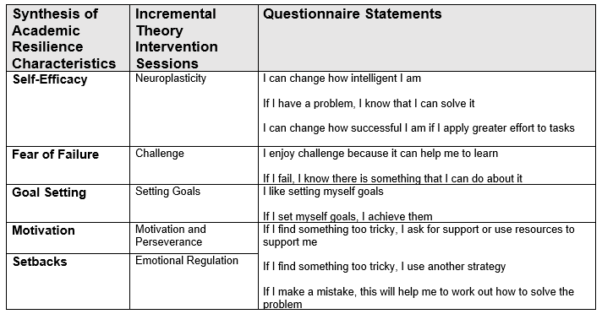
Figure 4 Synthesis of Academic Resilience Characteristics and Responding Interview Questions
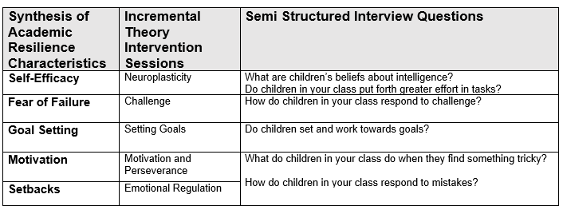

3.2 Methodology

This research's approach best answers the questions. This is the Positivist ontology of one reality and the interpretivist ontology of truth and reality. Thus, quantitative and qualitative research. The first research question evaluates the "extent" to which an intervention "impacts" learners' academic resilience, using a positivist paradigm, while the second examines how practitioners "perceive" impact, using an interpretivist paradigm. A pragmatic paradigm justifies using a mixed method design to answer a research topic using these two paradigms.

3.2.1 Equal Status Mixed Methods
The dominant technique in mixed methods research determines whether it is qualitative or quantitative. Johnson, Onwuegbuzie, and Turner (2007) propose a third perspective, equal status mixed methods research, where all components are equally prominent. Deweyan pragmatism agrees. According to Wyse et al. (2016), Dewey rejected the either-or logic dualism and believed truth and logic may be found at both ends. This research uses pragmatic mixed approaches since measurable and qualifiable research dominate the research challenge.
This research is associated with action research since it will execute and evaluate an intervention in one environment. Dewey's Theory of Inquiry describes the spiralling of knowledge-action processes, which action research may support. According to Creswell (2014), action research is defined by the researcher's involvement in the phenomena under investigation, which aligns with Dewey's idea that knowing and doing are not distinct (Morgan, 2013).
Felizer (2010) states that this design aids change-related knowledge creation. Action research seeks the best treatments for people and groups (Kaushik and Walsh, 2019). Ivankova and Wingo (2018) explain that this approach uses interventions in research cycles of creating, implementing, and assessing to enhance practise. An action research design within a mixed methodologies approach addresses the research topic by integrating positivist and interpretivist perspectives. Convergent parallel mixed method action research fits this study well. To better comprehend the research topic, Creswell (2014) suggests combining quantitative and qualitative data in one study. Johnson, Onwuegbuzie, and Turner (2007) call this equal status mixed methods study since neither dominates. Mixed techniques allow approaches to work independently while balancing their strengths and weaknesses. Felizer (2010) claims that between-methods triangulation reduces biases best due to this counterbalancing.

3.2.2 Inside Action Research
The research utilised Insider Action Research. Practitioners doing action research in their own setting, according to Coghlan and Brydon-Miller (2014). This is advantageous since practitioners know the setting's culture and networks. The context's professional contacts boost the possibility of participants trusting and participating with the study. However, this might make it hard to separate from the surroundings for objective study. While doing research in one location gives particular assessment and action for improvement, it reduces the study's external validity for generalisation.
Pragmatism suggests identifying research issues before methodologies. In this study, the research questions address the research topic, and the data collecting techniques are chosen to answer them. Action research designs employ hybrid approaches. Mixed methods and action research both use positivist and interpretivist assumptions to improve knowledge, according to Moseholm and Fetters (2017).

3.2.3 Research Question 1:
Punch (2009) claims that method selection is prioritised above research questions and that questions determine approach. Indeed, Mills (2011) and Ivankova and Wingo (2018) suggest that action research normally uses qualitative techniques, but the study questions may need both qualitative and quantitative methodologies, especially when qualitative data explains the quantitative. The first study question asks about the "extent" of the growth mindset "intervention," which implies quantitative data collecting (Cohen et al., 2011). The intervention is a programme developed by the researcher through customisation of Brainology in relation to the synthesis of Dweck and Yeager’s (2012) Incremental Theory characteristics and the five academic characteristics identified in the literature (figure 2), which are specific to the pupils within the school (Yeager and Walton, 2011). The intervention is delivered over 5 lessons (Appendix A) in one academic term to KS2 pupils in Years 5 and 6 by their normal class teachers.

3.2.3.1 Research Question 1 Sampling
Since the research question intends to determine the extent that an intervention has impacted on a specific set of pupils, the sampling strategy adopted for this research is non-probability purposive sampling. That is, pupils are selected based on their purpose for the research. As Flick (2018) puts it, participants are selected based on a set of criteria. The research participant criteria are KS2 pupils in a specific school in Wales. Therefore, the sample is based on characteristics defined by the aim and relevance to the research (Obilor, 2023).

3.2.3.2 Research Question 1 Data Collection Methods
In response to this question this research will administer a self-report 6-point 20-item Likert-Scale questionnaire to measure baseline academic resilience and post intervention in a repeated measure process.
The questionnaire will use questions developed from the synthesis of academic resilience and Dweck and Yeager’s (2012) Incremental Theory characteristics (figure 2) on an ordinal Likert-scale (Appendix B) and adaptation and expansion of the two existing Incremental Theory Likert-scale measures (Dweck et al., 1995; Dweck, 1999). The questionnaire includes 10 positive statements which reflect an academically resilient pupil and 10 negative statements which correspond to the positive statements. The Likert-scale questionnaire is chosen because it is easy to create and child-friendly. Statements will also be clearly defined and age-appropriate. The scale will have equal intervals to reduce central tendency bias (Cohen et al. 2011). Bishop and Heron (2015) suggest that learners may understand statements and interval distance differently. Felizer (2010) advises against utilising researcher-created questionnaires instead of dependable tools. Gray (2018) further cautions that this data collecting technique hinders action research cooperation. Gray (2018) adds that it is legitimate if it delivers data that other techniques cannot.

3.2.3.3. Question 1: Data Analysis
Cohen et al. (2011) argue that Likert-scales are non-parametric because they lack comparable statistics for analysis. Sullivan and Artino (2013) wonder whether such data transformed to statistics may be maintained as parametric-defined interval data. This study will involve repeated questionnaires pre- and post-intervention. Consequently, a Paired Sample t-Test will be carried out with the use of linear numeric codes so that the 6-points are translated into equal intervals numerically in increments of 1 (1-6). The questionnaire responses ranging from Strongly Disagree to Strongly Agree are coded 1-6 for positive statements and reverse coded 6-1 for negative statements (Appendix B). Participants are given a participant code so that the pre and post-test questionnaire can be analysed. An academic resilience score is generated from the total points on the pre and post-test questionnaire for each participant. The Paired Sample t-test academic resilience scores will be analysed using SPSS to determine the extent of the impact of the intervention effect size (Cohen’s d). In addition, the questionnaire statements and the corresponding academic resilience characteristic will be analysed individually to determine the impact of the intervention on the specific academic resilience characteristic using pre and post test mean average scores. SPSS is chosen for its ease of use, availability, and application in education research. Its main role is data analysis (Muijs, 2011).

3.2.4 Research Question 2
The second research question aims to explore the practitioners ‘perceptions’ of impact of the intervention. As this question explores perceptions, it carries the methodological implication of generating qualitative data. The first question sought to determine if there was an impact on the learners’ academic resilience, whereas the second asks if then, how?
Post intervention, the teachers will be carrying out their usual daily lessons with pupils. Teachers will be interviewed to find out their perceptions of pupils’ academic resilience across the five characteristics.

3.2.4.1 Research Question 2 Sampling
This research question is concerned with exploring the perceptions of the school’s Year 5 and Year 6 teachers. Consequently, a non-probability purposive sampling method will be applied (Flick, 2018; Obilor, 2023). The criteria determines that participants should be the Year 5 and 6 class teachers since they will be carrying out daily lessons post-intervention.

3.2.4.2 Research Question 2 Data Collection Methods
This study will employ semi-structured interviews (Appendix C) to investigate how people interpret their lives (Felizer, 2010). This study matches Cohen et al. (2011)'s interviewing goals. Interviews seek different perspectives of an event, identify study variables and their relationships, and offer triangulation when used with other methodologies.
Teachers are interviewed instead of students since they offer the intervention and are likely to understand the effect on all five qualities. The semi-structured interview synthesises academic resilience features (Figure 3) from the questionnaire. Semi-structured interviews triangulate quantitative "if" data but allow for longer responses in order to understand the "whys and hows." (Gray, 2018).
Gray (2018) states that interview methods may boost validity. This involves creating rapport and trust between the researcher and participant and allowing the interview enough time to neither restrict or strain participants. Flick (2018) adds that letting participants read the transcription, add or delete replies, and clarify meaning and comprehension improves internal validity. Conversely, as the interviews will be performed with a small sample and in one environment, they will not be readily generalised, weakening their external validity.

3.2.4.3 Research Question 2: Data Analysis
Interview data will be thematically evaluated. Qualitative data pattern and theme identification (Flick, 2018). Thematic analysis is preferred over content analysis because it allows instructors to analyse student perspectives (Braun and Clarke, 2006). The literature is used to code data topics. Braun et al. (2006) caution against this analysis. However, it helps compare participant viewpoints. Thematic analysis may cause discrepancies, although Nowell et al. (2017) claim it allows for flexibility and adaption without hindering rich, comprehensive qualitative data. Braun and Clarke’s (2006) six-step thematic analysis will be conducted using NVIVO software. This will include reading the transcripts, becoming familiar with the data and open coding the data in relation to its relevance to the predefined themes which will guide the analysis (synthesis of academic resilience characteristics). Thereafter, themes will be identified and reviewed and refined and written up.

3.2.6 Ethical Considerations
The British Educational Research Association (2018) Code of Practice and UWTSD Research Ethics and Integrity Code of Practice identifies the ethical principles required for conducting research. In addition, the UWTSD Research Data Management Policy (2022) which includes obligations under the UK Data Protection Act (2018) guide the collecting and storing of data. Consequently, throughout the research process the codes of practices and policies will be adhered to.

3.2.6.1 Consent
Before conducting the investigation, all participants will be asked for their informed consent (Appendix D). Participants will be informed of the research's purpose, aims, and objectives, as well as where and how their data will be stored and for how long. Participants will be informed of their right to withdraw from the research at any time without experiencing any negative consequences. This information will be provided both in written and verbal form. Participants will be given the opportunity to ask any questions and make an informed decision regarding their participation in the research. In addition to parental consent, all pupil's assent will be sought (UWTSD Code of Integrity and Ethics, 2022). This will be obtained through the use of a child-friendly checklist with the options yes and no. No images (such as emojis) will be used to ensure that children feel secure and comfortable saying both yes and no. To avoid pupils feeling obligated to participate as they are being asked by a professional within their context or colleagues feeling obliged to take part, all participants will be reminded that not participating in the research will not result in any negative repercussions (BERA, 2018). If pupils choose not to participate, they will be given an appropriate Growth Mindset activity, that they would normally do as part of their daily learning, to complete while other participants complete their questionnaires. Furthermore, it will be made clear throughout the research process that participants can withdraw from or resume the research at any time. This will be provided via consent forms, an information sheet, and debriefing. During the debriefing, the researcher will reiterate the aims of the study and provide opportunities for further questions.

3.2.6.2 Power Relations/Risks
As a member of staff, the researcher must ensure that the pupil’s see them as a researcher rather than their teacher. To this end, all pupil’s will be explicitly told that the research is conducted separately from the school and they can choose to participate or not participate, withdraw from the research and that there is no positive or negative consequence as a result (BERA, 2018).
In interviewing the teacher participants, the interview questions pertain to teacher's perceptions of pupil's academic resilience rather than the teacher's own practice or delivery of the intervention. As they will be involved in its implementation, teachers will be familiar with the intervention. This should therefore reduce the likelihood that the interview will cause anxiety or emotional distress. The interview questions will not be of a sensitive nature, and teachers will be reassured that there is no correct response, that they can clarify the meaning of the questions and omit their response at any time if they so choose. They will also have the opportunity to review the interview notes should they desire to modify or clarify the information (BERA, 2018)

3.2.6.3 Confidentiality and anonymity
BERA (2018) states that ‘The confidential and anonymous treatment of participants’ data is considered the norm for the conduct of research’ (p.1). As such, the research will be carried out under this normal conduct of research. This will include ensuring that participants are aware of confidentiality and anonymity within the research through written and verbal information and as part of the consent forms. In addition, the research will adhere to the UWTSD Data Management Policy (2022) and BERA (2018) guidelines when storing participants data. The list of participants which are assigned numerical codes and their corresponding data will be stored on a password encrypted file and the analysis of the data and interview notes will be stored on the researcher’s University storage cloud. In disseminating the results, no data will be shared that will enable the identification of the participants within the research which would breach to agreed anonymity and confidentiality (BERA, 2018).

Chapter 4- Findings/Data Analysis

4.1 Research Question 1
To what extent do Incremental Theory interventions impact on UKS2 pupils’ academic resilience? As the method of data collection generate quantitative data, a hypothesis and null hypothesis are used to guide data analysis. The data analysis will serve to support or not support the hypothesis.
$H_{0}$ There is no statistically significant difference between pre and post intervention academic resilience scores.
$H_{1}$ There is a statistically significant difference between pre and post intervention academic resilience scores.

4.1.1 Sample
The sample consisted of 50 UKS2 pupils across 2 classes. Year 5 is made up of 27 pupils (9-10 years old) and Year 6 is made up of 23 pupils (10-11 years old). Of the 50 pupils, 40 parental consent forms were returned, and all participants provided assent. Of the 40 pupils who provided consent and assent, two of the 40 pupil’s data was removed from the research due to being absent on the pre test questionnaire. The paired questionnaire data included in this research is n=38.

4.1.2 Intervention
The Brainology programme was customised to focus on the synthesised five academic resilience characteristics (Figure2) and resulted in a five-session intervention (Appendix A). The intervention was carried out with Year 5 and 6 pupils and delivered by their normal class teachers.

4.1.3 Data Analysis
The data collection tool (questionnaire) generated pre and post-test academic resilience scores which were imputed and analysed using SPSS software. In supporting or rejecting the hypothesis, $α$ (level of significance) will be $α=0.05$as if $α ≥0.05$we can assume that the two scores are statistically different (Cohen et al. 2011 ; Gray, 2018).

4.1.4 Paired t-Test Findings
Pre and post intervention questionnaire academic resilience scores were inputted into SPPS software, and a Paired Sample T-Test was run to analyse the data. This generated the mean of both pairs with standard deviation (SD), the correlation (r) of the pre intervention and post intervention scores, the two-sided p value of significance and Cohen’s d effect size.
Figure 5 t-Test Academic Resilience Scores
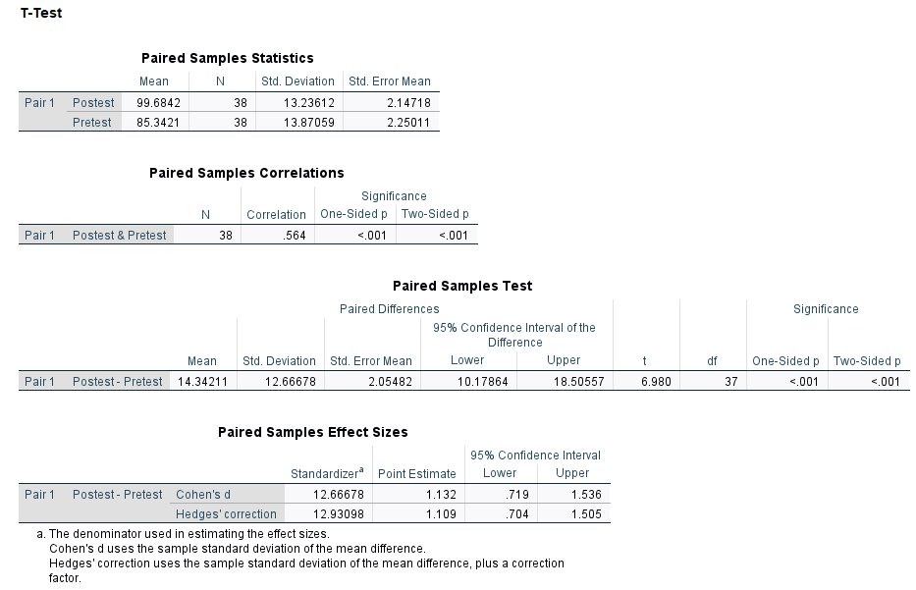
The paired samples t-Test showed that the pupil’s academic resilience had increased post intervention from (M = 85.3421, SD = 13.87059) to post intervention (M = 99.6842, SD = 13.23612; t = 6.980, p < .001, df= 37). As the p value is less than 0.05 at p < .001 , it can be said that the pre test scores are statistically significantly different from the post test scores. This supports the alternative hypothesis $H_{1}$: There is a statistically significant difference between pre and post intervention academic resilience scores and does not support the null hypothesis $H_{0}$: There is no statistically significant difference between pre and post intervention academic resilience scores.
This parametric statistical test was conducted using questionnaire ordinal statements i.e. Strongly Agree to Strongly Disagree assigned with scale measurements e.g. Strongly Agree=1. However, Davies (2022) states that ordinal statements are best analysed using non-parametric means. Consequently, ordinal data was inputted into SPSS and the Wilcoxon Signed Rank Test was used to determine the pre and post test scores were statistically different.
Figure 6 Wilcoxon Signed Rank Test Pre and Post Test Academic Resilience Scores
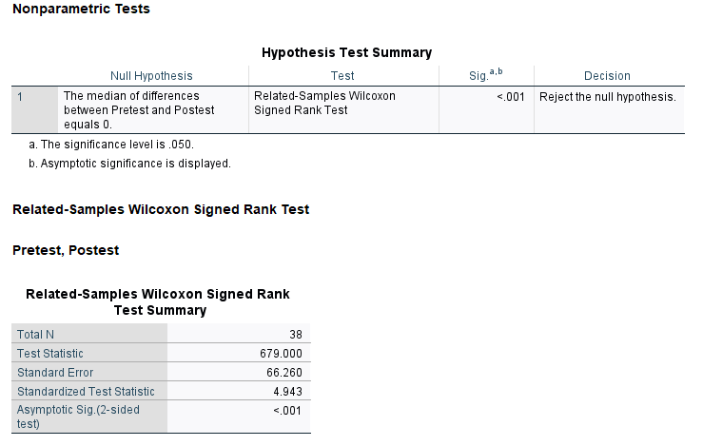
As the p value (Asymptotic sig.) is < .001 and therefore below the significance level of 0.05 in this Wilcoxon Signed Rank Test, the decision is to ‘Reject the null hypothesis’, the null hypothesis of this research is not supported. Both the non-parametric Wilcoxon Signed Rank Test and the parametric Paired t-Test analysis have generated p < .001 with a significance level of $α ≥0.05$, the pre and post-test data is statistically significantly different.
This address part of research question 1, which is to determine whether Incremental Theory interventions ‘impact’ UKS2 pupil’s academic resilience. To what extent do Incremental Theory interventions impact on UKS2 pupils’ academic resilience. The second part of research question 1 asks ‘To what extent’. Cohen et al. (2011) explain that this cannot be determined by statistical significance (p). Indeed, the authors maintain that p by itself has come to be regarded as an unsuitable indicator of effect because it is dependent on sample size and correlation. Either a large correlation and a small sample size, or a small correlation and a large sample size, can produce statistically significant differences. The problem is that it cannot determine which effect is decisive from a statistically significant study. The importance is to determine whether the difference is due to the sample size or the correlation. The effect size is able to accomplish this as it is a simplistic approach to determining the quantifiable difference between the two tests. Consequently, it can report on the effect size (Cohen’s d.) which statistical difference (p) does not. According to Cohen’s d. an effect size can lie between 0-1 (Cohen et al. 2011).

Figure 7 Cohen's d Effect Sizes (adapted from Cohen et al. 2011)
Effect Size (d.) | Rating
- - 0.20 | Weak Effect
0.21- 0.50 | Modest Effect
0.51- 1.00 | Moderate Effect
$$>1.00$$ | Strong Effect
In figure 7 the effect size for the Paired t-Test for pre and post test academic resilience scores was d 1.132. According to Cohen’s d, the effect of the Incremental Theory intervention is strong d >1.00.

4.1.5 Academic Resilience Characteristics Paired t-Test Findings
The questionnaire statements were divided into the academic resilience characteristics and were assigned scale measures to determine the pre and post test scores of the pupil’s academic resilience scores within the individual characteristics.
Figure 8 Paired Sample t-Test Academic Resilience Characteristics Pre and Post Test Scores
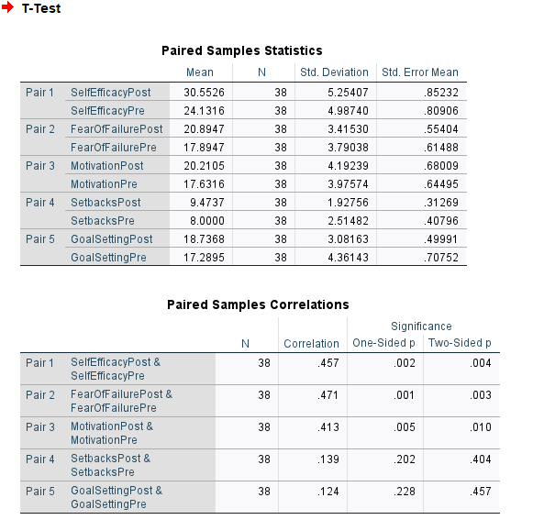
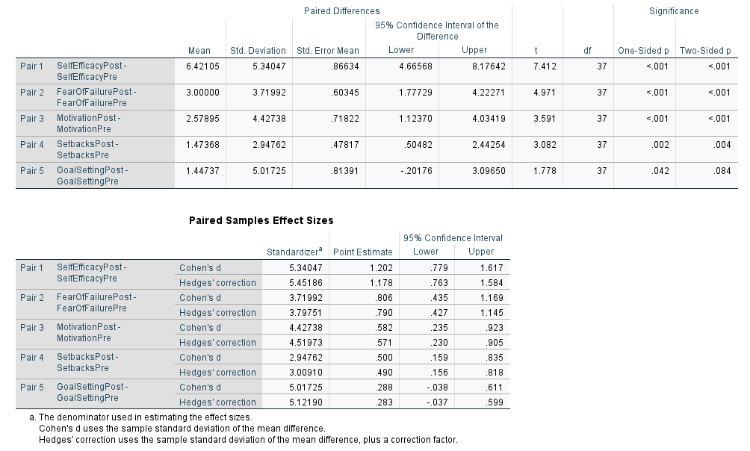
The paired samples t-Test showed that across the five academic resilience characteristics, the pupil’s mean academic resilience scores had increased post test. The p values of four of the post academic resilience characteristics show that there is a statistically significant different from the pre test as $α ≥0.05$ (Self Efficacy, Fear of Failure and Motivation = p < .001 and Setbacks = p 0.004). However, the p value of Setting Goals is p 0.84 is $α <0.05$ demonstrating that it is not statistically significantly different from the pre test score. The individual academic resilience characteristic effect sizes ranged from d = 0.288 and 1.202.
Figure 9 Pre and Post Test Academic Resilience Characteristic Scores

In figure 7 the strength of the effect size for the Paired t-Test for pre and post test was reported (Cohen et al.2011). The graph (figure 9) demonstrates that according to these effect sizes (Cohen’s d), Self-Efficacy = d.1.202 is therefore considered a strong effect size; Fear of Failure = d. 0.806 and Motivation d= 0.583 are considered moderate effect sizes; whilst Setbacks d= 0.5 and Goal Setting d= 0.288 are considered a modest effect size.

4.2 Research Question 2
What extent do UKS2 Teachers perceive that Incremental Theory interventions impact on UKS2 pupils’ academic resilience?

4.2.1 Sample/Intervention/Data Collection
The participants were the Year 5 and Year 6 Class teachers who delivered the intervention within their daily classroom teaching and learning over five sessions in one academic term. The teachers were asked about their perceptions of the extent to which the Incremental Theory Intervention had impacted on UKS2 Pupil’s academic resilience. The semi-structured interview (Appendix C) included questions which corresponded with the five academic resilience characteristics (figure 4). Within this research they are referred to as Participant A (PA) and Participant B (PB).

4.2.2 Data Analysis
The interview data was recorded and transcribed using Microsoft Teams and imported to NVIVO software. The data was analysed using the Six-Step Thematic Analysis (Braun and Clarke, 2006). In step 1, familiarisation with the data included listening to the audio recordings, checking the transcriptions and rereading the transcriptions. Conducting step 2 included reading through the transcriptions and generating initial codes by working through the data and ‘attending to each data item with equal consideration and identifying aspects of data items that are interesting and may be informative in developing themes’ (Byrne, 2022 p. 8). This generated 18 initial codes.
Figure 10 Initial Codes NVIVO
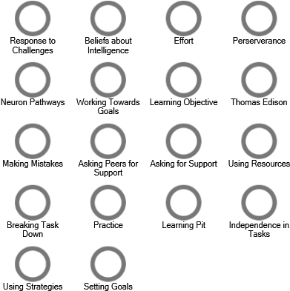
Byrne (2022) explains that a data driven, inductive approach generates codes that are seen with the data whilst theory-driven approach may generate codes based on a pre-defined theoretical framework identified. However, the author adds that coding and analysis usually includes a combined method. Indeed, despite the theoretical frame (Synthesis of academic resilience characteristics) guiding the initial coding, the data itself was not coded to these predefined themes in step 2 and was grouped under the five academic resilience characteristics after the data had been coded in step 3. This was carried out by reviewing and analysing the initial codes and grouping the codes according to their themes.
Figure 11 Academic Resilience Themes NVIVO
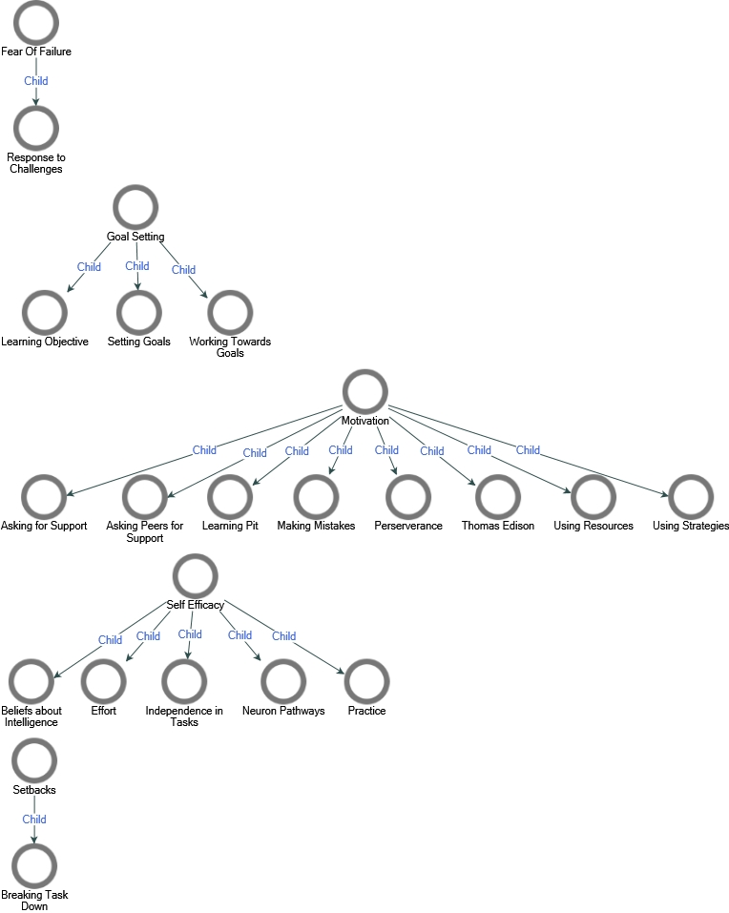
In step 4, Braun and Clarke (2006) advise that researchers revise their themes with the view of best answering the research question. As the themes set out in step 2, that is the five academic resilience characteristics when combined make up academic resilience, the themes were not revised as to best answer the research question ‘do incremental theory interventions impact on UKS2 pupil’s academic resilience. However, codes that were selected under Setbacks were relevant to that of Motivation. As a result, these themes were combined in revision.

Figure 12 Step 4 Revision of Themes
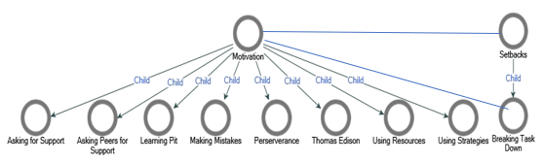
This was also the case for step 5 which advises that researchers rename and revise their themes to ensure that they are reflective of the coded content. As the themes were defined based on the five academic resilience characteristics and named as throughout this research, the themes remained the same.

4.2.2.3 Braun & Clarke (2006) Step 6 Write Report
The sixth step is writing up the data analysis which includes discussion of the codes within the themes and extracts from the data that evidence the appropriateness of the codes generated and the themes in which they sit.
Figure 13 NVIVO Autocodes Sentiment for Codes by Academic Resilience Characteristics

As demonstrated in the graph (figure 13), of the 48 sentiments coded, 45 were positive and 3 were negative. Overall, the teachers perceived the intervention to have made a positive impact on the pupils’ academic resilience.
Self-Efficacy
The teachers (PA & PB) both discussed how children’s beliefs about their intelligence had changed post intervention. There was discussion about how the pupil’s viewed themselves within their classroom i.e., lower, middle, and higher ability despite this never being communicated to the pupils. However, since the intervention pupils have made reference to working harder so that they could switch groups and have more challenging work. One of the teachers explained that this was most noticeable amongst ‘lower’ and ‘higher’ ability pupils, with ‘lower’ ability pupils realising that scientifically, the brain is malleable and therefore can changes and ‘higher’ ability pushing themselves in tasks despite being ‘good’ at the task in question. Both teachers discussed how they are referring to their learning as practising to make things easier. An example of this is that pupils are discussing the growth of their neuron pathways which will make them smarter and reference this post tasks during self-assessment and evaluation.
Teachers have noticed post intervention that pupils are applying greater effort in their tasks and across the curriculum particularly for those pupils who would seek support throughout the task becoming more independent. As PB stated:
I think it's been more noticeable that some of the children that almost constantly ask for help and support with each step along the way have been more independent. They're trying more on their own before they come into the point of needing to ask for help.

Fear of Failure
When challenging themselves, both teachers agreed that they view challenges as a way to ‘getting smarter’ and that without challenge or find something appropriately challenging, no real learning takes place. PA stated that the pupils now ‘relished challenge’ and ‘they love it when something's tricky because they know that they've challenged themselves’ and PB stated that ‘Some of them thrive on it and their faces light up, especially if it's a maths challenge, and they dive straight in’. However, the teachers did mention that whilst some pupils are now excited by challenge, there are a ‘few who need an awful lot of support in order to respond to challenges. That said, it was added by one of the teachers that there ‘others who have a look of fear and are hesitant but then actually do tackle it.
In answering several of the questions, both teachers continually referred to ‘The Learning Pit’ which was introduced in the intervention as a visual to explain learning, how challenges can bring about meaningful learning, and the strategies and resources that could be used to ‘get out’ of the learning pit. The teachers explained that the pupils ‘really enjoyed’ the Learning Pit and explained that it provided a ‘good visual for the children’. The pupils refer to the Learning Pit throughout their learning and this is seen by the teachers as improving metacognition and supporting them in understanding that challenge is a part of learning. Examples of this are seen in evaluating their learning, PA talked about how pupils had stated they were in the Learning Pit and evaluated the strategies and support they had to ‘get them out’.
When they find something tricky rather than thinking I can't do it, with some of them, they used to kind of shut down. We wouldn't get anything out of them because they found it too challenging. They couldn't see how they would get themselves out of it. They generally now see that as a positive. Now if something's challenging and tricky, they don't see as a negative anymore. They just realised it in the learning pit. (PA)

Motivation/Setbacks
One of the teachers reported on the impact on pupils’ motivation and commented that they saw one pupil a far greater effort and motivation to complete tasks. The pupil had recently joined the school (4 weeks previously) and had ‘little motivation with tasks’ and the difference ‘within him has been quite astonishing’.
The teachers reported that it has been noticeable that pupils are using additional strategies when finding tasks tricky. They refer to asking the teacher and their peers for support, using resources and different strategies. One of the teachers stated that there are a ‘few’ who seek support with the teacher but that it’s been noticeable that there are ‘quite a few’ asking their peers before asking the teacher for support.

It has been noticeable they're asking each other more for help as well and comparing and asking questions (PB)
Whilst the other stated that in reflection of their learning:
…they say I was in the learning pit, but I used my friend to help me, someone on another table to help me (PA)
However, one of the teachers explained that ‘there are still some who sit and wait for me to notice that they stuck and go over’.
Both teachers refer to a positive change in the way the pupils now use classroom resources. Indeed, one of the teachers found that the pupils in her class had come to realise the different ways they can support themselves during tricky tasks and that it is a part of learning to use them for tasks. The teacher felt that these were not previously utilised effectively but listing the ways in which they could support within the intervention enabled them to be more proactive in supporting themselves post intervention. This teacher then explained that in reflection of their learning, pupils were able to explain the different ways they had supported themselves
I used the strategy books in the classroom to help me. I use the work on the whiteboard to help me. I use the resources on the Google Classroom to help me. (PA)

Similarly, the other teacher stated that there have been ‘a couple who actually get up and go get things, if they haven’t got them, they get them’. The examples of this were maths resources e.g., 100 square. Likewise, both teachers saw a difference in how pupils were using alternative strategies. One of the teachers discussed how ‘some’ pupils were sitting and thinking about their work for longer and trying different strategies on scrap paper and whiteboards.
Both teachers were positive about the impact the intervention had on pupil’s understanding of mistakes and responses to mistakes. The teachers reported a shift in pupils’ understanding, that ‘it’s not about getting it right first time’, that it’s ‘okay to make a mistake’, that there are ‘little steps along the way’ and they ‘know now it’s part of the journey’. The teachers did add that there is ‘still some’ that do not like making mistakes and this leads to the pupils feeling frustrated.
Within the intervention, the pupils learned about Thomas Edison’s development of the lightbulb. In this, it was reported that Edison has made 999 mistakes before finally creating the lightbulb on the 1000 attempt. It is evident within the data that this had impacted on the UKS2 pupils, with the teachers referring to this part of the intervention several times across several questions. In one example, one of the teachers talked about a pupil who had not managed to complete her challenge. When asked the pupil stated that she would be like Thomas Edison and persevere. When returning with a successfully completed challenge, the pupil said that ‘at least it didn't take me 1000 steps’. Furthermore, PA stated that:
We know that he [Thomas Edison] had to make 999 mistakes in order for him to achieve what he wanted. So, they just know now that mistakes are not a bad thing and not a negative thing. It just means that they're doing something that is challenging them, and mistakes are part of the process

Goal Setting
Within the data analysis process, there were less codes relating to the theme of Goal Setting. In discussion with the teachers about if the intervention had impacted on Goal Setting, both teachers talked about how the pupils were setting goals but there were disparities about who was goal setting, how much support they had in goal setting and whether it was done on an individual or whole class basis. PB discussed how the pupils use their learning objective as a goal which guides their learning. They also discussed one pupil who had reflected on his learning and referred to his goal within the task ‘he hadn't managed to achieve the goal of fully, he could see that he'd made his way towards it and he said I'm really pleased I've managed to do part of it rather than achieve the whole thing’. PA stated that pupils in her class were ‘all setting themselves their own goals, and this is done automatically in their work’ and after completing tasks were able to identify their next goal and how they were going to achieve it.

Chapter 5- Discussion

5.1 Research Question Summary
The first research question was to determine: To what extent do Incremental Theory interventions impact on UKS2 pupils’ academic resilience? The data analysis set out to support or not support the hypothesis.
$H_{0}$ There is no statistically significant difference between pre and post intervention academic resilience scores.
$H_{1}$ There is a statistically significant difference between pre and post intervention academic resilience scores.
The second research question was to understand to what extent do UKS2 Teachers perceive that Incremental Theory interventions impact on UKS2 pupils’ academic resilience?

5.2 Overall Intervention Impact
To understand whether indeed the intervention did impact on the pupils’ academic resilience, the Paired t-test samples were analysed using SPSS software and determined that pupil’s academic resilience scores had increased. It was also determined that these results were statistically significantly different (p < .001). Furthermore, as the t-test used the questionnaire ordinal data assigned as scale measure, a non-parametric test was used to test the related samples using ordinal data. The Wilcoxon Signed Rank Test also found that there was a statistically significantly difference (p < .001). As a result, both tests supported the $H_{1}$ There is a statistically significant difference between pre and post intervention academic resilience scores. p < .001 is considered robust (Cohen et al. 2011). The t-test found that there was a positive impact on pupils’ academic resilience. To determine the ‘extent’ of that impact, as directed by the research question, the effect size of intervention was determined (Cohen’s d). There was an effect size of d. 1.132 which is considered a strong effect (Cohen et al., 2011).
Figure 14 NVIVO Proportion of Negative and Positive Code Sentiments

Pupils self-report of the impact (d.1.32) is consistent with the teachers’ perceptions of the impact of the intervention. Teachers’ perceptions of the impact were mostly positive, and the findings illustrated that there has been a positive change in how pupils are developing and utilising their academic resilience. This was illustrated both in the large proportion of moderately and very positive sentiments assigned in NVIVO (figure 13) as demonstrated in (figure 14).

5.3. Individual Academic Resilience Characteristics
The pre and post-test synthesised academic resilience characteristics scores were tested using a t-test to understand how the intervention had impacted pupils’ academic resilience scores within the individual characteristics.
Whilst the overall academic resilience intervention had impacted the pupil’ academic resilience with a large effect size and determined as statistically significantly different, this was only true of parts of the intervention.

Figure 15 Paired t-Test Academic Resilience d. and p. Values
Characteristic | p. | Statistically significant?  $$α ≥0.05$$ | d. | Effect Size
Self-Efficacy | <.001 | Yes | 1.202 | Strong
Fear of Failure | <.001 | Yes | .806 | Moderate
Motivation | <.001 | Yes | .582 | Moderate
Goal Setting | .002 | Yes | .5 | Modest
Setbacks | .084 | No | .288 | Modest

5.3.1 Self-Efficacy
Pupils reported a large impact (d. 1.202) on their self-efficacy that was statistically significantly different (p <.001). Similarly, teachers’ perceptions of the impact on pupils’ self-efficacy was positive, determined by the ‘moderately positive’ and ‘very positive’ sentiments coded to their interview data. Both the pupils self-reported large impact and the teachers stated impact were consistent with each other. Furthermore, the theoretical frame (Figure 1.) set out that academic resilience pupils put forth greater effort as they believe that intelligence is malleable and can be changed with effort. This is consistent with the teacher’s discussion about how they had both found it noticeable that pupils were applying greater effort and that they now had the belief that this could bring about changes in their intelligence. This was highlighted in pupils’ awareness of ‘lower’ and ‘higher’ ability and their reference to moving groups. In addition, this was further exemplified in pupils’ understanding and doing of practice making things easier and their greater levels of independence in tasks.

5.3.2 Fear of Failure
Pupils reported a moderate (d. 806) impact on their Fear of Failure that was statistically significantly different (p <.001) from pre test scores. The moderate impact is consistent with the teachers’ perceptions of the impact. Teachers’ mostly perceived pupils’ Fear of Failure as ‘moderately positive’ with one statement coded ‘moderately negative’ (figure.13). The teachers noticed that pupils viewed challenges as an opportunity to ‘get smarter’ and this was exemplified through a significant proportion of discussion and reference to the Learning Pit. This is consistent with the Theoretical Frame (figure 1.), academic resilient pupils see challenge as important to growth and the learning process. However, there were still some pupils who needed to be supported to try challenges.

5.3.3 Motivation
Whilst pupils reported a moderate impact (d.582) on their Motivation that was statistically significantly different (p <.001) from pre test scores, teachers reported the most ‘very positive’ and a large proportion of ‘moderately positive’ statements about this impact (figure 13). The theoretical frame (Figure 1.) characterised academic resilience pupils as persevering with tasks, trying new strategies, asking for support and utilising resources. This is consistent with the teachers’ perceptions of pupils Motivation. The teachers’ reported that it was more noticeable that pupils were seeking support from their peers and a positive change in how pupils interact with classroom resources. This was exemplified in their proactivity in collecting and using the resources independently. The teachers also noticed that pupils were highly motivated by the story of Thomas Edison as pupils were referring to this within their learning journeys and this supported them in understanding that mistakes are a part of learning.

5.3.4 Goal Setting
The pupils reported a modest impact (d. 0.5) on their Goal Setting that was statistically significantly different (p.002) from their pre test score. The modest impact is consistent with teachers’ perceptions of the impact on Goal Setting. Whilst teachers’ statements were coded as ‘moderately positive’ there was far less discussion about Goal Setting when compared to the other academic resilience characteristics. Teachers discussed how some pupils were able to identify further goals after completing their tasks and working towards the goals without prompting. However, there was some discussion about learning objectives operationalised as set goals. Whilst this is consistent with the Theoretical Frame (figure 1) there is an emphasis within the frame about pupils setting their own goals which supports them in becoming intrinsically motivated to achieve them.

5.3.5 Setbacks
Pupils reported a modest impact (d.288) on their Setbacks however this was not statistically significantly different (p. 0.84) from their pre test scores. This modest impact was consistent with teachers’ perceptions of the impact of Setbacks post intervention, there were three ‘moderately positive’ sentiment codes and one ‘moderately negative’ sentiment code (figure 13). The theoretical frame (figure 1) sets out that in the face of setbacks, pupils who are academically resilient persevere rather than feeling a sense of helplessness, emotional dysregulation and giving up. Whilst one of the teachers reported that there has been a shift in negativity around making mistakes, the other teacher explained how some pupils are frustrated with making mistakes.

5.4 Summary
In answering the overall research question, ‘Do Incremental Theory interventions improve pupils’ academic resilience?’ this research proposes that as weighted on the research as a whole, the quantitative and qualitative findings of the research have demonstrated that there has been a positive and large impact on pupils’ academic resilience which is consistent between data collection and analysis and with the theoretical frame. When divided into the academic resilience characteristics, the intervention had greater effects on, and was statistically significantly different for, Self-Efficacy, Fear of Failure and Motivation, whilst Goal- Setting and Setbacks had less impact with Setbacks as not statistically significantly different.

5.5 Limitations in Data Collection

As this research aligned itself to an action research design and that there was a small sample used within this research n=40, the external validity of the research is limited as the generalisability of the research is reduced. In addition, the methods used to collect the data i.e. researched-developed questionnaire and the non-probability sampling method have limited the reliability of the research.
To reduce limitations within this research, the mixed method design enabled the triangulation of data collection tools and analysis with the purpose of reducing biases and increasing the reliability and validity of the research. To this end Turner (2016), claims that to this end, triangulation improves the validity of a study by confirming the findings of the study with other collection tools and analysis. Despite this, throughout the research process, there has been limitations to the data collection process which can reduce the reliability and validity.

5.5.1 Questionnaire
On the one hand, to ensure that this research was measuring what it intended as set out in the research questions, the questionnaire was developed by the researcher to reflect a lack of standardised approach to measuring academic resilience (Rudd et al. 2021) and the ‘lack of a comprehensive measurement tool that measures the Mindset Theory in a valid and reliable way [which] is considered as a major gap in the field’ (Yilmaz, 2021, p.3) as well as customisation of the programme to best reflect the pupils, essential for scaling up an Incremental Theory intervention (Yeager and Walton, 2011), However on the other hand, as the questionnaire was researcher-developed based on the research’s Academic Resilience Theoretical Frame, this limits the external reliability of the measure and research. Despite this, the overall results illustrated that the questionnaire had a moderate correlation r= 0.564 which improves the internal reliability of the measure (Cohen et al. 2011).
5.5.2 Interview
Within the semi-structured interviews, teachers were asked about their perceptions of how the intervention impacted the pupils’ academic resilience based on the academic resilience theoretical frame. This presented biases in two ways. Firstly, this could have increased the likelihood of social desirability bias (Cohen et al., 2011). Despite teachers being informed about the aims and purpose of the study, they delivered the intervention, and the pupils are part of their own class so they may have answered questions more positively. Secondly, as the semi-structured interview was based on the academic theoretical frame, the questions were focused on the five academic resilience characteristics. Consequently, this may have increased confirmation bias (Gray, 2018).

5.5.3 Effect Size
In their study of reported effect sizes, Slavin et al. (2009) found that effect sizes in small pupil sample sizes studies (n > 250) were two to three times larger than those of larger studies. The small sample size in this research n=38 could have affected the effect size. In addition, Kraft, (2020) created a framework for interpreting and contextualising effect sizes. The author argues that correlation studies are more likely to produce larger effect sizes than causal studies e.g. Random Controlled Trials. Since this research produced correlational data, it is likely that this has impacted on the magnitude of the effect size. Furthermore, the author adds that outcomes that are more closely related to the intervention, measured immediately after and use measures with lower reliability are all likely to produce larger effect sizes. Similarly, as this research defined academic resilience characteristics which were operationalised within the intervention, questionnaire statements and semi-structured interview questions this is also likely to have impacted the magnitude of the effect size. As the questionnaires were given shortly after the intervention had concluded as well as the researcher-generated questionnaire itself, is likely to have impacted on the magnitude of the effect size. The intervention has impacted on pupils’ academic resilience with a large effect size but the truth of the magnitude of this effect is called into question by Kraft (2020).

5.6 Contributions to the Field
The literature identified several key gaps within academic resilience research. Firstly, despite brain growth spurts which are responsible for the development of executing functioning and thus academic resilience occurring within KS2, there is little or no research within the primary school or specifically in KS2. Whilst there has been some research pertaining academic resilience interventions (Brainology) within the UK, Wales or with primary aged pupils. Furthermore, Paunesku et al., (2015) recommended after their research into incremental theory interventions with teenagers, that it would be beneficial to conduct this research with younger learners. Lastly, Estyn (2020) recommended that best practice is to deliver interventions within pre-existing assessments e.g. (Thrive). However, as it is beyond the professional role of the teacher to assess pupils for their ACE score to determine specific interventions, the large proportion of pupils’ time that is spent in schools and developing resilience is seen as a buffer for the effects of ACEs, it is was beneficial to understand how academic resilience could be improved

Chapter 6- Recommendations

6.1 Implications for Future Research

As this research is aligned to Deweyan Pragmatism action research, the research serves as one cycle to inform the next, this is the view that truth is provisional, and each cycle brings us closer to the truth. As a result, this research has identified several points to guide the next cycle. This includes revising the intervention to improve the p value and d value for Setbacks. Additionally, future research will need to focus on a larger sample and over a longer period of time to explore whether post-test academic resilience scores, when not test immediately after the intervention, have similar effect sizes and remain increased over time.

6.2 Final Reflections

The research illustrated that for this sample, this intervention and within this context, Incremental Theory Interventions do improve UKS2 pupils’ academic resilience scores. This research is important for primary school practitioners who are seeking to improve academic resilience scores even though these results cannot be generalised beyond this study.

References

Aronson, J., Fried, C. B., and Good, C. (2002). Reducing the effects of stereotype threat on African American college students by shaping theories of intelligence. Journal of Experimental Social Psychology, (38) pp. 113–125.
Ashton, K., Bellis, M.A., Hardcastle, K., Hughes, K., Mably, S. and Evans, M., (2016). Adverse Childhood Experiences and their association with mental wellbeing in the Welsh adult population. Cardiff: Public Health Wales NHS Trust.
Avcı, S. (2022). Investigation of the individual characteristics that predict academic
Barton, E., Newbury, A., and Roberts, J. (2018) An evaluation of the Adverse Childhood Experience (ACE)-Informed Whole School Approach. Wales: Public Health Wales NHS Trust
Blackwell, L. A., Trzesniewski, K. H., & Dweck, C. S. (2007). Theories of intelligence and achievement across the junior high school transition: A longitudinal study and an intervention. Child Development, 78, pp. 246–263
Boullion, B., Withers, B., and Lippmann, M. (2020) Mindsets: Investigating resilience. Personality and Individual Differences, (174) pp. 1-10.
Braun, V. and Clarke, V., 2006. Using thematic analysis in psychology. Qualitative research in psychology, 3(2), pp.77-101.
British Educational Research Association [BERA] (2018) Ethical Guidelines for Educational Research, fourth edition, London.
Byrne, D., 2022. A worked example of Braun and Clarke’s approach to reflexive thematic analysis. Quality & quantity, 56(3), pp.1391-1412.
Cassidy, S (2016) The Academic Resilience Scale (ARS-30): A New Multidimensional Construct Measure, Front. Psychol. 7 (17) pp. 87-96 Chafouleas, S. M., Johnson, A. H., Overstreet, S., Santos, N. M. (2016). Toward a blueprint for trauma-informed service delivery in schools. School Mental Health, 8, 144–162.
Challenges and prospects, Routledge.
Cheung, D., 2018. The key factors affecting students’ individual interest in school science lessons. International Journal of Science Education, 40(1), pp.1-23.
Cho, M.H. and Heron, M.L., 2015. Self-regulated learning: The role of motivation, emotion, and use of learning strategies in students’ learning experiences in a self-paced online mathematics course. Distance Education, 36(1), pp.80-99.
Coghlan, D. and Brydon-Miller, M. eds., 2014. The SAGE encyclopedia of action research. Sage.
Cohen, L., Manion, L., Morrison, K. (2011) Research Methods in Education. 7th edn. New York: Routledge
Creswell, J. (2014) Qualitative inquiry and research design: Choosing among five traditions. Thousand Oaks, CA: Sage
Danese, A., and McEwen, BS. (2012) Adverse childhood experiences, allostasis, allostatic load, and age-related disease. Physiological Behaviour. 2012: 106 (1) pp.29-39
Davies, C., 2020. A quick guide to quantitative research in the social sciences.
Dee, R., Angus, E., Robinson, H., Kram, K., Tucker, S., Haas, S., and McClintock, D.(2020). Relationship between Adverse Childhood Experiences, Social-Emotional Competencies, and Problem Behaviors among Elementary-Aged Children, Journal of Child and Adolescent Counseling, 6:1, 70-82,
Doll, B., Brehm, K. and Zucker, S., 2014. Resilient classrooms: Creating healthy environments for learning. Guilford Publications.
Dweck, C., and Yeager, D. (2012) Mindsets That Promote Resilience: When Students Believe That Personal Characteristics Can Be Developed. Educational Psychologist, 47(4), pp.302–314
Dweck, C.S., Chiu, C.Y. and Hong, Y.Y., 1995. Implicit theories and their role in judgments and reactions: A word from two perspectives. Psychological inquiry, 6(4), pp.267-285.
Estyn. (2020) Knowing your children – supporting pupils with adverse childhood experiences (ACES). Cardiff: Crown
Felizer, M. (2010) Doing mixed methods research pragmatically: Implications for the rediscovery of pragmatism as a research paradigm. Journal of Mixed Methods Research 4, pp. 6–16.
Flick, UWE. (2018) An introduction to Qualitative Research. 6th edn. London: Sage
Gafoor, K.A. and Kottalil, N.K., 2011. Within Child Factors Fostering Academic Resilience: A Research Review. Online Submission, 2(2), pp.104-117.
Gray, D. (2018) Doing Research in the Real World. 4th edn. London: Sage
Hays-Grudo, J., and Morris, A. S. (2020). Adverse and protective childhood experiences: A developmental perspective. American Psychological Association.
Houtepen. LC., Heron. J,. Suderman, MJ,. Fraser, A,. Chittleborough, CR,. Howe, LD. (2020) Associations of adverse childhood experiences with educational attainment and adolescent health and the role of family and socioeconomic factors: A prospective cohort study in the UK. PLoS Med. 2020 Mar 2;17(3)
Hunt, T.K., Slack, K.S. and Berger, L.M., 2017. Adverse childhood experiences and behavioral problems in middle childhood. Child abuse & neglect, 67, pp.391-402.
Ivankova, N. and Wingo, N., 2018. Applying mixed methods in action research: Methodological potentials and advantages. American Behavioral Scientist, 62(7), pp.978-997.Jimenez, M., Wader, R., Lin, Y., Morrow, L., Reichman, N (2016) Adverse experiences in early childhood outcomes. Paediatrics 137 (2) pp. 1-12
Johnson, B., Onwuegbuzie, A., and Turner, L. (2007) Toward a Definition of Mixed Methods Research, Journal of Mixed Methods Research, 1(2) pp. 112-133
Jowkar, B., Kojuri, J., Kohoulat, N. and Hayat, A.A., 2014. Academic resilience in education: the role of achievement goal orientations. Journal of advances in medical education & professionalism, 2(1), p.33.
Kaushik, V., and Walsh, C. (2019). Pragmatism as a research paradigm and its implications for social research, Social Science 8 (1) pp. 255-272.
Kraft, M. A. (2020). Interpreting Effect Sizes of Education Interventions. Educational Researcher, 49(4), 241–253.
Maarouf, H. (2019) Pragmatism as a supportive paradigm for the mixed methods research approach: conceptualising the ontological, epistemological and axiological stance of pragmatism, International research, 12 (9) pp.1-10.
Martin, A., and Marsh, H. (2006) Academic buoyancy: Towards an understanding of students' everyday academic resilience, Journal of School Psychology 46(1) pp. 53-83
McCormick, G. (2019). Adverse Childhood Experiences (ACEs) An Evidence Review for Lambeth (Summary). LEAP: England.
McDowell, N (2017) The Association Between Adverse Childhood Experiences and Educational Outcomes Among Children Ages 6-17. Thesis, Georgia State University, 2017. Available at https://scholarworks.gsu.edu/iph_theses/528 (Accessed on 12/04/2021)
Mitchell, A. (2018) A Review of Mixed Methods, Pragmatism and Abduction Techniques” Journal of Business Research Methods, 16 (3) pp. 103-116rgan, D. (2007). Paradigms lost and pragmatism regained: Methodological implications of combining qualitative and quantitative methods, Journal of Mixed Methods 1(1) pp 48-76.
Moseholm, E. and Fetters, M.D., 2017. Conceptual models to guide integration during analysis in convergent mixed methods studies. Methodological Innovations, 10(2), p.2059799117703118.
Muijs, D., 2011. Leadership and organisational performance: from research to prescription?. International Journal of Educational Management, 25(1), pp.45-60.
Newbury, A., Barton, E., Snowdon, L., and Hopkins, J. (2020). Understanding the Impact of COVID-19 on Violence and ACEs Experienced by Children and Young People in Wales Interim Report. PHW: Cardiff
NHS Scotland. (2017) Tackling the attainment gap by preventing and responding to Adverse Childhood Experiences (ACEs). NHS Scotland: Edinburgh
Novotný, J., and Křeménková, L. (2016). The relationship between resilience and academic performance at youth placed at risk. Psychology, 60 (6), pp. 553–566
Nowell, L.S., Norris, J.M., White, D.E. and Moules, N.J., 2017. Thematic analysis: Striving to meet the trustworthiness criteria. International journal of qualitative methods, 16(1), p.1609406917733847.
Obilor, E.I., 2023. Convenience and purposive sampling techniques: Are they the same. International Journal of Innovative Social & Science Education Research, 11(1), pp.1-7.
OECD Agasisti, T., Avvisati, F., Borgonovi, F. and Longobardi, S., 2018. Academic resilience: What schools and countries do to help disadvantaged students succeed in PISA.
Orosz, G,. Péter-Szarka S,. Bothe, B,. Toth-Kiraly,I., and Berger, R. (2017) How Not to Do a Mindset Intervention: Learning from a Mindset Intervention among Students with Good Grades. Psychology. 8 (311) pp. 1-11
Paunesku, D., Walton, G, Romero, C., Smith, E., Yeager, D ., and Dweck, C. (2015). Mind-Set Interventions Are a Scalable Treatment for Academic Underachievement. Psychological Science pp. 1–10
Pechtel, P., Pizzagalli, DA. (2012) Effects of early life stress on cognitive and affective function: an integrated review of human literature. Psychopharmacology (Berl). 2011 Mar; 214(1):55-70.
Perfect, M., Turley, M., Carlson, J. S., Yohannan, J., and Gilles, M. S. (2016). School-related outcomes of traumatic event exposure and traumatic stress symptoms in students: A systematic review of research from 1990 to 2015. School Mental Health (8) pp. 7-43
Poole, J., Dobson, K., and Pusch, D. (2017). Childhood adversity and adult depression: The protective role of psychological resilience. Child Abuse &amp; Neglect (64), pp. 89-100.
Punch, F. (2009) Introduction to Research Methods in Education. London: Sage
Rachmawati, I., Multisari, W., Triyono, T., Simon, I.M. and da Costa, A., 2021. Prevalence of Academic Resilience of Social Science Students in Facing the Industry 5.0 Era. International Journal of Evaluation and Research in Education, 10(2), pp.676-683.
Rammstedt, B., Grüning, D.J. and Lechner, C.M., 2022. Measuring growth mindset: Validation of a three-item and a single-item scale in adolescents and adults. European Journal of Psychological Assessment.
reliability study. Research on Education and Psychology (REP), 6(Special Issue), 1-26.
resilience. International Journal of Contemporary Educational Research, 9(3), 543-556.
Rudd, G., Meissel, K. and Meyer, F., 2021. Measuring academic resilience in quantitative research: A systematic review of the literature. Educational Research Review, 34, p.100402.
Sale, J., Lohfeld, L., and Brazil, K (2002) Revisiting the Quantitative-Qualitative Debate: Implications for Mixed-Methods Research, Quality, and quantity, 36 (1) pp. 43-53
Sanders, LM. (2020) Is COVID-19 an adverse childhood experience (ACE): Implications for screening for primary care. J Pediatr. (222) pp4–6.
Schoon, I., 2006. Risk and resilience: Adaptations in changing times. Cambridge University Press.
Smith, L. (2018). Adverse Childhood Experiences: Interventions in Education. IRISS: Scotland
Spitzer, B., and Aronson, J (2015) Minding and mending the gap: Social psychological interventions to reduce educational disparities. Educational Psychology 85(1) pp. 1-18
Sullivan, G.M. and Artino Jr, A.R., 2013. Analyzing and interpreting data from Likert-type scales. Journal of graduate medical education, 5(4), pp.541-542.
Tashakkori, A., and Teddlie, C. (2008) Mixed Methodology: Combining Qualitative and Quantitative Approaches. Thousand Oaks: Sage Publications.
Traub, F., and Boynton-Jarett, R (2017) Modifiable Resilience Factors to Childhood Adversity for Clinical Paediatric Practice, Paediatrics 139 (5) p.1-16
Truebridge, S., 2016. Resilience: It begins with beliefs. Kappa Delta Pi Record, 52(1), pp.22-27.
Wang, M. C., and Gordon, E. W. (Eds.). (1994), Educational resilience in inner-city America:
Welsh Government (2018). Sources of resilience and their moderating relationships with harms from adverse childhood experiences. Cardiff: Crown
Wyse, D., Selwyn, N., Smith, E., and Suter, L. (2016) The BERA/SAGE Handbook of Educational Research. London: Sage
Yavuz, H., and Kutlu, O. (2016) Investigation of the Factors Affecting the Academic Resilience of Economically Disadvantaged High School Students. Education and Science 2016, 41 (186), pp. 1-19
Yeager, D.S. and Walton, G.M., 2011. Social-psychological interventions in education: They’re not magic. Review of educational Research, 81(2), pp.267-301.
Yılmaz, E., 2022. Development of Mindset Theory Scale (Growth and Fixed Mindset): A validity and reliability study. Research on Education and Psychology (REP), 6, pp.1-24.

Appendices

Appendix A: Five Intervention Lessons and Examples


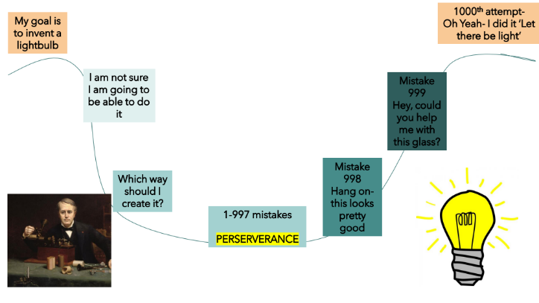
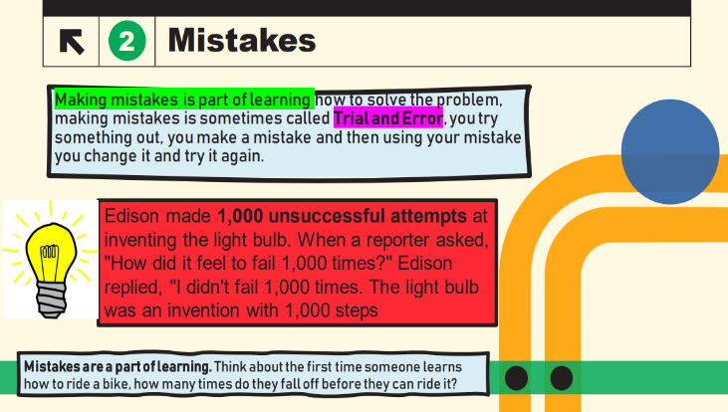
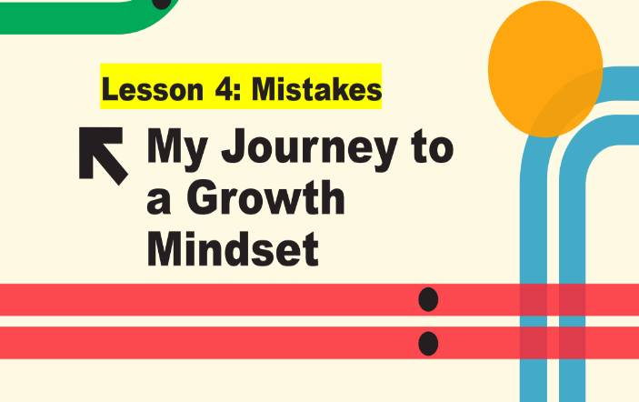
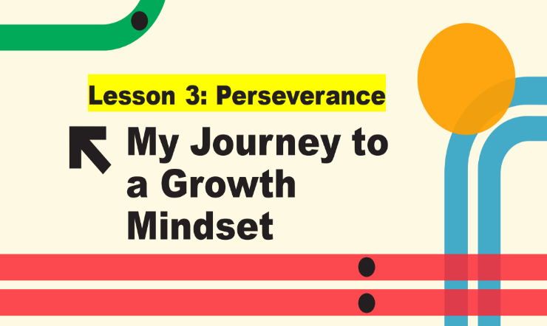
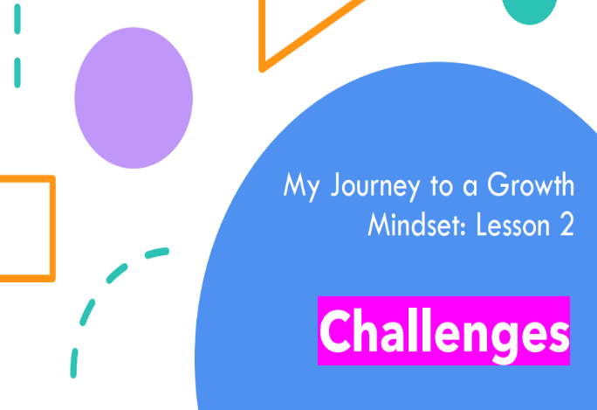


Appendix B: Questionnaire
Questionnaire
This questionnaire should take around 10 minutes. If you need any help to read these questions or if you are unsure of the meaning check with the teacher present. If you have any questions, please ask. Please tick your answer in one box. Remember there are no right or wrong answers and your results will be anonymous. Thank you

 | Question | Strongly Disagree | Disagree | Slightly disagree | Slightly agree | Agree | Strongly Agree
1 | I have a certain amount of intelligence, and I can’t really do much to change it. | Strongly Disagree | Disagree | Slightly disagree | Slightly agree | Agree | Strongly Agree
2 | I can change how intelligent I am | Strongly Disagree | Disagree | Slightly disagree | Slightly agree | Agree | Strongly Agree
3 | If I have a problem, I know that I can solve it | Strongly Disagree | Disagree | Slightly disagree | Slightly agree | Agree | Strongly Agree
4 | If I have a problem, I don’t know if I can solve it | Strongly Disagree | Disagree | Slightly disagree | Slightly agree | Agree | Strongly Agree
5 | Even if I apply greater effort, I can’t change how successful I am | Strongly Disagree | Disagree | Slightly disagree | Slightly agree | Agree | Strongly Agree
6 | I can change how successful I am if I apply greater effort to tasks | Strongly Disagree | Disagree | Slightly disagree | Slightly agree | Agree | Strongly Agree
7 | I enjoy challenge because it can help me to learn more | Strongly Disagree | Disagree | Slightly disagree | Slightly agree | Agree | Strongly Agree
8 | I don’t enjoy challenge because I may fail | Strongly Disagree | Disagree | Slightly disagree | Slightly agree | Agree | Strongly Agree
9 | If I fail, I know there is nothing that I can do about it | Strongly Disagree | Disagree | Slightly disagree | Slightly agree | Agree | Strongly Agree
10 | If I fail, I know there is something I can do about it | Strongly Disagree | Disagree | Slightly disagree | Slightly agree | Agree | Strongly Agree
11 | If I find something too tricky, I ask for support or use resources to support me | Strongly Disagree | Disagree | Slightly disagree | Slightly agree | Agree | Strongly Agree
12 | If I find something too tricky, I don’t know how to help myself | Strongly Disagree | Disagree | Slightly disagree | Slightly agree | Agree | Strongly Agree
13 | If I find something too tricky, I use another strategy | Strongly Disagree | Disagree | Slightly disagree | Slightly agree | Agree | Strongly Agree
14 | If I find something too tricky, I will give up | Strongly Disagree | Disagree | Slightly disagree | Slightly agree | Agree | Strongly Agree
15 | If I make a mistake, this will help me to work out how to solve the problem | Strongly Disagree | Disagree | Slightly disagree | Slightly agree | Agree | Strongly Agree
16 | If I make a mistake, it makes me upset or worried or angry | Strongly Disagree | Disagree | Slightly disagree | Slightly agree | Agree | Strongly Agree
17 | I like setting myself goals | Strongly Disagree | Disagree | Slightly disagree | Slightly agree | Agree | Strongly Agree
18 | I don’t like setting myself goals | Strongly Disagree | Disagree | Slightly disagree | Slightly agree | Agree | Strongly Agree
19 | If I set myself goals, I achieve them | Strongly Disagree | Disagree | Slightly disagree | Slightly agree | Agree | Strongly Agree
20 | If I set myself goals, I don’t always achieve them | Strongly Disagree | Disagree | Slightly disagree | Slightly agree | Agree | Strongly Agree

Appendix C: Semi Structured Interview

Focus Area | Example Questions
Self- Efficacy | How much effort do children in your class put into their tasks?  What are children’s beliefs about intelligence?
Fear of Failure | How do children in your class respond to challenge?
Motivation | What do children do in your class when they find something tricky?
Goal Setting | Do children in your class set goals and work to achieve them?
Setbacks | How do children in your class respond to setbacks and mistakes?

Appendix D: Participants Consent Form

PARENTAL CONSENT FORM
PROJECT TITLE: An investigation into Academic Resilience: Do Incremental Theory interventions impact academic resilience?

Name of Researcher: Lucy Le Masurier
Please initial boxes.
1.I confirm that I have read and understand the information sheet dated 28/04/2023 for the above study.
2. I understand that my child’s participation is voluntary and that I am free to withdraw my child from the study at any time, without giving any reason.
3. I understand that my child can choose to withdraw at any time, without giving a reason.
4. I understand that the information given by my child will be used in a university assignment.
5. I understand that my child’s name will not appear at any time.

6. I agree for my child to take part in the above study.
_____________________ _____________________________
Child’s name Parent signature Date

When completed, please return to Lucy Le Masurier by Monday 1st May
Thank you.

INFORMATION SHEET
PROJECT TITLE: An investigation into Academic Resilience: Do Incremental Theory interventions impact academic resilience?
Dear Parent / Guardian,
My name is Lucy Le Masurier and I am studying for an Education Doctorate (EdD) qualification at Yr Athrofa, University of Wales Trinity Saint David. I am a class teacher at Ynysfach Primary School.
I would like to invite your child to participate in my research project. The title of the project is ‘An investigation into ACEs and Academic Resilience: Do Incremental Theory interventions impact academic resilience?’. I aim to determine whether implementing Incremental Theory interventions within KS2 classrooms can improve learners’ academic resilience. Through your child’s participation, I hope to understand whether the intervention impacts academic resilience.
Your child will be taking part in incremental theory activities (Growth Mindset) as part as their learning within school. This will consist of five sessions. Prior to the first session, using a questionnaire within their registration time, they will be asked to self-report on their academic resilience. After the five sessions, they will be asked to complete the same questionnaire to determine whether their academic resilience has improved. The research is concerned whether the intervention impacts academic resilience.
All names will be kept strictly confidential, and the identity of participants will only be known to myself. Your child’s participation in this study is completely voluntary so you or your child can withdraw from the study at any stage. Your child will also be asked to give their assent before the beginning of the study.
After careful and precise analysis of the data obtained from the questionnaire, I would be happy to provide you with a copy of the findings at your request. The results of the research will be discussed in a university assignment that will contribute to my Doctor of Education (EdD) course. The results of this study will be stored on the University’s OneDrive and all raw data will be destroyed once the assessment has been marked.
I thank you in advance for your time. If any questions do arise, feel free to contact me at your convenience.
Yours sincerely,
Lucy Le Masurier
LemasurierL@hwbcymru.net

Appendix E: Ethics Form

APPLICATION FOR ETHICAL APPROVAL

In order for research to result in benefit and minimise risk of harm, it must be conducted ethically. A researcher may not be covered by the University’s insurance if ethical approval has not been obtained prior to commencement.

The University follows the OECD Frascati manual definition of research activity: “creative work undertaken on a systematic basis in order to increase the stock of knowledge, including knowledge of man, culture and society, and the use of this stock of knowledge to devise new applications”. As such this covers activities undertaken by members of staff, postgraduate research students, and both taught postgraduate and undergraduate students working on dissertations/projects.

The individual undertaking the research activity is known as the “principal researcher”.

Ethical approval is not required for routine audits, performance reviews, quality assurance studies, testing within normal educational requirements, and literary or artistic criticism.

Please read the notes for guidance before completing ALL sections of the form.

This form must be completed and approved prior to undertaking any research activity. Please see Checklist for details of process for different categories of application.

SECTION A: About You (Principal Researcher)
1 | Full Name: |  | Lucy Jayne Le Masurier
2 | Tick all boxes that apply: |  | Member of staff: | ☐ | Honorary research fellow: | ☐
 | Undergraduate Student | ☐ | Taught Postgraduate Student | ☒ | Postgraduate Research Student | ☐

3 | Institute/Academic Discipline/Centre: | Education and Humanities
4 | Campus: | Swansea
5 | E-mail address: | 1251415@student.uwtsd.ac.uk
6 | Contact Telephone Number: | 07342697296
 | For students:
7 | Student Number: | 1251415
8 | Programme of Study: | Doctorate in Education
9 | Director of Studies/Supervisor: | Dr Catherine Morgan

SECTION B: Approval for Research Activity
1 | Has the research activity received approval in principle?  (please check the Guidance Notes as to the appropriate approval process for different levels of research by different categories of individual) |  | YES | ☒ | NO | ☐
 |  |  |  |  | Date
2 | If Yes, please indicate source of approval (and date where known): Approval in principle must be obtained from the relevant source prior to seeking ethical approval | Research Degrees Committee |  | ☐
2 |  | Institute Research Committee |  | ☐
2 |  | Other |  | ☐

SECTION C: Internal and External Ethical Guidance Materials
 | Please list the core ethical guidance documents that have been referred to during the completion of this form (including any discipline-specific codes of research ethics, location-specific codes of research ethics, and also any specific ethical guidance relating to the proposed methodology). Please tick to confirm that your research proposal adheres to these codes and guidelines. You may add rows to this table if needed.
1 | UWTSD Research Ethics & Integrity Code of Practice | ☒
2 | UWTSD Research Data Management Policy | ☒
3 | BERA Guidelines 2018 | ☒

SECTION D: External Collaborative Research Activity
If there are external collaborators then you should gain consent from the contact persons to share their personal data with the university. If there are no external collaborators then leave this section blank and continue to section E.
1 | Institution
2 | Contact person name
3 | Contact person e-mail address
4 | Is your research externally funded? |  | YES | ☐ | NO |  | ☐
5 | Are you in receipt of a KESS scholarship? |  | YES | ☐ | NO |  | ☐
6 | Are you specifically employed to undertake this research in either a paid or voluntary capacity? | Voluntary | YES | ☐ | NO | ☐
7 |  | Employed | YES | ☐ | NO | ☐
8 | Is the research being undertaken within an existing UWTSD Athrofa Professional Learning Partnership (APLP)? | If YES then the permission question below does not need to be answered. | YES | ☐ | NO |  | ☐
9 | Has permission to undertake the research has been provided by the partner organisation? | (If YES attach copy)  If NO the application cannot continue | YES | ☐ | NO |  | ☐

Where research activity is carried out in collaboration with an external organisation
10 | Does this organisation have its own ethics approval system? | YES | ☐ | NO | ☐
 | If Yes, please attach a copy of any final approval (or interim approval) from the organisation (this may be a copy of an email if appropriate).

SECTION E: Details of Research Activity
1 | Indicative title: | An investigation into ACEs and Academic Resilience: Do Incremental Theory interventions impact academic resilience?
2 | Proposed start date: | November 2022 | Proposed end date: | January 2023
Introduction to the Research (maximum 300 words per section)
Ensure that you write for a Non-Specialist Audience when outlining your response to the points below:
Purpose of Research Activity
Proposed Research Question
Aims of Research Activity
Objectives of Research Activity
Demonstrate, briefly, how Existing Research has informed the proposed activity and explain
What the research activity will add to the body of knowledge
How it addresses an area of importance.
3 | Purpose of Research Activity  The purpose of this research is to respond to professional observations across a cluster of Primary Schools in South Wales. This has been through observation and discussion about learner’s’ lack of academic resilience which is consistent with the effects of Adverse Childhood Experiences (ACEs). A Welsh Survey found that ACEs are common in Wales and can have determinantal impacts on children social, emotional, and academic development (Bellisi et al. 2015). In addition, there is evidence to suggest that the COVID pandemic has exacerbated the effects of ACEs (Sanders, 2020). This research focuses on one of the effects that ACEs can have on children i.e., lower academic resilience, learning and attainment (Jimenez et al. 2016; McDowell. 2017; Houtepen et al. 2020). The literature highlighted that resilience building was one mitigating and protective factor against the effects of ACES (Ashton et al, 2016; Barton et al, 2018; Estyn, 2020). A literature review has identified a gap in research exploring academic resilience in the UK or Wales and with primary aged children specifically despite studies which have shown to improve resilience with secondary school aged children and adults undertaking undergraduate courses internationally (Aronson et al. 2002; Blackwell et al. 2007; Orosz et al. 2017; Paunesku et al. 2015). Additionally, a review of literature highlighted that responding to ACEs and low academic resilience in schools is usually through pre-existing interventions out of the classroom despite claims that these types of interventions are more effective as part of a whole school approach and within daily classroom teaching (Estyn, 2020). This research intends to explore the impact of Dweck’s (1999) incremental Theory interventions on learner’s academic resilience within the classroom.  References:  Aronson, J., Fried, C. B., and Good, C. (2002). Reducing the effects of stereotype threat on African American college students by shaping theories of intelligence. Journal of Experimental Social Psychology, (38) pp. 113–125.  Ashton, K., Bellis, M.A., Hardcastle, K., Hughes, K., Mably, S. and Evans, M., (2016). Adverse Childhood Experiences and their association with mental wellbeing in the Welsh adult population. Cardiff: Public Health Wales NHS Trust.  Barton, E., Newbury, A., and Roberts, J. (2018) An evaluation of the Adverse Childhood Experience (ACE)-Informed Whole School Approach. Wales: Public Health Wales NHS Trust  Bellis, M.A., Hughes, K., Leckenby, N., Hardcastle, K.A., Perkins, C. and Lowey, H., (2015). Measuring mortality and the burden of adult disease associated with adverse childhood experiences: a national survey. Journal of Public Health, 37 (3), 445-454.  Blackwell, L. A., Trzesniewski, K. H., & Dweck, C. S. (2007). Theories of intelligence and achievement across the junior high school transition: A longitudinal study and an intervention. Child Development, 78, pp. 246–263  Dweck, C. S. (1999). Self-Theories: Their Role in Motivation, Personality, and Development. Philadelphia, PA: Psychology Press.  Estyn. (2020) Knowing your children – supporting pupils with adverse childhood experiences (ACES). Cardiff: Crown  Houtepen. LC., Heron. J,. Suderman, MJ,. Fraser, A,. Chittleborough, CR,. Howe, LD. (2020) Associations of adverse childhood experiences with educational attainment and adolescent health and the role of family and socioeconomic factors: A prospective cohort study in the UK. PLoS Med. 2020 Mar 2;17(3)  Jimenez, M., Wader, R., Lin, Y., Morrow, L., Reichman, N (2016) Adverse experiences in early childhood outcomes. Paediatrics 137 (2) pp. 1-12  McDowell, N (2017) The Association Between Adverse Childhood Experiences and Educational Outcomes Among Children Ages 6-17. Thesis, Georgia State University, 2017. Available at https://scholarworks.gsu.edu/iph_theses/528 (Accessed on 12/08/2022)  Orosz, G,. Péter-Szarka S,. Bothe, B,. Toth-Kiraly,I., and Berger, R. (2017) How Not to Do a Mindset Intervention: Learning from a Mindset Intervention among Students with Good Grades. Psychology. 8 (311) pp. 1-11  Sanders, LM. (2020) Is COVID-19 an adverse childhood experience (ACE): Implications for screening for primary care. J Pediatr. (222) pp4–6.
4 | Research Question  The overall research question: ‘Do Incremental Theory interventions improve pupils’ academic resilience?’. This is divided into two further research questions: To what extent do Incremental Theory interventions impact on UKS2 pupils’ academic resilience? and to what extent do UKS2 Teachers perceive that Incremental Theory interventions impact on UKS2 pupils’ academic resilience?
5 | Aims of Research Activity  The aim of this research is to determine whether implementing Incremental Theory interventions specifically Brainology within KS2 classrooms in one school can improve learners’ academic resilience over 1 academic term.  (this box should expand as you type)
6 | Objectives of Research Activity  To define the characteristics of academic resilience to enable measurement pre and post interventions.  To determine a valid and reliable scale which measures the characteristics set out in objective 1.  To deliver and measure the impact of the intervention with KS2 learners .  To explore teacher’s perceptions of the impact of the intervention on KS2 learner’s academic resilience.  (this box should expand as you type)
Proposed methods (maximum 600 words)
Provide a brief summary of all the methods that may be used in the research activity, making it clear what specific techniques may be used. If methods other than those listed in this section are deemed appropriate later, additional ethical approval for those methods will be needed. You do not need to justify the methods here, but should instead describe how you intend to collect the data necessary for you to complete your project.
7 | Two methods of data collection are proposed: Semi-structure interviews and questionnaires.  Interviews are to be conducted with all KS2 teachers (4) at the school and are used to understand firstly their perceptions of learners’ academic resilience after the intervention has been implemented (over 1 term). Interview questions refer to the Dweck and Yeager’s (2012) resilience characteristics.  The researcher-constructed questionnaire will be administered to approximately 100 children within their usual lesson time. The questionnaire will gain baseline academic resilience data before the intervention is implemented and the same questionnaire will be given after the intervention (after terms) and used to determine whether the intervention has impacted learner’s academic resilience. The questionnaire is a Likert- scale that includes statements which refer to Dweck and Yeager’s (2012) resilience characteristics adapted to be child-friendly. This will include language and vocabulary which age appropriate and explained to the learners before it is undertaken.  Dweck, C., and Yeager, D. (2012) Mindsets That Promote Resilience: When Students Believe That Personal Characteristics Can Be Developed. Educational Psychologist, 47(4), pp.302–314.
Location of research activity
Identify all locations where research activity will take place.
8 | 1 Primary School, Neath and Port Talbot  (this box should expand as you type)
Research activity outside of the UK
If research activity will take place overseas, you are responsible for ensuring that local ethical considerations are complied with and that the relevant permissions are sought. Specify any local guidelines (e.g. from local professional associations/learned societies/universities) that exist and whether these involve any ethical stipulations beyond those usual in the UK (provide details of any licenses or permissions required). Also specify whether there are any specific ethical issues raised by the local context in which the research activity is taking place, for example, particular cultural and/or legal sensitivities or vulnerabilities of participants. If you live in the country where you will do the research then please state this.
9 | (this box should expand as you type)

10 | Use of documentation not in the public domain: Are any documents NOT publicly available? | NO | ☒
10 |  | YES | ☐
11 | If Yes, please provide details here of how you will gain access to specific documentation that is not in the public domain and that this is in accordance with the current data protection law of the country in question and that of England and Wales.  (this box should expand as you type)

 | Does your research relate to one or more of the seven aims of the Well-being of Future Generations (Wales) Act 2015? | YES | NO
12 | A prosperous Wales | ☐ | ☒
13 | A resilient Wales | ☐ | ☒
14 | A healthier Wales | ☒ | ☐
15 | A more equal Wales | ☒ | ☐
16 | A Wales of cohesive communities | ☐ | ☒
17 | A Wales of vibrant culture and thriving Welsh language | ☐ | ☒
18 | A globally responsible Wales | ☐ | ☒
19 | If YES to any of the above, please give details:
A healthier Wales: This research intends to determine whether Incremental Theory Interventions improve academic resilience which can support the people’s well-being and seeks to understand choices and behaviours that can benefit future health.

A more equal Wales: This research intends to determine whether academic resilience of KS2 learners can be improved which supports the target to enable people to fulfil their potential no matter their background or circumstance.

SECTION F: Scope of Research Activity
 | Will the research activity include: | YES | NO
1 | Use of a questionnaire or similar research instrument? | ☒ | ☐
2 | Use of interviews? | ☒ | ☐
3 | Use of focus groups? | ☐ | ☒
4 | Use of participant diaries? | ☐ | ☒
5 | Use of video or audio recording? | ☒ | ☐
6 | Use of computer-generated log files? | ☐ | ☒
7 | Participant observation with their knowledge? | ☐ | ☒
8 | Participant observation without their knowledge? | ☐ | ☒
9 | Access to personal or confidential information without the participants’ specific consent? | ☐ | ☒
10 | Administration of any questions, test stimuli, presentation that may be experienced as physically, mentally or emotionally harmful / offensive? | ☐ | ☒
11 | Performance of any acts which may cause embarrassment or affect self-esteem? | ☐ | ☒
12 | Investigation of participants involved in illegal activities? | ☐ | ☒
13 | Use of procedures that involve deception? | ☐ | ☒
14 | Administration of any substance, agent or placebo? | ☐ | ☒
15 | Working with live vertebrate animals? | ☐ | ☒
16 | Procedures that may have a negative impact on the environment? | ☐ | ☒
17 | Other primary data collection methods. Please indicate the type of data collection method(s) below. | ☐ | ☒
 | Details of any other primary data collection method:  (this box should expand as you type) | ☐ | ☒
If NO to every question, then the research activity is (ethically) low risk and may be exempt from some of the following sections (please refer to Guidance Notes).

If YES to any question, then no research activity should be undertaken until full ethical approval has been obtained.

SECTION G: Intended Participants
If there are no participants then do not complete this section, but go directly to section H.

 | Who are the intended participants: | YES | NO
1 | Students or staff at the University? | ☐ | ☒
2 | Adults (over the age of 18 and competent to give consent)? | ☒ | ☐
3 | Vulnerable adults? | ☐ | ☒
4 | Children and Young People under the age of 18? (Consent from Parent, Carer or Guardian will be required) | ☒ | ☐
5 | Prisoners? | ☐ | ☒
6 | Young offenders? | ☐ | ☒
7 | Those who could be considered to have a particularly dependent relationship with the investigator or a gatekeeper? | ☐ | ☒
8 | People engaged in illegal activities? | ☐ | ☒
9 | Others. Please indicate the participants below, and specifically any group who may be unable to give consent. | ☐ | ☒
 | Details of any other participant groups:  (this box should expand as you type) | ☐ | ☒

Participant numbers and source
Provide an estimate of the expected number of participants. How will you identify participants and how will they be recruited?
10 | How many participants are expected? | 100 participants  (this box should expand as you type)
11 | Who will the participants be? | 100 children (pupils within the school) and 4 KS2 Class Teachers  (this box should expand as you type)
12 | How will you identify the participants? | They will be attending or working at the school.  (this box should expand as you type)

 | Information for participants: | YES | NO | N/A
13 | Will you describe the main research procedures to participants in advance, so that they are informed about what to expect? | ☒ | ☐ | ☐
14 | Will you tell participants that their participation is voluntary? | ☒ | ☐ | ☐
15 | Will you obtain written consent for participation? | ☒ | ☐ | ☐
16 | Will you explain to participants that refusal to participate in the research will not affect their treatment or education (if relevant)? | ☒ | ☐ | ☐
17 | If the research is observational, will you ask participants for their consent to being observed? | ☐ | ☐ | ☒
18 | Will you tell participants that they may withdraw from the research at any time and for any reason? | ☒ | ☐ | ☐
19 | With questionnaires, will you give participants the option of omitting questions they do not want to answer? | ☒ | ☐ | ☐
20 | Will you tell participants that their data will be treated with full confidentiality and that, if published, it will not be identifiable as theirs? | ☒ | ☐ | ☐
21 | Will you debrief participants at the end of their participation, in a way appropriate to the type of research undertaken? | ☒ | ☐ | ☐
22 | If NO to any of above questions, please give an explanation
 | (this box should expand as you type)

 | Information for participants: | YES | NO | N/A
24 | Will participants be paid? | ☐ | ☒ | ☐
25 | Is specialist electrical or other equipment to be used with participants? | ☐ | ☒ | ☐
26 | Are there any financial or other interests to the investigator or University arising from this study? | ☐ | ☒ | ☐
27 | Will the research activity involve deliberately misleading participants in any way, or the partial or full concealment of the specific study aims? | ☐ | ☒ | ☐
28 | If YES to any question, please provide full details
 | (this box should expand as you type)

SECTION H: Anticipated Risks

Outline any anticipated risks that may adversely affect any of the participants, the researchers and/or the University, and the steps that will be taken to address them.

If you have completed a full risk assessment (for example as required by a laboratory, or external research collaborator) you may append that to this form.
1 | Full risk assessment completed and appended? |  | Yes | ☐
1 |  |  | No | ☒
2 | Risks to participants  For example: sector-specific health & safety, emotional distress, financial disclosure, physical harm, transfer of personal data, sensitive organisational information
 | Risk to participants:  1. Participants are interviewed in which they are asked about their perceptions of the intervention. This could affect the participant emotionally or bring about distress or anxiety.  2. The research will be conducted within the researchers own setting and with participants whom they have professional relationships with. The participants may feel coerced into taking part in the research.  3. Ensuring confidentiality and anonymity for participants.  (this box should expand as you type) | The aims, objectives and purpose of the research will be communicated to participants through an information sheet and orally with time given for discussion and questions. This will be given before the interview is conducted.  Throughout the study, participants will be continually reminded that it is their right to withdraw from the research at anytime during the research process without giving a reason or without a penalty.  The interview questions relate to their perceptions of children’s academic resilience and not about the teacher’s own practice or how the intervention is taught. Teachers will be familiar with the intervention as they will be involved in implementing it. Therefore, this should limit the potential for the interview to bring about anxiety or emotional distress.  Questions asked in the interview will not be of a sensitive nature and teachers will be reassured that there is no correct answer, reassured they can clarify meaning of the questions and omit their response if they wish at any point. They will also be given the opportunity to check the interview notes should they wish to make an adaptation or clarify.  2. All participants will be provided with clear and precise information about the purpose, aims and objectives of the research. It will be communicated to the participants that it is the right to withdraw from the research at any time and that not taking part in or withdrawing from the study will not result in any consequences.  3. Research will be conducted in compliance with GDPR law. It is known to the researcher that all participants have a right to access their data. Participant’s consent will be separately and destroyed securely when digitised. Codes information will be stored according to the UWTSD Data Management guidelines (should a participant wish to withdraw from the research when it has concluded). In disseminating any results, all participants data will be coded and they will not identifiable.
3 | If research activity may include sensitive, embarrassing or upsetting topics (e.g. sexual activity, drug use) or issues likely to disclose information requiring further action (e.g. criminal activity), give details of the procedures to deal with these issues, including any support/advice (e.g. helpline numbers) to be offered to participants. Note that where applicable, consent procedures should make it clear that if something potentially or actually illegal is discovered in the course of a project, it may need to be disclosed to the proper authorities
 | (this box should expand as you type)
4 | Risks to the investigator  For example: personal health & safety, physical harm, emotional distress, risk of accusation of harm/impropriety, conflict of interest
 | Risk to the investigator:  A risk that the researcher may be accused of impropriety.  Risk of accusation of coercion as the researcher has professional relationships with the participants. | Throughout the research process, the researcher will ensure that they are compliant with the laws governing the research (GDPR) and that they adhere to the BERA Ethical Guidelines for Education Research (2018), the UWTSD Code of Ethics and Integrity (2022) and the UWTSD Management of Data guidelines (2022). In addition, the researcher works within the research location within a professional capacity and has professional relationships with the participants at the setting.  Following the UWTSD and the BERA guidelines. Gaining consent and assent and reminding all participants that taking part in the research is voluntary and there will be no repercussions from not gaining consent, assent or withdrawal. Participants will be provided with the details of the researcher’s supervisor so that any issues can be raised directly with them.
5 | University/institutional risks  For example: adverse publicity, financial loss, data protection
 | Risk to the University:  Risk that the researcher will jeopardise the University’s Integrity | The researcher endeavours to uphold the University’s integrity by ensuring they conduct themselves in accordance to GDPR laws and according to the UWTSD research guidelines and the BERA Ethical Guidelines. In addition, in conducting the research, the researcher will ensure that the research is a true account of the data and that informed consent and assent is provided before conducting the research.
6 | Environmental risks  For example: accidental spillage of pollutants, damage to local ecosystems
 | Risk to the environment:  (this box should expand as you type) | How you will mitigate the risk to environment:  (this box should expand as you type)

 | Disclosure and Barring Service
 | If the research activity involves children or vulnerable adults, a Disclosure and Barring Service (DBS) certificate must be obtained before any contact with such participants. | YES | NO | N/A
7 | Does your research require you to hold a current DBS Certificate? | ☒ | ☐ | ☐
8 | If YES, please give the certificate number. If the certificate number is not available please write “Pending”; in this case any ethical approval will be subject to providing the appropriate certificate number.

SECTION I: Feedback, Consent and Confidentiality

1 | Feedback  What de-briefing and feedback will be provided to participants, how will this be done and when?
On both occasions, when the interview and questionnaire conclude, all participants will be reminded of the aims, objectives and purpose of the study; where they data is to be stored and for how long; that their data will remain confidential, and they will remain anonymous; and that they have the right to withdraw from the study at any time and there will be no consequences of this action. It will also be further explained that participants should not feel that there is an expectation for them to participate in the research due to their relationship with the researcher and they have the right to withdraw at anytime in addition to how the results will be disseminated. This will be communicated in child friendly language that is appropriate to the age and ability of the child. To ensure that participants are no worse off than when participating in the research, participants will be provided with opportunities to ask any questions about the research of for clarification or meaning. Furthermore, they will also be provided with the opportunity to discuss any issues arising from the research which the researcher can address or support. In addition, participants, if they wish, can be provided with the research references underpinning the research project.

(this box should expand as you type)
2 | Informed consent  Describe the arrangements to inform potential participants, before providing consent, of what is involved in participating. Describe the arrangements for participants to provide full consent before data collection begins. If gaining consent in this way is inappropriate, explain how consent will be obtained and recorded in accordance with prevailing data protection legislation.
Informed consent will be sought from all participants before the research is conducted. Participants will be informed of the purpose, aims and objectives of the research in addition as to where and how they data will be stored and how long it will be stored for. Participants will be told about their right to withdraw from the research at any time and this will not result in any adverse consequences. This information will be given on an information sheet and orally. Participants will be provided with the opportunity to ask any questions and make an informed choice about whether they would like to take part in the research. In addition to parental consent, assent will be sought from all children. This will be gained through using a child friendly tick sheet with the option yes and no. No images will be used (e.g. emojis) to ensure that children feel safe and happy to say both yes and no. Children will be reminded that there will be no negative consequence from not taking part in the research and if they do chose not to take part in the research, they will be provided with an appropriate activity to complete when their classmates are completing their questionnaire.
(this box should expand as you type)
3 | Confidentiality / Anonymity  Set out how anonymity of participants and confidentiality will be ensured in any outputs. If anonymity is not being offered, explain why this is the case.
The researcher will adhere to the UWTSD Data Management Policy when storing participants data. The list of participants which are coded instead of names and their corresponding data will be stored on a password encrypted file and the analysis of the data and interview notes will be stored on the researcher’s University storage cloud. In disseminating the results, pseudo names will be used for any included examples and no data will be shared that will enable the identification of the participants within the research.

(this box should expand as you type)

SECTION J: Data Protection and Storage

 | Does the research activity involve personal data (as defined by the General Data Protection Regulation 2016 “GDPR” and the Data Protection Act 2018 “DPA”)? | YES | NO
1 | “Personal data” means any information relating to an identified or identifiable natural person (‘data subject’). An identifiable natural person is one who can be identified, directly or indirectly, in particular by reference to an identifier such as a name, an identification number, location data, an online identifier or to one or more factors specific to the physical, physiological, genetic, mental, economic, cultural or social identity of that natural person. Any video or audio recordings of participants is considered to be personal data. | ☐ | x
 | If YES, provide a description of the data and explain why this data needs to be collected:
2 | (this box should expand as you type)
 | Does it involve special category data (as defined by the GDPR)? | YES | NO
3 | “Special category data” means sensitive personal data consisting of information as to the data subjects’ –  (a) racial or ethnic origin,  (b) political opinions,  (c ) religious beliefs or other beliefs of a similar nature,  (d) membership of a trade union (within the meaning of the Trade Union and Labour Relations (Consolidation) Act 1992),  (e) physical or mental health or condition,  (f) sexual life,  (g) genetics,  (h) biometric data (as used for ID purposes), | ☐ | x
 | If YES, provide a description of the special category data and explain why this data needs to be collected:
4 | (this box should expand as you type)

 | Will data from the research activity (collected data, drafts of the thesis, or materials for publication) be stored in any of the following ways? | YES | NO
5 | Manual files (i.e. in paper form)? | ☒ | ☐
6 | University computers? | ☒ | ☐
7 | Private company computers? | ☐ | ☒
8 | Home or other personal computers? | ☒ | ☐
9 | Laptop computers/ CDs/ Portable disk-drives/ memory sticks? | ☒ | ☐
10 | “Cloud” storage or websites? | ☒ | ☐
11 | Other – specify: | ☐ | ☒
12 | For all stored data, explain the measures in place to ensure the security of the data collected, data confidentiality, including details of backup procedures, password protection, encryption, anonymisation and pseudonymisation:
The data and the corresponding code will be managed on a password encrypted file. The analysis of the data will be kept separate on the researcher’s University cloud storage account. Paper based consent forms will be digitised and the original forms will be destroyed. The consent forms will be stored on a password encrypted file on a password encrypted removable memory device. All disseminated data will be anonymised.
(this box should expand as you type)

 | Data Protection
 | Will the research activity involve any of the following activities: | YES | NO
13 | Electronic transfer of data in any form? | ☒ | ☐
14 | Sharing of data with others at the University outside of the immediate research team? | ☐ | ☒
15 | Sharing of data with other organisations? | ☐ | ☒
16 | Export of data outside the UK or importing of data from outside the UK? | ☐ | ☒
17 | Use of personal addresses, postcodes, faxes, emails or telephone numbers? | ☐ | ☒
18 | Publication of data that might allow identification of individuals? | ☐ | ☒
19 | Use of data management system? | ☐ | ☒
20 | Data archiving? | ☐ | ☒
21 | If YES to any question, please provide full details, explaining how this will be conducted in accordance with the GDPR and Data Protection Act (2018) (and any international equivalents, where appropriate):
Analysed data will be uploaded to the researchers own University Cloud storage account immediately after it is analysed and the original file permanently deleted.

(this box should expand as you type)
22 | List all who will have access to the data generated by the research activity:
Researcher: Lucy Le Masurier

(this box should expand as you type)
23 | List who will have control of, and act as custodian(s) for, data generated by the research activity:
Researcher: Lucy Le Masurier
(this box should expand as you type)
24 | Give details of data storage arrangements, including security measures in place to protect the data, where data will be stored, how long for, and in what form. Will data be archived – if so how and if not why not.
All word processing document and spreadsheet files are encrypted with a password and saved on password encrypted memory sticks or stored on the University’s storage cloud which is secured by the university. However, the researcher will ensure that there is no access to their passwords or additional access to their accounts. Paper based consent forms are digitised and retained on a password encrypted file, these will then be immediately destroyed and original files uploaded to the University’s Cloud storage permanently deleted. Whilst GDPR laws do not define how long data should be kept for, it states that researchers must justify their decision to retain the data. The researcher will permanently destroy/ delete all data after the research is disseminated (after the research has been assessed by the University).

(this box should expand as you type)
25 | Please indicate if your data will be stored in the UWTSD Research Data Repository (see https://researchdata.uwtsd.ac.uk/ ). If so please explain. (Most relevant to academic staff)
 | (this box should expand as you type)
26 | Confirm that you have read the UWTSD guidance on data management (see https://www.uwtsd.ac.uk/library/research-data-management/) | YES | ☒
27 | Confirm that you are aware that you need to keep all data until after your research has completed or the end of your funding | YES | ☒

SECTION K: Declaration
The information which I have provided is correct and complete to the best of my knowledge. I have attempted to identify any risks and issues related to the research activity and acknowledge my obligations and the rights of the participants.

In submitting this application I hereby confirm that I undertake to ensure that the above named research activity will meet the University’s Research Ethics and Integrity Code of Practice which is published on the website: https://www.uwtsd.ac.uk/research/research-ethics/
1 | Signature of applicant: | L. LeMasurier | Date:  19/11/2022

For STUDENT Submissions:
2 | Director of Studies/Supervisor: |  | Date:
3 | Signature: |  | Date:

For STAFF Submissions:
4 | Academic Director/ Assistant Dean: |  | Date:
5 | Signature: |  | Date:

Checklist: Please complete the checklist below to ensure that you have completed the form according to the guidelines and attached any required documentation:
☒ | I have read the guidance notes supplied before completing the form.
☒ | I have completed ALL RELEVANT sections of the form in full.
☒ | I confirm that the research activity has received approval in principle
☐ | I have attached a copy of final/interim approval from external organisation (where appropriate)
☐ | I have attached a full risk assessment (where appropriate) ONLY TICK IF YOU HAVE ATTACHED A FULL RISK ASSESSMENT
☒ | I understand that it is my responsibility to ensure that the above named research activity will meet the University’s Research Ethics and Integrity Code of Practice.
☒ | I understand that before commencing data collection all documents aimed at respondents (including information sheets, consent forms, questionnaires, interview schedules etc.) must be confirmed by the DoS/Supervisor, module tutor or Academic Director.

RESEARCH STUDENTS AND STAFF ONLY
All communications relating to this application during its processing must be in writing and emailed to pgresearch@uwtsd.ac.uk , with the title ‘Ethical Approval’ followed by your name.
You will be informed of the outcome of your claim by email; therefore it is important that you check your University and personal email accounts regularly.
STUDENTS ON UNDERGRADUATE OR TAUGHT MASTERS PROGRAMMES should submit this form (and receive the outcome) via systems explained to you by the supervisor/module leader.

This form is available electronically from the Academic Office web pages: https://www.uwtsd.ac.uk/academic-office/appendices-and-forms/

