Web Application Development
  - Name
James Edward Millns

Student No
1708455

Email
1708455@student.uwtsd.ac.uk

Course
BSC (Hons) Software Engineering

Module Name
Application Development

Module Code
ACCA5012

Lecturer
Kemi Ademoye

Table of Contents
Table of Contents 2
Table Of Figures 4
1. Introduction 6
2. Application Development Concepts 7
2.1 Web Security Vulnerabilities 7
2.1.1 SQL Injection 7
2.1.2 Broken Authentication 8
2.1.3 Cross Site Scripting 9
2.2 Software Design Patterns 10
2.2.1 Overview 10
2.2.2 Decorator Design Pattern 11
3. Requirements 12
3.1 Context 12
3.2 Must Haves 12
3.3 Should Haves 12
3.4 Could Haves 12
3.5 Won’t Haves 13
1. Design 14
2. Implementation 15
2.1 Functionality 15
2.2 MVC 17
2.2.1 Model 17
2.2.2 Views 21
2.2.3 Controllers 23
2.3 Screen Shots 28
3. Evaluation 33
3.1 Testing 33
3.2 Overview 33
3.3 Future improvements 34
References 35

Table Of Figures
Figure 1: Entity Relationship Diagram of tables in model. 14
Figure 2: Filter and Search bar for games page. 15
Figure 3: Microsoft and Google account login options. 15
Figure 4: Tournament Booking menu. 15
Figure 5: Test Bookings saved to the database. 16
Figure 6: Application user entity 17
Figure 7: Booking Ticket entity 17
Figure 8: Booking Entity 17
Figure 9: Game Entity 18
Figure 10:Ticket Type entity 18
Figure 11: Tournament entity 18
Figure 12: Age rating enumerator. 19
Figure 13: Booking status enumerator. 19
Figure 14: Ticket Status enumerator. 19
Figure 15: Game table. 20
Figure 16: Ticket Type table/ 20
Figure 17: Tournament table. 20
Figure 18: wwwroot folder structure. 21
Figure 19: View collection. 21
Figure 20: Bookings Views 21
Figure 21: Games Views. 22
Figure 22:Home Views. 22
Figure 23: Shared Views 22
Figure 24: Tournaments Views 22
Figure 25: Controllers collection. 23
Figure 26: Booking Controller methods. 23
Figure 27: Games Controller methods. 23
Figure 28: Home Controller methods. 24
Figure 29: Tournament Controller methods. 24
Figure 30: IBookingRepo. 25
Figure 31: IGameRepo. 25
Figure 32: BaseRepo 25
Figure 33: BookingRepo 26
Figure 34: GameRepo 26
Figure 35: Base Sort Filter Page Option. 27
Figure 36: Filter By class. 27
Figure 37: Game Sort Filter Options. 27
Figure 38: Index page. 28
Figure 39: User registration page. 29
Figure 40: User Login page 30
Figure 41: Navigation bar. 30
Figure 42: Games page. 30
Figure 43: Game details page. 31
Figure 44: Create booking page. 32

Introduction
Web applications are now one of the most prevalent technologies available in modern society, with billions of users and thousands of applications, all offering instant access to personal data to those with the right authorization [1], [2]. Due to the availability and wide-spread implementation of web applications, they have become a prime target for attackers to find weak points and exploits to gain unauthorized access to the sensitive data [1], [2].
Even small errors in the implementation of an application could be exploited by seasoned attackers which can lead to the leak of sensitive information, hence it is important to ensure the applications have been correctly implemented and tested against all known forms of attacks to guarantee the application is protected [1], [3], [4].
The purpose of this report is to review and summarize different web application security vulnerabilities and identify how attackers can exploit these vulnerabilities to compromise the system and integrity of the data stored in the application, and how to best protect against these threats [5], [6].
Further from that, the report will identify different design patterns that can be used when developing a web application and will focus on one design pattern and outline the benefits of using it and explaining which contexts it is best suited for [7].
Finally, the report will document the design and implementation of a web application which uses the MVC design model to manage its user login and booking system. The web application will offer its users the opportunity to book themselves into regular gaming tournaments at the imaginary GameRoom venue.

Application Development Concepts

Web Security Vulnerabilities

SQL Injection
One often used method of attack is to exploit the vulnerabilities of the database resulting in the unauthorized extraction of sensitive data or injection of unwanted data [5], [6], [8], [9]. This can happen once an attacker identifies a user input field on a web application which performs a dynamic search on the database and has not been correctly protected [5], [6], [8], [9]. The attacker uses the weakness to trick the interpreter that constructs the query by inserting additional commands that were not intended to run [5], [6], [8], [9].
These attacks are known as SQL Injection Attacks (SQLIAs) and are one of the most common methods behind data security breaches, it is ranked number one in the Open Web Application Security Project (OWASP) Top Ten Application Security risks in 2017 [5], [6], [8], [9].
SQLIAs pose a severe threat to the integrity of the database as injection can result in data loss or corruption, lack of accountability, or denial of service [5], [6], [8], [9]. Data can be stolen, modified or deleted which can greatly impact the reputation of a businesses as their customer base would be reluctant to trust them any further with their sensitive data [5], [6], [8], [9].
To protect against SQLIAs, it is recommended to ensure that whenever an interpreter is used to construct a dynamic query with a user input, to separate the user input data from the query or command with the use of bind variables and prepared statements [5], [6], [8], [9]. This essentially means that the user input is converted to bind variable which the interpreter does not recognize as command logic [5], [6], [8], [9].

Broken Authentication
A common avenue of attack is to hijack user login sessions to gain access to data that would otherwise be inaccessible [5], [6], [10]. This happens when a web application’s functions that manage authentication and login sessions are not properly implemented which allows attackers to gain access to passwords, keys or session tokens which keep the user logged in [5], [6], [10].
Attackers often have access to a vast number of valid username and password combinations which they can use for login attempts [5], [6], [10]. They can use this list with automated tools to perform what is known as “credential stuffing” where a program tries to login with all the known login combinations [5], [6], [10]. If the web application does not implement protection against automated threats or credential stuffing attacks, then the web application can be used to determine if the login credentials on the list are valid or not [5], [6], [10].
Another way for attackers to gain access to a session token is when the application does not handle session expiration or timeouts correctly [5], [6], [10]. An example of this is when a user logs in to an application on a public computer and once finished with their session, instead of logging out they close the web browser and leave the computer, allowing an attacker to reload the webpage on the same computer and still having access to the previous user’s session [5], [6], [10].
These types of attacks can have a severe impact on the integrity of the system as they only need access to a few accounts or an admin account to do harm to the system [5], [6], [10]. With the right access, attackers may be able to steal financial assets, commit identity fraud or compromise and leak highly sensitive and private data [5], [6], [10]. Broken Authentication is ranked number 2 in the OWASP Top Ten Application Security Risks in 2017 [5], [6], [10].
To prevent broken authentication attacks, the web application needs to implement multi-factor authentication like SMS authentication codes or email confirmations [5], [6], [10]. Implementation of weak password checks can also prevent attackers from succeeding with credential stuffing, dictionary tool or brute force attacks [5], [6], [10]. The web application should properly manage the session IDs by generating new random IDs which cannot be replicated, and properly destroy the sessions after a prolonged period of inactivity, or upon exit of the web page [5], [6], [10].

Cross Site Scripting
Cross Site Scripting, otherwise known as XSS is a type of attack that injects code designed for malicious intent into a website [5], [6], [11]–[13]. Instead of the attacker trying to attack the web application’s integrity, they use the web application as a means of attacking its users [5], [6], [11]–[13]. XSS is one of the most common web application attacks, as almost every website requires the user to enable JavaScript and was ranked number 2 in the OWASP Top Ten 2013, and number 7 in 2017 [5], [6], [11]–[13].
The attacker uses un-sanitized user inputs on a web application as the point of entry, once an attacker has their script permanently on a web application, all users who visit the page will execute the malicious JavaScript [5], [6], [11]–[13].
There are three different types of XSS, each with different levels of severity; Reflected XSS, Stored XSS and DOM XSS [5], [6], [11]–[13]. Reflected XSS can change the appearance of the victim’s webpage and present them with interactive media which can be used to steal sensitive information [5], [6], [11]–[13]. Stored XSS changes the behavior of the user inputs on the webpage to send the user inputs to the attacker’s server to be stored for the data to be viewed later, this data can include passwords and financial credentials [5], [6], [11]–[13]. DOM XSS can steal the user’s cookies which can be used to allow the attacker to use the website pretending to be the victim [5], [6], [11]–[13].
The impact of DOM and Reflected XSS is moderate as user sessions can be hijacked and attackers can gain unauthorized access to sessions and credentials [5], [6], [11]–[13]. Stored XSS is the most severe, as it is the most difficult for users to notice and once the data has been stored in the attacker’s archives, there is no way of retrieving it [5], [6], [11]–[13].
To prevent XSS, the web application needs to correctly sanitize the user inputs to prevent the initial injection of the malicious code [5], [6], [11]–[13]. It is also recommended for developers to use trusted frameworks that automatically avoid XSS by design by avoiding standard JavaScript altogether [5], [6], [11]–[13].

Software Design Patterns

Overview
When working in a group project on a software solution, it can become apparent that members of the group program in different styles which can sometimes clash, when this happens it can become difficult to decipher and debug code as the data flow of the application can be unorganized and difficult to understand and where classes and methods end up having too much responsibility [7], [14], [15]. A way to combat this is to incorporate a software design pattern, which is a repeatable solution to problems that present themselves frequently [7], [14], [15]. Software design patterns were first introduced in Design Patterns: Elements of Reusable Object-Orientated Software by the “Gang of Four” (E. Gamma, R. Helm, R. Johnson, J. Vlissides) [7], [14], [15].
The book described 23 patterns that are divided into three categories [7], [14], [15];
Creational, which deals with object creation, and are used when the basic form of object creation could potentially result in problems or over complication of the code [7], [14], [15].
- Abstract Factory
- Builder
- Factory Method
- Prototype
- Singleton
Behavioral, which deal with interactions between objects and simplify and optimize the maintainability of the application [7], [14], [15].
- Chain of Responsibility
- Command
- Interpreter
- Iterator
- Mediator
- Memento
- Observer
- State
- Strategy
- Template Method
- Visitor
Structural, which deal with how classes and objects used and made to form larger more complex structures [7], [14], [15].
- Adaptor
- Bridge
- Composite
- Decorator
- Façade
- Flyweight
- Proxy

Decorator Design Pattern
The decorator design pattern allows an object to have responsibilities and functionality added and withdrawn dynamically without affecting other objects [7], [14], [16]. This pattern is used when extending the sub classes of an object causes errors in other objects or is impractical as it would take time to refactor the code [7], [14], [16].

Requirements

Context
GameRoom is a new (imaginary) venue located in Swansea who host video and table top game tournaments with a recurring weekly schedule. They have recently expanded their communication capabilities by creating their own website and would like to add a system which allows customers to sign up for tournaments and buy tickets in advance. The design and development of the application this report documents will be fulfilling that requirement.

Must Haves
The application must do/have the following:
- Show details of games and tournaments from central database.
- Allow users to search for games.
- Validate user forms to prevent SQL Injection.
- Allow users to create bookings.
- Allow Admins to create, update and delete game and tournaments.
- Use the MVC model.

Should Haves
The application should do/have the following:
- Allow users to register and log in.
- Allow users to log in with a Microsoft and Google account
- Allow users to apply filters help search for games.
- Allow users to select how many games are shown per page.

Could Haves
The application could do/have the following:
- Visually appealing user interface
- Offer a good user experience with intuitive interface.

Won’t Haves
The application won’t do/have the following:
- A fully detailed home page.
- A professionally designed layout.
- Other pages of the website except the index, games and privacy page.

Design
The application will use the MVC model where the model will be the database and all the data stored inside, like game and tournament details, booking and ticket information and user login in credentials [17]. The views will be what the user interacts with like the webpages, and the controller will be what communicates between the view and the model [17]. The view will present the user with a navbar, which includes a logo of the website, with a main body containing the details of the games in a grid using bootstrap styles [17].
The relationship between the different entities of the model have been depicted in Figure 1.
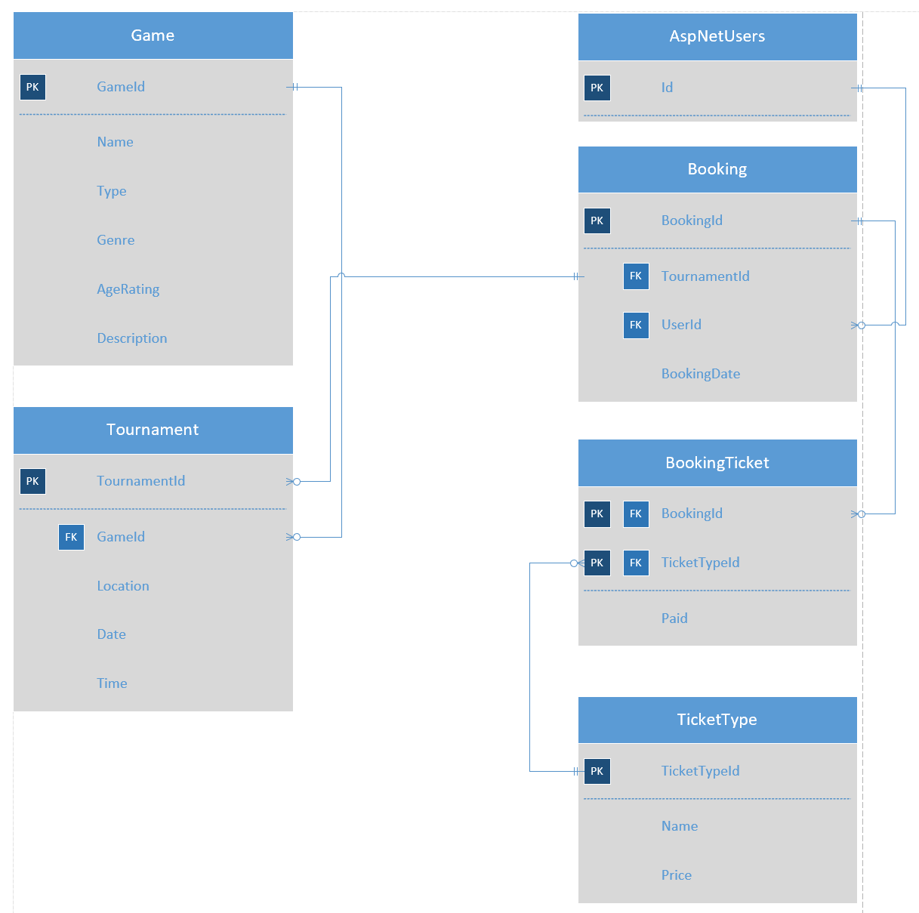
Figure 1: Entity Relationship Diagram of tables in model.

Implementation

Functionality
The web application allows users to search and filter games (Figure 2), log in with their Microsoft and google account (Figure 3) and create bookings for tournaments which are saved to the database (Figure 4 & 5).
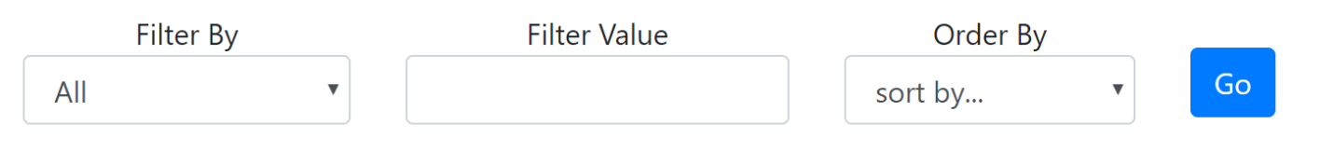
Figure 2: Filter and Search bar for games page.
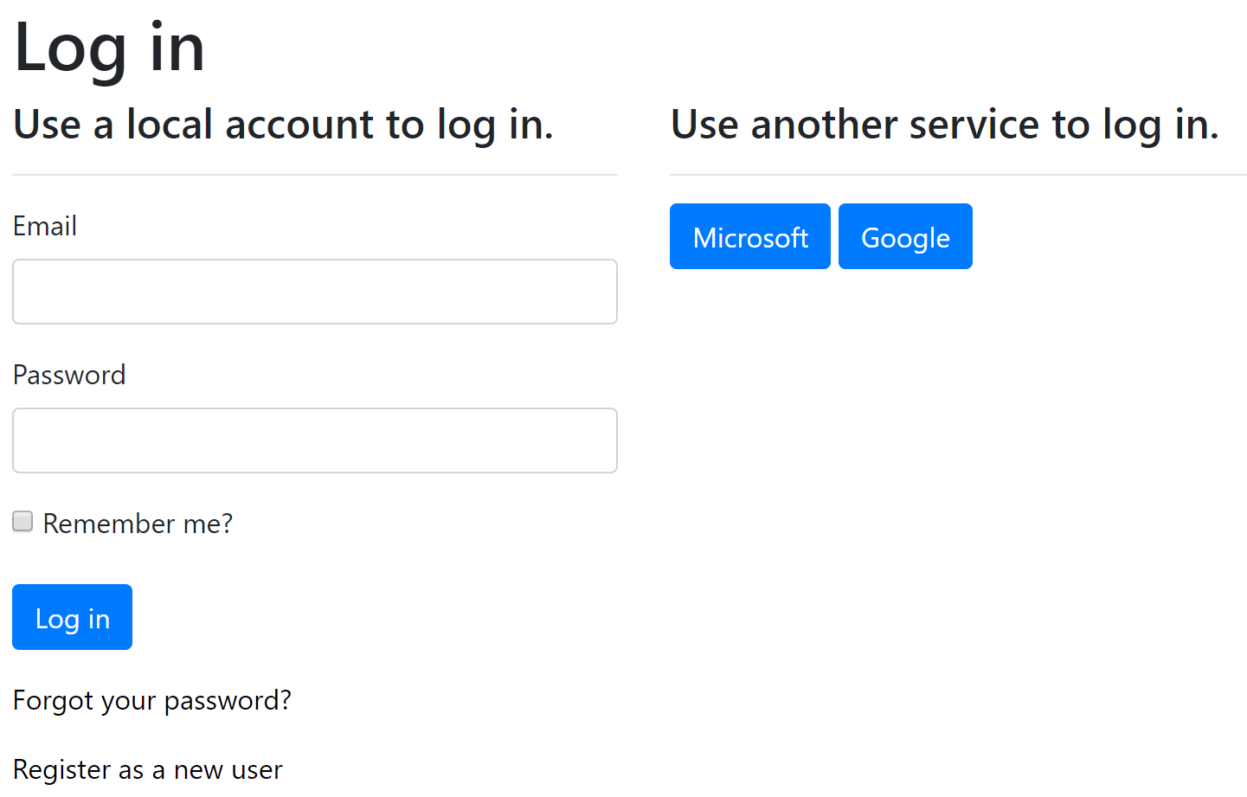
Figure 3: Microsoft and Google account login options.
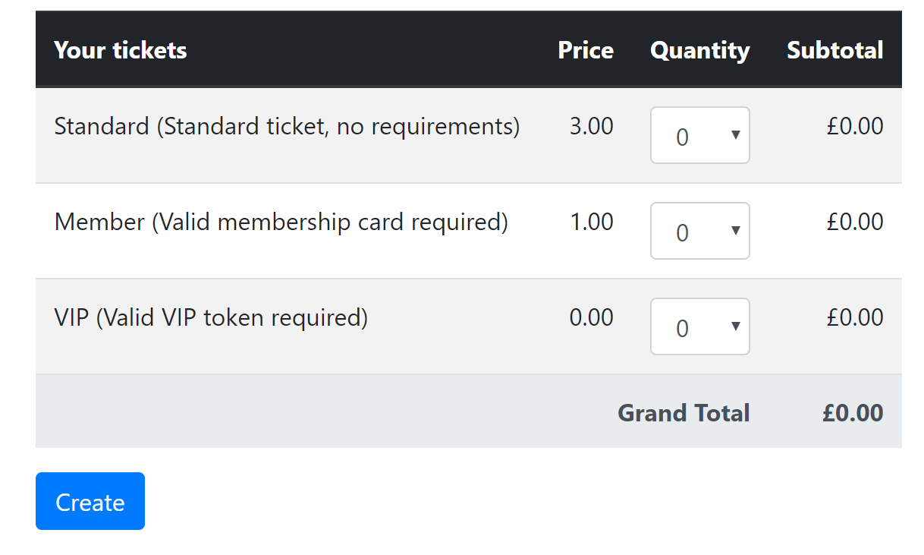
Figure 4: Tournament Booking menu.
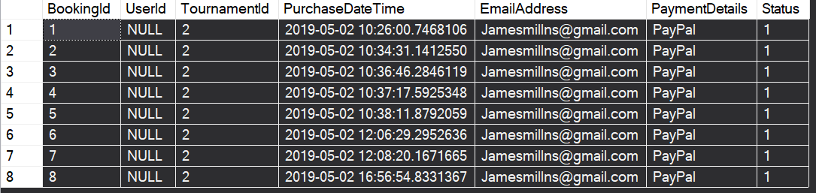
Figure 5: Test Bookings saved to the database.

MVC

Model
The structure of the entities that make the model part of the application have been depicted in Figures 6 – 11.
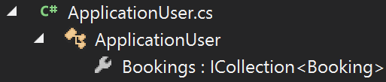
Figure 6: Application user entity
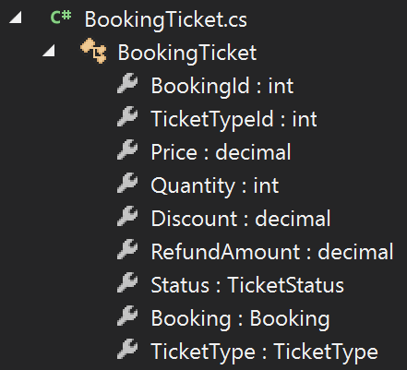
Figure 7: Booking Ticket entity
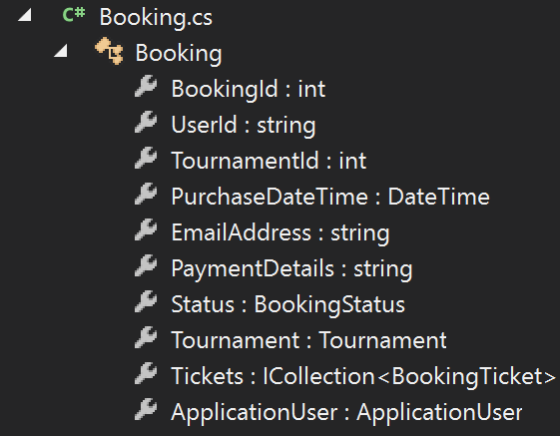
Figure 8: Booking Entity
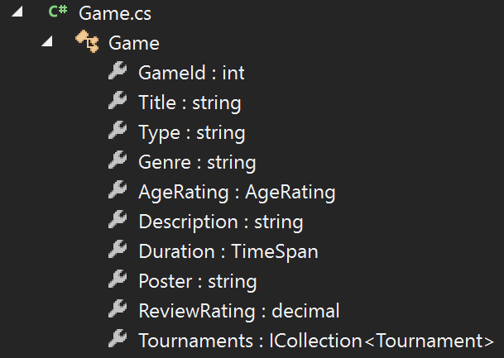
Figure 9: Game Entity
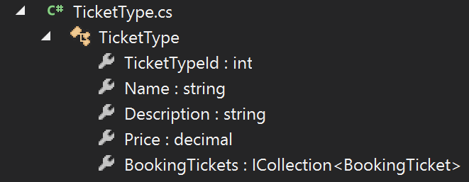
Figure 10:Ticket Type entity
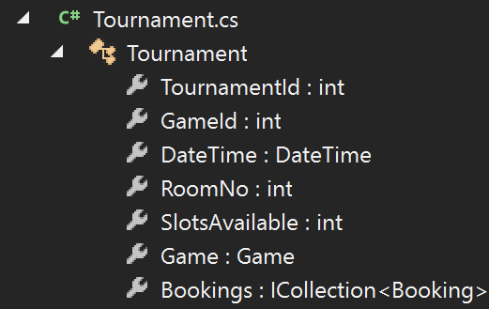
Figure 11: Tournament entity

The enumerators that were used to set the sets of names values for some of the entity’s attributes have been shown in Figure 12-14.
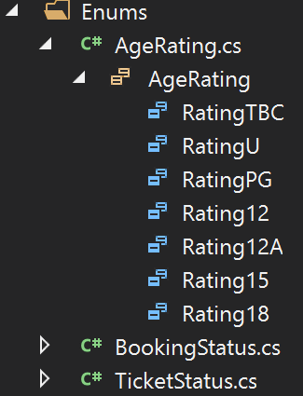
Figure 12: Age rating enumerator.
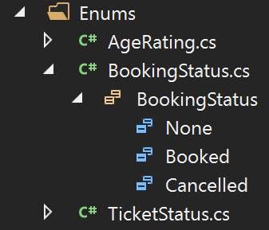
Figure 13: Booking status enumerator.
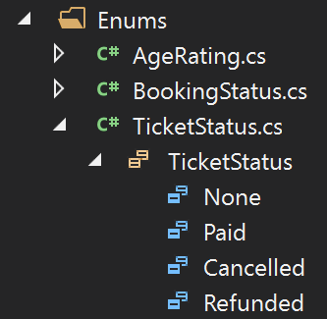
Figure 14: Ticket Status enumerator.

The values stored in the static tables of the database have been shown in Figures 15-17.
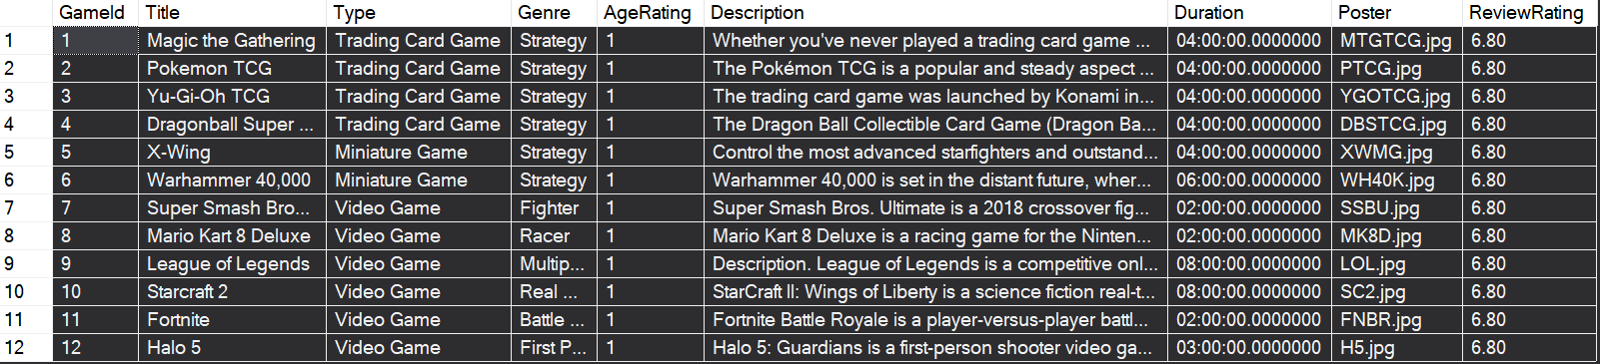
Figure 15: Game table.
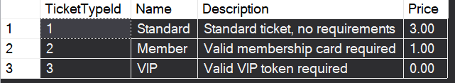
Figure 16: Ticket Type table/
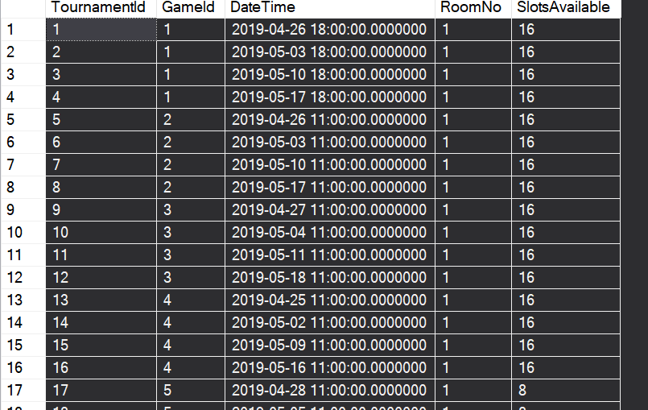
Figure 17: Tournament table.

Views
The styles and media used on the application have been shown in Figure 18.
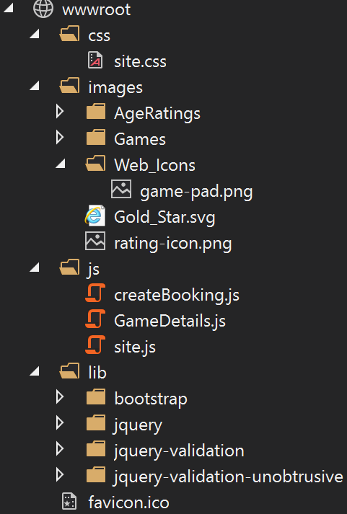
Figure 18: wwwroot folder structure.
The view structures have been shown in figures 19-24.
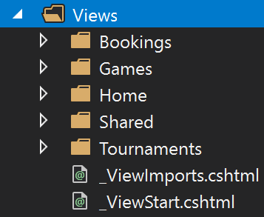
Figure 19: View collection.
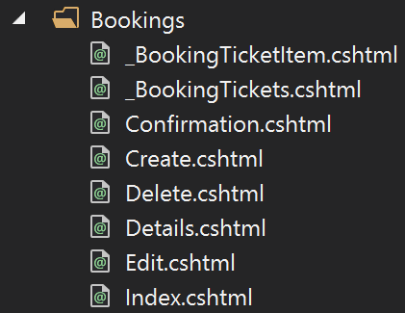
Figure 20: Bookings Views
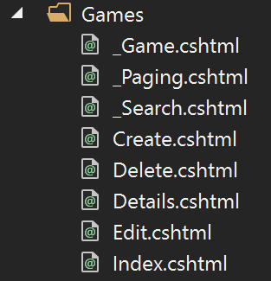
Figure 21: Games Views.
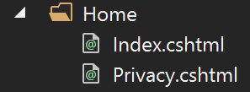
Figure 22:Home Views.
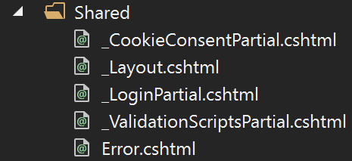
Figure 23: Shared Views
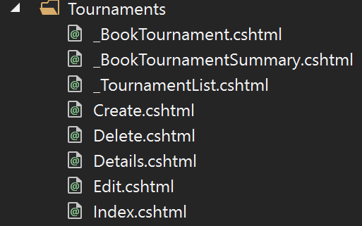
Figure 24: Tournaments Views

Controllers
The controllers and their methods have been detailed in Figures 25-29.
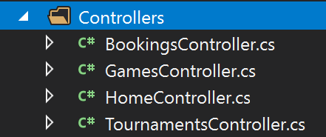
Figure 25: Controllers collection.
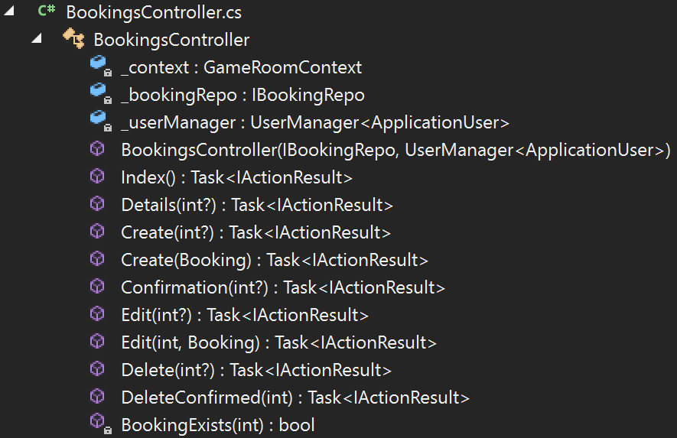
Figure 26: Booking Controller methods.
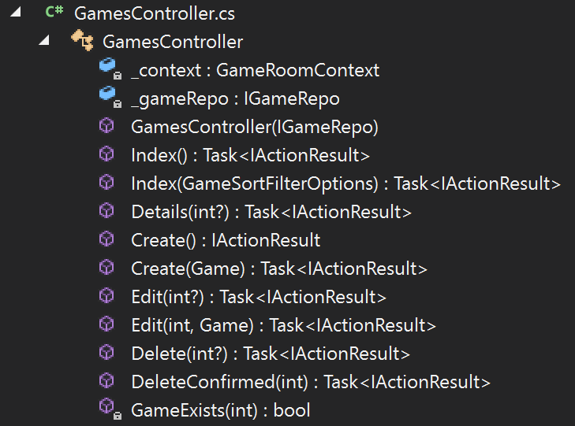
Figure 27: Games Controller methods.
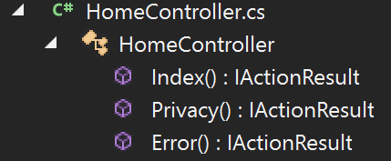
Figure 28: Home Controller methods.
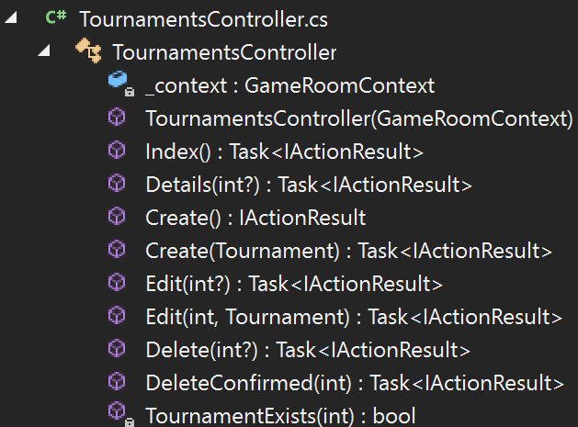
Figure 29: Tournament Controller methods.

The repositories of the application have been shown in Figures 30-34.
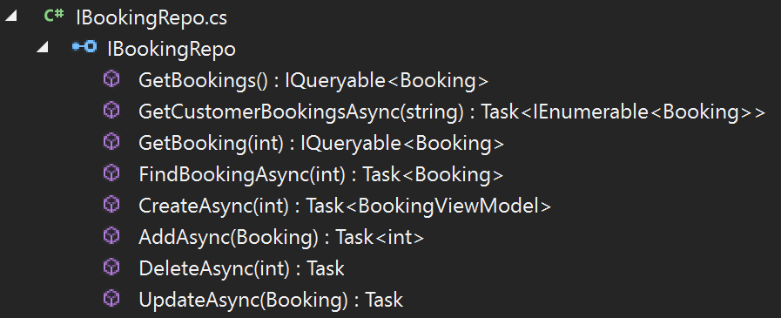
Figure 30: IBookingRepo.
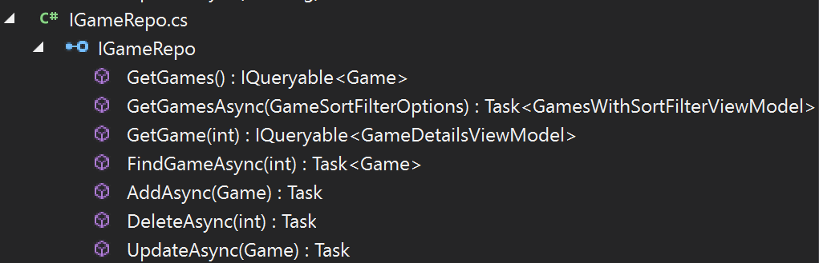
Figure 31: IGameRepo.
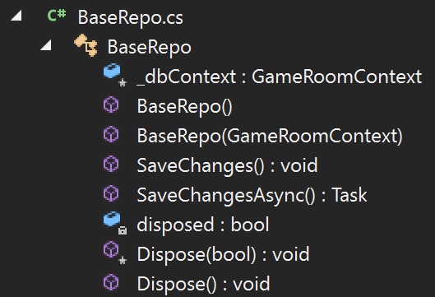
Figure 32: BaseRepo
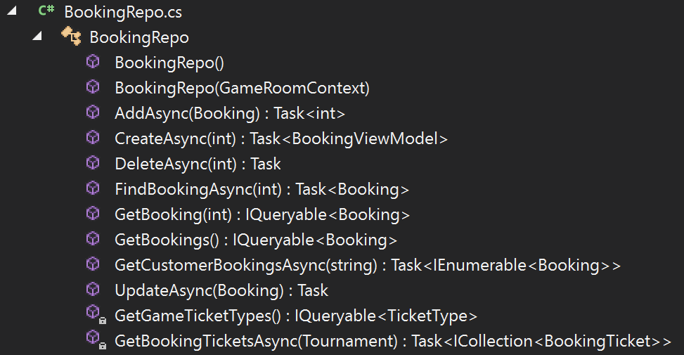
Figure 33: BookingRepo
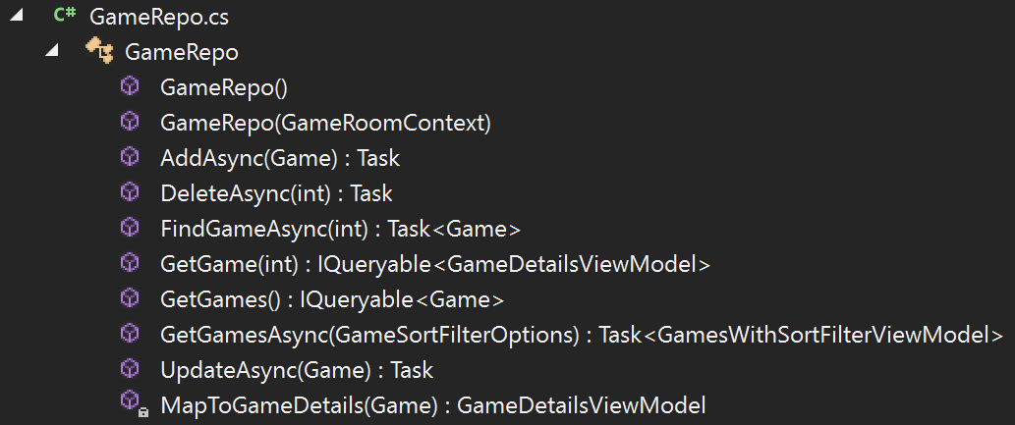
Figure 34: GameRepo

The sort filters have been shown in Figures 35-37.
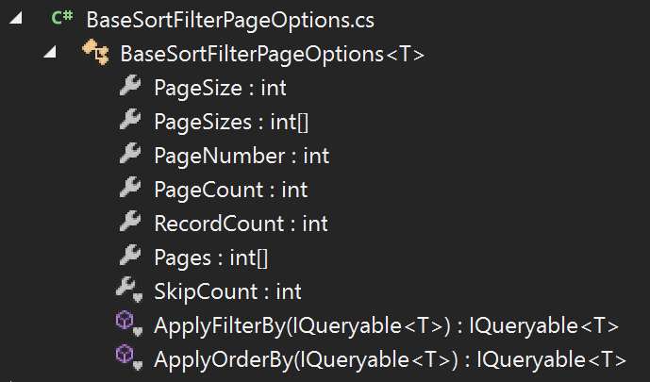
Figure 35: Base Sort Filter Page Option.
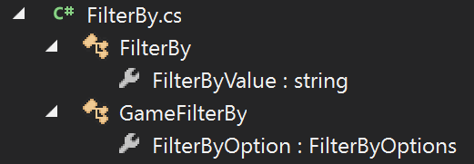
Figure 36: Filter By class.
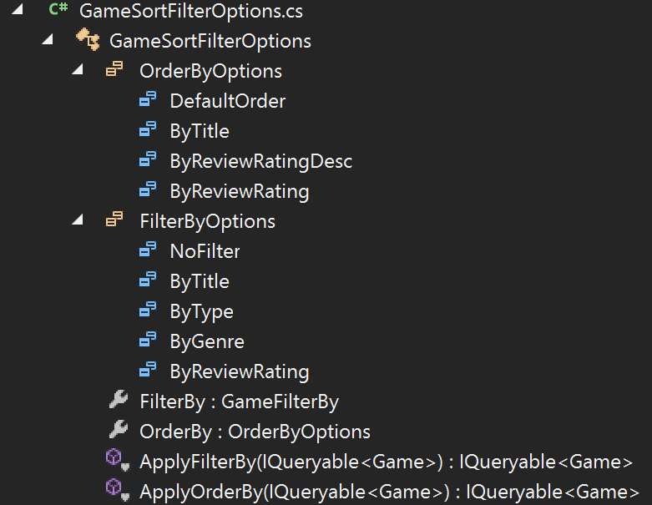
Figure 37: Game Sort Filter Options.

Screen Shots
The following Figures 38-44 show the implemented website application, each showcasing a different function that has been implemented.
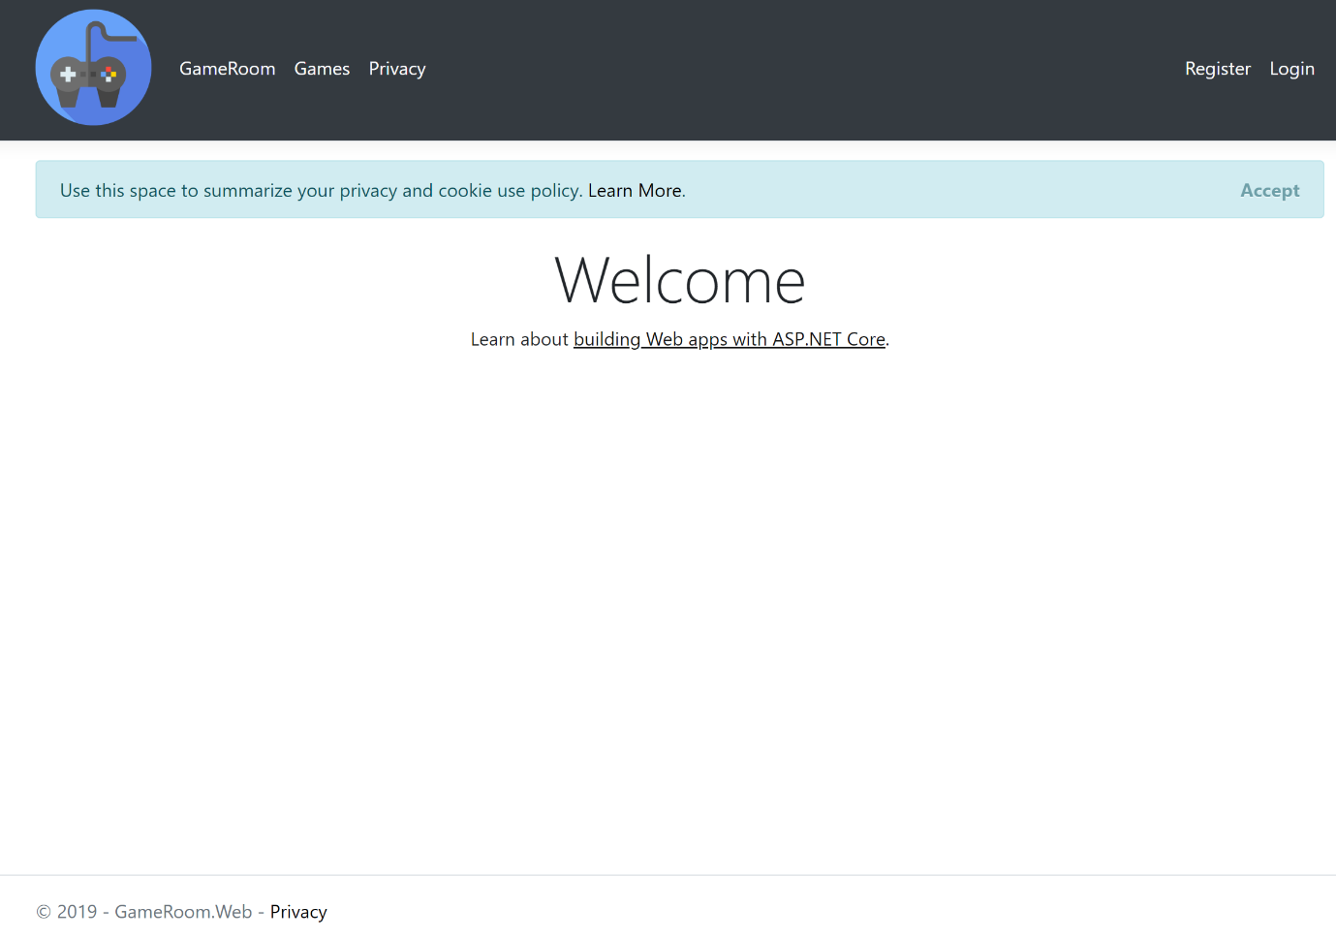
Figure 38: Index page.
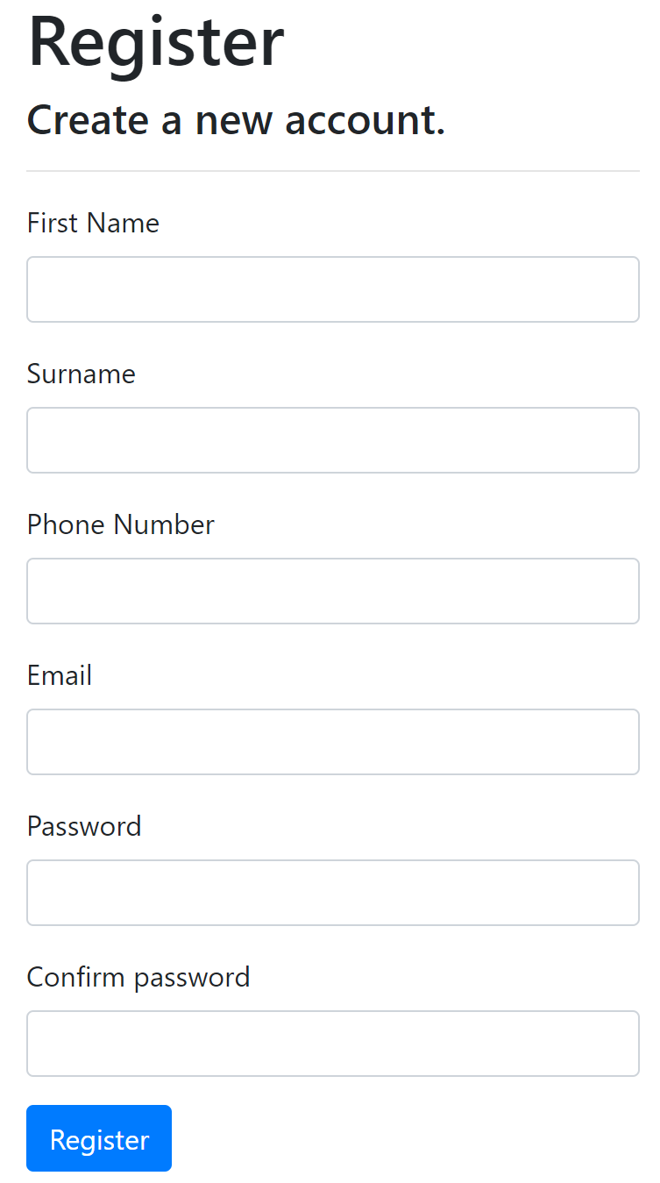
Figure 39: User registration page.
Figure 40: User Login page

Figure 41: Navigation bar.
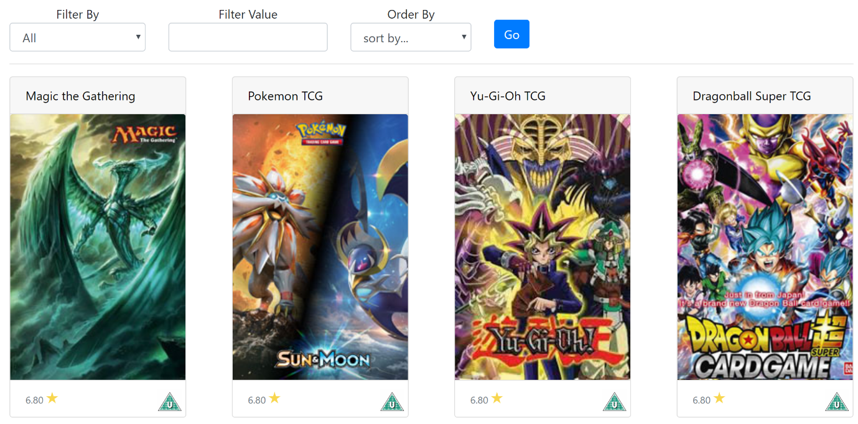
Figure 42: Games page.
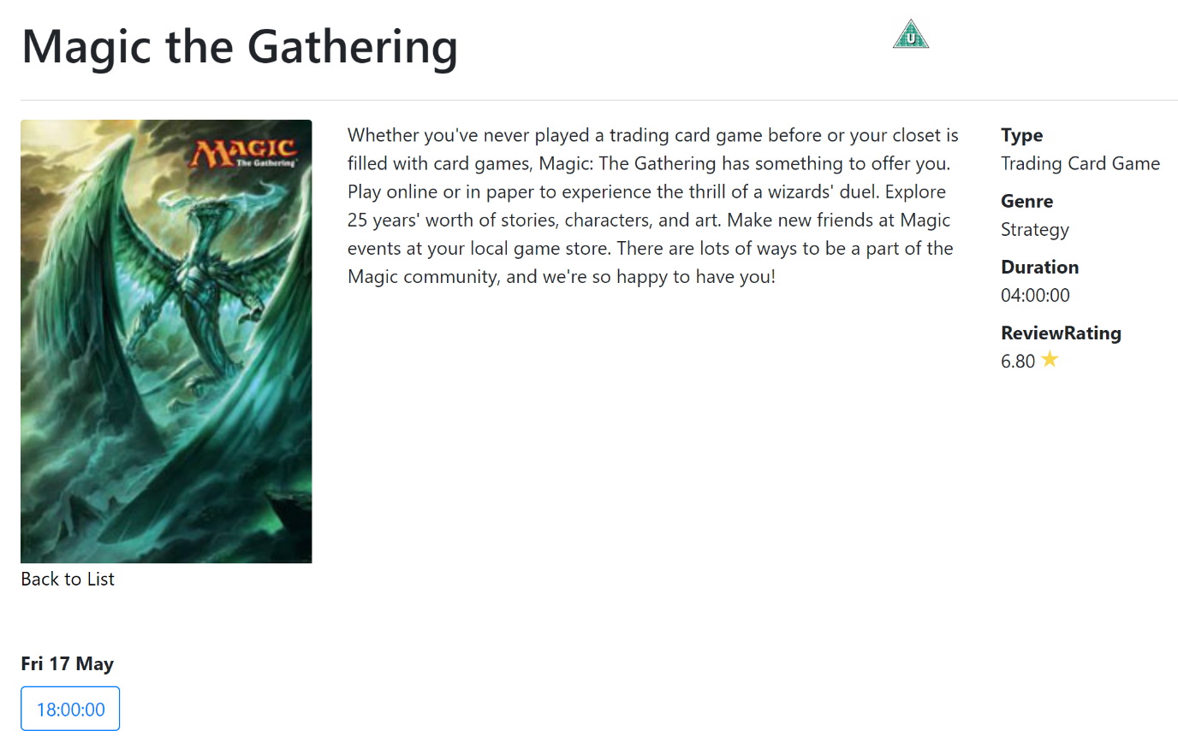
Figure 43: Game details page.
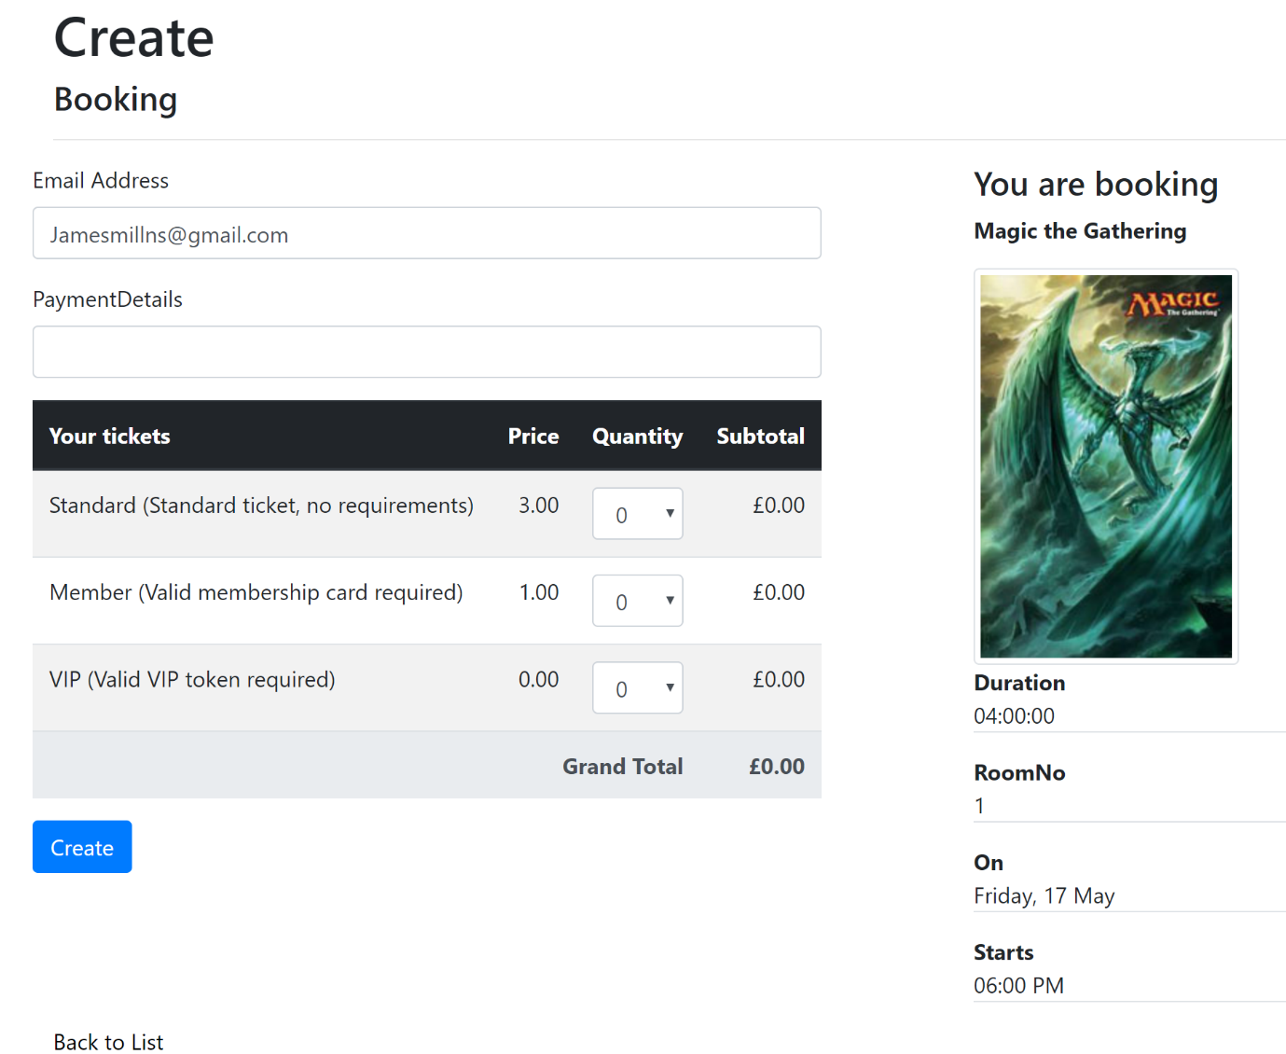
Figure 44: Create booking page.

Evaluation

Testing
Booking creation
The booking system of the application can successfully create new bookings made by the user and store them on the database of the system, one issue is there is no way currently for the user to view on the website what bookings they have made.
Sort filtering
The web application properly allows the user to sort and filter the search results of the games with the implemented solution. The number of results per page can be changed, one issue is with the displaying of the results of the page at the bottom overlapping the page number.
External logins
The web application allows the user to register of log in to the website with their Microsoft account, but unfortunately the google log in system would not function correctly and could not be fixed with the time constraints. This would be a future improvement given more time.

Overview
To evaluate the website, it is best to compare the final product to the initial requirements set.
The application successfully shows details of games and tournaments from a central database and it allow users to filter and search for games and change how many results are shown per page. The application validates user forms to prevent SQL injection.
The application allows users to create bookings and allows Admins to create, update and delete game and tournaments. The application also uses the MVC model.
The application allows users to register and log in with their email and Microsoft account.
The look of the website is clean and readable with contrasting colors and simple fonts, and the nav bar offers a simple and intuitive user experience.
The content of the website is on theme and shows clear to see images with paragraphs of details which give insight into the games.

Future improvements
If more time was allocated to the design and implementation of the web application, a view booking page would be implemented to allow users to view what tournaments that they have signed up for and allow admins to view all the bookings made for any given tournament to allow them to make proper arrangements for the store.
The google sign in option would also be corrected and the results per page tip would be corrected so it did not overlay the page numbers.

References
[1] J. Enrique and C. Rojas, “Web application Security,” 2013.
[2] D. A. and A. 2016 L. International Conference on Cyber Situational Awareness, Institute of Electrical and Electronics Engineers, D. A. and A. 2016. 06. 1.-14 L. International Conference on Cyber Situational Awareness, Cyber SA 2016.06.13-14 London, and CyberSA 2016.06.13-14 London, 2016 International Conference on Cyber Situational Awareness, Data Analytics And Assessment (CyberSA) 13-14 June 2016. IEEE, 2016.
[3] M. Bang and H. Saraswat, “Building an effective and efficient continuous web application security program,” in 2016 International Conference On Cyber Situational Awareness, Data Analytics And Assessment (CyberSA), 2016, pp. 1–4.
[4] A. Alzahrani, A. Alqazzaz, Y. Zhu, H. Fu, and N. Almashfi, “Web Application Security Tools Analysis,” in 2017 IEEE 3rd International Conference on Big Data Security on Cloud (BigDataSecurity), IEEE International Conference on High Performance and Smart Computing, (HPSC) and IEEE International Conference on Intelligent Data and Security (IDS), 2017, pp. 237–242.
[5] “OWASP Top 10-2017,” 2003.
[6] “Top 10 2013-Top 10 - OWASP.” [Online]. Available: https://www.owasp.org/index.php/Top_10_2013-Top_10. [Accessed: 06-May-2019].
[7] E. Gamma, Design patterns : elements of reusable object-oriented software. Addison-Wesley, 1995.
[8] I. Lee, S. Jeong, S. Yeo, and J. Moon, “A novel method for SQL injection attack detection based on removing SQL query attribute values,” Math. Comput. Model., vol. 55, pp. 58–68, 2012.
[9] P. R. Mcwhirter, K. Kifayat, Q. Shi, and B. Askwith, “SQL Injection Attack classification through the feature extraction of SQL query strings using a Gap-Weighted String Subsequence Kernel,” J. Inf. Secur. Appl., vol. 40, pp. 199–216, 2018.
[10] S. Wedman, A. Tetmeyer, and H. Saiedian, “An Analytical Study of Web Application Session Management Mechanisms and HTTP Session Hijacking Attacks,” Inf. Secur. J. A Glob. Perspect., vol. 22, pp. 55–67, 2013.
[11] “XSS Tutorial #1 - What is Cross Site Scripting? - YouTube.” [Online]. Available: https://www.youtube.com/watch?v=M_nIIcKTxGk. [Accessed: 06-May-2019].
[12] E. Kirda, N. Jovanovic, C. Kruegel, and G. Vigna, “Client-side cross-site scripting protection,” Comput. Secur., vol. 28, pp. 592–604.
[13] I. Hydara, A. Bakar, M. Sultan, H. Zulzalil, and N. Admodisastro, “Current state of research on cross-site scripting (XSS) â€“ A systematic literature review,” Inf. Softw. Technol., vol. 58, pp. 170–186, 2015.
[14] J. M. (Judith M. Bishop, C♯ 3.0 design patterns. O’Reilly, 2008.
[15] C. Zhang and D. Budgen, “A survey of experienced user perceptions about software design patterns,” Inf. Softw. Technol., vol. 55, pp. 822–835, 2013.
[16] V. K. Kerji, “Decorator Pattern with XML in web application,” in ICECT 2011 - 2011 3rd International Conference on Electronics Computer Technology, 2011, vol. 5, pp. 304–308.
[17] D. P. Pop and A. Altar, “Designing an MVC model for rapid web application development,” in Procedia Engineering, 2014, vol. 69, pp. 1172–1179.

marking criteria and Student FEEDBACK

This section details the extent to which the assessment criteria are demonstrated by you, which in turn determines your mark. The marks available for each category of skill are shown. Lecturers will use the space provided to comment on the achievement of the task(s), including those areas in which you have performed well and areas that would benefit from development/improvement.

Common Assessment Criteria Applied (Assignment 2) | Marks available | Marks  awarded
1. Engagement with Literature Skills

Very good evidence of engagement with literature skills and a wide range of appropriate reference sources have been consulted. (Grade mark: 100.00%) | 5 | 5
2. Knowledge and Understanding Skills

Excellent, detailed discussion of some of the common web security issues. Very good introduction to software design patterns generally, but requires a clearer explanation of how the chosen design pattern works and is relevant to web applications. (Grade mark: 72.00%) | 25 | 18
3. Cognitive and Intellectual Skills

A good evaluation of the application has been provided highlighting some of its limitations, while documentary evidence of testing is limited and needs to be improved beyond screenshots to further demonstrate different test cases of the application's functionality. (Grade mark: 55.00%) | 20 | 11
4. Practical Application Skills

An excellent attempt featuring a simple application based on the class tutorial but there is room for improvement. Requirements have been well thought out. Some CRUD functionality has been implemented and restricted using authorisation and you have also managed to get the default forms added by VS for editing and creating new records working. Filtering and paging is also working well. Overall, I would have liked to see some of your own ideas. Also change the content of the default home page added by VS. (Grade mark: 81.11%) | 45 | 36.5
5. Transferable Skills for Life and Professional Practice

The report is well-written and presented. (Grade mark: 90.00%) | 5 | 4.5

Assignment Mark (Assessment marks are subject to ratification at the Exam Board. These comments and marks are to give feedback on module work and are for guidance only until they are confirmed. ) | Late Submission Penalties (tick if appropriate) |  | 75%
 | Up to 1 week late (40% Max) |  | 75%
 | Over 1 week late (0%) |  | 75%

