Electrical & Electronic Engineering

A simple token based distributed network
Distributed Intelligence System
ACDA5018
Rebecca Coles
2218001
Table of Contents
Table of Figures 2
Introduction 3
Background Research 3
Point to Point Transmission System 3
Point to Multipoint Transmission System 3
Multi Master Transmission System 4
Design 5
Development 6
Master Code 7
Slave Code 9
Analysis 10
Flowchart 10
Operation of Programme 10
Quality Management 11
Summary 12
References 13

Table of Figures

Figure 1 - Schematic 5
Figure 2 - Master code 7
Figure 3 - Master code 7
Figure 4 - Master code 8
Figure 5 - Master code 8
Figure 6 - Slave code 9
Figure 7 - Slave code 9
Figure 8 - Flowchart of Microcontrollers 10

Introduction

This assignment focuses on the design and implementation of a simple token-based distributed network for a motor vehicle application using Proteus simulation software and CCS. The objective of this assignment is to develop a communication system where a single master node coordinates the operation of various lighting functions on one corner of a vehicle. This can be either the front or the rear and either left or right, this is done through the use of digital tokens.
The system uses a distributed approach where a slave node is responsible for controlling specific components such as indicators, brake lights and fog lights. Communication between the master and slave nodes is managed through token-passing, this is ensuring that only one node communicates at a time, thereby reducing the risk of data collision and improving reliability.
By simulating the network in Proteus, this project demonstrates a practical application of embedded systems and serial communication protocols in automotive electronics, while also highlighting the effectiveness of token-based control in managing distributed systems. [1]

Background Research

Point to Point Transmission System
A point to point transmission system is a communication setup in which data is transmitted directly between two devices, one being the transmitter and the other one being the receiver. This dedicated connection ensures that the data sent from the source reaches the destination without interference from other nodes, making the system both reliable and efficient for one to one communication. Due to its simplicity, this type of system is often used in applications where low latency, high speed and secure communications are required. In addition, since there is no need for complex addressing, the software is minimal.
However, there are disadvantages to the point to point system, these include its lack of scalability, also the addition of more devices requires dedicated links, which increases cost and complexity. As a result, while highly effective in isolated or simple systems, point to point communication is not suitable for larger or more dynamic network environments.

An example of point to point systems is a USB connection between a computer and a device, these include a mouse, keyboard or external hard drive. The computer acts as transmitter and the device is the receiver. Data is transmitted directly between the two devices through a dedicated USB cable. [2]

Point to Multipoint Transmission System
A point to multipoint transmission system is a communication where one central device, often referred to as the master or sender, communicates with multiple connected devices. In this setup, the master node is responsible for sending out data and this data is projected to all the connected receivers in the network. However, only the receiver that is specifically addressed by the master will respond to the data, which helps prevent conflicts in communication and ensures that each device only processes the information meant for it.
This type of system is highly efficient for applications that require data to be distributed to multiple devices, yet with minimal communication conflicts.

Point to multipoint systems are commonly used in sensor networks, where a central node collects data from multiple remote sensors.
An example of point to multipoint system is a Wi-Fi router system. Where the router is the master, sending out signals and devices such as laptops, smartphones, tablets and printers are the multipoint receivers. Although all these devices are connected to the same network, only the device that is request specifically by the data transmitted by the master, such as internet access or file sharing respond to the router. This allows efficiency and organisation within the system.
This structure within the system allows for greater scalability compared to point to point systems, as it reduces the need for dedicated connections between each pair of devices. However it is important for clear communication such as addressing or channels to prevent collision within the system. [3]

Multi Master Transmission System
A multi master transmission system is a type of communication network in which more than one device is instructed to initiate communication. Unlike point to point systems where communication is controlled by a single direction at a time, the multi master system allows any master node within the network to send command or request data as needed. Each master has equal priority and control, making the network more flexible and capable of handling high demand communication needs.
Multiple masters can attempt to communicate at the same time, this setup requires mechanisms for collision, detection and avoidance. These mechanisms help prevent data corruption and ensure that only one master successfully transmits on the network at any given time.

Examples of this include protocols such as I²C (Inter Integrated Circuit). This manages any conflict when multiple masters try to control the bus simultaneously.
The advantages of a multi master system is its increased flexibility, fault tolerance and system robustness. Other advantages include if any master fails, another can often take over its role without significant system disruption. This makes multi master systems ideal for complex or critical applications, such as industrial automation, robotics and certain automotive systems where distributed control is needed.

However, this design comes with increased complexity. As a result, while powerful the multi master systems are typically only used when their benefits such as redundancy and distributed control, outweigh the added complexity.

In conclusion, the point to point, point to multipoint and multi-master transmission systems differ in structure, scalability and complexity. Point to point systems involve direct communication between two devices, offering simplicity and reliability but limited scalability. In contrast, point to multipoint systems allow one central master to communicate with multiple receivers, improving scalability and efficiency for broader communication, though only one device initiates transmission. Multi-master systems take this further by allowing multiple devices to initiate communication, providing flexibility and redundancy, but requiring complex mechanisms to prevent data collisions. Each system is suited to different applications based on the balance between simplicity, control and scalability [4].

Design

The circuit diagram shown below is a communication setup using two PIC 18F4550 microcontrollers. One has been configured as a master and the other a slave. As shown in figure 1, microcontroller U1 and U2. Each microcontroller is assigned distinct operational roles and is linked via dedicated communication pathways to enable data exchange between them.

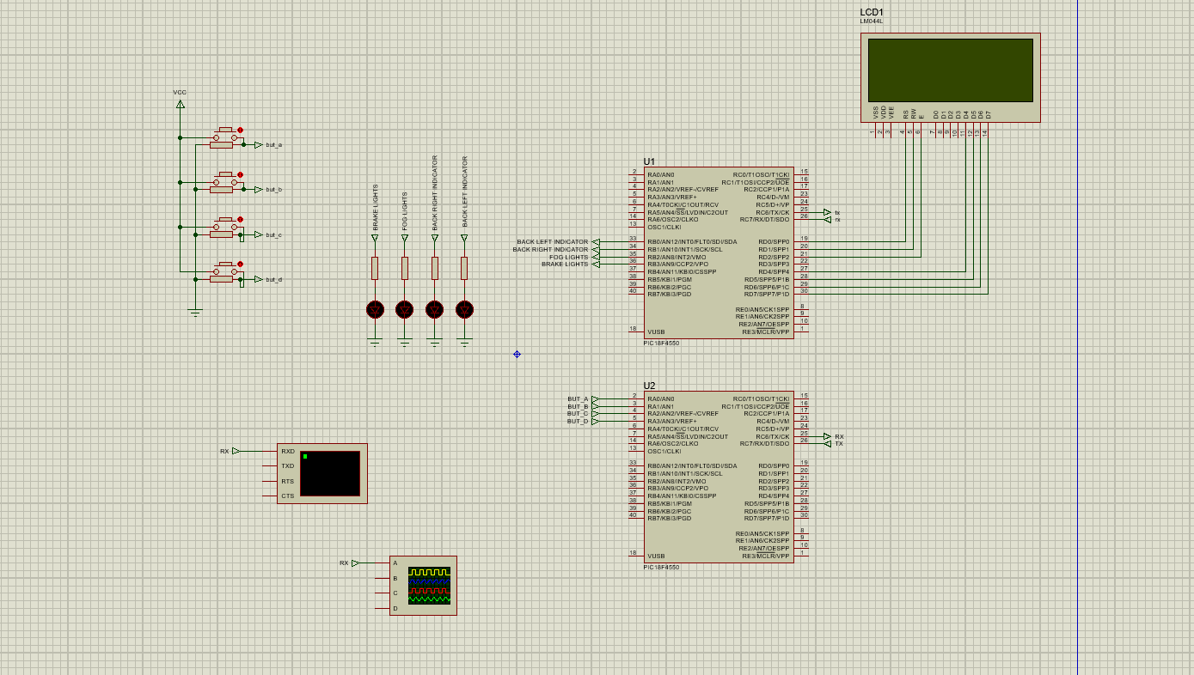
Figure 1 - Schematic
There are several key components used in this design, each one holding a key role into making the circuit work efficiently and effectively.

Firstly the microcontrollers (U1 & U2). The system uses two PIC18F4550 microcontrollers, one being used as the master and the other being used as the slave. The master, also know as U1 on the figure oversees the core control logic and transmits command signals to the slave controller, while the slave, known as U2 registers these commands and drives the corresponding output functions required.

Secondly the LED’s or the outputs of the circuit. Four individual outputs have been connected to LED’s, each LED representing a specific function to the vehicle. simulating a specific rear vehicle. Brake light, fog lights, back right indicator and back left indicator. Each output is sequenced with a push button and protected by 220Ω resistors, this limits current to the LED’s.
Next a power supply. As shown in the schematic a power supply delivering appropriate voltage to both control and output components. Each output path includes current limiting resistors to protect the LED’s and ensure safe and reliable operation.
Finally the communication interface between microcontrollers. Data exchange between the microcontrollers, master to slave is done through universal asynchronous receiver/transmitter, using clearly designated TX (transmit) and RX (receive) lines. UART is a common and efficient communication in embedded systems due to its simplicity.

The benefits and the reason for choosing to use UART in this application is that it is easy to use and set up, which makes it popular in many embedded systems. It only requires two wires, one to send data and one to receive. UART works well over short distances and is widely supported, making it useful for connecting to computers, debugging or basic communication between devices.

The schematic shown in figure 1 illustrates a real world application of a distributed control system in a vehicle. This is where a master microcontroller interprets user inputs. An example of this is a simple switch activations, which is then transmitted to the slave microcontroller. The slave microcontroller then responds by ensuring specific outputs, which include functions like brake lights, indicators or reverse lights on the vehicle are switched to the on state. This master and slave communication system is commonly used in modern vehicles to streamline control of electronics. By using this system it enhances system reliability, scalability and helps reduce the complexity of the system.

Development

This section outlines the development of the programs for the master and slave microcontrollers in the distributed system. The master microcontroller is responsible for processing user inputs and sending corresponding commands to the slave microcontroller, which then activates the relevant outputs such as indicator lights or brake lights. Using UART communication, the master and slave microcontrollers exchange data efficiently. The microcontrollers are structured to ensure smooth communication, precise control of the system. Detailed coding is provided to describe the functionality and configuration of the system.
Each microcontroller is programmed to manage how input signals are processed and how corresponding outputs are generated. The core functionality is supported by header files, which define essential parameters and configurations that govern the microcontroller’s operation, these include pin assignments, communication settings and timing constraints.
See figures below of coding.

Master Code
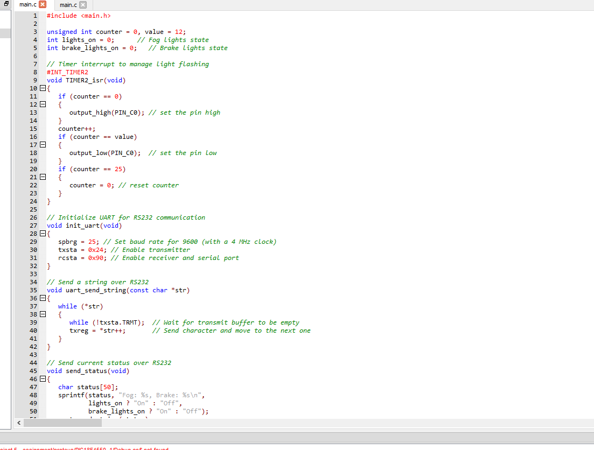
Figure 2 - Master code
This section of the code reads a button press and send over a signal using UART to the slave. It includes initialization for UART and uses polling to check button state.

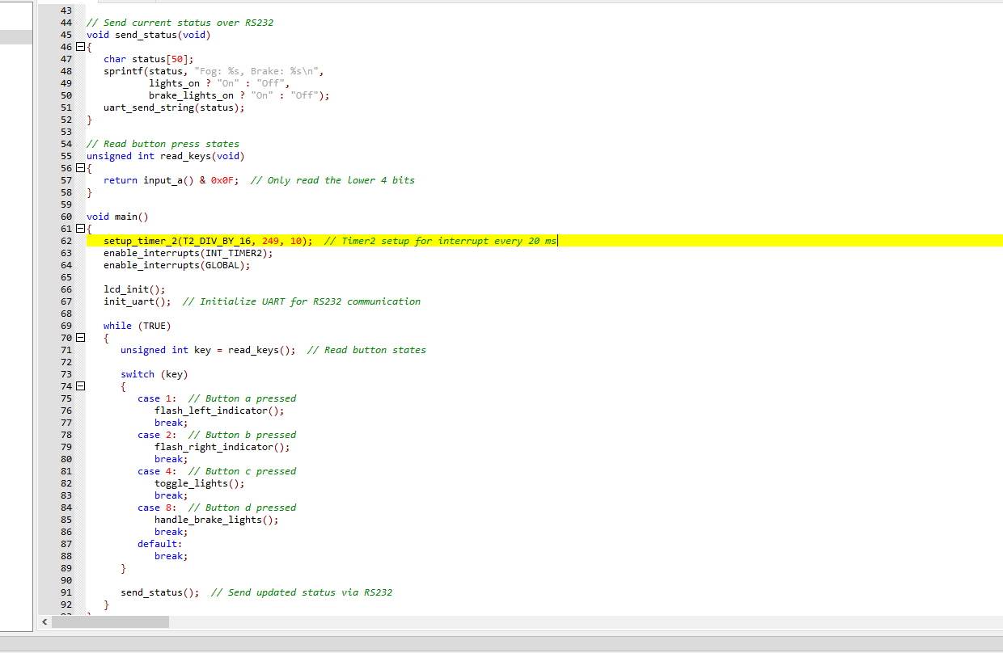
Figure 3 - Master code
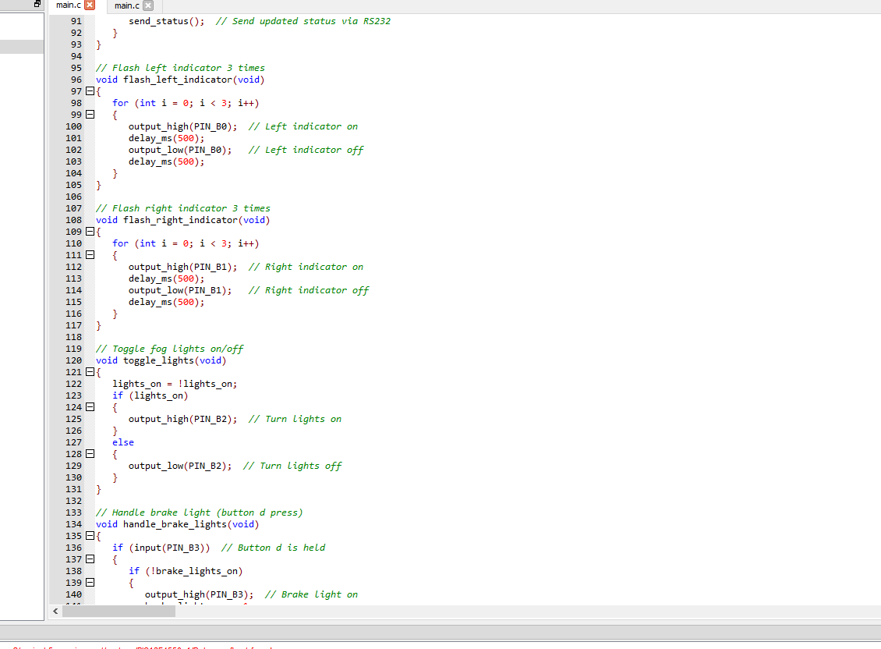
Figure 4 - Master code
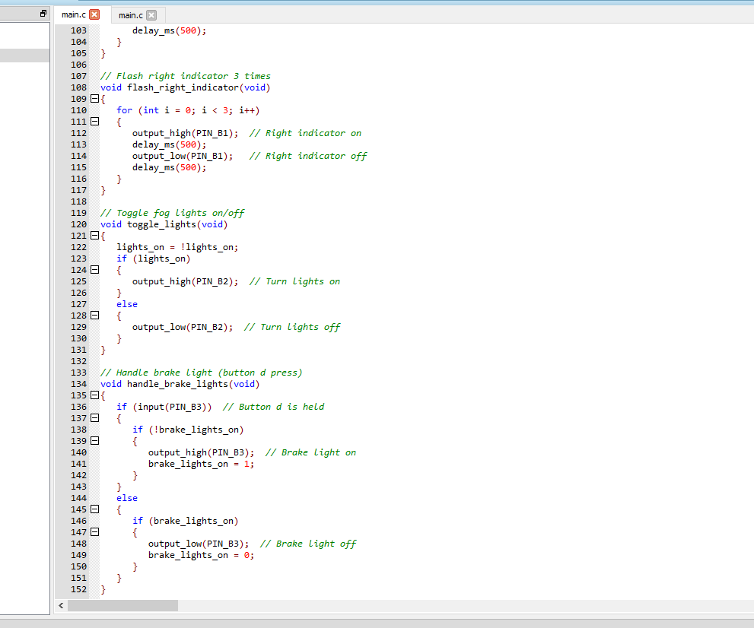
Figure 5 - Master code
The master microcontroller program is designed to manage the rear lighting of a vehicle. This includes brake lights, fog lights and indicators left and right. It receives input data via UART and turns these inputs as button presses. Buttons A-D are described below.
- Brake Lights: These are activated momentarily whenever the brake button, button D is pressed, mimicking the real time response of a vehicle's brake pedal.
- Fog lighting: This is operated with button C. Each press switches the light between ON and OFF states.
- Indicator Lights: These are triggered by pressing the indicator button, this is both button A and B. This initiates a 3 times flash, lasting 5 seconds once buttons are pressed for either indicator.

Slave Code
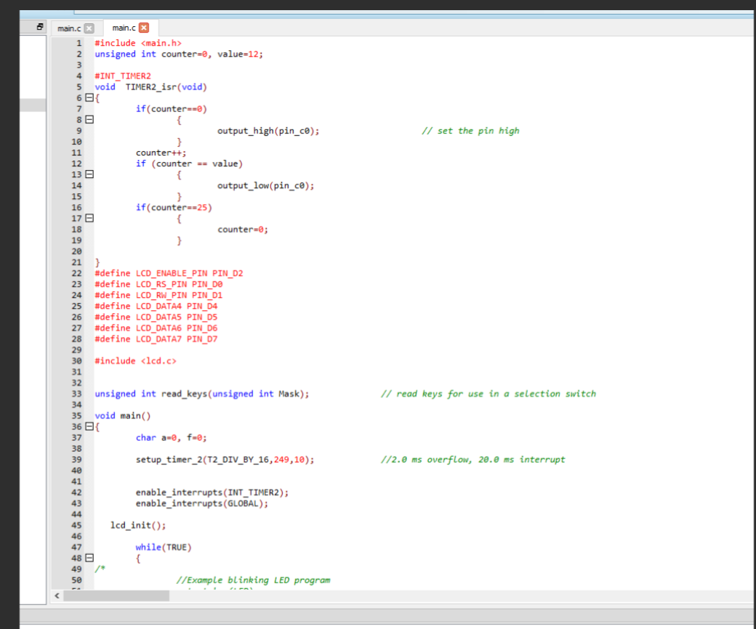
Figure 6 - Slave code
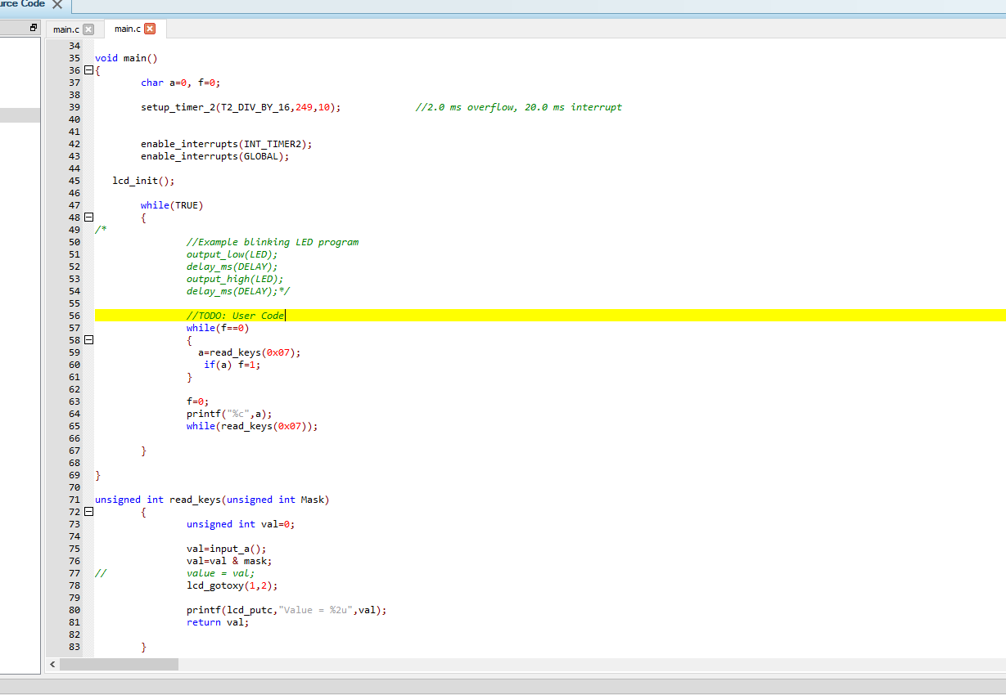
Figure 7 - Slave code
The slave listens for incoming data on UART. When it receives data, it turns on the output to simulate the lights on a vehicle.

The slave microcontroller program is responsible for continuously monitoring user inputs connected to ports A. These are buttons A-D. Its function is to detect if there any changes in the button states and communicate this information to the master microcontroller using UART. The master then processes the received data and determines the appropriate lighting actions. This setup delegates input monitoring to the slave while ensuring the master is making the decisions, making it an efficient control system.

Analysis

Flowchart
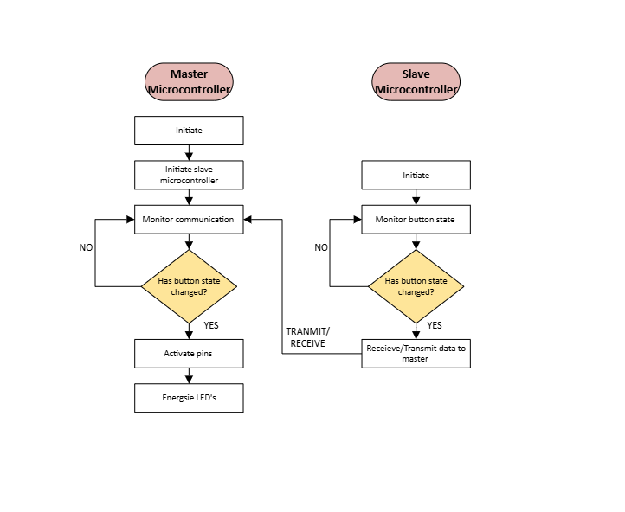
Figure 8 - Flowchart of Microcontrollers
The flowchart included in this project provides a clear visual representation of the interaction between the master and slave microcontrollers within the vehicle. It outlines the logical sequence of operations, starting from how the slave microcontroller continuously monitors button inputs and sends specific characters and data over to the UART, which then gets received by the master microcontroller whenever a change of state is detected. The master then interprets these inputs and triggers the appropriate outputs, such as activating the brake light, toggling the fog lights or initiating a timed flashing sequence for the indicator light. This visual breakdown is beneficial because it simplifies the understanding of the system's control logic. It also highlights data flow, decision points and supports effective system validation.

Operation of Programme
The system is designed around two microcontrollers, one master and the other slave, both PIC18F4550 devices. The slave microcontroller is responsible for monitoring four input buttons: brake, fog lights and indicators left and right. When a button press is detected, the slave transmits a corresponding character (A–D) to the master microcontroller over a UART serial connection.

Quality Management
Quality management is a fundamental aspect of embedded systems design, particularly in the automotive industry, where safety, reliability and compliance with strict standards are critical. In this project, where microcontrollers are used to control the vehicle’s rear lighting functions, applying a Quality Management System (QMS) ensures that the system is developed and maintained to a high standard throughout its lifecycle. The importance of quality management in this context is reflected in several key areas:
- Safety: Vehicle lighting is essential for driver visibility and signalling to other road users. Quality management ensures that each lighting function, such as brake, fog lights and indicator lights responds accurately and consistently to user inputs. This reduces the risk of malfunctions that could lead to hazardous situations on the road.
- Reliability and Consistency: A QMS enforces practices that make the system robust under different conditions. This includes software design standards, thorough testing procedures and consistent coding practices. Ensuring the system behaves predictably across various use cases prevents unexpected failures and maintains performance over time.
- Error Prevention and Detection: Quality management techniques such as code reviews, version control, unit testing and system simulations on software’s. These practices help identify and correct issues like logic errors, UART communication faults or software confusion before the system is put into service, this reducing the likelihood of real life failures.
- Standards Compliance: Automotive systems are governed by internationally recognized standards such as ISO 26262 - functional safety for road vehicles and ISO 9001 - quality management systems. A structured QMS ensures that development processes align with these standards, which is often a requirement for commercial automotive projects and manufacturing.
- Continuous Improvement: One of the core principles of quality management is ongoing improvement. Through testing, feedback and performance reviews, the system can be refined over time. This allows for updates that enhance functionality and respond to new safety requirements or user needs.

In summary, integrating a quality management approach into this microcontroller system not only increases its dependability but also aligns it with industry standards. Overall, quality management ensures that your system is built correctly, safely and is maintainable, which is critical in any real world application [5] [6].

Summary

This project demonstrates the design and implementation of a microcontroller based distributed system for automotive applications, using a master and slave architecture. The system effectively manages critical vehicle lighting functions, including brake lights, fog lights and the left and right indicators, through communication between two PIC microcontrollers via UART. The application of quality management principles ensures that the system meets safety, reliability and performance standards, which are crucial in automotive environments. By adhering to recognised standards such as ISO 26262 for functional safety and ISO 9001 for quality management, the system can be developed, tested and maintained for any continuous improvement and regulatory compliance. Overall, this report highlights the importance of implementing structured design processes and quality management systems in the development of embedded systems, particularly those that are safety critical and require long term dependability.

References

[1] | “Lab Center,” 27 04 2025. [Online]. Available: https://www.labcenter.com/.
[2] | “Introduction to digital communication,” A.Smith, 2015.
[3] | “Point to multipoint communication in wirless networks,” R.H.Weber and A.K.Popescu, 2012.
[4] | Data and computer communications, W.Stallings, 2014.
[5] | “ISO,” 05 05 2025. [Online]. Available: https://www.iso.org/standards/popular/iso-9000-family.
[6] | Quality Management Systems: Benefits and Best Practices, S.G.Hansen & H.F.Greenfield, 2019.

