Marketing Management
(LCMB7001_BIRM)
Critical Evaluation of Marketing Activities

Student’s name : Mustafizur Rahman
Student ID : 1711957
Lecturer Name : Dr Oluwaseun (Olu) Adegbite

Executive summary
In this competitive world, every business organisation faces challenges to gain more market share and survive in the market. Effective marketing strategy and policy are a must to sustain in the market. This report discusses the issues of marketing management from the perspective of British Telecommunication. The report comprises four parts. The first part discusses the key concepts of marketing, essentials, and research approach. The second part discusses the critical evaluation of British Telecommunication’s marketing activities. In this part, macro and micro environment analyses of the company, target market, and marketing mix are discussed. The third and fourth parts of the conclusion and recommendation respectively.

Contents
Introduction 3
Literature review 4
Case study approach of the British Telecommunication 4
Task 1: Critical evaluation of British Telecommunication’s marketing activities 5
Michael porter's five forces framework 5
PEST Analysis 6
SWOT Analysis 8
Target markets 9
STP Analysis of British Telecommunication 9
Marketing Mix 10
Selection of Media 11
Measuring success 11
Contribution of Marketing 12
Challenges faced by British Telecommunication 12
Task 2: Conclusion 14
Task 3: Recommendations 16
Reference 18

Table of Figures
Figure 1: Logo and moto of British Telecommunication . 4
Figure 2: Michael porter's five forces framework. 6
Figure 3: Macro environmental analysis 8
Figure 4: SWOT analysis framework. 9
Figure 5: STP analysis. 10
Figure 6: 4P’s of the marketing mix 11
Figure 7: BT’s Market Share 13

Introduction
In the current global market, establishing a successful corporation is difficult due to uncountable challenges faced by the organisations. It affects their long-term planning and standards are set likewise to maximise and maintain their market position. This report discusses the issues of marketing management from the perspective of British Telecommunication. The report would highlight the internal, macro, and micro aspects of the company to identify how effective is their marketing strategy. This would also help to identify the shortcomings and where BT has to put effort to improve their performance.
Overview British Telecommunication
British Telecommunication is a British multinational telecommunication company founded in 1846 as an Electric Telegraph Company. Previously, it was a government-owned company controlled by the Postal department. In 1980, the British Telecom brand was launched which is working independently from Post Office in 1981 (BT, 2021).
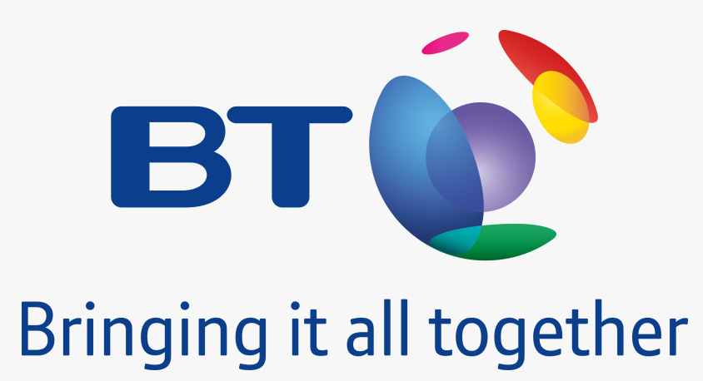
Figure 1: Logo and moto of British Telecommunication (BT, 2021).
In 1984 as British Telecommunication Plc sold approximately 50% shares publicly and became a public limited company. In the 1990s, BT went international by entering Irish telecommunication market in a joint venture with the Electric Supply Board, the power provides by the Irish state (BT, 2021). BT Group is operating in more than 180 countries globally.

Literature review (Concept and importance of marketing):
According to Philip Kotler (2018, p. 4) marketing is a social and managerial process that helps individuals and groups to acquire what they want and need in exchange for goods produced in terms of money. In an organisation, marketing is about understanding market needs and wants, and creating demands for innovations (Sheehan, 2011, p. 12).
According to Hooley, (2020, p. 38) Businesses make their marketing plan focusing on gaining new clients, retaining the existing ones, creating a brand, and making public relations to promote the product or services in the market. Amid fierce competition, it is difficult to stand out in the crowd this is where marketing strategies help to acquire a competitive position in the market (Kotler, 2018, p. 67).
According to Sood, (2017, p. 78) porter's five forces framework is a viable tool to analyse the industry. It suggests analysing five forces that help to determine the current condition of the market. PESTEL is one of the effective frameworks to analyse macro-environment (Samanta, 2014, p. 64). It helps to understand the external forces of the business. An analyst also should focus on vision, mission, organisational behaviour, current resources, operational process to analyse the internal environment (Drummond, 2008, p. 37-41). It is effective to use SWOT frameworks to analyse the internal environment of an organisation.
According to Philip Kotler (2018, p. 56), an effective way to make a marketing plan is STP analysis. Market segmentation is a process of creating small groups in a market based on various aspects like similar needs and requirements. An organisation can get a competitive advantage by targeting a specific group of people and it should design innovative products and should make a marketing plan for them (Wang, 2014, p. 36).

Case study approach of the British Telecommunication
This study aims to critically evaluate the marketing management of British Telecommunication. The researcher followed a secondary research method to collect data about the company. He collected data from several sources such as websites, journals, books, and reports, etc. The researcher applied Porter’s five forces, PEST, and SWOT to analyse the internal, macro, and microenvironmental issues. He also did STP analysis to understand the customer of the company.

Task 1: Critical evaluation of British Telecommunication’s marketing activities

Michael porter's five forces framework
Bargaining Power of Buyers (Moderate)
The customers in the telecom industry of the UK have significant power as there are dozens of large and small operators that give them a vast variety of offerings to choose from according to their needs. Thus, customers can easily switch to other operators. However, BT has a strong network infrastructure and quality services that can hold the customers.
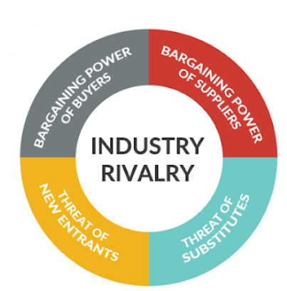
Figure 2: Michael porter's five forces framework (Sheehan, 2011).
Bargaining Power of Suppliers (Low)
The suppliers of BT have low bargaining power though they can exert high pressure on BT's prices. Their suppliers are the ones who supply Sims, mobile phones, fiber optics, and many. BT is a giant company that has a strong relationship with numerous suppliers which control their power.
The threat of New Entrants (Low)
In the UK the threat of new entrants in the telecom sector is low. The industry requires high capital to build a strong infrastructure, government regulations, and economies of scale. Additionally, more investment is needed to cover the expenses and maintain the quality network. All new entrants have to get approved by UK Telecoms regulator Ofcom to offer mobile services.
The threat of substitute products or services (low)
The key substitute product or services of telecommunication are landlines, mobile phones, and broadband. BT is the largest provider of these three products or services. So, the impact of substitutes is low in the industry. Currently, social networking sites like Skype, Video calls, and other channels have taken the mobile services.
Industry Rivalry (Moderate)
The rivalry in the existing market is moderate. So, BT has to charge a competitive price. BT holds the largest market share of fixed broadband with 34% in 2019 and also stands out in fixed-line call volumes with over 19.1 billion minutes which increased by 2.8 billion during the pandemic. Moreover, when it comes to superfast broadband access BT is the major player with 84% (Statista, 2021). After the acquisition of EE, BT has exposure to the 5G market too.

PEST Analysis
Political: The political environment of the UK is stable enough. However, changes in laws and regulations affect the operations of BT. Though the UK has strong relationships with neighbouring countries, Brexit has affected the company's growth in EU countries badly and has restricted them to enjoy free trade. Even political instability in EU countries and changing legislations has become a concern.
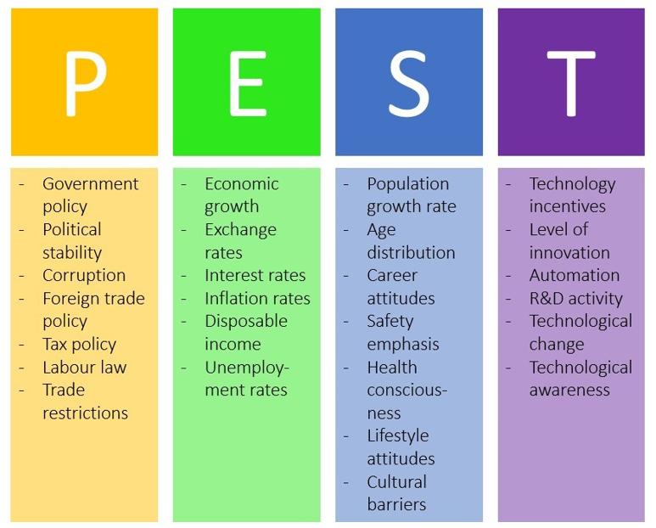
Figure 3: Macro environmental analysis (Czinkota, 2011)
ECONOMICS: The UK possess 6th rank in the world economy. The Covid-19 pandemic telecom industry has grabbed significant opportunities as the whole world went online. The economy of the UK scores 78.4% in economic freedom score becoming 7th freest in the 2021 Index (Statista, 2021). However, the overall performance of the economy is high and a stable one for BT to continue its work and take advantage when the world is going online.
SOCIAL: the UK is a multicultural country that is in the top 10 ranks with the most educated population, therefore they have a high standard of living. In 2020, the UK has encountered a total population of 67.22 million with an average growth rate of 0.6% per annum. Among which 62.86 million people are using the internet with 92.17% internet user penetration rate. However, the daily user is 46.6 million. This gives a broad perspective on the opportunities BT gets in its home market (Statista, 2021).
TECHNOLOGICAL: Innovations have become important for telecom industries to stand out in the crowd with frequent technological advancement. Therefore, BT Group has considered technology as key to competence by providing wireless services, fast internet speed, and other data services. The facilities of 5G, Ethernet technology, and iPhone innovations have facilitated the demand for broadband reducing the total cost. Technological inventions have allowed BT to diversify and grow.

SWOT Analysis
Strengths: British Telecommunication is one of the leading service providers in the UK who has a very strong brand image both domestically and internationally. BT offers a diverse range of services with the latest technology such as IP phone calls, fixed-line Telephony, broadband, Digital television, and IT services (BT, 2021). They have the highest coverage area and a wide distribution network.
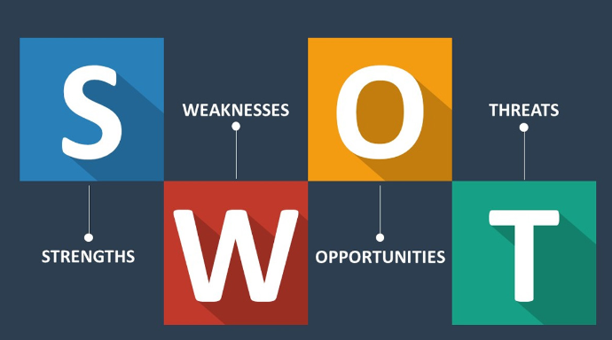
Figure 4: SWOT analysis framework (Dibb, 2012).
Weaknesses: BT mobile business is not yet fully developed which can be a great opportunity for them. Further, their lack of promotional strategies for their cheap voice calls can be an issue. As customers have low switching costs, BT needs to promote its services heavily for customer awareness. Further, their limited liquidity can create hurdles while planning marketing strategies
Threats: BT follows the Universal Declaration of Human Rights and International Labour Organisation rules, in case of breaching these rules the company may face lawsuits and loss of reputation. The company faces fierce competition from domestic and international players (BT, 2021). Moreover, natural disasters can destroy BT's infrastructure too.
Opportunities: Technological advancement in recent years provides a wide range of opportunities. The IP voice communication will help BT to gain a wider customer base. With the outrage of internet usage, BT has changed its phone calls from fixed lines to the internet. BT has launched social media platform to interact with its customers too which would allow them to understand its customers and bring innovative services to satisfy their needs.
Before implementing marketing strategies BT needs to study the buying behaviour as it differs from place to place. Since the UK is a multicultural country, every customer has different needs (In Lee, 2018, p. 34). In remote areas purchasing internet, broadband and other services would be easy for the customers but maintaining it is expensive. Even for BT, providing high-quality services in these areas would be expensive too to build infrastructure.

Target markets
British Telecommunication adopts several efficient marketing strategies to acquire a distinct market position and satisfy customers' anticipations. British Telecom embraces innovative marketing to offer value to its customers.

STP Analysis of British Telecommunication
Market Segmentation
BT group divides the market into different segments based on market needs. BT operates in fives segments to serve its customers. The Consumer segment offers broadband, mobile, home phone and, digital television services (BT, 2021). The Enterprise segment sells IT services to public sector organisations and businesses by providing network products and services. The Global services include IT infrastructure services and managed networks. The Openreach segment creates and manages the fixed network connecting the homes and businesses (BT, 2021).
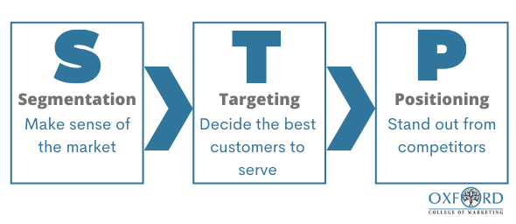
Figure 5: STP analysis (Wang, 2014).
Targeted Audience
British Telecom targets a mass audience, as the percentage of people using mobile phones and the internet is immense. However, the BT group focuses on major corporate houses, businesses, and individuals who use communication solutions and services (BT, 2021). Further people from the 18-44 years age group are more tilted toward internet usage. As it provides broadband, mobile, home phone and, digital television services the main targets of the firm are people who live in the city area for broadband and digital television services. It also targets remote area people and offers mobile and home phone service.
Positioning
BT Group is the oldest and leading telecommunication company in the UK. They have positioned themselves as the most reliable service provider with innovative products and services. BT Global Services is the major telecom service provider to corporate and governments whereas, BT Retail segment is the top supplier of broadband, subscription television, and telephony in the UK with more than 18 million customers. It serves the whole area of the UK and so it has infrastructures all over the country. Moreover, as it is a multinational organisation, it has business operations over the world, especially in European countries.

Marketing Mix

Figure 6: 4P’s of the marketing mix (Londhe, 2014.)
Product: BT has a diversified portfolio including consumer goods and services blended with old and new technologies. They have mobile phones, landline telephones, fiber optics networks, digital television, and IT services. They have also stepped into business consultancy and solutions to capture different markets.
Price: BT Group offers various pricing plans to meet different needs. They offer access to basic high-speed products without additional services till 1 MB with many services such as email facility and internet security. To compete in a highly competitive market BT follows competitive-based pricing as they alter their prices according to the competitors. They also offer bundle pricing with various plans based on customers' utility rates.
Place: the area in which BT is operating is a very crucial factor to consider as it aims to cover rural and remote areas too. Even BT has worked effortlessly to avoid distribution channel conflicts. Thus, they have used different channels for different offerings.
Promotion: BT is the oldest firm in the telecommunication industry which has given them a clear understanding of promotions of its offerings. BT uses similar promotional tactics as its competitors Virgin Media. The promotional campaigns focus mainly on marketing media, gaming, and technology media. In recent years BT shifted its marketing strategy from celebrities and hyperbole to building trust by taking an emotional approach to become more relevant to the customers after its targeting scandal.

Selection of Media
BT advertises heavily on televisions, radio, billboards, and the internet. They also use their websites to promote themselves. Sponsorship is their major way of advertisement thus they have sponsored numerous concerts at Hyde Park, Rugby games, and Olympics 2012. However, today the most important method is social media platforms where they connect with their customers to get their feedback and arrange competitions. Even to communicate with customers they use emails, posts, door-to-door sales, and leaflets. BT uses both ATL and BTL channels to reach different segments which is a successful strategy.

Measuring success
BT opened an online forum where they connected with people to get feedback and resolve their issues. This also helped them to address all the complaints they were getting. This was measured by the decreasing number of complaints they received later after the initiative. Their marketing strategies are effective on the current issues they face but they would need better effective strategies in the long run. For instance, if their market share is studied for a period of time then it would be clear that it is fluctuating.
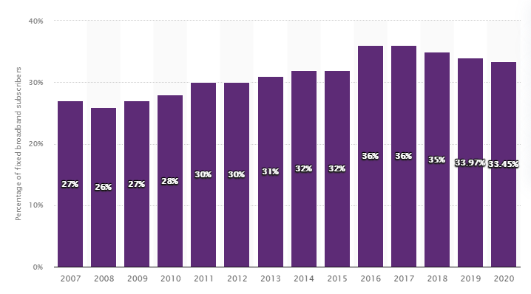
Figure 7: BT’s Market Share (Statista, 2021)
BT changed their campaign with real-life heroes and people from next door who were sharing their life experiences to gain the trust back. The campaign was more effective now as customers felt that the company cares for them. Along with this, they invested to give a satisfying experience to their customers.

Contribution of Marketing
The company is doing fairly well, and obviously, the marketing strategies have an impact on it. The company possesses around 34% of the total market, but the company is lacking behind despite offering high quality and high speed. The company is one of the key service providers in the government offices and corporate offices which adds great value to its brand. However, the company is unable to leverage its resources to the fullest to be a dominant player. The fluctuation in its market share clearly shows that customers are switching which means their marketing management has some flaws. Rather than attracting new clients, they are unable to retain their existing customers. The company’s revenues are also declining like in 2016 the quarterly revenue was 6.13 billion pounds in the third quarter wherein the fourth quarter in 2020 the revenue was recorded 5.29 billion pounds. Overall, the company is facing a hard time and BT needs to focus genuinely on its marketing strategies.

Challenges faced by British Telecommunication
The key challenges that are faced by the company are briefly pointed out below:
- As there are dozens of large and small operators that give a vast variety of discount offers it is very challenging to retain existing customers.
- It needs to offer competitive prices to the customer to hold the current market share and to increase the figure.
- Brexit has affected the company's growth in EU countries badly and has restricted them to enjoy free trade. Even political instability in EU countries and changing legislations has become a concern.
- The rapid change in technology increases demand for new investment. The organisation has to modify strategies and operational processes.
- It needs to develop innovative products and services based on the technological changes to sustain itself in the market.

Task 2: Conclusion
British telecommunication is doing business for more than 146 years in the UK. Today, BT is one of the key players in the telecommunication industry but it fails to gain the market share that it should possess. Despite offering a high-speed network, the company lacks in providing differentiated plans for different segments of the market. This is clearly evident through its market share percentage. BT has a strong infrastructure but they need to penetrate the wider market. They have overlooked niche segments that are captured by their rivals. They need to focus more on the individuals along with the corporate houses. They have missed the households, but during the pandemic when everyone went online and people required broadband at home for work and study, BT was unable to penetrate the opportunity. BT has undertaken different marketing strategies in different situations intending to provide high-quality services.
BT has a wide range of products therefore it requires to stop the obsolete technologies and embrace the new ones. It has been seen that BT has been slow to adopt changes. In the era of globalisation, customers are more aware of new technologies which increase their expectations from one of the oldest firms. BT has launched swift broadband and tablet strategy to cope up with the rapidly changing technology however it might incur a loss of revenues if not embraced by customers in their daily lives. The marketing strategies have been very successful for BT, but they need to leverage more on their promotional activities with new and modern ads to attract more clients. BT focuses on a few of its offerings in ad campaigns and forgetting its core. Therefore, balanced strategies are required to mitigate the imbalance of product promotions. A client has the right to be aware of new plans as soon as they come into the market.
Furthermore, BT is a multinational company that forces BT to make different advertisements based on the local needs. It is required for the clients to feel a personal touch with the brand. BT has few loopholes in its marketing strategies otherwise their every marketing campaign has been successful. They need to analyse their environment and strength and weaknesses to build more strong strategies for their success in the future. However, the contribution of marketing in the performance of BT Group was significant as the workforce was included in the campaign giving them responsibility.
The workforce from UK and Ireland was also in charge of interacting with clients directly to resolve their issues. The above analysis identifies that in the strong external environment BT is yet to gather the entire market. Their long-term vision needs to be restructured to innovate new offerings and reach out to the entire nation. They have only captured 34% of the market whereas, they have the potential to penetrate the market fully. Their marketing strategies have been unable to reach its customers, therefore aggressive marketing is needed. BT has unable to penetrate the urban market fully whereas they are yet to step into the remote and rural areas. Their internet and mobile service plans are yet not too diversified to accumulate all the customers' needs. Customers' expectations are rising where BT is too slow to adopt changes and innovate new technologies. Embracing a few technologies would help BT to serve wider customers on the go.

Task 3: Recommendations
British Telecommunication is a key player in the UK market but yet the company is far behind. They only possess 34% of the total market whereas, around 92% of the total population in the UK is using the internet today. Therefore, BT needs to rework on their marketing plan to attract more customers. Thus, there are few recommendations based on the above analysis.
BT is highly concerned about its customers and shareholders to maintain its market share. Their marketing strategies enabled them to achieve success and improvements. The strategies gave them competitive advantage by building a new image and improving its expansions internationally. However, today BT needs more modern strategies to meet the lacking and shortage. BT has identified the lacking of promotion of its offerings especially regarding occasional payphones which have dissatisfied its customers most. BT should focus more on its after-sales services for its future.
According to the market analysis, restructure of pricing is needed such as Flat pricing and Tiered pricing. Flat Pricing allows customers to enjoy more services at the price they are willing to pay as many clients desired to pay high for better services. Fixed prices restrict them to enjoy vast services. Contrary, in tiered pricing customers, experiences service as per its requirements and willingness to pay. It joins IT network and telecommunication costs and customers' value. BT should connect with its customers anywhere at a reasonable price by owning a hotspot technology to connect devices and gadgets with high-speed internet (Sarkar, 2012).
In the era of technological advancement, BT needs to innovate to remain relevant in such a competitive market. They have to develop new products with a blend of old and new technologies so that they can maintain their market share as the company has penetrated the targeted market completely with existing products. This would also help them to expand and exploit the international market (Sarkar, 2012). The addition of new products would allow them to meet the new needs of their customers and also promote their previous offerings. However, in the IT sector products become obsolete rapidly with the emergence of new technology leading to new products.
The company uses various channels to reach their customers, however, to get into the daily lives of the customers BT has to aware customers with back-to-back campaigns, sponsoring various events, and most importantly active presence on social media platforms. BT needs to develop its advertisement and become more aggressive (Sarkar, 2012). An informative but yet different plan for different occasions advertisement is important. Today the world is fighting against the deadly virus of COVID19 which has changed the way of living. Since the pandemic hit and the world went under strict lockdown everything was closed. One thing that brought people together is the internet.
Businesses and educations were conducted virtually, and people were significantly available on social media. Hence, aggressive digital media is required to reach a greater customer base. As people are more dependent on the internet, everyone needs internet thus BT can make special plans during this pandemic for its customers so that a larger number of people gets on board with BT. Moreover, providing high-quality services is important as the telecommunication industry runs on word of mouth. People are keen to choose tried and tested service providers. Thus, satisfied and loyal customers can refer BT services to other people. They can offer referral discounts to motivate the customers (Sarkar, 2012). The demand for IT solutions and network services has increased during the pandemic. This transformation from a traditional way of conducting works to modern technology has given BT Group vast opportunities for growth and has also attracted competition from other service providers. Moreover, BT can offer special café plans for these people. They can also provide high-speed Wi-Fi connections using WLANs at affordable prices attracting Apple users.
The business of BT fluctuated due to the rapid technological change and environmental changes. It needs to modify its products and services as per the change of environment (Summanen, and Pollitt, 2015). The competitors focus on the specific segments and snatched the market of BT. In this case, the company has to create new products and services as well as needs to give attractive offers to the customer to retain them for the long term.

Reference
Brassington, F. & Pettit, S., (2010) Principles of Marketing, Harlow: FT Prentice Hall.
British Telecom Inc. (2006). Embracing Open Innovation A new approach to creating sustainable value.
British Telecommunications, (2021). Home | BT Plc. [online] Bt.com. Available at: <https://www.bt.com/about> [Accessed 23 October 2021].
BT, (2021). Topic: British Telecommunications (BT). [online] Statista. Available at: <https://www.statista.com/topics/3413/british-telecommunications-bt/> [Accessed 25 October 2021].
Clowe, K., and Becke, D., (2013). Integrated Advertising, Promotion and Marketing Communications. 6th ed. Prentice Hall.
Dibb, S. (2012) Marketing concepts and strategies . 6th ed. Andover :, Cengage Learning.
Drummond, G. (2008) Strategic marketing: planning and control. 3rd ed. John. Ensor & Ruth. Ashford (eds.). Amsterdam; London:, Butterworth- Heinemann.
Ho, J.K.K., (2014). Formulation of a systemic PEST analysis for strategic analysis. European academic research, 2(5), pp.6478-6492.
Ho, R.C. (2020) Strategies and tools for managing connected consumers. Hershey, Pennsylvania:, IGI Global.
Hooley, G.J. (2020) Marketing strategy and competitive positioning. Seventh edition. Brigitte Nicoulaud, John M. Rudd, & Nick Lee (eds.). Harlow, England; New York:; Harlow, England; New York :, Pearson.
Khanlari, A. (2015) Strategic customer relationship management in the age of social media. Austin DeMarco, Kayla Wolfe, Caitlyn Martin, & Jason Mull (eds.). Hershey, Pennsylvania:, Business Science Reference.
Kotler, P. (2018) Principles of marketing [electronic resource]. 17th, global ed. Gary. Armstrong & Marc Oliver. Opresnik (eds.). Harlow:, Pearson.
Samanta, I. (2014) Strategic marketing in fragile economic conditions. Somanth Chaudhuri (ed.). Hershey, Pennsylvania:, Business Science Reference.
Sheehan, B. (2011) Marketing management [electronic resource]. Lausanne, Switzerland:, AVA Pub.
Sood, T. (2017) Strategic marketing management and tactics in the service industry. Hershey, Pennsylvania:, IGI Global.
Statista, (2021). Topic: Internet usage in the UK. [online] Statista. Available at: <https://www.statista.com/topics/3246/internet-usage-in-the-uk/#dossierKeyfigures> [Accessed 25 October 2021].
Statista, (2021). Unemployment rate forecast UK 2021 | Statista. [online] Statista. Available at: <https://www.statista.com/statistics/374800/unemployment-rate-forecast/> [Accessed 25 October 2021].
Wang, C. (2014) Brand management in emerging markets:theories and practice. Jiaxun He & Madhupa Bakshi (eds.). Hershey, Pennsylvania :, Business Science Reference
Summanen, T. and Pollitt, M., 2015. British Telecom: Searching for a winning strategy. University of Cambridge, Judge Business School.

