With reference to the historical development of two museums of your choice, explore how public museums became emblems of politically virtuous nation states.

Public museums are social institutions. They are not politically neutral and they are not always conveyors of social truths. The long standing and well admired institution founded from elitist and bourgeois individuals have created what we see today as the authority on the presentation of our history. This is not always something to be trusted. As Napoleon so notably said, “What is history, but a fable agreed upon?”
And in this case, so are the museums.
In this essay I will explore the political standing of some of Europe’s oldest and most famous institutions, how they came to be and the issues that they face today in this decade’s political climate. Focusing research efforts on three historic museums in particular, considering the notion of museums forming from chaotic political situations such as Museé Du Louvre or the State Hermitage Museum (Including the Kunstkamera Museum of Anthropology and Ethnography) and contrasting it with the Ashmolean Museum and the British Museum, built specifically to house pre-existing collections. By discussing museum origins, the ideas of ‘politically virtuous nation states’ will emerge from the artefacts themselves and the dubious sources of these collections. All museums are political, and to understand what it is that makes them such is to deconstruct the question and define ‘politically virtuous’ in this context. Political virtue in the enlightenment age is questionable; it leads to notions of being advanced in science, medicine and understanding of the world, moving towards secularism and empire.
Taking the meaning of ‘virtuous’ it opposes the idea of colonialism and empire, as a virtuous state or nation theoretically would not partake in such atrocities. Can one attribute virtue to the Museé du Louvre for its heroic efforts in restoring the artefacts taken by Napoleon in Egypt? By these standards our beloved British Museum has little to no virtue as the Benin Bronzes and the Elgin Marbles still reside in its cathedral sized halls whilst the public stare intimately at things that do not belong. By exploring the political situations that define these museums and the chaos they arose from, it provides the standpoint for discussion of revolution and repatriation, speaking of war crimes and looted goods. Determining the meaning of ‘politically virtuous nation state’ means that my research and exploration of the topic can have a starting point of politics and war, where by most museums come to acquire their main collections.
Historically, the world looks to the UK for the longest standing and still functioning public museums, and with the Enlightenment era sweeping Europe the emergence of science and collecting became more prevalent amongst the upper classes. When we explore the effect the period had on collectors, we see the emergence of the cabinets of curiosities, and the first public museum in Britain, the Ashmolean. Founded on John Tredescant’s collection from his travels in Europe comprised of mainly botanic specimens, with other objects he deemed to be ‘curious.’ Passing this down to Elias Ashmole, the museum was first of its kind. Although founded originally for the use of the university, it became open to the public towards the end of the 17th century. The museum became an emblem for universities in this country, displaying their vast wealth and academic achievements through the institution and so becoming a symbol of the educated elite. However due in part to this, the museum was never particularly taken seriously on the world stage, as Giebelhausen says “[the Ashmolean] lacked the character of a princely institution and all of its political implications.” Museums since their very foundations have been politically active, because of their founders, their contributors and their social grandeur. Giebelhausen makes this statement when comparing the Ashmolean with the Kunstkamera in St Petersburg, claiming that it is the patronage of the royal and wealthy that makes the difference in European museums. Her ideas are interesting, as it highlights that the social, political and cultural power lied at that time with the monarchies of various countries. This is true of earlier museums, Kunstkamera and the State Hermitage Museum being products of this ‘princely’ nature, having royalty build and determine the collections.
One of the most notable royalist based museums is the Museé du Louvre, as the revolutionaries so famously stormed the building, opening the treasures to the public and displaying how the other half lived. This reclamation of history by the people has played an important role in the museum’s social status, as almost immediately after it was liberated, it was opened. People were encouraged through its doors to view the royal splendour that had been hidden from them for decades. Poverty worsened, and then arts and culture took precedent, paintings were observed and reproduced in the winding hallways of the once lavish royal residence and finally accessible to everybody no matter the social class. The splendour of the princely galleries was furthered when Napoleon became Emperor of France and spent years expanding the collection and the buildings, with his efforts the French Empire grew in leaps and bounds, and so did the collections. The Louvre became a public display of the spoils of war, having artefacts from classical Greece through ancient Egypt, but still bringing the same feeling of being in touch with history that is still sought after today.
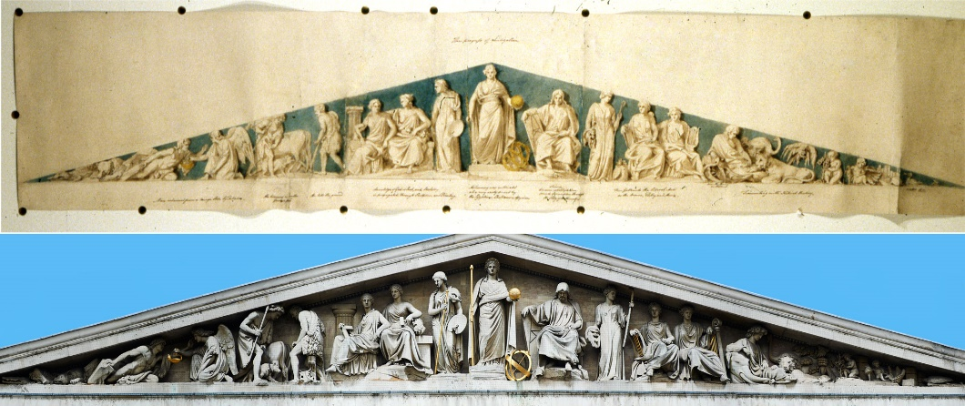
In having this public royal collection, the foundation of the institution is bourgeois based. Museums that are formed and in the public eye are formed from the spoils of colonialism, placing emphasis on the ‘alien’ and ‘eccentric’ ways of foreign cultures. As the Kunstkamera was originally, and still today is, a museum of Anthropology and Ethnography, we see these values passed through to the collections and thus the people. Furthering the work of Peter the Great of Russia, his wife Catherine began what is today one of the largest museums in the world, The State Hermitage Museum. It was then that the re-emergence of classicism came into force within Europe, especially affecting architectural styles and building choices. This is most evident in the construction of the current British Museum galleries, the world-famous colonnade and the vivid white pediment depicting the ‘Progress of Civilisation’ built in 1852 which is a very testament to enlightenment thought (see figure one, above). The pediment includes figures to represent collections, from science, art, music and sculpture.
Figure 1: British Museum South Front Pediment

As Catherine the Great, Empress of Russia, began collecting various classical sculptures, paintings, and writings the artefacts grew into what we know today as the Hermitage Museum. Occupying the Winter Palace today, this grand palace of history harbours itself a chaotic past. The Hermitage museum is now a collection seven buildings, with most of them flanking the palace’s green grandeur, but the private royal collection was broken apart and distributed amongst the royal palaces after the 1917 October revolution. Revolution plays a key part in the progress and ‘virtue’ of this museum, giving the people a sense of reclamation of their histories and their involvement in curating. By opening these things to the public immediately after they opened the doors, there was what could have been described as an ownership change, the museum and its contents were then there for the enjoyment of those who would not in normal political circumstances, have had the chance to indulge in such culture.
Addressing previous ideas of neoclassicism, it brings the discussion to the British Museum. Beginning with the current museum’s instantly recognisable colonnade, it can be distinguished across the world as an authoritative institution of history and culture. The very neoclassical architecture echoes the foundations and values of such a museum; overpoweringly large, built from stone as white as the founders, and with a dominating glass ceiling that displays the museum’s fragility. The gleaming white building that represents hundreds of years of white, all male museum directors putting forwards their staunch ideas of what the museum should look like, shaping it to create the product we have today. Understandably, the museum has done plenty for the furthering of science and understanding; and has contributed to creation of other museums such as the Natural History Museum and the expansion of the British Library. The museum itself has been planted in the centre of British elite society since 1753, a time when exploration and expedition was a common outing amongst the wealthy.
Notions of collecting and the Grand Tour of Europe fed into Sir Hans Sloane’s collection. Slone saw himself becoming a commodifier of the unusual, and presenting the museum within the confides of Montagu House, since demolished to make way for the towering building we see today. The collection grew, it was opened to the public in 1759 and became a hit only amongst the upper classes, despite it being free, visitors still had to apply for entry and groups were limited. It was very much divided by class, as those lower and working class individuals were shamed and looked down upon, and most likely refused entry should they try. Sloane’s collection and the British Museum was very much a product of its time, as many of the objects were taken from slave driven plantations in the West Indies. During this era, these practices were very much normal everyday life, and they were not questioned. However, in contrast to today’s British Museum, these notions of a foundation of slavery are very much ignored or played down, as if the wealth of the vast historic collection was not something worth addressing. These approaches to curation, create an ‘idealised past.’ This notion of idealised history is dangerous, dangerous to minority groups and dangerous to society itself. Museums themselves are seen as institutions that are to echo social histories and material history, and when these histories are embellished or ignored, it can lead to a generation of people thinking in a certain way. Material culture was not necessarily produced to aid political agendas, although the way it is presented can change a person’s entire perspective on a culture or ethnic group. Thus putting smaller, marginalised and ethnic groups into cultural identities into categories seen as unimportant or inconsequential. Despite being the height of architectural and cultural importance at the time, the museum is very much a product of its time, the halls are kept to their 19th century standards, and the permanent exhibitions rarely change. Though museums seek to become politically neutral, it is rarely achieved. Britain’s imperialist past is inextricably intertwined with every aspect of this museum. Discussions around these ideas can be summarised by Alice Procter, a researcher who bases her work on addressing colonialist pasts:
“There is no such thing as neutrality or objectivity. Every label in a gallery was written by a person. Every object was placed, every room was designed. Those people are reflecting their backgrounds in the choices they make, consciously or not.”
The quote highlights the fact the organisation and formation of such collections have been and always will be with the bias, virtue and politics engrained in the director’s very persona. This, it would seem, has resulted in historic museums such as the British Museum and the Louvre becoming politically stagnant. In the current world, these institutions cannot afford to be locked in time and in values, or they will become irrelevant. Whilst trying to keep their historic splendour at the heart of their focus, attempts to create a more ‘modern’ approach to museum culture come in the form of travelling exhibitions or temporary exhibitions. Temporary exhibitions within museum spaces allow for discussion surrounding current affairs to be explored through artefacts, an example of this is the Desire, Love & Identity exhibition that ran at the British Museum from 11th of May to the 15th of October 2017. This exhibition was in reaction to the 50 years since the Sexual Offences Act was passed and homosexuality was partially decriminalised. Although the effort to address this through the museum’s collection, it was the museum’s smallest display room with dimly lit cabinets hidden away from view with no more than 20 ‘LGBTQ+ related’ objects. The choices made with the placement, the decisions of artefacts and the lighting choices affect one’s perception of the exhibition as a whole, creating an atmosphere of shame, darkness and hiding. This exhibition was accompanied by a guided tour of LGBTQ+ related objects that were already on display around the museum, meaning the visitor would have to seek out themselves the artefacts in the collection. Executed poorly for the members of that community but also giving the impression that minorities with historic material culture can be disregarded so easily. Representation and the presentation of temporary exhibitions can give the museum a chance at engaging with current affairs, but even so the majority of them are focused on the ancient and historic rather than the recent, relevant and engaging. Travelling exhibitions create a sense of sharing and collaboration between the museums, the artefacts and the visiting public, whilst also taking the stress off of the museum to create its own exhibit, it can use others.
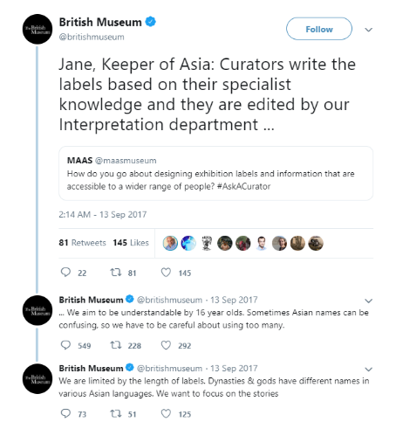
In today’s political climate, and the emergence of repatriation claims and restitution agreements are becoming ever more fervent, with older long standing objects such as the aforementioned Elgin Marbles, but also with more recent claims with Hoa Hakananai’a and the Rapa Nui authorities. Other claims have been at the centre of the museum’s media presence, as the fragility of the curators shines through in the fact that they cannot give solid evidential reasons as to why the repatriation cannot happen. Although it is the collection that makes a museum, the actions and display of those artefacts are what form the virtue of the institution itself. Although these are the most well-known and prevalent cases of issues and debates surrounding the institution, it does not stop with just artefacts. In 2017, the museum was subject to further interrogation as a rather troubling and racially insensitive tweet was sent out from the museum’s official account. The thread of tweets read as follows:
Original Question: How do you go about designing exhibition labels and information that is accessible to a wider range of people? #AskACurator
The British Museum, particularly Jane Portal, Keeper of Asia (a much disputed title) replied:
“Curators write the labels based on their specialist knowledge and are edited by our interpretation department, we aim to be understandable by 16 year olds. Sometimes Asian names can be confusing so we have to be careful about using too many […]”

Shazia Awan in her article makes points that allude to ideas that Celtic names, Greek names or Roman names are kept on labels and even thrust upon visitors as they have been in history classes for centuries, and so why should Asian names be taken any less seriously? “Perhaps it wouldn’t be so confusing if the staff were more diverse.”
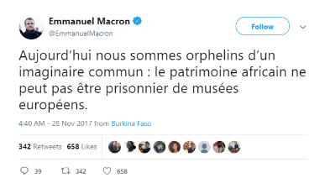
Whilst these dramas and problems are at the centre of the British Museum’s publicity issues, across the water in France, the recently elected Emmanuel Macron has vowed to be a soldier in the war against postmodern colonialism through artefacts, especially that of French Africa. During his tour of Burkina Faso and Ghana he pledged in a speech to return the cultural heritage of their stolen artefacts to their rightful countries. Claiming to make these things happen before 2021 was bold, but not unattainable. He furthered his stance on the issue after backlash from the French Government due to costs, by saying “le patrimoine africain ne peut pas être prisonnier de musées européens” or in English, “African heritage must not be a prisoner of European museums.”
Is the repatriation of artefacts what defines the virtue of the museum? It could be argued yes, as it is a valid and public attempt to come to terms with their historic collections. These standards see museums such as the Louvre as proactive and engaged with the disputable past, and addressing the concerns of the nations to which these objects belong. On the other hand, it also could be argued no, as the collection itself has an historical agency to it, becoming itself an artefact. If all museums were to return their treasures, their galleries would be almost empty. If they are to refuse to return the artefacts they are defending a politically turbulent past. Politically virtuous museums cannot exist, in a perfect world, perhaps they could. But this work is imperfect, and museums must deal with the implications of their pasts, and seek to bring justice to objects. It should not be a case of Rapa Nui natives sobbing over an artefact that is rightfully theirs. Or the Greeks being unable to access one of the most impressive part of their classical histories. Museums can be emblems of nations, but mainly due to their historic importance, not their current importance. The Louvre’s glass pyramid is one of the most recognisable sites in Europe, and Napoleon’s treasures are viewed by millions across the globe, but they still harbour stolen Egyptian goods with glee. However, who is to say where the line of repatriation is? Should we be returning the royal collection to the final decedents of the last French monarchy? Or should every non British object in the British Museum be handed back to the relevant countries? Although repatriation is important it is only the largest and most unique artefacts that are sought after, if the smaller items are more disposable or widely available so be it, but the rules surrounding such efforts need to be laid out clearly, and in a multi-country agreed piece of legislation. Alas, that is much discussion for the future.
In conclusion, historical museums are political emblems of successful colonialist countries. Their collections that are marvelled at by thousands of visitors per year are sourced by dubious means and their sources are not addressed. Historical museums cannot have virtue, for their very roots are born from slave-earnt money and the spoils of various wars across Europe. The repatriation efforts of the French Prime Minister have been valiant, and head in a direction other historic long standing institutions should follow, but I fear it will be many years to come before the stubbornness of museum officials especially in this country follow suit and return objects of much controversy. Arguments of income, stability and visitor enjoyment just are not enough to maintain the views put forwards. ‘Politically virtuous’ nation states have a duty to their people and their historic legacy to address and deal with these contested histories that have been swept aside for so long, every institution should be a colonialism apologist in order to truly become morally secure in their collections.

Bibliography and Notes
Awan, S. The British Museum gleams with stolen riches from its colonial past – but Asian names are too 'confusing' for inclusion, (2017) <https://www.independent.co.uk/voices/british-museum-tweet-twitter-row-asian-names-confusing-curator-colonialism-a7946431.html> Accessed: 21-12-18
Bresc-Bautier, Geneviève, ‘The Louvre: A National Museum in a Royal Palace’, Museum International, 55 (2003), 61–67 <https://doi.org/10.1111/1468-0033.00414> Accessed: 12-12-18
British Museum Blog, Pediment.jpg, (2017) <blog.britishmuseum.org/wp-content/uploads/2016/09/pediment.jpg> [Designs by Sir Richard Westmacott above the photograph] Accessed 21-12-18 [Figure One]
British Museum, Desire, Love, Identity, (2017) <https://www.britishmuseum.org/about_us/past_exhibitions/2017/desire,_love,_identity.aspx> Accessed: 20-12-18
Gibelhausen, M. The Architecture of the Museum; Symbolic Structures, Urban Contexts, (2003) Manchester University Press, page 11-18.
Macron, E. Twitter, (2017): https://twitter.com/EmmanuelMacron/status/935488489663156226
Miller, E. That Noble Cabinet: A History of the British Museum, (1973) London, p116
Omar R, Ndhlovu B, Gibson L, Vawda S, Museums and the idea of Historical Progress, ICOM, (2012)< http://network.icom.museum/fileadmin/user_upload/minisites/comcol/pdf/Museums_and_the_Idea_of_Historical_Progress_ICMAH_COMCOL.pdf> Accessed: 19-12-18
Portal, J. Twitter, (2017) https://twitter.com/britishmuseum/status/907895235526701056 Accessed: 21-12-18
Procter, A, Museums are hiding their imperial pasts – which is why my tours are needed | The Guardian, (2018) <www.theguardian.com/commentisfree/2018/apr/23/museums-imperialist-pasts-uncomfortable-art-tours-slavery-colonialism> Accessed 19-12-18
Quinn, A. After a Promise to Return African Artefacts, France Moves Toward a Plan - The New York Times, (2018)< www.nytimes.com/2018/03/06/arts/design/france-restitution-african-artifacts.html> Accessed: 21-12-18
Unknown, History of the Ashmolean │Ashmolean Museum, Accessed: 19-12-2018 www.ashmolean.org/history-ashmolean

Unknown, History of the Ashmolean │Ashmolean Museum, [online] Accessed: 19-12-2018 www.ashmolean.org/history-ashmolean
Gibelhausen, M. The Architecture of the Museum; Symbolic Structures, Urban Contexts, (2003) Manchester University Press, page 18.
Bresc-Bautier, Geneviève, ‘The Louvre: A National Museum in a Royal Palace’, Museum International, 55 (2003), 61–67 <https://doi.org/10.1111/1468-0033.00414> Accessed: 12-12-18
British Museum Blog, Pediment.jpg, (2017) <blog.britishmuseum.org/wp-content/uploads/2016/09/pediment.jpg> [Designs by Sir Richard Westmacott] Accessed: 20-12-18
Miller, E. That Noble Cabinet: A History of the British Museum, (1973) London, p116
Gibelhausen, pp1
Procter, A, Museums are hiding their imperial pasts – which is why my tours are needed | The Guardian, (2018) <www.theguardian.com/commentisfree/2018/apr/23/museums-imperialist-pasts-uncomfortable-art-tours-slavery-colonialism> Accessed 19-12-18
Omar R, Ndhlovu B, Gibson L, Vawda S, Museums and the idea of Historical Progress, ICOM, (2012)< http://network.icom.museum/fileadmin/user_upload/minisites/comcol/pdf/Museums_and_the_Idea_of_Historical_Progress_ICMAH_COMCOL.pdf> Accessed: 19-12-18
British Museum, Desire, Love, Identity, (2017) <https://www.britishmuseum.org/about_us/past_exhibitions/2017/desire,_love,_identity.aspx> Accessed: 20-12-18
Awan, S. The British Museum gleams with stolen riches from its colonial past – but Asian names are too 'confusing' for inclusion, (2017) <https://www.independent.co.uk/voices/british-museum-tweet-twitter-row-asian-names-confusing-curator-colonialism-a7946431.html> Accessed: 21-12-18
Portal, J. Twitter, (2017) <https://twitter.com/britishmuseum/status/907895235526701056>
Ibid
Quinn, A. After a Promise to Return African Artefacts, France Moves Toward a Plan - The New York Times, (2018)< www.nytimes.com/2018/03/06/arts/design/france-restitution-african-artifacts.html> Accessed 21-12-18
Macron, E. Twitter, (2017): <https://twitter.com/EmmanuelMacron/status/935488489663156226>

