

Children, Young People and Families
(BMHP5004_LON)

Assessment Component 1

Case study - Written Report

Student name: Ronke Olomola

Student number: 1916047

Group:

Lecturer name: Bianca Sanfilippo

Submission Date:

Word count:

Learner declaration

This assignment is my own original work. No part of this work has been copied from any other source or person except where due acknowledgement is made, and no part of the work has been previously submitted for assessment at this or any other institution.
I have read the Student Academic Integrity Policy and understand its implications.

Student signature: R Olomola Date:

Children are always needing, care, love and protection, this is often where the parents are able to give them these unconditionally, in order to give children a good start in life. However sometimes the protectors, which are the parents become the predators. This case study will be identifying a family facing adversity. The specific issues in this case study will be discussed and explored, the issues include alcohol mis use, drug abuse, child neglect, child kidnapping and the involvement of the criminal justice system. An analysis of the efficacy of the professional involvement of the health and social care agencies playing an active role, as well as the current policy and decision- making processes will be identified and discussed. Current policies and the case management initiatives used by multi-disciplinary services to meet the various needs and vulnerabilities of the child and family involved in this case study will be identified. Finally, recommendations for improvement required in this case study will be discussed.

The case of Shannon Matthews happened in 2008, in West Yorkshire, England. Shannon came from a single parent family and lived with her mother called Karen, Shannon rarely got a home cooked meal and lived mostly on chocolates and biscuits. It was stated that Shannon requested to go and live with her father. Shannon was known the social services and was on the high-risk register. Karen reported to the police that her daughter was missing, It was after twenty four days that Shannon was found drugged and afraid, in Paul Drake house who is the Karen’s boyfriend’s uncle. Both Paul and Karen were found guilty of kidnapping and false imprisonment and given eight years in prison. (Moss, 2018).

What is a vulnerable Child?
A vulnerable child could be defined as a child that is in danger, which could be due to different unfavourable conditions that the child is been subjected to. Public Health England (2020) defines a vulnerable child as any children at greater risk of experiencing physical, or emotional harm, and or experiencing poor outcomes due to one or more factors, in their lives. Sharon could be identified as a vulnerable child because, she was not feed properly at home, all the child benefit Karen got for Sharon’s up- keep was not used to look after Sharon but was used for buying alcohol and unhealth foods for Sharon and the rest of the family. When considering Maslow Hierarchy of needs (2020), for an individual to get to the level of self- actualization needs which is the highest level, one of the levels is food the individual to be able to be able to cloth eat well and living conditions need to be comfortable. Hence in Sharon’s situation the living conditions were not conducive for a child, so it could be stated that she needed a comfortable and stable home life, which appears to be absent in this case. Below is a diagram of the Maslow hierarchy of needs.

The Maslow Hierarchy of Needs (2020)
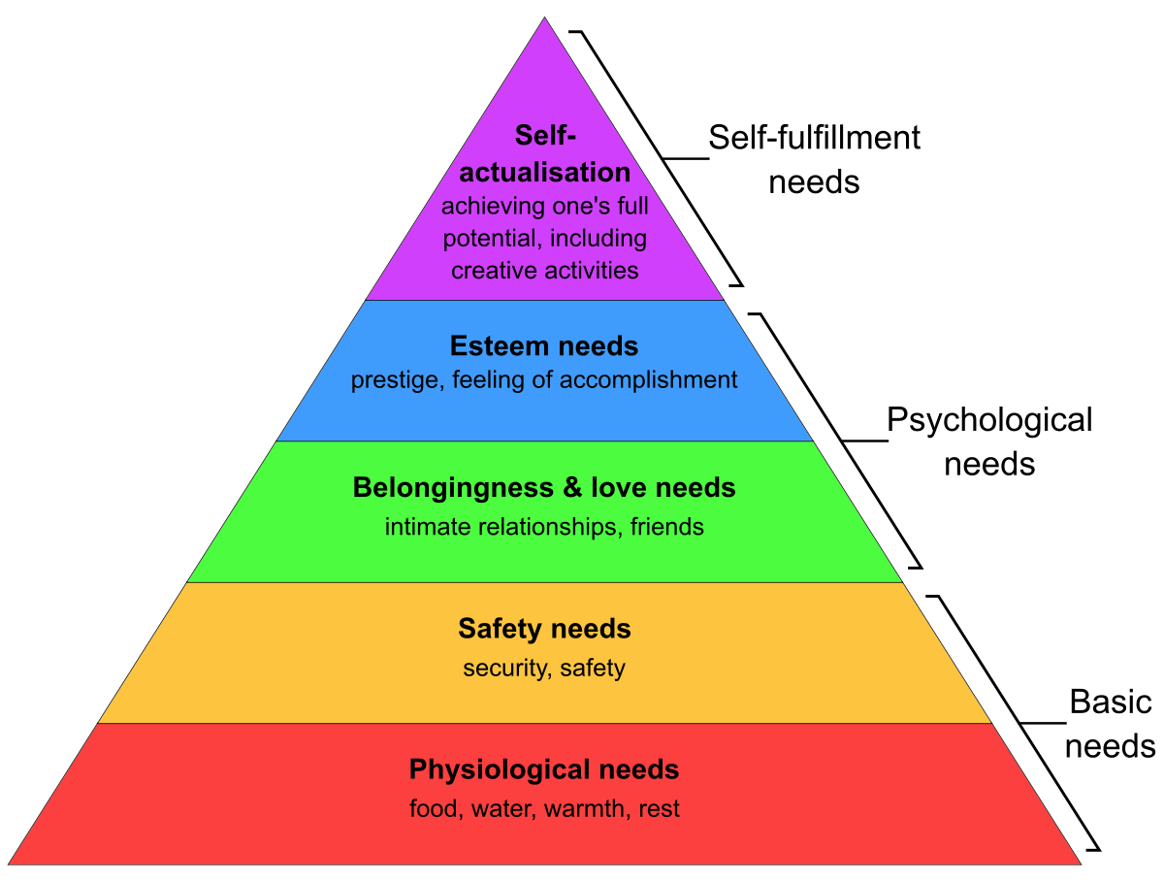

The Risk Factors That Made Shannon Vulnerable

Neglect
Neglect could be defined as when an individual such as a child is not given the supervision and care that is needed to make such a child comfortable and free from harm. NSPCC (2020) defines “child neglect is the going failure to meet a child’s basic needs and the most common form of child abuse”. Shannon was neglected hence the reason where the social services decided to put her on the “at risk register”. The case study did not state there was any other follow up as to Shannon’s welfare. Below is a chart from NSPCC showing the percentage of children that surfer from neglect is 59.0%

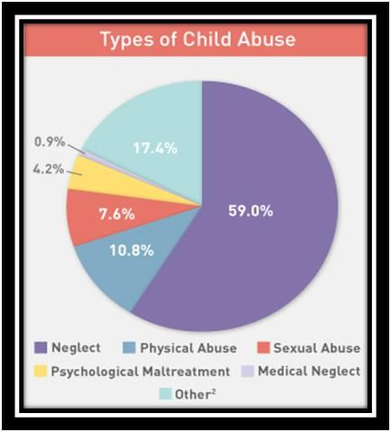

Alcohol Abuse
Shannon’s mother used the child benefit that should have been used for buying food and other essentials for the family to buy alcohol hence the statement that Shannon made that she hoped she would get a cooked meal. Children perform better when they live in a structured and healthy home. Panico et al (2019) explain that children tend to develop better when raised by married parents on average as there cognitive, emotional and development outcomes in childhood. Hence Shannon was at a disadvantage as Karen was not interested in look after her. House of Parliament (2017) explain that parental alcohol misuse can have very negative impacts on children’s everyday routine and affect their mental and physical wellbeing, hence Shannon was not happy with her mother drinking with her boyfriend and other friends that came to the house.

Child Kidnapping
Shannon was subjected to child kidnapping by her mother and her mother’s boyfriend’s uncle. This is the utmost betrayal on the part of Shannon as Karen was supposed to be her protector and make sure no harm came to her.

Analysis
The assessment, intervention of multi-agency and results

The Assessment Framework Triangle
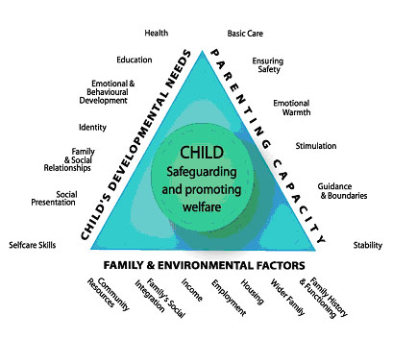I
Image :Working Together to Safeguard Children A guide to inter agency working to safeguard and promote the welfare of children (2018)

The Social services had a referral as regards Shannon’s poor school attendance. The social services then decide, whether an assessment needs to be carried out and in the case of Shannon, this was necessary. Shannon became the subject of assessment by the health and social care agencies when her attendance is school was very low.

For Shannon to be put on the “at risk register “, above is the assessment framework needs to be utilised to assess Shannon’s situation to see if she is at risk. The fact that Shannon was not going to school regularly, and was looking unkept, made the health care professional put her on the “at risk register”. Shannon could be described as a child facing adversity, hence the reason why she was put on the at-risk register. For Shannon to be seen as a child at risk there were three questions that she had to meet the criteria, firstly is Shannon in need? (Section 17 children act 1989) Secondly is their reasonable cause to suspect that Shannon is suffering or is like to suffer? Lastly is Shannon in need of accommodation (section 21A children act 1989).

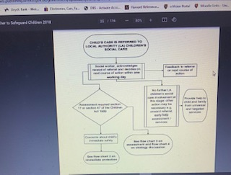

Image :Working Together to Safeguard Children A guide to inter agency working to safeguard and promote the welfare of children (2018) page 35

Above is a flow chart that the social services use to assess if a detailed assessment is needed. The local authorities must decide within 24 hours.

Discussion
The children’s Rights – Human Rights Joint Committee (2007) states that the UNCRC 1991 highlights that every child has a right to education, hence the reason why Shannon’s attendance in school was being monitored. The right to a standard of living adequate for the child’s physical, mental, spiritual moral and social developments, therefore Shannon needed to be protected, physically, mentally, spiritually and her social developments. The Equality Act (2010) states that every child has a right to equal access to health and care services and support. Hence Shannon deserved the best and should have been treated better than the way her mother. The Police force had to get involved as Shannon’s case as she was reported missing, they worked very quick and the date protection (2018), was taken into consideration and all the multiagency health and social workers were able to share information discretely. The local authorities which had the social workers worked effectively also Shannon’s school would have been contacted and they would have given information that they had.

Evaluation

Shannon was found quite quickly this was due to the support of the neighbours and the fact that the police force acted quickly. The fact that Shannon was found drowsy and possibly drugged was very worrying. Must of the time Social workers aim not to split families apart, however in the case of Shannon the mother was the predator and was the one who planned Shannon’s disappearance, such a rule of keep the family together would not be possible in this case study.

Ashiabi et al (2015) explain Bronfenbrenner’s Bioecological theory and state that there are there are four layers, first the microsystem which is the immediate environment in which a child lives, in the case of Shannon there were as her mother was not looking after her properly. Shannon rarely had cooked meals. The second lay is the mesosystem, which describes interrelationships between different microsystems in the case of Shannon this was absent as Shannon’s mother had no relationship with Shannon’s school, however this would have helped Shannon academically. The third lay is the ecosystem this involves the parents place of work, in the case of Shannon, her mother was unemployed so that lay was not an option for her. The fourth lay is the macrosystem this includes cultural values and describes the economic conditions of the family. In the case of Shannon, her mother was unemployed and had left home at the age of 16. She is not reported to have had any education or to have ever being employed. Shannon’s mother was on benefits which demonstrated that she was poor. Below is a diagram of the Bronfenbrenner’s bioecological theory

The Bronfenbrenner’s bioecological theory
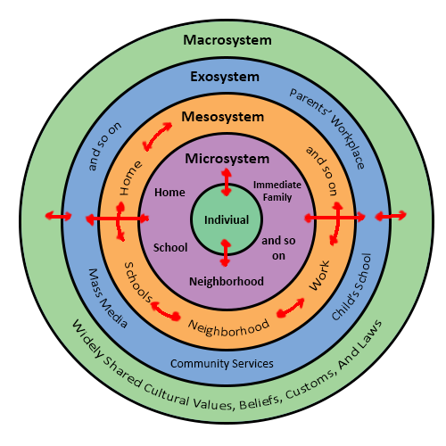
Image from wordpress.com

Recommendations
Shannon could have left her mother’s care if her voice was heard. It was stated that she had told her mother that she would prefer to live with her father. Shannon’s mother did not want to let her go since she was collecting her child benefit. The local authority could have got involved with the family earlier and probably paying the family a visit and see how the family lived. It was stated that Shannon’s mother left her door open to visitor and was not conducive to raising children.

Conclusion

Reference
Abbas, J., (2020) Service quality in higher education institutions: qualitative evidence from the students’ perspectives using Maslow hierarchy of needs

Ashiabi, S, G., O’Neal, K, K., (2015), ‘Child social development in context, an examination of some propositions in bronfenbrenner’s bioecological theory

Children Act (1989)

Children’s Right Human Rights Joint Committee (2007) www.parliment.uk

Data Protection (2018)

Equality Act (2010)

House of Parliament (2018) Parliament Office of Science and Technology Parental Alcohol Misuse and Children Number 570 Feb 2018

Moss, A., (2018), Shannon Matthews: “the unravelling of the truth” BBC News

NSPCC (2021) Every childhood is worth fighting for

Panico, L., Bartley, M., Kely, J, Y., Mcmunn, A., Sacker, A., (2019), ‘trajectories and early child health in the UK: Pathways to health’

Public Health England (2020) “No child left behind” understanding and quantifying vulnerability www.gov.uk/phe

Working Together to Safeguard Children A guide to inter agency working to safeguard and promote the welfare of children (2018)

