Running Head: [Reflection]

Academic and Employability skills
Module code: LCHS4001
Module leader: Anita Nan
Student ID:2133758
Student name: Alda Costa

Table of Contents
Introduction 1
Description 2
Feelings 3
Evaluation 4
Analysis 5
Action Plan 7
Conclusion 8
Referencing 8

Introduction
A Gibbs reflex cycle is a helpful approach to self-awareness and management that may be utilised in order to achieve a higher knowledge of one's encounters and the rewards that can be attained as a result of those experiences. After years of research, Graham Gibbs finally writes a book that explains the core principle of the Gibbs cycle in great detail. This idea, which is investigated in depth by well-known psychologists as well as historians, is given in a manner that is both rational and straightforward, which may be advantageous to human beings. Graham Gibbs has high expectations that the issue can be resolved if it is first broken down into more manageable parts (Sekarwinahyu et al. 2019).
In order to
In this assignment you will find an explanation of why it is vital to approach to reflect the understand of this module in a reflection form. Three topics will be covered in this and will reflect how useful they were and what has been learned from this that could consider later from future aspects. The three topics that will be discussed are T1(Academic Writing), T2(Time Management Skills) and T3(Referencing).

Gibbs Reflection
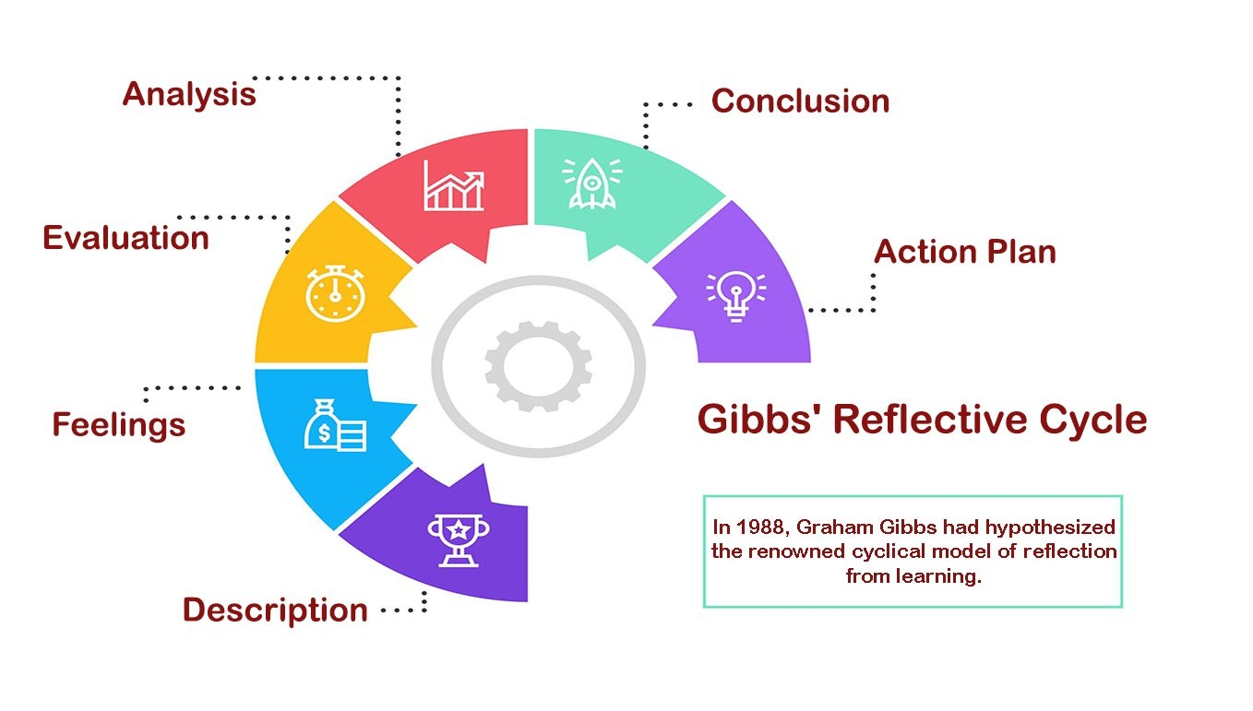
Figure 1 - Gibbs Reflective Cycle

Description
Topics | Description
T1  Academic Writing | Writing is an essential component in the process of creating new information in the current era. During my time spent in school, I came to the realisation that writing is unlike any other form of expression, and this epiphany is among the most life-changing insights I've ever gained. As a direct consequence of this, there is a significant deal of diversity in the ways in which it is written, represented, and referred to. Writing has proven to be difficult for me simply due to the fact that I'm not a very great writer. In order to persuade the reader, a modern writer needs to choose his or his words very carefully and provide convincing evidence.
T2  Time Management Skills | Time management is an aspect of management that involves organising and making plans how to allocate time between various tasks. Even when time is short and pressure is high, the key lies in effective time management, which allows you to work faster and better, not harder, to get more accomplished in less time. At both my current job and my current school, I get a habit of putting off doing the work until the last minute. Let's pretend I have such a task on this topic but I decide to make a fool of myself by saying I forgot about it and instead spend my time playing a video game online (Adams and Blair, 2021).
T3 – Referencing | Since ancient times, people have placed a high value on the cultural practise of writing things down. In the world of academia, philosophers and intellectuals have left an indelible mark thanks to the exceptional penmanship and profound knowledge they have possessed. In the current day and age, that is still the situation. It seems inevitable that there will eventually be a style guide that is acceptable everywhere.

Feelings
Topics | Feelings
T1  Academic Writing | Since I first started writing for school, my thoughts have seemed brilliant and clear in my head, but as soon as I wrote them into English, they were dull or hazy. In both the different lengths forms of my comments, there were numerous statements that were complicated and difficult to comprehend. When an author has poor writing skills, it is more difficult for readers to understand the author's statements and the logic behind those claims. In several instances, my writing was likewise choppy and disorganised. Because of the language barrier, it was challenging for me to concentrating on organising my thoughts and finding a solution to the problem.
T2  Time Management Skills | When I think about how much time I waste procrastinating, especially at night, another word comes to mind: vengeance. The term "sleep procrastination" refers to the practise of putting off going to bed because one would rather spend their time doing something else. Procrastinating going to sleep as a form of "revenge" can be a helpful strategy for those with stressful jobs that consume most of their waking hours.  Though I'm supposed to be having fun with my online video game, I've been distracted by thoughts of my upcoming homework assignments. If you're a chronic procrastinator, it's probably not because of your lack of organisational skills, but rather, your desire to avoid unpleasant feelings. Think about it, because once we avoid a task, when doing an assignment, it is not even though our moment is unorganised. It could be due to the task's extreme difficulty and sheer volume.
T3 – Referencing | Through taking this course on Research Methods in Education, I've had my interest peaked inside the APA Referencing 6th Edition. It is respectful to acknowledge the ideas and work of others by using the appropriate citations. Even though the professor touched on some other issues that underlined the value of referencing, the ones that jumped out to me the most were these three.

Evaluation
Topics | Evaluation
T1  Academic Writing | Because of the language barrier, it was challenging for me to concentrating on organising my thoughts and finding a solution to the problem. Because a well-thought-out research strategy serves as the basis for any story that is fascinating, authors are required to be always on the lookout for successful models that they may model their work after. Even though I was aware that having a distinct point of view was critical to the success of my story, I had a hard time deciding which one to use.  My capacity to speak clearly in English as a second language has significantly increased as a result of my participation in a wide variety of different activities throughout the years. Writing assistance is available on campus for students who attend this educational institution. In the past, if I had to hand in documents, I would have such a bad feeling. I failed miserably because I made the error of trying to explain as many distinct thoughts as I could in as few words as possible, and as a consequence, the outcomes were not good. I was able to realise the importance of dividing my work into sections that were easier for me to handle as a result of attending classes with the instructor, which led to a significant improvement in the quality of what I produced.
T2  Time Management Skills | Effective time management was highlighted as a key takeaway from a recent webinar on the subject of planning. Think optimistically and picture a successful outcome for my task; this will help me get a head start on it. It is also important to be able to make decisions and set priorities in order to complete my work efficiently. A plan's purpose is to do more than just imagine just how things should go; it's also to set priorities. Starting with the most important parts of the job will allow me to devote more time to the other tasks that require my attention. When students like me learn to manage their time efficiently, they are able to get more done in less time since they're not distracted by things like social media (Wolters and Brady 2021).
T3 – Referencing | To begin, it will lend more credibility to what you've already accomplished. It is crucial that you do this since the credibility of your study as a whole is dependent on the reliability of the sources that you credit in your article. Because of both of these factors, I found myself interested in this subject. The second reason is that I think it's necessary to give credit where credit is due when providing information. It is essential due to the fact that some dishonest persons would try to pass off the work of others as their own.

d) Analysis
Topics | Analysis
T1  Academic Writing | What I have learned that before piecing together lengthy passages, it can be good to first disassemble them into sections that are simpler to understand and more manageable on an individual basis. Run-on sentences, which plagued my writing in the past, have been eradicated as a result of this modification. In addition, I just recently joined a writers' organisation, where I'll get the opportunity to network with other writers and pick their brains for helpful tips. I'm very excited about this new opportunity! Because of this, I am able to recognise issues that I could have missed on my own and it prevents me from making the same mistakes that previous authors have made. According to the evidence presented by (Dalziel, et al., 2019).
T2  Time Management Skills | Dwight Eisenhower’s matrix, which I just learned about, is a useful tool for organising my work in terms of urgency. To begin, make a quadrant consisting of four squares, with one axis representing urgency and another representing importance. To put it another way, if something is critical, you should get it done right away because it ranks high on your list of priorities. When something needs to happen but it's not an emergency, you make an appointment. You delegate tasks that are both urgent and unimportant. You don't do it unless it's an absolute necessity (Bratterud et al., 2020).
T3 – Referencing | In-text citations and just a reference list are the two primary elements that make up the author-date system of referring. Within the body of the textual citation, the author(s) the publication year are either completely or primarily included in parenthesis. I was surprised to learn that the only thing necessary is really to list the publishing year, followed by a comma, and last names of all of the writers. Include page numbers, chapter or section numbers if you need to be extremely exact, such as when you are going to quote, paraphrase, or summarise something (Connolly and Harvey, 2018). While I was working on my assignments for C.P.C.E., I came to the realisation that I was going to unknowingly commit academic fraud since I wasn't going to correctly reference the sources that I used.

Conclusion
In conclusion, I would like to strengthen my academic writing skills further by practising them in a variety of different ways. In spite of the challenging nature of the academic programmes I am participating in, I have devised a schedule that will enable me to be successful. When I apply for grants and submit manuscripts, I want to come across as an authority on the subject, and improving my writing practises should help me do that. In spite of the fact that I try to avoid confrontation whenever possible (Kao et al., 2021).
In addition to Time management skills, by using the technique Dwight Eisenhower’s matrix, I was able to more efficiently prioritise my work and thus complete my tasks faster. Because many students, especially those without reliable internet access, struggle to keep up with their Google Classroom assignments on time, it's instructive that the webinar addressed this issue. As a result, my classmates would learn valuable lessons in how to better manage their time and focus on their studies.
Lastly for referencing my appreciation for the APA style of reference has grown over the years because it enables me to produce work that is well received by the academic world. As an additional perk, I have gained the knowledge necessary to detect instances of copying with my own writing and eliminate them. I will soon be wrapping up a project idea and also my Ph.D. thesis, and I am confident that this new knowledge will be of tremendous use to me in both of these endeavours.

Action Plan
Academic Skills | Goals to be achieved | TIME-RELATED
“Time Management Skills” | My ability to manage my time better will improve if I complete my work and studies on time. To ensure that everything is done correctly and on time, I must also follow a daily schedule. | Approx. 2 months
“Academic Writing” | I intend to participate in a training course in order to improve my ability to handle circumstances that involve a significant number of languages or academic methods particularly difficult challenges. | Approx. 3 Months
“Referencing” | Since referencing errors can be significant, I plan to be more careful when delivering and referencing my documents. I will also try new referencing methods.  I will succeed in what I set out to do if I take careful notes on the directions given to me and what I have learned from my module | Approx. 2 months

Conclusion
I am aware that it is essential for me to express my ideas in a way that is unambiguous and uncompromising while accomplishing these three academic skills mentioned above in the assignment. In addition, I am now aware of how to make sure that the person reading my work completely understands what I am trying to convey and able to understand my skills on individual level clear and crystal. It is my intention to continue honing it by establishing even more links between various concepts like above. As a consequence of this, I will be able to organise my ideas more effectively and will have a greater sense of confidence in my own capabilities and skills.

Referencing
Adams, R.V. and Blair, E., 2019. Impact of time management behaviors on undergraduate engineering students’ performance. Sage Open, 9(1), p.2158244018824506.
Bratterud, H., Burgess, M., Fasy, B.T., Millman, D.L., Oster, T. and Sung, E.C., 2020, August. The Sung diagram: revitalizing the Eisenhower matrix. In International Conference on Theory and Application of Diagrams (pp. 498-502). Springer, Cham.
Connolly, M. and Harvey, W.J., 2018. Critical pedagogy and APA: A resonant (and timely) interdisciplinary blend. Adapted Physical Activity Quarterly, 35(3), pp.293-307.
Dalziel, F., 2019. Fostering Reflection in Academic Writing: An ELP Approach. Sandra Ballweg, Bärbel Kühn (Hg.) Portfolioarbeit im Kontext von Sprachenunterricht, p.97.
Kao, V., 2021. Research, Reflection and Creation: Engaging First-Year Students in Academic Writing Through Course-Based Research on Art. Michigan Academician, 47(3), pp.100-100
Perrin, R., 2020. Pocket Guide to APA Style with APA 7e Updates. Cengage Learning.
Scheff, K.R., 2021. Generic Expectations in First Year Writing: Teaching Metadiscoursal Reflection and Revision Strategies for Increased Generic Uptake of Academic Writing (Doctoral dissertation, University of South Florida).
Wolters, C.A. and Brady, A.C., 2021. College students’ time management: A self-regulated learning perspective. Educational Psychology Review, 33(4), pp.1319-1351.

