Student name: Sarder Rahman Maruf
Student ID number: 2311256
Programme: BA (Hons) in Hospitality and Hotel Management
Module: Managing Guest Service Experience (Placement)
Module code: BMIH6011
Assignment Title: Portfolio 6 elements
Submission deadline: 28th of April 2026
Table of Contents Page No
Part 1 - Reflective Supervisory Analysis 3
1.1. Introduction 3
1.2. Description 3
1.3. Feelings 3
1.4. Evaluation 4
1.5. Analysis 4
1.6. Conclusion 6
1.7. Action plan 7
Part 2: Hotel Mentor Feedback 8
Part 3: Academic Tutor Feedback 13
Part 4: Reflection on Hotel and Academic Tutor Feedback 15
4.1. Introduction 15
4.2. Understanding the Feedback 15
4.3. Impact on the feedback 16
4.4. Action for growth 16
4.5. Conclusion 17
References 18

Part 1 - Reflective Supervisory Analysis

1.1. Introduction
In this reflective analysis I have evaluated a complex guest service issue that I have encountered during my placement at the Novotel Hotel in Cardiff central. The service issue was gust complaint regarding delayed check in due to poor coordination between the Front Office, Housekeeping and Maintenance departments at the Hotel. The purpose of this reflaction is to critically assess my personal experiences using Gibbs Reflective Cycle and demonstrate an understanding of supervisory responsibilities in managing cross departmental service delivery.
During my placement, I worked across both Food & Beverage (F&B) and Front Office, gaining exposure to operational workflows, gust interactions and interdepartmental coordination. This reflaction applies key theories such as Service Quality (SERVQUAL), Service recovery, leadership, organisational culture and guest experience management to evaluate the situation. It also proposes alternative supervisory strategies to improve service performance and enhance overall guest satisfaction in a hospitality context.

1.2. Description
The front office incident occurred during the high-volume check in period when multiple gusts arrived simultaneously. Several guests had confirmed bookings; however, their rooms were not ready upon their arrival. This resulted in extended waiting times ranging from 30 minutes to over an hour causing frustration among guests.
The root of the issue lay in poor coordination between FO, Housekeeping, and maintenance. Housekeeping faced staff shortage and delays in cleaning rooms, while maintenance hand not completed required repairs in some rooms. Fron office staff were not updated in real time regarding room status yet continued to process arrivals without clear communication. This clearly highlighted lack of empathy, motivation and lack of responsibility towards the organisations where staff and man agent are employed.
Guests repeatedly approached the front desk for updates, but responses were often unapathetic and lack professionalism. No service recovery action such as offering refreshments or compensation were implemented. As a result, guest dissatisfaction escalated with some expressing complaints and referencing negative online reviews. From a supervisor perspective, there was a clear failure in communication, coordination, and guest management, which significantly impacted service quality and the overall gust experience.

1.3. Feelings
Initially, I felt concerned and uncomfortable observing how guests were trodden during the delay. As someone studying hospitality management, I recognised that the behaviour displayed by staff did not align with customer service principles taught in academic settings. I was particularly surprised by lack of empathy and absence of proactive solutions to manage guest dissatisfaction. At the same time, I felt conflicted as I understood that staff were under pressured due to operational challenges such as staff shortages and workload. This aligns with Alansari, Omri & Singh (2024), that staff shortage creates stressful environment which can influence staff behaviour.
As I reflect further, I became more aware of the importance of leadership and supervision in the guiding staff behaviour during high pressure situation. The experience motivated me to think critically about how such situations could be managed more effectively through better planning, communicating and service recovery strategies.

1.4. Evaluation
There were both positive and negative aspects of this situation. On the positive side, the hotel had structured operational systems in place, such as room management software “Opera Cloud” and defined departmental roles. Staff could perform their tasks individually and there was evidence of operational knowledge within departments. However, the negative aspects significantly outweighed the positives. The most critical issues were the failure in interdepartmental communication, which created operational silos. This aligns with service management literature, which highlights that service delivery in hospitality is highly interdependent requiring seamless coordination between departments. Looking from SERVQUAL context, number of service gaps were evident such as reliability gaps emerged from the failure to deliver rooms on time. Responsiveness gaps were found on slow response to guest needs and empathy gap were found on lack of care towards guest concerns.
Additionally, there was a clear absence of service recovery strategies, which are essential in maintaining customer satisfaction after service failure. Research such as McKinsey (2016), suggests that effective service recovery can enhance customer loyalty, however, in this case no such effort was made. Leadership at the service point was weak as supervisors did not intervene to mange the situation nor they guided the staff behaviour. This therefore reflects a lack of visible leadership and poor organisational culture where customer satisfaction was not prioritised.

1.5. Analysis
The situation be critically analysed using several management theories. At first with Service Quality Theory (Figure 1) highlights gaps between customer expectations and actual service delivery. In this case, guests expected timely check in and respectful behaviour, however, experienced delays and poor communication. This created a negative perception of service quality, directly impacting satisfaction and brad reputation.

Figure 1.SERVQUAL Model of Service Quality
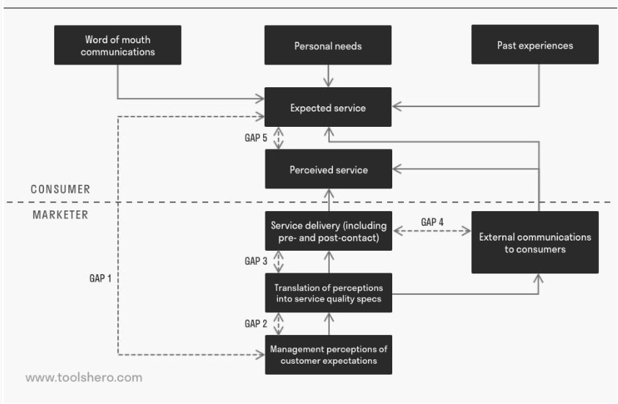
Source: (Mulder,2024).
Secondly, Service Recovery Theory suggests that organisations should response proactively to service failures through compensation, apology, and problem resolution. According to the service recovery paradox, effective recovery can improve customer loyalty. However, Yu (2022), the hotel failed to apply even basic recovery strategies, such as offering refreshments or providing clear updates, which worsened guest dissatisfaction. Third leadership theory, particularly transformational leadership emphasises the importance of motivating staff setting clear expectations and leading by example.
The absence of storing leadership in the situation resulted in low staff motivation, poor behaviour and lack of accountability. This also links to Herzberg’s Motivation Theory (Figure 1) were lack of recognition support and engagement can reduce employee performance. From an organisational cultural perspective, the hotel demonstrated a task oriented rather than customer-oriented culture. Staff were focused on completing assigned duties rather than delivering a positive guest experience. This reflects a misalignment between organisational values and service expectations.
Figure 2 Herzberg’s Motivation Theory
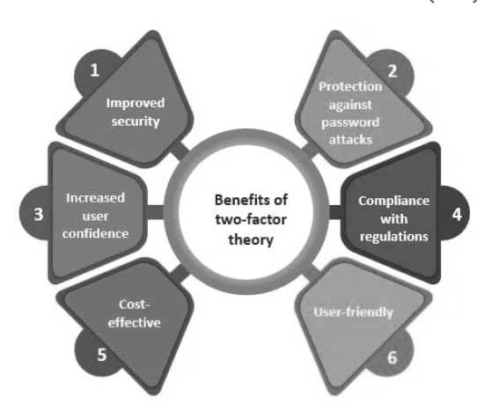
Source: (Kumar,2023)
Furthermore, Gust Experience Management Theory (Figure3), highlights the importance of designing seamless customer journeys. In this case, the guest journey was disrupted at critical touchpoint, leading to negative overall experience. At an industry level, mainly in hotel businesses, these issues reflect common challenges including staff storages, high workload and operational silos, which can compromise service quality if not management effectively with proper planning of supports.
Figure 3 Guest Experience Management theory
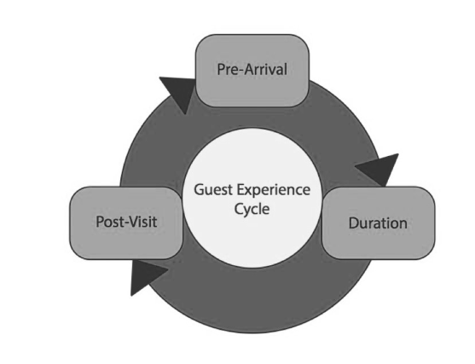
Source: (Liebman,2014)

1.6. Conclusion
This experience has provided valuable insights into the complexities of managing guest service across multiple departments. It highlighted the critical importance of communication, coordination, leadership and service recovery in delivering high quality guest experience. While the hotel had operational systems in place, the lack of integration between departments and absence of proactive management lead to service failure. The situation demonstrated that technical efficiency alone is not sufficient effective supervision and strong customer focused culture are equally important.
I have learned that managing guest complaints requires not only problem-solving skills but also emotional intelligence, empathy ad leadership presence. Addressing issues early maintaining clear communication and implementing service recovery strategies are essential to printing escalation. Overall, this relation has enhanced my understanding of supervisory responsibilities in hospitality mainly in managing complex, multi-departmental service situations.

1.7. Action plan
To improve future practice serval supervisory number of strategies can be implemented. First, improving interdepartmental communication is essential. This could involve real time room status updates through integrated systems and regular coordination briefings between Front Office, Housekeeping and maintenance (Chemmanur,2024).
Secondly, implementing standardised service recovery protocols would ensure consistent responses to guest complaints (Ghanekar,2022). For example, offering complimentary drinks, clear communication and sincere apologies during delays can significs improve guest perception.
Thirdly, leadership development is crucial. Supervisions should adopt a more proactive role guiding staff behaviour, providing support during peak times, and reinforcing customers service standards (Orkamo et al,2025). Training in emotional intelligence and conflict management would further enhance staff performance.
Moreover, investing in staff training and development can improve service skills, communication and customer engagement. This would also increase motivation and accountability (Heinrich,2025). Also from an organisational perspective, fostering a customer centric culture is vital (Heinrich,2025). This can be achieved through regular feedback, performance monitoring and recognition of good service. Finally, contingency planning for high demand periods, including adequate staffing and scheduling, would help reduce operational pressure and improve service delivery (Heinrich,2025).

Part 2: Hotel Mentor Feedback
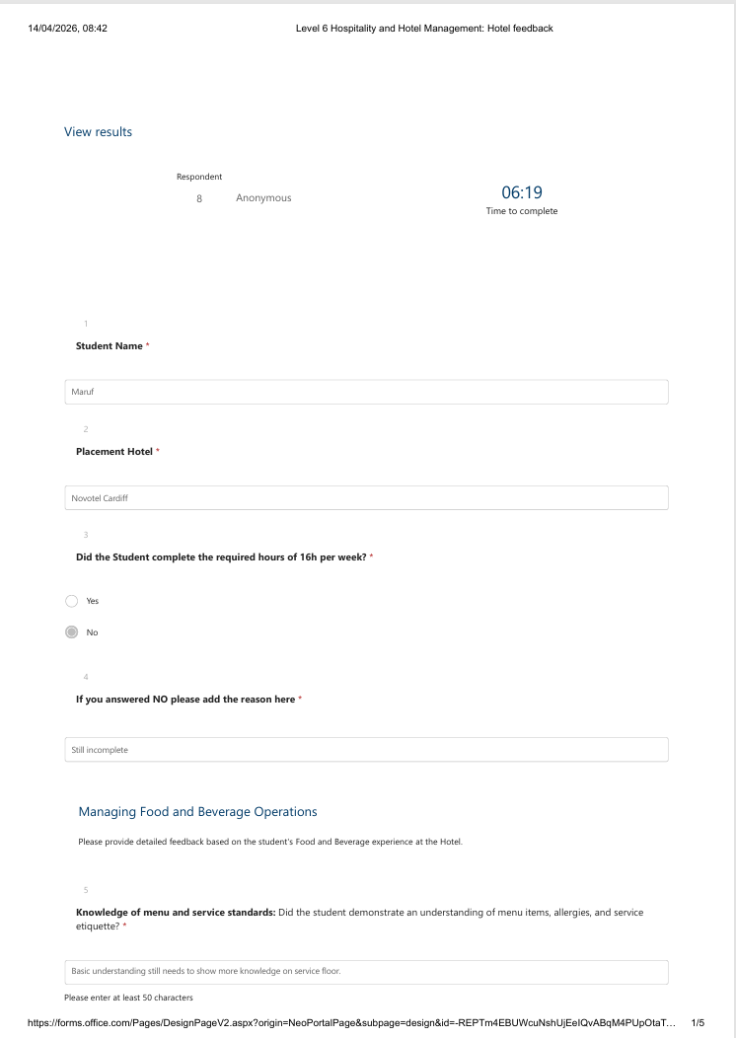
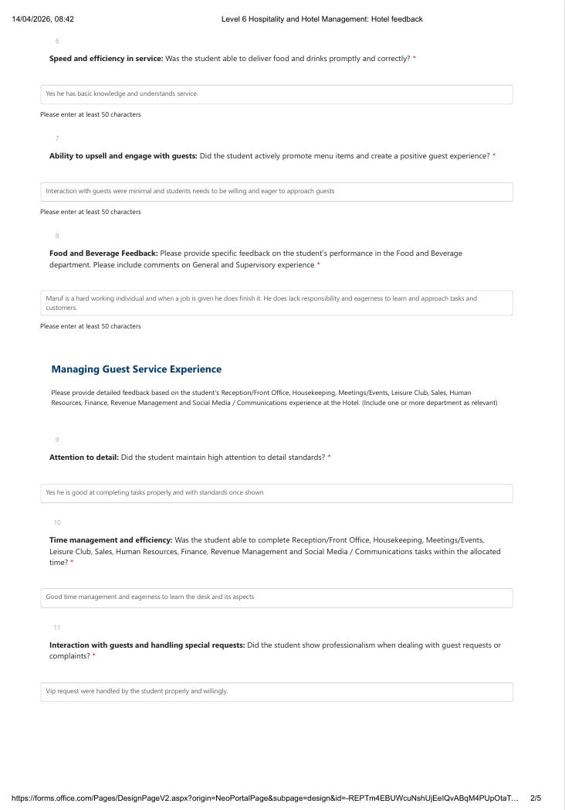
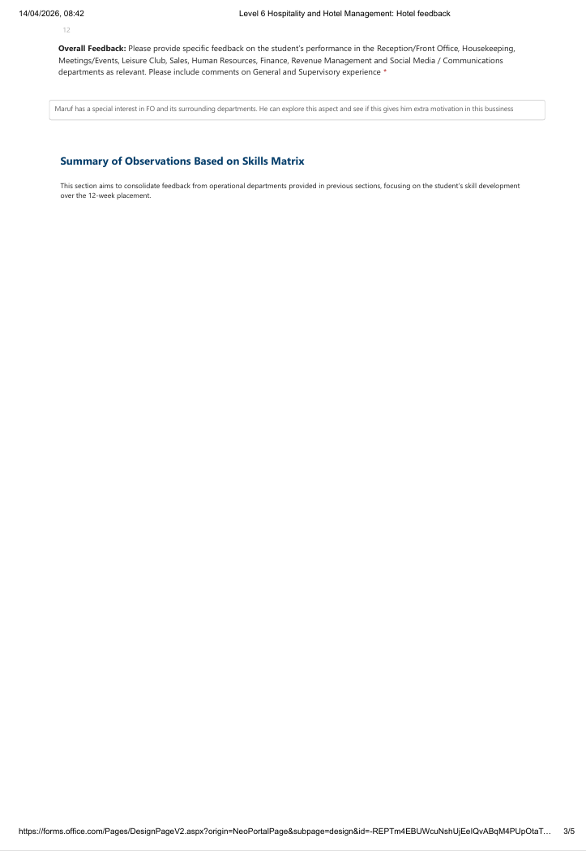
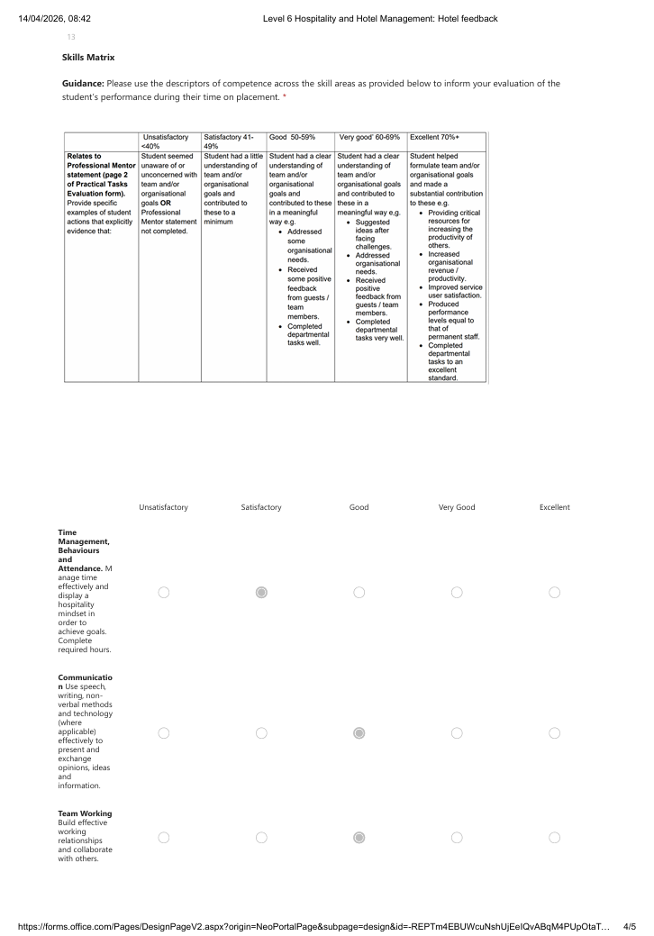
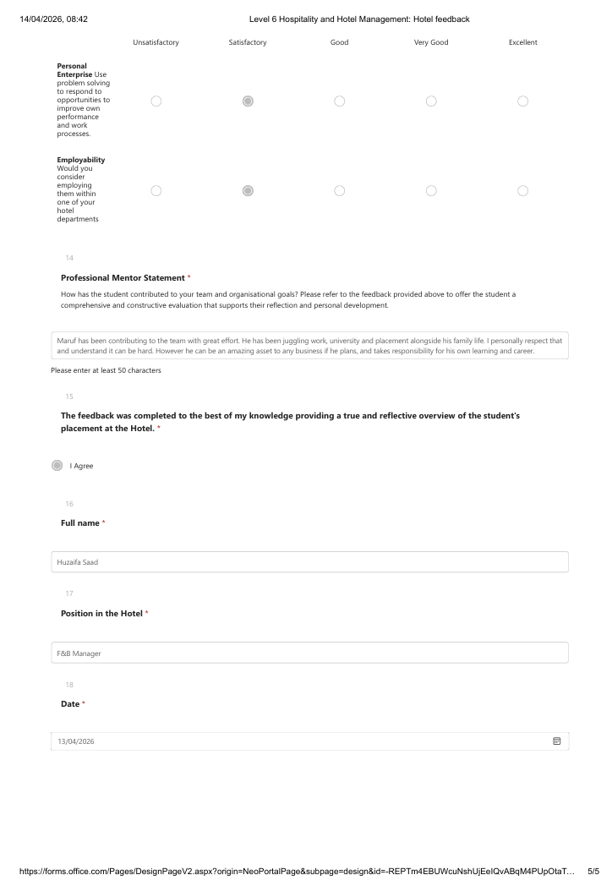


Part 3: Academic Tutor Feedback
Tutor Feedback
Student Name: Maruf Rahman
Student ID: 2311256
Time Management
Maruf has faced ongoing challenges with time management throughout this placement. Factors such as a long commute, external work commitments, and time off due to injury have impacted his ability to maintain a consistent average of 16 hours per week.
As a result, Maruf has struggled to keep up with the required placement hours and is currently working to recover this time. It is positive to see that he has recently taken responsibility by arranging a full working week and taking leave from his job in order to catch up. This demonstrates an awareness of the situation and a willingness to address it.
However, throughout much of the term, Maruf has found it difficult to prioritise his full-time university commitments alongside his other responsibilities. His working pattern has been restricted, which has also limited his exposure to different areas within the placement.
From a tutor’s perspective, Maruf’s engagement with scheduled meetings has been inconsistent, and attendance at one-to-one sessions has been poor. Moving forward, stronger planning, prioritisation, and a more consistent approach to managing his time will be essential in order to successfully complete the placement and gain maximum benefit from the experience.

Communication
Maruf’s communication throughout the placement has been inconsistent. While he is professional and responsive during live discussions, such as on Teams, his communication via email has often been delayed, with responses sometimes taking several days or longer.
He has also missed a number of scheduled meetings, which has limited opportunities for support and guidance. Improving communication in these areas will be important, particularly in ensuring that any challenges are addressed promptly.
Maruf would benefit from being more proactive in communicating any difficulties he is facing, whether related to placement hours, shifts, or academic work. Maintaining regular and timely communication is a key expectation within both academic and professional environments.
Looking ahead, developing a more consistent and reliable communication approach will support Maruf in managing his responsibilities more effectively.

Behaviour
Maruf has demonstrated a mixed level of engagement throughout his placement. At times, he has shown a tendency to withdraw from challenges rather than address them directly, which has impacted his overall progress and experience.

However, when present and engaged, Maruf demonstrates the ability to be a capable and professional member of staff. He is able to carry out the required tasks effectively and contributes positively within a team environment.

His recent efforts to take greater responsibility for his placement hours are encouraging and suggest a shift towards a more proactive approach. Building on this momentum will be important as he continues to develop.

Moving forward, Maruf will need to show greater consistency in his engagement, reliability, and overall approach. Taking a more proactive stance and fully committing to the placement will allow him to gain significantly more from the experience.

Problem-Solving
Maruf has shown that he possesses the practical ability to perform well within the placement environment. When on shift, he is able to manage tasks effectively and demonstrates a solid understanding of operational requirements.

However, his overall approach to problem-solving has at times been limited by a lack of proactivity. Avoiding or delaying engagement with challenges has reduced opportunities for development and learning.

His recent decision to take action in addressing his placement hours shows a positive step towards taking responsibility and resolving issues. Continuing to adopt this mindset will be important in strengthening his problem-solving capabilities.

Looking ahead, Maruf should focus on developing a more proactive approach when faced with challenges, seeking support when needed, and taking early action to prevent issues from escalating.

Maruf is a strong student in practical terms, but he will need to improve how he manages and balances his time across university, placement, and personal commitments. By developing greater organisation, communication, and engagement, he will be better positioned to succeed both in his placement and within the wider hospitality industry.

Tutor: Daniel Payne
Signature: Daniel Payne
Date: 14th April 2026

Part 4: Reflection on Hotel and Academic Tutor Feedback

4.1. Introduction
This part of the reflation critically evaluates the feedback received from both hotel mentor at the Novotel Cardiff and my Placement tutor, with the aim of identifying strengths, addressing weakness and supporting my professional development within guest service operations. Feeback is an essential component of learning in hospitality management as it provides insights into real world performances, highlights area for improvement and guides future development. With analysis of both perspectives, this reflection explores how my performance was perceived in operational and academic contexts. It also examines how the feedback aligns with my placement experience across front office and food and beverage department. Ultimately, this reflation aims to develop a clear understanding of supervisory expectations improve my guest service capabilities and support my long-term career progression in the hospitality industry.

4.2. Understanding the Feedback
The feedback from my hotel mentor highlights number of key strengths in my performance. For instance, I was recognised as hardworking and reliable person with capacities of completing assigned tasks effectively. I also demonstrated good time management during my shifts, attention to detail and the ability to follow operational standard once trained. In front office, I showed professionalism when handling VIP guest requests and developed a clear interest in front office operations. My ability to work within a team and contribute positively was also acknowledged.
However, the hotel mentor also identified several areas for improvement. These included limited guest interaction, lack of confidence in approaching customers, and weak upselling skills. Moreover, I was described as lacking initiative, responsibility and eagerness to learn mainly in proactively engaging with tasks and customers. My knowledge of menu and service standards in F&B was considered basis and required further development.
Similarly, my placement tutor’s feedback focused on challenges related to time management, communication and engagement. Due to external factors such as commuting, work commitments and injury, I struggled to maintain consistent placement hours. My communication was described as inconsistent, particularly with delayed email responses and missed meetings. The tutor also noted a tendency to withdraw from challenges rather than address them proactively which limited my learning opportunities.
Common theme across both feedback source includes lack of proactivity, inconsistent engagement, and the need for stronger communication responsibility. While the hotel mentor focused more on operational performance and guest interaction, the placement tutor emphasised academic engagements, time management and professional behaviour while providing complementary perspectives on my overall development.

4.3. Impact on the feedback
The feedback has significantly I improved my understanding of my strengths within guest service roles. It reinforced that I am reliable, capable and able to perform well when given clear instructions and training. My ability to handle operational tasks, work within a team and maintain standards demonstrates that I have a strong foundation in hospitality operations.
However, the feedback also highlighted critical areas of development mainly my lack of proactivity, confidence, and communication consistency. Reflecting on my placement experiences, I can relate these issues to specific situations. For example, during busy periods at the front office, I often hesitated to take initiative when dealing with guest complaints or delays. Similar, in F&B I did not actively engage with guests or attempt to upsell. Which aligns with the feedback provided.
The feedback also helped me recognise that technical ability alone is not sufficient in hospitality. Effective guest service requires confidence, communication and proactive mindset. My hesitation to approach challenges or communicate issues early limited my ability to fully benefit from the placement. Furthermore, this reflaction has reshaped my understanding of supervisory expectations. It is understood that a supervisor is not only responsible for completing task but also for leading by example, taking initiative and ensuring high standard of guest experience. the feedback highlighted the importance of being accountable, responsive, and engage mainly in fast paced hospitality environment. Overall, the feedback has made me more aware of the significance of professional responsibility, self-management, and continuous improvement which are essential for success in gust service management roles.

4.4. Action for growth
Based on the feedback, I have identified number of key actions that I will have to take to support my development. These are first as follows.
I will focus on improving my communication skills mainly through responding to emails promptly, attending scheduled meeting consistently and proactively informing supervisors of any challenges. This shall help to build reliability and professionalism in both academic and workplace environment.
I shall work on developing a more proactive mindset by actively seeking opportunities to engage with guests, take initiatives in tasks and address challenges early. For instance, I shall practice initiating conversations with guests, offering assistance and participating more contently in service delivery.
Third I shall improve my guest service skills, mainly in aeras such as upselling, service recovery and customer engagement. This can be achieved through additional training, observing experienced staff and applying theoretical knowledge such as service quality and customer satisfaction in principle.
I shall also work on to enhance my time management and prioritisation skills using Eisen Howard time management matrix and creating structured schedule that priorities tasks, allocate to others and balance university, works and placement commitment. This shall ensure consistency and reduce last minutes pressure on me.
The above actions that I have set up shall directly support my performance in the future placements and professional roles by improving my confidence, reliability and ability to delivery high quality guest experiences. In the long term as I am to pursue a career in hospitality management, these improvements will help me develop into a competent and effective supervisor capable of managing teams and delivering excellent service standards.

4.5. Conclusion
Reflecting on both hotel mentor and placement tutor feedback has provide valuable insight into my performance and development needs. While demonstrated strengths in reliability, teamwork and operational ability, the feedback clearly highlighted areas for improvement mainly in communication, proactivity and professional engagement.
This reflective process has helped me understanding the importance of taking responsivity for my learning, actively engaging in my role, and developing key supervisory skills. It has also reinforced that success in hospitality requires not only technical competence but also strong interpersonal and leadership abilities.
Moving forward, I am committed to applying these lessons by improving my communication, taking greater initiative and continuously developing guest service skills and to succeed in future supervisory and management roles within the hospitality industry.

References
Alansari, A, N, Omri, A & Singh, K. (2024). Staff shortages linked to burnout, depression, and anxiety among outpatient nurses: a cross-sectional analysis at Hamad General Hospital, Qatar. BMC Nurs. Vol 24. Pp: 1118. Available: https://pmc.ncbi.nlm.nih.gov/articles/PMC12379308/ (Accessed: 20th of April 2026).
Chemmanur, A. (2024). Humanising hospitality through technology. Deloitte: 11 Nov. Available: https://www.deloitte.com/uk/en/Industries/consumer/blogs/humanising-hospitality-through-technology.html (Accessed: 20th of April 2026).
CID (2025). Employee engagement and motivation. CIPD. Available: https://www.cipd.org/uk/knowledge/factsheets/engagement-factsheet/ (Accessed: 20th of April 2026).
Ghanekar, S. (2022). The Innovation in Hotel Industry Called “The SmartRoom”. Journal of environmental Technologies. Vol 5 (1). Pp:15-36. Available: https://www.researchgate.net/publication/365790995_The_Innovation_in_Hotel_Industry_Called_The_Smart_Room (Accessed: 20th of April 2026).
Heinrich, A. (2025). 5 Benefits of Corporate Employee Training & Development. Harvard Business Review: 22nd May. Available: https://online.hbs.edu/blog/post/employee-training-development (Accessed: 20th of April 2026).
Kumar, R. (2023). Two Factor Theory: A Simple Overview. Techno PM: Oct. Available: https://www.techno-pm.com/blogs/project-management-concepts/two-factor-theory-a-simple-overview (Accessed: 20th of April 2026).
Liebman, J. (2014). Managing Guest Experiences in Hospitality/Tourism: A Loyalty Approach. LinkedIn: 4th Dec. Available: https://www.linkedin.com/pulse/20141204202357-94474780-managing-the-guest-experience-in-hospitality-tourism/ (Accessed: 20th of April 2026).
Mulder, P. (2024). SERVQUAL Model of Service Quality. Tools hero. Tools Hero: 20th Dec. Available: https://www.toolshero.com/quality-management/servqual-model/ (Accessed: 20th of April 2026).
McKinsey & Company (2016). Customer experience: Creating value through transforming customer journeys. McKinsey & Company: Nov. Available: https://www.mckinsey.com/~/media/McKinsey/Industries/Public%20and%20Social%20Sector/Our%20Insights/Customer%20Experience/Creating%20value%20through%20transforming%20customer%20journeys.pdf (Accessed: 20th of April 2026).
Orkamo, M, et al. (2025). Leadership behaviours to promote organisational performance in private sector digital transformation: A systematic literature review. Digital Business. Vol 5 (2). No: 100155. Available: https://www.sciencedirect.com/science/article/pii/S266695442500050X (Accessed: 20th of April 2026).
Tukira, M & Desianti, S, L. (2025). He role of training and development in enhancing employee engagement: a systematic literature revies. Feedforward: Journal of Human Resource. Vol. 5 (2).Pp: 77- 95. Available: https://www.researchgate.net/publication/395673157_The_Role_of_Training_and_Development_in_Enhancing_Employee_Engagement_A_Systematic_Literature_Review (Accessed: 20th of April 2026).
Yu, M. (2022). Hotel guest satisfaction during COVID-19 outbreak: The moderating role of crisis response strategy. Tour Management. Vol 27. No: 104618. Available: https://pmc.ncbi.nlm.nih.gov/articles/PMC9234001/ (Accessed: 20th of April 2026).

