Title: A comparison of the marketing methods of two multinational hotel chains.
Student name: Mohammed Nazir Hussain
Student ID number: 2132107
Module Title: Marketing Essentials BMIH4005 Resit
Lecturer’s name: Chris Wikin
Contents
Introduction 3
Marketing Approach 4
Figure 1: Six Senses Logo 4
Figure 2: Novotel Hotel 5
Current market position 6
Marketing Strategies 6
Consideration in Marketing 9
Conclusion 10
References 11

Introduction
Marketing is critical for hotels since it spreads the word about the facility, attracts new customers, and increases revenues. Hotels may boost their lead generation, room reservations, and customer retention rates by directing their marketing efforts to the exact demographics that they have identified as being most likely to be interested in their facility. The digital revolution has made a strong online presence and diligent reputation management critical components of any good marketing strategy. Furthermore, a well-executed marketing plan may help hotels increase their market share and differentiate themselves from their competitors. Both Six Senses and Novotel have outstanding marketing strategies that have a huge influence on the hospitality sector.

Marketing Approach
In 1995, Sonu Shivdasani launched the first resort under the Six Senses Hotels Resorts Spas brand in Phuket, Thailand. The concept behind the business is to give eco-conscious, affluent travelers a unique, authentic, and luxurious hospitality experience. Six Senses is a marketing approach founded on a solid belief in the significance of environmental stewardship, involvement in local communities, and personal development. By promoting local communities and cultures and reducing energy, water, and waste, the firm became an industry pioneer in "green" tourism. In the early 2000s, Six Senses developed resorts in remote locations such as Bali, the Maldives, and Seychelles (Chung, 2017). In 2008, the firm built its first spa, which offered a variety of holistic health and wellness treatments. Six Senses has improved its marketing approach over the years by emphasizing wellness and immersive travel experiences to position itself as an industry leader in the premium wellness hotel sector. Since acquiring Six Senses in 2015, the InterContinental Hotels Group has been dedicated to preserving and enhancing the company's trademark combination of luxury hospitality and holistic well-being. Six Senses' current marketing approach emphasizes the company's commitment to environmental conservation, guest health and happiness, and community participation.
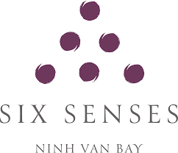

Figure 1: Six Senses Logo
(Source: Author)
Novotel, founded in France in 1967 and owned by AccorHotels, is a reasonably priced hotel brand with a global presence. While the brand's marketing approach has evolved, it has always focused on offering both leisure and business travelers high-quality, conveniently accessible accommodations. In its early days, Novotel marketed itself as an "all-inclusive" hotel, which meant that customers may check in and immediately begins to enjoy the hotel's dining options, bar, and room service. In the 1980s and 1990s, Novotel shifted its marketing strategy to highlight the company's worldwide reach and cutting-edge capabilities as it rapidly expanded into new countries, notably in Europe and Asia(Michopoulou, 2020). Novotel has prioritized digital technology like mobile check-in and digital room keys over the past several years to give its customers a more streamlined and convenient stay.
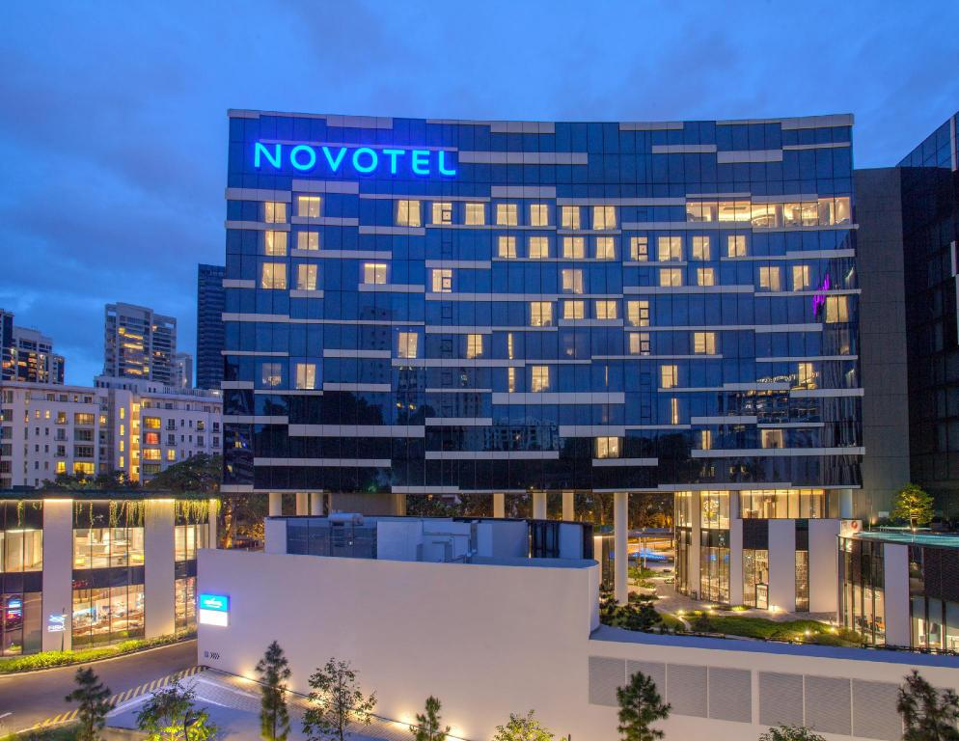

Figure 2: Novotel Hotel
(Source: Author)

Current market position
The Six Senses Hotels Resorts Spas brand is a luxury hotel network with sites in the Americas, Europe, and Asia. Wellness, sustainability, and cultural immersion are fundamental to the brand's marketing appeal to potential customers. Spa treatments, yoga classes, and wholesome meals are just a few of the wellness services at Six Senses, which places a focus on the overall health of its guests. Six Senses advertises its venues by stressing their natural beauty and encouraging guests to immerse themselves in the local culture. As part of the brand's commitment to environmental responsibility, efforts are made to reduce the use of throwaway plastics and sustainably support local farmers (Willium, 2021). Six Senses aims to provide its guests with a distinctive and authentic travel experience by including all of these elements.
As far as I'm aware, the current marketing plan for Novotel hotels emphasizes the brand's commitment to comfort, convenience, and sustainability until at least 2021. All advertising efforts for Novotel emphasize the hotel's spacious rooms, lavish amenities, and stress-free stay alternatives. Through its Planet 21 sustainability effort, the corporation demonstrates its dedication to lowering its environmental impact and assisting local communities (Heaton, 2013). In addition, smartphone check-in and other tech-driven services are crucial to Novotel's marketing strategy since they reflect the brand's commitment to making customers' travels convenient and pleasant.

Marketing Strategies
Six Senses Hotels Resorts Spas use several marketing strategies to advertise its amenities and increase brand recognition. These strategies are intended to attract a big audience and give interested parties a memorable experience that graphically displays what sets the brand apart. Social media marketing is a primary concern for Six Senses, and the firm has a substantial following on sites such as Instagram, Facebook, and Twitter, where it frequently shares photographs of its breathtaking locales and promotes its products. They attempt to persuade prospective visitors to make a reservation by publishing captivating and engaging content, such as photographs and videos of their lodgings. They utilize these channels to interact with their target audience, address customer service concerns, and expand their fan base. Six Senses employs influencer marketing to inform a bigger audience about its hotels and resorts. These individuals have a huge following because they provide personal endorsements (Pakpahan, Komala, and Suja, 2022). To extend its consumer base, Six Senses leverages the power of word-of-mouth by developing relationships with notable individuals. Six Senses promotes the unique experiences that tourists may have at their resorts by generating and distributing informative and engaging content on their blog and website. Their blog acts as a forum for informing consumers about the company's environmental commitment. Six Senses offers a referral program that compensates clients for suggesting their hotels. This method of advertising is particularly effective since it depends on the goodwill of existing customers and their recommendations to reach new ones. Six Senses use event marketing by providing events and experiences at its resorts to introduce guests to its services and provide them the opportunity to engage with potential business partners. Through events that the brand throws, the business's distinctive offering may be promoted and the customer experience can be enhanced. Six Senses uses public relations to increase its consumer base and enhance its reputation in the eyes of the general public. By collaborating with media outlets and notable people, they may tell their brand's story and connect with new audiences (Menon and Menon, 2017). These promotional strategies are merely a handful of the many employed by Six Senses to increase brand recognition and attract clients to its hotels.
On the other hand, Novotel, a hotel network owned by Accor, employs a range of promotional strategies to raise awareness and interest in their properties. These strategies are intended to attract a big audience and inform prospective purchasers about the firm. The website of Novotel is well-designed and user-friendly, showing their various lodgings and providing prospective visitors with all the information they need to make a reservation. The ease with which search engine users may discover the website increases the possibility that they will do so and, perhaps, make a purchase. Email marketing (email advertising) is an integral aspect of Novotel's marketing strategy for promoting their hotels and specials to past guests and potential new guests (Iqbal, 2016). By sending them customized and targeted emails, they may approach their audience at the right time with the relevant content to convince them to book a stay. Novotel makes considerable use of social media marketing on platforms such as Facebook, Twitter, and Instagram to promote its lodgings and services. They attempt to persuade prospective customers to make a reservation by publishing captivating and engaging content such as photographs and videos. Novotel emphasizes the unique experiences available at its hotels through the development and dissemination of instructive and entertaining content on its website and blog. In addition to sharing travel tips and suggestions on their blog, they also tell readers about the company's mission (Luther, 2020). Novotel's Le Club Accorhotels program rewards repeat guests for their loyalty with privileges. This method of advertising is particularly effective since it depends on the goodwill of existing customers and their recommendations to reach new ones. Novotel partners with travel agencies, airlines and other industries to promote their properties and expand their reach. By forging alliances with established firms and using their current consumer base, they may reach new audiences effectively and credibly. They discovered that implementing a multi-channel approach enabled them to increase their audience reach and create a more comprehensive brand experience than their competitors.

Consideration in Marketing
Sustainability and green messaging are central to Six Senses Hotels' marketing strategy, highlighting the company's commitment to preserving the environment and enhancing the lives of its guests. Their advertising campaigns emphasize the eradication of plastic waste, the utilization of renewable energy sources, the encouragement of community engagement, and environmentally responsible company practices. (Angoujard, 2015) The firm is devoted to promoting sustainable tourism and preserving the natural beauty of its destinations by educating and involving visitors in these crucial issues. Global hotel chain Novotel's marketing strategy is highly impacted by environmental issues. Reducing energy use, minimizing waste, and preferring eco-friendly products are all methods to protect the environment. The hotel's efforts to reduce its environmental effect are acknowledged by the brand's "Green Globe" accreditation. Novotel cares about contemporary issues such as health and well-being in addition to environmental sustainability. As part of its self-proclaimed objective to encourage visitors to live more balanced lifestyles, several hotels in the group provide fitness centers, spas, and healthy dining alternatives (Margerison, 2019). Novotel's marketing strategy reflects the company's desire to remain at the forefront of an ever-changing industry by stressing environmental sustainability and health and wellness.

Conclusion
Effective hotel marketing is crucial to the expansion of the hotel industry. By having a great awareness of their audience and using effective marketing techniques, hotels may increase their bottom line, acquire market share, and stand out from the crowd. Messages of sustainability and greenness, as well as discussions of timely topics such as health and wellness, are integral components of a successful marketing campaign. A well-executed marketing strategy is one method for hotels to react swiftly to the ever-changing modern travel business.

References
Angoujard, R. (2015). Exceeding customer expectations at Novotel. Strategic HR Review, 4(2), pp.8–9. doi:10.1108/14754390580000585.
Chung, H. (2017). Marketing Control and Marketing Standardisation Strategies: An Integrated Typology. SSRN Electronic Journal, 3(2). doi:10.2139/ssrn.1071192.
Heaton, D. (2013). Business in the Big Picture: Managing for Sustainability. Journal of Business & Hotel Management, 01(02). doi:10.4172/2324-9129.1000e105.
Iqbal, U. (2016). Hotel and Business Management. Journal of Hotel & Business Management, 05(02). doi:10.4172/2169-0286.1000e113.
Luther, S. (2020). Go Pros and Goats – how to evolve hotel marketing strategies in the Covid-19 era – by Richard Thorburn. Campaign Middle East.
Margerison, J. (2019). Business accounting for hospitality and tourism. International Journal of Hospitality Management, 15(1), pp.96–97. doi:10.1016/s0278-4319(96)90049-3.
Menon, A. and Menon, A. (2017). Entrepreneurial Marketing Strategy: The Emergence of Corporate Environmentalism as Market Strategy. Journal of Marketing, 61(1), p.51.
Michopoulou, E. (2020). ‘The future of global hospitality: What is going to matter?’ – Neil Jacobs, the CEO of Six Senses Hotel Resorts Spas. International Journal of Spa and Wellness, 1(1), pp.1–2. doi:10.1080/24721735.2020.1790236.
Pakpahan, A., Komala, I.G.A.M.K. and Suja, I.K. (2022). Best Practices of Sustainable Development to Make Six Senses Uluwatu a Green Hotel. Jurnal Bali Membangun Bali, 3(1), pp.75–98. doi:10.51172/jbmb.v3i1.227.
Willium, A. (2021). Six Senses Hotels Resorts Spas recognizes hosts as the magic behind the third top hotel brand win. [online] InterContinental Hotels Group PLC. Available at: https://www.ihgplc.com/en/news-and-media/news-releases/2019/six-senses-hotels-resorts-spas-recognises-hosts-as-magic-behind-third-top-hotel-brand-win.

