Ways of thinking
Ffion Lewis - 2311987

Word Count:

Semiotics essay: 389
Manifestos Essay: 564
Reflective Writing Essay: 564

Total: 1,517

Semiotics: Deconstruction of Coca-Cola advertisement; ‘A classic never goes out of style’
(Coca-Cola, 2018)
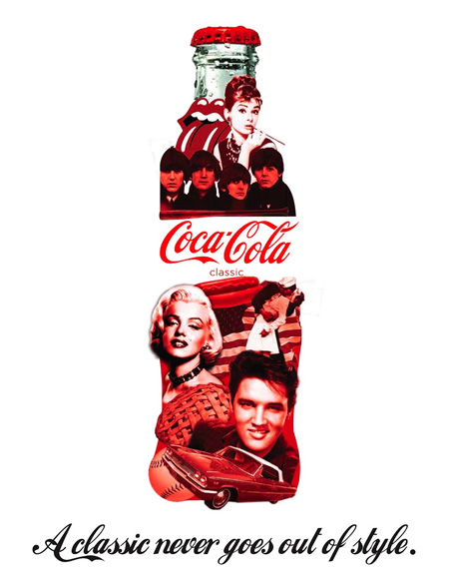
For my semiotics essay, I have chosen to deconstruct the Coca Cola print advertisement. “Semiotics is the study of signs, and sign-making behaviours. As defined by the Swiss Linguist, Ferdinand de Saussure, semiotics is regarded as the "the life of signs within society," (Berger, 2008, p.2). Semiotics provides insight into the collective understanding of what is seen and what is perceived of any given artwork (Berger, 2008). In the image, well-known icons such as The Beatles, Elvis Presley, and Marilyn Monroe, who stole the Hollywood limelight from the 1950’s onwards, are artfully arranged to form the silhouette of the bottle.

The advertisement's colour palette is elegant and simple, focusing wholly on red and white—the two main colours that come with the with Coca-Cola branding across its vast franchise. The striking red of the bottle set against a clean white backdrop grabs the viewer's attention, guiding them to absorb the message being put across in the advert. “The way we see things is affected by what we know or what we believe” (Berger, 2008, chapter 1) it is widely appreciated that white is a classic colour. The timelessness of the white background complements the poster perfectly, as sources suggest it symbolizes "Weddings, New life, Death, and Winter" (Windsor and Newton, 2024). The text "A classic never goes out of style" (Coca-Cola, 2018) features the same font used for "Coca-Cola" boldly presented at the centre of all their merchandise and in the advertisement's bottle. This cursive font portrays a story-like quality to the message and the advertisement. The text seems to assure us that the Coca-Cola branding and company, like legendary figures such as Marilyn Monroe and The Beatles, will never fade from style.

“To change the mind of a reader, authors compose written persuasion according to a set of rhetorical features” (Chambliss and Garner, 1996). The compelling title and font in the advertisement shows the Cola bottle in a new light, associating it with something unique and timeless such as The Rolling Stones. This makes us realize how worldwide the brand is, and how it could always be seen as a 'Classic'. The image of the Coca-Cola bottle with famous names from history supports this persuasion (Chambliss and Garner, 1996). The basic yet popular advertisement with its powerful message effectively convinces the audience, pushing everyone to purchase the product.

References
Berger, J (2008) Ways of Seeing. London: Penguin Group
Chambliss, M. J and Garner, R. (1996). ‘Do Adults Change their Minds after Reading Persuasive Text?’ Written Communication, 13(3), pp. 291-313. DOI: https://doi.org/10.1177/0741088396013003001
Windsor and Newton (2024) White: The colour of life, death, weddings and winter. Available at: White: The colour of life, death, weddings and winter | Articles | Winsor & Newton (winsornewton.com) (Accessed: 10 December 2023)

Manifesto Writing: 8 short statements regarding beliefs, principles and design practice
- There should be more shelter for the homeless.
- Treat everyone with the same level of respect, until they earn more or lose the right.
- Everyone should be open to learn the art of manifestation.
- Always be pleasant to everyone.
- Mental health should be put at the forefront of health care priorities in the UK.
- Wages should be equal for both genders no matter what job they are in.
- Love work but also love your life – the world and your job need you to be well rested, well-nourished and well supported. Balance is key.
- Always put yourself and your needs first.

Keywords & Images: Prioritising Mental health
Mental health should be put at the forefront of health care priorities in the UK.
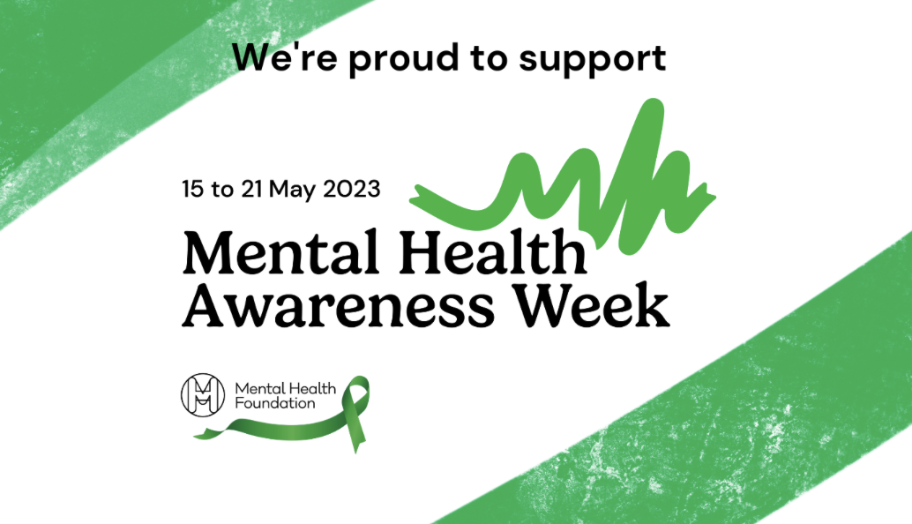
(Royal Marines Charity, 2024)

Mental health is a topic that is spoken about often today, so I believe that taking an understanding to this topic and showing an interest can be a big help to people who may be struggling. “Approximately 1 in 4 people in the UK will experience a mental health problem each year In England, 1 in 6 people report experiencing a common mental health problem, such as anxiety and depression in any given week” (Mind Charity, 2017). As we know, it cannot always be easy to spot the signs in someone who is battling with their own head, so spotting the symptoms of someone who is suffering can be tricky. This is why I believe that Healthcare organisations within the UK need to start prioritising their patients who speak up about their mental health issues sooner rather than later, as the outcome isn’t good. “Over 700,000 people take their own life each year” (World Health Organisation, 2023). There was also a noticeable jump in statistics during the COVID-19 outbreak, due to the world being at standstill and having to stay inside all the time. I believe that there was a jump in the statistics during the pandemic because we were given time to think too deeply, whereas if we had been in work or school, or doing things we enjoy, this would not have been the case; “Unexpected behaviour changes during the COVID-19 pandemic may have contributed to the increasing trend of suicidal attempts reported” (BMC Psychiatry, 2022).
References
Mind Charity, (2017) ‘Mental health facts and statistics’. Available at: https://www.mind.org.uk/media-a/2958/statistics-facts-2017.pdf (Accessed 11 December 2023)
World Health Organisation, (2024) ‘Suicide; key facts’ Available at: https://www.who.int/news-room/fact-sheets/detail/suicide#:~:text=Overview,on%20the%20people%20left%20behind. (Accessed 11 December 2023)

BMC Psychiatry, (2022) ‘Impact of the COVID-19 pandemic on suicidal attempts and death rates: a systematic review’ Available at: https://bmcpsychiatry.biomedcentral.com/articles/10.1186/s12888-022-04158-w (Accessed December 11 2023)

Keywords & Images: Manifestation, the art of getting what you want.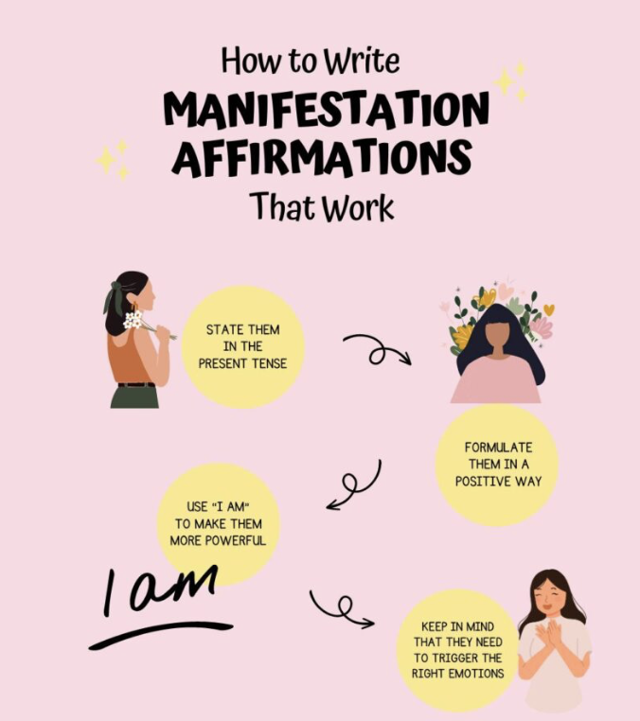
“Applying principles of attracting to oneself, through love, whatever materials, energy, or help were needed to promote wholeness or further growth” (Spangler, 2009) This is known as the art of manifestation. Manifestation is channelling what you desire in life by repeating positive thoughts and phrases. It is said, that by consistently repeating statements over time, you can shift your thoughts and life narrative into getting what you truly want. This form of art is also known as ‘The Moses Code’ (Twyman, 2021) and has been used as a process for over “3,500 years, changing the world for a second time” (Twyman, 2021). It’s believed that manifestation is a way of reigniting a flame inside of you, and it’s god’s way of giving you back what you deserve in life. It can come from gratitude and kindness and is rewarding to those who deserve it.
References
Spangler, D (2009) The Laws of Manifestation: A Consciousness Classic. Weiser Books
Twyman J.F (2021) The Moses Code: The most powerful manifestation tool in the history of the world. Hay House INC

Keywords and Images: Shelter, Homeless, United Kingdom
There should be more shelter for the homeless.

This manifesto is based off homelessness and poor housing in the UK, because I believe that it is truly outrageous. I feel that our British government does not have enough organisational morale or any drive to make a change for the homeless and is more interested in social events such as in parliament or with other government parties. “The number of people living in temporary accommodation has risen by an alarming 74% in the last 10 years” (SHELTER, 2023) something the charity ‘SHELTER’ argues is driven by a shortage of cheap homes, and an over population of expensive private renting. “68% of families living in temporary accommodation have been there for over a year” (Access, 2023) showing that this type of accommodation doesn’t end up being temporary and stretches to more long term, especially now as housing and rent prices continue to rise. For this to change, the government needs to invest more money into the UK’s ever-growing homelessness crisis, instead of paying for things that we don’t need as much of.
References
SHELTER, (2023) ‘At least 271,000 people are homeless in England Today’ Available at: https://england.shelter.org.uk/media/press_release/at_least_271000_people_are_homeless_in_england_today#:~:text=The%20number%20of%20people%20living,expensive%20and%20unstable%20private%20renting. (Accessed December 11, 2023)
Access, 2023 ‘Temporary Accommodation – what is it and how can it reduce homelessness’ Available at: https://www.theaccessgroup.com/en-gb/local-authority/software/housing-management-system/what-is-temporary-accommodation/#:~:text=Over%2068%25%20of%20families%20living,families%20are%20in%20temporary%20housing. (Accessed December 11, 2023)

Practise based writing.
A practical reflection of my work at Dyfed Powys Police Force
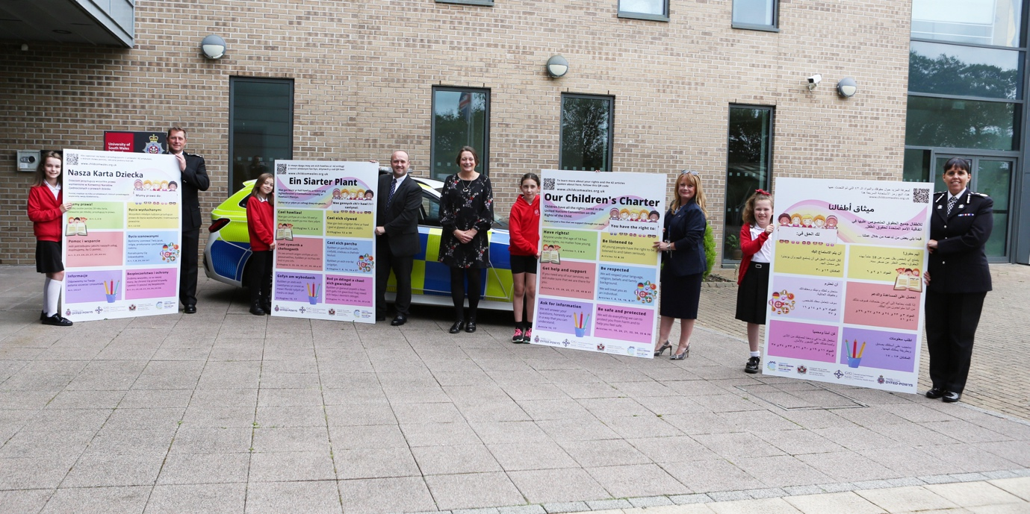
For my reflection essay, I will be reflecting on a piece of work that I completed whilst I was doing my graphic design apprenticeship with Dyfed Powys Police force. The task brief was to complete a children’s rights charter to raise awareness on their rights, which would then be displayed in police forces, doctor’s surgeries, schools and fire stations in the Carmarthenshire area. The task had a firm brief as it needed to appeal to children aged between 3-15, which is quite a broad range. To perfect the brief I was given, I had to arrange meetings with the Chief Constable over the course of a few weeks so that we could communicate with the local organisations and send them our drafts. This then gave us enough time to make any changes that were needed and to ensure that everyone was happy with the current process and future design processes. The only slight issue that we faced in the design process was considering gender neutrality and LGBTQ+ laws- “It is well established in international human rights law that states must take steps to safeguard the rights of LGBTI people” (United Nations Human Rights, 2023) When we had sent off our final design, we quicky realised that a carton illustration I had used of a baby had a pink bow on it, meaning that it wasn’t gender neutral. This was quick to change, and we changed the bow to a gender-neutral colour such as cream. Once this had been changed, the design was perfect.

The feedback that we received from the organisations in the Carmarthenshire area was outstanding, and we got posted in multiple local newspapers. I was also praised for my efforts in the police force’s end of year awards ceremony, winning the ‘Design of the year’ award. The only part of the process that I fund particularly tricky was the translations. We needed the charter to be translated to Welsh, Polish, Russian and Latin. With the help of the translation team and a few extra hours of work, this was easily accomplished. Translations ae important in a design process as its vital to show diversity “The skills of translation are becoming ever more important and desirable. Today’s multicultural and multilingual society demands effective, efficient, and empathetic communication between languages and cultures” (UOE, 2018)
The meaning of the charter was to appeal to children and to create a poster that they’ll want to learn from and to educate them on their rights – “They (children) tend to have well-developed imaginations and often think in pictures” (Ability Path, 2023). I think that all in all I managed to achieve that and more, the organisations and the children loved it. Due to this, I insured that the design was lively and fun. I would’ve liked to have known what translations we needed to complete beforehand, so that I could’ve based the final design around how big the text would need to be, the font, the colours etc. This just would’ve saved me a bit of time in the process and then I could’ve presented all posters, including the translated ones all at once to my peers and the surrounding organisations. Despite this, I enjoyed the process and felt that it was a great learning experience for me getting to design from such a specific brief, alongside people who have worked in the industry for so long.

References

United Nations Human Rights, (2023) ‘About LGBTI people and human rights’ Available at: https://www.ohchr.org/en/sexual-orientation-and-gender-identity/about-lgbti-people-and-human-rights#:~:text=The%20core%20legal%20obligations%20of,sex%20relations%20and%20transgender%20people (Accessed 11 December 2023)

University of Exeter, (2018) ‘The Importance of Translation Studies’ Available at: https://blogs.exeter.ac.uk/translation/blog/2018/06/19/the-importance-of-translation-studies/ (Accessed 11 December 2023)

Ability Path, (2023), ‘Children’s Learning Styles’ Available at: https://abilitypath.org/ap-resources/childrens-learning-styles/ (Accessed 11 December 2023)

